LAB ASSIGNMENT 03
Performance Analysis
Execution Time, Peak Memory and Complexity of Greedy Algorithms

Student Name | Hemant Mukhiya
Roll Number | 2401201013
Course / Semester | BCA / 5th
Subject | Design and Analysis of Algorithms
Submitted for academic assessment

1. Objective
Measure elapsed execution time and Python-tracked peak memory for Fractional Knapsack, Activity Selection, and Huffman Compression, then compare those observations with their theoretical time and auxiliary-space costs.

2. Measurement Method
The benchmark uses time.perf_counter() around each function call and tracemalloc to inspect peak traced memory. The values below reproduce one run on predefined test inputs; repeated runs and different machines may produce different measurements.
import time
import tracemalloc
def measure_performance(function, *args):
tracemalloc.start()
start = time.perf_counter()
output = function(*args)
elapsed = time.perf_counter() - start
current_bytes, peak_bytes = tracemalloc.get_traced_memory()
tracemalloc.stop()
peak_kb = peak_bytes / 1024
return output, elapsed, peak_kb

Measurement steps
• tracemalloc.start() begins tracking Python allocations.
• time.perf_counter() provides a high-resolution clock for elapsed time.
• The target algorithm runs between the start and end timestamps.
• get_traced_memory() returns current and peak traced allocations; dividing peak bytes by 1024 converts the value to KB.
• The helper returns the algorithm output, elapsed seconds, and peak traced KB.

3. Experimental Results
The values below are those visible in the supplied notebook output. Fractional Knapsack and Huffman Compression use the larger test data in the performance cell.
Algorithm | Observed output | Execution time (seconds) | Peak memory (KB)
Fractional Knapsack | 250.0 | 0.000118 | 0.234375
Activity Selection | [(1, 2), (3, 4), (5, 7), (8, 9)] | 0.000329 | 0.226562
Huffman Compression | 107 | 0.000816 | 9.697266
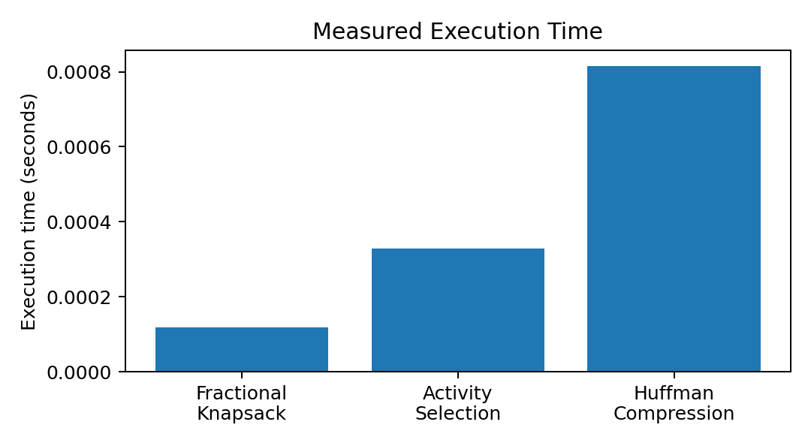
Figure 1. Runtime comparison based on the recorded run.
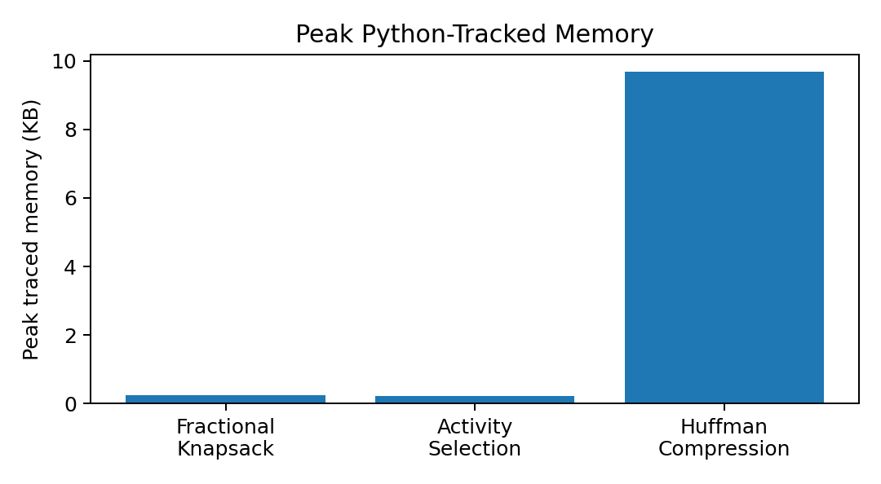
Figure 2. Peak traced memory comparison based on the recorded run.

4. Interpreting the measurements

Fractional Knapsack
Items are ranked by value-to-weight ratio and consumed in that order until the capacity is used. The output 250.0 belongs to the five-item performance dataset, not the three-item illustration whose result is 240.0.

Activity Selection
Activities are ordered by finishing time and accepted whenever their start is no earlier than the last chosen finish. The measured result contains four compatible intervals.

Huffman Compression
The algorithm counts character occurrences and uses a min-heap to repeatedly combine the two least-frequent nodes. The accumulated merge totals produce the encoded size. The performance run uses a longer string than the 'aaabbc' demonstration, which yields 9 bits.

5. Theoretical Complexity
Algorithm | Best time | Average time | Worst time | Auxiliary space
Fractional Knapsack | O(n log n) | O(n log n) | O(n log n) | O(n)
Activity Selection | O(n log n) | O(n log n) | O(n log n) | O(n)
Huffman Compression | O(n + k log k) | O(n + k log k) | O(n + k log k) | O(k)
Here, n is the number of items or activities, or the text length for Huffman coding. The variable k represents the number of distinct characters. Sorting dominates the first two methods. Huffman processing counts frequencies in O(n) and performs heap merges in O(k log k).

6. Exporting Result Tables
The notebook saves the performance and complexity data as separate CSV files so the tables can be reused in spreadsheets or later analysis.
performance_df.to_csv("lab3_performance_results.csv", index=False)
complexity_df.to_csv("lab3_complexity_comparison.csv", index=False)
print("Performance and complexity tables saved successfully.")

7. Conclusion
The measurements give a snapshot of one execution, while asymptotic analysis explains expected growth as the input becomes larger. Fractional Knapsack recorded the shortest runtime, and Huffman Compression recorded the highest traced peak memory in this run. Since the datasets are small, the results should not be treated as universal rankings; stronger comparisons require repeated runs and larger inputs.

