LAB 2 (3)
Visualizations, Comparative Charts & Performance Observations I Hemant Mukhiya| BCA (AI & Data Science) | Roll No: 2401201013
1. Visualizations
The following comparative charts were generated from the benchmark results.

Search Algorithms
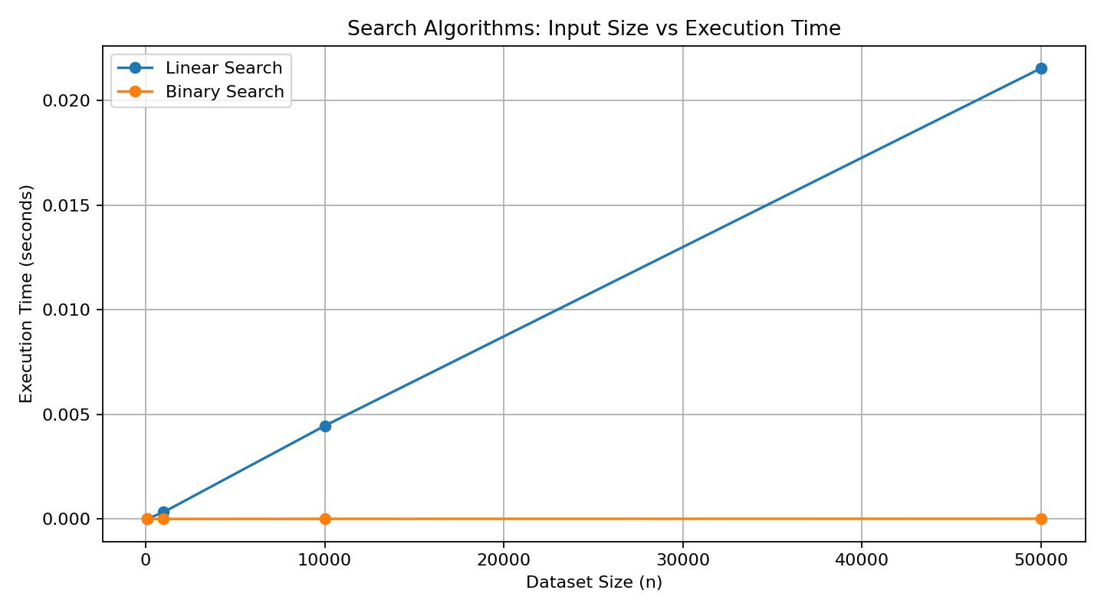
Figure 1. Linear Search vs Binary Search execution time.
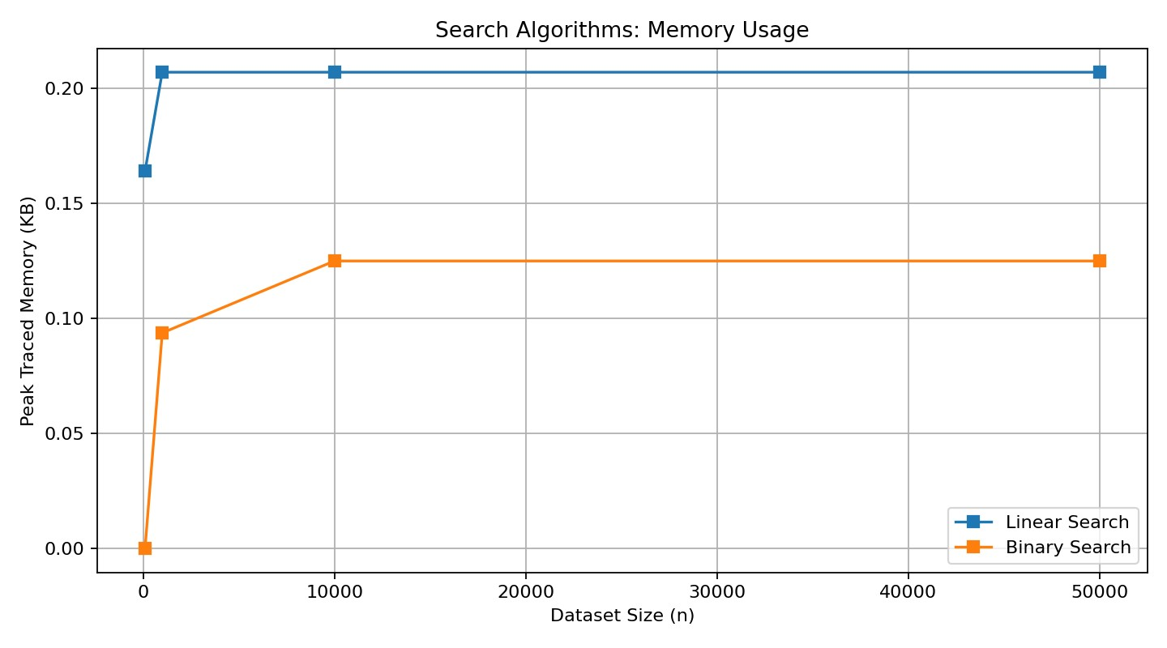
Figure 2. Search memory usage.

Factorial Programs
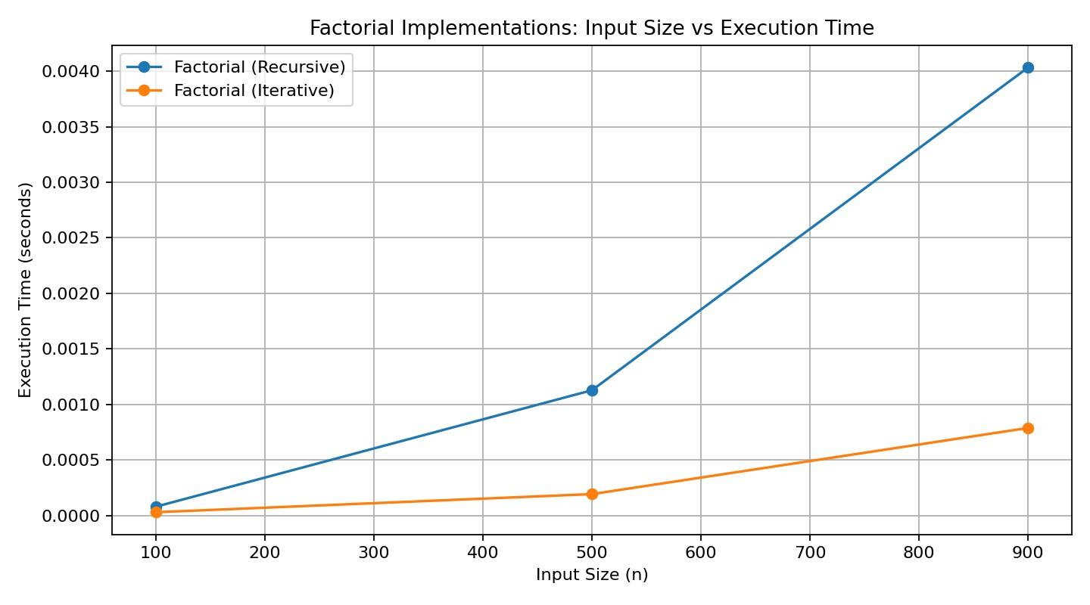
Figure 3. Recursive vs Iterative Factorial execution time.
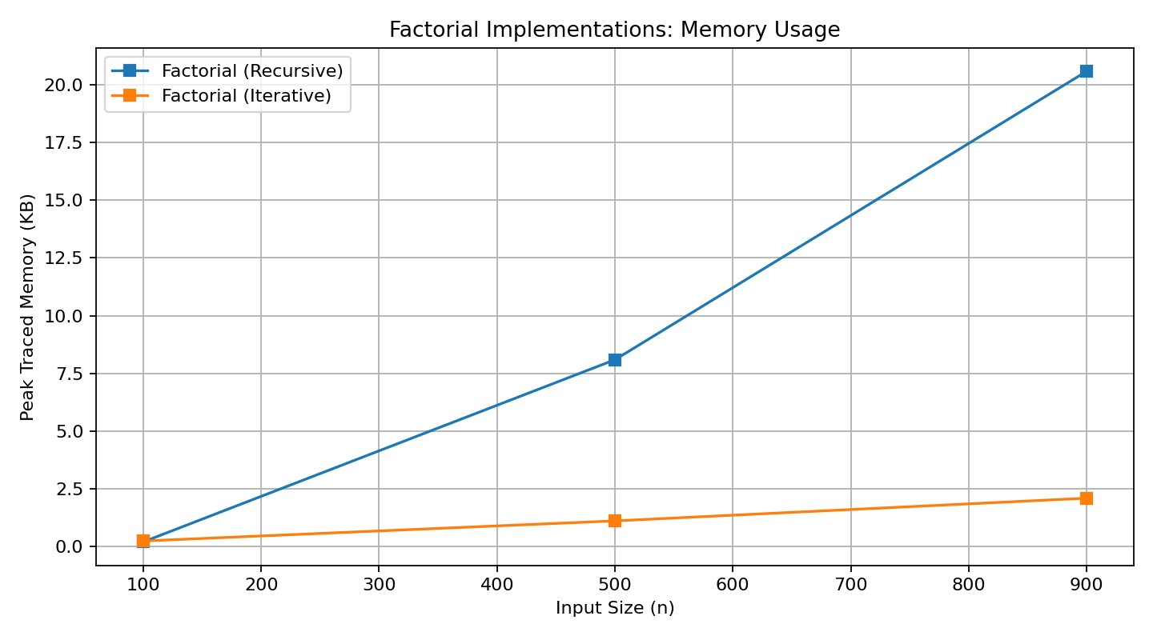
Figure 4. Factorial memory usage.

Loop-Based Programs
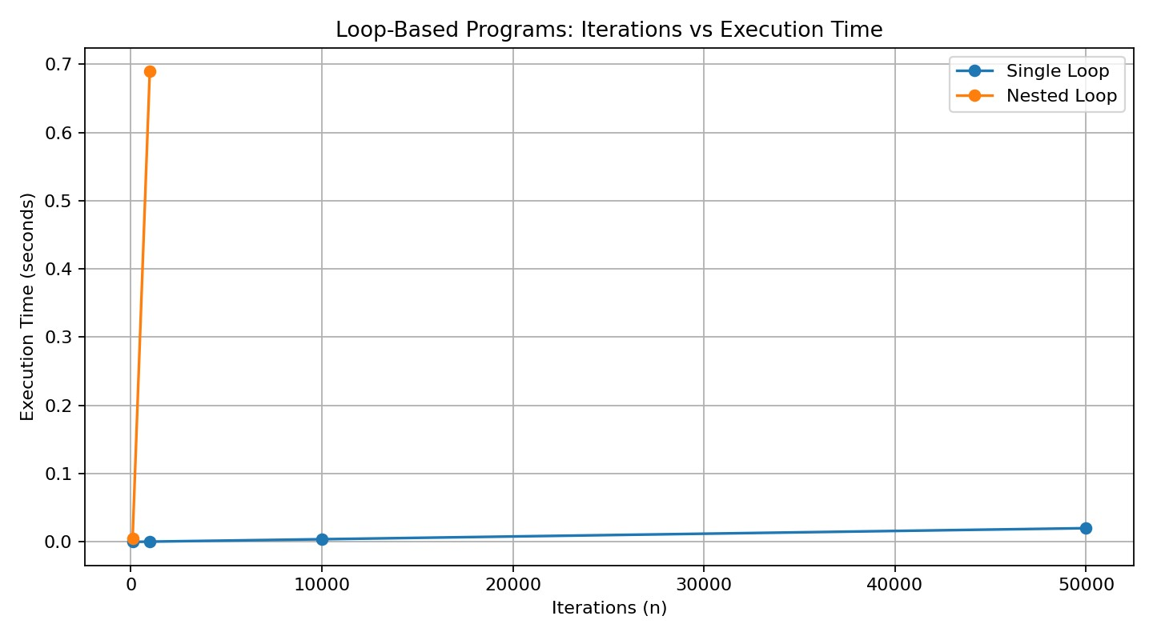
Figure 5. Single Loop vs Nested Loop execution time.
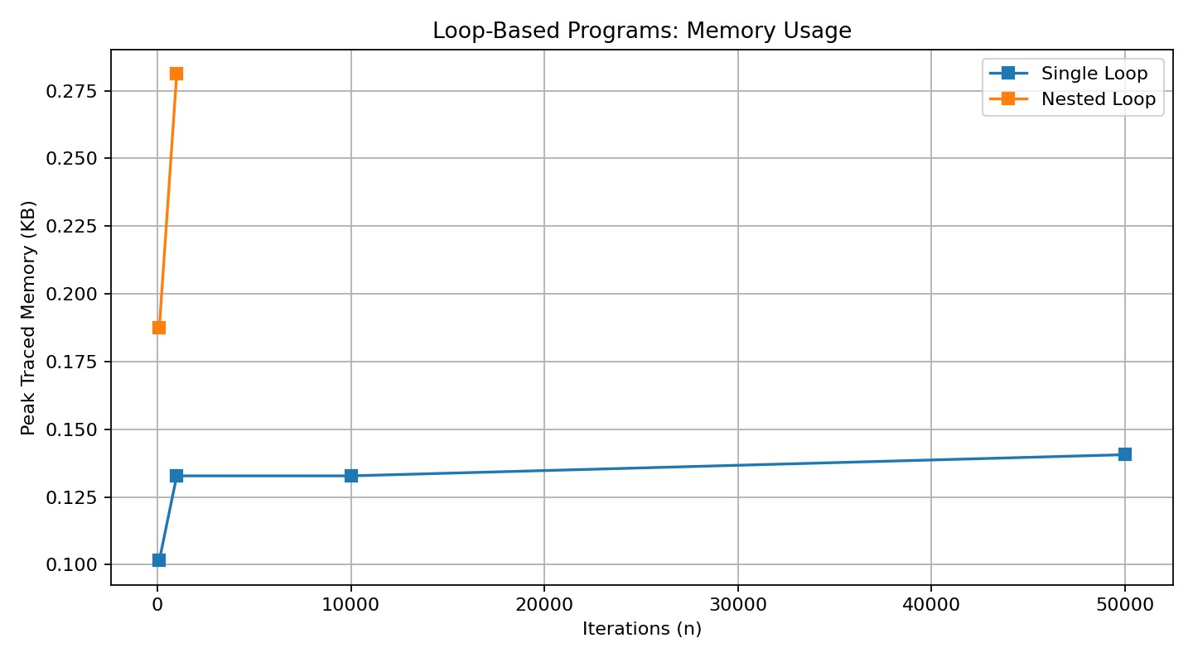
Figure 6. Loop memory usage.

Combined Dashboard
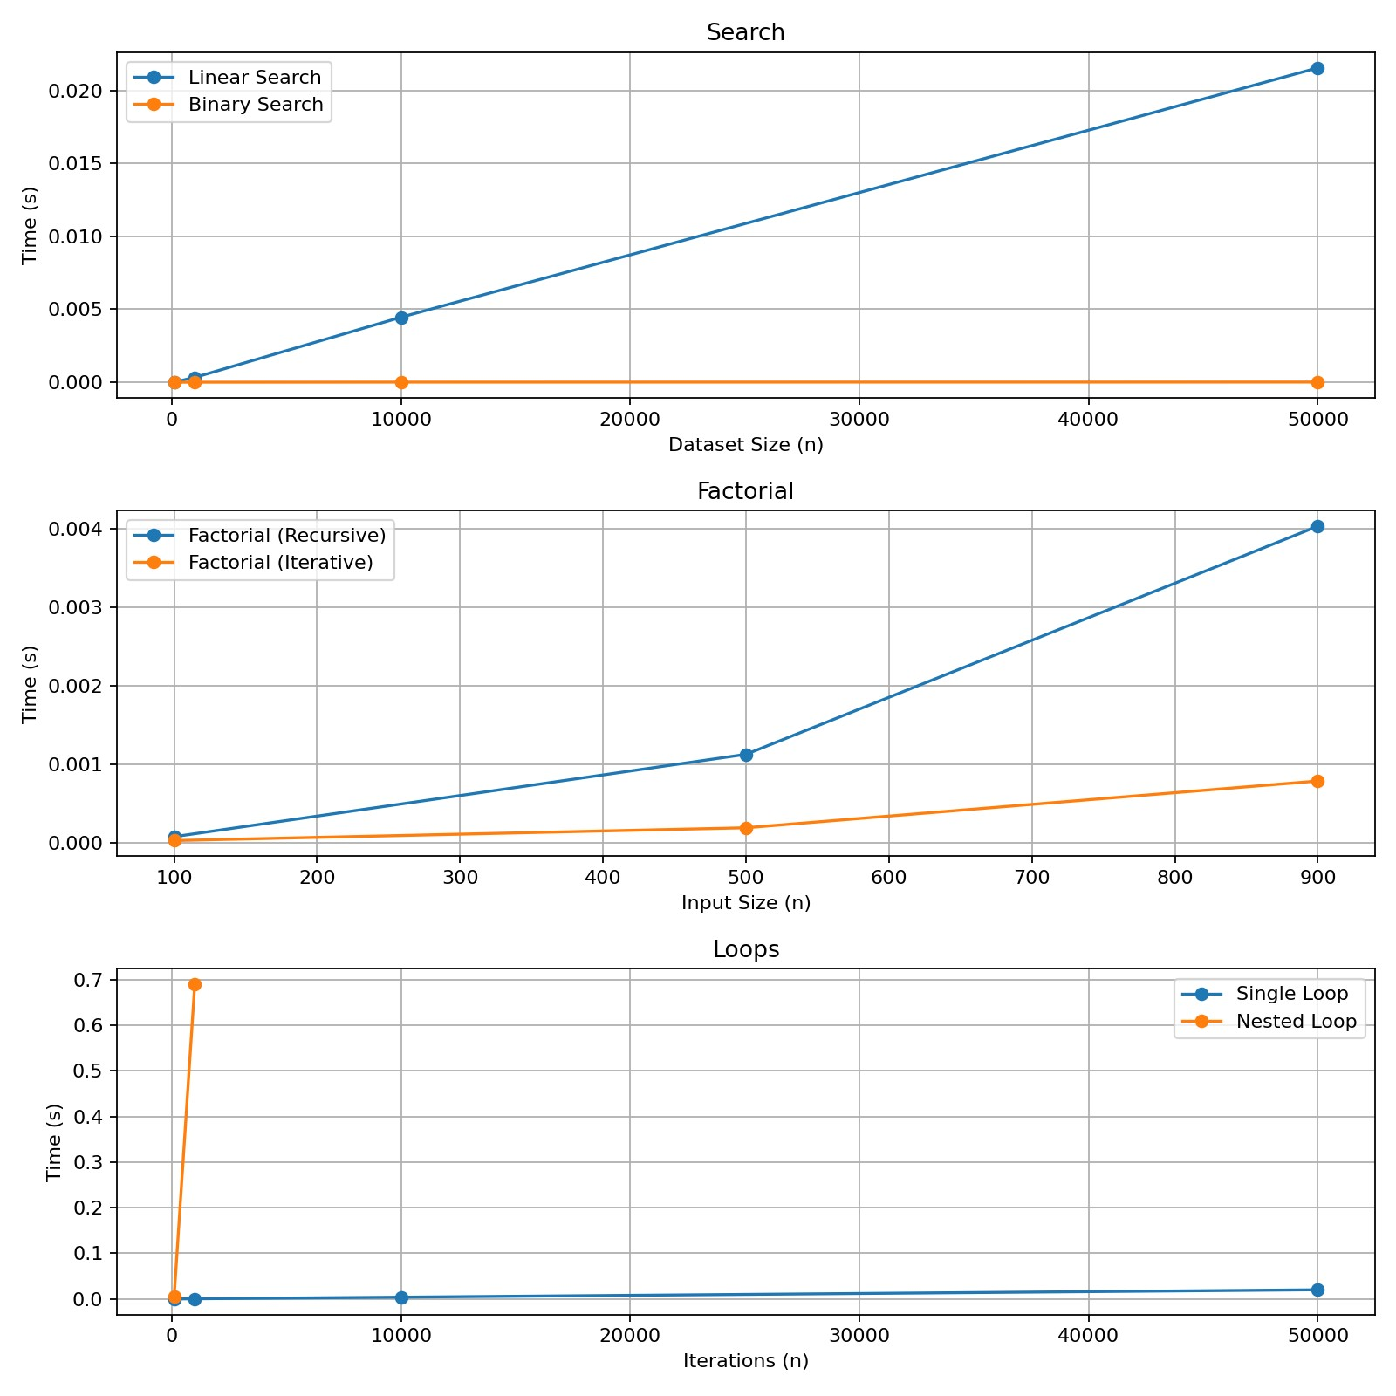
Figure 7. Combined execution-time dashboard.

Application Output Screenshot
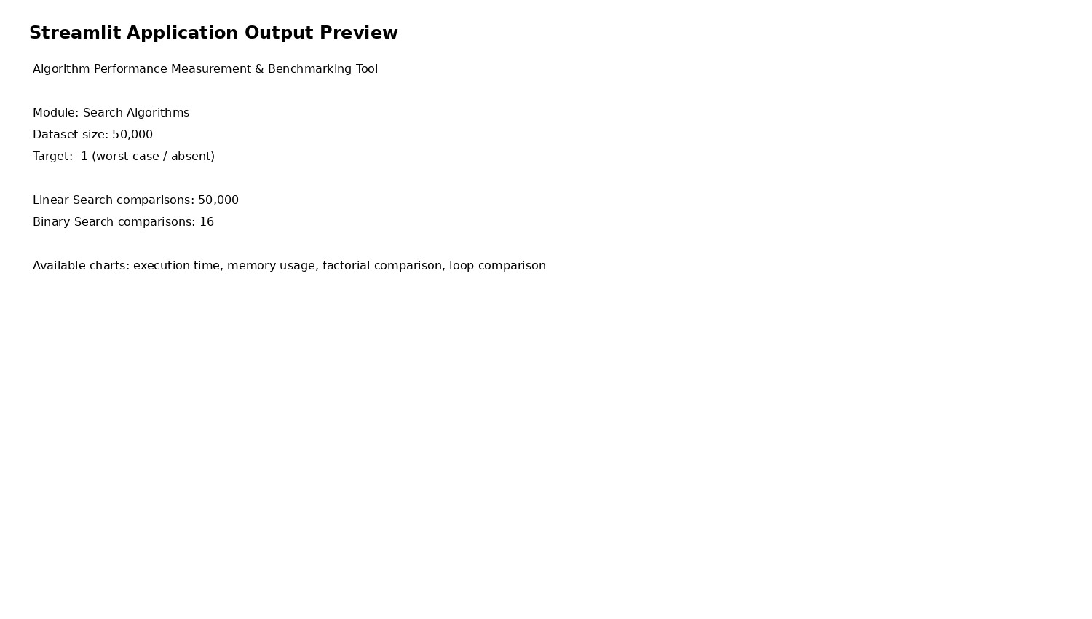
Figure 8. Application/output capture.

Performance Observations
Binary Search demonstrates logarithmic comparison growth, Linear Search grows linearly, and Nested Loop grows quadratically. The factorial implementations both have O(n) time complexity, while the recursive version requires O(n) call-stack space compared with O(1) auxiliary space for the iterative version.

