**1. Introduction:**

Particle swarm optimization (PSO) is a population based stochastic optimization technique developed by Dr. Eberhart and Dr. Kennedy in 1995, inspired by social behaviour of bird flocking or fish schooling.

PSO shares many similarities with evolutionary computation techniques such as Genetic Algorithms (GA). The system is initialized with a population of random solutions and searches for optima by updating generations. However, unlike GA, PSO has no evolution operators such as crossover and mutation. In PSO, the potential solutions, called particles, fly through the problem space by following the current optimum particles.

Compared to GA, the advantages of PSO are that PSO is easy to implement and there are few parameters to adjust. PSO has been successfully applied in many areas: function optimization, artificial neural network training, fuzzy system control, and other areas where GA can be applied.

**2. Background Artificial Life:**  
  
The term "Artificial Life" (ALife) is used to describe research into human-made systems that possess some of the essential properties of life. ALife includes two-folded research topic:

1. ALife studies how computational techniques can help when studying biological phenomena  
2. ALife studies how biological techniques can help out with computational problems.  
  
The focus of this report is on the second topic. Actually, there are already lots of computational techniques inspired by biological systems. For example, artificial neural network is a simplified model of human brain; genetic algorithm is inspired by the human evolution.

Here we discuss another type of biological system - social system, more specifically, the collective behaviours of simple individuals interacting with their environment and each other. Someone called it as swarm intelligence.

There are two popular swarm inspired methods in computational intelligence areas: Ant colony optimization (ACO) and particle swarm optimization (PSO). ACO was inspired by the behaviours of ants and has many successful applications in discrete optimization problems.

The particle swarm concept originated as a simulation of simplified social system. The original intent was to graphically simulate the choreography of bird of a bird block or fish school. However, it was found that particle swarm model can be used as an optimizer.

3. The Algorithm:

PSO simulates the behaviours of bird flocking. Suppose the following scenario: a group of birds are randomly searching food in an area. There is only one piece of food in the area being searched. All the birds do not know where the food is. But they know how far the food is in each iteration. So what's the best strategy to find the food? The effective one is to follow the bird which is nearest to the food.

PSO learned from the scenario and used it to solve the optimization problems. In PSO, each single solution is a "bird" in the search space. We call it "particle". All of particles have fitness values which are evaluated by the fitness function to be optimized, and have velocities which direct the flying of the particles. The particles fly through the problem space by following the current optimum particles.

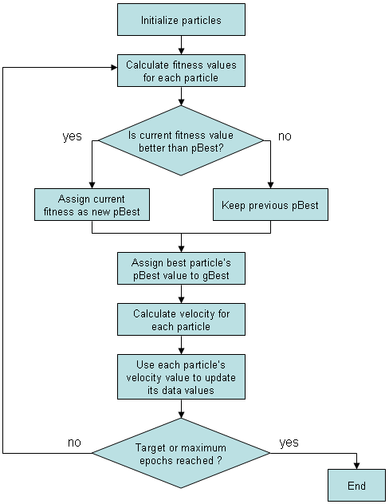

4. Pseudo Code:

For each particle

{

Initialize particle

}

Do until maximum iterations or minimum error criteria

{

For each particle

{

Calculate Data fitness value

If the fitness value is better than pBest

{

Set pBest = current fitness value

}

If pBest is better than gBest

{

Set gBest = pBest

}

}

For each particle

{

Calculate particle Velocity

Use gBest and Velocity to update particle Data

}

5. Bibliography:

The development of PSO is still ongoing. And there are still many unknown areas in PSO research such as the mathematical validation of particle swarm theory.  
  
The following resources proved to be very beneficial.  
  
<http://www.engr.iupui.edu/~eberhart/>  
  
<http://users.erols.com/cathyk/jimk.html>  
  
<http://www.alife.org>  
  
<http://www.aridolan.com>  
  
<http://www.red3d.com/cwr/boids/>  
  
<http://iridia.ulb.ac.be/~mdorigo/ACO/ACO.html>  
  
<http://www.engr.iupui.edu/~shi/Coference/psopap4.html>