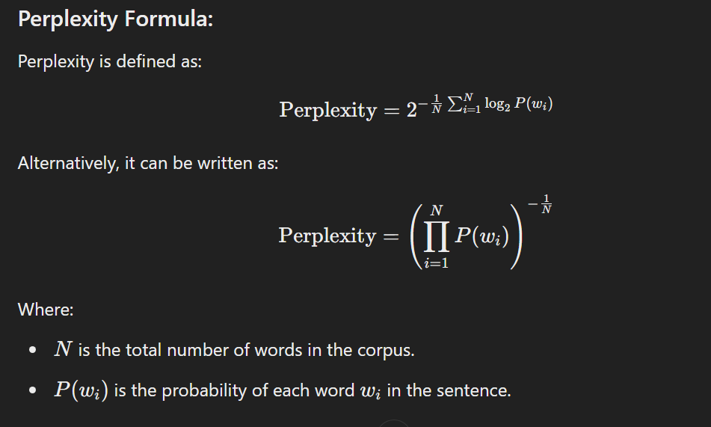

**Example Corpus:**

We will use the same two sentences as before:

1. **Sentence 1**: "I like dogs"
2. **Sentence 2**: "Dogs are cute"

**Step-by-Step Corrected Calculation:**

**1. Assume Probabilities from a Language Model:**

We use the same probabilities as before:

* **Sentence 1:**
  + P(I)=0.2P
  + P(like∣I)=0.1
  + P(dogs∣like)=0.4
* **Sentence 2:**
  + P(Dogs)=0.3
  + P(are∣Dogs)=0.2
  + P(cute∣are)=0.5

**2. Calculate the Sentence Probabilities:**

* **Sentence 1**:

P("I like dogs")=0.2×0.1×0.4=0.008P

**Sentence 2**:

P("Dogs are cute")=0.3×0.2×0.5=0.03

**3. Total Probability for the Corpus:**

The total probability of the corpus is the product of the probabilities of the individual sentences.

P(corpus)=P("I like dogs")×P("Dogs are cute")

P(corpus)=0.008×0.03=0.00024

**4. Number of Words in the Corpus:**

* Sentence 1 has 3 words.
* Sentence 2 has 3 words.
* Total number of words N=6

**5. Perplexity Calculation:**

Now, apply the perplexity formula:

**Perplexity= P(corpus)-1/N = 0.00024-1/6**

Let's calculate this:

**Perplexity = 0.00024-1/6 ≈ 9.66**

**Final Result:**

The **perplexity** of the given two-sentence corpus is approximately **9.66**.