RETAILPLUSE
Retail Analytics & Inventory Risk Management
Python+PowerBi
Zidio Internship Project
Developed By:
Hemant Kakde
1.Project Overview
RetailPulse is a retail analytics project using Python for data inspection, data-quality checks, exploratory data analysis (EDA), and analytical-field preparation, and Power BI for data modelling, DAX measures, and interactive reporting. The aim is to turn sales, product, customer, store, promotion, and inventory data into useful business insights.
Architecture Overview
RetailPulse uses a Python-to-Power BI analytics workflow. CSV files are inspected and prepared with Python; the prepared data is then modelled in Power BI, where DAX measures and report visuals support business analysis. This is a logical overview—verify each transformation and report page against the final script and PBIX.
SOURCE DATA — CSV FILES
Sales transactions • Product master • Customer master • Store master • Promotions • Inventory snapshot / flags
↓
PYTHON — PANDAS / NUMPY
Inspect • Validate • Clean/transform • Feature preparation • EDA
↓
PREPARED DATA / ANALYSIS OUTPUT
Validated fields and exported CSV, where generated
↓
POWER BI DATA MODEL
SalesF + ProductD + CustomerD + StoreD + DateD + PromotionD
Inventory_Snapshot_F &Inventory_Flags_F remains separate at its own grain
↓
DAX MEASURES & VISUALS
Revenue • Orders • Units • AOV • Cost / Gross Profit (after validation)
↓
RETAILPULSE DASHBOARDS
Sales • Product • Customer • Store/Region • Inventory • Transaction analysis

2.Problem Statement
Retail information is distributed across large transaction files and supporting master tables. Reliable validation, analysis, and modelling are needed to understand sales performance, product contribution, customer behaviour, and inventory risk.
- Inspect and validate large retail datasets.
- Explore sales by date, channel, product, store, and customer.
- Prepare useful analytical fields where appropriate.
- Organize facts and dimensions in Power BI.
- Present key metrics through clear, interactive reports.

3.Objectives
- Inspect data structure, data types, missing values, duplicates, and distributions.
- Use Pandas for validation and grouped analysis.
- Explore revenue by channel, product/category, and time period.
- Prepare date and business-analysis fields where required.
- Create and validate DAX measures for revenue, orders, units, cost, gross profit, and margin.
- Keep inventory analysis at its own grain to avoid duplicating sales totals.
- Separate work completed from future enhancements.

4.Tools and Technologies
Tool | Role
Python | Data inspection, validation, EDA and feature preparation
Pandas / NumPy | Tabular processing and numerical operations
Power BI | Data model, report pages, visuals, slicers and interactive analysis
DAX | Measures and date-related calculations
CSV | Source datasets for sales, product, customer, store, promotion and inventory

5.Dataset Description
File | Approx. rows | Typical contents
sales_transactions.csv | About 9,972,038 | date, receipt_id, store_id, sku_id, customer_id, quantity, unit_price, total_value, channel, discount_pct, promo_id
sku_master.csv | 5,000 | Product name, category, subcategory, brand, unit/cost price
customer_master.csv | 10,000 | Age, gender, city, loyalty segment, preferred channel, registration date
store_master.csv | 30 | Store name, city, type, opening date
promotions.csv | 100 | Promotion name, dates, discount and promotion type/target
inventory_snapshot.csv | About 21,228 | Store/SKU stock, reorder point, safety stock, restock date
sku_inventory_flags.csv | 600 | SKU flag, affected stores, optional time window and notes

6.Python Workflow
- Load CSV files and inspect samples with head(), dimensions with shape, data types/non-null counts with
info(), and numerical summaries with describe().
- Check missing values, duplicate rows, and suspicious values such as non-positive quantities or prices.
- Convert date columns to datetime before date-based analysis.
- Use groupby() and aggregations to summarize revenue by channel, product/category, or time.
- Explore numeric distributions and trends with charts where appropriate.
- Derived fields such as gross sales, discount amount, cost, gross profit, margin, date attributes, age groups, or inventory flags should be described as implemented only if they remain in the final script/export.

7.Power Bi Data Model
Table | Purpose / grain
SalesF | Sales line/transaction records and measures
ProductD | SKU, product name, category, subcategory, brand, cost price
CustomerD | Customer age group, city and loyalty segment
StoreD | Store, city and store type
PromotionD | Promotion details matched by promo ID
DateD | Calendar for year, quarter, month, day and date filtering
Inventory_snapshot_F | Store_id,sku_id,stock_on_hand,recorder_point,safety_stock,last_restock_date
Inventory_flags | Sku_id,flag,affected_stores,windows_start,windows_end,notes

Use one-to-many relationships from unique dimension keys to fact tables. Datetable[Date] should relate to the sales date
Date_table =
ADDCOLUMNS(
CALENDAR(MIN(SalesF[date]), MAX(SalesF[date])),
"Year", YEAR([Date]),
"Month Number", MONTH([Date]),
"Month Name", FORMAT([Date], "MMMM"),
"Quarter", "Q" & FORMAT([Date], "Q"),
"Day Number", WEEKDAY([Date], 2),
"Day Name", FORMAT([Date], "dddd")
)
Date_table sort Month Name by Month Number for chronological order.

8.Dax Measures
Measure | Example DAX | Meaning
Total Revenue | SUM(FactSales[total_value]) | Sum of recorded transaction value
Total Orders | DISTINCTCOUNT(FactSales[receipt_id]) | Distinct receipt IDs; validate order grain
Total Units | SUM(FactSales[quantity]) | Quantity sold
Total Customers | DISTINCTCOUNT(FactSales[customer_id]) | Distinct customers in current filter context
AOV | DIVIDE([Total Revenue], [Total Orders]) | Average revenue per receipt
Total Cost | SUMX(FactSales, FactSales[quantity] * RELATED(DimProduct[cost_price])) | Estimated product cost; requires valid relationship
Gross Profit | [Total Revenue] - [Total Cost] | Revenue less estimated product cost
Profit Margin % | DIVIDE([Gross Profit], [Total Revenue]) | Gross profit divided by revenue

9.Dashboard Pages and Suggested Analysis
1.Executive Overview
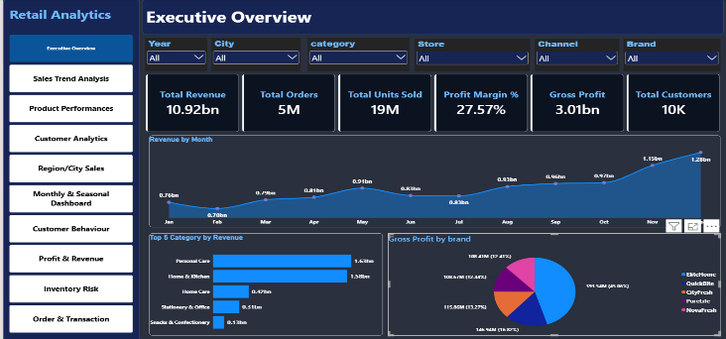
Provides a high-level summary of overall business performance, tracking total revenue, orders, profit, and monthly trends with top categories and brands
2.Sales Trend Analysis
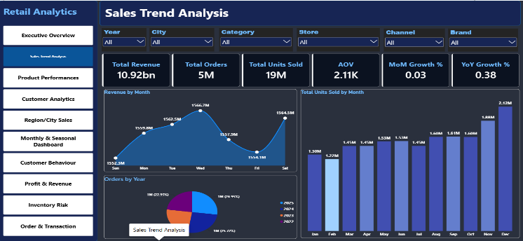
Analyzes sales patterns over time, including month-on-month, year-on-year growth, and day-of-week performance to identify seasonality.

3.Product Performances
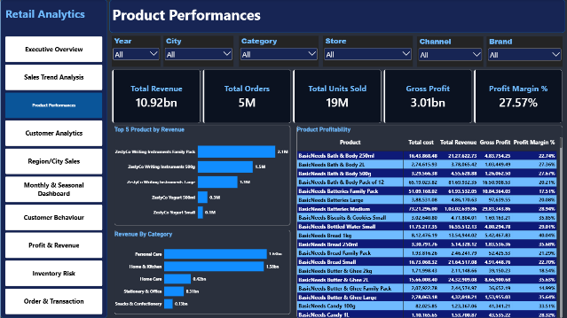
Evaluates product and category-wise performance based on revenue, units sold, and profitability to identify top-selling and high-margin products.
4.Customer Analytics
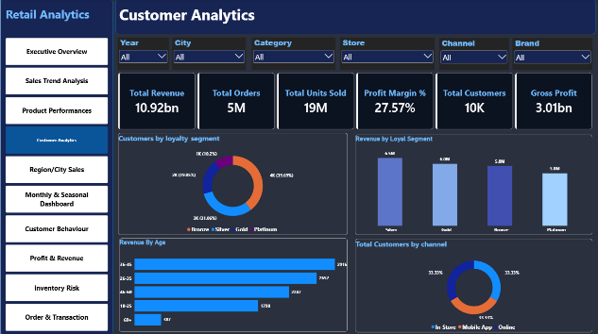
Provides demographic insights on customers, analyzing distribution by loyalty segment, age group, and channel to understand customer profile
5.Region And City Sales
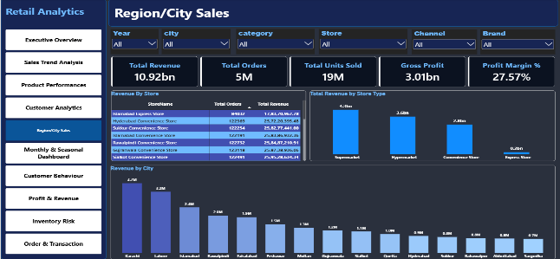
Displays geographical performance across cities and store types, highlighting revenue contribution by location and store format.
6.Monthly And Seasonal
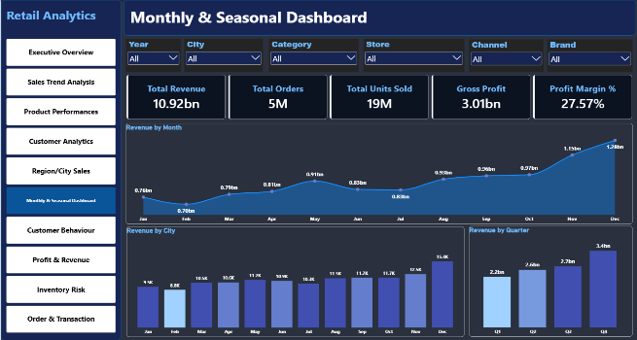
Shows quarterly and monthly seasonal trends to understand peak and low seasons for revenue and order planning.

7.Customer Behaviour
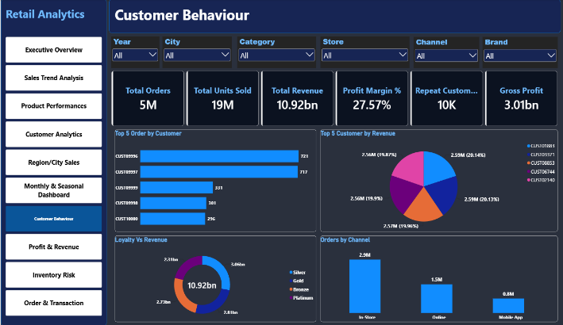
Examines customer purchasing behavior, including top customers by orders and revenue, loyalty segment contribution, and preferred shopping channels.
8.Profit And Revenue
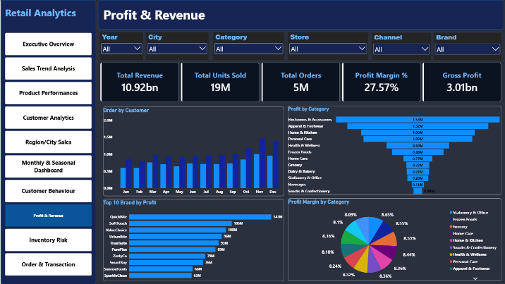
Focuses on profitability analysis, comparing profit and revenue across categories and brands along with profit margin distribution.
9.Inventory Risk
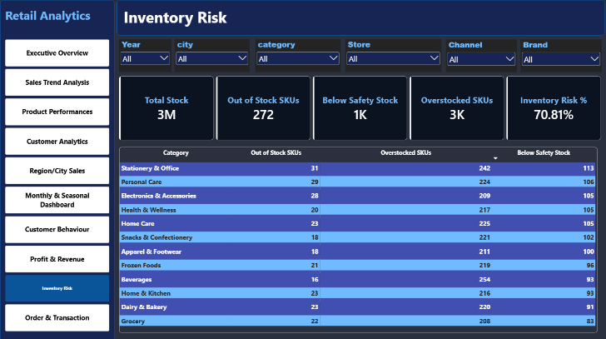
Monitors inventory health by tracking out-of-stock, below safety stock, and overstocked SKUs to identify stock risks and prevent sales loss and overstocking.

10.Order and Transaction
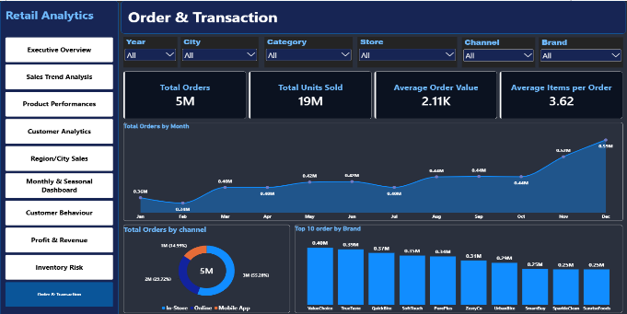
Tracks order-related KPIs such as Average Order Value (AOV), average items per order, and order volume trends by channel.
10.Challenges and Lesson Learned
- Large CSV files can consume substantial RAM; chunking helps most when processing is incremental.
- Date columns need consistent date types before relationships and time-based visuals work correctly.
- Blank promotion IDs may indicate non-promotional transactions, but confirm the business rule before replacing blanks.
- Dimension keys should be unique on the one-side of a relationship.
- Joining inventory snapshots to transaction rows carelessly can duplicate sales totals.
- Repeat-customer measures need a clear definition and must be tested under date filters.
- Validate measures against sample rows and totals before presenting results.
11.Conclusion
RetailPulse shows a practical analytics workflow: inspect and prepare retail data with Python, then organize and analyze it in Power BI. A final submission includes the actual Python script, final exported dataset, validated PBIX model.

