Name: Hemant Marotkar
UID: 23015002 Date: 1-10-26

AIM:- Detect outliers/anomalies in network traffic using density-based clustering (DBSCAN)

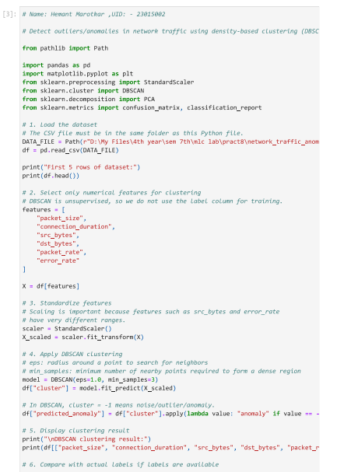
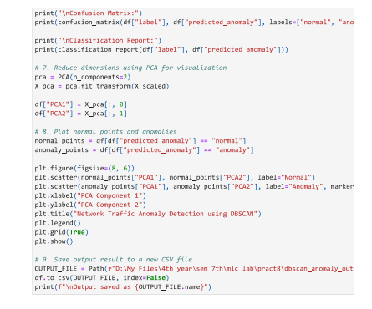
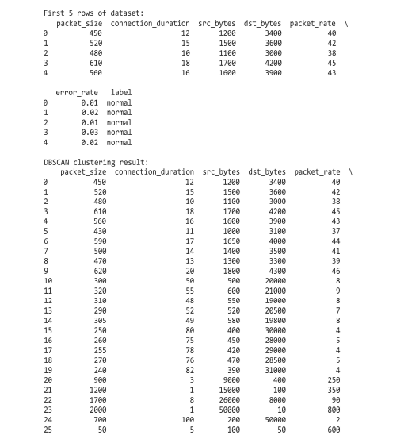
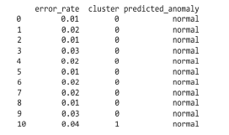
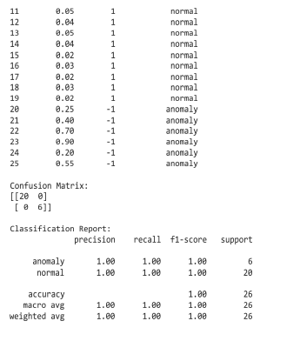
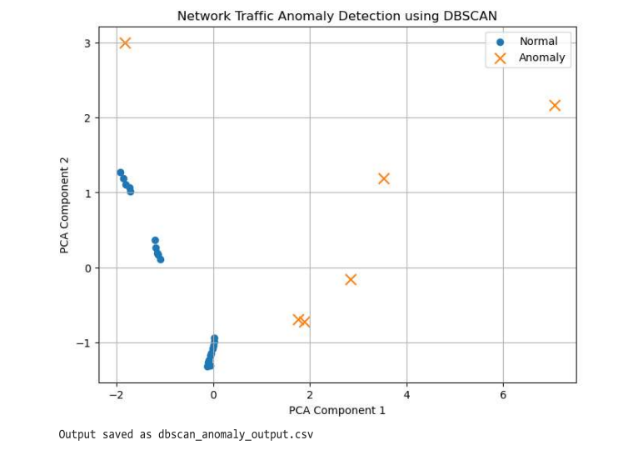

Conclusion:
We performed an experiment to detect outliers/anomalies in network traffic using density-based clustering (DBSCAN)

