Neural Network Experiment-6

Name -Hemant Kumar

Roll.No.-24UADS1021

Objective
WAP to train and evaluate a Recurrent Neural Network using PyTorch Library to predict the next value in a sample time series dataset.

Description of Model
The implemented model is a Recurrent Neural Network (RNN) designed for time-series forecasting, specifically to predict the next value in a sequential dataset. Unlike traditional feedforward neural networks, RNNs are well-suited for sequential data because they maintain a hidden state that captures temporal dependencies between previous inputs.
The input to the model consists of a univariate time series generated synthetically using a sine wave combined with Gaussian noise. This dataset simulates real-world temporal patterns while maintaining simplicity for analysis. The data is processed using a sliding window approach, where sequences of fixed length (30 time steps) are used as input to predict the next value in the sequence.
Each input sample has the shape:
$$\left(batch_size , sequence_length , input_features\right)$$
where the number of features is 1 (single time series).
🔹 Model Architecture
The architecture consists of:
- Recurrent Neural Network (RNN) layer
- Dropout layer
- Fully Connected (Linear) output layer
The RNN layer processes sequential data step-by-step, updating its hidden state at each time step. The hidden state is computed as:
$$h_{t}=tanh⁡(W_{h}x_{t}+U_{h}h_{t-1}+b_{h})$$
where:
- $x_{t}$is the input at time step $t$
- $h_{t}$is the hidden state
- $W_{h},U_{h}$are weight matrices
The model uses:
- 2 RNN layers
- 64 hidden units
The final output is taken from the last time step and passed through a fully connected layer to produce the predicted value.
🔹 Regularization
To prevent overfitting:
- Dropout (0.2) is applied after the RNN layer
- Gradient clipping is used to avoid exploding gradients:
$$∥∇∥≤1$$
🔹 Loss Function
The model is trained using Mean Squared Error (MSE):
$$MSE=\frac{1}{N}∑(y_{i}-{\hat{y}}_{i})^{2}$$
This measures the difference between predicted and actual values.
🔹 Optimization
The model uses the Adam optimizer, which adapts learning rates dynamically using momentum and adaptive scaling.
Additionally, a learning rate scheduler (ReduceLROnPlateau) is used to reduce the learning rate when validation loss stops improving.
🔹 Training Process
- Dataset split:
  - Training: 70%
  - Validation: 15%
  - Testing: 15%
- Training is performed for 50 epochs
- Best model is selected based on lowest validation loss

Code.py
import torch
import torch.nn as nn
import numpy as np
import matplotlib.pyplot as plt
from torch.utils.data import Dataset, DataLoader
# 1. Reproducibility
torch.manual_seed(42)
np.random.seed(42)
DEVICE = torch.device("cuda" if torch.cuda.is_available() else "cpu")
print(f"Using device: {DEVICE}")
# 2. Generate Sample Time Series Dataset
def generate_time_series(n_points: int = 1000) -> np.ndarray:
"""
Synthetic time series: sine wave + small Gaussian noise.
Easy to visualise, yet non-trivial enough to test the RNN.
"""
t = np.linspace(0, 8 * np.pi, n_points)
series = np.sin(t) + 0.1 * np.random.randn(n_points)
return series.astype(np.float32)
# 3. PyTorch Dataset
class TimeSeriesDataset(Dataset):
"""
Sliding-window dataset.
Each sample → (sequence of length seq_len, next scalar target)
"""

def __init__(self, series: np.ndarray, seq_len: int = 30):
self.seq_len = seq_len
self.X, self.y = [], []
for i in range(len(series) - seq_len):
self.X.append(series[i : i + seq_len])
self.y.append(series[i + seq_len])
self.X = torch.tensor(np.array(self.X)).unsqueeze(-1) # (N, seq_len, 1)
self.y = torch.tensor(np.array(self.y)).unsqueeze(-1) # (N, 1)

def __len__(self):
return len(self.X)

def __getitem__(self, idx):
return self.X[idx], self.y[idx]
# 4. RNN Model
class RNNModel(nn.Module):
"""
A simple many-to-one RNN for time-series forecasting.

Architecture
────────────
RNN → Dropout → Linear
"""

def __init__(
self,
input_size: int = 1,
hidden_size: int = 64,
num_layers: int = 2,
output_size: int = 1,
dropout: float = 0.2,
):
super().__init__()
self.hidden_size = hidden_size
self.num_layers = num_layers

self.rnn = nn.RNN(
input_size=input_size,
hidden_size=hidden_size,
num_layers=num_layers,
batch_first=True, # input shape: (batch, seq, feature)
dropout=dropout if num_layers > 1 else 0.0,
)
self.dropout = nn.Dropout(dropout)
self.fc = nn.Linear(hidden_size, output_size)

def forward(self, x: torch.Tensor) -> torch.Tensor:
# x: (batch, seq_len, input_size)
h0 = torch.zeros(self.num_layers, x.size(0), self.hidden_size).to(x.device)
out, _ = self.rnn(x, h0) # out: (batch, seq_len, hidden_size)
out = self.dropout(out[:, -1, :]) # take last time-step
return self.fc(out) # (batch, output_size)
# 5. Training Function
def train(
model: nn.Module,
loader: DataLoader,
criterion: nn.Module,
optimizer: torch.optim.Optimizer,
) -> float:
model.train()
total_loss = 0.0
for X_batch, y_batch in loader:
X_batch, y_batch = X_batch.to(DEVICE), y_batch.to(DEVICE)
optimizer.zero_grad()
pred = model(X_batch)
loss = criterion(pred, y_batch)
loss.backward()
nn.utils.clip_grad_norm_(model.parameters(), max_norm=1.0)
optimizer.step()
total_loss += loss.item() * X_batch.size(0)
return total_loss / len(loader.dataset)
# 6. Evaluation Function
def evaluate(
model: nn.Module,
loader: DataLoader,
criterion: nn.Module,
) -> tuple[float, np.ndarray, np.ndarray]:
model.eval()
total_loss = 0.0
all_preds = []
all_targets = []
with torch.no_grad():
for X_batch, y_batch in loader:
X_batch, y_batch = X_batch.to(DEVICE), y_batch.to(DEVICE)
pred = model(X_batch)
loss = criterion(pred, y_batch)
total_loss += loss.item() * X_batch.size(0)
all_preds.extend(pred.cpu().numpy().flatten())
all_targets.extend(y_batch.cpu().numpy().flatten())
avg_loss = total_loss / len(loader.dataset)
return avg_loss, np.array(all_preds), np.array(all_targets)
# 7. Metrics
def compute_metrics(preds: np.ndarray, targets: np.ndarray) -> dict:
mse = np.mean((preds - targets) ** 2)
mae = np.mean(np.abs(preds - targets))
rmse = np.sqrt(mse)
ss_res = np.sum((targets - preds) ** 2)
ss_tot = np.sum((targets - targets.mean()) ** 2)
r2 = 1 - ss_res / ss_tot if ss_tot != 0 else float("nan")
return {"MSE": mse, "MAE": mae, "RMSE": rmse, "R²": r2}
# 8. Plotting (6 comprehensive panels)
def plot_results(
train_losses: list,
val_losses: list,
preds: np.ndarray,
targets: np.ndarray,
series_full: np.ndarray,
n_train: int,
n_val: int,
metrics: dict,
n_show: int = 120,
):
errors = preds - targets
palette = {
"blue": "#2563EB",
"red": "#DC2626",
"green": "#059669",
"amber": "#D97706",
"purple": "#7C3AED",
"slate": "#475569",
}

fig = plt.figure(figsize=(18, 11))
fig.patch.set_facecolor("#F8FAFC")
fig.suptitle(
"RNN Time-Series Prediction — Full Evaluation Dashboard",
fontsize=16, fontweight="bold", color="#1E293B", y=0.98,
)

gs = fig.add_gridspec(2, 3, hspace=0.42, wspace=0.32,
left=0.06, right=0.97, top=0.92, bottom=0.07)

# ── Panel 1: Full dataset overview with train/val/test split ──────────
ax1 = fig.add_subplot(gs[0, :2]) # wide, spans 2 columns
n_test = len(series_full) - n_train - n_val
t_all = np.arange(len(series_full))
# shade regions
ax1.axvspan(0, n_train, alpha=0.08, color=palette["blue"], label="Train region")
ax1.axvspan(n_train, n_train + n_val, alpha=0.12, color=palette["amber"], label="Val region")
ax1.axvspan(n_train + n_val, len(series_full), alpha=0.10, color=palette["green"], label="Test region")
ax1.plot(t_all, series_full, color=palette["slate"], linewidth=0.9, alpha=0.8, label="Raw series")
ax1.set_title("① Full Time-Series with Train / Val / Test Split", fontweight="bold")
ax1.set_xlabel("Time Step"); ax1.set_ylabel("Value")
ax1.legend(fontsize=8, ncol=4); ax1.grid(alpha=0.25)
# ── Panel 2: Training & Validation loss curves ────────────────────────
ax2 = fig.add_subplot(gs[0, 2])
epochs = range(1, len(train_losses) + 1)
ax2.plot(epochs, train_losses, color=palette["blue"], linewidth=1.8, label="Train MSE")
ax2.plot(epochs, val_losses, color=palette["red"], linewidth=1.8, linestyle="--", label="Val MSE")
ax2.fill_between(epochs, train_losses, val_losses,
where=[v > t for v, t in zip(val_losses, train_losses)],
alpha=0.08, color=palette["red"])
ax2.set_title("② Train vs Validation Loss", fontweight="bold")
ax2.set_xlabel("Epoch"); ax2.set_ylabel("MSE Loss")
ax2.legend(); ax2.grid(alpha=0.25)
# ── Panel 3: Predictions vs Actuals (zoomed test window) ──────────────
ax3 = fig.add_subplot(gs[1, :2])
t_win = np.arange(n_show)
ax3.plot(t_win, targets[:n_show], color=palette["green"], linewidth=2.0, label="Actual")
ax3.plot(t_win, preds[:n_show], color=palette["amber"], linewidth=1.8,
linestyle="--", alpha=0.9, label="Predicted")
ax3.fill_between(t_win, targets[:n_show], preds[:n_show],
alpha=0.12, color=palette["amber"])
ax3.set_title(f"③ Predictions vs Actuals — first {n_show} test steps", fontweight="bold")
ax3.set_xlabel("Time Step"); ax3.set_ylabel("Value")
ax3.legend(); ax3.grid(alpha=0.25)
# ── Panel 4: Scatter — Actual vs Predicted ────────────────────────────
ax4 = fig.add_subplot(gs[1, 2])
ax4.scatter(targets, preds, alpha=0.35, s=12,
color=palette["purple"], edgecolors="none")
lo, hi = min(targets.min(), preds.min()), max(targets.max(), preds.max())
ax4.plot([lo, hi], [lo, hi], color=palette["red"], linewidth=1.5,
linestyle="--", label="Perfect fit")
ax4.set_title(f"④ Actual vs Predicted (R²={metrics['R²']:.3f})", fontweight="bold")
ax4.set_xlabel("Actual"); ax4.set_ylabel("Predicted")
ax4.legend(fontsize=8); ax4.grid(alpha=0.25)

plt.show()
plt.close()
# Second figure — Error & Distribution analysis (2 panels)
fig2, axes2 = plt.subplots(1, 2, figsize=(14, 5))
fig2.patch.set_facecolor("#F8FAFC")
fig2.suptitle("RNN — Residual & Distribution Analysis",
fontsize=14, fontweight="bold", color="#1E293B")

# Panel 5: Residuals over time
ax5 = axes2[0]
ax5.plot(errors, color=palette["purple"], linewidth=0.9, alpha=0.8)
ax5.axhline(0, color=palette["red"], linewidth=1.2, linestyle="--")
ax5.axhline( errors.std(), color=palette["slate"], linewidth=0.8, linestyle=":")
ax5.axhline(-errors.std(), color=palette["slate"], linewidth=0.8, linestyle=":",
label=f"±1 std ({errors.std():.3f})")
ax5.fill_between(range(len(errors)), errors, 0,
where=(errors > 0), alpha=0.15, color=palette["amber"])
ax5.fill_between(range(len(errors)), errors, 0,
where=(errors < 0), alpha=0.15, color=palette["blue"])
ax5.set_title("⑤ Residuals (Predicted − Actual) over Test Steps", fontweight="bold")
ax5.set_xlabel("Test Step"); ax5.set_ylabel("Error")
ax5.legend(fontsize=8); ax5.grid(alpha=0.25)
#Panel 6: Error distribution histogram
ax6 = axes2[1]
ax6.hist(errors, bins=30, color=palette["blue"], alpha=0.72,
edgecolor="white", linewidth=0.5)
ax6.axvline(errors.mean(), color=palette["red"], linewidth=1.8,
linestyle="--", label=f"Mean={errors.mean():.4f}")
ax6.axvline(errors.mean() + errors.std(), color=palette["amber"],
linewidth=1.2, linestyle=":", label=f"±1σ={errors.std():.4f}")
ax6.axvline(errors.mean() - errors.std(), color=palette["amber"],
linewidth=1.2, linestyle=":")
ax6.set_title("⑥ Error Distribution Histogram", fontweight="bold")
ax6.set_xlabel("Prediction Error"); ax6.set_ylabel("Count")
ax6.legend(fontsize=8); ax6.grid(alpha=0.25)

fig2.tight_layout()
plt.show()
plt.close()
# 9. Main
def main():
#Hyper-parameters
SEQ_LEN = 30
BATCH_SIZE = 64
EPOCHS = 50
LR = 1e-3
TRAIN_FRAC = 0.70
VAL_FRAC = 0.15
# TEST_FRAC = 0.15 (remainder)
#Data
series = generate_time_series(n_points=1000)
n = len(series)
n_train = int(n * TRAIN_FRAC)
n_val = int(n * VAL_FRAC)

train_series = series[:n_train]
val_series = series[n_train : n_train + n_val]
test_series = series[n_train + n_val :]

train_ds = TimeSeriesDataset(train_series, SEQ_LEN)
val_ds = TimeSeriesDataset(val_series, SEQ_LEN)
test_ds = TimeSeriesDataset(test_series, SEQ_LEN)

train_loader = DataLoader(train_ds, batch_size=BATCH_SIZE, shuffle=True)
val_loader = DataLoader(val_ds, batch_size=BATCH_SIZE)
test_loader = DataLoader(test_ds, batch_size=BATCH_SIZE)

print(f"Dataset splits → Train: {len(train_ds)} | Val: {len(val_ds)} | Test: {len(test_ds)}")

#Model, Loss, Optimiser
model = RNNModel(hidden_size=64, num_layers=2, dropout=0.2).to(DEVICE)
criterion = nn.MSELoss()
optimizer = torch.optim.Adam(model.parameters(), lr=LR)
scheduler = torch.optim.lr_scheduler.ReduceLROnPlateau(
optimizer, patience=5, factor=0.5
)

print(f"\nModel Parameters: {sum(p.numel() for p in model.parameters() if p.requires_grad):,}\n")

# Training Loop
train_losses, val_losses = [], []
best_val_loss = float("inf")
best_state = None

print(f"{'Epoch':>6} {'Train Loss':>12} {'Val Loss':>10}")
print("─" * 36)

for epoch in range(1, EPOCHS + 1):
tr_loss = train(model, train_loader, criterion, optimizer)
vl_loss, _, _ = evaluate(model, val_loader, criterion)
scheduler.step(vl_loss)

train_losses.append(tr_loss)
val_losses.append(vl_loss)

if vl_loss < best_val_loss:
best_val_loss = vl_loss
best_state = {k: v.clone() for k, v in model.state_dict().items()}

if epoch % 5 == 0 or epoch == 1:
print(f"{epoch:>6} {tr_loss:>12.6f} {vl_loss:>10.6f}")

# Restore Best Weights
model.load_state_dict(best_state)
print(f"\n✓ Best validation loss: {best_val_loss:.6f}")

#Test Evaluation
test_loss, preds, targets = evaluate(model, test_loader, criterion)
metrics = compute_metrics(preds, targets)

print("\n" + "═" * 40)
print(" TEST SET EVALUATION")
print("═" * 40)
print(f" Test MSE : {metrics['MSE']:.6f}")
print(f" Test MAE : {metrics['MAE']:.6f}")
print(f" Test RMSE : {metrics['RMSE']:.6f}")
print(f" Test R² : {metrics['R²']:.4f}")
print("═" * 40)

#Plot
plot_results(
train_losses, val_losses,
preds, targets,
series_full=series,
n_train=n_train,
n_val=n_val,
metrics=metrics,
)

if __name__ == "__main__":
main()

Output.txt
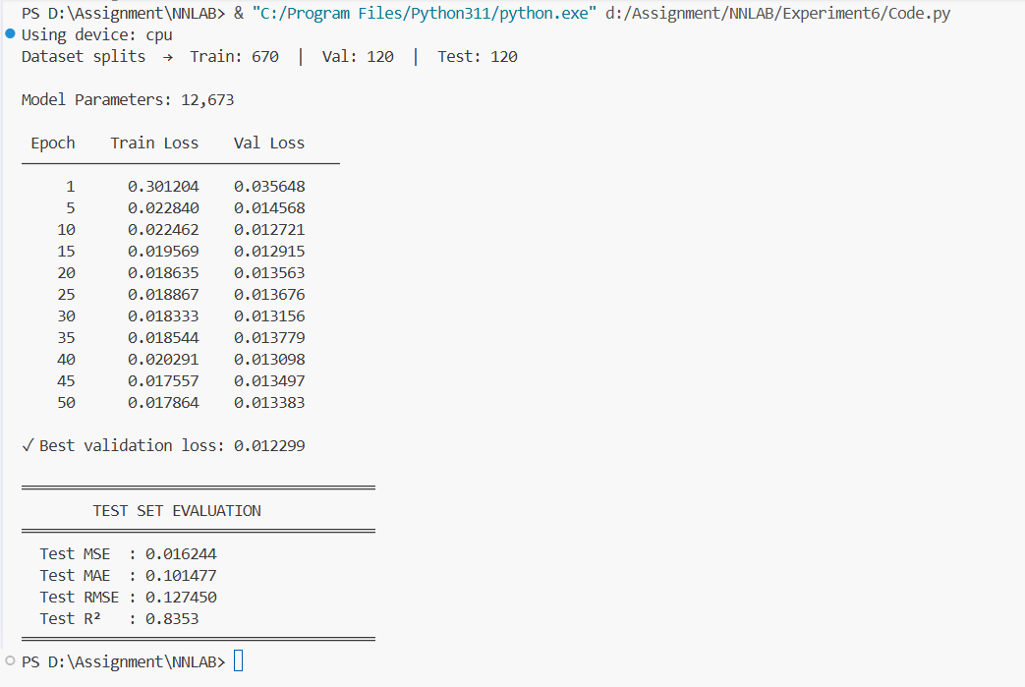

Description of Code
The program is implemented using PyTorch to build and train a Recurrent Neural Network (RNN) for time-series prediction. The code is modular and organized into sections including dataset generation, preprocessing, model definition, training, evaluation, and visualization.
1. Dataset Generation
A synthetic time-series dataset is generated using a sine wave with added Gaussian noise:
series = np.sin(t) + 0.1 * np.random.randn(n_points)
Total data points: 1000
This simulates real-world temporal patterns with slight randomness
Ensures reproducibility using fixed random seeds
2. Data Preprocessing
The dataset is converted into a supervised learning format using a sliding window approach:
Sequence length: 30
Input: past 30 values
Output: next value
Example:
[ x₁, x₂, ..., x₃₀ ] → x₃₁
The data is then:
Converted into PyTorch tensors
Reshaped to:
$$\left(N , sequence_length , 1\right)$$3. Dataset & DataLoader
A custom PyTorch Dataset class is implemented:
class TimeSeriesDataset(Dataset)
Returns (sequence, target) pairs
Used with DataLoader for:
Batching (batch size = 64)
Shuffling (training only)
Dataset split:
Training: 70%
Validation: 15%
Testing: 15%
4. RNN Model Architecture
The model is defined using PyTorch’s nn.Module:
self.rnn = nn.RNN(...)
self.dropout = nn.Dropout(0.2)
self.fc = nn.Linear(...)
Architecture:
Input size: 1
Hidden size: 64
Number of layers: 2
Dropout: 0.2
Flow:
Input Sequence → RNN → Last Hidden State → Dropout → Fully Connected → Output
Only the last time step output is used for prediction
5. Model Training
The model is trained using a custom training loop:
loss = criterion(pred, y_batch)
loss.backward()
optimizer.step()
Key Features:
Loss Function: Mean Squared Error (MSE)
Optimizer: Adam
Epochs: 50
Gradient Clipping: prevents exploding gradients
Learning Rate Scheduler: ReduceLROnPlateau
Training and validation losses are recorded for each epoch.
6. Experiments / Hyperparameters
The program uses the following configuration:
Sequence length: 30
Batch size: 64
Learning rate: 0.001
Hidden units: 64
RNN layers: 2
Dropout: 0.2
These hyperparameters affect model performance and generalization.
7. Model Evaluation
After training, the model is evaluated on the test dataset using multiple regression metrics:
MSE (Mean Squared Error)
MAE (Mean Absolute Error)
RMSE (Root Mean Squared Error)
R² Score
From your output:
Test MSE: 0.016244
Test MAE: 0.101477
Test RMSE: 0.127450
Test R²: 0.8353
8. Visualization
The program generates advanced visualizations (6 panels):
First Figure:
Full dataset with train/val/test split
Training vs validation loss curves
Predictions vs actual values
Scatter plot (actual vs predicted)
Second Figure:
Residual (error) analysis
Error distribution histogram
These plots help in:
Understanding model performance
Detecting overfitting/underfitting
Analyzing prediction errors

Output-Visualization
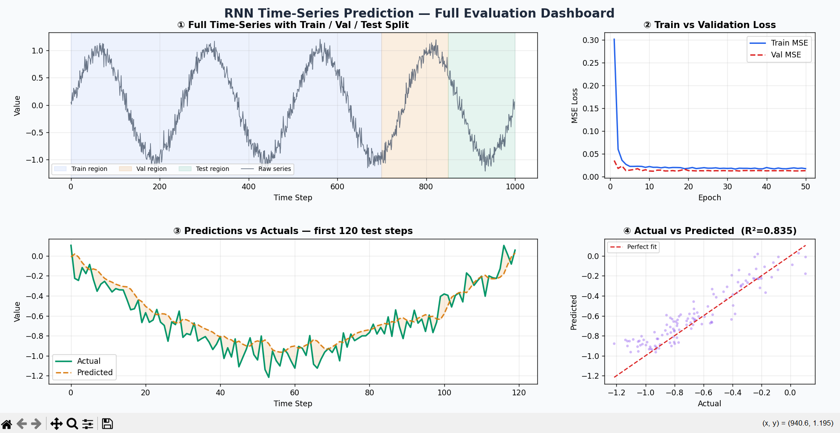
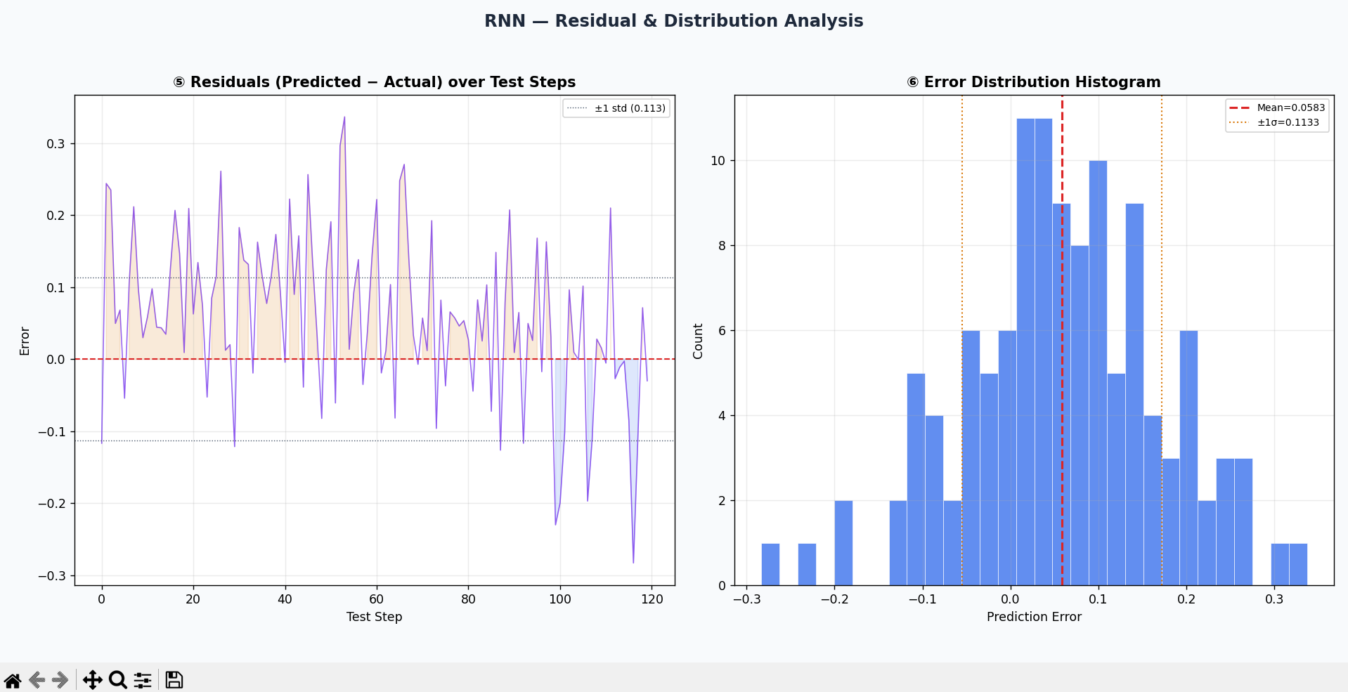

My Comments

Limitations
    - The model uses a basic RNN architecture, which is known to struggle with long-term dependencies due to issues like vanishing gradients.
    - The model is trained on a synthetic sine-wave dataset with noise, which is relatively simple compared to real-world time-series data (e.g., stock prices, weather data).

Scope of Improvement
    - The model is trained on a synthetic sine-wave dataset with noise, which is relatively simple compared to real-world time-series data (e.g., stock prices, weather data).
    - Extend the model to handle multiple input features instead of a single time series, allowing it to learn relationships between different variables.

