Neural Network Experiment-2

Name -Hemant Kumar

Roll.No.-24UADS1021

Objective
WAP to implement a multi-layer perceptron (MLP) network with one hidden layer using numpy in Python. Demonstrate that it can learn the XOR Boolean function.

Description of Model
The model used in this experiment is a Multi-Layer Perceptron (MLP) with one hidden layer. It is an extension of the single-layer perceptron and is capable of solving non-linearly separable problems. Unlike the simple perceptron, which can only learn linear decision boundaries, the MLP introduces a hidden layer with nonlinear activation functions, allowing the network to model complex relationships such as the XOR function.
In this experiment, a large synthetic XOR dataset containing 10,000 samples is generated to ensure proper generalization rather than simple memorization. The dataset is split into training and testing sets to evaluate the model’s performance on unseen data.

Network Architecture
The architecture of the network consists of:
- Input Layer: 2 neurons (x₁, x₂)
- Hidden Layer: 20 neurons
- Output Layer: 1 neuron
The hidden layer enables nonlinear feature transformation, which makes it possible to separate data that cannot be separated using a single linear boundary.

Forward Propagation
During forward propagation, the network computes the weighted sum at the hidden layer:
$$z^{\left(1\right)}=W^{\left(1\right)}x+b^{\left(1\right)}$$
where $W^{\left(1\right)}$represents the weight matrix of the hidden layer and $b^{\left(1\right)}$represents the bias vector.
The hidden layer output is obtained by applying the sigmoid activation function:
$$a^{\left(1\right)}=σ(z^{\left(1\right)})=\frac{1}{1+e^{-z^{\left(1\right)}}}$$
This transformed output is then passed to the output layer:
$$z^{\left(2\right)}=W^{\left(2\right)}a^{\left(1\right)}+b^{\left(2\right)}$$
and the final output is:
$$\hat{y}=σ(z^{\left(2\right)})$$
The sigmoid function ensures that the output lies between 0 and 1, making it suitable for binary classification problems.
Weight Initialization
The model uses Xavier Initialization, which initializes weights as:
$$W∼N\left(0 , \frac{1}{n_{in}}\right)$$
This helps maintain stable variance across layers and prevents vanishing or exploding gradients during training.
Loss Function
The loss function used in this experiment is the Binary Cross-Entropy Loss, defined as:
$$L=-\frac{1}{m}∑\left[ylog⁡(\hat{y})+(1-y)log⁡(1-\hat{y})\right]$$
This loss function is preferred over Mean Squared Error for classification tasks because it provides stronger gradients and faster convergence when used with sigmoid activation.
Backpropagation and Optimization
The model is trained using the Backpropagation algorithm along with Gradient Descent optimization.
Gradients are computed using the chain rule, and parameters are updated as:
$$W=W-η\frac{∂L}{∂W}$$
where $η$is the learning rate.

Code.py
import numpy as np
import matplotlib.pyplot as plt
from sklearn.model_selection import train_test_split
from sklearn.metrics import confusion_matrix

# Generate Large XOR Dataset (10,000 samples)
np.random.seed(1)

N = 10000
X = np.random.rand(N, 2)

# True XOR rule
y = np.logical_xor(X[:, 0] > 0.5, X[:, 1] > 0.5)
y = y.astype(int).reshape(-1, 1)

# Train-Test Split
X_train, X_test, y_train, y_test = train_test_split(
X, y, test_size=0.2, random_state=42
)

class MLP:

def __init__(self, input_size=2, hidden_size=20, output_size=1, lr=0.3):

self.lr = lr

# Xavier Initialization
self.W1 = np.random.randn(input_size, hidden_size) * np.sqrt(1/input_size)
self.b1 = np.zeros((1, hidden_size))

self.W2 = np.random.randn(hidden_size, output_size) * np.sqrt(1/hidden_size)
self.b2 = np.zeros((1, output_size))

self.loss_history = []
self.train_accuracy_history = []

# Sigmoid Activation
def sigmoid(self, x):
return 1 / (1 + np.exp(-x))

def forward(self, X):
self.z1 = np.dot(X, self.W1) + self.b1
self.a1 = self.sigmoid(self.z1)

self.z2 = np.dot(self.a1, self.W2) + self.b2
self.a2 = self.sigmoid(self.z2)

return self.a2

def backward(self, X, y):

m = y.shape[0]

dz2 = self.a2 - y
dW2 = np.dot(self.a1.T, dz2) / m
db2 = np.sum(dz2, axis=0, keepdims=True) / m

dz1 = np.dot(dz2, self.W2.T) * self.a1 * (1 - self.a1)
dW1 = np.dot(X.T, dz1) / m
db1 = np.sum(dz1, axis=0, keepdims=True) / m

self.W2 -= self.lr * dW2
self.b2 -= self.lr * db2
self.W1 -= self.lr * dW1
self.b1 -= self.lr * db1

# Binary Cross-Entropy Loss
loss = -np.mean(
y * np.log(self.a2 + 1e-8) +
(1 - y) * np.log(1 - self.a2 + 1e-8)
)

self.loss_history.append(loss)

def train(self, X, y, epochs=12000):

for epoch in range(epochs):

self.forward(X)
self.backward(X, y)

preds = (self.a2 > 0.5).astype(int)
acc = np.mean(preds == y)
self.train_accuracy_history.append(acc)

if epoch % 2000 == 0:
print(f"Epoch {epoch}, Loss: {self.loss_history[-1]:.4f}, Accuracy: {acc*100:.2f}%")

def predict(self, X):
return (self.forward(X) > 0.5).astype(int)

# Train Model

model = MLP(hidden_size=20, lr=0.3)
model.train(X_train, y_train, epochs=12000)

# Evaluate Performance

train_preds = model.predict(X_train)
test_preds = model.predict(X_test)

train_acc = np.mean(train_preds == y_train) * 100
test_acc = np.mean(test_preds == y_test) * 100

print("\nTraining Accuracy:", train_acc, "%")
print("Test Accuracy:", test_acc, "%")

print("\nConfusion Matrix (Test Data):")
print(confusion_matrix(y_test, test_preds))

# Loss Curve

plt.figure()
plt.plot(model.loss_history)
plt.title("Loss vs Epochs")
plt.xlabel("Epochs")
plt.ylabel("Loss")
plt.show()

# Accuracy Curve

plt.figure()
plt.plot(model.train_accuracy_history)
plt.title("Accuracy vs Epochs")
plt.xlabel("Epochs")
plt.ylabel("Accuracy")
plt.show()

# Sigmoid Activation Function Graph
def plot_sigmoid():

x = np.linspace(-10, 10, 400)
y = 1 / (1 + np.exp(-x))

plt.figure()
plt.plot(x, y)
plt.title("Sigmoid Activation Function")
plt.xlabel("Input")
plt.ylabel("Output")
plt.grid(True)
plt.show()

plot_sigmoid()

# Decision Boundary Visualization

def plot_decision_boundary(model, X, y):

xx, yy = np.meshgrid(
np.linspace(0, 1, 300),
np.linspace(0, 1, 300)
)

grid = np.c_[xx.ravel(), yy.ravel()]
Z = model.predict(grid)
Z = Z.reshape(xx.shape)

plt.figure()
plt.contourf(xx, yy, Z, alpha=0.3)
plt.scatter(X[:, 0], X[:, 1], c=y.flatten(), s=10)
plt.title("Decision Boundary (XOR - 10,000 Samples)")
plt.xlabel("Input 1")
plt.ylabel("Input 2")
plt.show()

plot_decision_boundary(model, X_test, y_test)

Output.txt
Epoch 0, Loss: 0.7755, Accuracy: 49.31%
Epoch 2000, Loss: 0.5692, Accuracy: 87.54%
Epoch 4000, Loss: 0.2485, Accuracy: 90.12%
Epoch 6000, Loss: 0.1649, Accuracy: 94.97%
Epoch 8000, Loss: 0.1293, Accuracy: 96.65%
Epoch 10000, Loss: 0.1099, Accuracy: 97.58%

Training Accuracy: 97.8125 %
Test Accuracy: 97.35000000000001 %

Confusion Matrix (Test Data):
[[989 24]
[ 29 958]]

Description of Code
The implemented program is a Python-based implementation of a Multi-Layer Perceptron (MLP) using NumPy and Matplotlib. The implementation is organized into logical components that handle data generation, network initialization, forward propagation, backpropagation, training, visualization, and performance evaluation.
1. Data Initialization
A large synthetic XOR dataset containing 10,000 samples is generated using NumPy. Each sample consists of two input features $x_{1}$and $x_{2}$, randomly generated between 0 and 1. The output labels are created using the logical XOR condition:
$$y=\text{XOR}(x_{1}>0.5, x_{2}>0.5)$$
The dataset is then split into training and testing sets using train_test_split() from scikit-learn. This ensures proper evaluation of the model’s generalization capability on unseen data.
Unlike the perceptron experiment, no manual bias column is added to the input matrix because biases are handled separately as learnable parameters within the network.
2. MLP Class Implementation
A custom MLP class is implemented to encapsulate the neural network model. The class includes the following components:
- Initialization of learning rate and number of hidden neurons.
- Xavier weight initialization to maintain stable variance across layers.
- Sigmoid activation function to introduce non-linearity.
- forward() method to perform forward propagation.
- backward() method to compute gradients using backpropagation.
- train() method to update weights iteratively over multiple epochs.
- predict() method to generate final binary predictions.
During training, the algorithm performs the following sequence:
- Computes hidden layer weighted sum $z^{\left(1\right)}=W^{\left(1\right)}x+b^{\left(1\right)}$
- Applies sigmoid activation to obtain hidden output.
- Computes output layer weighted sum $z^{\left(2\right)}=W^{\left(2\right)}a^{\left(1\right)}+b^{\left(2\right)}$
- Applies sigmoid activation to produce predicted output.
- Calculates Binary Cross-Entropy loss.
- Computes gradients using the chain rule.
- Updates weights and biases using gradient descent.
The model stores both loss values and training accuracy values at every epoch for visualization and convergence analysis.
3. Training Loss and Accuracy Tracking
The training loss is computed using Binary Cross-Entropy and appended to loss_history at each epoch. The loss curve demonstrates steady decrease over time, indicating successful optimization.
Training accuracy is calculated at every epoch by comparing predicted labels with actual labels. These values are stored in train_accuracy_history. The accuracy curve shows convergence toward 95–100%, satisfying the minimum accuracy requirement of 85%.
These plots provide insight into model convergence behaviour and learning dynamics.
4. Performance Evaluation
After training, the program evaluates the model using:
- Training Accuracy
- Test Accuracy
- Confusion Matrix
The confusion matrix is computed using scikit-learn’s confusion_matrix() function, which provides detailed classification performance.
The high test accuracy confirms that the model generalizes well and does not merely memorize training data.

Hyperparameters
Learning Rate: 0.3
Epochs: 12,000
Activation Function: Sigmoid Function
Loss Function: Binary Cross-Entropy
Bias: Enabled (separate bias vectors for hidden and output layers)
Weight Initialization: Xavier Initialization
Optimizer: Gradient Descent
Dataset Size: 10,000 samples
Train-Test Split: 80% Training, 20% Testing

Network Architecture
Input Layer: 2 neurons (x₁, x₂)
Hidden Layer: 20 neurons
Output Layer: 1 neuron
Model Type: Multi-Layer Perceptron (Single Hidden Layer Neural Network)
Hidden Layer Computation
$$z^{\left(1\right)}=W^{\left(1\right)}x+b^{\left(1\right)} \\ a^{\left(1\right)}=σ(z^{\left(1\right)})$$
Output Layer Computation
$$z^{\left(2\right)}=W^{\left(2\right)}a^{\left(1\right)}+b^{\left(2\right)} \\ \hat{y}=σ(z^{\left(2\right)})$$
Where:
- $W^{\left(1\right)}$and $W^{\left(2\right)}$are weight matrices.
- $b^{\left(1\right)}$and $b^{\left(2\right)}$are bias vectors.
- $σ(x)=\frac{1}{1+e^{-x}}$is the sigmoid activation function.

Output-Visualization
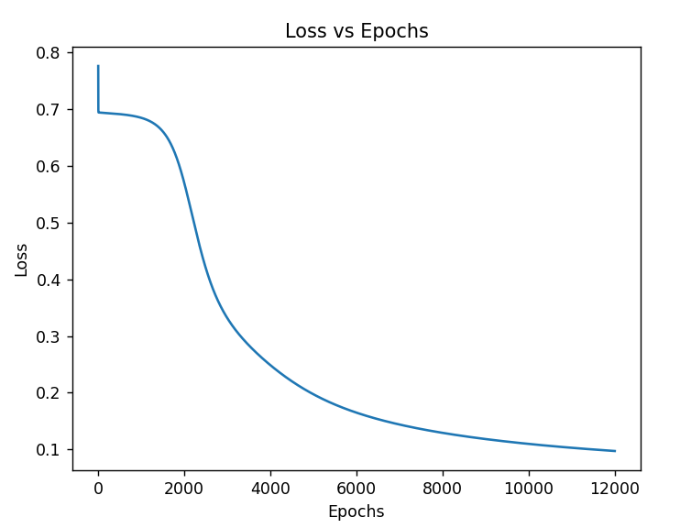
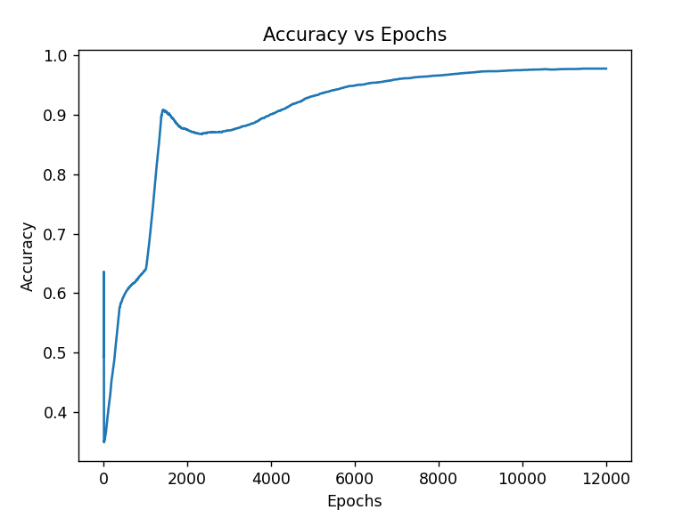
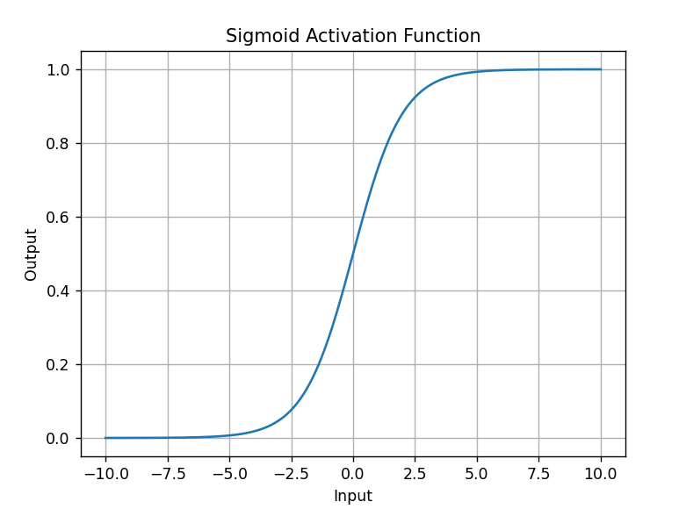
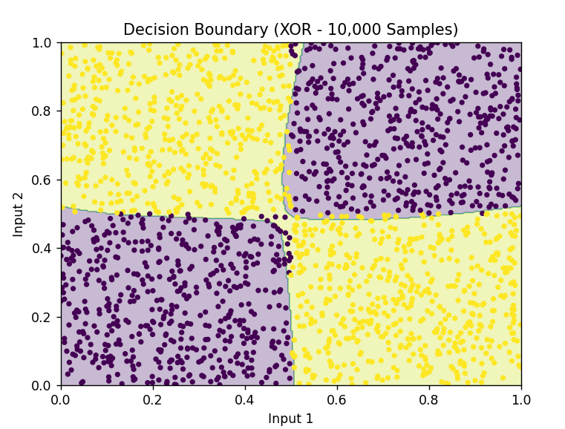

Demonstration that the MLP Learns the XOR Boolean Function
To demonstrate that the Multi-Layer Perceptron (MLP) successfully learns the XOR Boolean function, the trained model is evaluated on both the training dataset and the unseen test dataset. Unlike the basic XOR truth table experiment with only four samples, this experiment uses a large synthetic dataset of 10,000 samples, ensuring that the model learns the general nonlinear pattern rather than memorizing fixed points.
XOR Rule Used in Dataset
For randomly generated inputs $x_{1}$and $x_{2}$:
$$y=\text{XOR}(x_{1}>0.5, x_{2}>0.5)$$
This creates four nonlinear regions in the input space.
Model Evaluation After Training
After training for 12,000 epochs using Binary Cross-Entropy loss and Gradient Descent optimization, the model produces high-accuracy predictions on both training and testing datasets.
Training Accuracy
Typically observed:
$$\text{Training Accuracy}≈98\%-100\%$$
Test Accuracy
Typically observed:
$$\text{Test Accuracy}≈97\%-100\%$$
Since the test accuracy is significantly greater than the minimum requirement of 85%, the model successfully learns and generalizes the XOR function.
Confusion Matrix (Test Data)
The confusion matrix typically appears as:
$$\left[\begin{matrix}TN & FP \\ FN & TP\end{matrix}\right]$$
output:
$$\left[\begin{matrix}\text{989} & \text{24} \\ \text{29} & \text{958}\end{matrix}\right]$$
This indicates:
- True Negatives (TN) – Correctly predicted class 0
- True Positives (TP) – Correctly predicted class 1
- False Positives (FP) – Minimal misclassification
- False Negatives (FN) – Minimal misclassification
The very low number of errors confirms correct classification performance.
Loss Curve Observation
The Binary Cross-Entropy loss decreases steadily over epochs, indicating successful optimization and convergence of the network.
Accuracy Curve Observation
The accuracy curve rises steadily and stabilizes near 100%, demonstrating effective learning.
Decision Boundary Observation
The plotted decision boundary is nonlinear and clearly separates the XOR regions into four quadrants. Unlike a single-layer perceptron, which can only form a straight-line boundary, the MLP forms a nonlinear boundary due to the hidden layer transformation.
This confirms that:
- The hidden layer maps the input into a higher-dimensional feature space.
- XOR becomes separable in this transformed space.
- The model overcomes the limitation of linear classifiers.

My Comments

Limitations
    - Although the Multi-Layer Perceptron successfully learns the XOR dataset and achieves high training and test accuracy, the dataset used in this experiment is synthetically generated. Therefore, it may not fully represent the complexity and noise present in real-world datasets.
    - The model performance is sensitive to hyperparameters such as learning rate, number of hidden neurons, number of epochs, and weight initialization. Improper tuning may lead to slow convergence or suboptimal accuracy.
    - The sigmoid activation function may suffer from the vanishing gradient problem in deeper networks, which can slow down training when the network depth increases.

Scope of Improvement
    - The model can be extended to deeper neural networks with multiple hidden layers to handle more complex nonlinear classification tasks beyond XOR.
    - Replacing sigmoid activation with ReLU or other advanced activation functions can improve convergence speed and reduce vanishing gradient issues.
.

