Neural Network Experiment-7

Name -Hemant Kumar

Roll.No.-24UADS1021
Objective
WAP to retrain a pretrained imagenet model to classify a medical image dataset.

Description of Model
The model used in this experiment is a Transfer Learning-based Convolutional Neural Network (CNN) built using pretrained architectures from the PyTorch library. Instead of training a model from scratch, the approach leverages models pretrained on the ImageNet dataset, allowing efficient learning even with limited medical data.
The task is a binary image classification problem, where the model predicts whether a chest X-ray image belongs to:
- Normal
- Pneumonia
The dataset used is PneumoniaMNIST, which contains labeled medical images for supervised learning.
Model Architecture
The framework supports multiple pretrained CNN architectures such as:
- ResNet (e.g., ResNet18, ResNet50)
- EfficientNet (EfficientNet-B0)
- DenseNet121
- VGG16
These models consist of:
- A feature extractor (backbone) pretrained on ImageNet
- A custom classification head modified for binary classification
For example, in ResNet:
- The final fully connected layer is replaced with:
  - Dropout → Linear → ReLU → Dropout → Linear
This enables the model to adapt high-level learned features to the medical domain.
Input Processing
Each input image undergoes preprocessing:
- Resizing to a fixed size (e.g., 224×224)
- Data augmentation (random crop, flip, rotation, color jitter)
- Normalization using ImageNet mean and standard deviation
This improves generalization and prevents overfitting.
Training Mechanism
The model computes predictions using forward propagation:
- Input image → CNN backbone → Feature maps → Classifier → Output logits
The loss is computed using Cross Entropy Loss, defined as:
- Measures difference between predicted probabilities and actual labels
An optional weighted loss is used to handle class imbalance.
Optimization
The model is trained using:
- Optimizer: AdamW (adaptive gradient optimization with weight decay)
- Learning Rate Scheduler: Cosine Annealing
This dynamically adjusts the learning rate to improve convergence.
Training Strategy
- Supports freezing the backbone, where only the classification head is trained
- Uses mini-batch training via DataLoader
- Implements mixed precision training (FP16) when GPU is available for faster computation
During training:
- Forward pass → loss computation → backward pass → weight update

Code.py
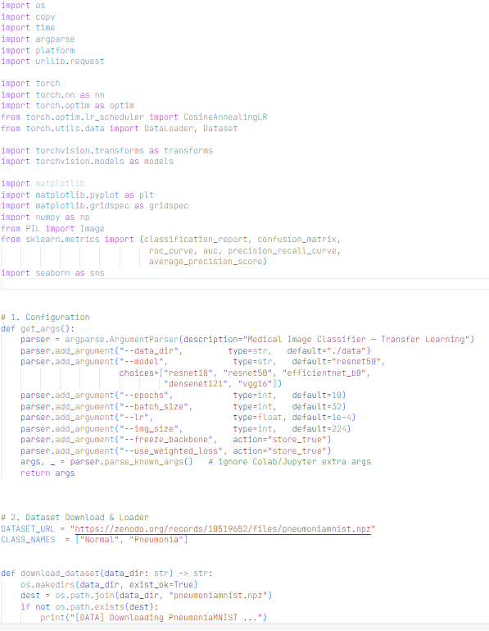
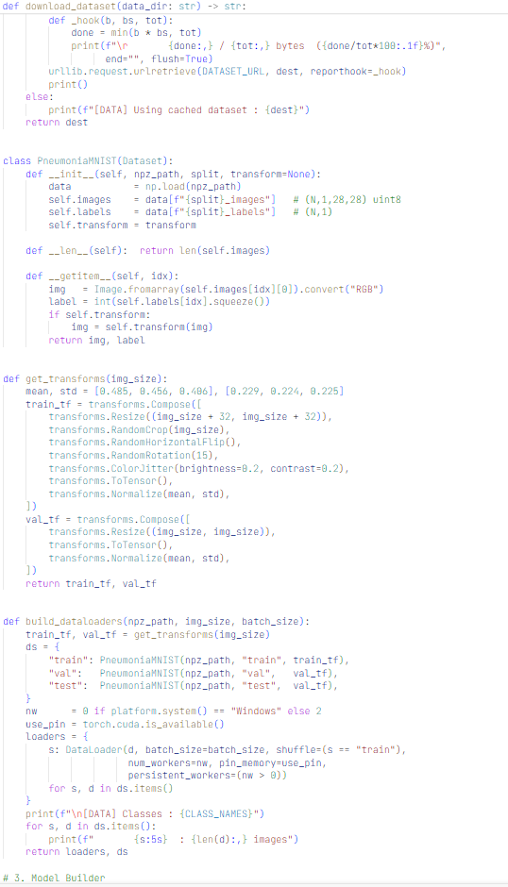
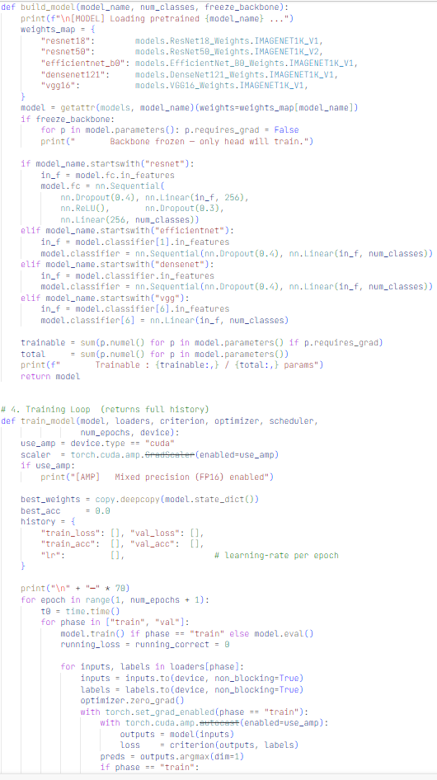
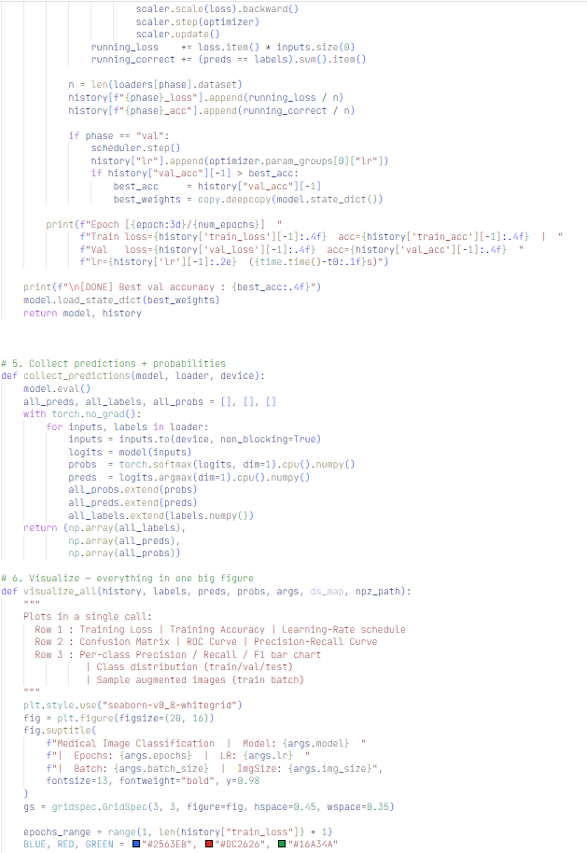
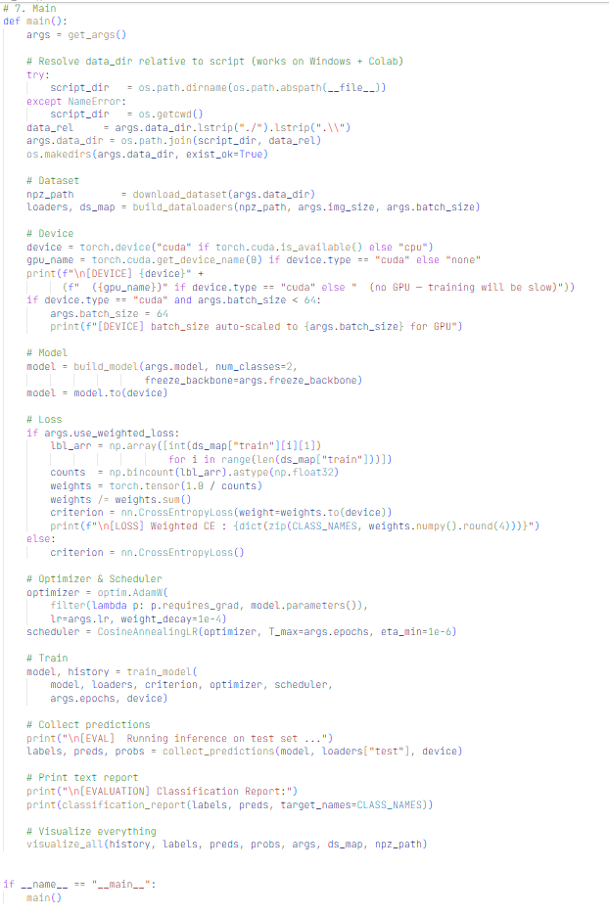

Output.txt
[DATA] Using cached dataset : /content/data/pneumoniamnist.npz

[DATA] Classes : ['Normal', 'Pneumonia']
train : 4,708 images
val : 524 images
test : 624 images

[DEVICE] cuda (Tesla T4)
[DEVICE] batch_size auto-scaled to 64 for GPU

[MODEL] Loading pretrained resnet50 ...
Trainable : 24,033,090 / 24,033,090 params
[AMP] Mixed precision (FP16) enabled

──────────────────────────────────────────────────────────────────────
/tmp/ipykernel_8632/1881318139.py:189: FutureWarning: `torch.cuda.amp.GradScaler(args...)` is deprecated. Please use `torch.amp.GradScaler('cuda', args...)` instead.
scaler = torch.cuda.amp.GradScaler(enabled=use_amp)
/tmp/ipykernel_8632/1881318139.py:213: FutureWarning: `torch.cuda.amp.autocast(args...)` is deprecated. Please use `torch.amp.autocast('cuda', args...)` instead.
with torch.cuda.amp.autocast(enabled=use_amp):
Epoch [ 1/10] Train loss=0.4082 acc=0.8027 | Val loss=0.3233 acc=0.8760 lr=9.76e-05 (28.3s)
Epoch [ 2/10] Train loss=0.3299 acc=0.8566 | Val loss=0.4224 acc=0.8378 lr=9.05e-05 (23.8s)
Epoch [ 3/10] Train loss=0.3154 acc=0.8653 | Val loss=0.3090 acc=0.8683 lr=7.96e-05 (23.2s)
Epoch [ 4/10] Train loss=0.2992 acc=0.8738 | Val loss=0.3779 acc=0.8359 lr=6.58e-05 (23.7s)
Epoch [ 5/10] Train loss=0.2902 acc=0.8783 | Val loss=0.3389 acc=0.8645 lr=5.05e-05 (24.4s)
Epoch [ 6/10] Train loss=0.2814 acc=0.8806 | Val loss=0.3294 acc=0.8588 lr=3.52e-05 (23.3s)
Epoch [ 7/10] Train loss=0.2653 acc=0.8908 | Val loss=0.3481 acc=0.8340 lr=2.14e-05 (24.9s)
Epoch [ 8/10] Train loss=0.2577 acc=0.8959 | Val loss=0.3556 acc=0.8473 lr=1.05e-05 (29.3s)
Epoch [ 9/10] Train loss=0.2405 acc=0.9034 | Val loss=0.3574 acc=0.8397 lr=3.42e-06 (25.0s)
Epoch [ 10/10] Train loss=0.2373 acc=0.9006 | Val loss=0.3761 acc=0.8340 lr=1.00e-06 (23.8s)

[DONE] Best val accuracy : 0.8760

[EVAL] Running inference on test set ...

[EVALUATION] Classification Report:
precision recall f1-score support

Normal 0.82 0.55 0.65 234
Pneumonia 0.77 0.93 0.84 390

accuracy 0.78 624
macro avg 0.79 0.74 0.75 624
weighted avg 0.79 0.78 0.77 624

Description of Code
The implemented program is a Python-based medical image classification pipeline that uses transfer learning with deep convolutional neural networks. It is built using libraries such as PyTorch, NumPy, Matplotlib, and scikit-learn.
The code is modular and organized into distinct components that handle data loading, preprocessing, model building, training, evaluation, and visualization.
1. Data Initialization and Loading
The program automatically downloads the PneumoniaMNIST dataset, which contains labeled chest X-ray images for binary classification (Normal vs Pneumonia).
- A custom dataset class is implemented to:
  - Load .npz data
  - Convert grayscale images to RGB
  - Apply transformations
- Data is split into:
  - Training set
  - Validation set
  - Test set
- DataLoader is used to efficiently batch and shuffle data during training.
2. Data Preprocessing and Augmentation
Two transformation pipelines are defined:
- Training Transformations:
  - Resize and random crop
  - Horizontal flipping
  - Rotation and color jitter
  - Normalization
- Validation/Test Transformations:
  - Resize
  - Normalization
These augmentations help improve generalization and reduce overfitting.
3. Model Construction
The program supports multiple pretrained CNN architectures such as:
- ResNet (18, 50)
- EfficientNet-B0
- DenseNet121
- VGG16
A model-building function:
- Loads pretrained weights (ImageNet)
- Optionally freezes the backbone layers
- Replaces the final classification layer with a custom head
This enables the model to adapt learned features for binary classification.
4. Training Loop Implementation
A dedicated training function performs the learning process:
- Iterates over epochs and phases (train + validation)
- Performs:
  - Forward pass
  - Loss computation (CrossEntropyLoss)
  - Backpropagation
  - Weight updates using AdamW optimizer
- Uses:
  - Mixed precision training (FP16) for faster computation on GPU
  - Gradient scaling for stability
- Tracks:
  - Training loss and accuracy
  - Validation loss and accuracy
  - Learning rate per epoch
The best model weights are saved based on validation accuracy.
5. Learning Rate Scheduling
A Cosine Annealing Scheduler is used to gradually reduce the learning rate:
- Helps avoid local minima
- Improves convergence stability
6. Prediction and Inference
After training:
- The model is evaluated on the test dataset
- Predictions and probability scores are collected
- Softmax is applied to obtain class probabilities
7. Performance Evaluation
The program evaluates model performance using:
- Accuracy (Train & Validation)
- Confusion Matrix
- Classification Report (Precision, Recall, F1-score)
- ROC Curve and AUC Score
- Precision-Recall Curve
These metrics provide a comprehensive understanding of model performance.
8. Visualization Module
A comprehensive visualization function generates multiple plots in a single figure:
- Training vs Validation Loss Curve
- Training vs Validation Accuracy Curve
- Learning Rate Schedule
- Confusion Matrix (with counts and percentages)
- ROC Curve
- Precision-Recall Curve
- Per-class Precision, Recall, F1-score bar chart
- Class distribution across dataset splits
- Sample augmented images
These visualizations help analyze learning behavior and model performance.
9. Key Functional Features
- Automatic dataset download and handling
- Modular and reusable code structure
- Support for multiple architectures
- GPU acceleration with mixed precision
- Advanced evaluation and visualization tools
10. Observations from Code Behavior
- Transfer learning enables faster convergence compared to training from scratch
- Data augmentation improves generalization
- Validation accuracy is used to prevent overfitting
- Visualization tools provide deep insights into training dynamics

Hyperparameters
Learning Rate: 1e-4
Epochs: 10
Batch Size: 32
Optimizer: AdamW
Loss Function: Cross Entropy Loss
Dropout: 0.3 – 0.4

Network Architecture
Input Layer:
- Image size: 224 × 224 × 3 (RGB)
Feature Extractor (Backbone):
- Pretrained convolutional layers (e.g., ResNet50)
- Extracts high-level spatial features from images
Classifier Head (Modified):
- Fully Connected Layer
- ReLU Activation
- Dropout
- Final Linear Layer (2 outputs)
Output Layer:
- 2 neurons → representing:
  - Normal
  - Pneumonia

OUPUT CURVES
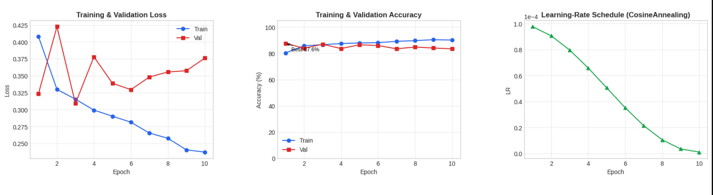
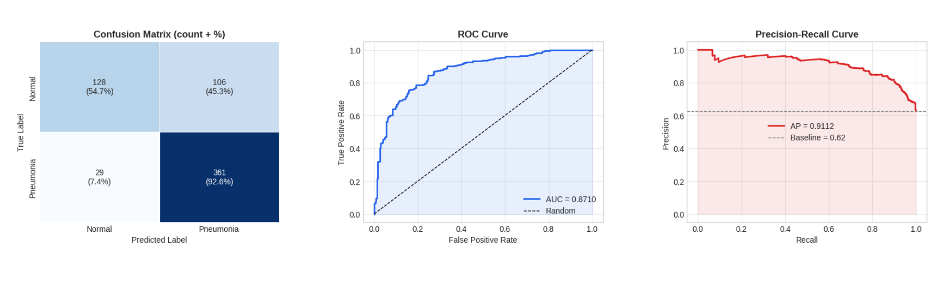
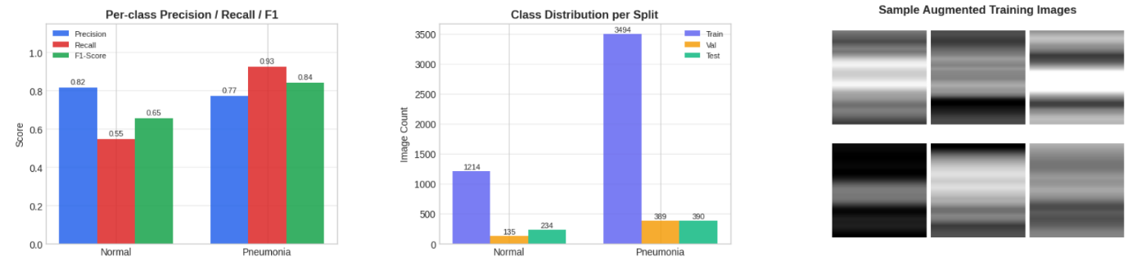

My Comments

Limitations
- The model relies heavily on pretrained weights (ImageNet). If the medical domain differs significantly, feature mismatch may reduce performance.

Although PneumoniaMNIST is useful, it is relatively small and simplified compared to real-world medical datasets, which may affect generalization.

Scope of Improvement
- Instead of freezing pretrained layers, selectively unfreezing deeper layers can improve domain-specific feature learning.
- Training on more diverse and high-resolution medical datasets can improve robustness and real-world applicability.
- Using more powerful models (e.g., EfficientNet variants or Vision Transformers) can improve performance..

