Neural Network Experiment-5

Name -Hemant Kumar

Roll.No.-24UADS1021

Objective
WAP to train and evaluate a convolutional neural network using Keras Library to classify MNIST fashion dataset. Demonstrate the effect of filter size, regularization, batch size and optimization algorithm on model performance.

Description of Model
The implemented model is a Convolutional Neural Network (CNN) designed for multi-class classification of clothing images from the Fashion-MNIST dataset. Unlike fully connected neural networks, CNNs are specifically designed to process grid-structured data such as images, allowing the model to automatically learn spatial features like edges, textures, and object shapes.
The input to the model consists of 28×28 grayscale images, which are first normalized to the range [0,1] by dividing pixel values by 255. This normalization improves numerical stability and speeds up convergence during training. Each image is reshaped into the format (28 × 28 × 1) to represent height, width, and a single color channel.
The CNN architecture is composed of two convolutional blocks followed by a fully connected classification head. Each convolutional block contains convolutional layers, batch normalization, pooling, and optional regularization components.
The first convolutional block consists of two Conv2D layers with 32 filters each. These layers apply learnable kernels of size 3×3 or 5×5 across the input image to detect low-level features such as edges and contours. The convolution operation can be expressed as:
$$S(i,j)=\sum_{m}{\sum_{n}{I(i+m,j+n)⋅K(m,n)}}$$
where $I$represents the input image and $K$represents the convolution kernel.
After convolution, Batch Normalization is applied to stabilize the distribution of activations and accelerate training. The feature maps are then downsampled using Max Pooling, which reduces spatial dimensions while preserving important features. Max pooling selects the maximum value within each pooling window:
$$y=max⁡(x_{1},x_{2},...,x_{n})$$
The second convolutional block contains two Conv2D layers with 64 filters, allowing the model to capture higher-level and more complex visual patterns. Similar to the first block, batch normalization and max pooling are applied to improve training stability and reduce dimensionality.
To prevent overfitting, regularization techniques such as L2 weight decay and Dropout are optionally used. L2 regularization penalizes large weights by adding a regularization term to the loss function:
$$L_{total}=L_{data}+λ∑w^{2}$$
where $λ$controls the strength of regularization.
Dropout randomly disables a fraction of neurons during training, forcing the network to learn more robust representations.
After feature extraction, the resulting feature maps are flattened into a one-dimensional vector and passed to a fully connected dense layer with 256 neurons using the ReLU activation function:
$$ReLU(x)=max⁡(0,x)$$
ReLU introduces non-linearity into the model, enabling it to learn complex patterns in the data.
The final output layer consists of 10 neurons corresponding to the 10 clothing categories in the Fashion-MNIST dataset. The network produces class probabilities using the Softmax activation function:
$$P(y=i)=\frac{e^{z_{i}}}{\sum_{j=1}^{C}{e^{z_{j}}}}$$
The model is trained using the Sparse Categorical Cross-Entropy loss function, defined as:
$$L=-\sum_{i=1}^{C}{y_{i}}log⁡({\hat{y}}_{i})$$
where $y_{i}$is the true class label and ${\hat{y}}_{i}$is the predicted probability.
Different optimization algorithms such as Adam, SGD with Momentum, and RMSprop are used to update model parameters during training. These optimizers adjust the weights using gradient-based learning to minimize the loss function.
The network is trained for 5 epochs with different configurations of filter sizes, batch sizes, regularization techniques, and optimizers. Model performance is evaluated using training accuracy, validation accuracy, loss curves, confusion matrix, and per-class accuracy analysis.
The experimental results demonstrate how different hyperparameters influence CNN performance and generalization capability on image classification tasks.

Code.py
import numpy as np
import matplotlib.pyplot as plt
import matplotlib.gridspec as gridspec
from sklearn.metrics import confusion_matrix
from tensorflow import keras
from tensorflow.keras import layers, regularizers
from tensorflow.keras.datasets import fashion_mnist

# 1. LOAD & PREPROCESS
CLASS_NAMES = ['T-shirt', 'Trouser', 'Pullover', 'Dress', 'Coat',
'Sandal', 'Shirt', 'Sneaker', 'Bag', 'Ankle boot']

(x_train, y_train), (x_test, y_test) = fashion_mnist.load_data()
x_train = x_train.astype("float32")[..., np.newaxis] / 255.0
x_test = x_test .astype("float32")[..., np.newaxis] / 255.0

x_val, y_val = x_train[-6000:], y_train[-6000:]
x_tr, y_tr = x_train[:-6000], y_train[:-6000]

print(f"Train: {x_tr.shape} Val: {x_val.shape} Test: {x_test.shape}")

# 2. MODEL BUILDER
def build_model(filter_size=3, use_regularization=False, optimizer='adam'):
"""
Two conv-blocks + dense classifier.
filter_size : kernel size (3 or 5)
use_regularization : L2 weight decay + Dropout when True
optimizer : string or keras Optimizer instance
"""
l2 = regularizers.l2(1e-4) if use_regularization else None

model = keras.Sequential([
# Block 1
layers.Conv2D(32, filter_size, padding='same', activation='relu',
kernel_regularizer=l2, input_shape=(28, 28, 1)),
layers.BatchNormalization(),
layers.Conv2D(32, filter_size, padding='same', activation='relu',
kernel_regularizer=l2),
layers.MaxPooling2D(2),
layers.Dropout(0.25) if use_regularization else layers.Lambda(lambda x: x),

# Block 2
layers.Conv2D(64, filter_size, padding='same', activation='relu',
kernel_regularizer=l2),
layers.BatchNormalization(),
layers.Conv2D(64, filter_size, padding='same', activation='relu',
kernel_regularizer=l2),
layers.MaxPooling2D(2),
layers.Dropout(0.25) if use_regularization else layers.Lambda(lambda x: x),

# Classifier head
layers.Flatten(),
layers.Dense(256, activation='relu', kernel_regularizer=l2),
layers.Dropout(0.50) if use_regularization else layers.Lambda(lambda x: x),
layers.Dense(10, activation='softmax'),
])

model.compile(optimizer=optimizer,
loss='sparse_categorical_crossentropy',
metrics=['accuracy'])
return model

# 3. TRAINING HELPER
EPOCHS = 5

def train_and_evaluate(label, filter_size=3, use_reg=False,
batch_size=64, optimizer='adam'):
print(f"\n{'━'*60}\n {label}\n{'━'*60}")
model = build_model(filter_size, use_reg, optimizer)
history = model.fit(x_tr, y_tr,
validation_data=(x_val, y_val),
epochs=EPOCHS, batch_size=batch_size, verbose=1)
test_loss, test_acc = model.evaluate(x_test, y_test, verbose=0)
print(f" Test Accuracy: {test_acc*100:.2f}% | Loss: {test_loss:.4f}")
return history, test_acc, test_loss, model

# 4. RUN EXPERIMENTS
# A - Filter size
hist_f3, acc_f3, loss_f3, _ = train_and_evaluate("Filter 3x3 (baseline)", filter_size=3)
hist_f5, acc_f5, loss_f5, _ = train_and_evaluate("Filter 5x5", filter_size=5)

# B - Regularization
hist_noreg, acc_noreg, loss_noreg, _ = train_and_evaluate("No Regularization", use_reg=False)
hist_reg, acc_reg, loss_reg, _ = train_and_evaluate("L2 + Dropout", use_reg=True)

# C - Batch size
hist_b32, acc_b32, loss_b32, _ = train_and_evaluate("Batch 32", batch_size=32)
hist_b128, acc_b128, loss_b128, _ = train_and_evaluate("Batch 128", batch_size=128)

# D - Optimizer
hist_adam, acc_adam, loss_adam, best_model = train_and_evaluate("Adam", optimizer=keras.optimizers.Adam(1e-3))
hist_sgd, acc_sgd, loss_sgd, _ = train_and_evaluate("SGD+Mom", optimizer=keras.optimizers.SGD(0.01, momentum=0.9))
hist_rmsp, acc_rmsp, loss_rmsp, _ = train_and_evaluate("RMSprop", optimizer=keras.optimizers.RMSprop(1e-3))

# 5. SUMMARY TABLE
results = [
("Filter 3x3 (baseline)", acc_f3, loss_f3),
("Filter 5x5", acc_f5, loss_f5),
("No Regularization", acc_noreg, loss_noreg),
("L2 + Dropout", acc_reg, loss_reg),
("Batch size 32", acc_b32, loss_b32),
("Batch size 128", acc_b128, loss_b128),
("Optimizer: Adam", acc_adam, loss_adam),
("Optimizer: SGD+Momentum", acc_sgd, loss_sgd),
("Optimizer: RMSprop", acc_rmsp, loss_rmsp),
]

print("\n\n" + "="*58)
print(f" {'Experiment':<36} {'Acc (%)':>8} {'Loss':>8}")
print("="*58)
for name, acc, loss in results:
print(f" {name:<36} {acc*100:>7.2f}% {loss:>8.4f}")
print("="*58)

# 6. PLOTTING UTILITIES
BG, PANEL = '#0d0f18', '#12152a'
TC, LC, GC = '#e8e8e8', '#aaaaaa', '#252545'
C = ['#00d4ff', '#ff6b6b', '#a8ff78', '#ffbe0b', '#8338ec', '#06d6a0']

ep = range(1, EPOCHS + 1)

def style(ax, title, ylabel='Accuracy'):
ax.set_facecolor(PANEL)
ax.set_title(title, color=TC, fontsize=11, fontweight='bold', pad=8)
ax.set_xlabel('Epoch', color=LC, fontsize=9)
ax.set_ylabel(ylabel, color=LC, fontsize=9)
ax.tick_params(colors=LC)
ax.grid(True, color=GC, ls='--', alpha=0.7)
for sp in ax.spines.values():
sp.set_color(GC)
ax.legend(facecolor=PANEL, edgecolor=GC, labelcolor=TC, fontsize=8)

# FIGURE 1 — Training curves (accuracy + loss) for all 4 experiments
fig1, axes1 = plt.subplots(4, 2, figsize=(16, 22), facecolor=BG)
fig1.suptitle('CNN on Fashion-MNIST Training Curves (5 Epochs)',
fontsize=15, fontweight='bold', color='white', y=0.995)

experiment_rows = [
([(hist_f3, 'Filter 3x3', C[0]),
(hist_f5, 'Filter 5x5', C[1])],
'A Filter Size Accuracy', 'A Filter Size Loss'),

([(hist_noreg, 'No Reg', C[2]),
(hist_reg, 'L2+Dropout', C[3])],
'B Regularization Accuracy', 'B Regularization Loss'),

([(hist_b32, 'Batch 32', C[4]),
(hist_b128, 'Batch 128', C[5])],
'C Batch Size Accuracy', 'C Batch Size Loss'),

([(hist_adam, 'Adam', C[0]),
(hist_sgd, 'SGD+Mom', C[1]),
(hist_rmsp, 'RMSprop', C[2])],
'D Optimizer Accuracy', 'D Optimizer Loss'),
]

for row, (hist_list, title_acc, title_loss) in enumerate(experiment_rows):
ax_acc = axes1[row, 0]
ax_los = axes1[row, 1]
for hist, lbl, color in hist_list:
ax_acc.plot(ep, hist.history['accuracy'], color=color, lw=2, ls='--', label=f'{lbl} train')
ax_acc.plot(ep, hist.history['val_accuracy'], color=color, lw=2, label=f'{lbl} val')
ax_los.plot(ep, hist.history['loss'], color=color, lw=2, ls='--', label=f'{lbl} train')
ax_los.plot(ep, hist.history['val_loss'], color=color, lw=2, label=f'{lbl} val')
style(ax_acc, title_acc, 'Accuracy')
style(ax_los, title_loss, 'Loss')

plt.tight_layout(rect=[0, 0, 1, 0.995])
plt.savefig('fig1_training_curves.png', dpi=150, bbox_inches='tight', facecolor=BG)
print("\nSaved -> fig1_training_curves.png")

# FIGURE 2 — Test accuracy bar + overfitting gap
fig2, (ax_bar, ax_gap) = plt.subplots(1, 2, figsize=(18, 7), facecolor=BG)
fig2.suptitle('CNN on Fashion-MNIST Performance Comparison',
fontsize=14, fontweight='bold', color='white')

# Bar: test accuracy
bar_labels = [r[0] for r in results]
accs = [r[1] * 100 for r in results]
bcols = [C[i % len(C)] for i in range(len(results))]

ax_bar.set_facecolor(PANEL)
bars = ax_bar.bar(bar_labels, accs, color=bcols, edgecolor=BG, width=0.6)
for bar, acc in zip(bars, accs):
ax_bar.text(bar.get_x() + bar.get_width()/2, bar.get_height() + 0.15,
f'{acc:.1f}%', ha='center', va='bottom',
color=TC, fontsize=9, fontweight='bold')
ax_bar.set_ylim(min(accs) - 3, 101)
ax_bar.set_ylabel('Test Accuracy (%)', color=LC, fontsize=11)
ax_bar.set_title('Test Accuracy All Experiments', color=TC, fontsize=12, fontweight='bold')
ax_bar.tick_params(axis='x', colors=LC, rotation=25)
ax_bar.tick_params(axis='y', colors=LC)
ax_bar.grid(True, axis='y', color=GC, ls='--', alpha=0.6)
for sp in ax_bar.spines.values():
sp.set_color(GC)

# Bar: train-val gap (overfitting indicator) at final epoch
gap_labels = ['Filter 3x3', 'Filter 5x5',
'No Reg', 'L2+Drop',
'Batch 32', 'Batch 128',
'Adam', 'SGD+Mom', 'RMSprop']

gap_values = [
(hist_f3.history['accuracy'][-1] - hist_f3.history['val_accuracy'][-1]) * 100,
(hist_f5.history['accuracy'][-1] - hist_f5.history['val_accuracy'][-1]) * 100,
(hist_noreg.history['accuracy'][-1] - hist_noreg.history['val_accuracy'][-1]) * 100,
(hist_reg.history['accuracy'][-1] - hist_reg.history['val_accuracy'][-1]) * 100,
(hist_b32.history['accuracy'][-1] - hist_b32.history['val_accuracy'][-1]) * 100,
(hist_b128.history['accuracy'][-1] - hist_b128.history['val_accuracy'][-1]) * 100,
(hist_adam.history['accuracy'][-1] - hist_adam.history['val_accuracy'][-1]) * 100,
(hist_sgd.history['accuracy'][-1] - hist_sgd.history['val_accuracy'][-1]) * 100,
(hist_rmsp.history['accuracy'][-1] - hist_rmsp.history['val_accuracy'][-1]) * 100,
]

gcols = ['#ff6b6b' if g > 5 else '#a8ff78' for g in gap_values]
ax_gap.set_facecolor(PANEL)
gbars = ax_gap.bar(gap_labels, gap_values, color=gcols, edgecolor=BG, width=0.6)
for bar, g in zip(gbars, gap_values):
ax_gap.text(bar.get_x() + bar.get_width()/2, bar.get_height() + 0.2,
f'{g:.1f}%', ha='center', va='bottom',
color=TC, fontsize=9, fontweight='bold')
ax_gap.axhline(5, color='#ffbe0b', ls='--', lw=1.5, label='Overfitting threshold (5%)')
ax_gap.set_ylabel('Train - Val Accuracy (%)', color=LC, fontsize=11)
ax_gap.set_title('Overfitting Gap (lower = better generalisation)',
color=TC, fontsize=12, fontweight='bold')
ax_gap.tick_params(axis='x', colors=LC, rotation=25)
ax_gap.tick_params(axis='y', colors=LC)
ax_gap.grid(True, axis='y', color=GC, ls='--', alpha=0.6)
for sp in ax_gap.spines.values():
sp.set_color(GC)
ax_gap.legend(facecolor=PANEL, edgecolor=GC, labelcolor=TC, fontsize=9)

plt.tight_layout()
plt.savefig('fig2_comparison.png', dpi=150, bbox_inches='tight', facecolor=BG)
print("Saved -> fig2_comparison.png")

# FIGURE 3 — Confusion matrix for best model (Adam)
y_pred = best_model.predict(x_test, verbose=0).argmax(axis=1)
cm = confusion_matrix(y_test, y_pred)

fig3, ax3 = plt.subplots(figsize=(11, 9), facecolor=BG)
ax3.set_facecolor(PANEL)
im = ax3.imshow(cm, cmap='Blues')
plt.colorbar(im, ax=ax3)
ax3.set_xticks(range(10)); ax3.set_xticklabels(CLASS_NAMES, rotation=45, ha='right', color=LC)
ax3.set_yticks(range(10)); ax3.set_yticklabels(CLASS_NAMES, color=LC)
ax3.set_xlabel('Predicted Label', color=LC, fontsize=11)
ax3.set_ylabel('True Label', color=LC, fontsize=11)
ax3.set_title('Confusion Matrix Best Model (Adam, 5 Epochs)',
color=TC, fontsize=13, fontweight='bold', pad=12)
thresh = cm.max() / 2.0
for i in range(10):
for j in range(10):
ax3.text(j, i, str(cm[i, j]), ha='center', va='center', fontsize=8,
color='white' if cm[i, j] > thresh else 'black')
for sp in ax3.spines.values():
sp.set_color(GC)
ax3.tick_params(colors=LC)
plt.tight_layout()
plt.savefig('fig3_confusion_matrix.png', dpi=150, bbox_inches='tight', facecolor=BG)
print("Saved -> fig3_confusion_matrix.png")

# FIGURE 4 — Sample predictions grid (3 rows x 8 cols = 24 images)
fig4, axes4 = plt.subplots(3, 8, figsize=(18, 7), facecolor=BG)
fig4.suptitle('Sample Predictions Best Model (blue = correct | red = wrong)',
color='white', fontsize=13, fontweight='bold')

for i, ax in enumerate(axes4.flat):
ax.imshow(x_test[i, :, :, 0], cmap='gray')
pred_l = CLASS_NAMES[y_pred[i]]
true_l = CLASS_NAMES[y_test[i]]
color = '#00d4ff' if y_pred[i] == y_test[i] else '#ff6b6b'
ax.set_title(f'P: {pred_l}\nT: {true_l}', color=color, fontsize=7, pad=2)
ax.axis('off')

plt.tight_layout()
plt.savefig('fig4_sample_predictions.png', dpi=130, bbox_inches='tight', facecolor=BG)
print("Saved -> fig4_sample_predictions.png")

# FIGURE 5 — Per-class accuracy bar chart
per_class_acc = cm.diagonal() / cm.sum(axis=1) * 100

fig5, ax5 = plt.subplots(figsize=(12, 6), facecolor=BG)
ax5.set_facecolor(PANEL)
pcols = [C[i % len(C)] for i in range(10)]
pbars = ax5.bar(CLASS_NAMES, per_class_acc, color=pcols, edgecolor=BG, width=0.6)
for bar, acc in zip(pbars, per_class_acc):
ax5.text(bar.get_x() + bar.get_width()/2, bar.get_height() + 0.4,
f'{acc:.1f}%', ha='center', va='bottom',
color=TC, fontsize=9, fontweight='bold')
ax5.set_ylim(0, 110)
ax5.axhline(per_class_acc.mean(), color='#ffbe0b', ls='--', lw=2,
label=f'Mean Accuracy: {per_class_acc.mean():.1f}%')
ax5.set_ylabel('Accuracy (%)', color=LC, fontsize=11)
ax5.set_title('Per-Class Accuracy Best Model (Adam)',
color=TC, fontsize=13, fontweight='bold')
ax5.tick_params(axis='x', colors=LC, rotation=20)
ax5.tick_params(axis='y', colors=LC)
ax5.grid(True, axis='y', color=GC, ls='--', alpha=0.6)
for sp in ax5.spines.values():
sp.set_color(GC)
ax5.legend(facecolor=PANEL, edgecolor=GC, labelcolor=TC, fontsize=10)

plt.tight_layout()
plt.savefig('fig5_per_class_accuracy.png', dpi=150, bbox_inches='tight', facecolor=BG)
print("Saved -> fig5_per_class_accuracy.png")

print("\nAll done!")

Output.txt
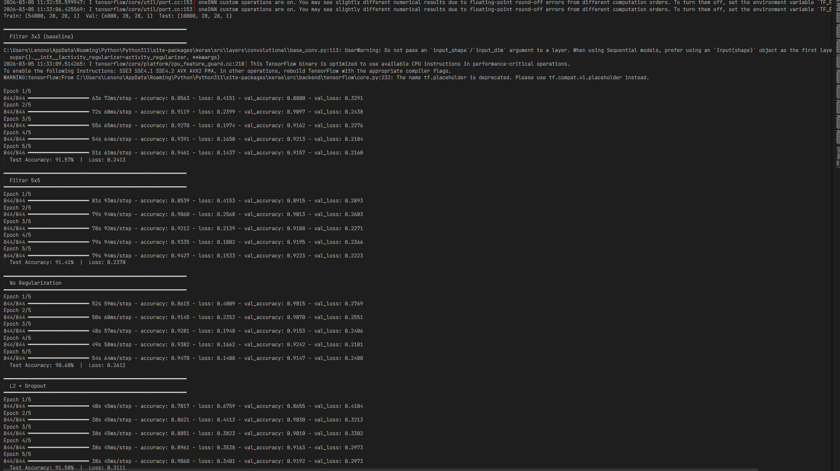
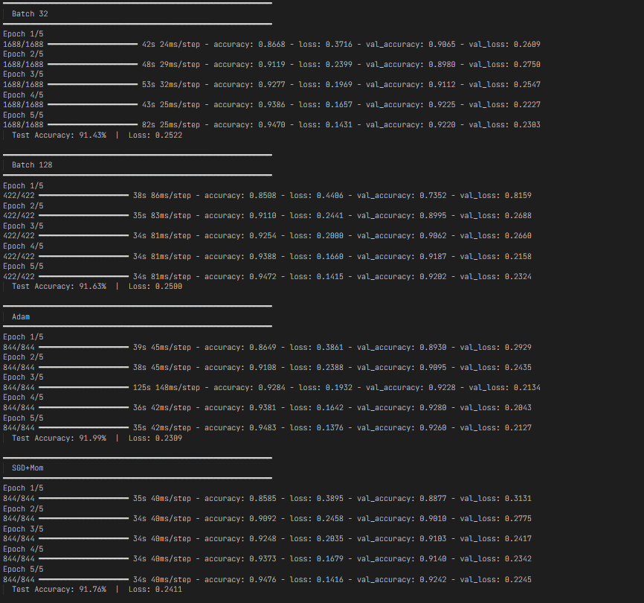
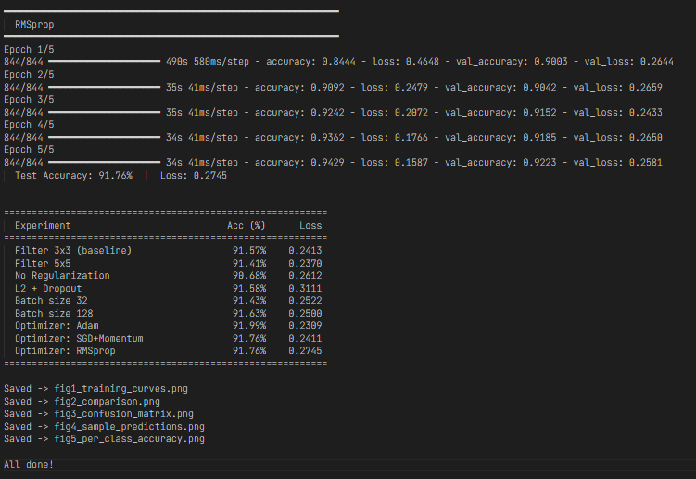

Description of Code
The program is implemented using TensorFlow 2.x with the Keras API to build and train a Convolutional Neural Network (CNN) for image classification on the Fashion-MNIST dataset. The code is organized into sections including dataset loading, preprocessing, model construction, training, evaluation, and visualization.
1. Dataset Loading
The Fashion-MNIST dataset is loaded using:
from tensorflow.keras.datasets import fashion_mnist
It contains 70,000 grayscale images (28×28 pixels) of clothing items. The dataset is divided into 60,000 training images and 10,000 test images. Each sample consists of an image and its corresponding class label.
2. Data Preprocessing
Before training the CNN, the following preprocessing steps are applied:
- Normalization: Pixel values are scaled from 0–255 to [0,1] to improve training stability.
- Reshaping: Images are reshaped from (28,28) to (28,28,1) to include the grayscale channel required by CNNs.
- Validation Split: The training set is divided into 54,000 training samples and 6,000 validation samples to monitor model performance during training.
3. CNN Model Architecture
The CNN is implemented using the Keras Sequential API. It consists of two convolutional blocks followed by a fully connected classifier.
- Block 1: Conv2D (32 filters), Batch Normalization, Conv2D, MaxPooling, optional Dropout
- Block 2: Conv2D (64 filters), Batch Normalization, Conv2D, MaxPooling, optional Dropout
After feature extraction, the feature maps are flattened and passed to a Dense layer with 256 neurons using ReLU activation. The final output layer contains 10 neurons with Softmax activation for classification of clothing categories.
4. Model Compilation
The model is compiled using:
model.compile(optimizer=optimizer,
loss='sparse_categorical_crossentropy',
metrics=['accuracy'])
The Sparse Categorical Cross-Entropy loss function is used for multi-class classification, and different optimizers such as Adam, SGD with Momentum, and RMSprop are tested.
5. Training Process
A helper function train_and_evaluate() trains the model using:
model.fit()
The model is trained for 5 epochs with different batch sizes (32 and 128) while using a validation set to monitor performance. Training and validation accuracy and loss are stored for analysis.
6. Experiments Performed
The program evaluates the effect of different hyperparameters:
- Filter Size: 3×3 vs 5×5 convolution kernels
- Regularization: No regularization vs L2 + Dropout
- Batch Size: 32 vs 128
- Optimizer: Adam, SGD with momentum, and RMSprop
7. Model Evaluation
After training, the model is evaluated on the test dataset using model.evaluate(), which computes test accuracy and test loss. A summary table displays the performance of each experiment.
8. Visualization
The program generates plots of training accuracy, validation accuracy, training loss, and validation loss. These graphs help analyze model learning behavior and detect overfitting or underfitting.

Hyperparameters
The CNN model is trained using several hyperparameters that control the learning process and model optimization. The model is trained for 5 epochs, meaning the training dataset is passed through the network five times. Two batch sizes (32 and 128) are tested to analyze their effect on training stability and computational efficiency.
Different optimization algorithms are evaluated, including Adam, SGD with momentum, and RMSprop. These optimizers update the network weights using gradient-based learning according to the rule:
$$W=W-η\frac{∂L}{∂W}$$
where $η$represents the learning rate.
The experiments also compare two convolution filter sizes (3×3 and 5×5) to study their impact on feature extraction. To reduce overfitting, optional L2 regularization and Dropout are applied during training. The hidden layers use the ReLU activation function, while the output layer uses Softmax activation for multi-class classification.
The model is trained using the Sparse Categorical Cross-Entropy loss function, which measures the difference between predicted class probabilities and true labels.

Network Architecture
The implemented model is a Convolutional Neural Network (CNN) used for multi-class image classification on the Fashion-MNIST dataset. The input to the network is a 28×28 grayscale image, represented as a tensor of shape (28, 28, 1). Convolutional layers are used to extract spatial features such as edges, textures, and patterns from the input images.
The network consists of two convolutional blocks followed by a fully connected classifier. Each block contains Conv2D layers, Batch Normalization, and MaxPooling to extract features and reduce spatial dimensions. The first block uses 32 filters, while the second block uses 64 filters, allowing the model to learn increasingly complex features. Optional Dropout and L2 regularization are used to reduce overfitting.
After feature extraction, the feature maps are flattened and passed through a Dense layer with 256 neurons using ReLU activation. The final output layer contains 10 neurons with Softmax activation, producing probabilities for the 10 Fashion-MNIST classes. The model parameters are optimized during training using gradient-based optimizers such as Adam, SGD with momentum, or RMSprop.

Output-Visualization
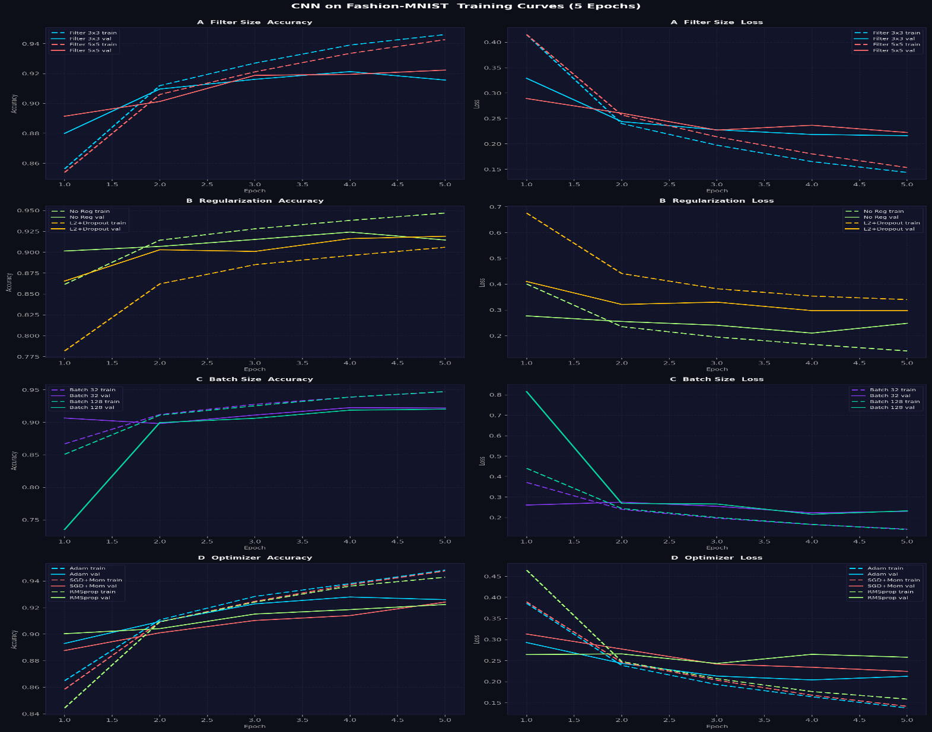

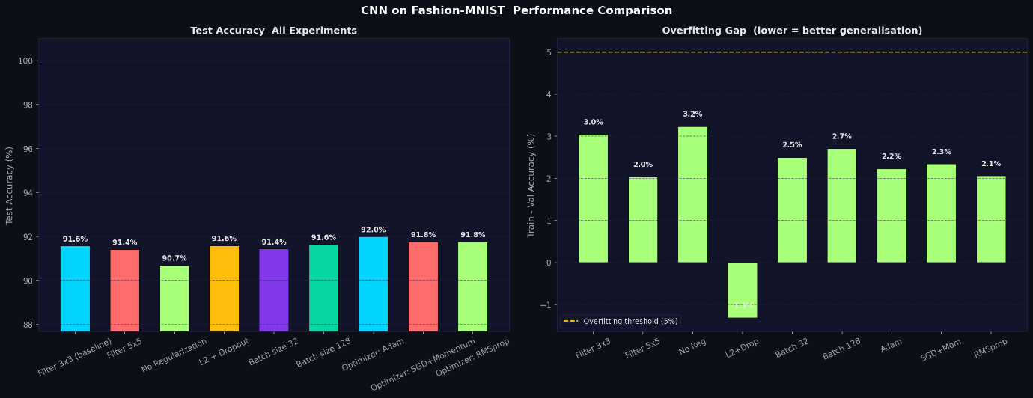
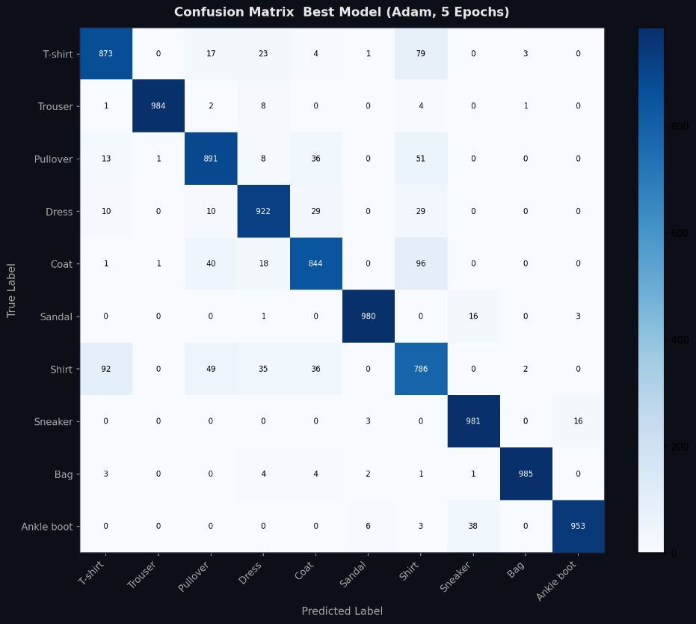
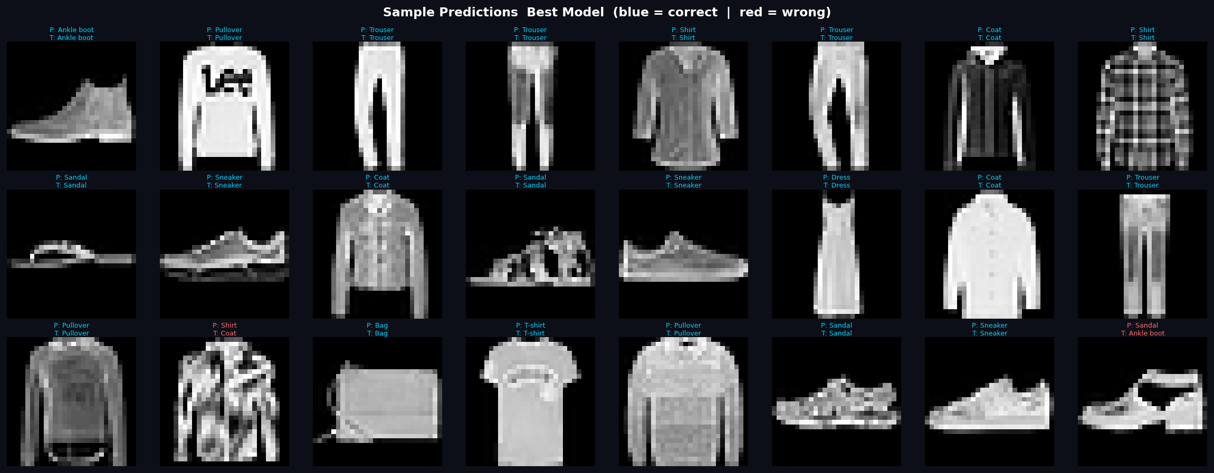
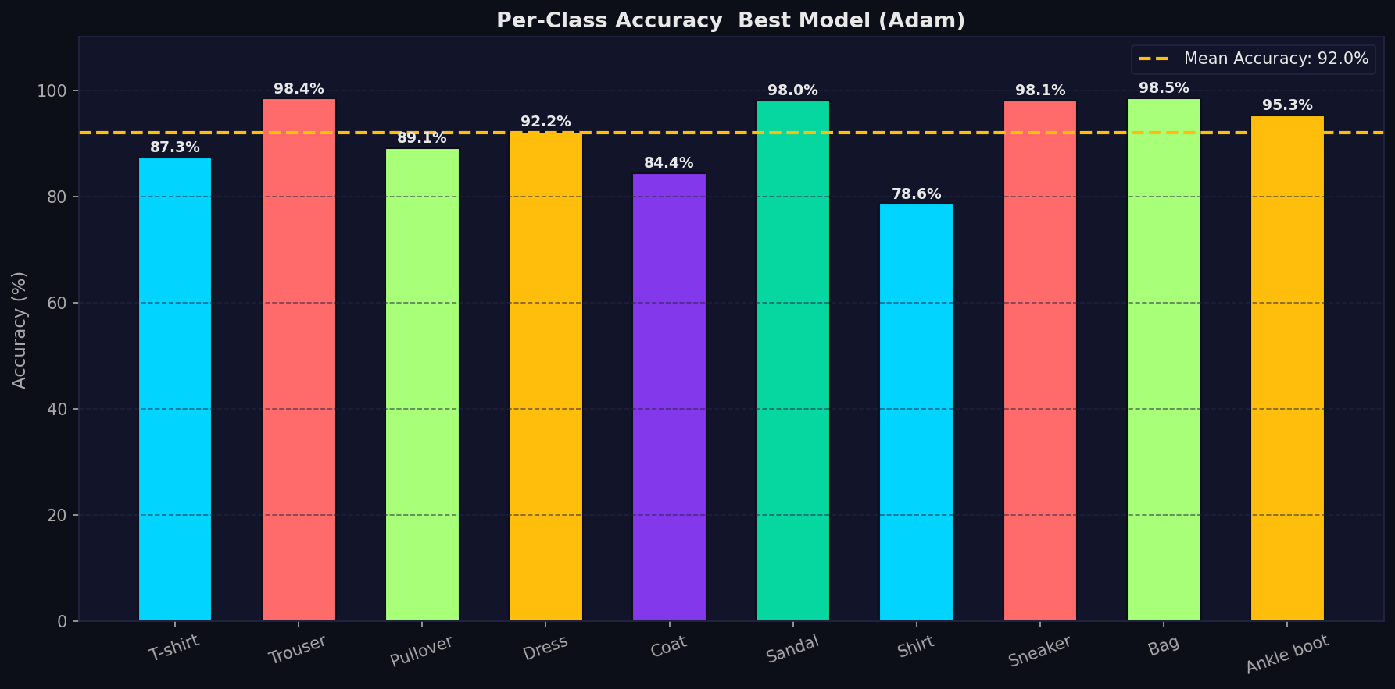

Effect of Hyperparameters on Model Performance
Several experiments were conducted to study the effect of filter size, regularization, batch size, and optimization algorithm on CNN performance for the Fashion-MNIST dataset. Model performance was evaluated using test accuracy and loss.
1. Effect of Filter Size
Two convolution filter sizes were tested: 3×3 and 5×5.
Filter Size | Test Accuracy
3×3 | 91.57%
5×5 | 91.41%
The 3×3 filter achieved slightly better performance while requiring fewer parameters. Smaller filters capture fine spatial details and are computationally more efficient.
2. Effect of Regularization
The model was tested with and without regularization.
Configuration | Test Accuracy
No Regularization | 90.68%
L2 + Dropout | 91.58%
Applying L2 regularization and dropout improved generalization, reducing overfitting and slightly increasing test accuracy.
3. Effect of Batch Size
Batch Size | Test Accuracy
32 | 91.43%
128 | 91.63%
Both batch sizes produced similar results. However, batch size 128 trained faster while maintaining good accuracy, making it slightly more efficient.
4. Effect of Optimization Algorithm
Optimizer | Test Accuracy
Adam | 91.99%
SGD + Momentum | 91.76%
RMSprop | 91.76%
The Adam optimizer achieved the highest accuracy (91.99%) due to its adaptive learning rate and momentum-based updates.
Best Model Configuration
The best performing configuration from the experiments was:
- Filter size: 3×3
- Regularization: L2 + Dropout
- Batch size: 128
- Optimizer: Adam
This configuration achieved approximately 92% test accuracy on the Fashion-MNIST dataset.

My Comments

Limitations
    - The model is trained for only 5 epochs, which may not allow the network to fully converge or reach its maximum classification accuracy.
    - The experiments are conducted on the Fashion-MNIST dataset, which is relatively simple and contains low-resolution grayscale images. Therefore, the model may not generalize well to more complex real-world image datasets.
    - The model uses a relatively simple CNN architecture with two convolutional blocks, which may limit its ability to capture more complex hierarchical features.

Scope of Improvement
    - Increase the number of training epochs and apply techniques such as early stopping to improve model performance while preventing overfitting.
    - Perform systematic hyperparameter tuning, including learning rate scheduling, optimizer parameters, filter counts, and number of convolution layers.
    - Utilize GPU acceleration to enable faster training and experimentation with deeper neural networks.

