Neural Network Experiment-1

Name -Hemant Kumar

Roll.No.-24UADS1021

Objective
WAP to visualize the Perceptron Learning Algorithm using numpy and matplotlib/seaborn in Python. Evaluate performance of a single perceptron for NAND and XOR truth tables as input dataset

Description of Model
The model used in this experiment is a Single Layer Perceptron, which is one of the simplest forms of artificial neural networks used for binary classification problems. The perceptron is a linear classifier that attempts to separate data points using a linear decision boundary defined by the equation:
$$w^{T}x=0$$
where $w$represents the weight vector and $x$represents the input feature vector including bias.
The perceptron receives two input features $x_{1}$and $x_{2}$along with a bias term. The bias helps shift the decision boundary and allows the model to learn more flexible linear separations. During training, the perceptron computes a weighted sum of inputs called the net input:
$$net=b+w_{1}x_{1}+w_{2}x_{2}$$
This net input is passed through a step activation function, which produces a binary output:
- Output = 1 if $net≥0$
- Output = 0 if $net<0$
The model is trained using the Perceptron Learning Algorithm (PLA). Whenever the predicted output differs from the actual target value, the weights are updated using the rule:
$$w=w+η(y_{actual}-y_{pred})x$$
where $η$is the learning rate.
In this experiment, the perceptron is applied to two logical datasets:
- NAND Dataset – A linearly separable dataset that can be learned successfully by a single perceptron.
- XOR Dataset – A non-linearly separable dataset used to demonstrate the limitation of linear models.
The visualization component of the model shows how the decision boundary evolves during training. For NAND, the boundary stabilizes after few epochs, indicating convergence. For XOR, the decision boundary continuously shifts, showing that a single perceptron cannot learn non-linear relationships.
The performance of the model is evaluated using training accuracy, test accuracy, confusion matrix, and training loss curve.

Code.py
import numpy as np
import pandas as pd
import matplotlib.pyplot as plt
import time
from sklearn.metrics import confusion_matrix, accuracy_score

class Perceptron:

def __init__(self, lr=1.0, epochs=6, sleep_time=1.0):
self.lr = lr
self.epochs = epochs
self.sleep_time = sleep_time

def step(self, z):
return 1 if z >= 0 else 0

#Decion Boundry Visualizer
def plot_boundary(self, ax, X, y, title):

ax.clear()
ax.set_title(title)

# plot points
for i in range(len(X)):
if y[i] == 1:
ax.scatter(X[i][0], X[i][1], marker="o", s=120, label="Class 1" if i==0 else "")
else:
ax.scatter(X[i][0], X[i][1], marker="x", s=120, label="Class 0" if i==0 else "")

# decision boundary w^T x = 0
# w0 + w1*x + w2*y = 0 -> y = -(b + w1*x)/w2
if self.w[2] != 0:
x_vals = np.array([-1,2])
y_vals = -(self.w[0] + self.w[1]*x_vals) / self.w[2]
ax.plot(x_vals, y_vals, 'k--', label="w^T x = 0")

ax.set_xlim(-0.5,1.5)
ax.set_ylim(-0.5,1.5)
ax.legend()

plt.draw()
plt.pause(0.01)

#Train Function

def fit(self, X, y, title="DATA"):

X_bias = np.c_[np.ones(X.shape[0]), X]
self.w = np.zeros(X_bias.shape[1])
losses = []

print("\n\n====== TRAINING ON", title, "======")

plt.ion()
fig, ax = plt.subplots()

for epoch in range(self.epochs):

print("\n====================================")
print(f"Epoch {epoch+1}")
print("====================================")

table_rows = []
error_count = 0

for i in range(len(X_bias)):

x = X_bias[i]
x1, x2 = X[i]
y_actual = y[i]

z = np.dot(self.w, x)
y_pred = self.step(z)

error = y_actual - y_pred

# update rule
self.w = self.w + self.lr * error * x

if error != 0:
error_count += 1

# Table Format
table_rows.append([
x1,
x2,
round(self.w[1],2),
round(self.w[2],2),
round(self.w[0],2),
y_actual,
y_pred
])

# animated decision boundry
self.plot_boundary(ax, X, y, f"{title} - Epoch {epoch+1}")
time.sleep(self.sleep_time)

losses.append(error_count)

df = pd.DataFrame(
table_rows,
columns=["x1","x2","w1","w2","b","y_actual","y_pred"]
)

print(df.to_string(index=False))

plt.ioff()
plt.show()

return losses

#Predict

def predict(self, X):
X_bias = np.c_[np.ones(X.shape[0]), X]
preds = []
for x in X_bias:
preds.append(self.step(np.dot(self.w,x)))
return np.array(preds)

#Datasets

X_nand = np.array([
[0,0],
[0,1],
[1,0],
[1,1]
])
y_nand = np.array([1,1,1,0])

X_xor = np.array([
[0,0],
[0,1],
[1,0],
[1,1]
])
y_xor = np.array([0,1,1,0])

#Loss Curve Function

def plot_loss(losses, title):
plt.figure()
plt.plot(losses, marker='o')
plt.title(f"Training Loss Curve - {title}")
plt.xlabel("Epoch")
plt.ylabel("Errors")
plt.show()

if __name__ == "__main__":

# ================= NAND =================
model1 = Perceptron(lr=1.0, epochs=6, sleep_time=1.0)
losses1 = model1.fit(X_nand, y_nand, title="NAND")

pred_train = model1.predict(X_nand)

print("\nConfusion Matrix (NAND):")
print(confusion_matrix(y_nand, pred_train))

print("Training Accuracy:", accuracy_score(y_nand, pred_train))

plot_loss(losses1, "NAND")

model2 = Perceptron(lr=1.0, epochs=6, sleep_time=1.0)
losses2 = model2.fit(X_xor, y_xor, title="XOR")

pred_train2 = model2.predict(X_xor)

print("\nConfusion Matrix (XOR):")
print(confusion_matrix(y_xor, pred_train2))

print("Training Accuracy:", accuracy_score(y_xor, pred_train2))

plot_loss(losses2, "XOR")

Output.txt

====== TRAINING ON NAND ======

====================================
Epoch 1
====================================
x1 x2 w1 w2 b y_actual y_pred
0 0 0.0 0.0 0.0 1 1
0 1 0.0 0.0 0.0 1 1
1 0 0.0 0.0 0.0 1 1
1 1 -1.0 -1.0 -1.0 0 1

====================================
Epoch 2
====================================
x1 x2 w1 w2 b y_actual y_pred
0 0 -1.0 -1.0 0.0 1 0
0 1 -1.0 0.0 1.0 1 0
1 0 -1.0 0.0 1.0 1 1
1 1 -2.0 -1.0 0.0 0 1

====================================
Epoch 3
====================================
x1 x2 w1 w2 b y_actual y_pred
0 0 -2.0 -1.0 0.0 1 1
0 1 -2.0 0.0 1.0 1 0
1 0 -1.0 0.0 2.0 1 0
1 1 -2.0 -1.0 1.0 0 1

====================================
Epoch 4
====================================
x1 x2 w1 w2 b y_actual y_pred
0 0 -2.0 -1.0 1.0 1 1
0 1 -2.0 -1.0 1.0 1 1
1 0 -1.0 -1.0 2.0 1 0
1 1 -2.0 -2.0 1.0 0 1

====================================
Epoch 5
====================================
x1 x2 w1 w2 b y_actual y_pred
0 0 -2.0 -2.0 1.0 1 1
0 1 -2.0 -1.0 2.0 1 0
1 0 -2.0 -1.0 2.0 1 1
1 1 -2.0 -1.0 2.0 0 0

====================================
Epoch 6
====================================
x1 x2 w1 w2 b y_actual y_pred
0 0 -2.0 -1.0 2.0 1 1
0 1 -2.0 -1.0 2.0 1 1
1 0 -2.0 -1.0 2.0 1 1
1 1 -2.0 -1.0 2.0 0 0

Confusion Matrix (NAND):
[[1 0]
[0 3]]
Training Accuracy: 1.0

====== TRAINING ON XOR ======

====================================
Epoch 1
====================================
x1 x2 w1 w2 b y_actual y_pred
0 0 0.0 0.0 -1.0 0 1
0 1 0.0 1.0 0.0 1 0
1 0 0.0 1.0 0.0 1 1
1 1 -1.0 0.0 -1.0 0 1

====================================
Epoch 2
====================================
x1 x2 w1 w2 b y_actual y_pred
0 0 -1.0 0.0 -1.0 0 0
0 1 -1.0 1.0 0.0 1 0
1 0 0.0 1.0 1.0 1 0
1 1 -1.0 0.0 0.0 0 1

====================================
Epoch 3
====================================
x1 x2 w1 w2 b y_actual y_pred
0 0 -1.0 0.0 -1.0 0 1
0 1 -1.0 1.0 0.0 1 0
1 0 0.0 1.0 1.0 1 0
1 1 -1.0 0.0 0.0 0 1

====================================
Epoch 4
====================================
x1 x2 w1 w2 b y_actual y_pred
0 0 -1.0 0.0 -1.0 0 1
0 1 -1.0 1.0 0.0 1 0
1 0 0.0 1.0 1.0 1 0
1 1 -1.0 0.0 0.0 0 1

====================================
Epoch 5
====================================
x1 x2 w1 w2 b y_actual y_pred
0 0 -1.0 0.0 -1.0 0 1
0 1 -1.0 1.0 0.0 1 0
1 0 0.0 1.0 1.0 1 0
1 1 -1.0 0.0 0.0 0 1

====================================
Epoch 6
====================================
x1 x2 w1 w2 b y_actual y_pred
0 0 -1.0 0.0 -1.0 0 1
0 1 -1.0 1.0 0.0 1 0
1 0 0.0 1.0 1.0 1 0
1 1 -1.0 0.0 0.0 0 1

Confusion Matrix (XOR):
[[1 1]
[1 1]]
Training Accuracy: 0.5

Description of Code
The implemented program is a Python-based simulation of the Perceptron Learning Algorithm using NumPy, Matplotlib, and scikit-learn. The entire implementation is organized into logical components that handle data processing, training, visualization, and evaluation.
1. Data Initialization
The NAND and XOR truth tables are defined as NumPy arrays. Each dataset contains two input features and one binary output label. A bias term is automatically added to the input matrix to allow the perceptron to learn a shifted decision boundary.
2. Perceptron Class Implementation
A custom Perceptron class is created to encapsulate the learning algorithm. The class includes:
- Initialization of learning rate and number of epochs.
- A step() activation function that converts continuous net input into binary output.
- A fit() method that performs training using iterative weight updates.
- A predict() method that generates predictions for new inputs.
During training, the algorithm iterates over each sample and updates weights only when a misclassification occurs. A structured table is printed at each epoch showing input values, updated weights, bias, actual output, and predicted output.
3. Decision Boundary Visualization
The program uses Matplotlib to display an animated decision boundary defined by $w^{T}x=0$. After each weight update, the graph refreshes to show how the boundary changes. The animation includes a sleep delay to make learning behaviour visually clear.
- Blue markers represent class 1.
- Red markers represent class 0.
- A dashed line represents the learned boundary.
4. Training Loss Calculation
The training loss is measured as the number of misclassified samples per epoch. These values are stored in a list and plotted as a loss curve after training completes. For NAND, the loss reduces to zero, indicating convergence. For XOR, the loss fluctuates because the dataset cannot be separated linearly.
5. Performance Evaluation
After training, the program calculates:
- Training accuracy using predicted labels.
- Confusion matrix using scikit-learn functions.
- Loss curve visualization to analyze learning behaviour.
The program also prints whether the model satisfies the minimum accuracy requirement.

Hyperparameters
Learning Rate: 1.0
Epochs: 6
Activation Function: Step Function
Bias: Enabled
Weight Initialization: Zeros
Sleep Time (Animation): 1 second

Network Architecture
Input Layer: 2 neurons (x1, x2)
Bias Unit: 1
Output Layer: 1 neuron
Model Type: Single Layer Perceptron
Mathematical Decision Boundary: $w^{T}x=0$
Expanded Form: $b+w_{1}x_{1}+w_{2}x_{2}=0$
The model learns a linear decision boundary separating classes.

NAND OUPUT CURVES
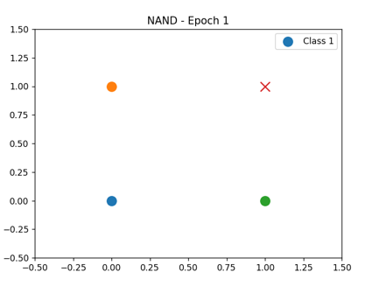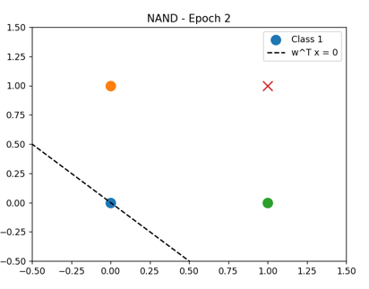
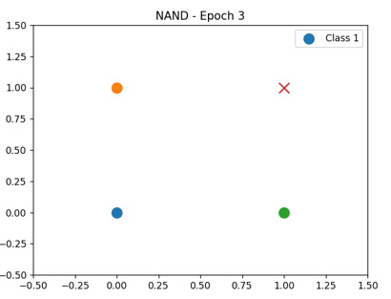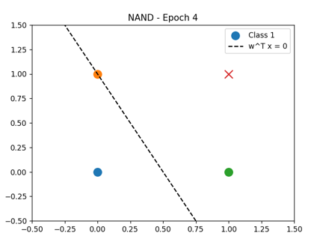
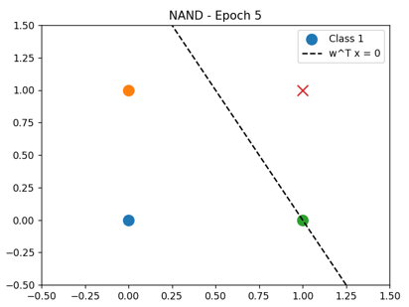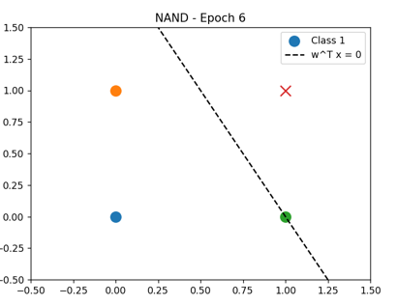

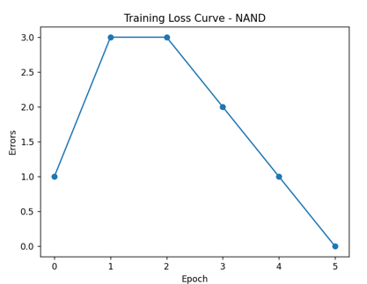

XOR OUTPUT CURVES
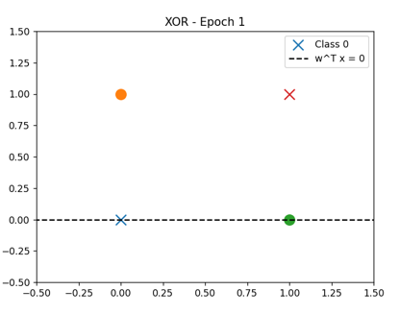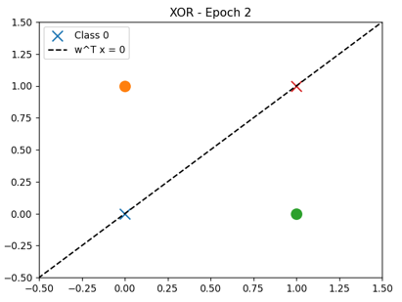
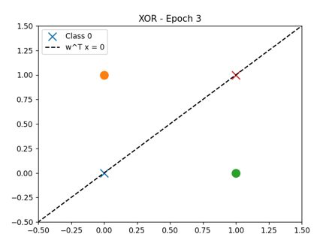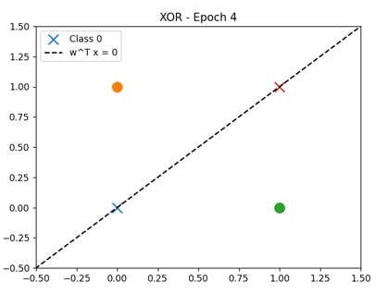
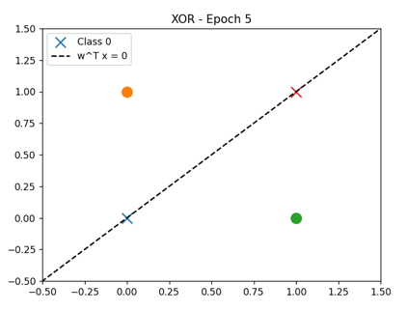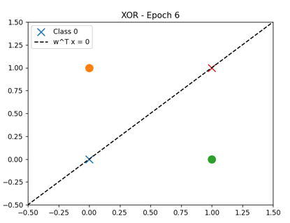

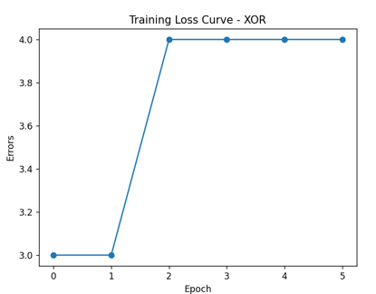

My Comments

Limitations
- A single-layer perceptron can only learn linearly separable problems, so it fails to correctly classify the XOR dataset.
- The model uses a step activation function, which limits learning capability for complex patterns.
- A fixed learning rate may lead to slow convergence or unstable weight updates.
- The experiment is performed on a very small dataset, which limits generalization.

Scope of Improvement
- Using a multi-layer perceptron can help solve non-linearly separable problems like XOR.
- Replacing the step function with non-linear activation functions such as sigmoid or ReLU can improve performance.
- Adaptive learning rates or advanced optimization methods can make training more efficient.
- Training on larger datasets and using validation techniques can improve robustness.

