Neural Network Experiment-4

Name -Hemant Kumar

Roll.No.-24UADS1021

Objective
WAP to evaluate the performance of implemented three-layer neural network with variations in activation functions, size of hidden layer, learning rate, batch size and number of epochs.

Description of Model
The implemented model is a fully connected three-layer Artificial Neural Network (ANN) designed for multi-class classification of handwritten digits from the MNIST dataset.
The network consists of:
- Input Layer: 784 neurons (flattened 28×28 grayscale image pixels normalized to [0,1])
- Hidden Layer 1: Variable size (e.g., 64, 256, 512)
- Hidden Layer 2: Half the size of the first hidden layer
- Output Layer: 10 neurons representing digit classes (0–9)
The hidden layers use non-linear activation functions (ReLU, Sigmoid, or Tanh) depending on the experiment. The output layer produces logits, and class probabilities are computed internally using the Softmax Cross-Entropy loss function.
Weights are initialized using manual He initialization:
$$std=\sqrt{\frac{2}{n_{in}}}$$
which helps maintain stable gradient flow during training.
Backpropagation is implemented using TensorFlow’s tf.GradientTape, and parameters are updated using mini-batch gradient descent:
$$W=W-η\frac{∂L}{∂W}$$
This experiment evaluates the effect of activation function, hidden layer size, learning rate, batch size, and number of epochs on model performance.

Code.py
import tensorflow as tf
import tensorflow_datasets as tfds
import numpy as np
import matplotlib.pyplot as plt
from sklearn.metrics import confusion_matrix
import seaborn as sns

# Load & Preprocess
(ds_train_raw, ds_test_raw), _ = tfds.load(
'mnist', split=['train', 'test'], as_supervised=True, with_info=True
)

def preprocess(image, label):
image = tf.cast(image, tf.float32) / 255.0
image = tf.reshape(image, [-1])
label = tf.one_hot(label, depth=10)
return image, label

# He Initialization
def he_init(shape):
return tf.Variable(tf.random.normal(shape, stddev=tf.sqrt(2.0 / shape[0])))

# Build Network
def build_network(hidden_size):
W1 = he_init([784, hidden_size])
b1 = tf.Variable(tf.zeros([hidden_size]))
W2 = he_init([hidden_size, hidden_size // 2])
b2 = tf.Variable(tf.zeros([hidden_size // 2]))
W3 = he_init([hidden_size // 2, 10])
b3 = tf.Variable(tf.zeros([10]))
return [W1, b1, W2, b2, W3, b3]

# Forward Pass
def forward_pass(X, params, activation='relu'):
W1, b1, W2, b2, W3, b3 = params
act_fn = {'relu': tf.nn.relu, 'sigmoid': tf.nn.sigmoid, 'tanh': tf.nn.tanh}[activation]
A1 = act_fn(tf.matmul(X, W1) + b1)
A2 = act_fn(tf.matmul(A1, W2) + b2)
return tf.matmul(A2, W3) + b3

# Training Function
def train_and_evaluate(activation='relu', hidden_size=256, lr=0.01,
batch_size=128, epochs=10):
params = build_network(hidden_size)

ds_train = ds_train_raw.map(preprocess).shuffle(60000).batch(batch_size)
ds_test = ds_test_raw.map(preprocess).batch(batch_size)

steps = 60000 // batch_size
train_acc_history, train_loss_history = [], []

for epoch in range(epochs):
correct = total = 0
epoch_loss = 0.0

for X_batch, y_batch in ds_train.take(steps):
with tf.GradientTape() as tape:
logits = forward_pass(X_batch, params, activation)
loss = tf.reduce_mean(
tf.nn.softmax_cross_entropy_with_logits(labels=y_batch, logits=logits))
grads = tape.gradient(loss, params)
for p, g in zip(params, grads):
p.assign_sub(lr * g)

epoch_loss += loss.numpy()
preds = tf.argmax(logits, axis=1)
labels = tf.argmax(y_batch, axis=1)
correct += tf.reduce_sum(tf.cast(preds == labels, tf.float32)).numpy()
total += X_batch.shape[0]

avg_loss = epoch_loss / steps
train_acc_history.append(correct / total)
train_loss_history.append(avg_loss)
print(f" Epoch {epoch+1}/{epochs} | Loss: {avg_loss:.4f} | Acc: {correct/total:.4f}")

# Test accuracy + collect predictions
correct = total = 0
all_preds, all_labels = [], []

for X_batch, y_batch in ds_test:
logits = forward_pass(X_batch, params, activation)
preds = tf.argmax(logits, axis=1)
labels = tf.argmax(y_batch, axis=1)
all_preds.extend(preds.numpy())
all_labels.extend(labels.numpy())
correct += tf.reduce_sum(tf.cast(preds == labels, tf.float32)).numpy()
total += X_batch.shape[0]

test_acc = correct / total
return test_acc, train_acc_history, train_loss_history, all_preds, all_labels

# Helper: plot accuracy curves + confusion matrices
def plot_experiment(title, param_name, param_values, results):
n = len(results)

# Accuracy curves
plt.figure(figsize=(4*n, 4))
for i, (label, test_acc, acc_hist, _, _, _) in enumerate(results):
plt.subplot(1, n, i+1)
plt.plot(acc_hist)
plt.title(f"{param_name}={label}\nTest Acc: {test_acc:.4f}")
plt.xlabel("Epoch")
plt.ylabel("Accuracy")
plt.ylim(0.7, 1.0)
plt.tight_layout()
plt.suptitle(f"Effect of {title} — Accuracy Curves", y=1.02)
plt.show()

# Confusion matrices
plt.figure(figsize=(5*n, 4))
for i, (label, test_acc, _, _, all_preds, all_labels) in enumerate(results):
cm = confusion_matrix(all_labels, all_preds)
plt.subplot(1, n, i+1)
sns.heatmap(cm, annot=True, fmt='d', cmap='Blues',
xticklabels=range(10), yticklabels=range(10),
cbar=False, annot_kws={"size": 6})
plt.title(f"{param_name}={label}\nTest Acc: {test_acc:.4f}")
plt.xlabel("Predicted")
plt.ylabel("Actual")
plt.tight_layout()
plt.suptitle(f"Effect of {title} — Confusion Matrices", y=1.02)
plt.show()

# EXPERIMENT A: Vary Activation Function
print("\n===== Varying Activation Function =====")
activations = ['relu', 'sigmoid', 'tanh']
act_results = {}
act_data = []

for act in activations:
print(f"\nActivation: {act}")
test_acc, acc_hist, loss_hist, preds, labels = train_and_evaluate(activation=act, epochs=10)
act_results[act] = test_acc
act_data.append((act, test_acc, acc_hist, loss_hist, preds, labels))
print(f" --> Test Accuracy: {test_acc:.4f}")

plot_experiment("Activation Function", "Activation", activations, act_data)

# EXPERIMENT B: Vary Hidden Layer Size
print("\n===== Varying Hidden Layer Size =====")
hidden_sizes = [64, 256, 512]
size_results = {}
size_data = []

for hs in hidden_sizes:
print(f"\nHidden Size: {hs}")
test_acc, acc_hist, loss_hist, preds, labels = train_and_evaluate(hidden_size=hs, epochs=10)
size_results[hs] = test_acc
size_data.append((str(hs), test_acc, acc_hist, loss_hist, preds, labels))
print(f" --> Test Accuracy: {test_acc:.4f}")

plot_experiment("Hidden Layer Size", "Hidden", hidden_sizes, size_data)

# EXPERIMENT C: Vary Learning Rate
print("\n===== Varying Learning Rate =====")
learning_rates = [0.001, 0.01, 0.1]
lr_results = {}
lr_data = []

for lr in learning_rates:
print(f"\nLearning Rate: {lr}")
test_acc, acc_hist, loss_hist, preds, labels = train_and_evaluate(lr=lr, epochs=10)
lr_results[lr] = test_acc
lr_data.append((str(lr), test_acc, acc_hist, loss_hist, preds, labels))
print(f" --> Test Accuracy: {test_acc:.4f}")

# Loss curves for LR
n = len(lr_data)
plt.figure(figsize=(4*n, 4))
for i, (label, test_acc, _, loss_hist, _, _) in enumerate(lr_data):
plt.subplot(1, n, i+1)
plt.plot(loss_hist)
plt.title(f"LR={label}\nTest Acc: {test_acc:.4f}")
plt.xlabel("Epoch")
plt.ylabel("Loss")
plt.tight_layout()
plt.suptitle("Effect of Learning Rate — Loss Curves", y=1.02)
plt.show()

# Confusion matrices for LR
plt.figure(figsize=(5*n, 4))
for i, (label, test_acc, _, _, all_preds, all_labels) in enumerate(lr_data):
cm = confusion_matrix(all_labels, all_preds)
plt.subplot(1, n, i+1)
sns.heatmap(cm, annot=True, fmt='d', cmap='Blues',
xticklabels=range(10), yticklabels=range(10),
cbar=False, annot_kws={"size": 6})
plt.title(f"LR={label}\nTest Acc: {test_acc:.4f}")
plt.xlabel("Predicted")
plt.ylabel("Actual")
plt.tight_layout()
plt.suptitle("Effect of Learning Rate — Confusion Matrices", y=1.02)
plt.show()

# EXPERIMENT D: Vary Batch Size
print("\n===== Varying Batch Size =====")
batch_sizes = [32, 128, 256]
batch_results = {}
batch_data = []

for bs in batch_sizes:
print(f"\nBatch Size: {bs}")
test_acc, acc_hist, loss_hist, preds, labels = train_and_evaluate(batch_size=bs, epochs=10)
batch_results[bs] = test_acc
batch_data.append((str(bs), test_acc, acc_hist, loss_hist, preds, labels))
print(f" --> Test Accuracy: {test_acc:.4f}")

plot_experiment("Batch Size", "Batch", batch_sizes, batch_data)

# EXPERIMENT E: Vary Number of Epochs
print("\n===== Varying Number of Epochs =====")
epoch_counts = [5, 10, 20]
epoch_results = {}
epoch_data = []

for ep in epoch_counts:
print(f"\nEpochs: {ep}")
test_acc, acc_hist, loss_hist, preds, labels = train_and_evaluate(epochs=ep)
epoch_results[ep] = test_acc
epoch_data.append((str(ep), test_acc, acc_hist, loss_hist, preds, labels))
print(f" --> Test Accuracy: {test_acc:.4f}")

plot_experiment("Number of Epochs", "Epochs", epoch_counts, epoch_data)

# BEST MODEL: Auto-select from results, then plot confusion matrix
print("\n===== Finding Best Configuration =====")

best_activation = max(act_results, key=act_results.get)
best_hidden = max(size_results, key=size_results.get)
best_lr = max(lr_results, key=lr_results.get)
best_batch = max(batch_results, key=batch_results.get)
best_epochs = max(epoch_results, key=epoch_results.get)

print(f" Best Activation : {best_activation} → {act_results[best_activation]:.4f}")
print(f" Best Hidden Size : {best_hidden} → {size_results[best_hidden]:.4f}")
print(f" Best LR : {best_lr} → {lr_results[best_lr]:.4f}")
print(f" Best Batch Size : {best_batch} → {batch_results[best_batch]:.4f}")
print(f" Best Epochs : {best_epochs} → {epoch_results[best_epochs]:.4f}")

print(f"\n===== Training Best Model =====")
print(f"Config: activation={best_activation} | hidden={best_hidden} | "
f"lr={best_lr} | batch={best_batch} | epochs={best_epochs}")

best_acc, _, _, all_preds, all_labels = train_and_evaluate(
activation=best_activation,
hidden_size=best_hidden,
lr=best_lr,
batch_size=best_batch,
epochs=best_epochs
)
print(f"\nBest Model Test Accuracy: {best_acc:.4f}")

cm = confusion_matrix(all_labels, all_preds)
plt.figure(figsize=(10, 8))
sns.heatmap(cm, annot=True, fmt='d', cmap='Blues')
plt.title(f"Confusion Matrix - Best Model\n"
f"activation={best_activation} | hidden={best_hidden} | "
f"lr={best_lr} | batch={best_batch} | epochs={best_epochs}\n"
f"Test Accuracy: {best_acc:.4f}")
plt.xlabel("Predicted")
plt.ylabel("Actual")
plt.tight_layout()
plt.show()

# SUMMARY TABLE
print("\n" + "="*45)
print(" SUMMARY OF RESULTS")
print("="*45)

print("\n[A] Activation Functions:")
for k, v in act_results.items():
marker = " ◄ best" if k == best_activation else ""
print(f" {k:8s} : {v:.4f}{marker}")

print("\n[B] Hidden Layer Sizes:")
for k, v in size_results.items():
marker = " ◄ best" if k == best_hidden else ""
print(f" {k:5d} : {v:.4f}{marker}")

print("\n[C] Learning Rates:")
for k, v in lr_results.items():
marker = " ◄ best" if k == best_lr else ""
print(f" {k:.4f} : {v:.4f}{marker}")
print(" * LR=0.1 may show unstable training due to large gradient updates")

print("\n[D] Batch Sizes:")
for k, v in batch_results.items():
marker = " ◄ best" if k == best_batch else ""
print(f" {k:5d} : {v:.4f}{marker}")

print("\n[E] Epoch Counts:")
for k, v in epoch_results.items():
marker = " ◄ best" if k == best_epochs else ""
print(f" {k:4d} : {v:.4f}{marker}")

print(f"\n[Best Model] activation={best_activation} | hidden={best_hidden} | "
f"lr={best_lr} | batch={best_batch} | epochs={best_epochs}")
print(f" Test Accuracy: {best_acc:.4f}")
print("="*45)

Description of Code
The program is implemented using TensorFlow 2.x low-level API only, without using Keras.
The code is structured into the following logical components:
- Dataset Loading & Preprocessing
The MNIST dataset is loaded using tensorflow_datasets. Images are normalized, flattened into 784-dimensional vectors, and labels are one-hot encoded. Mini-batching and shuffling are handled using the tf.data pipeline.
- Network Construction
A modular build_network() function initializes weights and biases using manual He initialization. The network architecture is dynamically adjustable based on the hidden layer size parameter.
- Forward Propagation
The forward_pass() function performs matrix multiplication (tf.matmul), bias addition, and applies the selected activation function to hidden layers.
- Loss Function
The loss is computed using tf.nn.softmax_cross_entropy_with_logits, and batch loss is averaged using tf.reduce_mean().
- Training Loop (Backpropagation)
For each epoch:
  - Forward pass is executed.
  - Loss is computed.
  - Gradients are calculated using tf.GradientTape.
  - Parameters are updated manually using gradient descent.
  - Training accuracy and loss are recorded.
- Experimental Evaluation
Separate experiments are conducted by varying:
  - Activation function
  - Hidden layer size
  - Learning rate
  - Batch size
  - Number of epochs
Accuracy curves and confusion matrices are generated for each configuration.
- Best Model Selection
The best-performing configuration is automatically selected based on test accuracy, retrained, and evaluated using a final confusion matrix. A summary table highlights the best values for each hyperparameter.

Output.txt
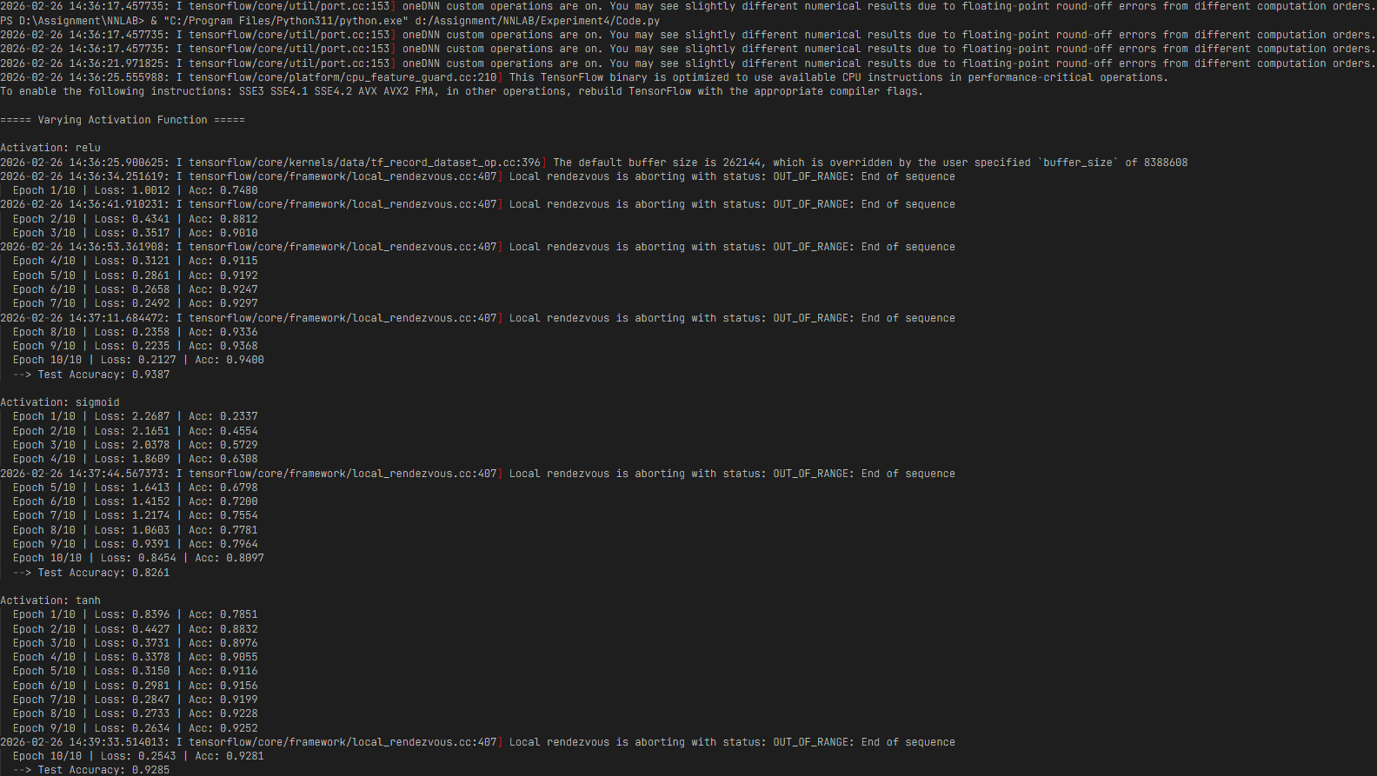
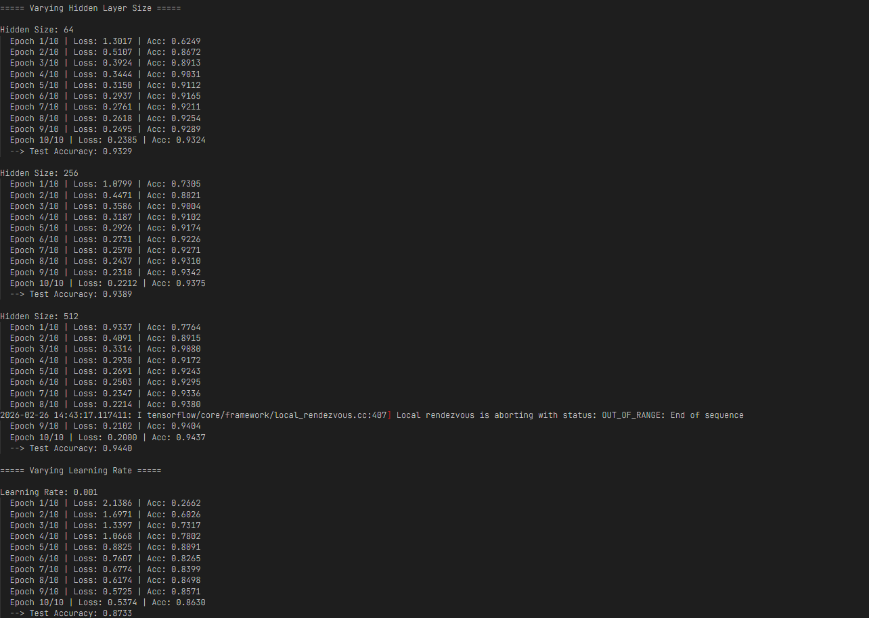
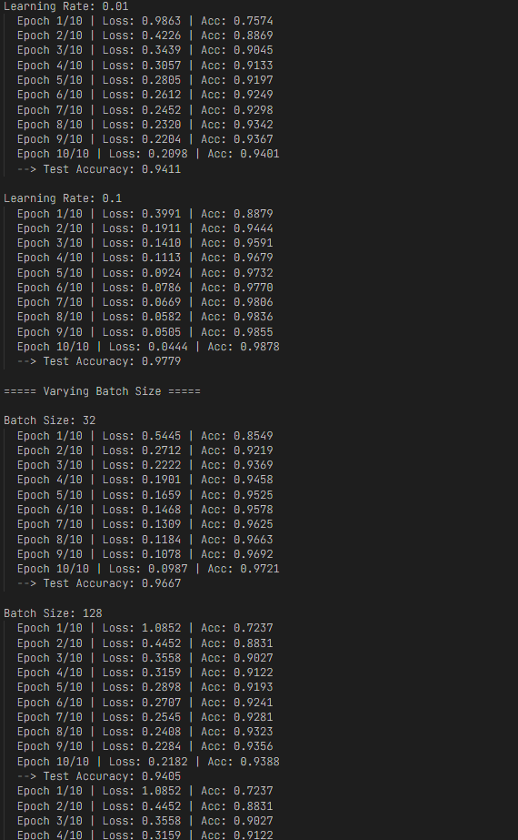
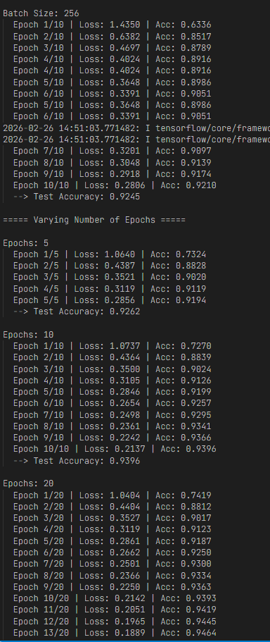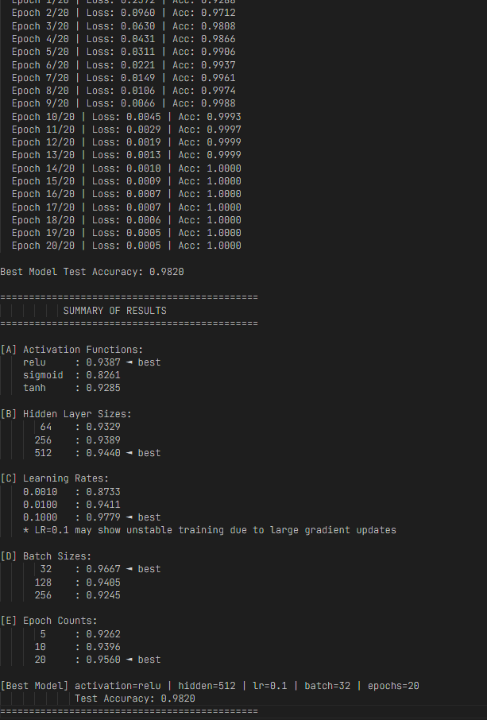

Output-Visualization
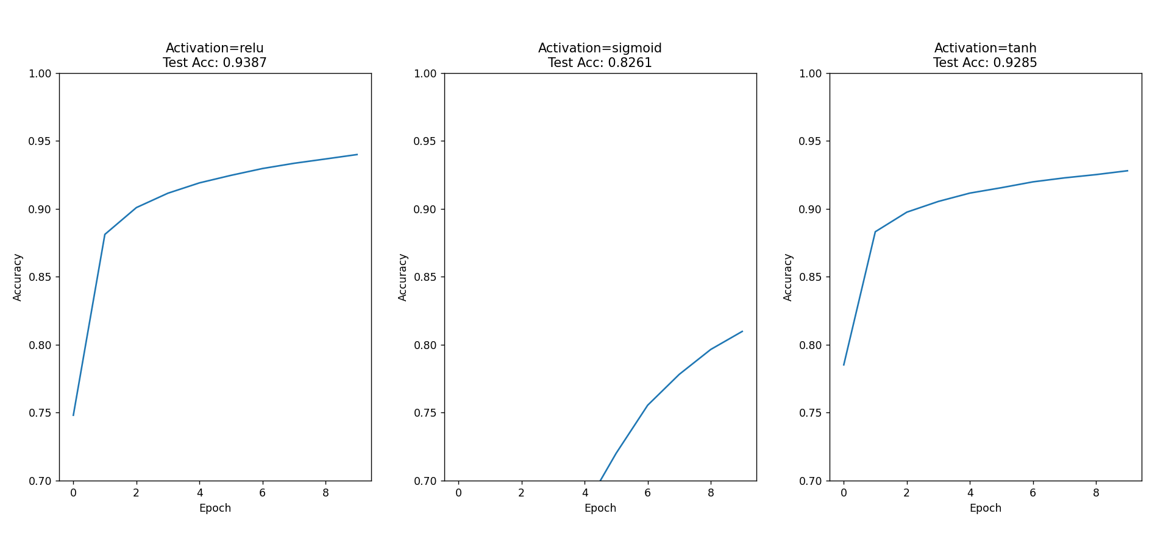
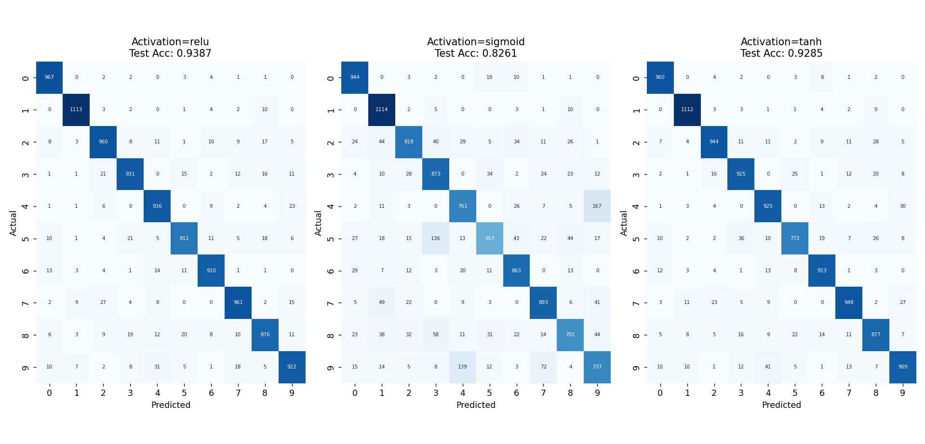
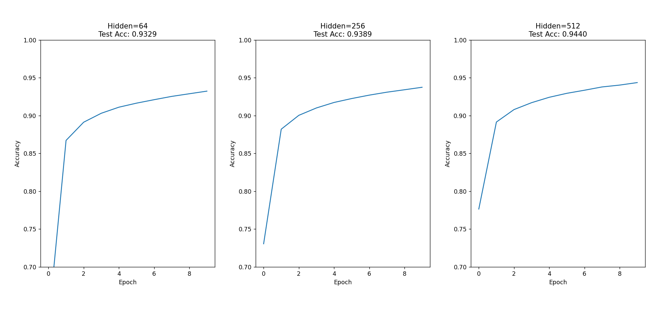
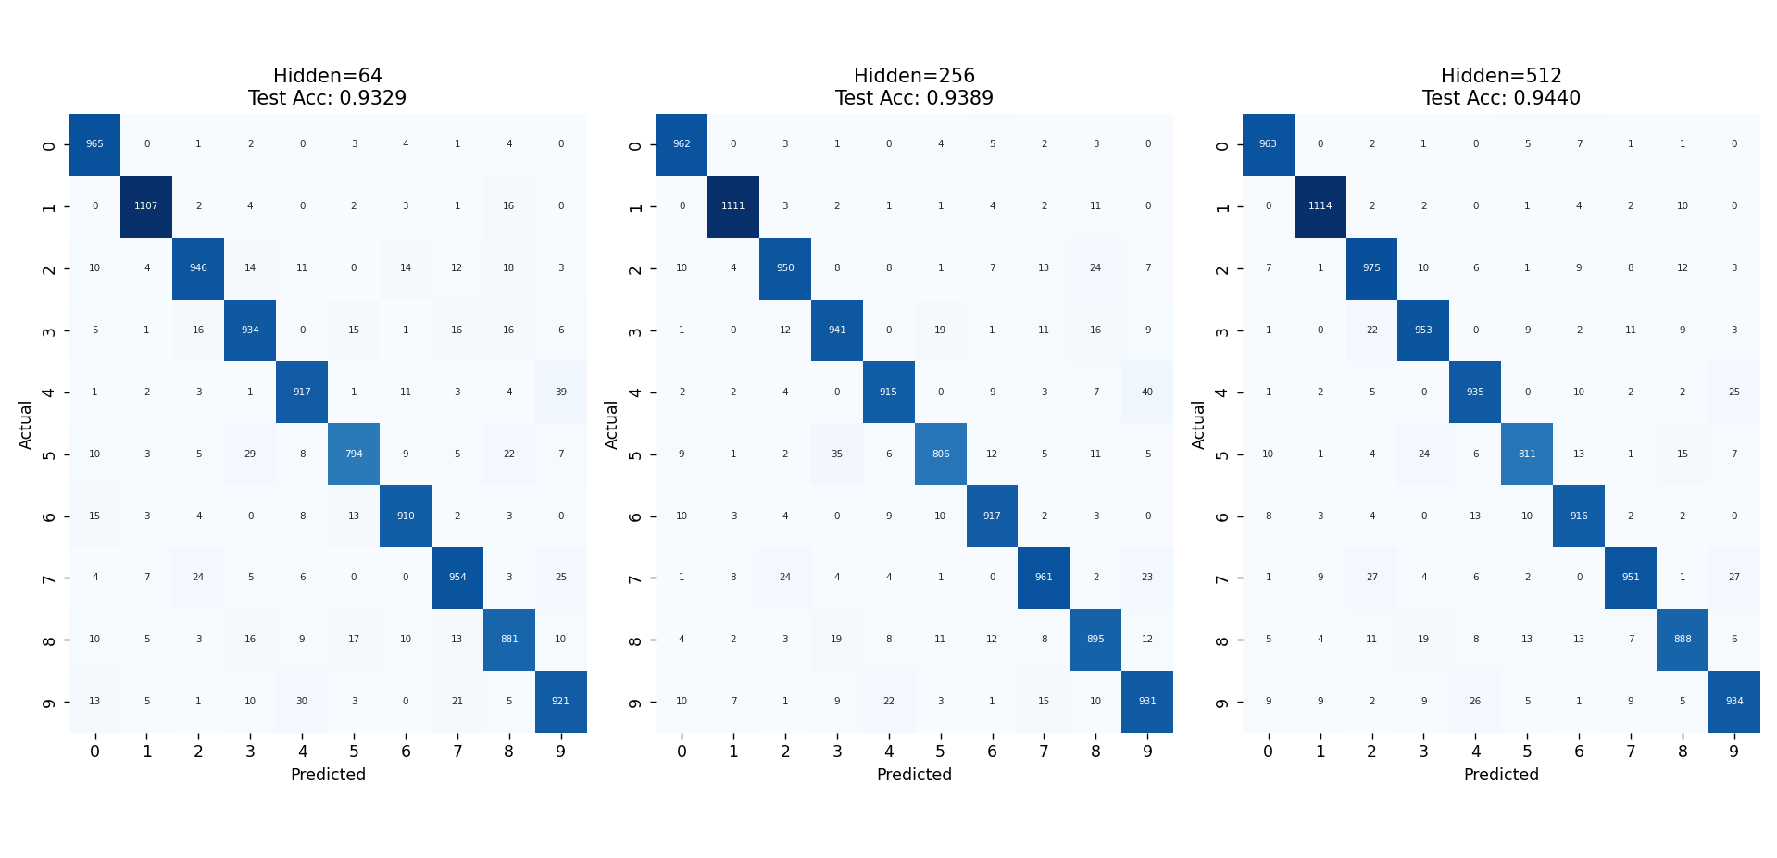
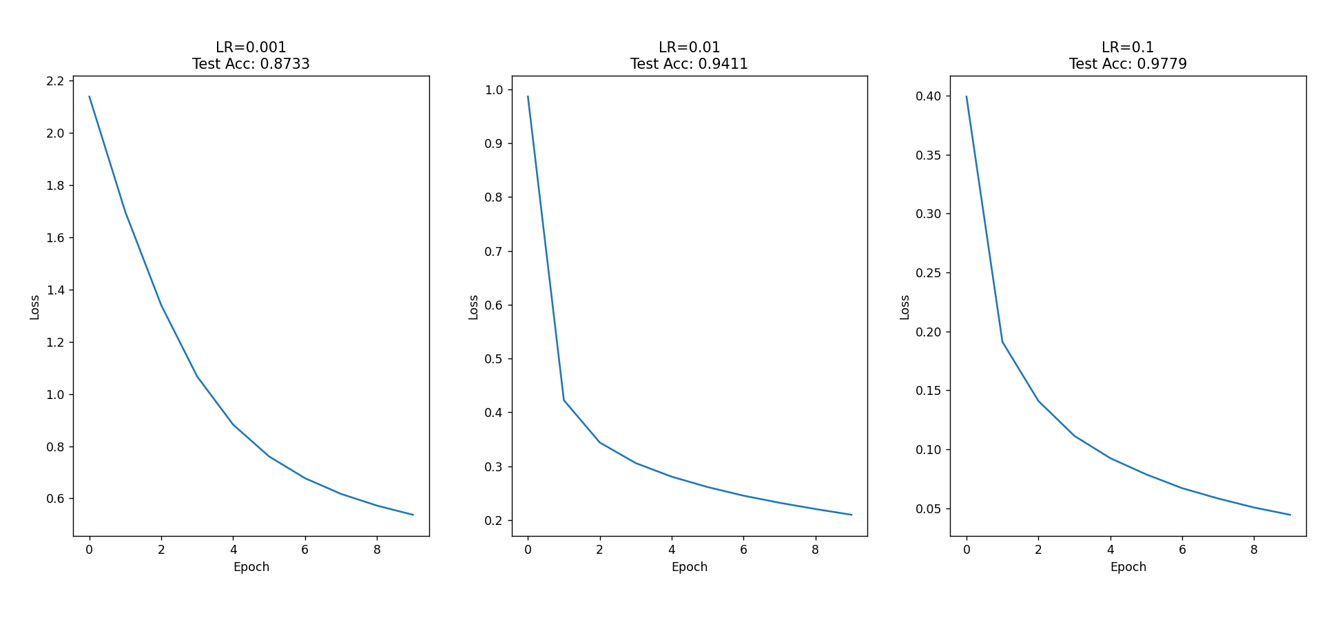
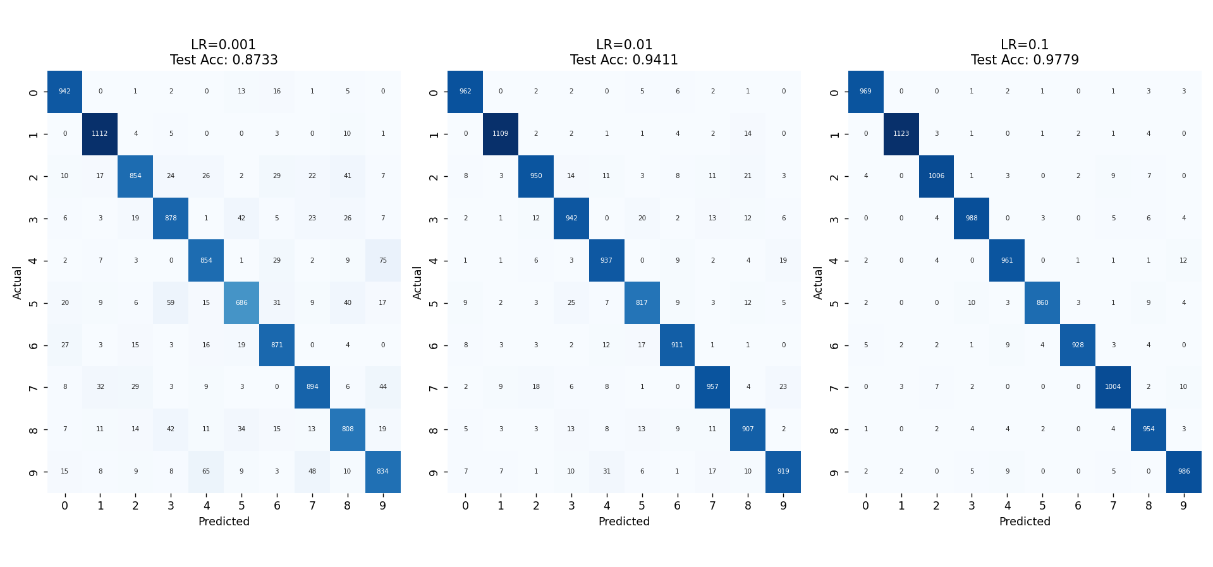
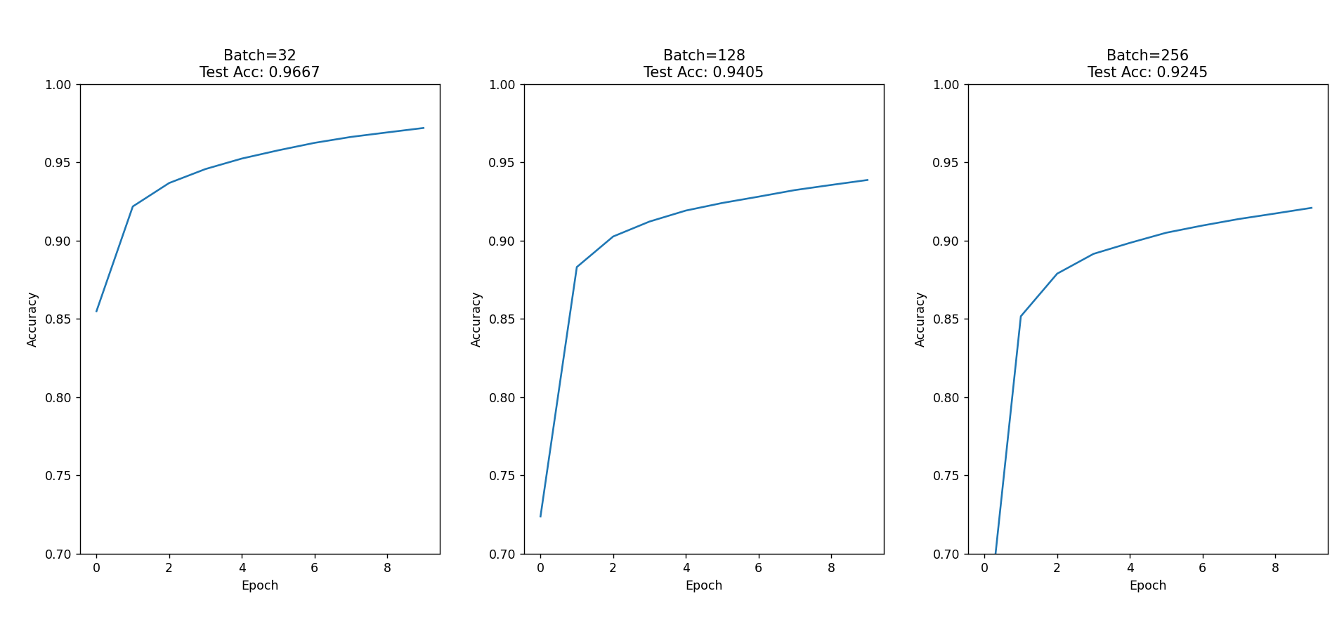
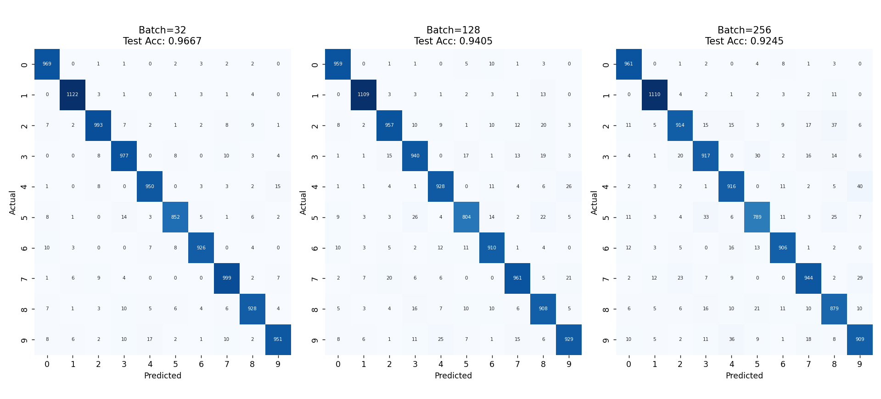
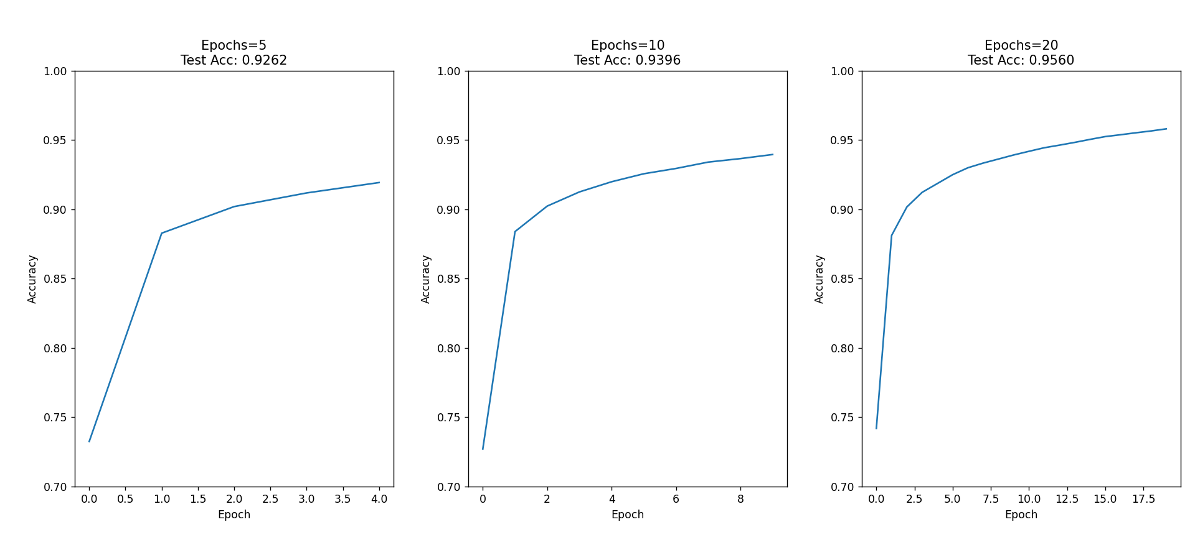
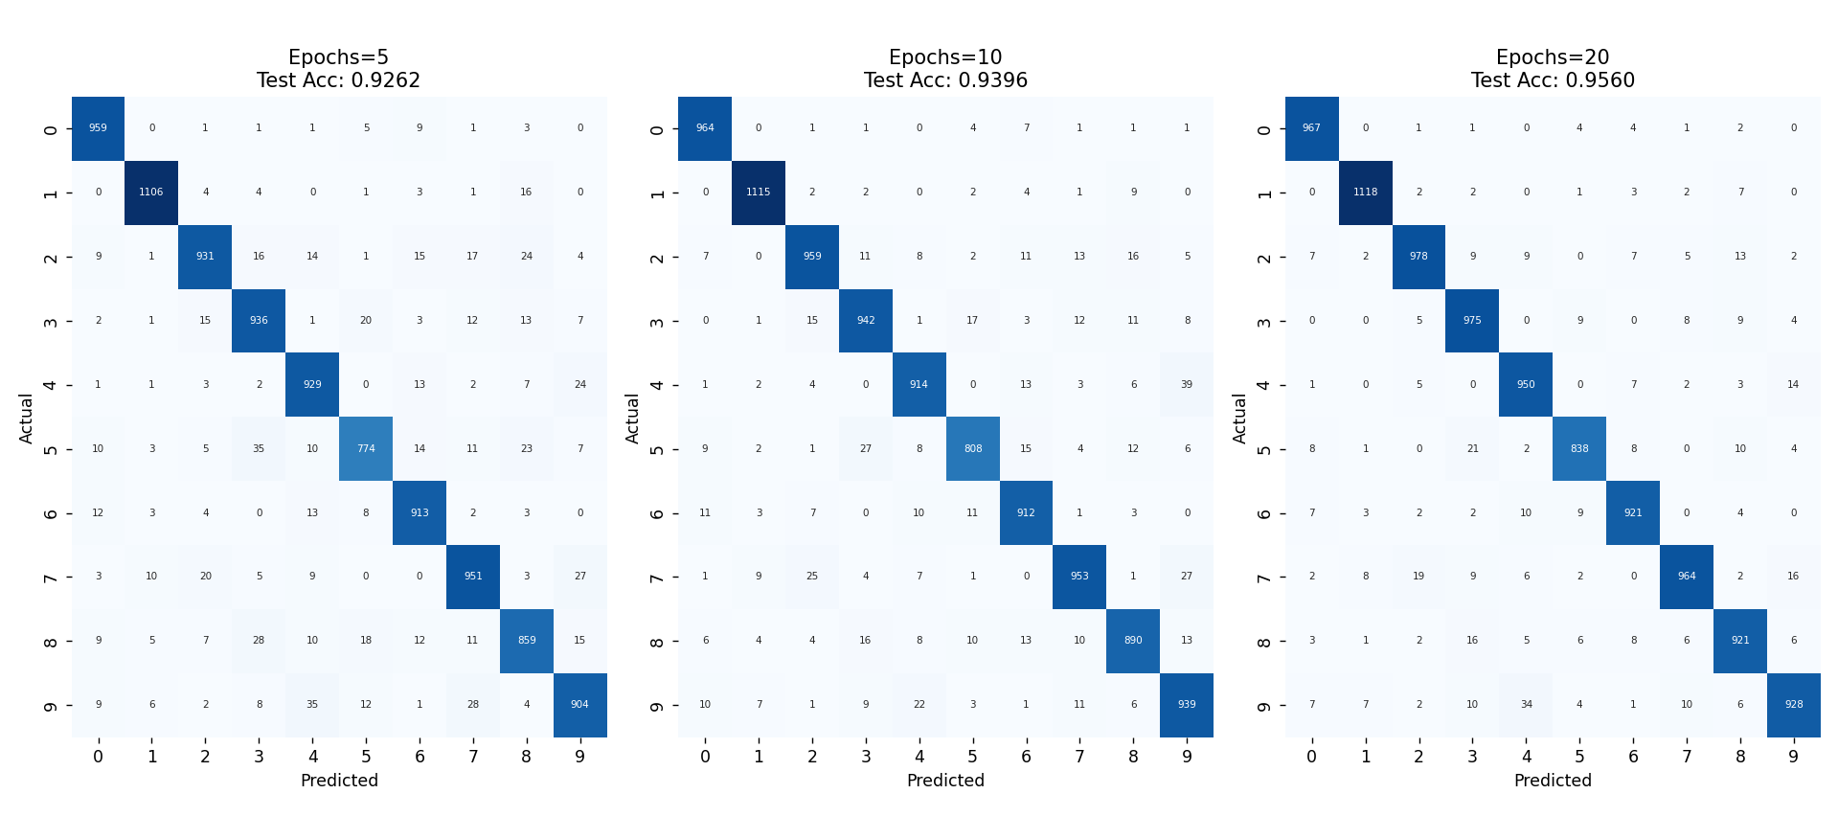
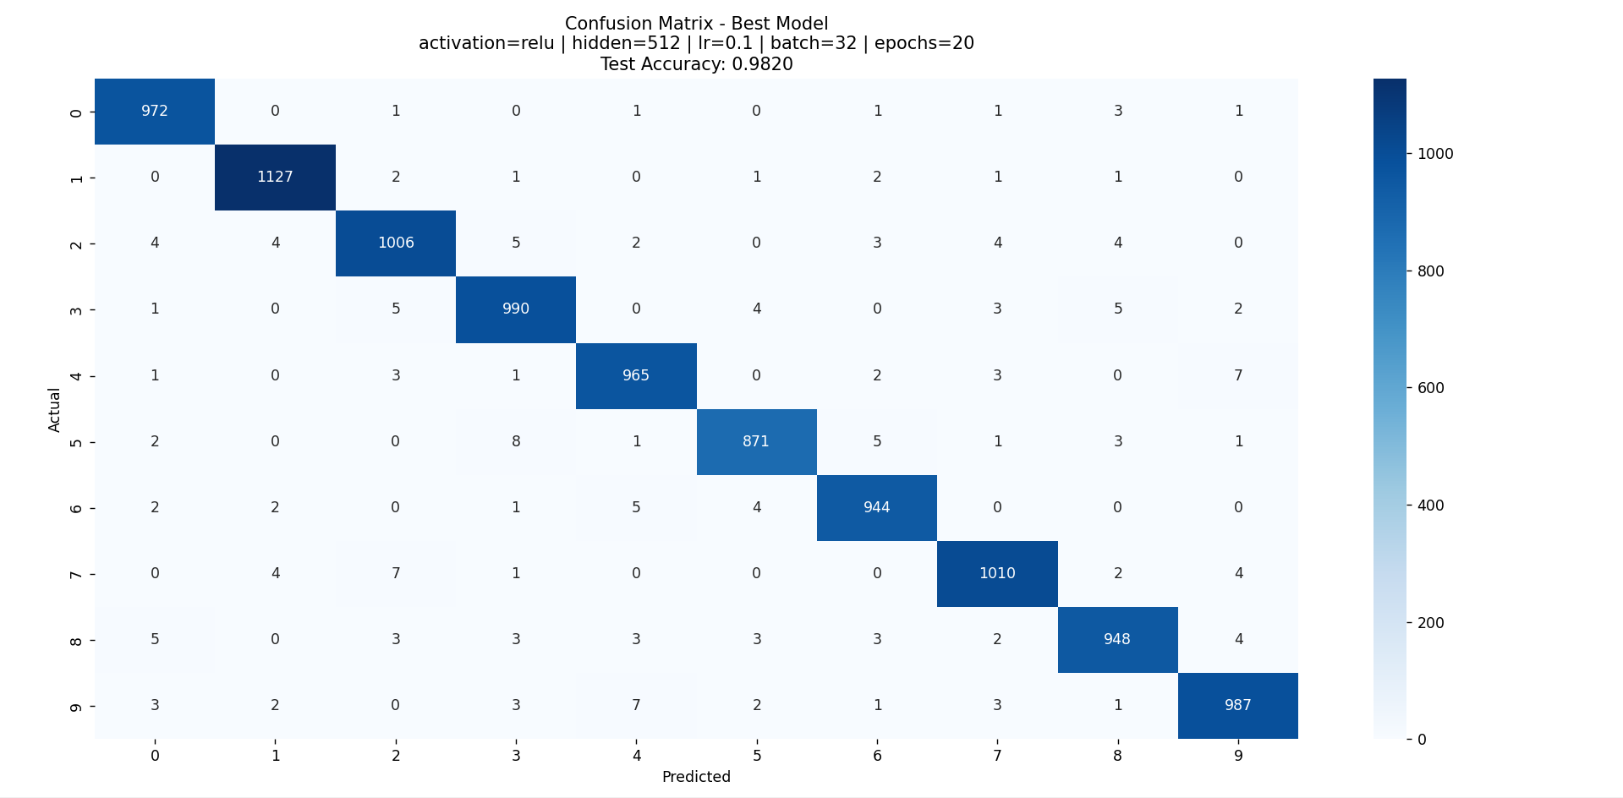

My Comments

Limitations
    - The test set is used multiple times for comparison instead of using a separate validation set.
    - Only a limited range of values is tested for learning rate, batch size, hidden size, and epochs.
    - Each configuration is trained only once, so results may vary slightly due to random initialization.

Scope of Improvement
    - Use a separate validation dataset for proper hyperparameter tuning.
    - Train each configuration multiple times and report average accuracy.
    - Extend evaluation to deeper models or more complex datasets.

