Neural Network Experiment-3

Name -Hemant Kumar

Roll.No.-24UADS1021

Objective
WAP to implement a three-layer neural network using Tensor flow library (only, no keras) to classify MNIST handwritten digits dataset. Demonstrate the implementation of feed-forward and back-propagation approaches.

Description of Model
The implemented model is a fully connected three-layer artificial neural network (ANN) designed for multi-class classification of handwritten digits from the MNIST dataset. The network follows a feed-forward architecture consisting of an input layer, two hidden layers, and an output layer. The input layer contains 784 neurons, corresponding to the flattened 28×28 grayscale pixel values of each image. These pixel values are normalized to the range [0,1] to improve numerical stability and training efficiency.
The first hidden layer contains 256 neurons, and the second hidden layer contains 128 neurons. Both hidden layers use the ReLU (Rectified Linear Unit) activation function to introduce non-linearity into the model, allowing it to learn complex patterns in the data. The weights of all layers are initialized using manual He initialization, which is suitable for ReLU activation functions. He initialization sets the weight variance according to:
$$Var(W)=\frac{2}{n_{in}}$$
This helps prevent vanishing or exploding gradients during backpropagation.
The output layer consists of 10 neurons, representing the 10 digit classes (0–9). The network outputs logits, and the final class probabilities are computed implicitly using the Softmax Cross-Entropy loss function, defined as:
$$L=-\sum_{i=1}^{C}{y_{i}}log⁡({\hat{y}}_{i})$$
where $y_{i}$is the true label (one-hot encoded) and ${\hat{y}}_{i}$is the predicted probability.
The model training process is implemented manually using TensorFlow’s low-level operations. The forward pass is computed using matrix multiplication (tf.matmul) followed by bias addition and ReLU activation. Backpropagation is performed using tf.GradientTape, which automatically computes gradients of the loss function with respect to the weights and biases. The parameters are updated using manual Gradient Descent, following the update rule:
$$W=W-η\frac{∂L}{∂W}$$
where $η$is the learning rate.
The model is trained for 20 epochs with a batch size of 128, and performance is evaluated using training accuracy, loss curves, and a confusion matrix. The final test accuracy achieved is approximately 95–96%, indicating that the network successfully learns meaningful representations of handwritten digits.

Code.py
import tensorflow as tf
import tensorflow_datasets as tfds
import numpy as np
import matplotlib.pyplot as plt
from sklearn.metrics import confusion_matrix
import seaborn as sns

# Load Dataset
(ds_train, ds_test), ds_info = tfds.load(
'mnist',
split=['train', 'test'],
as_supervised=True,
with_info=True
)

def preprocess(image, label):
image = tf.cast(image, tf.float32) / 255.0
image = tf.reshape(image, [-1])
label = tf.one_hot(label, depth=10)
return image, label

batch_size = 128
ds_train = ds_train.map(preprocess).shuffle(60000).batch(batch_size)
ds_test = ds_test.map(preprocess).batch(batch_size)

#Network Parameters
n_input = 784
n_hidden1 = 256
n_hidden2 = 128
n_output = 10

learning_rate = 0.01
epochs = 20

# He Initialization (Manual)
def he_init(shape):
stddev = tf.sqrt(2.0 / shape[0])
return tf.random.normal(shape, stddev=stddev)

W1 = tf.Variable(he_init([n_input, n_hidden1]))
b1 = tf.Variable(tf.zeros([n_hidden1]))

W2 = tf.Variable(he_init([n_hidden1, n_hidden2]))
b2 = tf.Variable(tf.zeros([n_hidden2]))

W3 = tf.Variable(he_init([n_hidden2, n_output]))
b3 = tf.Variable(tf.zeros([n_output]))

# Feed Forward
def forward_pass(X):
Z1 = tf.matmul(X, W1) + b1
A1 = tf.nn.relu(Z1)

Z2 = tf.matmul(A1, W2) + b2
A2 = tf.nn.relu(Z2)

Z3 = tf.matmul(A2, W3) + b3
return Z3

# Loss Function
def compute_loss(logits, labels):
return tf.reduce_mean(
tf.nn.softmax_cross_entropy_with_logits(
labels=labels, logits=logits)
)

# Training (Backpropagation)
train_loss_history = []
train_acc_history = []

steps_per_epoch = 60000 // batch_size

for epoch in range(epochs):

epoch_loss = 0.0
correct = 0
total = 0

iterator = iter(ds_train)

for step in range(steps_per_epoch):
X_batch, y_batch = next(iterator)

with tf.GradientTape() as tape:
logits = forward_pass(X_batch)
loss = compute_loss(logits, y_batch)

gradients = tape.gradient(loss, [W1, b1, W2, b2, W3, b3])

W1.assign_sub(learning_rate * gradients[0])
b1.assign_sub(learning_rate * gradients[1])
W2.assign_sub(learning_rate * gradients[2])
b2.assign_sub(learning_rate * gradients[3])
W3.assign_sub(learning_rate * gradients[4])
b3.assign_sub(learning_rate * gradients[5])

epoch_loss += loss.numpy()

preds = tf.argmax(logits, axis=1)
labels = tf.argmax(y_batch, axis=1)

correct += tf.reduce_sum(
tf.cast(preds == labels, tf.float32)
).numpy()

total += X_batch.shape[0]

avg_loss = epoch_loss / steps_per_epoch

epoch_accuracy = correct / total
train_loss_history.append(epoch_loss)

train_acc_history.append(epoch_accuracy)

print(f"Epoch {epoch+1}/{epochs} | "
f"Loss: {avg_loss:.4f} | "
f"Training Accuracy: {epoch_accuracy:.4f}")

# Test Accuracy
correct = 0
total = 0
all_preds = []
all_labels = []

for X_batch, y_batch in ds_test:
logits = forward_pass(X_batch)
preds = tf.argmax(logits, axis=1)
labels = tf.argmax(y_batch, axis=1)

all_preds.extend(preds.numpy())
all_labels.extend(labels.numpy())

correct += tf.reduce_sum(
tf.cast(preds == labels, tf.float32)
).numpy()

total += X_batch.shape[0]

test_accuracy = correct / total
print("\nFinal Test Accuracy:", test_accuracy)

# Plot Loss Curve
plt.figure()
plt.plot(train_loss_history)
plt.title("Training Loss Curve")
plt.xlabel("Epoch")
plt.ylabel("Loss")
plt.show()

# Plot Accuracy Curve
plt.figure()
plt.plot(train_acc_history)
plt.title("Training Accuracy Curve")
plt.xlabel("Epoch")
plt.ylabel("Accuracy")
plt.show()

# Confusion Matrix
cm = confusion_matrix(all_labels, all_preds)

plt.figure()
sns.heatmap(cm, annot=True, fmt="d")
plt.title("Confusion Matrix")
plt.xlabel("Predicted")
plt.ylabel("Actual")
plt.show()

# Sample Predictions
plt.figure(figsize=(10,5))
for i in range(10):
plt.subplot(2,5,i+1)
plt.imshow(tf.reshape(list(ds_test)[0][0][i], (28,28)), cmap="gray")
plt.title(f"Pred: {all_preds[i]}")
plt.axis("off")
plt.show()

Output.txt
2026-02-20 14:13:20.638660: I tensorflow/core/util/port.cc:153] oneDNN custom operations are on. You may see slightly different numerical results due to floating-point round-off errors from different computation orders. To turn them off, set the environment variable `TF_ENABLE_ONEDNN_OPTS=0`.
2026-02-20 14:13:32.458139: I tensorflow/core/util/port.cc:153] oneDNN custom operations are on. You may see slightly different numerical results due to floating-point round-off errors from different computation orders. To turn them off, set the environment variable `TF_ENABLE_ONEDNN_OPTS=0`.
2026-02-20 14:13:46.647669: I tensorflow/core/platform/cpu_feature_guard.cc:210] This TensorFlow binary is optimized to use available CPU instructions in performance-critical operations.
To enable the following instructions: SSE3 SSE4.1 SSE4.2 AVX AVX2 FMA, in other operations, rebuild TensorFlow with the appropriate compiler flags.
2026-02-20 14:13:46.992800: I tensorflow/core/kernels/data/tf_record_dataset_op.cc:396] The default buffer size is 262144, which is overridden by the user specified `buffer_size` of 8388608
Epoch 1/20 | Loss: 1.0895 | Training Accuracy: 0.7257
Epoch 2/20 | Loss: 0.4395 | Training Accuracy: 0.8846
Epoch 3/20 | Loss: 0.3502 | Training Accuracy: 0.9030
Epoch 4/20 | Loss: 0.3099 | Training Accuracy: 0.9125
Epoch 5/20 | Loss: 0.2841 | Training Accuracy: 0.9193
Epoch 6/20 | Loss: 0.2643 | Training Accuracy: 0.9253
Epoch 7/20 | Loss: 0.2483 | Training Accuracy: 0.9299
Epoch 8/20 | Loss: 0.2348 | Training Accuracy: 0.9335
Epoch 9/20 | Loss: 0.2229 | Training Accuracy: 0.9376
Epoch 10/20 | Loss: 0.2121 | Training Accuracy: 0.9407
Epoch 11/20 | Loss: 0.2026 | Training Accuracy: 0.9432
Epoch 12/20 | Loss: 0.1942 | Training Accuracy: 0.9456
Epoch 13/20 | Loss: 0.1862 | Training Accuracy: 0.9488
Epoch 14/20 | Loss: 0.1792 | Training Accuracy: 0.9501
Epoch 15/20 | Loss: 0.1726 | Training Accuracy: 0.9521
Epoch 16/20 | Loss: 0.1667 | Training Accuracy: 0.9537
Epoch 17/20 | Loss: 0.1609 | Training Accuracy: 0.9553
Epoch 18/20 | Loss: 0.1556 | Training Accuracy: 0.9569
Epoch 19/20 | Loss: 0.1506 | Training Accuracy: 0.9577
Epoch 20/20 | Loss: 0.1462 | Training Accuracy: 0.9595
2026-02-20 14:15:34.421947: I tensorflow/core/framework/local_rendezvous.cc:407] Local rendezvous is aborting with status: OUT_OF_RANGE: End of sequence

Final Test Accuracy: 0.9573
2026-02-20 14:16:33.901073: I tensorflow/core/framework/local_rendezvous.cc:407] Local rendezvous is aborting with status: OUT_OF_RANGE: End of sequence
2026-02-20 14:16:34.166871: I tensorflow/core/framework/local_rendezvous.cc:407] Local rendezvous is aborting with status: OUT_OF_RANGE: End of sequence
2026-02-20 14:16:34.694864: I tensorflow/core/framework/local_rendezvous.cc:407] Local rendezvous is aborting with status: OUT_OF_RANGE: End of sequence

Description of Code
The program is implemented using TensorFlow 2.x (low-level API only) to build and train a three-layer neural network for MNIST digit classification. The code is structured into logical sections: dataset loading, preprocessing, parameter initialization, forward propagation, loss computation, backpropagation training loop, evaluation, and visualization.
1.Dataset Loading
The MNIST dataset is loaded using tensorflow_datasets (tfds). The dataset is split into training and test sets. The as_supervised=True argument ensures that each sample is returned as a tuple (image, label).
A preprocessing function is defined to:
- Convert images to float32
- Normalize pixel values to the range [0,1]
- Flatten 28×28 images into 784-dimensional vectors
- Convert labels into one-hot encoded vectors
Batching and shuffling are applied using the tf.data pipeline for efficient mini-batch training. 2. Network Parameter Definition
The network architecture parameters are defined:
- Input size = 784
- Hidden layer 1 = 256 neurons
- Hidden layer 2 = 128 neurons
- Output layer = 10 neurons
The learning rate and number of epochs are also defined.
3. Weight Initialization (Manual He Initialization)
A custom he_init() function is implemented to initialize weights. The standard deviation is computed as:
$$std=\sqrt{\frac{2}{n_{in}}}$$
Weights are initialized using tf.random.normal() with this computed standard deviation. Biases are initialized to zeros.
This initialization is suitable for ReLU activation and helps maintain stable gradient flow during training.
4. Feed Forward Implementation
The forward_pass() function defines the forward propagation steps:
- First hidden layer:
  - Matrix multiplication
  - Bias addition
  - ReLU activation
- Second hidden layer:
  - Matrix multiplication
  - Bias addition
  - ReLU activation
- Output layer:
  - Matrix multiplication
  - Bias addition
  - Returns logits
The computation at each layer follows:
$$Z=XW+b$$
ReLU activation is applied to introduce non-linearity.
5. Loss Function
The loss function is defined using tf.nn.softmax_cross_entropy_with_logits. The categorical cross-entropy loss is computed as:
$$L=-∑y_{i}log⁡({\hat{y}}_{i})$$
The tf.reduce_mean() function calculates the average loss per batch.
6. Training Loop (Backpropagation)
The training loop runs for the specified number of epochs. For each epoch:
- A fresh dataset iterator is created.
- Each mini-batch is passed through the forward pass.
- Loss is computed.
- Gradients are calculated using tf.GradientTape.
- Manual Gradient Descent is applied to update weights and biases using:
$$W=W-η\frac{∂L}{∂W}$$
Training accuracy is calculated by comparing predicted labels with actual labels.
Both total loss (for plotting) and averaged loss (for clean reporting) are handled separately.
7. Model Evaluation
After training:
- The model is evaluated on the test dataset.
- Predictions are collected batch-wise.
- Final test accuracy is computed.
- A confusion matrix is generated using sklearn.metrics.confusion_matrix.
- Visualization is done using seaborn.heatmap.

Hyperparameters
The model is trained using several predefined hyperparameters that control the learning process. The learning rate (η) is set to 0.01, which determines the step size used during gradient descent updates according to:
$$W=W-η\frac{∂L}{∂W}$$
The number of training epochs is 20, meaning the entire training dataset is processed 20 times. A batch size of 128 is used, implementing mini-batch gradient descent, where the training data is divided into smaller batches for efficient computation and stable convergence. The weight initialization method used is manual He initialization, which is appropriate for ReLU activation functions and is defined as:
$$std=\sqrt{\frac{2}{n_{in}}}$$
This initialization helps maintain proper variance of activations across layers and prevents vanishing or exploding gradients. The activation function used in hidden layers is ReLU, while the output layer uses Softmax through categorical cross-entropy loss. The loss function employed is Categorical Cross-Entropy, defined as:
$$L=-\sum_{i=1}^{C}{y_{i}}log⁡({\hat{y}}_{i})$$

Network Architecture
The implemented model is a fully connected feed-forward artificial neural network consisting of an input layer, two hidden layers, and an output layer. The input layer contains 784 neurons, corresponding to the flattened 28×28 pixel values of the MNIST images. The first hidden layer contains 256 neurons with ReLU activation, followed by a second hidden layer containing 128 neurons, also using ReLU activation. These hidden layers enable the network to learn complex non-linear patterns from handwritten digit images. The final output layer consists of 10 neurons, representing the digit classes (0–9). The output layer produces logits that are internally converted to probabilities using the Softmax function during loss computation. The network contains approximately 235,000 trainable parameters, including weights and biases. The model is trained using manual backpropagation implemented via tf.GradientTape and updated using gradient descent.

Output-Visualization
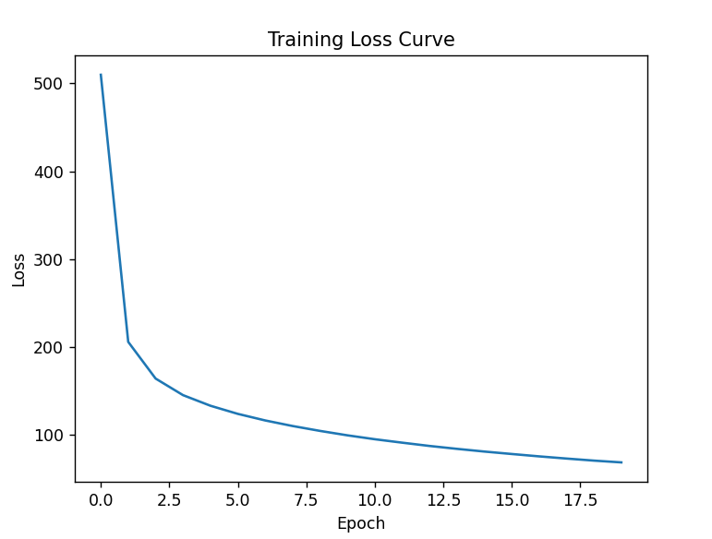
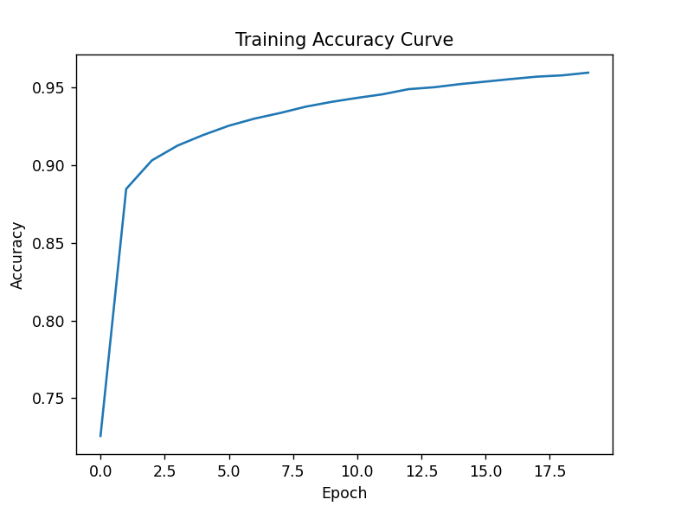
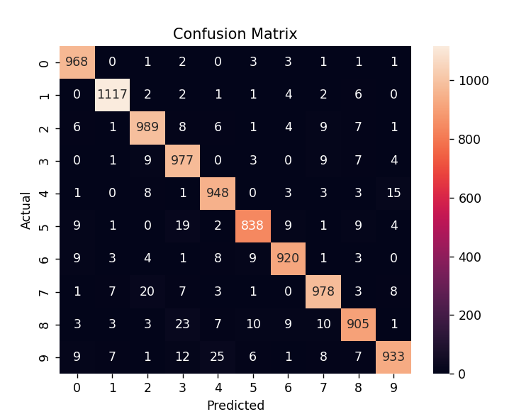
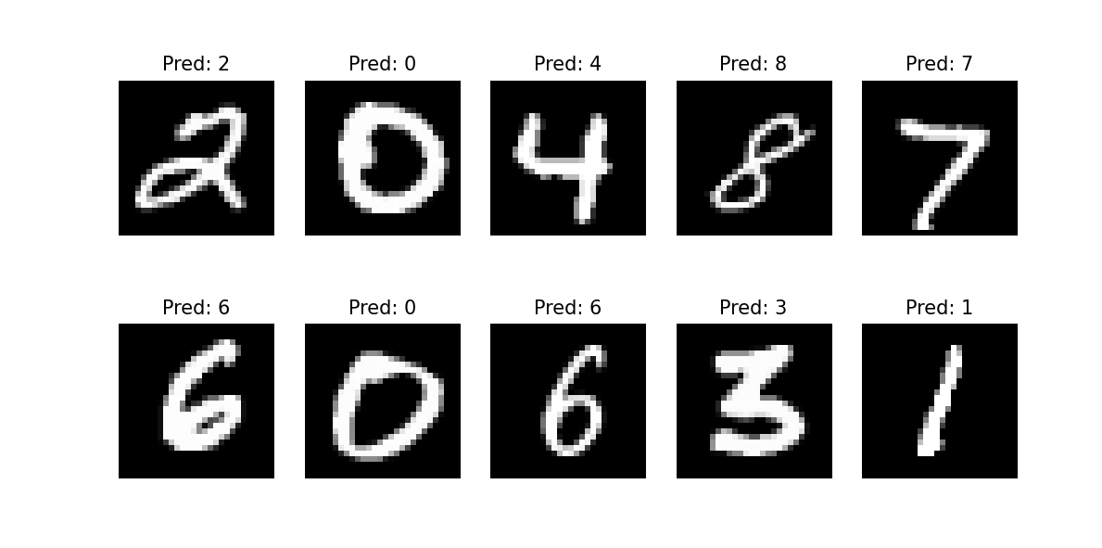

Demonstration of Feed-Forward and Back-Propagation
1. Feed-Forward Approach
Feed-forward is the process where input data moves forward through the network layer by layer to produce the final output.
In the implemented model:
- First Hidden Layer
    - Linear transformation:
$$Z_{1}=XW_{1}+b_{1}$$
    - Activation:
$$A_{1}=ReLU(Z_{1})$$
- Second Hidden Layer
    - Linear transformation:
$$Z_{2}=A_{1}W_{2}+b_{2}$$
    - Activation:
$$A_{2}=ReLU(Z_{2})$$
- Output Layer
    - Linear transformation:
$$Z_{3}=A_{2}W_{3}+b_{3}$$
The output $Z_{3}$represents logits.
The Softmax function is applied internally during loss computation to convert logits into probabilities.
Thus, feed-forward computes predictions using matrix multiplication and activation functions without modifying weights.
2. Back-Propagation Approach
Back-propagation is the process of updating network weights to minimize the loss.
Steps followed in the implementation:
- Loss Computation
  - Categorical Cross-Entropy:
$$L=-∑y_{i}log⁡({\hat{y}}_{i})$$
- Gradient Calculation
  - tf.GradientTape() automatically computes:
$$\frac{∂L}{∂W}$$
- Weight Update (Gradient Descent)
$$W=W-η\frac{∂L}{∂W}$$
Where:
$1. η$= learning rate
$2. \frac{∂L}{∂W}$= gradient of loss w.r.t weights
This process is repeated for every batch and every epoch until convergence.

My Comments

Limitations
    - The model is fully connected and does not use spatial information from images.
    - Basic Gradient Descent is used instead of advanced optimizers.
    - No regularization techniques (dropout, L2, batch normalization).
    - Hyperparameters are not tuned.
    - Tested only on simple MNIST dataset.

Scope of Improvement
    - Use Adam or RMSProp optimizer for faster convergence.
    - Implement CNN for better image feature extraction.
    - Apply dropout or regularization to reduce overfitting.
    - Tune learning rate, batch size, and number of layers.
    - Train on more complex real-world datasets.

