Open Microsoft SQL serval management

Create database-

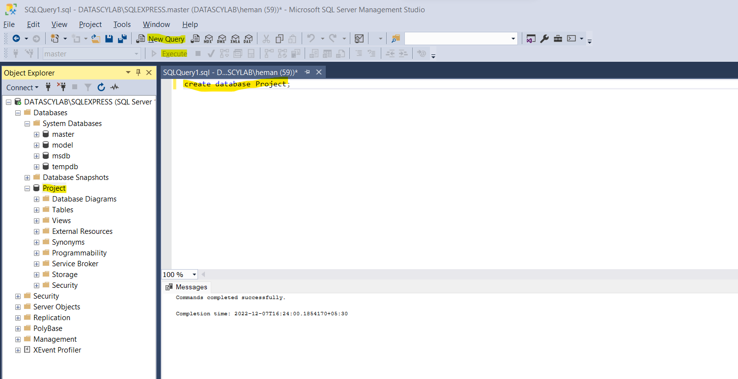

Importing excel data(Note-Save excel file to 2003)-

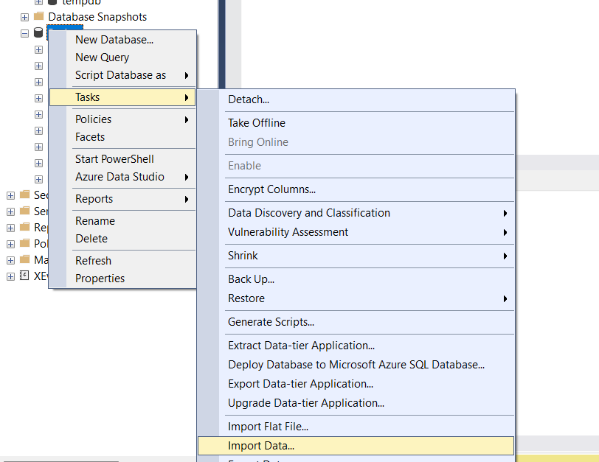

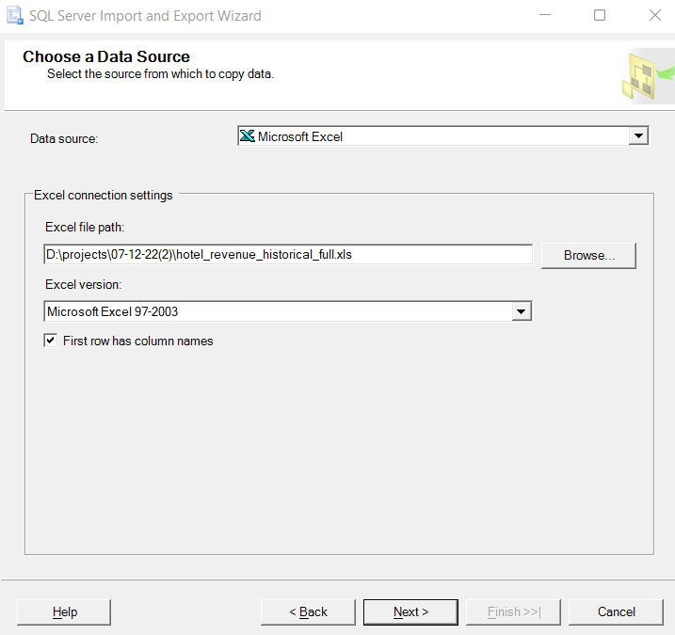

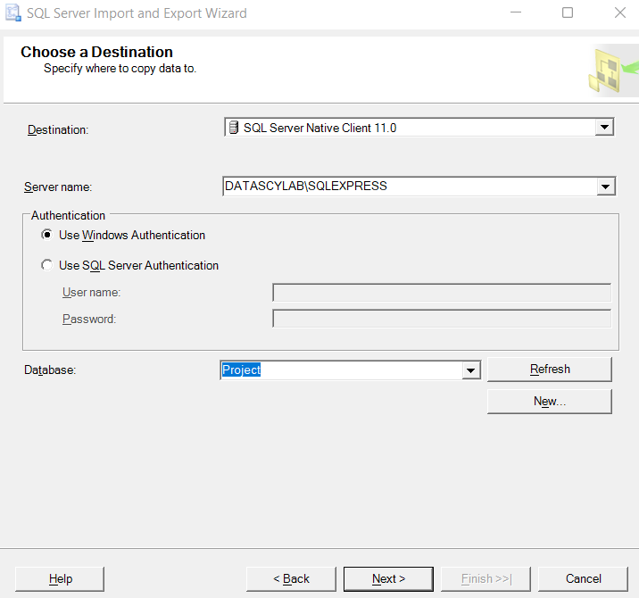

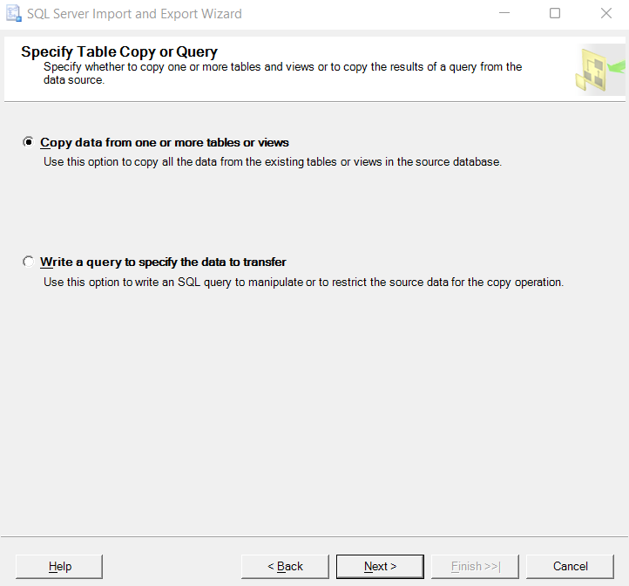

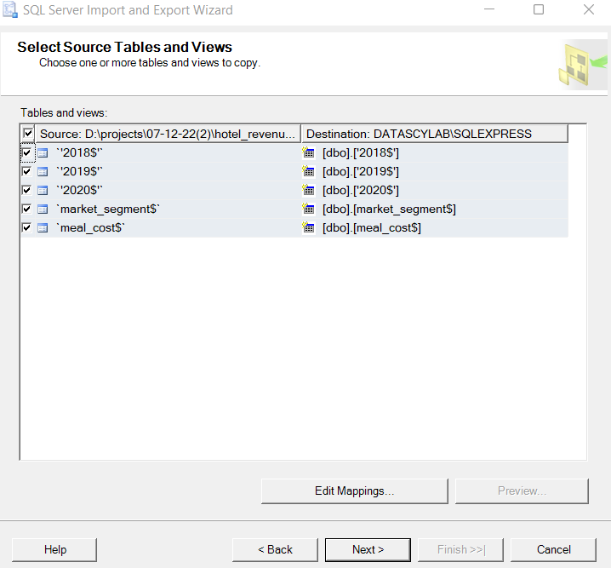

After importing data to sql our next goal is to develop a query which can combine all tables so as we can use it in powerbi dashboard creation

Query as follows-

/*create temporary column hotels*/

with hotels as (

select * from dbo.['2018$']

union

select * from dbo.['2019$']

union

select * from dbo.['2020$'])

/*adding discount column to hotels table from market_segment table with left join*/

select * from hotels

left join dbo.market_segment$

on hotels.market_segment=market_segment$.market_segment

/*adding meal cost column to hotels table from meal_cost table with left join*/

left join dbo.meal_cost$

on hotels.meal=meal_cost$.meal

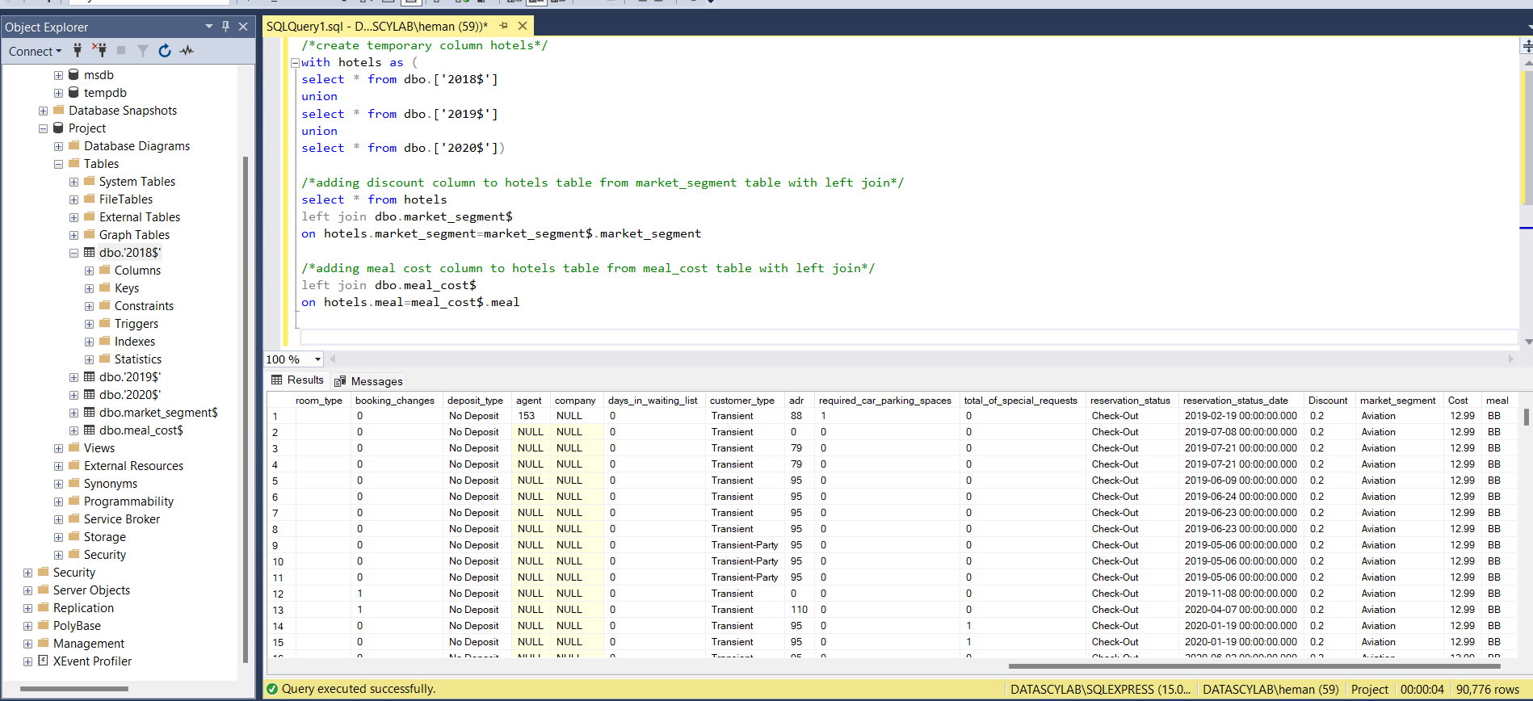

Then open powerbi and click on import data from sql server and fill details of server name,database and query

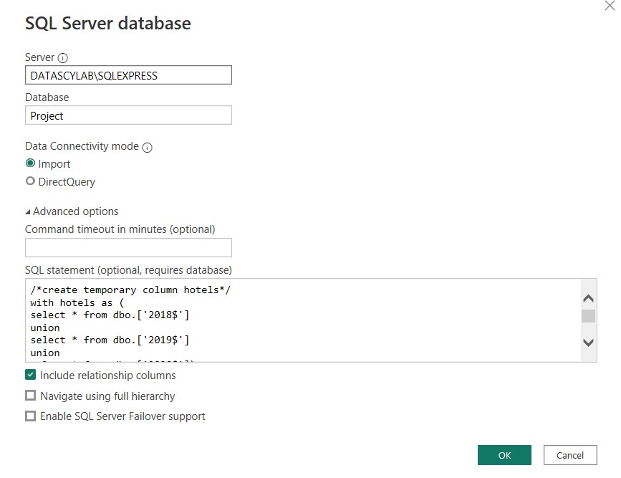

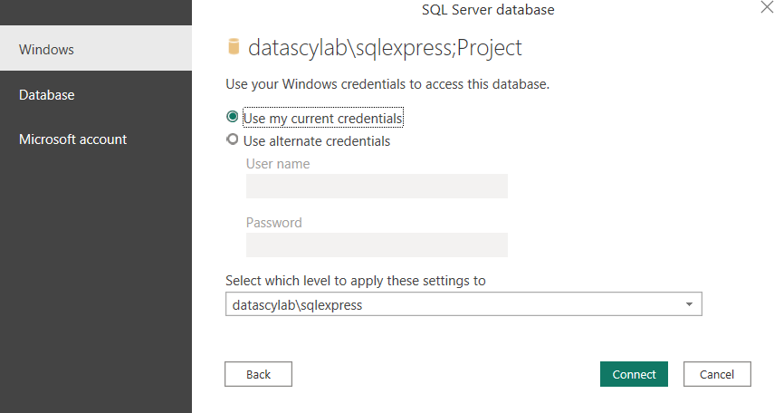

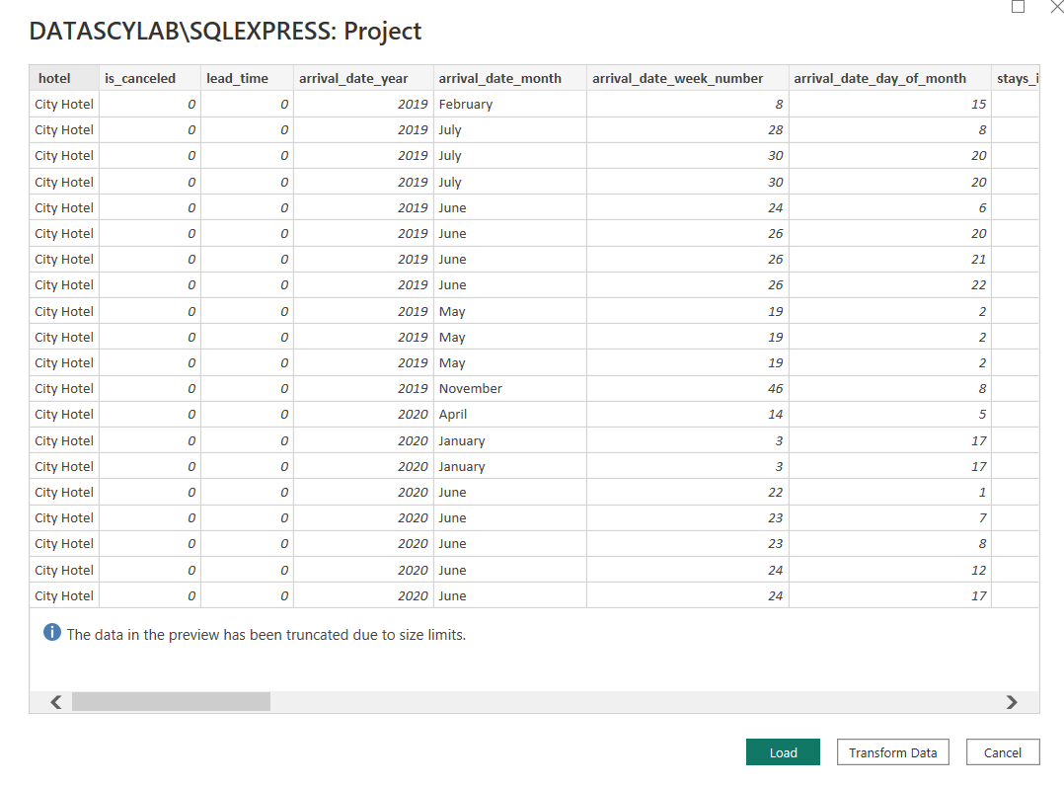

After loading data to powerbi

We first calculate whether revenue increases year in year?

For that we create a column revenue

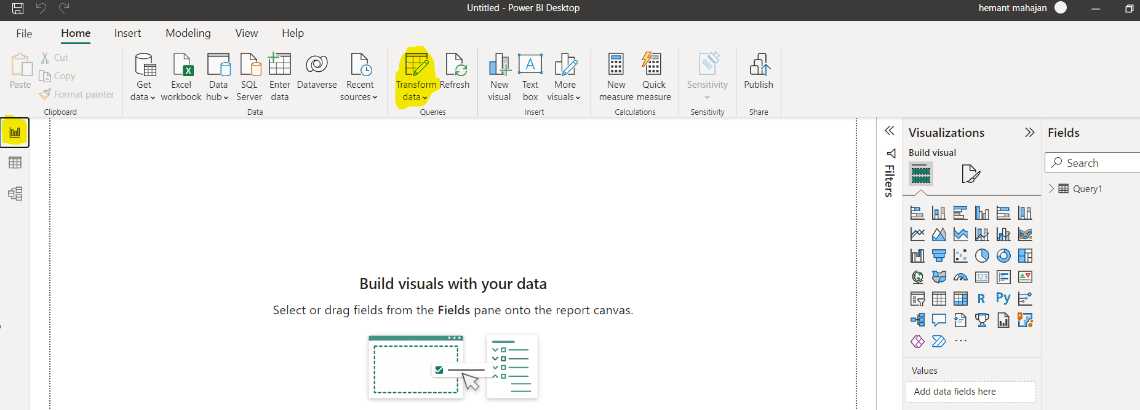

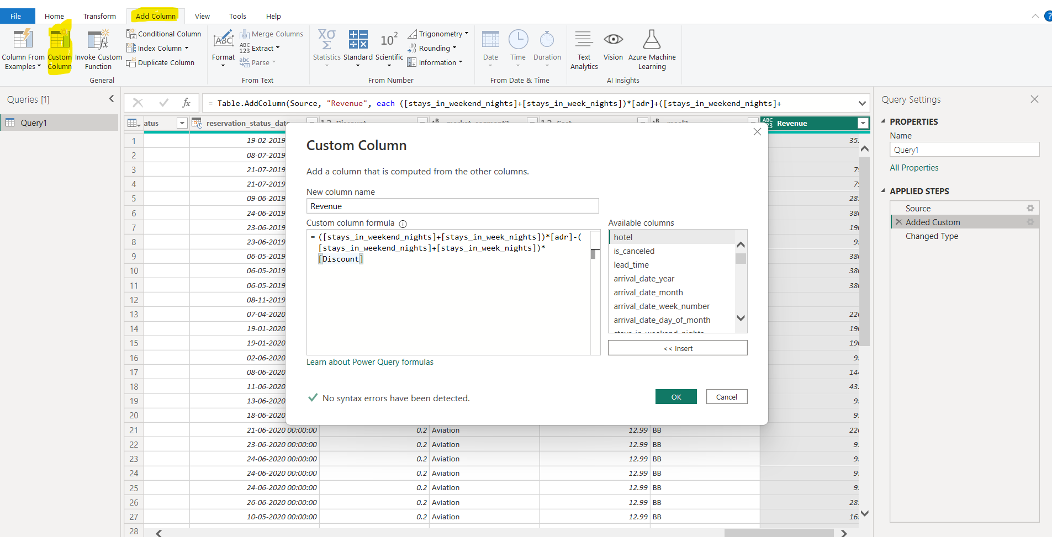

Convert Revenue column into decimal number

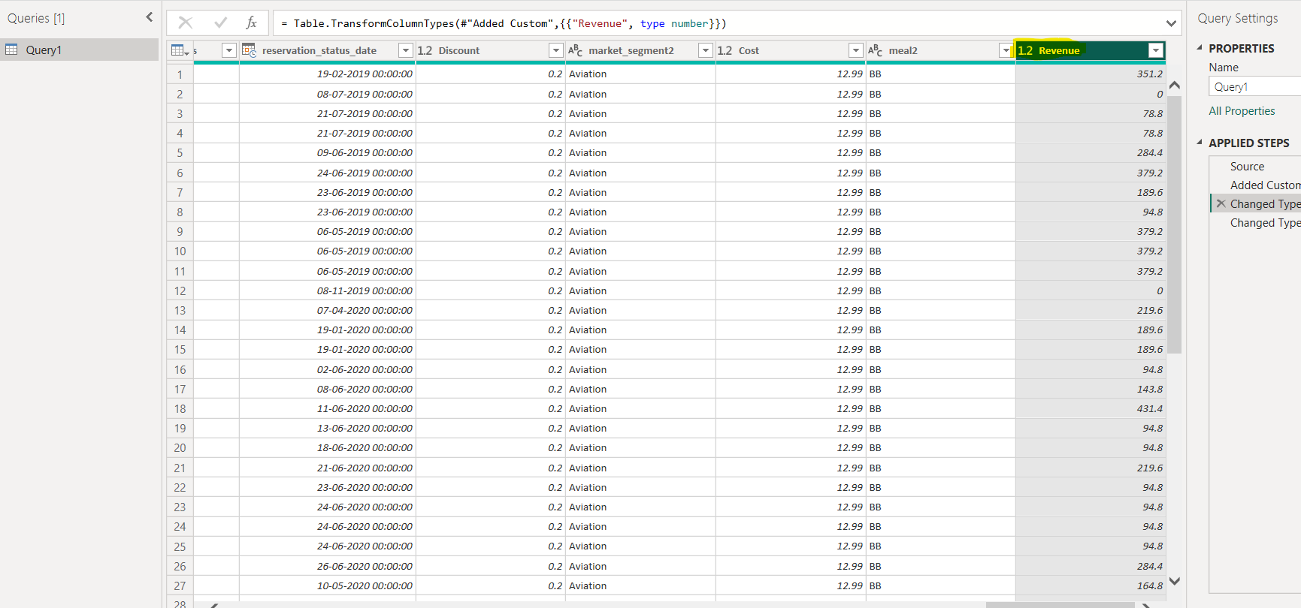

Close and save the changes

Insert lines to separate charts in dashboard

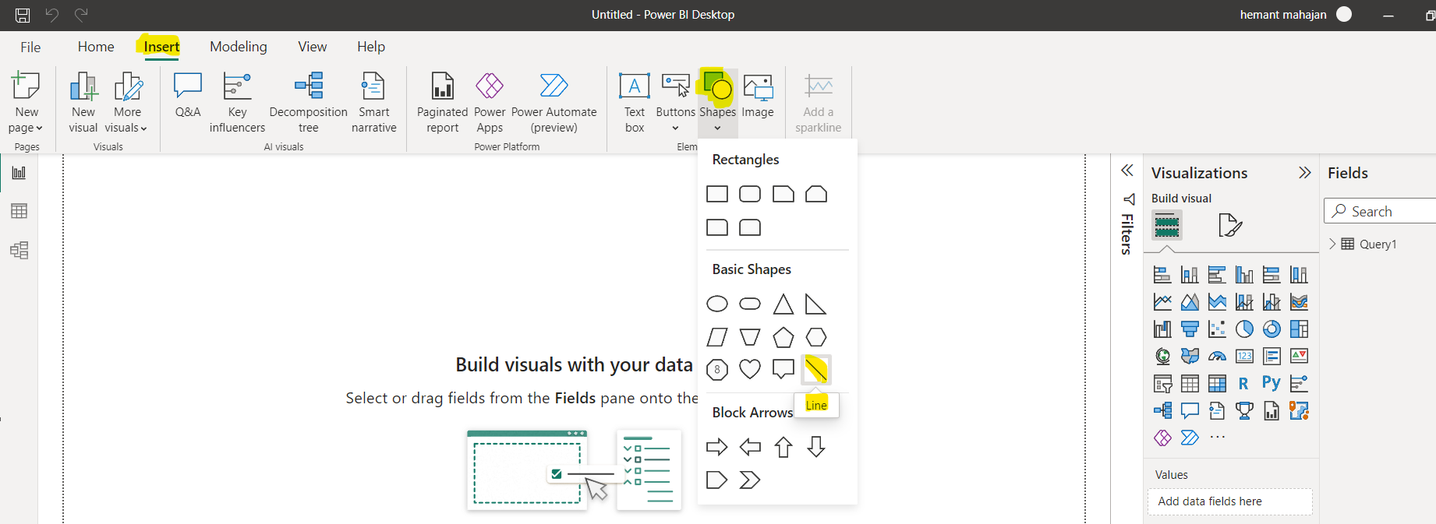

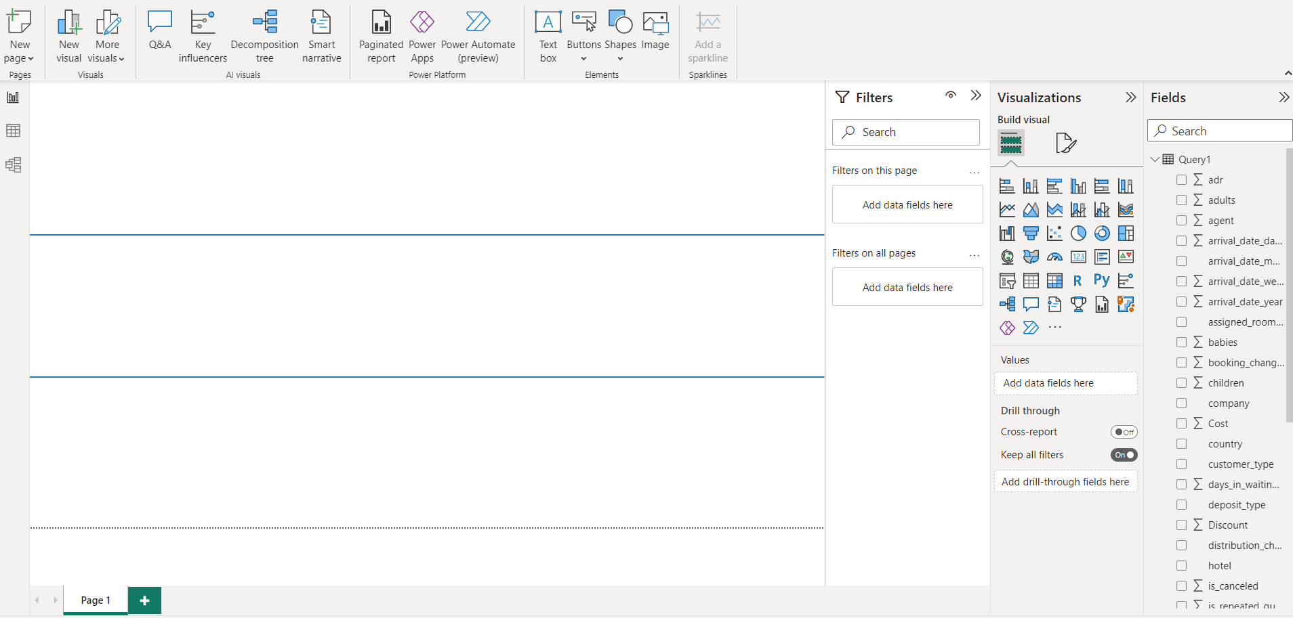

Add total revenue to dashboard

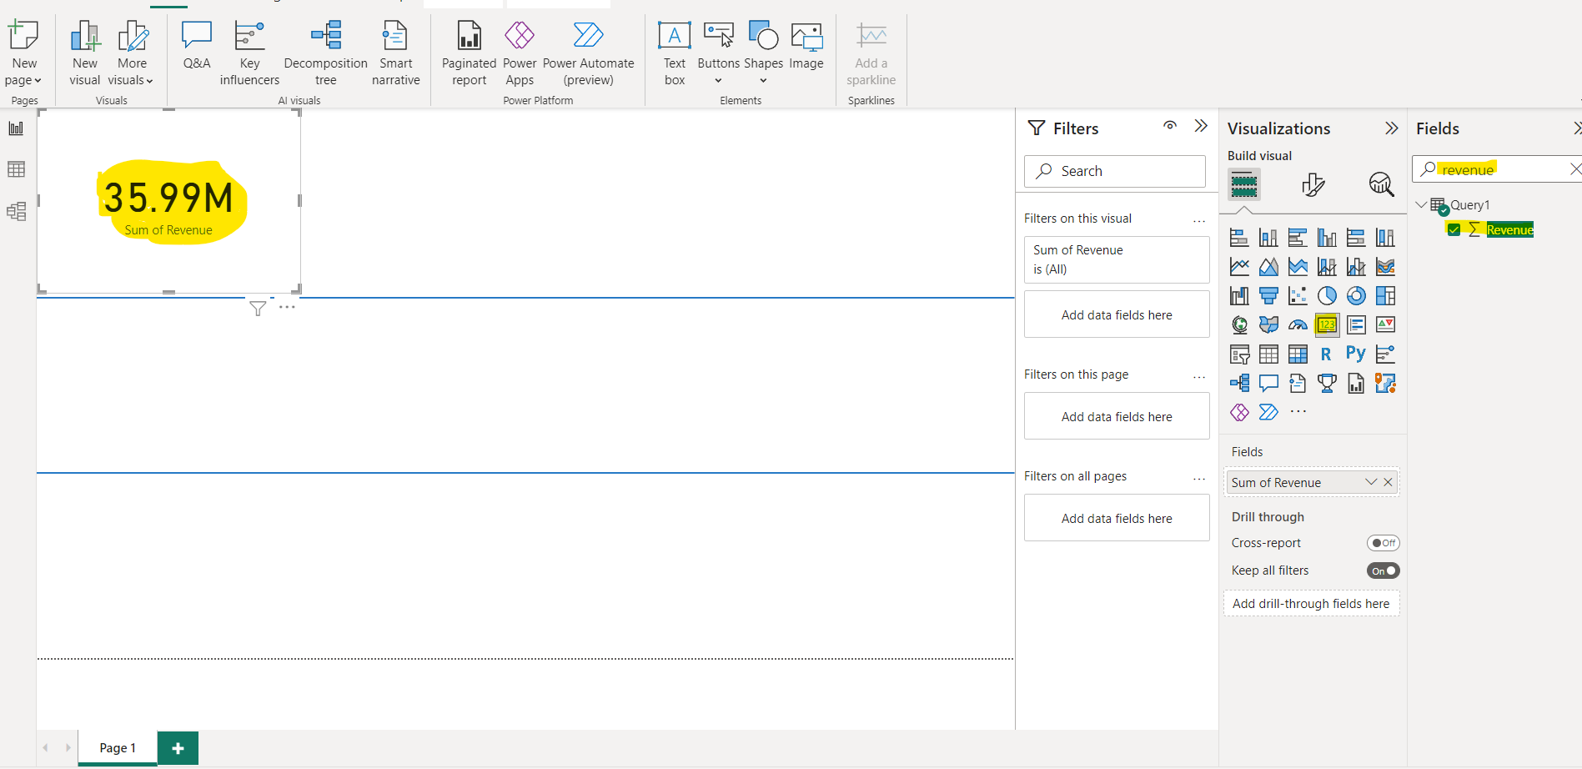

Add average adr

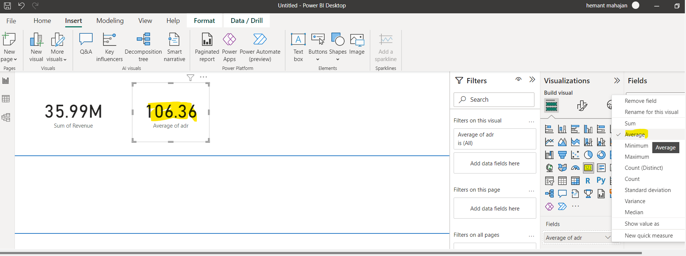

To create new measure called Total_Nights:

1st make a copy of Average of adr and then

Right click on field and select New Measure

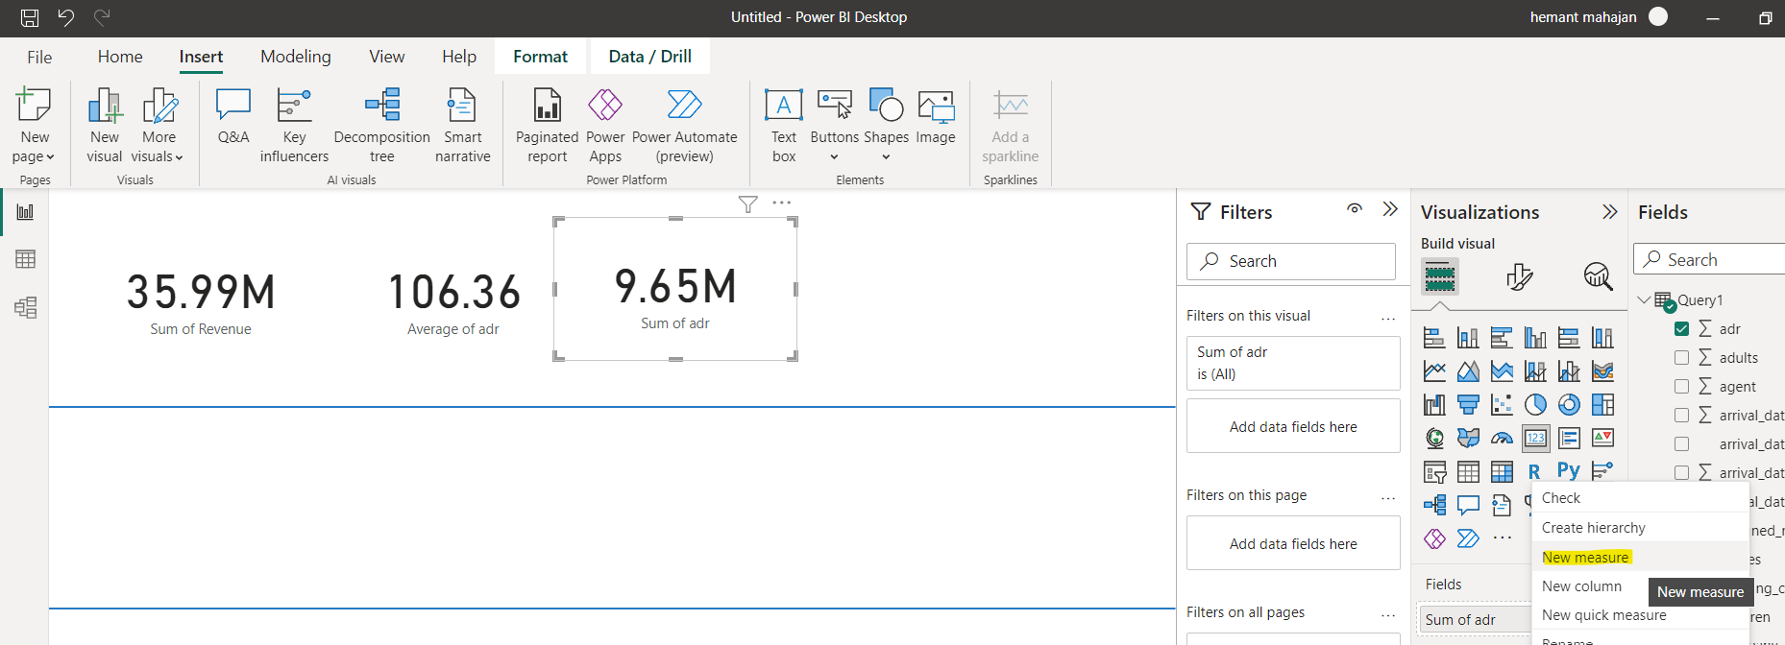

Add power query as below and drag Total_Nights to field drop down as highlighted below

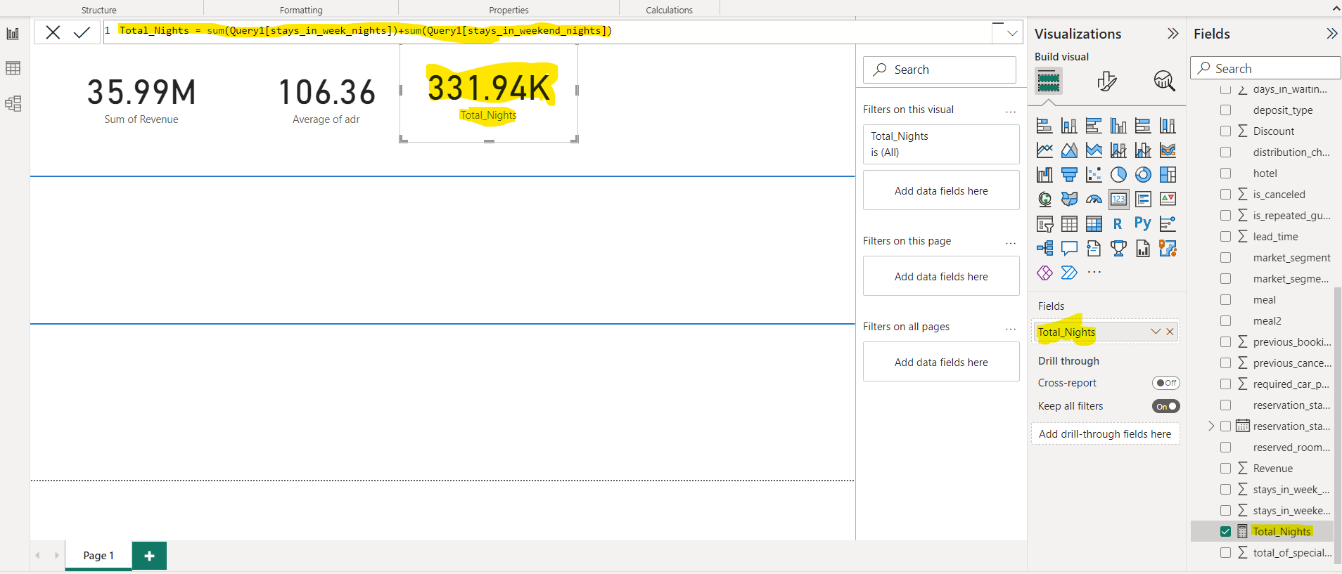

Calculate Average discount

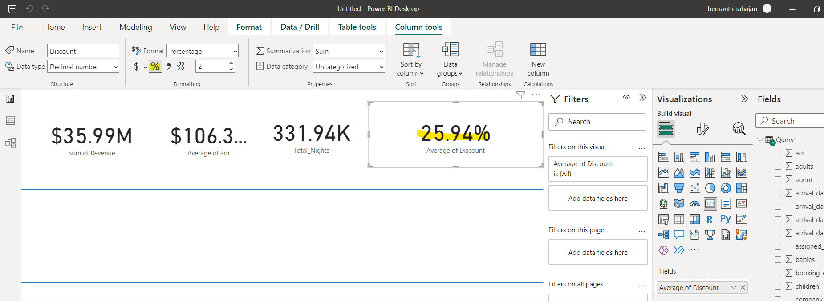

Line chart of sum of revenue

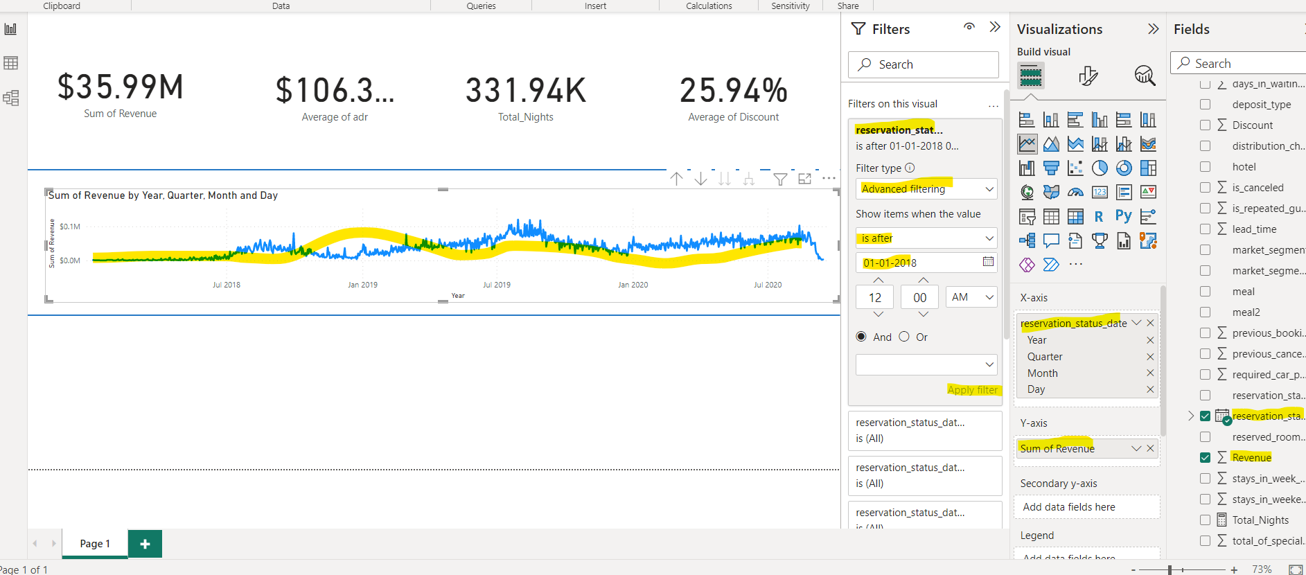

Add country filter

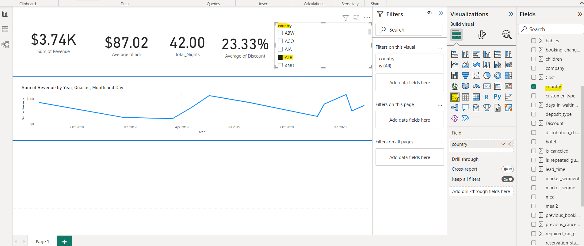

Convert country filter to dropdown

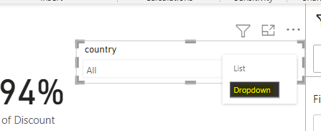

Similarly create dropdown for hotel

Drag hotel to line chart to create separate line charts for city and resort hotels

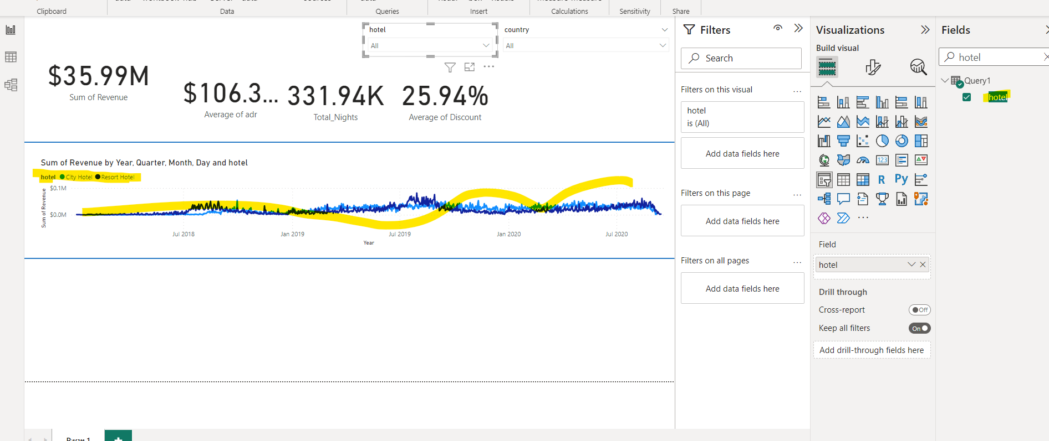

Create line chart of respective fields-

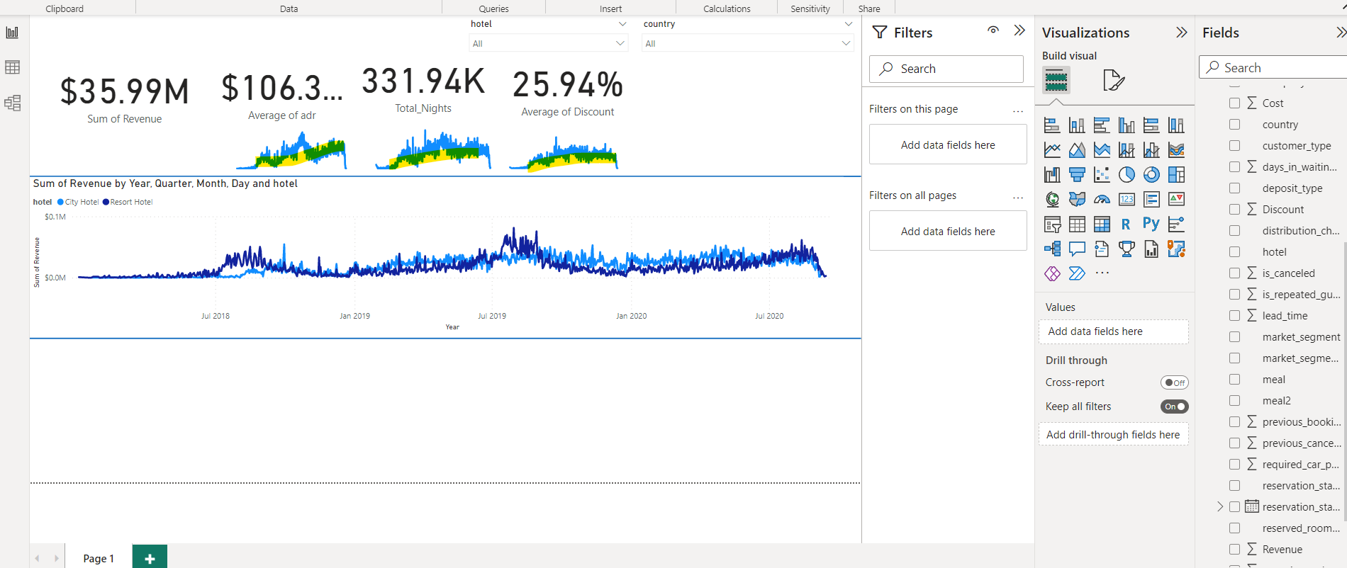

Add sum of required car spacing

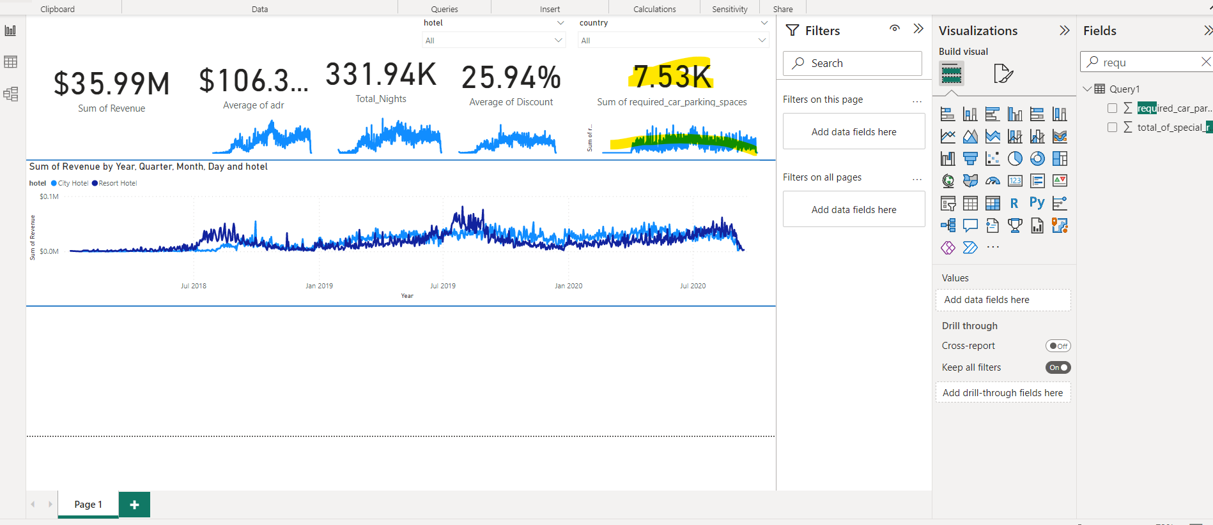

Add trendline-

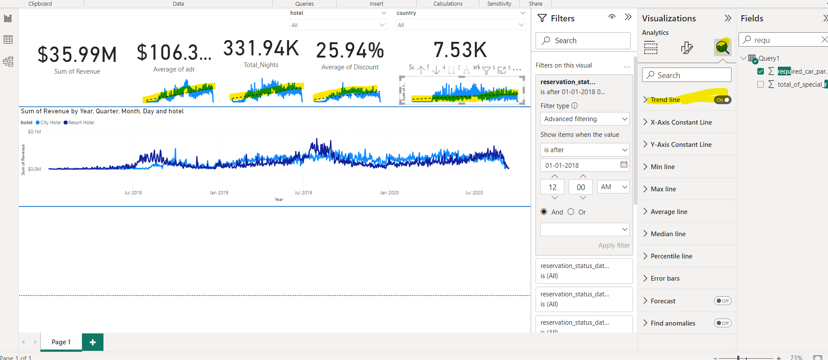

Increase page size-

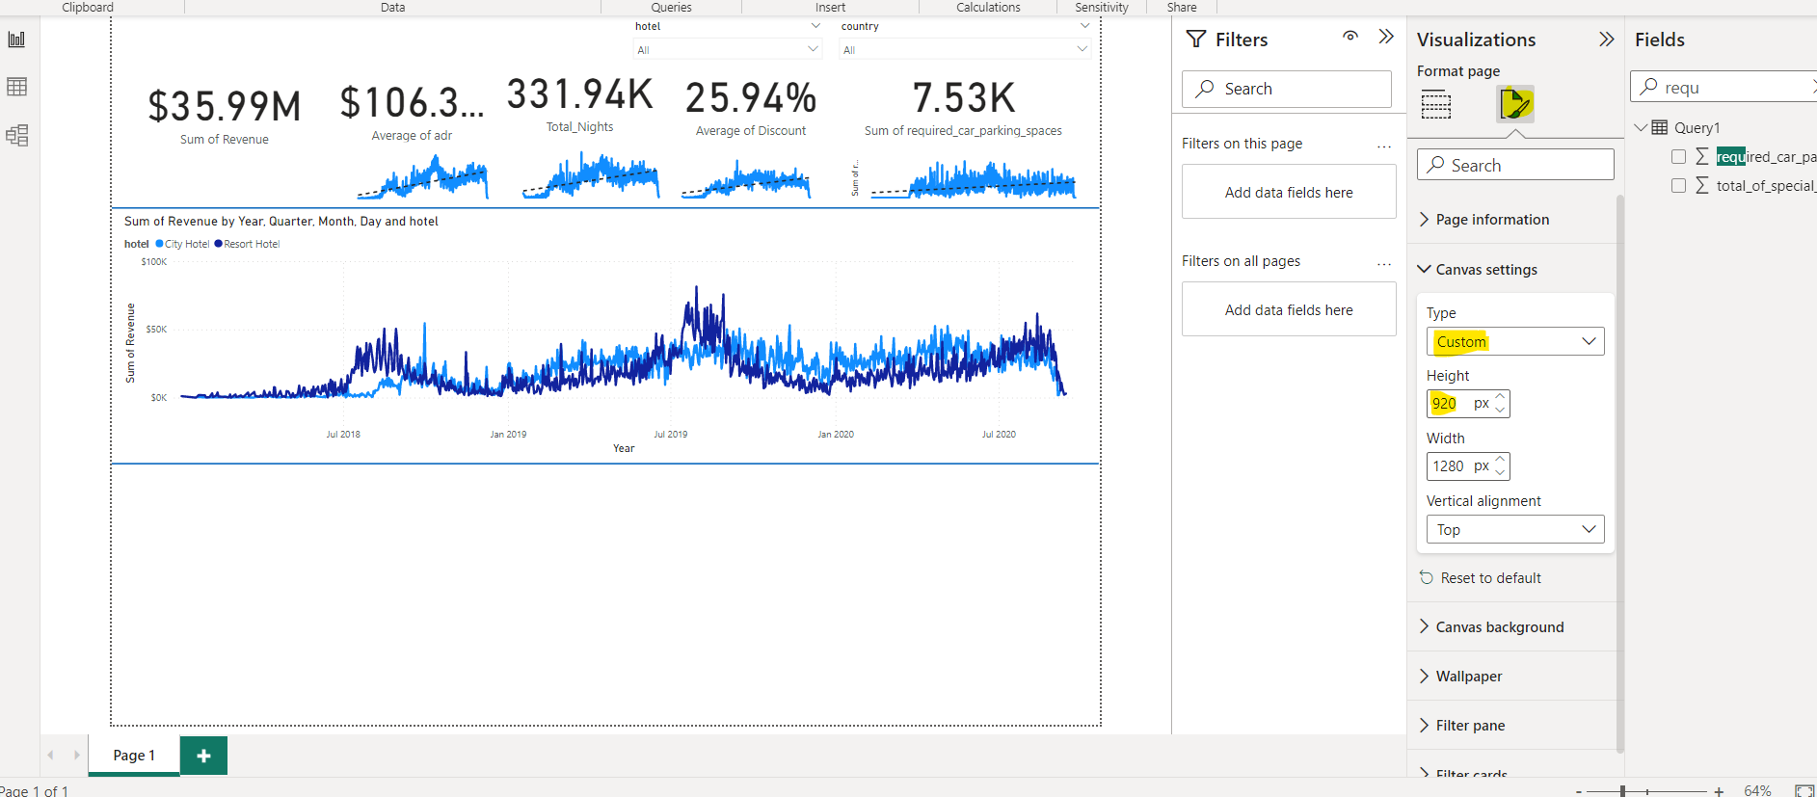

Create a donut chart of revenue by hotel type

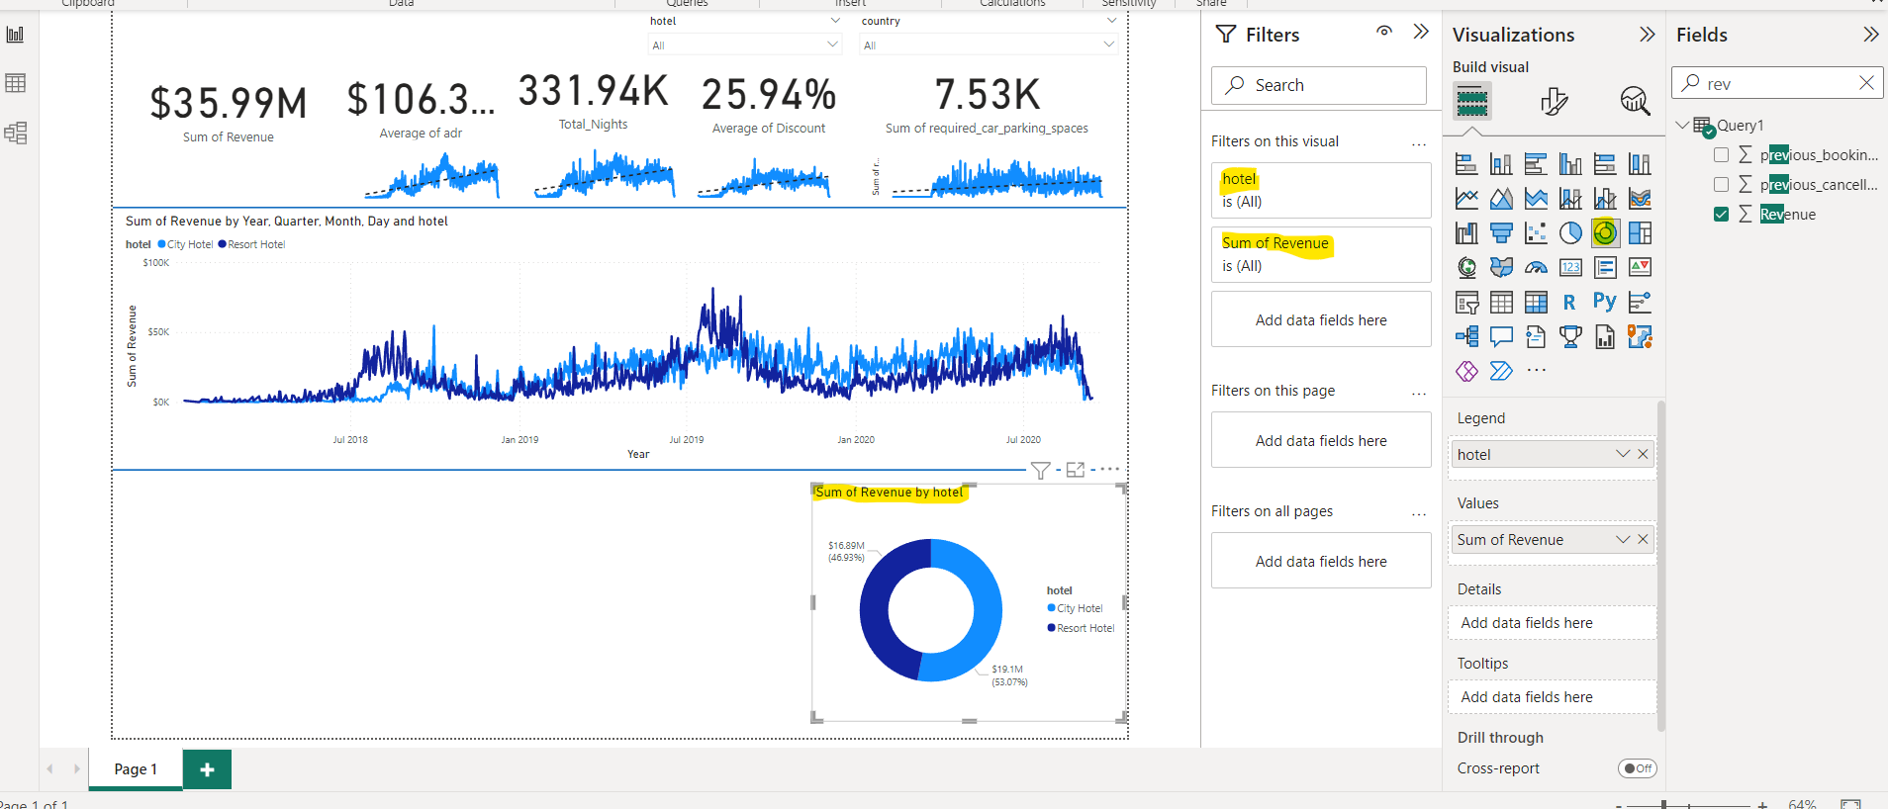

Create a table and a new measure Parking_percentage

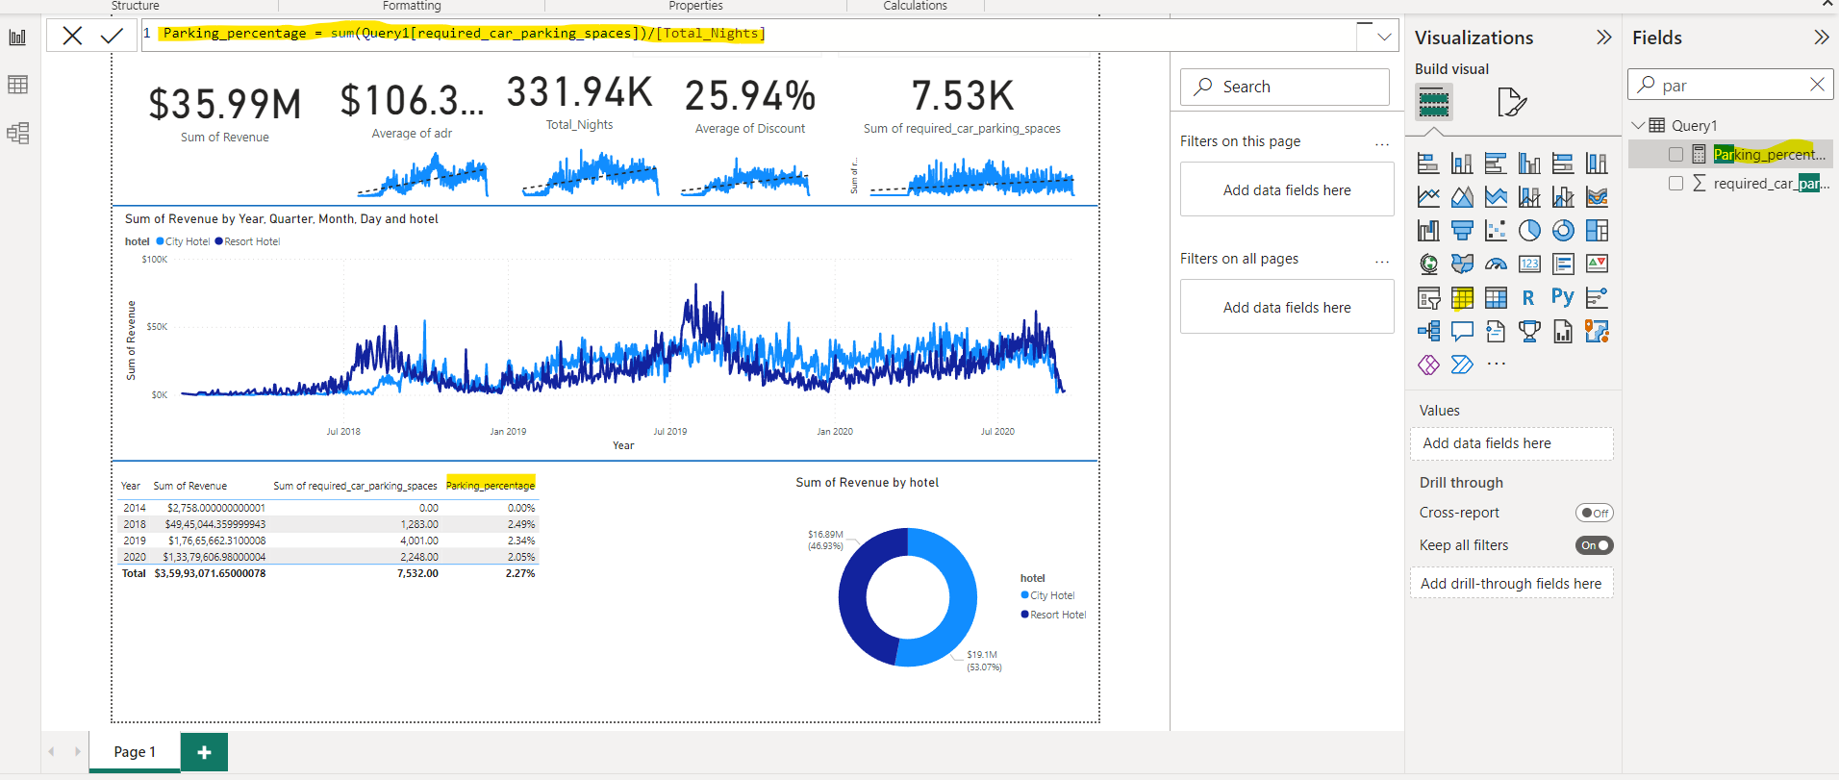

Segregate hotel type along row in table-

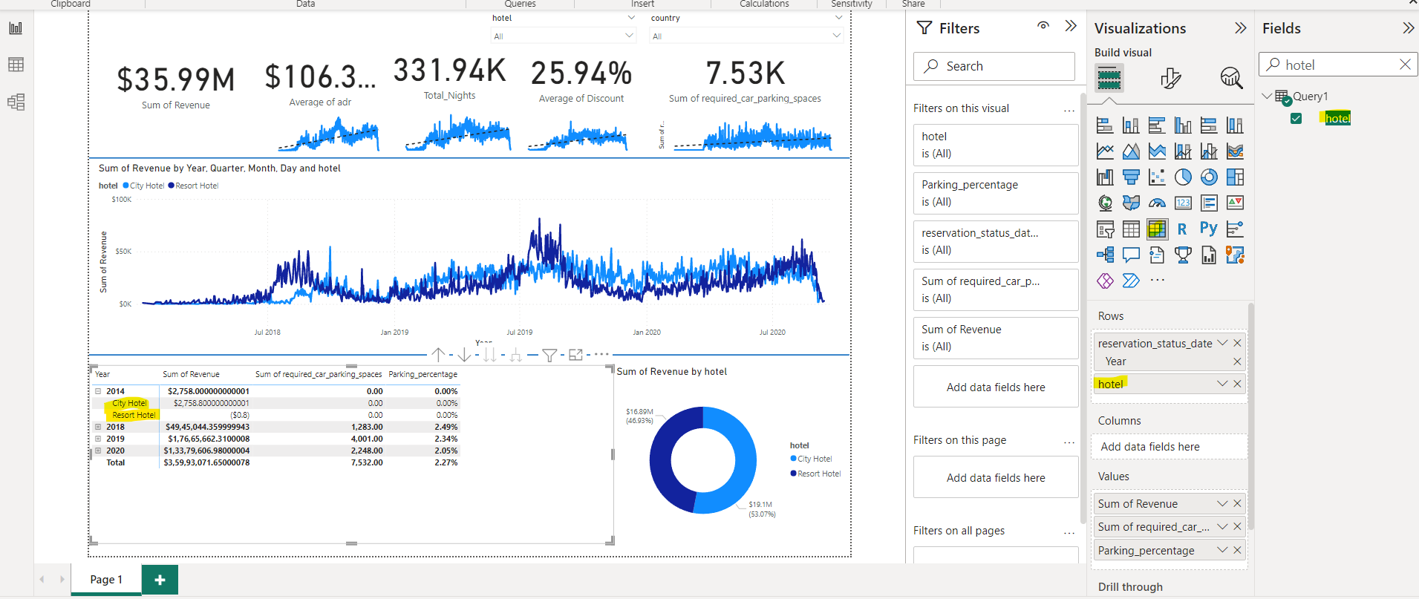

Add reservation status date filter

