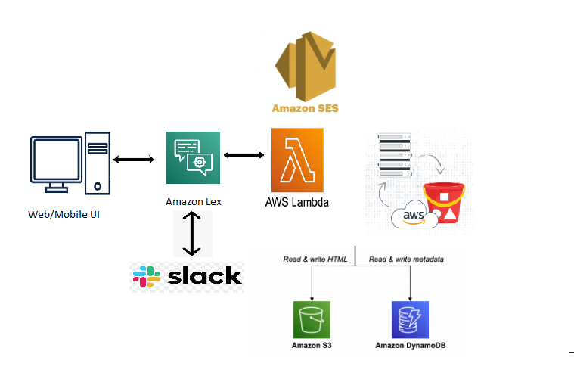

**Architecture Overview**

This architecture represents an **AWS-powered chatbot** that interacts with users via a **web/mobile UI or Slack**. The chatbot uses **Amazon Lex**, an AI-based conversational interface, and integrates with **AWS Lambda** for backend processing. It also interacts with **Amazon S3, Amazon DynamoDB, and Amazon SES** for data storage, metadata handling, and email notifications.

**Components Explanation**

**1. Web/Mobile UI & Slack (User Interaction Layer)**

* Users interact with the chatbot via a **web or mobile application** or through **Slack**.
* Messages are sent to **Amazon Lex**, which processes user input using NLP (Natural Language Processing).

**2. Amazon Lex (Conversational AI)**

* **Amazon Lex** handles voice and text-based inputs, interprets intents, and determines the next action.
* It **integrates with AWS Lambda** to process user queries dynamically.

**3. AWS Lambda (Backend Processing)**

* Lambda acts as the backend service for **Amazon Lex**.
* It processes user inputs, queries databases, and determines the appropriate response.
* The function performs operations such as:
  + Fetching or storing data in **DynamoDB**.
  + Reading/writing **HTML content in S3**.
  + Sending email notifications via **Amazon SES**.

**4. Amazon DynamoDB (Metadata Storage Layer)**

* **DynamoDB** is used to store structured data such as **user queries, session data, and chatbot responses**.
* AWS Lambda reads/writes metadata dynamically based on chatbot interactions.

**5. Amazon S3 (Content Storage Layer)**

* **Amazon S3** stores **HTML files, documents, or other relevant resources** needed by the chatbot.
* Lambda reads and writes content to **S3 buckets** as per chatbot logic.

**6. Amazon SES (Email Notifications)**

* **Amazon Simple Email Service (SES)** is used to send automated emails triggered by chatbot interactions.
* Example: If a user requests a **receipt or confirmation email**, Lambda calls **Amazon SES** to send it.

**Workflow Explanation**

1. A user interacts with the chatbot via a **web/mobile UI or Slack**.
2. **Amazon Lex** processes the input and identifies the user's intent.
3. Lex triggers **AWS Lambda**, which:
   * Queries **DynamoDB** for metadata.
   * Retrieves or updates information in **S3**.
   * Sends emails using **Amazon SES** (if needed).
4. The chatbot responds to the user via **Lex**, completing the interaction.

**Use Case Example**

* A user asks, **“Can you send me my order details?”**
* Amazon Lex identifies the intent and calls **AWS Lambda**.
* Lambda fetches order details from **DynamoDB**, retrieves an invoice from **S3**, and sends an email using **Amazon SES**.
* The chatbot responds with **“I have emailed your order details.**

**Introduction**

*"Hey everyone! Today, I’m excited to share a project I built – an AI-powered chatbot for an ice cream shop!"*

**Problem Statement**

*"One of my friends owns an ice cream shop, and he wanted an easy way for his customers to place orders online. He asked me if I could develop a chatbot that could take orders, provide menu details, and even send order confirmations."*

**Solution Overview**

*"To solve this, I built a chatbot using* ***Amazon Lex****, which allows customers to interact with the system using natural language. The chatbot processes orders and interacts with backend services for seamless functionality."*

**Technical Implementation**

1. **Amazon Lex** – *Handles user interactions and understands customer requests.*
2. **AWS Lambda** – *Processes orders, fetches data, and manages business logic.*
3. **Amazon SES** – *Sends confirmation emails for order receipts.*
4. **Amazon S3** – *Hosts the chatbot application, making it accessible via a web link.*
5. **Slack Integration** – *As an extra feature, I integrated the chatbot with Slack, allowing my friend to manage orders from Slack as well!*

**Deployment & Testing**

*"Once the chatbot was ready, I deployed the application on* ***Amazon S3*** *and shared the link with my friend. He tested it from his end and was really happy with the results. The chatbot worked exactly as expected, handling customer orders smoothly and even sending email confirmations!"*

**Conclusion**

*"This project not only met the initial requirements but also exceeded expectations by adding Slack integration. Now, my friend can take orders both via the web and Slack, making the process super efficient!"*

*"That’s all for this project. Thanks for watching, and let me know if you have any questions!*