This is testing of Git project

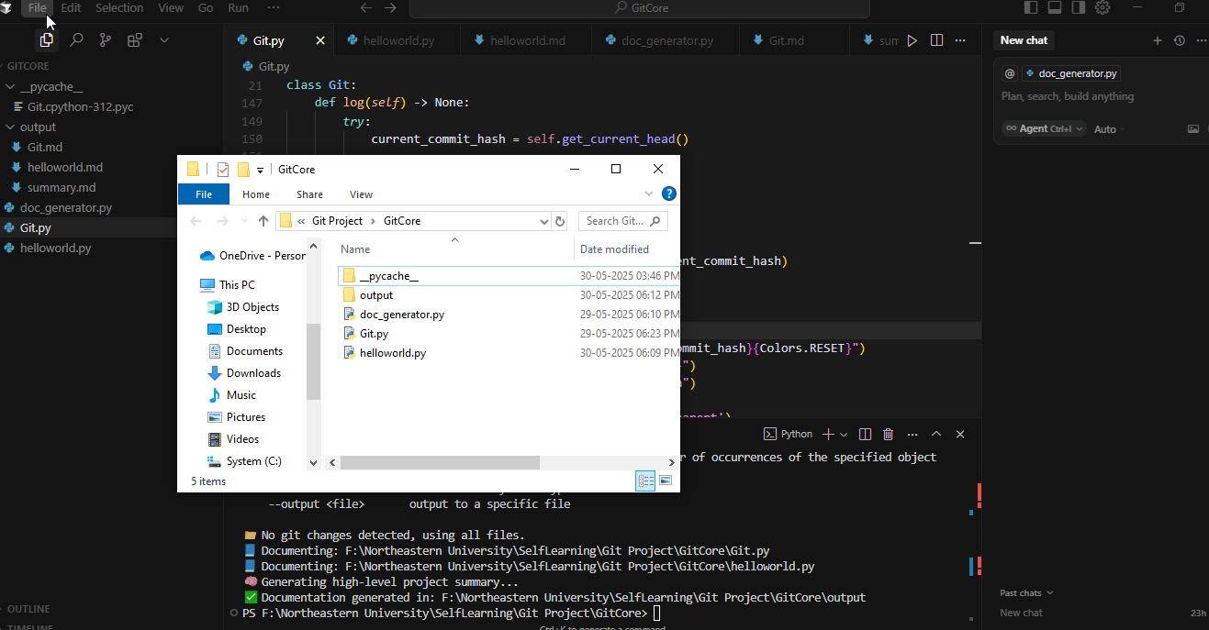

1. Git Init

Command : python Git.py init

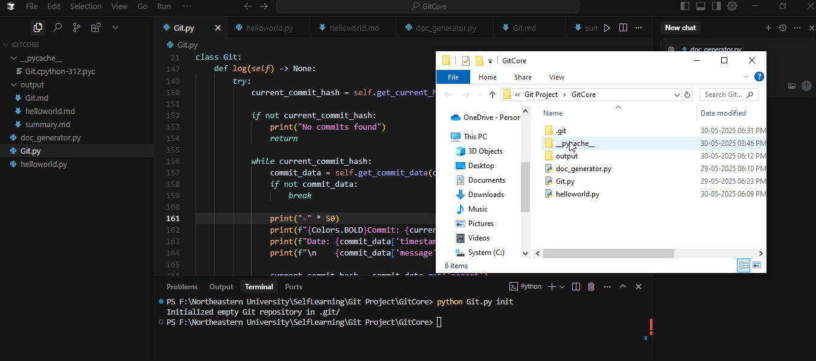

1. Git Add

Command: python Git.py add {filename}

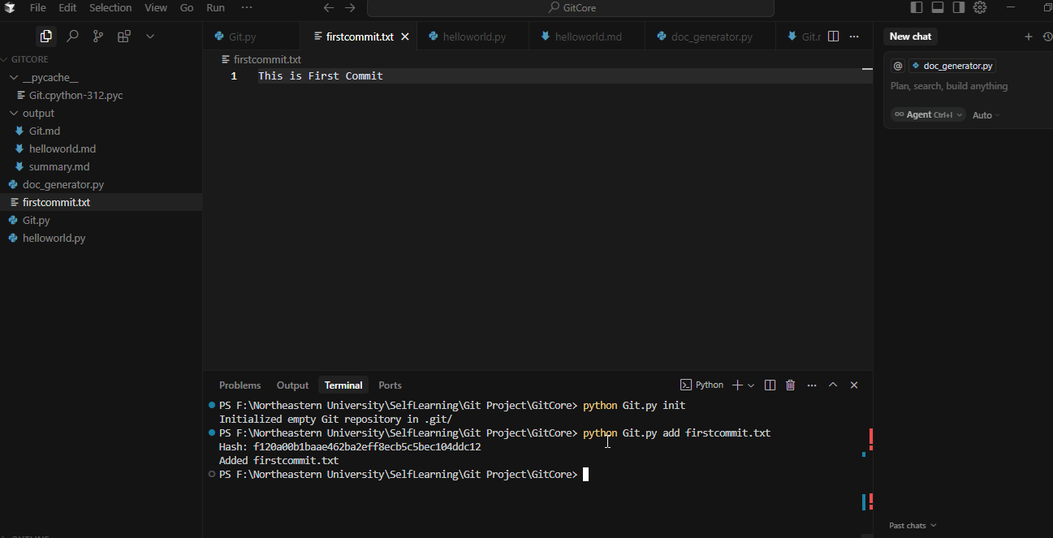

It creates Hash for file

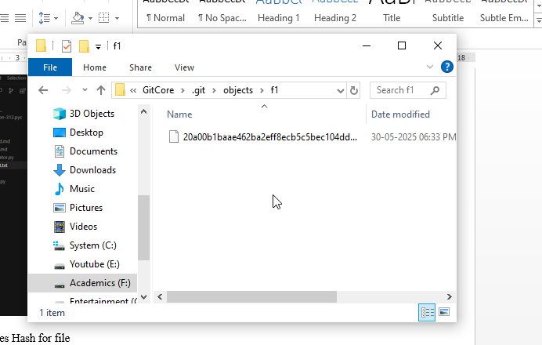

Index file will have the same hash

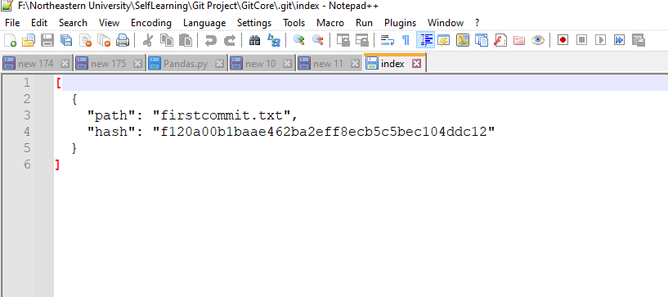

1. Git status

Command: python Git.py status

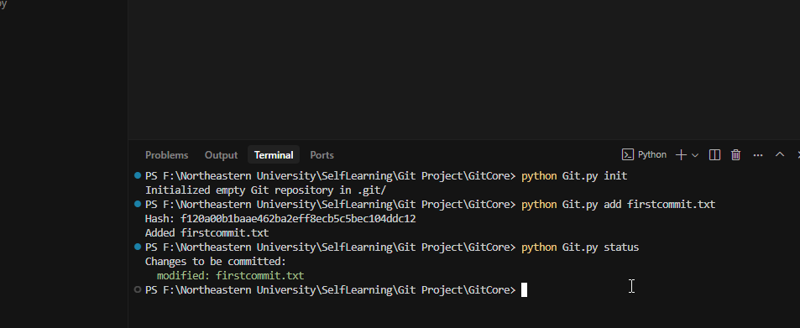

1. Git commit

Command python Git.py commit –m “message”

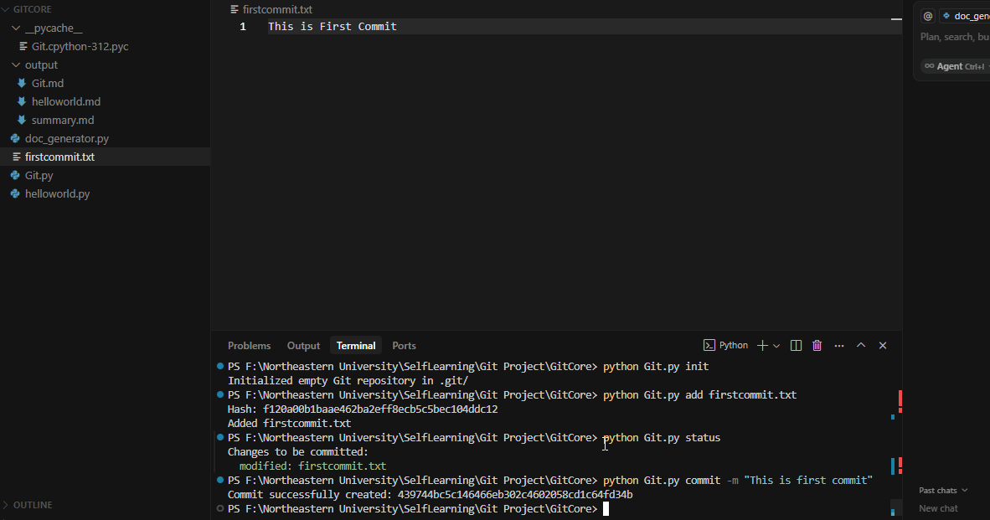

After commit

It adds another hash for commit in objects folder and empty the content of the index file

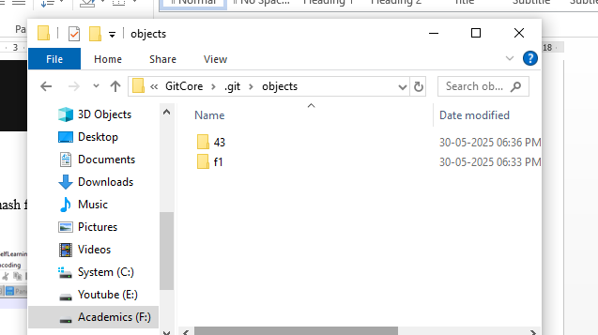

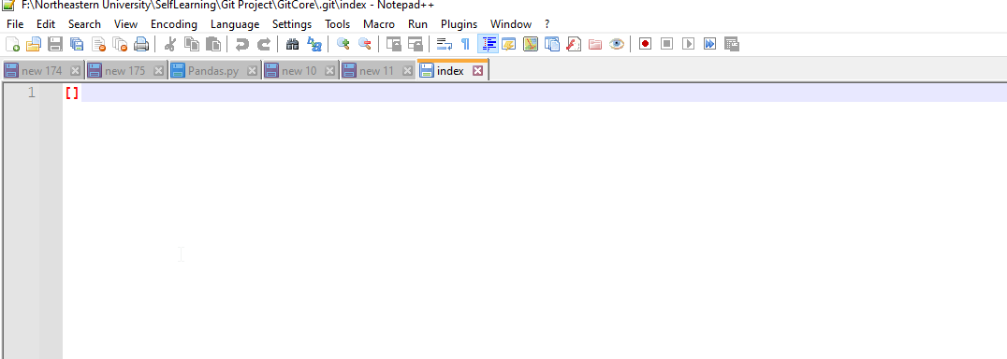

1. Git log

Command: python Git.py log

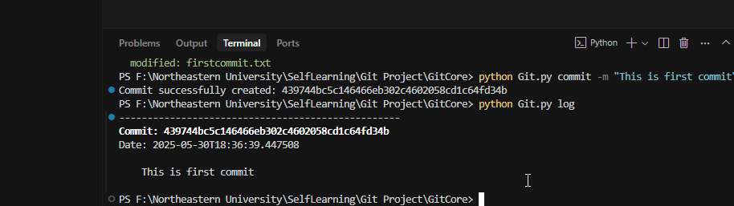

Adding new file as well as making changes in first file to see the difference

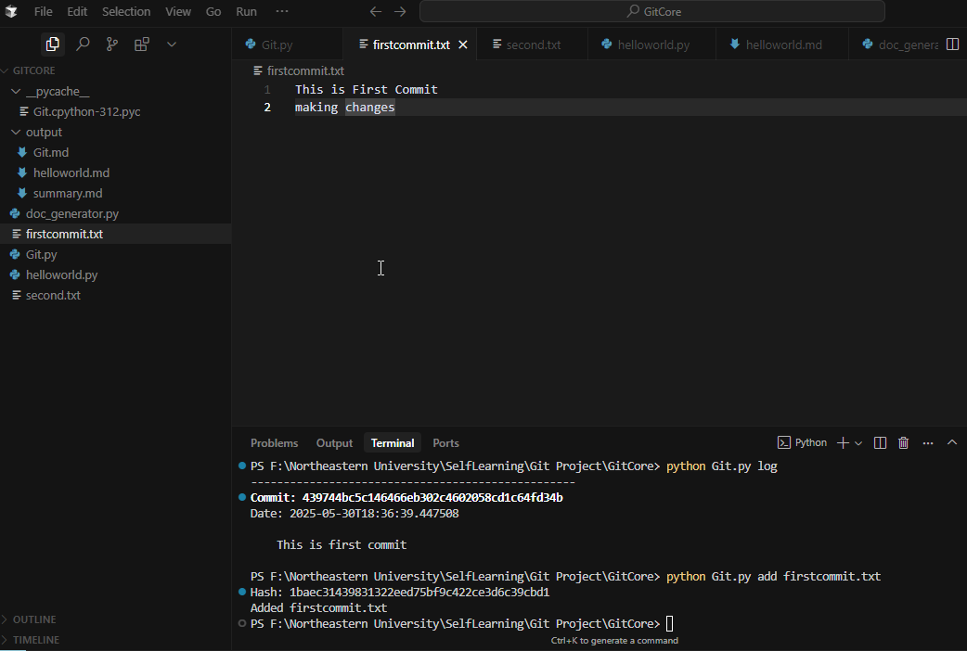

Adding second (new file)

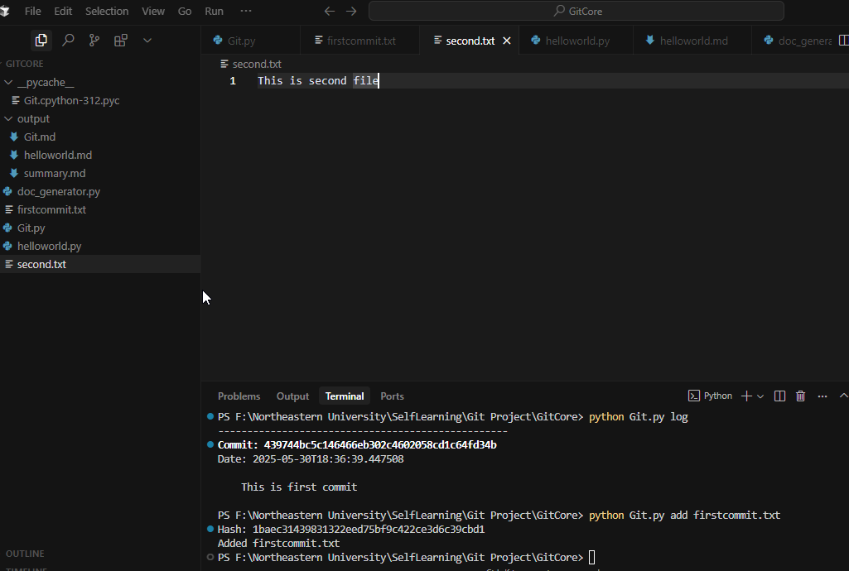

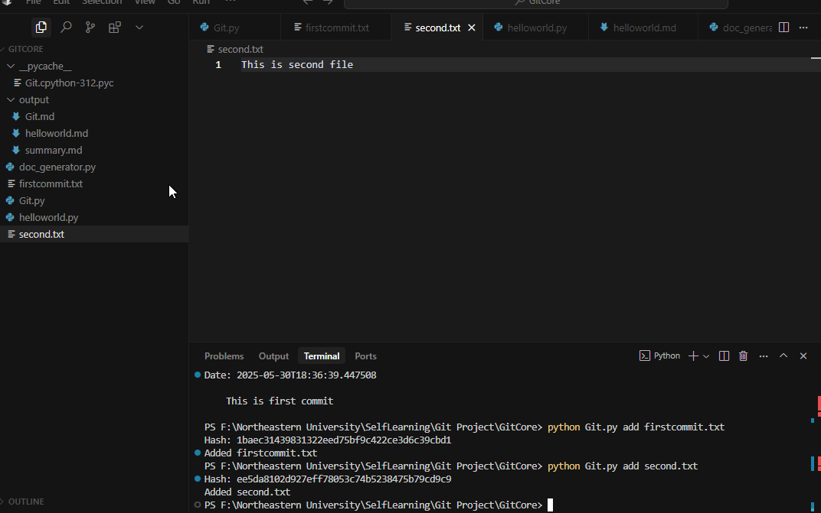

Committing changes

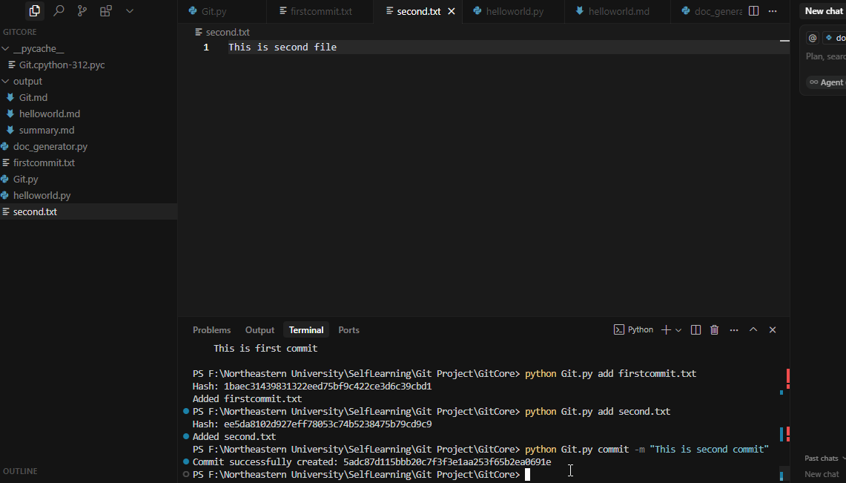

Git show

Command: python Git.py show {hashId}

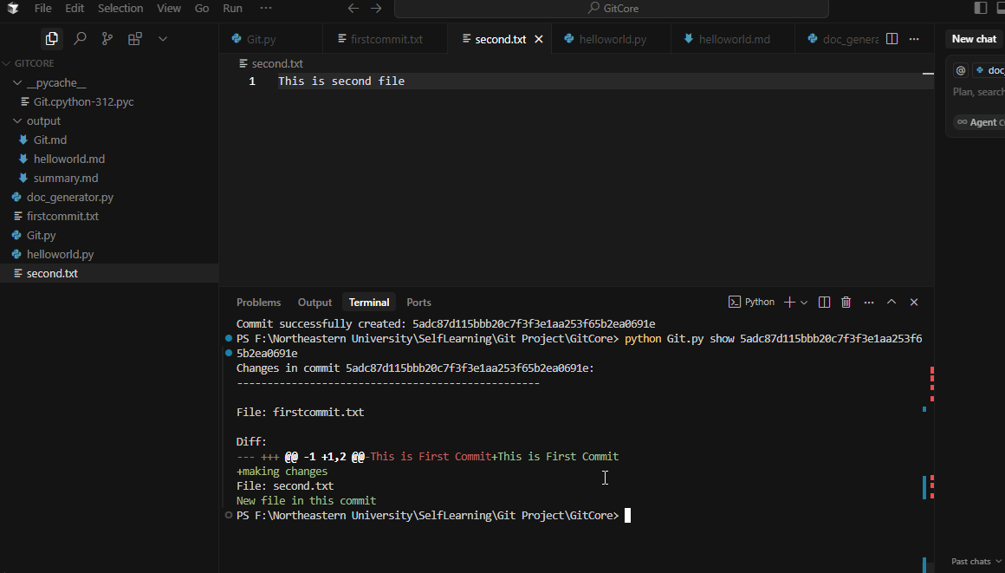

Why does This is First Commit appear as both - and +?

This happens because of the **default behavior of difflib.unified_diff()** when comparing two strings that **do not end with a newline** (\n).

If original file content was:

This is First Commit

and that line did **not end with a newline**, then difflib treats it as an **entire line change** when another line is added.

So internally, it sees:

* Before: "This is First Commit"
* After: "This is First Commit\nmaking changes\n"

And because the first version lacks a \n, the library thinks you **replaced** the old line with a new one (even if visually it looks the same), hence:

-This is First Commit

+This is First Commit

+making changes

Logs

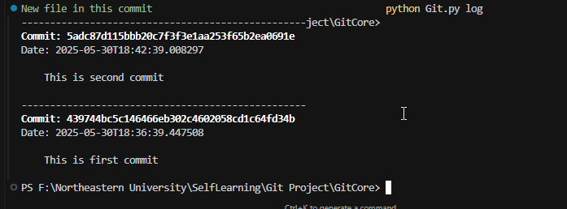

The project also has auto document generator

Command: python doc_generator.py

Used Gemini model to generate document

