**Arena for AGV**

For the demonstration of our project, here is a prototype of a warehouse.

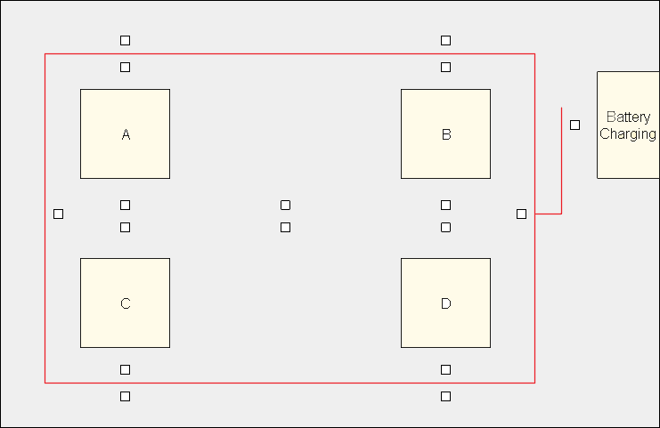

Fig 1

The basic function of AGV is to transfer the load from one position to another. Here A, B, C, D are various positions in the warehouse where materials are placed or picked from. Small boxes in the figure are the QR codes present on the floor for the position identification, direction control and pick or place action. Battery charging section is for automatic battery charging of AGV.

There are 3 ways by which AGV can navigate viz:

1. Line following and QR code for position and action
2. Using QR codes only
3. Person following

For the line following, the red line shown in the figure will be used. Small boxes present on the either side of the line represent QR codes for position and task decision. Navigation using QR codes only can be demonstrated in the central part of arena where red line is absent. Person following means the AGV will follow a person who can load and unload the AGV according to the instructions he/she receives.

A side arm mounted on the AGV is used for pick and place.

Load cell is used for preventing the overloading in person following mode. Buzzer is used to notify person.

Self-charging feature is for automatic battery charging when it drops certain value.

Thus, smart and efficient techniques:

1. Navigation
2. Line following
3. QR code
4. Person following
5. Self-charging and low voltage detection
6. Alarm for overloading

(Open for discussion)…