**Automated Guided Vehicle**

1.1 Introduction:

Today the Automated guided vehicle plays an important role in the design of new factories and warehouses. In an automated process, AGVs are programmed to communicate with other robots to ensure the product is moved smoothly through the warehouse, whether it is being stored for future use or sent directly to shipping areas.  AGV is one kind of transportation that follows the given respective paths and route. It is widely used industrial fields and community services as well as in dangerous working it is able to sense and respond in the given environment.

The first AGV was brought to market in the 1950s, by Barrett Electronics of Northbrook, and at the time it was simply a tow truck that followed a wire in the floor instead of a rail. Over the years the technology has become more sophisticated and today automated vehicles are mainly Laser navigated ex: LGV which works more accurately and precisely in industrial fields, manufacturing processes medical fields. The robot perform hard, dangerous and accurate work in order to make our life easy as they can work for hours without taking rest. They can work without making errors in very less time. The AGV can also store objects on a bed. The objects can be placed on a set of the conveyor and then pushed off by reversing them. Some AGVs use forklifts to lift objects for storage. AGVs are employed in nearly every industry, including, pulp, paper, metals, newspaper, and general manufacturing. Transporting materials such as food, linen or medicine in hospitals is also done. An AGV can also be called a laser guided vehicle (LGV) or self-guided vehicle (SGV). Lower cost versions of AGVs are often called Automated Guided Carts (AGCs) and are usually guided by magnetic tape.

Types of navigation in AGV’S

● Wired navigation - A slot is cut in to the floor and a wire is placed approximately 1 inch below the surface. This slot is cut along the path the AGV is to follow. This wire is used to transmit a radio signal. A sensor is installed on the bottom of the AGV close to the ground. The sensor detects the relative position of the radio signal being transmitted from the wire. This information is used to regulate the steering circuit, making the AGV follow the wire.

● Guide tape navigation - AGVs use tape for the guide path. The AGV is fitted with the appropriate guide sensor to follow the path of the tape. One the major advantage of tape over wired guidance is that can be easily removed and relocated if the course needs to change. Coloured tape is initially less expensive, but lacks the advantage of being embedded in high traffic areas where the tape may become damaged or dirty. The flexible magnetic bar can also be embedded in the floor like wire but works under the same provision as magnetic tape and so remains unpowered or passive. Another advantage of magnetic guide tape is the dual polarity.

● Laser target navigation - The navigation is done by mounting reflective tape on walls, poles or fixed machines. The AGV carries a laser transmitter and receiver on a rotating turret. The laser is transmitted and received by the same sensor. The angle and (sometimes) distance to any reflectors that in line of sight and in range are automatically calculated. This information is compared to the map of the reflector layout stored in the AGV’s memory. This allows the navigation system to triangulate the current position of the AGV. The current position is compared to the path programmed in to the reflector layout map. The steering is adjusted accordingly to keep the AGV on track. It can then navigate to a desired target using the constantly updating position

1.2 Arena:

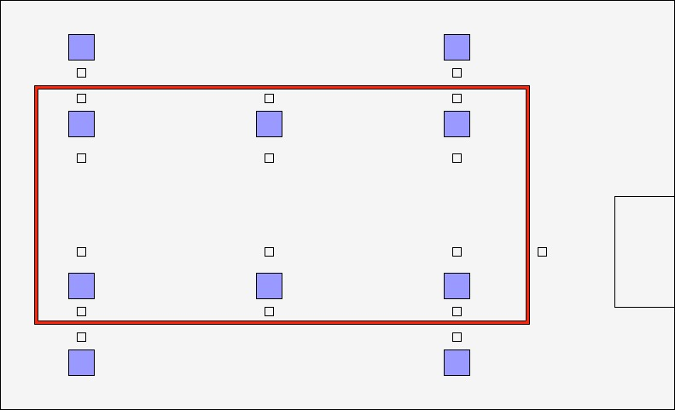

Battery charging

D

C

B

A

Fig 1

For the demonstration of our project, here is the prototype of a warehouse. Blue boxes indicate the locations to and from which material is transported from one position to another. Red line marked is the line on which the AGV can travel using sensors or machine vision. The smaller boxes on either side of the line as well as in the front of blue boxes represent QR codes with which path planning and actions to be performed can be decided.

1.3 Tasks:

There are 3 sections in which the demonstration is divided. Let us call them D1, D2, D3 for the sake of convenience.

1. D1:

Here AGV will use machine vision for the line following application. This will be demonstrated on the red line shown in the figure1. QR codes on the either side of the line are used for decision of pick or place. A, B, C, D are the positions for pick and place application. Side arms present on either side of the AGV are used for it. Configured QR codes pasted on the floor will work as feedback in decision making.

1. D2:

This section will be demonstrated in the internal part of red line. Here we are mainly focusing on the path planning algorithm. Node numbers or values are predefined for the positions in the QR code. By using By using an user interface and IoT platform, start point and destination points are provided to AGV. The optimum path will be decided by the AGV itself. A load cell is used as a feedback to prevent overloading condition.

1. D3:

This is the more advanced feature of AGV. Here AGV will follow a particular person. Machine learning algorithm will be implemented for the same. Also the load cell is used for the preventing overloading.

1. D4:

This is the self-charging feature in which the low battery level will be detected and it will move automatically towards battery charging station. The position of the battery charging station will be decided by a special QR code.