SWIPT-NOMA Optimization using Reinforcement Learning
This project implements Reinforcement Learning (RL) agents to optimize the Pairwise Error Probability (PEP) in a Cooperative Non-Orthogonal Multiple Access (NOMA) system with Simultaneous Wireless Information and Power Transfer (SWIPT).
By intelligently controlling the Continuous Power Splitting ratio (ρ), the RL agents minimize the PEP for both near and far users simultaneously, significantly outperforming fixed-ratio baselines.

Algorithm Details

1. Q-Learning (Tabular Contextual Bandit)
- Formulation: Single-step MDP (γ = 0) where the agent learns the expected immediate Pareto-reward for choosing a discretized ρ.
- State Space: Binned representations of SNR, SNR distances (δ), noise variance (σ_n²), and energy efficiency (η).
- Action Space: 19 discrete actions mapping to ρ in [0.05, 0.95].

2. DDPG - Deep Deterministic Policy Gradient
- Formulation: Actor-Critic continuous control method acting as a contextual bandit (γ = 0).
- State Space: Continuous 5-dimensional vector: [SNR_dB / 40.0, delta_1, delta_2, sigma_n2, eta].
- Action Space: Continuous ρ in (0, 1) output via a Sigmoid activation (scaled to [0.05, 0.95]).
- Networks: 2-layer MLPs (128 -> 64 hidden units).
- Exploration: Ornstein-Uhlenbeck (OU) Noise injected into the continuous action space.

Reward Function (Pareto Hypervolume)
Both agents use a custom, unified reward function designed for Multi-Objective Optimization to balance the near-user and far-user PEPs:
- - Computes a state-specific Pareto Front of PEPs.
- - Grants higher rewards for maximizing the Hypervolume (pushing PEPs closer to zero).
- - Penalizes actions that are strictly dominated by other ρ choices.
- - Grants a boolean +0.5 bonus if the chosen ρ lands exactly on the Pareto Frontier.

System Variables & Context Values
Parameter | Base Value | Grid / Range | Description
K | 5 | - | Total number of relays available.
M | 2 | - | Total number of users receiving the superposition coded signal.
K_ORDER | 3 | - | Target index for the partially selected relay.
USER_ORDERS | (1, 2) | - | Indices representing the near (1) and far (2) users.
LAMBDA | 1.0 | - | Path loss / structural environmental scale factor.
BASELINE_RHO | 0.5 | - | The constant, unoptimized power-splitting ratio baseline.
SNR_DB | 20.0 dB | [0.0, 40.0] | Signal-to-Noise Ratio at the source transmitter.
DELTA (δ) | [0.05, 0.10] | [0.0, 1.0] | The distances/channel variances for the near and far users.
SIGMA_N2 (σ_n²) | 1.0 | [0.5, 1.0] | Additive White Gaussian Noise (AWGN) variance.
ETA (η) | 0.8 | [0.6, 1.0] | Energy conversion efficiency of the SWIPT relay harvesters.

Results and Evaluation
You can view the specific learning curves and policy behavior against baselines in the plots/ directory:
plots/q_learning_training_progress.png: Q-Table convergence over 10,000 episodes
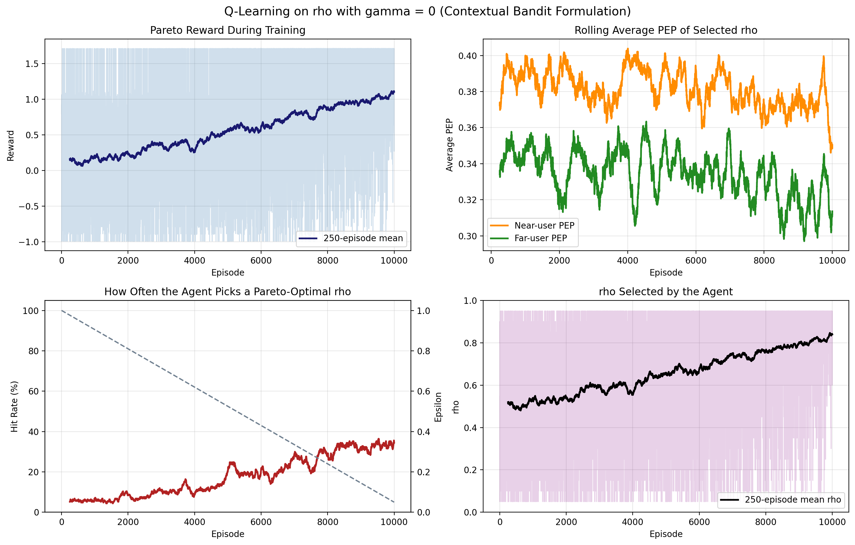
plots/ddpg_training_progress.png: Actor/Critic convergence and OU-Noise exploration curves.
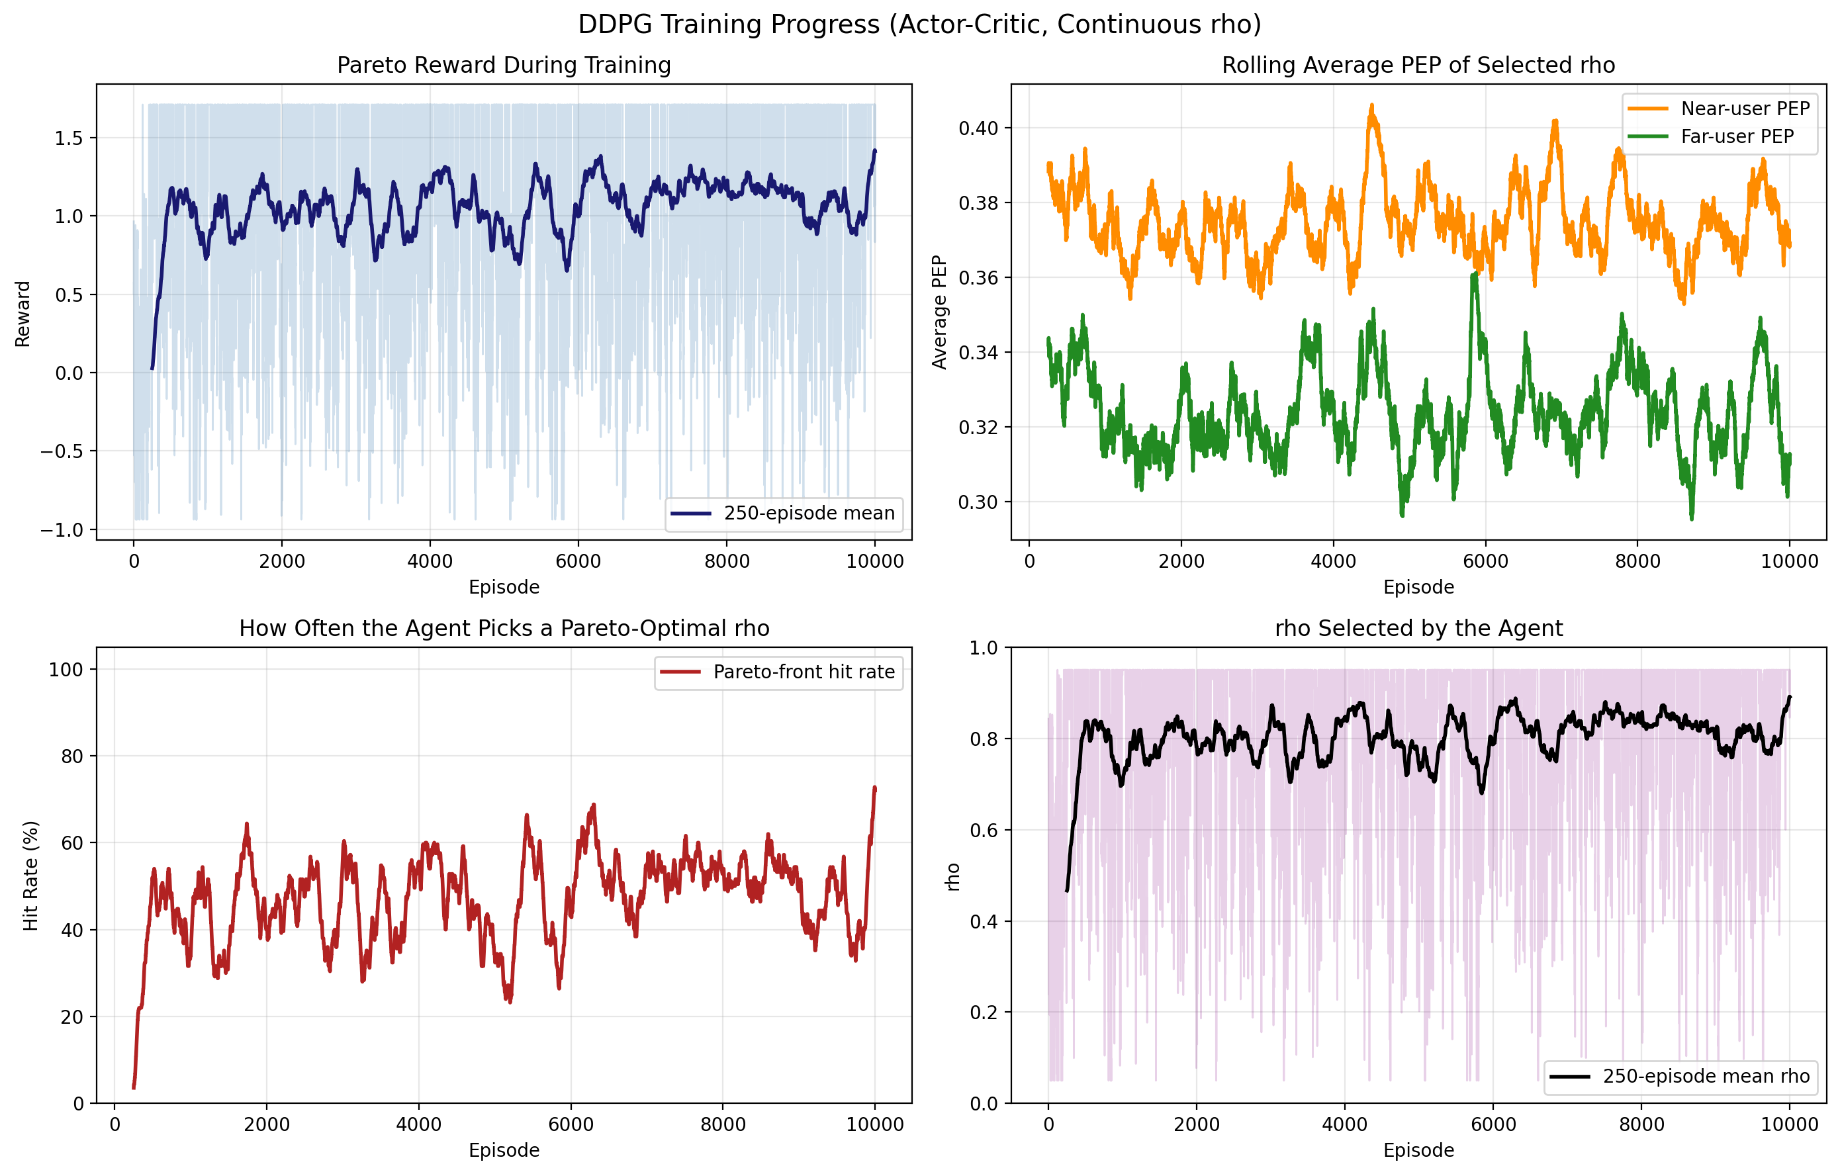
plots/q_learning_policy_evaluation.png / plots/ddpg_pep_vs_snr.png: Sweeps demonstrating the massive, orders-of-magnitude PEP reduction RL achieves over a fixed 0.5 rho at high SNRs.
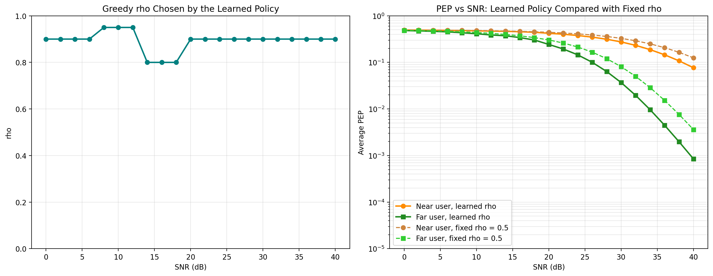
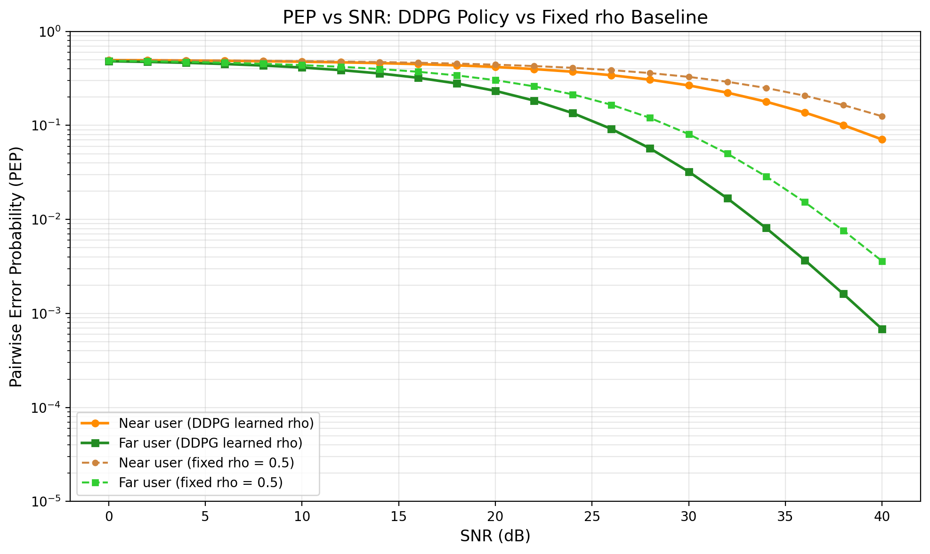
plots/pep_vs_rho_fixed_state.png: Visualizes why optimization is hard—showing the conflicting "bathtub" curves of the near and far user PEPs across the ρ axis.
