Assignment – 1

Submitted by:- Hemant Kumar Rathore

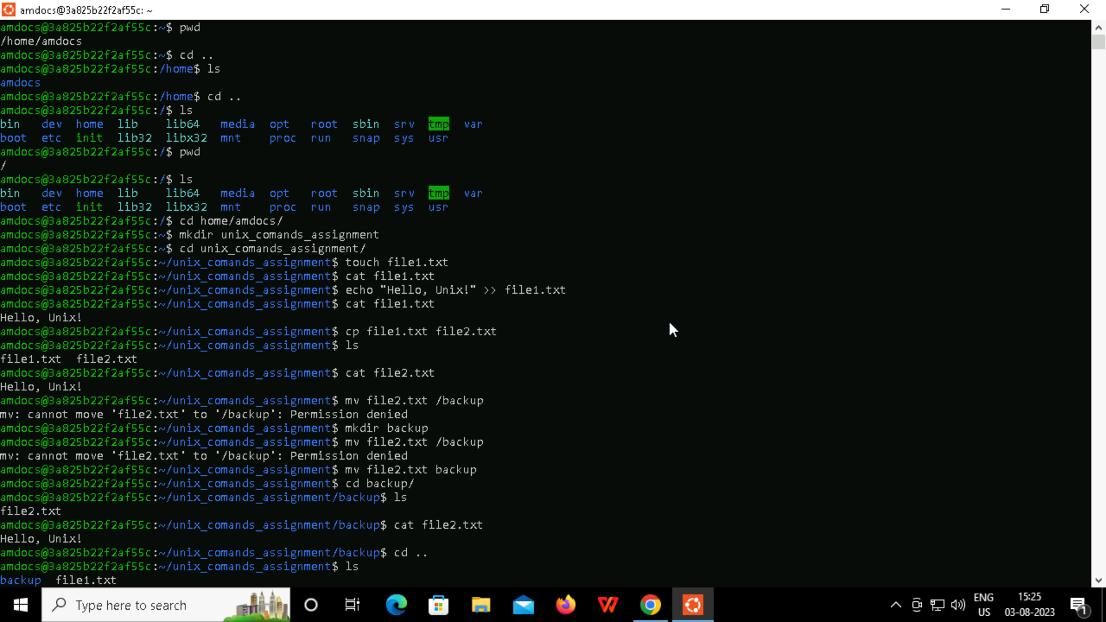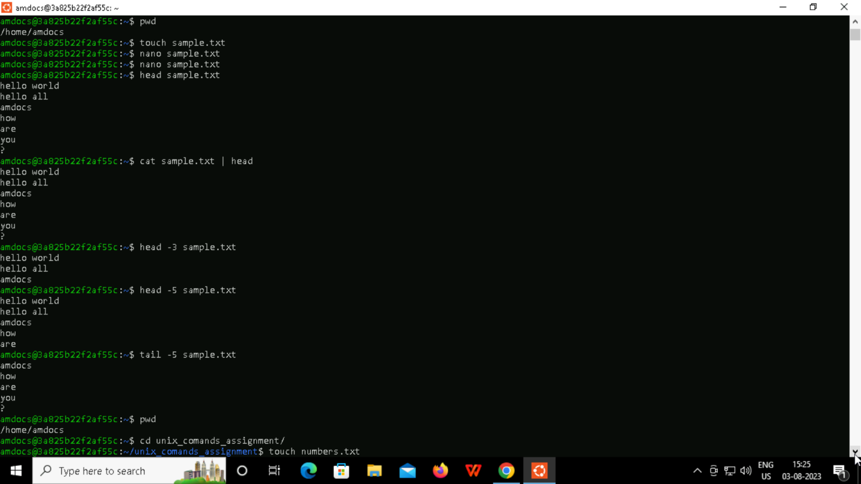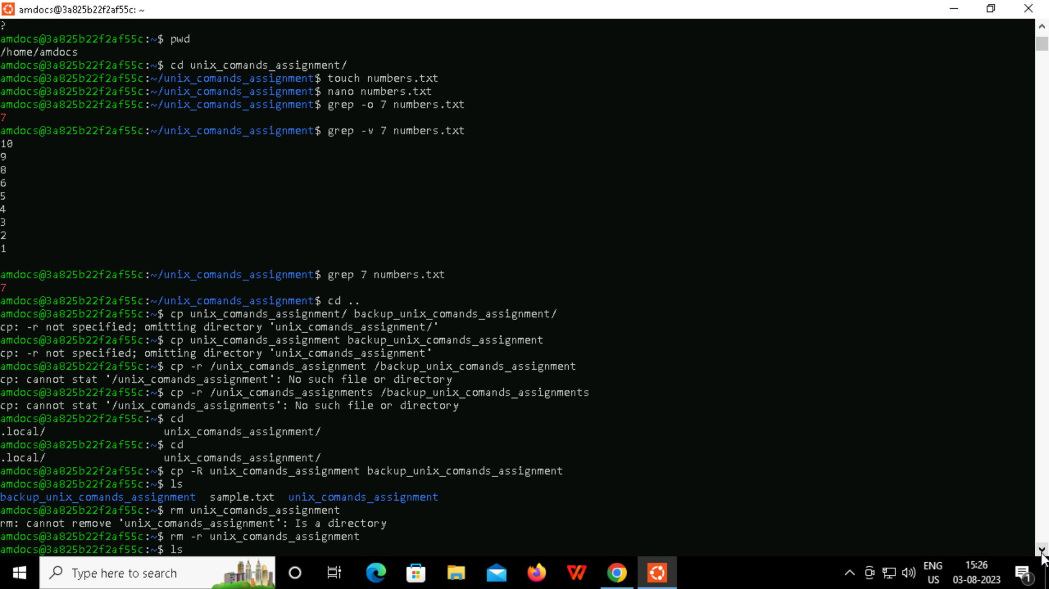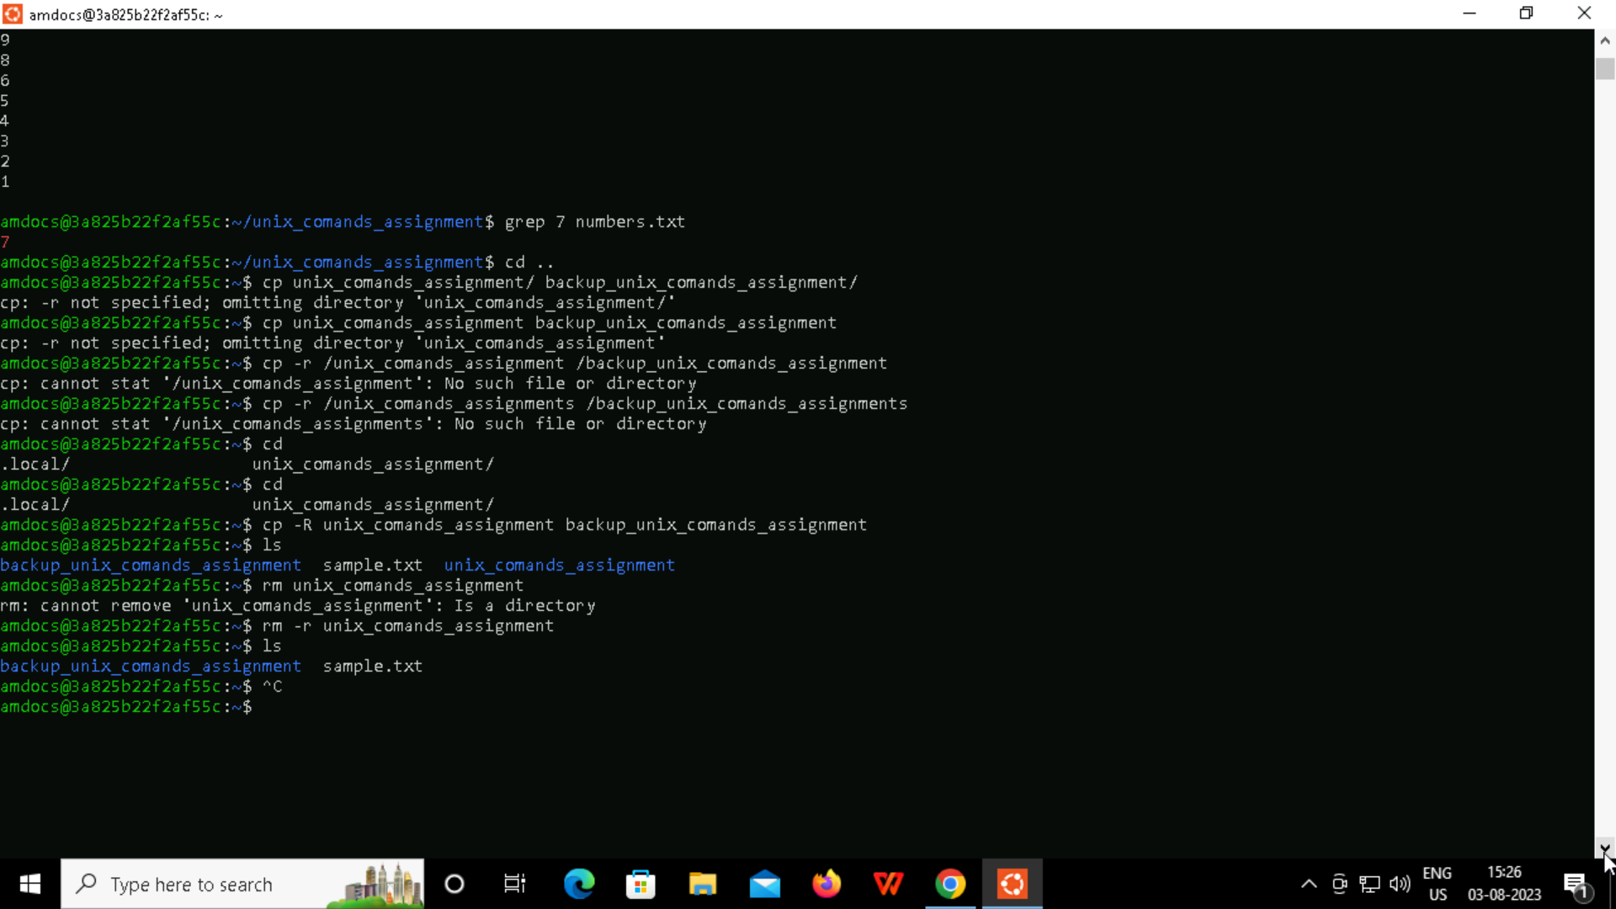

Today, we have learned about some basics as well as some advance Unix shell commands and introduction to Unix operating system. Few of the commands are ls, mkdir, rm, cd, chmod, rmdir, touch, vim, and many more. It was a wonderful learning experience. The way of covering topics and hands on practical implementation of commands really encouraged me and helped me to learn about those topics very easily. I learned some new commands which I have never used before, and this session really helped me to revise the commands which I have learned before.