# **Introduction to Linux Operating System:-**

Linux is a community of open-source Unix like operating systems that are based on the [Linux Kernel](https://www.geeksforgeeks.org/the-linux-kernel/). It was initially released by **Linus Torvalds** on September 17, 1991. It is a free and open-source operating system and the source code can be modified and distributed to anyone commercially or non commercially under the GNU General Public License.

Initially, Linux was created for personal computers and gradually it was used in other machines like servers, mainframe computers, supercomputers, etc. Nowadays, Linux is also used in embedded systems like routers, automation controls, televisions, digital video recorders, video game consoles, smartwatches, etc. The biggest success of Linux is Android(operating system) it is based on the Linux kernel that is running on smartphones and tablets. Due to android Linux has the largest installed base of all general-purpose operating systems. Linux is generally packaged in a Linux distribution.

Linux distribution is an operating system that is made up of a collection of software based on Linux kernel or you can say distribution contains the Linux kernel and supporting libraries and software. And you can get a Linux based operating system by downloading one of the Linux distributions and these distributions are available for different types of devices like embedded devices, personal computers, etc. **Around 600 + Linux Distributions** are available and some of the popular Linux distributions are:

* Arch Linux
* Garuda Linux(Based on Arch Linux and i am currently using it)
* Manjaro (It’s also based on Arch Linux and i used it previously)
* Linux Mint
* Ubuntu
* Debian
* Fedora
* Deepin

## **It’s Daily Life Commands:-**

1. **pwd** - When you first open the terminal, you are in the home directory of your user. To know which directory you are in, you can use the “pwd” command. It gives us the absolute path, which means the path that starts from the root. The root is the base of the Linux file system. It is denoted by a forward slash( / ). The user directory is usually something like "/home/username".

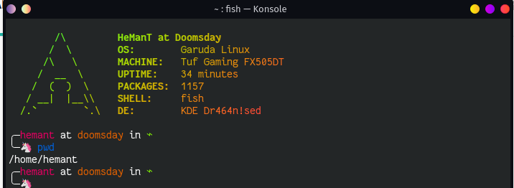

1. **ls** - Use the "ls" command to know what files are in the directory you are in. You can see all the hidden files by using the command “ls -a”.

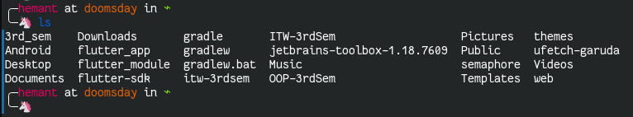

1. **cd** - Use the **“cd"** command to go to a directory. For example, if you are in the home folder, and you want to go to the Downloads folder, then you can type in **“cd Downloads”**. Remember, this command is case sensitive, and you have to type in the name of the folder exactly as it is. But there is a problem with these commands. Imagine you have a folder named **“3rd Sem”**. In this case, when you type in **“cd 3rd Sem”**, the shell will take the second argument of the command as a different one, so you will get an error saying that the directory does not exist. Here, you can use a backward slash. That is, you can use **“cd 3rd\ Sem”** in this case or do **cd “3rd Sem”**. To go back from a folder to the folder before that, you can type **“cd ..”** . The two dots represent back.

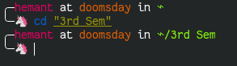

1. **mkdir & rmdir** — Use the mkdir command when you need to create a folder or a directory. For example, if you want to make a directory called “**ITW_Lab”**, then you can type **“mkdir ITW_Lab”**. Remember, as told before, if you want to create a directory named **“ITW Lab”**, then you can type **mkdir “ITW Lab”** . Use **rmdir** to delete a directory. But **rmdir** can only be used to delete an empty directory. To delete a directory containing files, use **rm**.

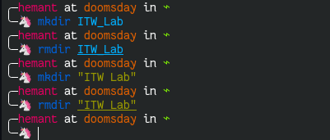

1. **touch** - The **touch** command is used to create a file. It can be anything, from an empty text file to an empty zip file. For example, **“touch new”**.(Yes in linux you can make text files without specifying the **.txt** extension)

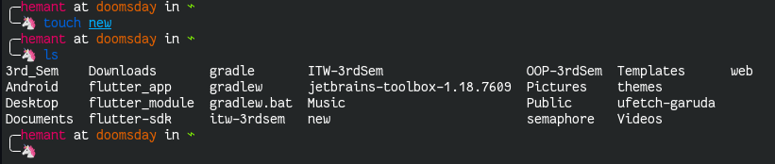

1. **Man & --help** - To know more about a command and how to use it, use the man command. It shows the manual pages of the command. For example, **“man cd”** shows the manual pages of the cd command. Typing in the command name and the argument helps it show which ways the command can be used **(e.g., cd –help)**.

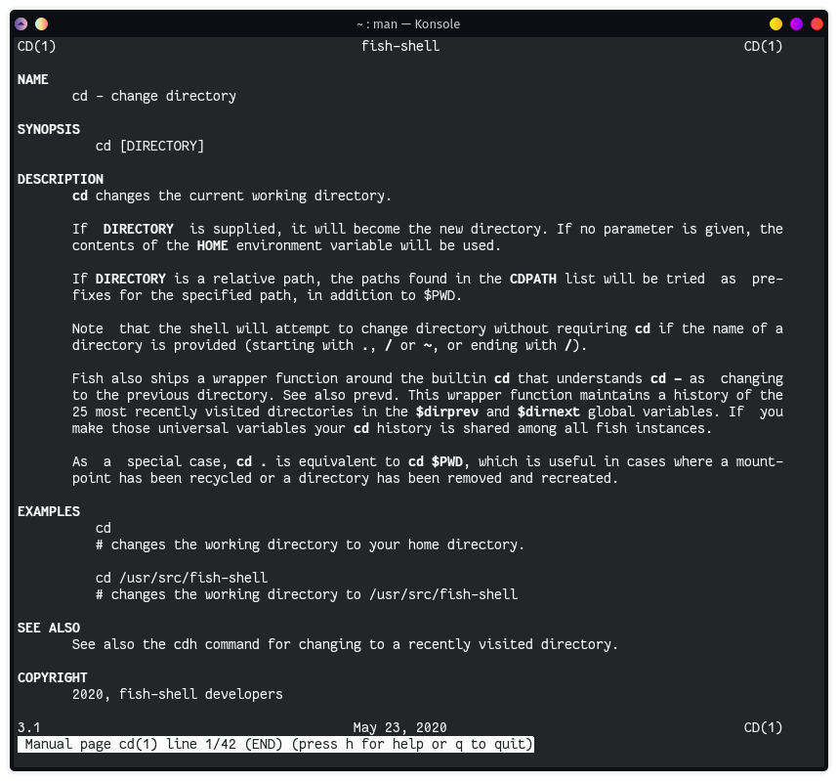

1. **cp** - Use the cp command to copy files through the command line. It takes two arguments: The first is the location of the file to be copied, the second is where to copy.

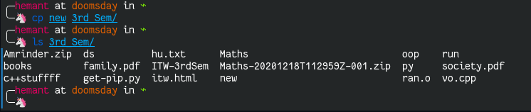

1. **mv** - Use the mv command to **move files through** the command line. We can also use the mv command to r**ename a file**. For example, if we want to rename the file “**new**” to “**text**”, we can use “**mv new text**”. It takes the two arguments, just like the **cp** command.

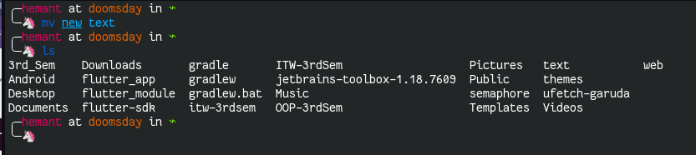

1. **cat** - Use the **cat** command to display the contents of a file. It is usually used to easily view programs.

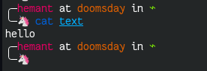

1. **nano** - nano is already installed text editor in the Linux command line. The nano command is a good text editor that denotes keywords with color and can recognize most languages. You can create a new file or modify a file using this editor. For example, if you need to make a new file named "**new_file.txt"**, you can create it by using the command “**nano new_file.txt**”. You can save your files after editing by using the sequence Ctrl+X, then Y (or N for no).

