**VARIOUS TOOLS USED IN MICROSOFT EXCEL**

There are a variety of functions available in Excel. Here are some of the most common functions you'll use:

* **SUM**: This function **adds** all of the values of the cells in the argument.
* **AVERAGE**: This function determines the **average** of the values included in the argument. It calculates the sum of the cells and then divides that value by the number of cells in the argument.
* **COUNT**: This function **counts** the number of cells with numerical data in the argument. This function is useful for quickly counting items in a cell range.
* **MAX**: This function determines the **highest** **cell value** included in the argument.
* **MIN**: This function determines the **lowest cell value** included in the argument.

## 

## **The SUM Function**

#### The sum function is the most used function when it comes to computing data on Excel. This function works to sum a group of numbers in a specific set of cells. You don’t need to type a long cumbrous formula just to calculate the sum of all the data you need.This function is performed by typing the formula on the function bar and highlighting the cells you want summed before clicking “Enter”.

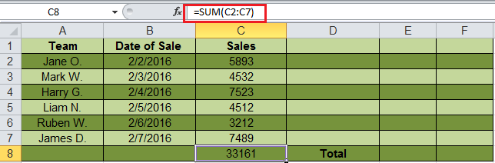

The syntax formula for *sum* function is “=SUM” (number1, number2, etc.).

In this image, the *sum* function for the cells C2 through C7 is obtained through the formula “=SUM(C2:C7)”, giving you the result of 33161.

## **The TEXT Function**

Text function is a useful tool that helps convert a date (or number) into a text string in a particular format. It falls in the category of string formulas that converts numerical values to a string. It is handy when users need to view numeric data in a readable format. Take note that the “TEXT” formula only works to convert numeric values to text. Therefore, its results cannot be calculated.

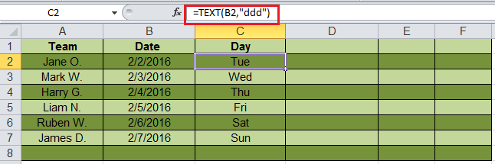

The syntax formula for *text* function is “=TEXT” (value, format_text).

“Value” refers to the particular number you wish to convert to text.

“Format_text” defines the format of the conversion.

## **The VLOOKUP Function**

VLookup is powerful Excel function that is often overlooked. Users will find it useful when they need to find specific data on a large table. You can also use VLookup to search for names, phone number, or specific data on your sheet. Instead of manually looking for the names and wasting time scrolling through hundreds of data, the [VLookup function](http://spreadsheeto.com/vlookup/) makes this process faster and more efficient.

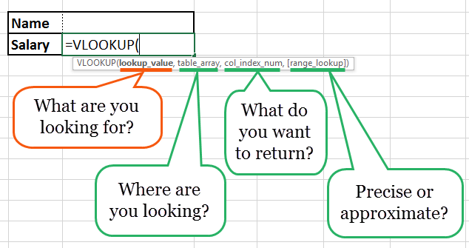

The VLookup formula is “=VLOOKUP” (lookup_value, table_array, col_index_num, *range_lookup*).

* “lookup_value” is the data you want to find.
* “table_array” is the data column where you want to limit your search.
* “col_index_num” is the column number within the table that you want to return a value from.
* “range_lookup” is an optional argument that allows you to search for the exact match of your lookup value without sorting the table.

## **The AVERAGE Function**

The average function is an extremely useful tool for getting the average value in a range of cells. Like the sum function, it is frequently used in computing and analyzing data on spreadsheet. Basically, the average function works to find the “arithmetic mean” for a group of cells. Aside from the average function, Excel also has the median and mode function.

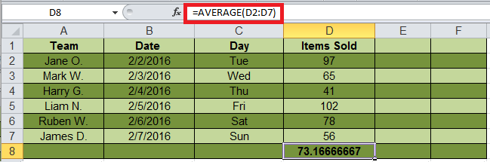

The syntax formula for the average function is “AVERAGE” (number1, number2, etc.).

* “Number 1” refers to the first number in the range where you want the average.
* “Number 2” is the additional reference of the average range. You can get an average of up to a maximum of 255 cells.

Additional ­­Examples:

“=AVERAGE (A2:A10)” – computes the average of numbers in cells A2 through A10.

“=AVERAGE (B2: B10, 7)” – computes the average of the numbers in cells B2 through B10 and the number 7.

## 

## **The CONCATENATE Function**

This function is a good time saver when you need to combine data from 2 or more cells. Unlike the merge tool which physically merges two or more cells into a single cell, the concatenate function only combines the contents of the combined cells. In the latest version of Excel ( 2016), the concatenate function has been replaced with concat function and will be incorporated in more future versions of Excel.

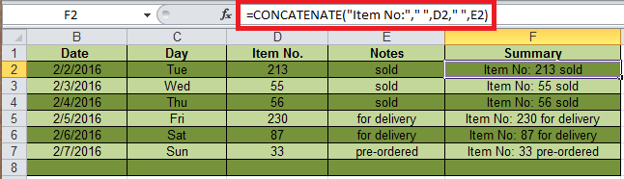

The syntax formula for the *concatenate* function is “CONCATENATE” (text1, [text2…text_n]),

* “Text1, Text2…text_n” are the data you want to combine.