Aim:- Identify the peripherals of a computer , components in a CPU and its functions

PERIPHERALS DEVICES

A **peripheral device** is generally defined as any auxiliary **device** such as a computer mouse or keyboard, that connects to and works with the computer in some way. Other examples of **peripherals** are expansion cards, graphics cards, image scanners, tape drives, microphones, loudspeakers, webcams, and digital cameras.

Types of peripherals devices

## Input Devices: An Input Device is a hardware component which helps the user to provide proper instructions to Computer System. Input devices act as an intermediary between user and other computer components. Eg: Keyboard, Mouse etc.

1. Output Devices: The output device is any piece of computer hardware equipment that converts information into human-readable form. Eg: Speakers, Printers etc.

INPUT DEVICES

1. **keybord** :- A **computer keyboard** is a [typewriter-style device](https://en.wikipedia.org/wiki/Typewriter#Keyboard_layouts) which uses an arrangement of buttons or [keys](https://en.wikipedia.org/wiki/Push-button) to act as [mechanical levers](https://en.wikipedia.org/wiki/Mechanical_keyboard) or [electronic switches](https://en.wikipedia.org/wiki/Electronic_switching_system). Replacing early [punched cards](https://en.wikipedia.org/wiki/Punched_card) and [paper tape](https://en.wikipedia.org/wiki/Paper_tape) technology, interaction via [teleprinter](https://en.wikipedia.org/wiki/Teleprinter)-style keyboards have been the main [input method](https://en.wikipedia.org/wiki/Input_device) for [computers](https://en.wikipedia.org/wiki/Computer) since the 1970s, supplemented by the [computer mouse](https://en.wikipedia.org/wiki/Computer_mouse) since the 1980s.

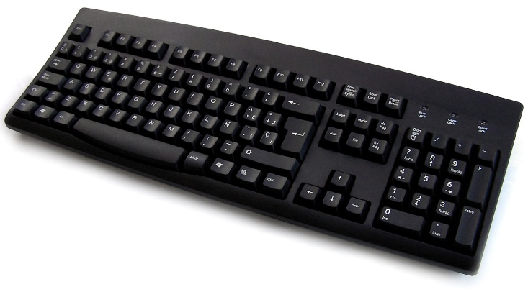

1. **Mouse** :- Pointing devices are the most commonly used input devices today. A **pointing device** is any human interface device that allows a user to input spatial data to a computer. In the case of mouse and touchpads, this is usually achieved by detecting movement across a physical surface. Analog devices, such as [3D mice](https://en.wikipedia.org/wiki/3D_mouse), [joysticks](https://en.wikipedia.org/wiki/Joystick), or [pointing sticks](https://en.wikipedia.org/wiki/Pointing_stick), function by reporting their angle of deflection. Movements of the pointing device are echoed on the screen by movements of the [pointer](https://en.wikipedia.org/wiki/Pointer_(user_interface)), creating a simple, intuitive way to navigate a computer's [graphical user interface](https://en.wikipedia.org/wiki/Graphic_User_Interface)

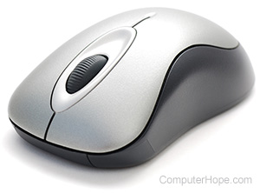

## Scanner:- Scanner is an input device, which works more like a photocopy machine. It is used when some information is available on paper and it is to be transferred to the hard disk of the computer for further manipulation.

## Scanner captures images from the source which are then converted into a digital form that can be stored on the disk. These images can be edited before they are printed.

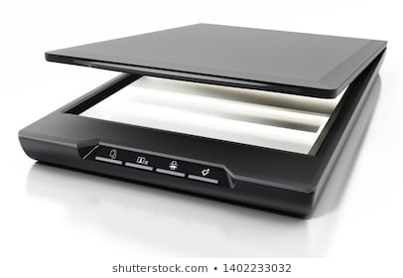

1. 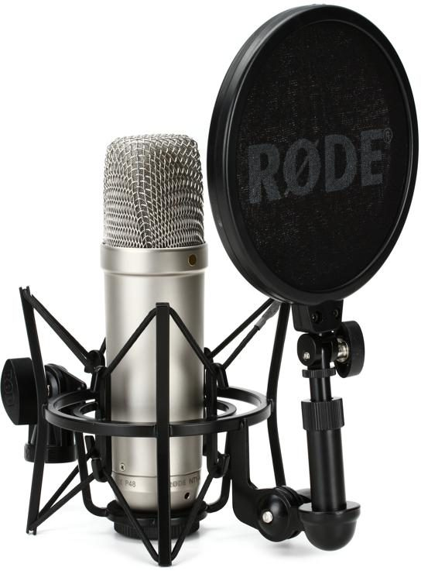**Microphone** :- A **microphone** is a device that captures audio by converting sound waves into an electrical signal. ... Since dynamic **microphones** use a simple design, they are typically very durable and do not require electrical power. Condenser - Condenser **microphones** are commonly used for audio recording purposes
2. **Webcam**:- A is a hardware input device which is either connected to the computer by a USB or inbuilt (in laptops) and is capable of taking still picture or motion video of the user or an object in front of it. The photos taken are of the compact digital type which can be uploaded or used over the internet.

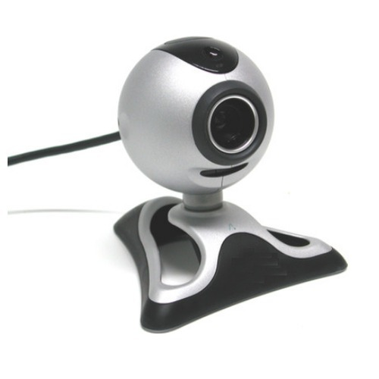

OUTPUT DEVICES

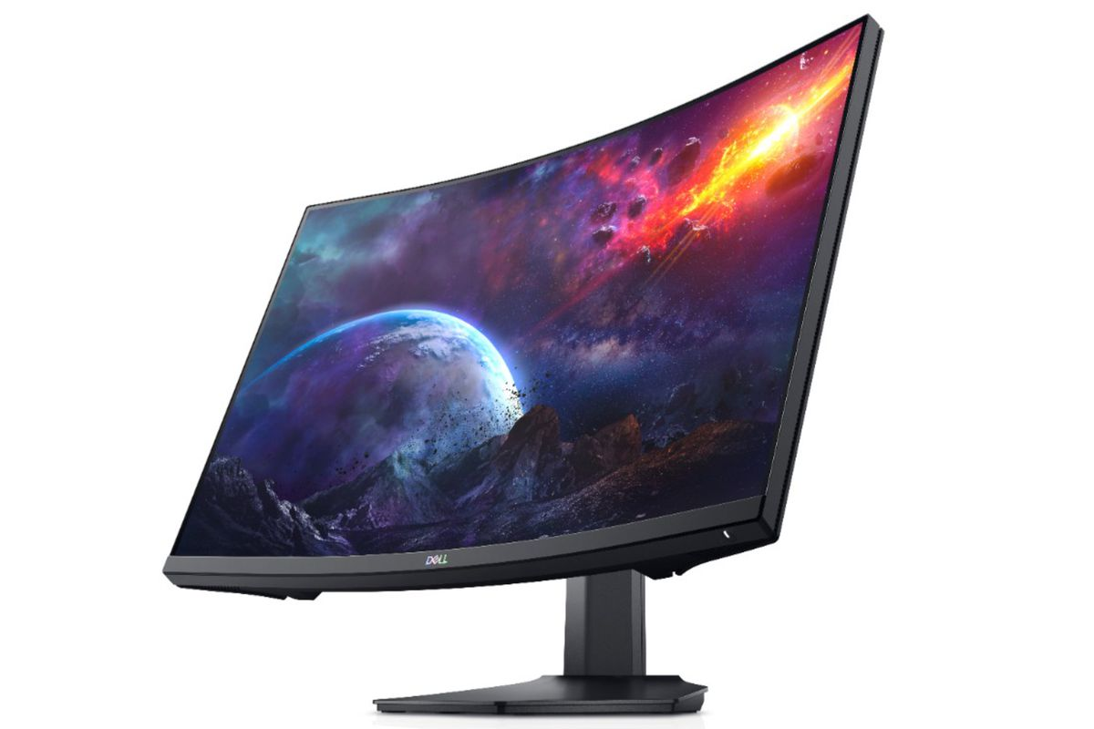1**.Monitor :-** A computer **monitor** is an output device that displays information in pictorial form. A **monitor** usually comprises the visual display, circuitry, casing, and power supply. ... Older **monitors** used a cathode ray tube (CRT).

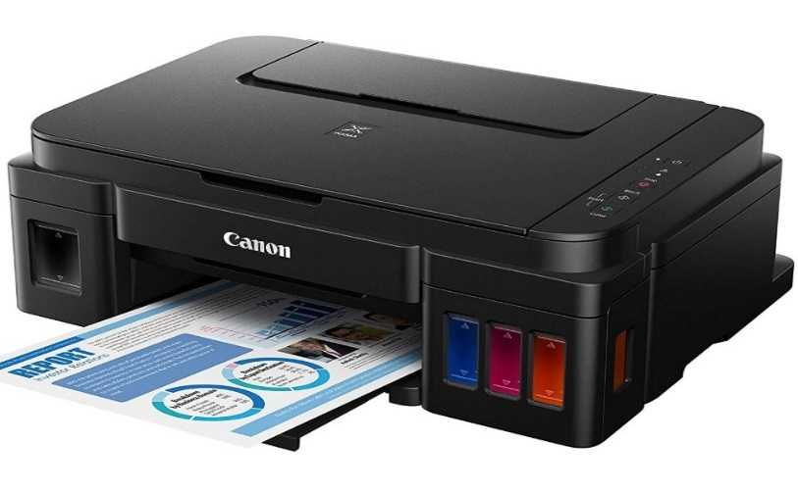 **2.Printer** :- In [computing](https://en.wikipedia.org/wiki/Computing), a **printer** is a [peripheral](https://en.wikipedia.org/wiki/Peripheral) device which makes a persistent representation of graphics or text, usually on [paper](https://en.wikipedia.org/wiki/Paper). While most output is human-readable, bar code printers are an example of an expanded use for printers. The different types of printers include 3D printer, inkjet printer, laser printer, thermal printer, etc.

3.**Speaker** :- **Speakers** are one of the most common output devices used with **computer** systems. **Speakers** are transducers that convert electromagnetic waves into sound waves. ... The **speakers** receive audio input from a device such as a **computer** or an audio receiver. This input may be either in analog or digital form.

:- 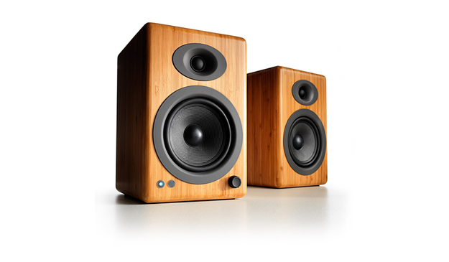

4**.Headphones** :- **Headphones** are small speakers that can be worn in or around your ears. **Headphones** that connect to an analog audio port (such as a 3.5 mm audio jack) process analog audio. ... **Headphones** that connect to a digital port, such as a USB or Lightning port process digital audio



5. **Projector :-** It is a display device that projects a computer-created image onto another surface: usually some sort of whiteboard or wall. The computer transmits the image data to its video card, which then sends the video image to the projector. It is most often used for presentations, or for viewing videos.

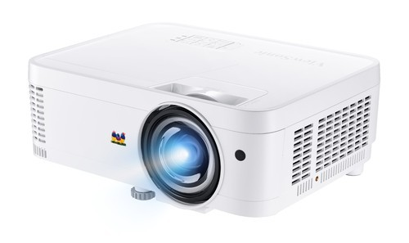COMPONENTS OF CPU

CPU stands for Central processing unit .It is also known as microprocessor or processor . A CPU is brain of a computer . It is responsible for all functions and processes .Regarding computing power ,the CPU is the most important element of a computer system .The CPU is consisted of thin layers of thousands of transistors .Each transistor receives a set of inputs and produces output . Transistors hold a key role in functioning of CPU as they make computer able to count and perform logical operations which is called processing .It processes the instructions that it collects by decoding the code in programs . Computers use two types of storage: Primary storage and secondary storage. The CPU mainly interacts with primary storage or main memory ,referring to it for both instructions and data.

Main Components of CPU:  
  
The main components of CPU help it in performing various functions. The components of a CPU work together, and their making/manufacturing determine the complexity of operations as well as how fast they can be carried out.

The three components of the CPU are following,  
**1.**Arithmetic Logic Unit  
**2.** Control Unit  
**3.** Registers

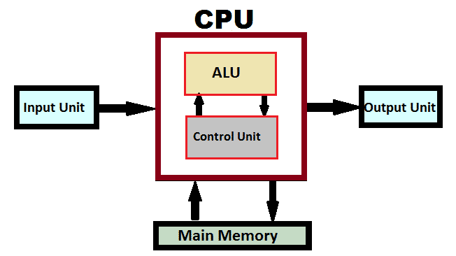  
  
Arithmetic Logic Unit (ALU)  
  
There is electronic circuitry in arithm etic logic unit which executes all arithmetic and logical operations .Its function is obvious from its name .It performs arithmetic calculations like as addition, subtraction, multiplication and division as well as comparisons .The unit can compare numbers, letters, or special characters .There can be more than one Arithmetic logic unit in a CPU, and these ALUs can also be used for the purpose of maintaining timers that help run the computer.

Control Unit(CU)

There is circuitry in the control unit which uses electrical signals to instruct the whole computer system for carrying out or executing, already stored program instructions. Its name clearly shows that it controls and co-ordinates computer components . It extracts instructions from memory and decodes and executes them. In fact it regulates the flow of information through the processor .In short ,it can be said ,this component receives, decodes, stores results and manages execution of data that flows through the CPU. Its communication with both arithmetic unit and memory is inevitable.

Registers/The Memory Unit  
  
Registers are temporary storage areas which are responsible for holding the data that is to be processed .They store the instructions and data in a processor .This data is further used by Control Unit .There are some registers that are set aside for specific tasks, these generally include a program counter, stack, and flags.