**Install Power BI Desktop and share the final screenshot of the report view page which appears when power desktop starts.**

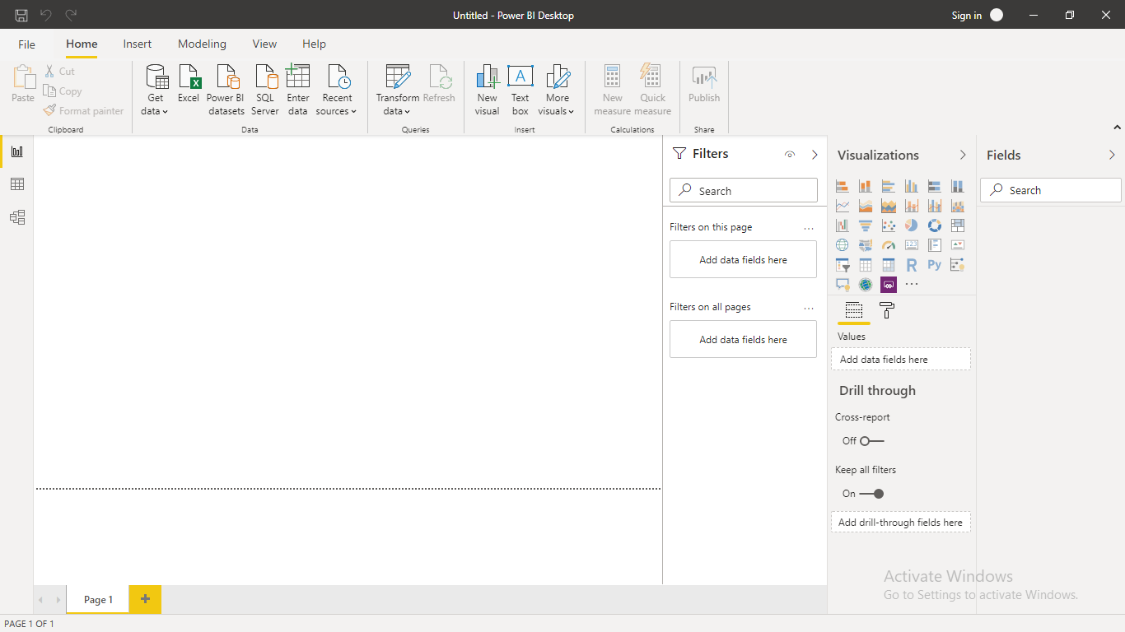

**Install Power BI Desktop and share the final screenshot of the report view page which appears when power desktop starts.**

**− Report View**



**− Data View**

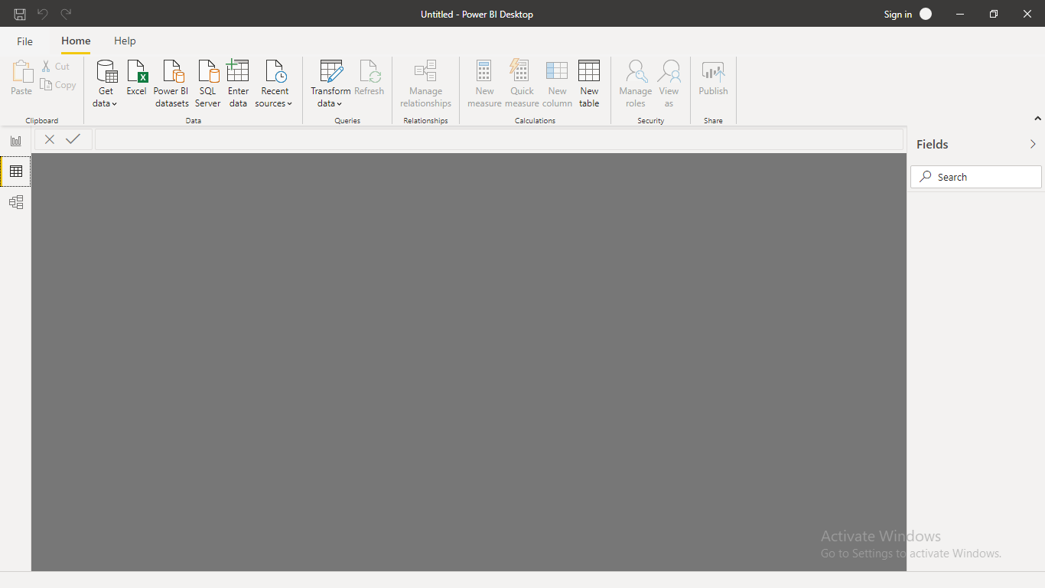

**− Model View**

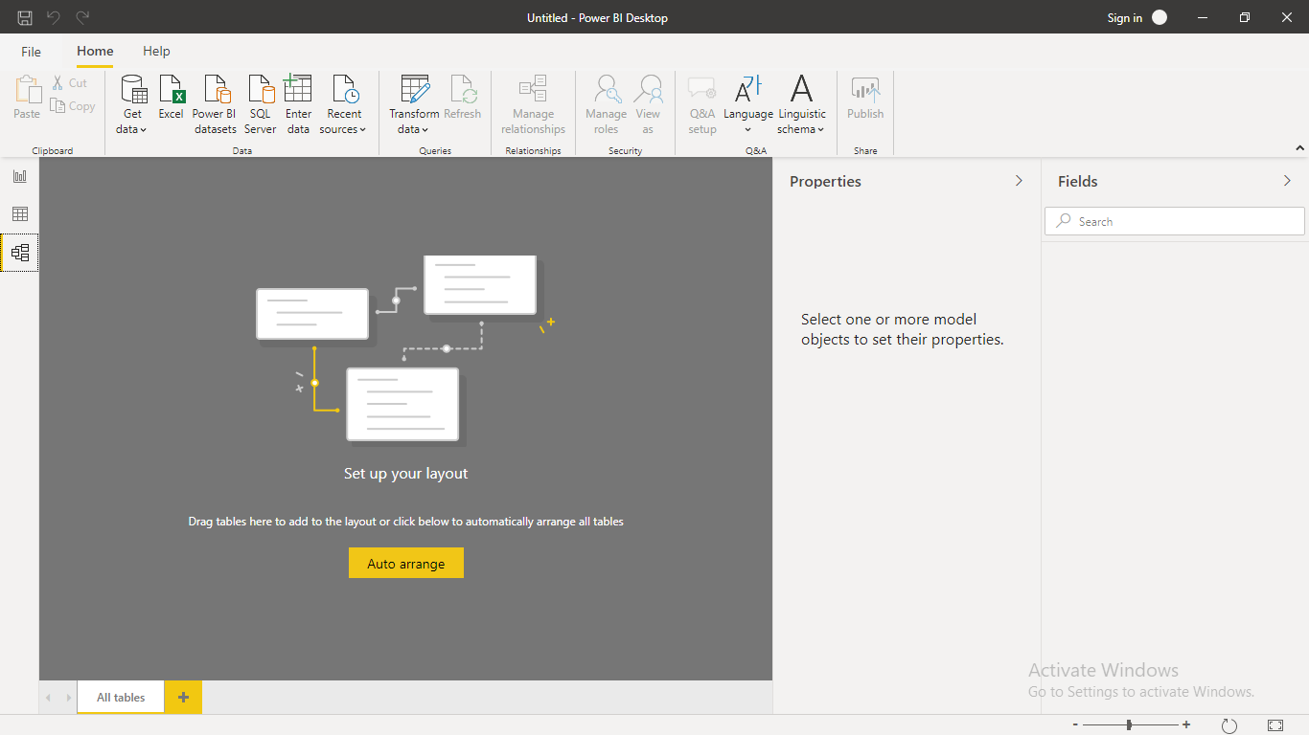

**− Power Query Editor**

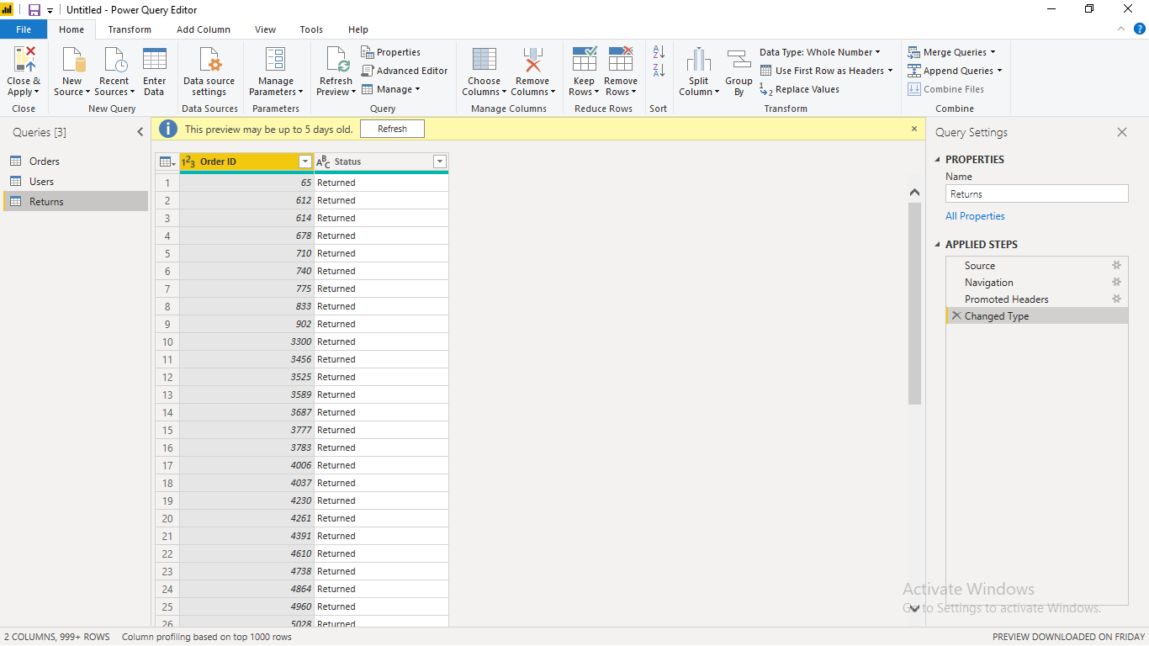

**− Advance Editor**

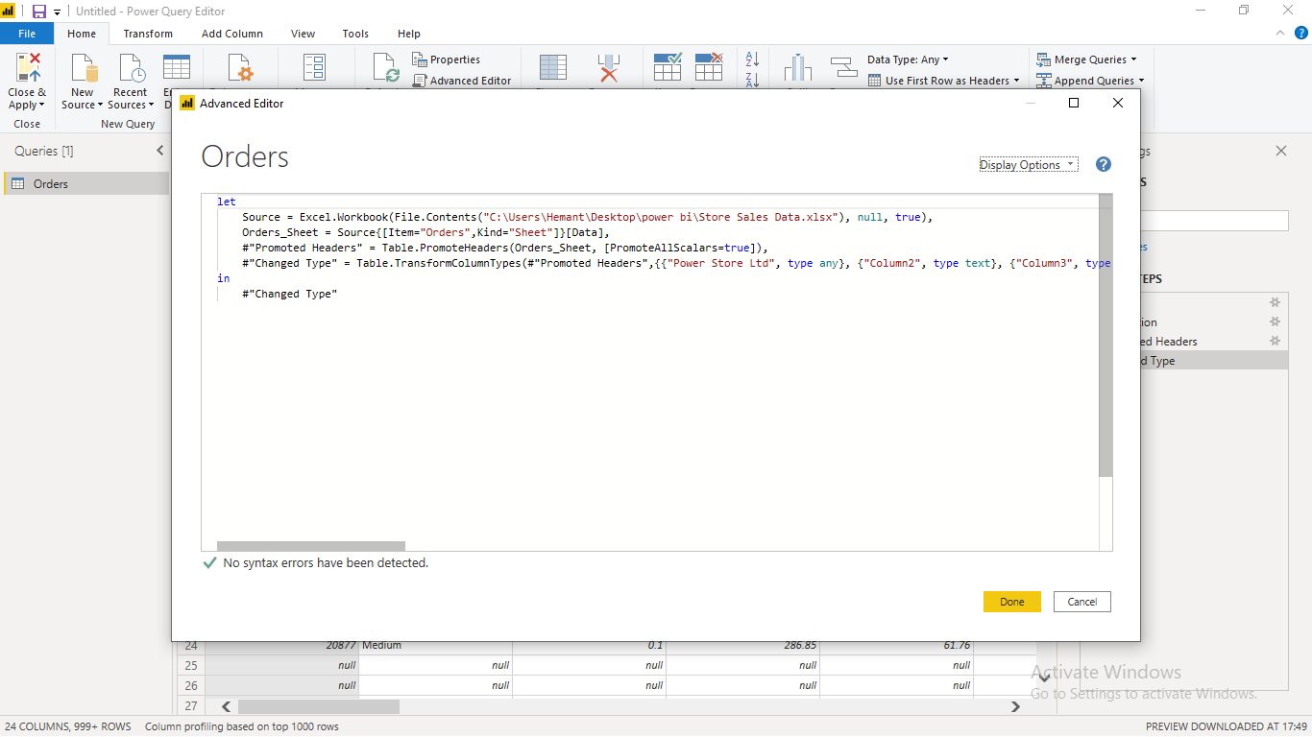

**Prepare a document with details of the following along with their price**

**Power BI Desktop**

Free

**Power BI Pro**

Self-service and modern BI in the cloud

Collaboration, publishing, sharing, and ad-hoc analysis

Fully managed by Microsoft

$9.99 - Monthly price per user

**Power BI Premium**

Enterprise BI, big data analytics, cloud and on-premises reporting

Advanced administration and deployment controls

Dedicated cloud compute and storage resources

Allows any user to consume Power BI content

$4,995 - Monthly price per dedicated cloud compute and storage resource with annual subscription