**Workshops**

(Don’t call this Study Groups – substitute every label called “Study Group” ect. with “Workshop”)

The Workshop structure and functionality must be as the same as the study group functionality, we developed for the Gym-online.dk – off course **modified** to Stream-to-go’s theme and needs.

**Please carefully review the Study Group in the Gym-online.dk structure and copy it into the Stream-to-go platform.**

I.e. the person who creates the study group, is entitled to:

* Create the Workshop (“Duration (minutes)” is not necessary and must be deleted) – Starting date is also not necessary.
* Options like in Gym-online.dk like allowing the study group members to invite other participants into the group by a checkbox.

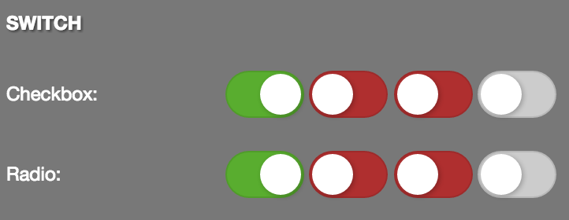

Use one of these check boxes: <http://aqvatarius.com/themes/taurus_v12/html/form_elements.html>

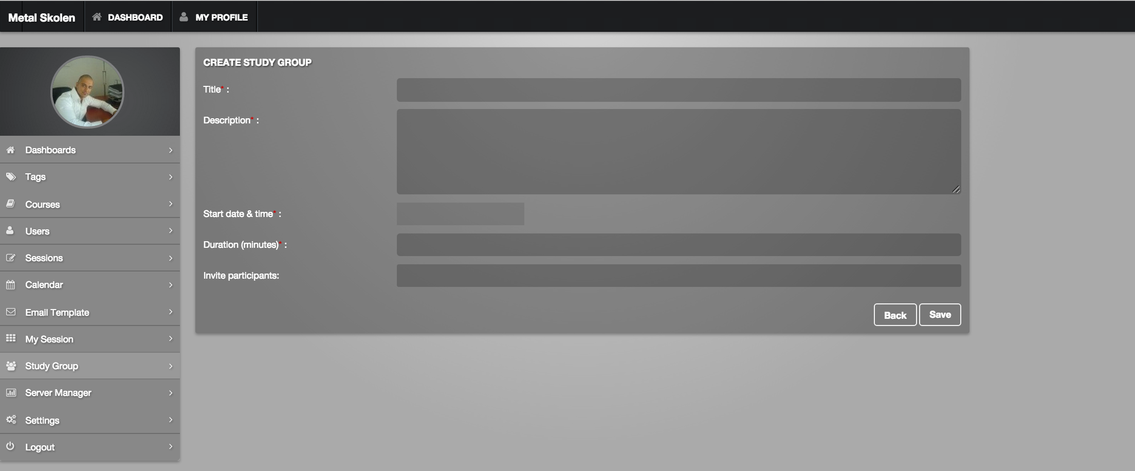

* The invitation must be filtered by:

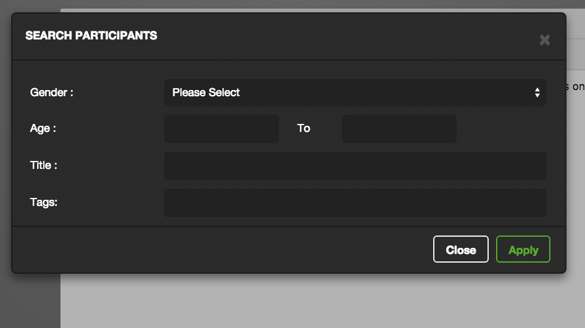

As in the course invitations, we need this “SEARCH PARTICIPANTS” module to filter and search amongst:

* Gender (Female, Male, both)
* Age
* **No titles**
* Tags
* Tags
* Tags
* …

-----------------------------------------------------------

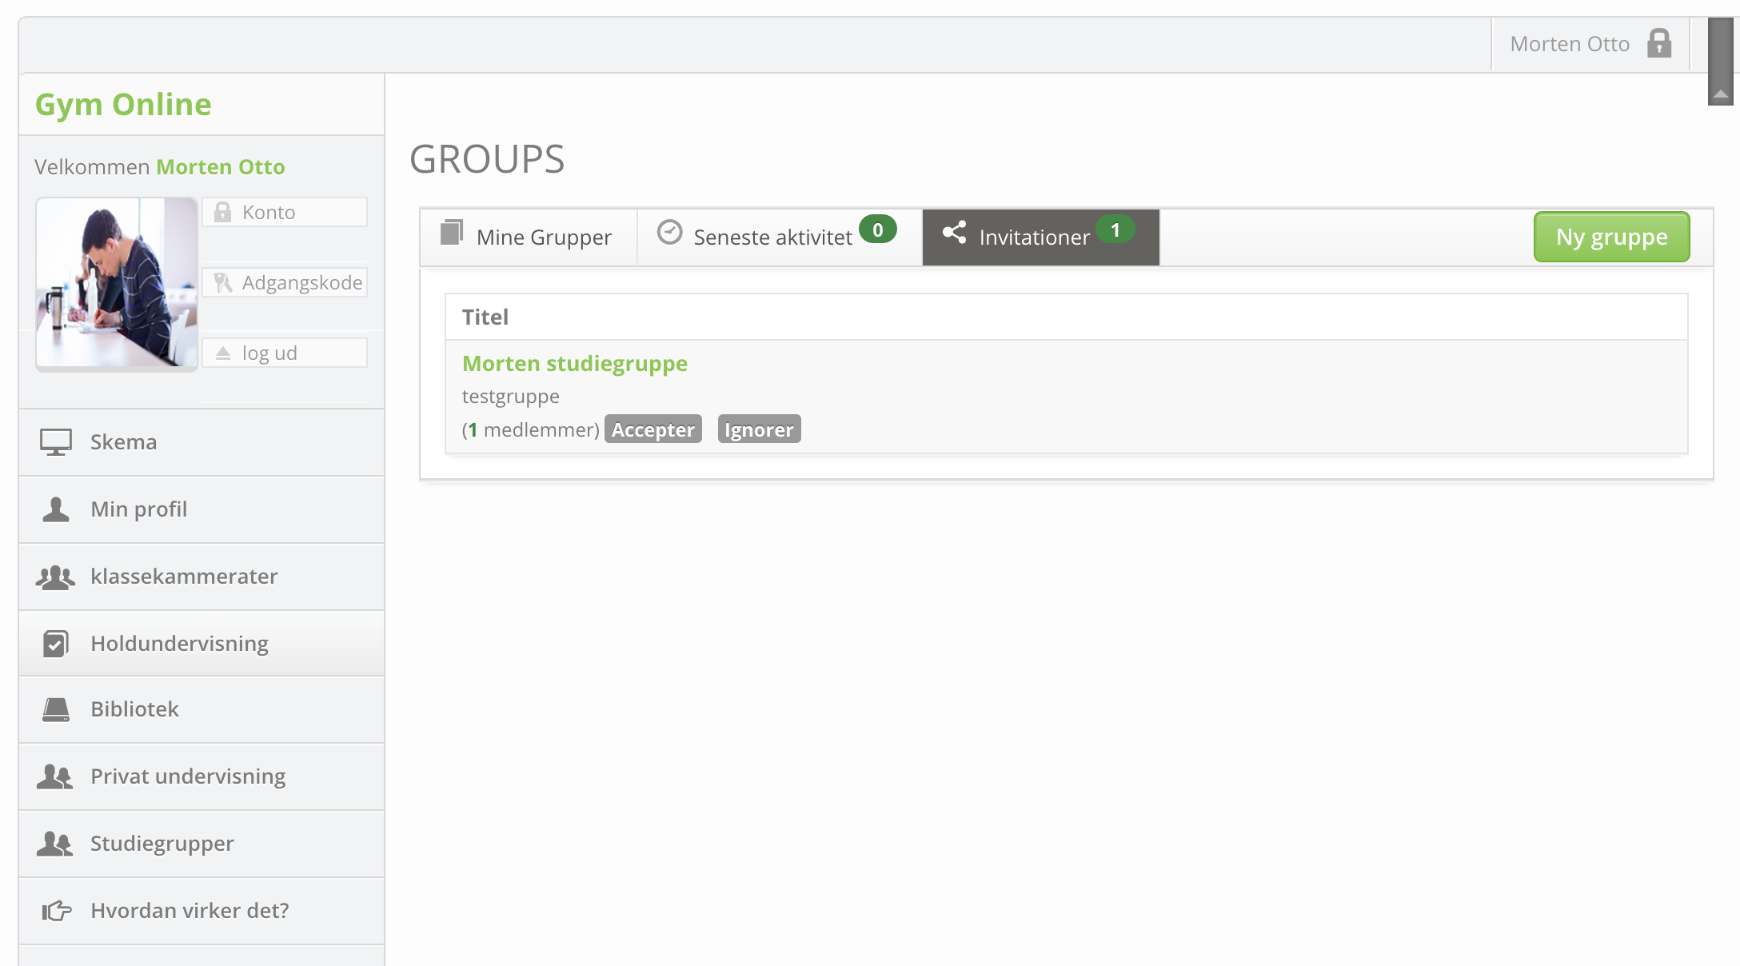

Like in the Gym-online.dk the user can see incoming invitations, accept, delete or create new Workshops ect.

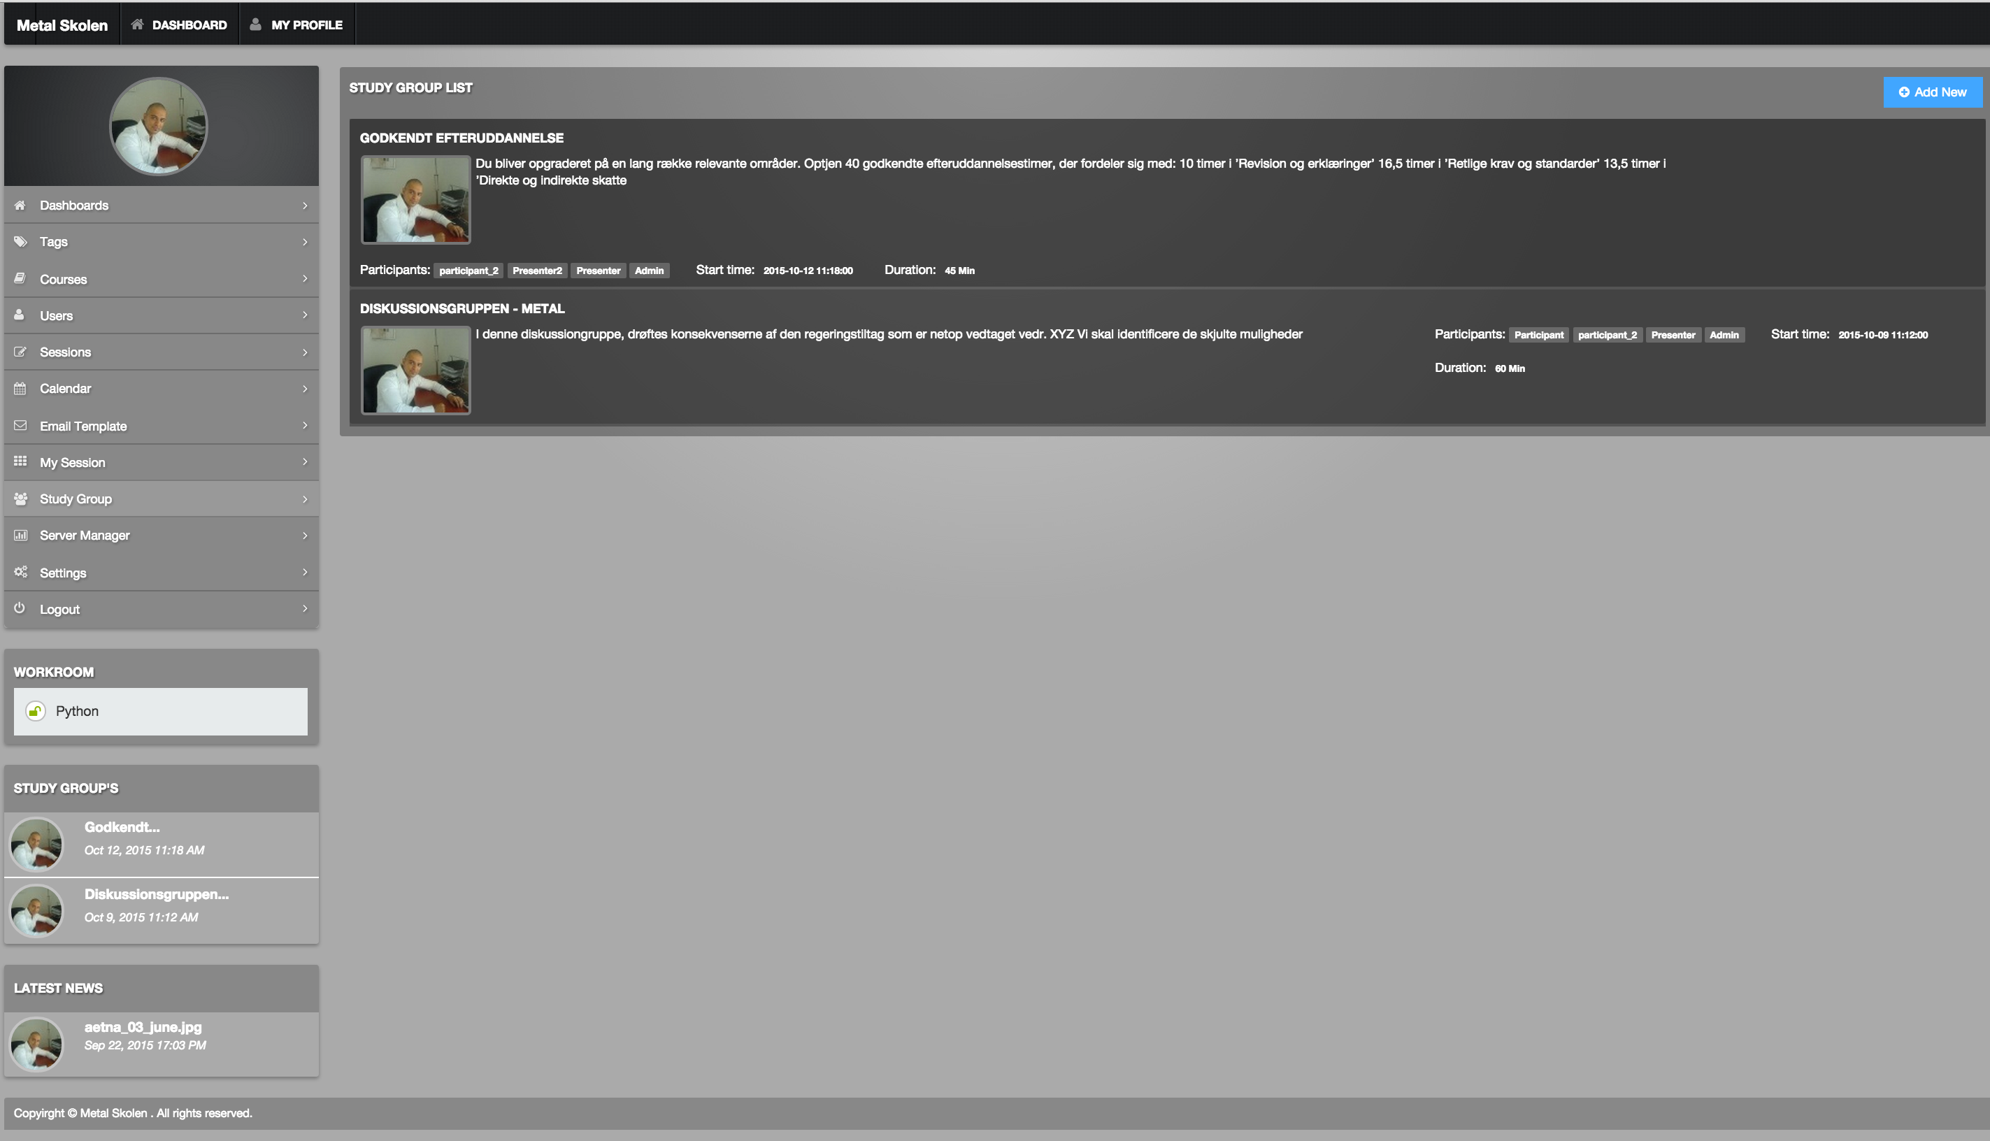

Like in the Gym-online.dk any user must be able to exit a group, whenever they wish.

Workshop Lists

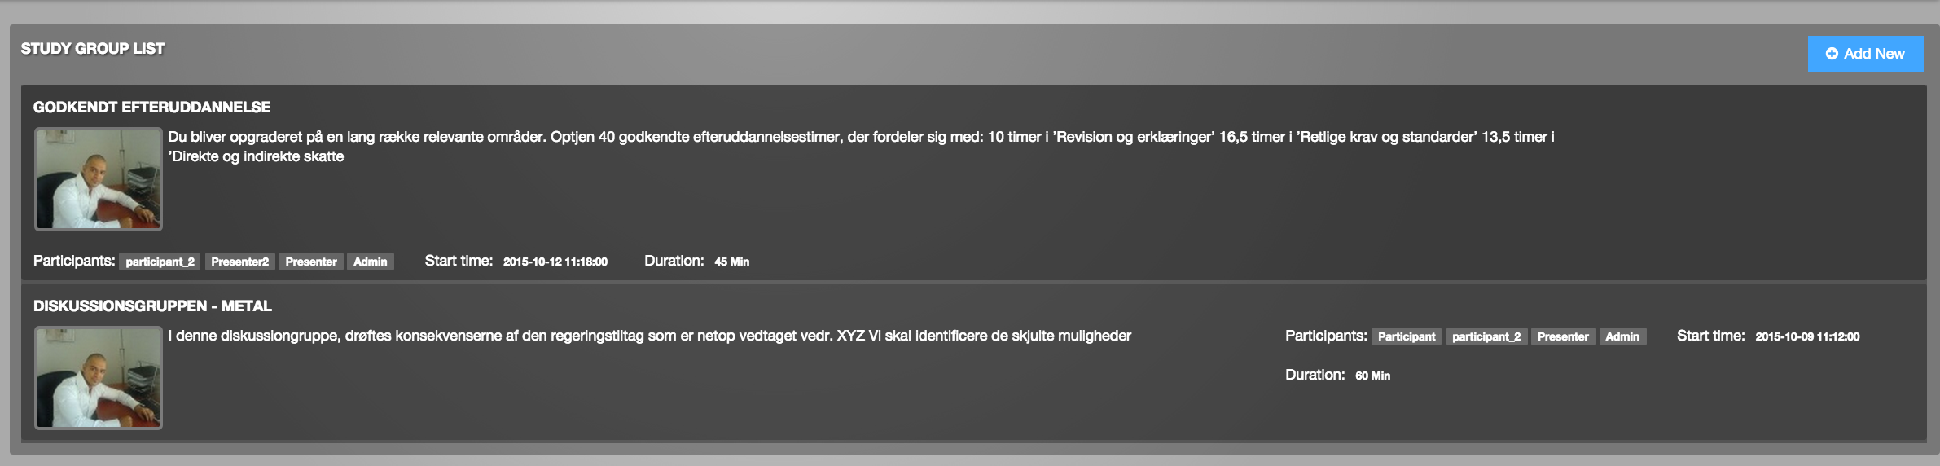

The **GOOD** design (all boxes must look like this)

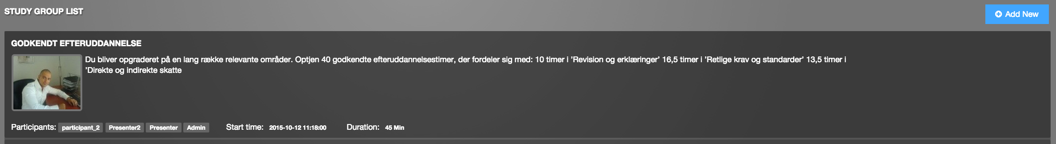



**NOT** good design

Like in the Gym-online.dk any user must be able to exit a group whenever they wish

---------------------------------

Every **study group** will get its own **WORKROOM** named after the Workshop name.

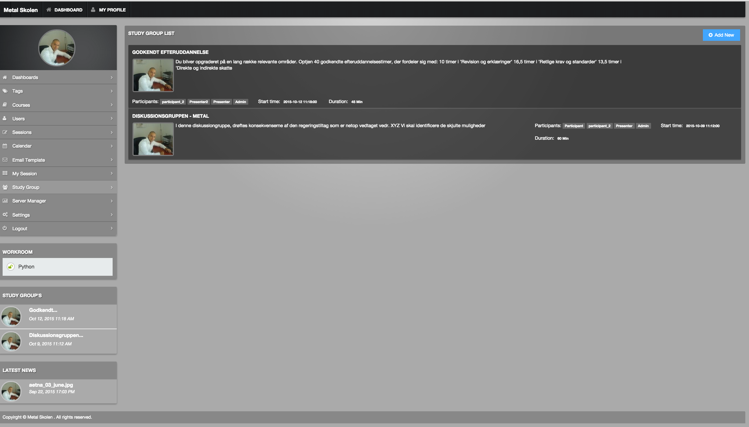

“Study Groups” must be “My workshops” and this must link to the associated workrooms for these particular workshops.