Customer Shopping Behavior Analysis

Project Overview

This project analyzes customer shopping behavior for a leading retail company to uncover patterns in purchasing decisions across demographics, product categories, and sales channels (online vs. offline). The study focuses on identifying the factors that influence consumer choices — such as discounts, reviews, seasonal trends, and payment preferences — and how these drivers impact repeat purchases and long-term loyalty. By leveraging transactional and behavioral data, the project provides actionable insights to enhance customer engagement, optimize marketing strategies, and strengthen product offerings.

Business Problem
The retail company is experiencing shifts in customer purchasing behavior across demographics, product categories, and sales channels (online vs. offline). Management has observed that traditional marketing and product strategies are no longer delivering consistent results. Key uncertainties remain around which factors — such as discounts, product reviews, seasonal demand, or payment preferences — most strongly influence consumer decisions and repeat purchases.
Without a data-driven understanding of these drivers, the company risks:
- Inefficient marketing spend due to poorly targeted campaigns.
- Missed opportunities to engage customers and build loyalty.
- Suboptimal product and pricing strategies that fail to match evolving consumer needs.
- Losing competitive advantage in both online and offline markets.

Objective
The objective of this project is to analyze customer shopping behavior data to uncover the key factors influencing purchasing decisions and repeat purchases. By examining demographics, product categories, and sales channels (online vs. offline), the project aims to identify how elements such as discounts, product reviews, seasonal demand, and payment preferences drive consumer engagement. The ultimate goal is to generate actionable insights that help the retail company improve sales performance, enhance customer satisfaction, and build long-term loyalty through optimized marketing and product strategies.

Dataset Description
The dataset consists of 3,900 customer transaction records with 18 attributes, capturing demographic, transactional, and behavioral aspects of shopping behavior. It provides a comprehensive view of how customers interact with products, promotions, and sales channels.
Key Columns:

Customer Information:
- Customer ID – Unique identifier for each customer.
- Age, Gender, Location – Demographic details.

Purchase Details:
- Item Purchased, Category, Size, Color – Product-level attributes.
- Purchase Amount (USD) – Transaction value.
- Season – Seasonal context of purchase.

Customer Feedback & Engagement:
- Review Rating – Customer satisfaction score (with some missing values).
- Subscription Status – Indicates loyalty program membership.
- Previous Purchases – Count of past transactions.
- Frequency of Purchases – Qualitative measure of shopping regularity.
Promotions & Discounts:
- Discount Applied, Promo Code Used – Indicators of promotional influence.
Logistics & Payment:
- Shipping Type – Delivery preference.
- Payment Method – Mode of payment (cash, card, digital wallets, etc.).
Structure:
- Rows: 3,900 entries (each representing a transaction).
- Columns: 18 variables (mix of numeric, categorical, and text).
- Data Types: Integer, float, and string values.
- Notable Missing Values: 37 nulls in Review Rating.

Tools & Technologies Used
- Python (pandas): Data cleaning and feature engineering
- SQL (PostgreSQL): Solved exploratory data analysis (EDA) queries directly in the database
- Power BI: Built interactive dashboards and visualized customer shopping behavior insights

Data Cleaning & Preprocessing
Inspected dataset structure using df.head(), df.info(), and df.describe() to validate 3,900 rows and 18 attributes.
Handled missing values: Identified 37 nulls in Review Rating and imputed category-wise medians for robust analysis.
Standardized schema: Converted column names to lowercase, replaced spaces with underscores, and renamed fields (e.g., purchase_amount_(usd) → purchase_amount) for consistency.
Feature engineering:
- Created age_group bins (Young Adult, Adult, Middle-aged, Senior) using pd.qcut().
- Mapped purchase frequency categories (Weekly, Monthly, Quarterly, etc.) into numeric days for quantitative analysis.
- Dropped redundant fields (promo_code_used) after validation.
Database integration: Exported cleaned dataset into MySQL/PostgreSQL using SQLAlchemy and PyMySQL, enabling structured storage and SQL-based EDA.

Exploratory Data Analysis (SQL)

Revenue by Gender:
- Business Insight: Male customers contributed 67.7% of total revenue, while female customers accounted for 32.3%. This indicates that male customers are the dominant revenue drivers in this dataset. The insight can guide marketing strategies to strengthen engagement with female customers (to balance contribution) or to double down on male-focused campaigns where ROI is already higher.

Premium Discount Users:
- Result: 839 customers used discounts but still spent above the average purchase amount.
- Insight: This segment represents high-intent buyers who remain profitable even during promotions. They are ideal candidates for premium loyalty programs and targeted offers.

Top 5 Products by Review Rating:
- Result: Shirt (3.62), Jeans (3.65), Blouse (3.68), Scarf (3.71), Shorts (3.71).
- Insight: These moderately rated products highlight areas for quality improvement. Promoting higher-rated items can boost customer satisfaction, while addressing lower ratings can reduce churn.

Shipping Preference Analysis:
- Result: Standard Shipping → Avg. $58.46, Express Shipping → Avg. $60.48.
- Insight: Customers choosing Express shipping spend ~3.5% more on average. This suggests a willingness to pay for convenience, supporting differentiated delivery pricing strategies.

Subscription Effectiveness:
- Result:
- Non-Subscribers → 2,847 customers, Avg. $59.87, Total Revenue $170,436.
- Subscribers → 1,053 customers, Avg. $59.49, Total Revenue $62,645.
- Insight: While subscribers spend slightly less per purchase, they represent a smaller but loyal base. Non-subscribers contribute 73% of total revenue, showing that expanding the subscription program could unlock more value if paired with exclusive benefits.

Discount Sensitivity by Product:
- Result: Hat (50%), Sneakers (49%), Coat (49%), Sweater (48%), Pants (47%).
- Insight: These products are highly price-sensitive, with nearly half of purchases made using discounts. This highlights the need for strategic promotions and careful margin management in these categories.

Customer Segmentation (New, Returning, Loyal):
- Result: Loyal (3,116), Returning (701), New (83).
- Insight: Loyal customers dominate the base (~77% of total customers), while new acquisitions are minimal. This suggests strong retention but limited acquisition, guiding strategies toward expanding new customer acquisition channels while maintaining loyalty rewards.

Category Leaders (Top 3 Products per Category):
- Result Examples:
- Accessories → Jewelry (171), Sunglasses (161), Belt (161)
- Clothing → Blouse (171), Pants (171), Shirt (169)
- Footwear → Sandals (160), Shoes (150), Sneakers (145)
- Outerwear → Jacket (163), Coat (161)
- Insight: These products are category leaders driving sales volume. Insights support inventory prioritization, cross-selling strategies, and promotional focus on top-performing items.

Repeat Buyers & Subscriptions:
- Result: Repeat buyers (>5 purchases) → Non-subscribers: 2,518, Subscribers: 958.
- Insight: While loyal customers exist in large numbers, only 27.5% adopt subscriptions. This shows an opportunity to convert repeat buyers into subscribers through targeted membership benefits.

Revenue Contribution by Age Group:
- Result: Young Adult ($62,143), Middle-aged ($59,197), Adult ($55,978), Senior ($55,763).
- Insight: Young Adults contribute the highest revenue (31%), followed closely by Middle-aged customers. Seniors, despite smaller numbers, still generate significant revenue. This demographic breakdown guides advertising budget allocation and product positioning.

Power BI DashBoard:

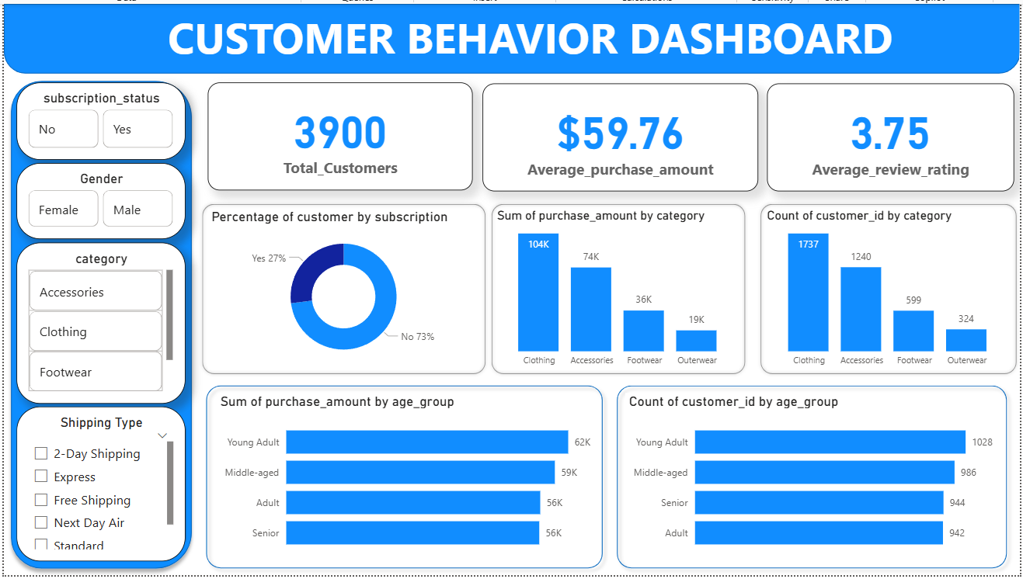

Key Business Insights:
Customer Overview
- Total Customers: 3,900
- Average Purchase Amount: $59.76
- Average Review Rating: 3.75
- The customer base shows balanced engagement with moderate spending and satisfaction levels.

Subscription Behavior
- 73% non-subscribers vs 27% subscribers — a large portion of customers are not enrolled in the subscription program.
- Indicates potential to expand loyalty programs and convert repeat buyers into subscribers through exclusive benefits.

Category Performance
- Clothing leads with $104K revenue and 1,737 customers, followed by Accessories ($74K, 1,240 customers).
- Footwear ($36K) and Outerwear ($19K) contribute less, suggesting scope for product diversification or targeted promotions.
- Clothing and Accessories together account for ~70% of total revenue, marking them as core business drivers.

Age Group Insights
- Young Adults generate the highest revenue ($62K) and have the largest customer base (1,028 customers).
- Middle-aged customers follow closely ($59K revenue, 986 customers).
- Indicates that marketing efforts should focus on young and middle-aged demographics, who show strong purchasing power.

Shipping Preferences
- Filters allow dynamic analysis of spending by shipping type (Express, Standard, Free, etc.).
- Express shipping customers spend slightly more, suggesting willingness to pay for faster delivery — an opportunity for premium shipping upsells.

Overall Business Takeaways
- Revenue Concentration: Clothing and Accessories dominate sales — optimize inventory and marketing around these categories.
- Customer Retention: High proportion of loyal customers (from SQL segmentation) aligns with strong repeat purchase behavior.
- Growth Opportunity: Subscription and discount-sensitive segments can be leveraged for personalized offers and loyalty expansion.
- Demographic Targeting: Young Adults are the most profitable group — tailor campaigns and product lines to their preferences.

Business Recommendations
1. Targeted Marketing by Gender
- Since male customers contribute 68% of revenue, campaigns should focus on reinforcing male-driven product categories.
- At the same time, design female-focused promotions to increase engagement and balance revenue contribution.

2. Expand Loyalty & Subscription Programs
- Only 27.5% of repeat buyers are subscribers.
- Introduce exclusive benefits (early access, premium discounts, free shipping) to convert loyal customers into subscribers.
- This will strengthen retention and increase recurring revenue.

3. Product Strategy
- Clothing and Accessories drive ~70% of revenue → prioritize inventory, promotions, and cross-selling in these categories.
- Discount-sensitive items (Hat, Sneakers, Coat, Sweater, Pants) should be bundled with premium products or offered in limited-time deals to protect margins.
- Improve moderately rated products (Shirt, Jeans, Blouse, Scarf, Shorts) through quality checks and customer feedback initiatives.

4. Demographic-Focused Campaigns
- Young Adults (31% revenue) and Middle-aged customers (29%) are the most profitable segments.
- Allocate higher advertising budgets to these demographics with tailored product lines and digital campaigns.
- Seniors, though smaller in number, still generate significant revenue — consider value-driven offers for this group.

5. Shipping & Delivery Optimization
- Customers using Express shipping spend 3.5% more.
- Introduce premium delivery options (same-day, priority shipping) with small fees to capture additional revenue.
- Maintain competitive pricing for Standard shipping to retain cost-sensitive customers.

6. Customer Acquisition vs Retention
- Current base is dominated by Loyal customers (77%), while New customers are only 2%.
- Invest in acquisition campaigns (social media ads, referral programs, influencer partnerships) to grow the new customer base.
- Continue retention strategies (personalized offers, loyalty rewards) to sustain the strong loyal segment.

