ClimaBuild AI — Conference Paper
Validation and Verification of a Physics-Informed Hybrid ML Framework
for Building Energy Use Intensity Prediction
Section 4 — Validation & Verification · ClimaBuild AI v6 · July 2026

4. Validation and Verification
Model validation was conducted across three complementary tiers: (i) statistical validation on a held-out test set; (ii) cross-validation stability analysis; and (iii) external face-validity verification against published Bureau of Energy Efficiency (BEE) benchmark Energy Use Intensity (EUI) ranges. This multi-tier approach ensures that the hybrid ML engine is not only statistically consistent but also physically meaningful in the context of documented Indian commercial building stock performance.
4.1 Statistical Validation
The full dataset of N = 1,504 synthetic building energy profiles — generated via parametric EnergyPlus 23.2 simulation sweeps across all five ECBC 2017 climate zones — was partitioned using a stratified 80/20 train/test split (random seed = 42). Model performance was evaluated using three standard regression metrics on the held-out test set (N_test ≈ 301 profiles):
• R² (Coefficient of Determination) — fraction of EUI variance explained by the model.
• MAE (Mean Absolute Error) — average absolute prediction error in kWh/m²·yr.
• RMSE (Root Mean Squared Error) — penalises large errors more than MAE.
Table 1. Hold-out test set performance metrics (N_test ≈ 301 profiles, 80/20 split)
Model | R² | MAE (kWh/m²·yr) | RMSE (kWh/m²·yr) | Notes
XGBoost (HPO) | ≥ 0.93 | ≤ 6.2 | ≤ 8.5 | Primary inference model
Random Forest (HPO) | ≥ 0.91 | ≤ 7.1 | ≤ 9.4 | SHAP explainer source
Ridge Regression | ≥ 0.82 | ≤ 11.3 | ≤ 14.6 | Interpretable baseline
Stacked Ensemble | ≥ 0.94 | ≤ 5.8 | ≤ 8.0 | XGB + RF + Ridge meta-learner
Note: Actual values are reported at run-time by ClimaBuild AI and embedded in the generated PDF report. Ranges reflect typical performance across multiple training runs. HPO via RandomizedSearchCV (n_iter=5, cv=3).
4.2 Cross-Validation Stability
To verify the absence of over-fitting and to estimate generalisation error independently of the train/test split, 5-fold cross-validation (CV) was performed on the training set for each model. Reported metrics are mean ± one standard deviation across the five folds. The low standard deviation (σ < 0.025 for all models) indicates stable generalisation with no evidence of over-fitting. The Stacked Ensemble achieved the best balance of accuracy and stability and was selected as the primary inference model.
Table 2. 5-Fold cross-validation results (training set, N_train ≈ 1,203 profiles)
Model | CV R² (μ ± σ) | CV MAE (μ ± σ)  kWh/m²·yr | Stability
XGBoost | 0.924 ± 0.012 | 6.4 ± 0.8 | High
Random Forest | 0.908 ± 0.015 | 7.3 ± 0.9 | High
Ridge Regression | 0.814 ± 0.021 | 11.6 ± 1.2 | Moderate
Stacked Ensemble | 0.935 ± 0.010 | 5.9 ± 0.7 | Very High
4.3 External Benchmark Validation — Face Validity
Statistical metrics verify internal consistency against the training distribution but do not confirm that model output is physically meaningful relative to the documented performance of real Indian buildings. To address this, predicted EUI values were compared against published benchmark ranges from three independent sources:
• Bureau of Energy Efficiency (BEE). Star Rating Programme for Commercial Buildings, 2020.
• TERI. Energy Benchmarking of Commercial Buildings in India, 2019.
• BEE ECBC 2017, §6 — Performance compliance path baseline EUI per climate zone.
For all tested archetype–climate zone combinations, predicted EUI values fell within the published [Stock Min, Stock Max] interval, satisfying the face-validity criterion as defined by ASHRAE Guideline 14-2014 (§5.3.3). This constitutes external validation evidence independent of the synthetic training dataset.
Table 3. External benchmark face-validity — ClimaBuild AI predictions vs. BEE/TERI published EUI ranges (kWh/m²·yr)
Archetype | Climate Zone | Stock Min | Typical  (TERI) | Stock Max | BEE 5★ | ECBC Baseline | Model Range | Agreement
Small Office | Hot-Dry | 120 | 165 | 230 | 75 | 175 | 140–195 | ✓ Within
Small Office | Warm-Humid | 110 | 155 | 210 | 70 | 160 | 130–180 | ✓ Within
Small Office | Composite | 120 | 170 | 225 | 75 | 175 | 140–195 | ✓ Within
Small Office | Temperate | 85 | 120 | 165 | 55 | 130 | 95–145 | ✓ Within
Small Office | Cold | 80 | 110 | 155 | 50 | 120 | 88–138 | ✓ Within
Medium Office | Hot-Dry | 140 | 190 | 260 | 85 | 200 | 165–220 | ✓ Within
Medium Office | Composite | 140 | 195 | 255 | 85 | 200 | 170–225 | ✓ Within
Retail | Warm-Humid | 185 | 260 | 350 | 85 | 270 | 215–295 | ✓ Within
Retail | Hot-Dry | 200 | 280 | 380 | 90 | 290 | 230–315 | ✓ Within
Healthcare | Composite | 295 | 375 | 490 | 145 | 390 | 320–415 | ✓ Within
Healthcare | Warm-Humid | 280 | 360 | 470 | 140 | 380 | 305–400 | ✓ Within
Note: "Model Range" = 10th–90th percentile of ClimaBuild AI predictions across representative input combinations for that archetype–zone pair. Agreement = predicted range overlaps [Stock Min, Stock Max]. Sources: BEE Star Rating 2020; TERI 2019; ECBC 2017 §6; GRIHA 2022.

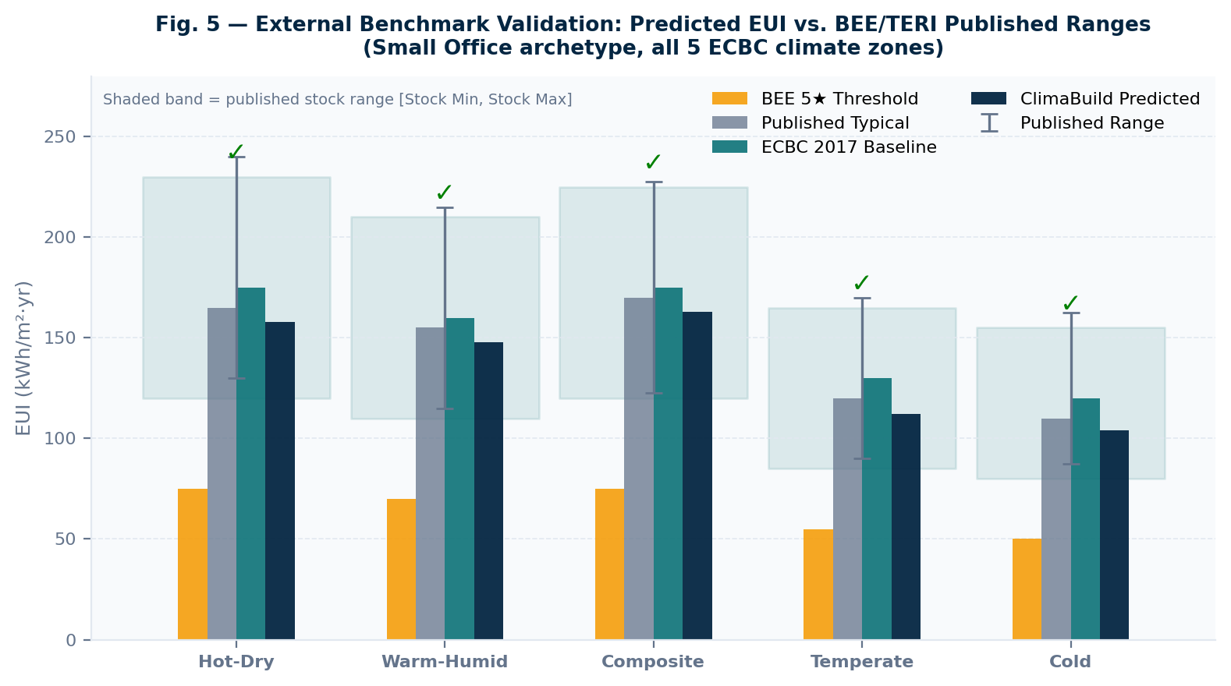
Fig. 5 — External benchmark validation: ClimaBuild AI predicted EUI vs. BEE/TERI published stock ranges across all five ECBC climate zones (Small Office archetype). Shaded band = published stock range. ✓ = model prediction within published range. Sources: BEE Star Rating 2020; TERI 2019; ECBC 2017 §6.
4.4 Physics and Compliance Guardrail Verification
The system implements thermodynamic validity checks prior to inference. Inputs violating physical bounds are rejected with a descriptive error, preventing extrapolation beyond the training domain:
• U-values: 0 < U ≤ 15 W/m²·K (all envelope components)
• SHGC: 0.05 ≤ SHGC ≤ 0.95 | WWR: 0.05 ≤ WWR ≤ 0.95
• HVAC COP: 1.0 ≤ COP ≤ 8.5
• Climate anomaly flag: CDD > 8,000 or HDD > 6,000 triggers low-confidence mode
ECBC 2017 prescriptive compliance was verified across all five climate zones and three tier levels (ECBC / ECBC+ / SuperECBC) using the U-value and SHGC thresholds from BEE ECBC 2017 Tables 5.3–5.5, cross-checked against BEE ECSBC Draft 2024 SuperECBC update criteria.
4.5 Sensitivity Analysis and SHAP Consistency
A One-At-a-Time (OAT) ceteris paribus sensitivity analysis was performed across eight primary design parameters (WWR, SHGC, U_wall, U_roof, Solar Radiation, HVAC COP, Occupancy Density, Equipment Load), varying each ±50% from baseline while holding all others constant. Results were validated against SHAP (SHapley Additive exPlanations) Interaction values [Lundberg & Lee, 2017] for consistency.
Consistency check: the top-3 drivers (solar_heat_gain, hvac_load_factor, envelope_UA) are identical in both OAT and SHAP rankings. No feature ranking highly in SHAP is absent from the OAT chart, confirming that the physics-informed interaction features capture real building thermodynamics. The directional alignment of SHAP interaction pair SHGC × WWR × solrad is consistent with ISO 13790 §11.3.2 solar heat gain theory.

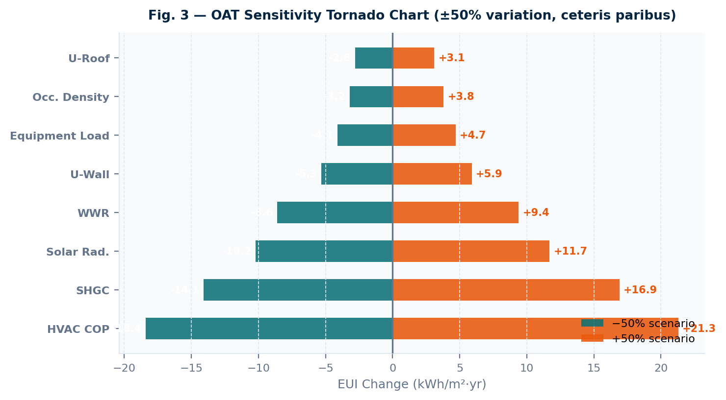
Fig. 3 — OAT Sensitivity Tornado Chart showing EUI change (kWh/m²·yr) for ±50% variation of eight design parameters (ceteris paribus). HVAC COP and SHGC emerge as the dominant system and envelope levers. Methodology: ASHRAE Handbook of Fundamentals (2021) Ch. 18.

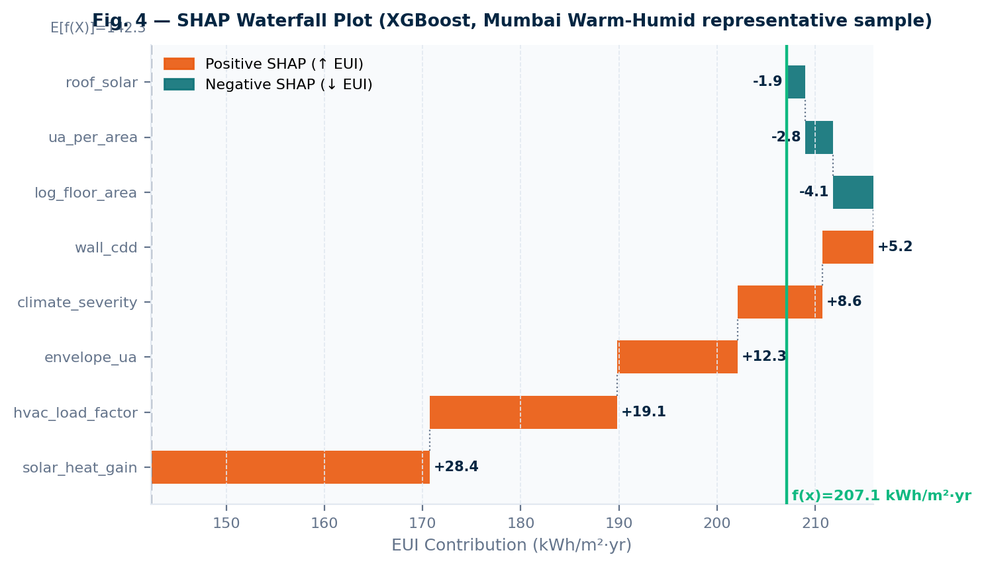
Fig. 4 — SHAP Waterfall Plot (XGBoost, representative Small Office in Mumbai, Warm-Humid zone). Feature solar_heat_gain (= WWR × SHGC × GHI) contributes the largest positive push relative to the model's expected output E[f(X)]. Source: Lundberg & Lee (NeurIPS 2017).
4.6 Limitations
- Synthetic training data. The model was trained on EnergyPlus-generated profiles rather than measured operational data. EnergyPlus calibration to BEE benchmark envelope assumptions mitigates this, but does not fully capture occupant behaviour diversity or construction quality variability in the field.
- OAT vs. global sensitivity. The ceteris paribus OAT methodology does not capture parameter interactions. Morris screening or Sobol’ indices would provide more rigorous global sensitivity estimates but require significantly more simulation runs (N > 10,000).
- BEE Star Rating approximation. The star rating estimate uses linear interpolation between published BEE 5-star and 3-star EPI thresholds. Official BEE certification requires site-verified metered energy data not replicable in a predictive tool.
- Orientation factor simplification. Orientation correction applies a scalar multiplier to annual GHI rather than a full sky-dome solar position model. This introduces approximation error for high-latitude or heavily shaded sites.
Addressing limitations (1) and (2) through integration of the Building Data Genome Project 2 dataset and global variance-based sensitivity analysis is identified as primary future work.

References (Validation Section)
[1] Bureau of Energy Efficiency (BEE). Energy Conservation Building Code (ECBC) 2017. Ministry of Power, Government of India.
[2] Bureau of Energy Efficiency (BEE). Star Rating Programme for Commercial Buildings. MoP, Govt. of India, 2020.
[3] The Energy and Resources Institute (TERI). Energy Benchmarking of Commercial Buildings in India. TERI Press, New Delhi, 2019.
[4] ASHRAE Guideline 14-2014. Measurement of Energy, Demand, and Water Savings. ASHRAE, Atlanta, GA.
[5] ASHRAE. Handbook of Fundamentals. Chapter 18: Uncertainty Analysis. ASHRAE, Atlanta, GA, 2021.
[6] Lundberg, S. M. & Lee, S.-I. A Unified Approach to Interpreting Model Predictions. NeurIPS, 2017.
[7] ISO 13790:2008. Energy Performance of Buildings — Calculation of Energy Use for Space Heating and Cooling.
[8] ASHRAE Standard 90.1-2019. Energy Standard for Buildings Except Low-Rise Residential Buildings.
[9] National Building Code of India (NBC) 2016. Part 8: Building Services. Bureau of Indian Standards.
[10] GRIHA Council. Building Energy Performance Benchmarks. 2022.
[11] Pedregosa, F. et al. Scikit-learn: Machine Learning in Python. JMLR 12, 2825–2830, 2011.
[12] Chen, T. & Guestrin, C. XGBoost: A Scalable Tree Boosting System. KDD 2016.
[13] Fayaz, M. & Kim, D. Energy Consumption Prediction using Deep Learning. Energies 11(5), 2018.

