Task 1 & 2:

List out your Skills and Experience in the Web Development field and if you have any previous projects, then provide a Github link.

**Note - I hadn't made any big project yet, everything I mentioned below is on my GitHub with the same name.**

GitHub - <https://github.com/HemantUmre12>

Git/ GitHub -

Have the necessary knowledge of Git and GitHub for contributing to a project.

VS Code -

Well-versed with visual studio code, the shortcuts, command palette, various modes, terminal, etc.

HTML/ CSS/ JavaScript -

Animated-css-grid-

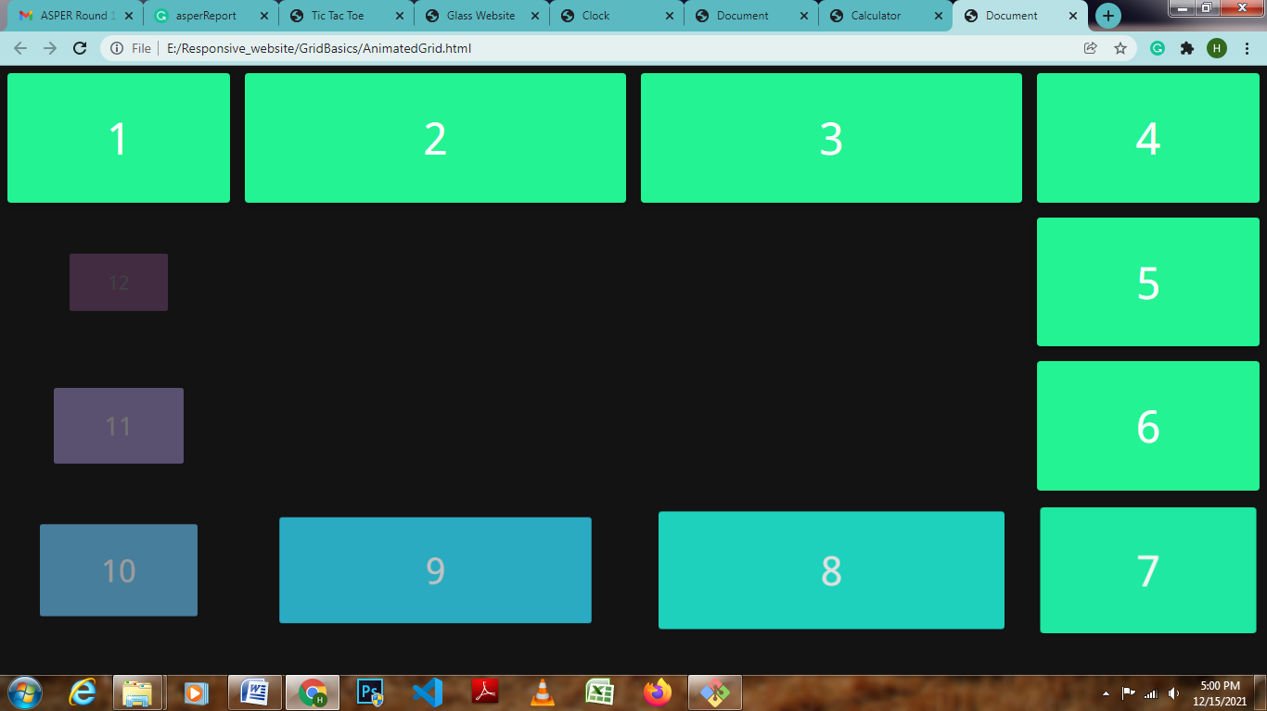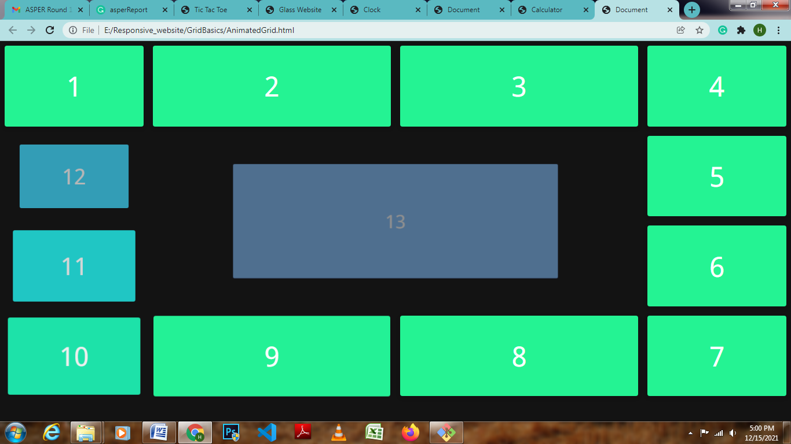

Glass-website-

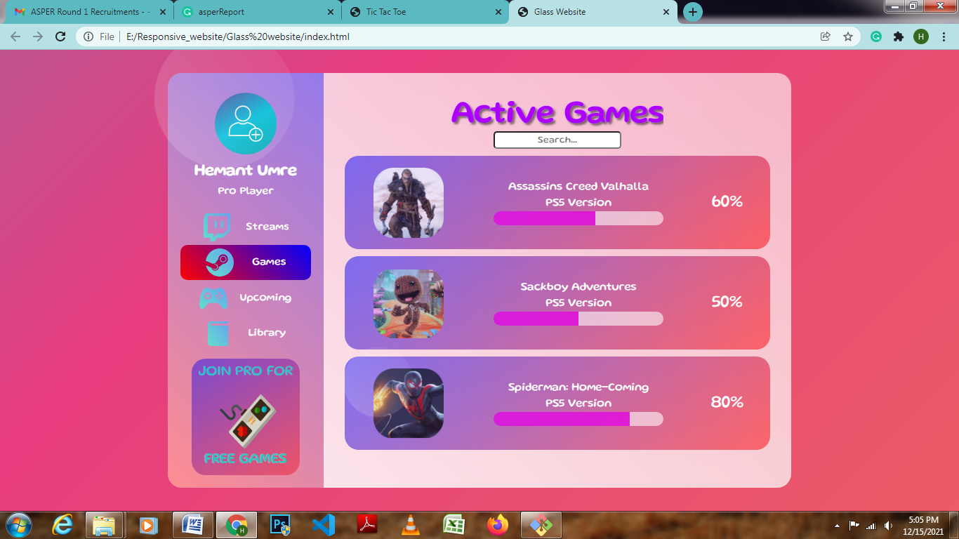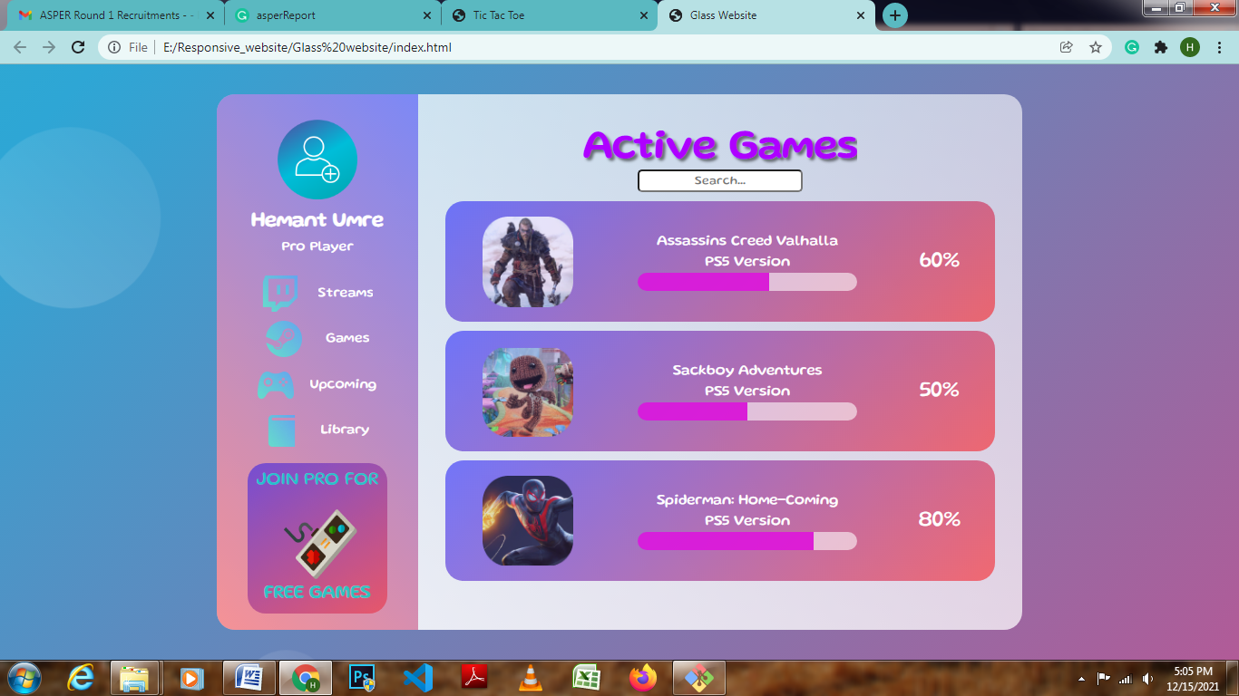

Simple-Calculator-

A Simple Calculator performs basic arithmetic operation using JavaScript.

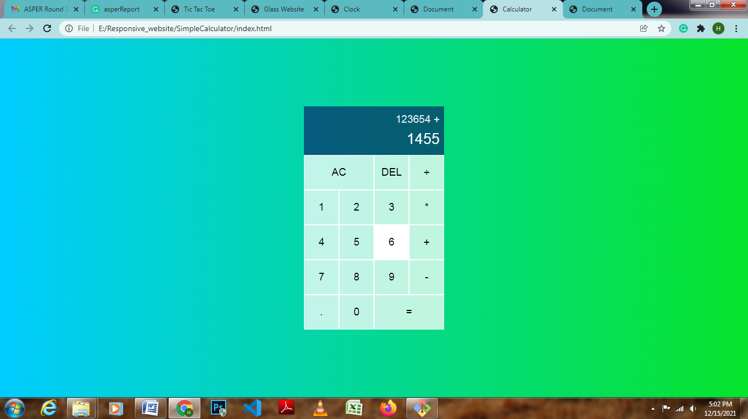

Tic-Tac-Toe

Using JavaScript follows same logic as basic Tic-Tac-Toe game.

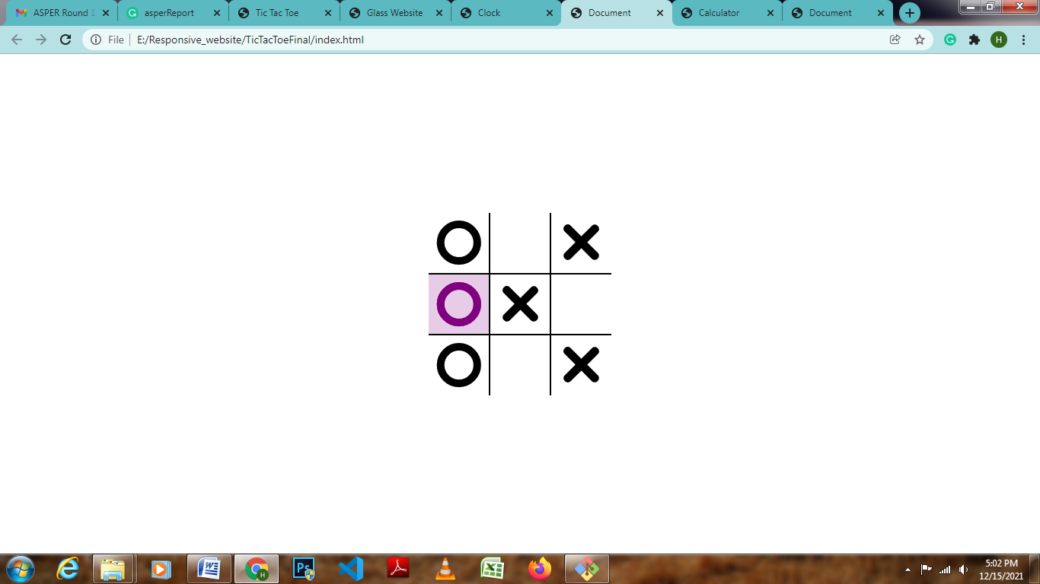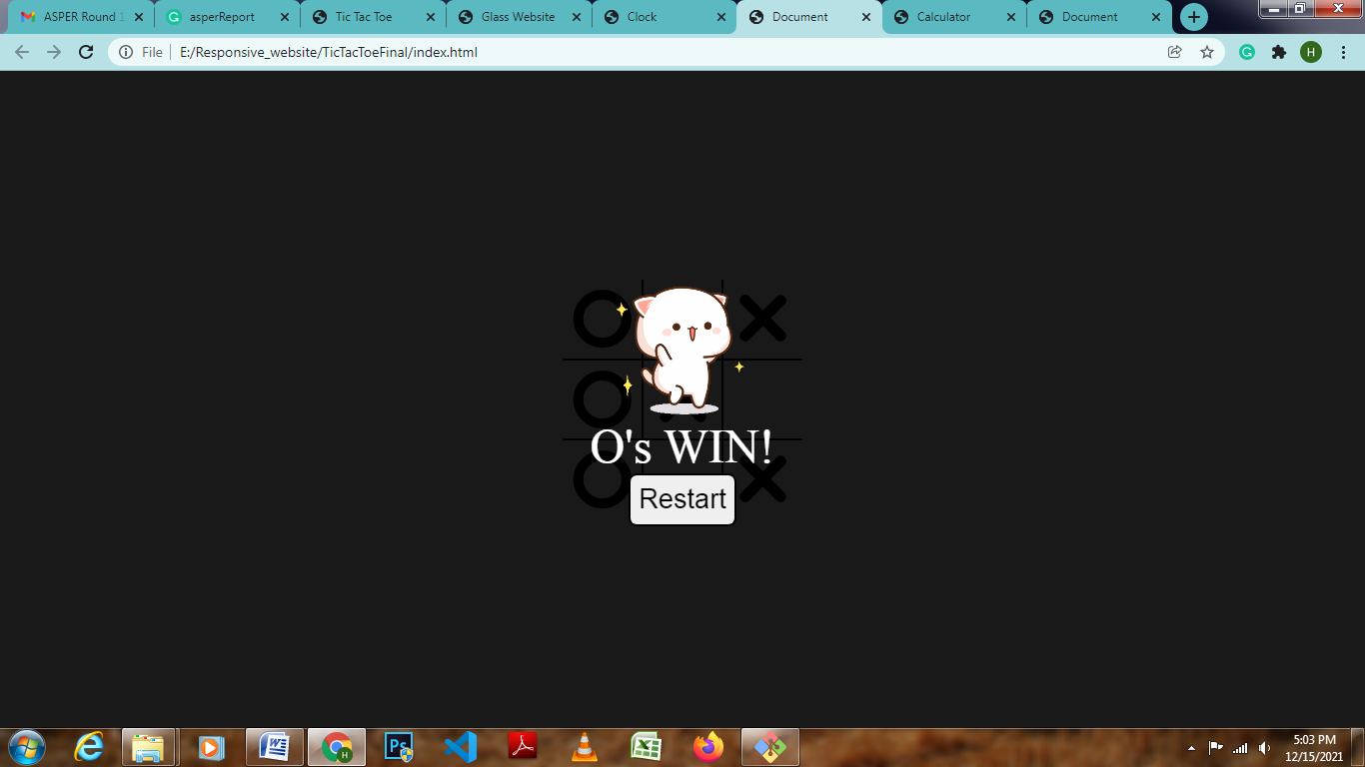

Analog Clock-

