Report

How I made this page, what I learned/revised/used are dissected below.

**Code:** <https://github.com/HemantUmre12/AsperR1.git>

**Navigation bar-**

**Used -**

* "<ul>" tag as container and "<li>" for individual element.
* "display: flex;" to make things easy.
* "margin-right: auto" on the logo to separate it from other elements.
* “position: fixed;” to separate nav-bar from natural flow and fix it at the top.

**Underline hover effect-**

Underline the hovered element, used "transition" and "transform" to create this effect.

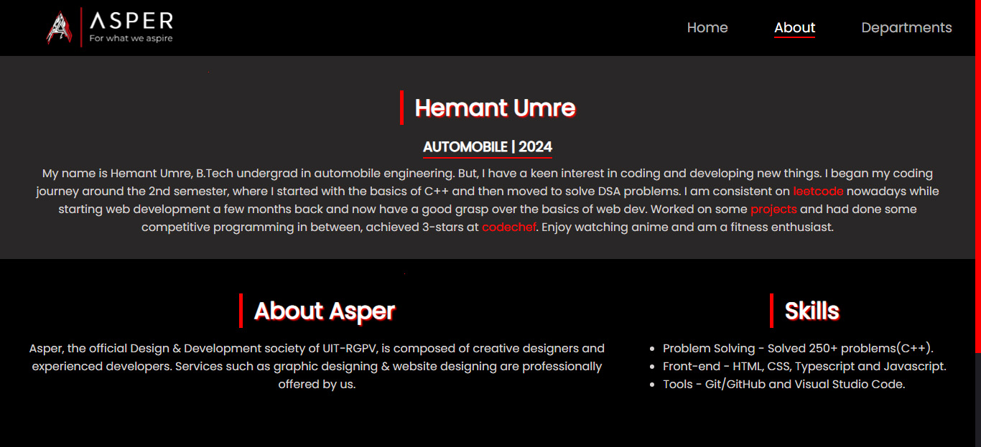

**Main content-**

Used "grid" for layout and then "grid-template-column" to specify the number of columns, spanned "about-yourself" over two columns.

**Social Media-**

For social handles used the "<a>" tag, to create hyperlinks and pngs as background. Also, added a little hover effect.



**Small Screens-**

Added media query to change the layout to make things convenient for smaller devices.

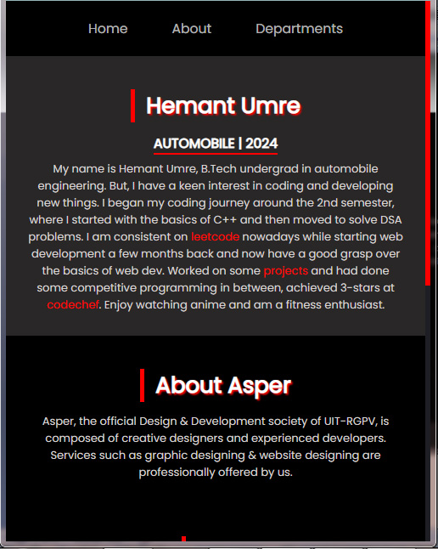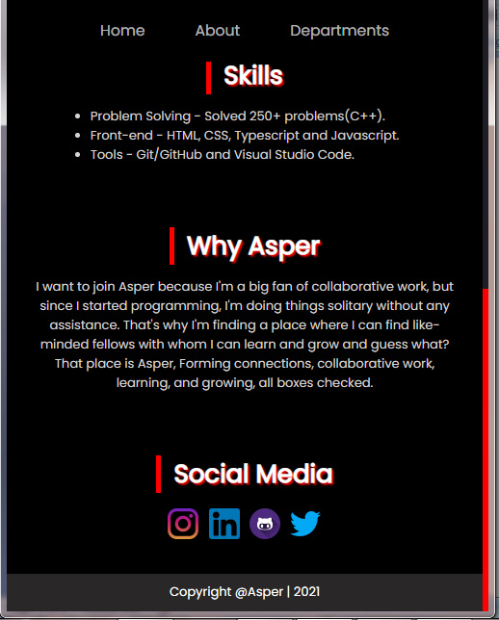

**CSS Variables-**

To make changing themes easy, I used css variables all over the places.

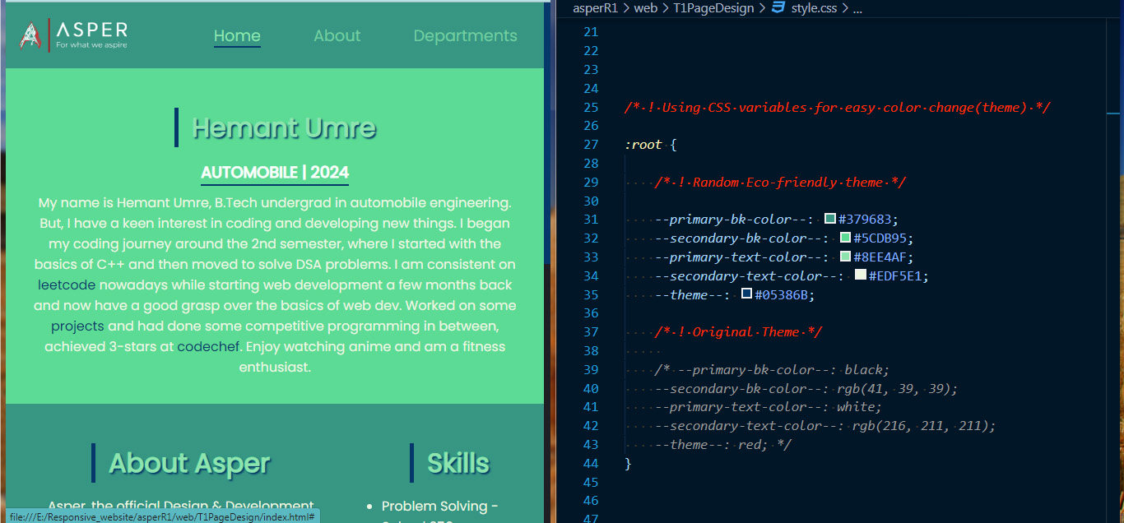

**Footer-**

