Require Changes to WCF Improvement

1. Separating this part within DLLS and from Web
2. Date Less service for availability
3. Guidance and way to Incorporate messages easily in DLLS

Architecture

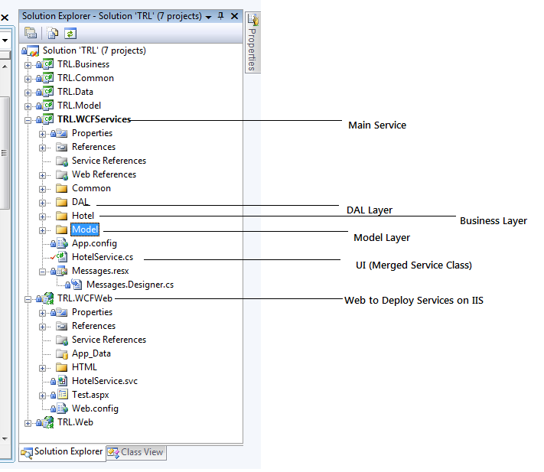

Method Name: GetHotelAvailibility()

Request:

<HotelAvailibilityRQ>

<SessionId>CB8C0A28-315F-4A55-A84D-E7EE69282423</SessionId>

<CityCode>WSD</CityCode>

<CheckinDate>2012-12-25</CheckinDate>

<CheckoutDate>2012-12-26</CheckoutDate>

<Room>2</Room>

<Guest>8</Guest>

<RoomGroup>

<Room>

<RoomType>SGL</RoomType>

<Qty>1</Qty>

<GuestInfo>

<index>1</index>

<Adult>2</Adult>

<Children>2</Children>

<ChildrenAges>12,13</ChildrenAges>

</GuestInfo>

</Room>

</RoomGroup>

</HotelAvailibilityRQ>

Response:

<HotelAvailibilityRS>

<SessionId>CB8C0A28-315F-4A55-A84D-E7EE69282423</SessionId>

<HotelList>

<HotelInfo>

<HotelCode>MON-WSD-3302</HotelCode>

<HotelName>Monaco Washington DC, a Kimpton Hotel</HotelName>

<City>Delhi</City>

<CityCode>DEL</CityCode>

<CountryCode>IN</CountryCode>

<ProviderCode>JTB</ProviderCode>

<HighRate>129.0</HighRate>

<LowRate>83.85</LowRate>

<RateCurrencyCode>USD</RateCurrencyCode>

<latitude>47.62244</latitude>

<longitude>-122.35672</longitude>

<Currency>USD</Currency>

<Star>3</Star>

<HotelAddress>

700 F. Street NW, Washington DC, DC 20004 (Downtown / Chinatown, Penn Quarter, Upper Northwest)<br/><br/>

</HotelAddress>

<HotelDesc></HotelDesc>

<HotelThumbImageUrl>http://localhost/TRL.Web/Images/Packages/Hotels/no_photo.jpg</HotelThumbImageUrl>

</HotelInfo>

</HotelList>

</HotelAvailibilityRS>

Method Name : HotelReservation()

Request

<BookingRQ>

<HotelCode>MON-WSD-3302</HotelCode>

<HotelName>Monaco Washington DC, a Kimpton Hotel</HotelName>

<CheckinDate>2012-12-26</CheckinDate>

<CheckoutDate>2012-12-27</CheckoutDate>

<NoOfAdults>2</NoOfAdults>

<NoOfChild>2</NoOfChild>

<IPAddress>111.11.1.1</IPAddress>

<TotalAmount>100</TotalAmount>

<CurrencyCode>USD</CurrencyCode>

<SelectedRoomType>SGL</SelectedRoomType>

<SelectedRoomcategory>STD</SelectedRoomcategory>

<SelectedRoomTypeQuantity>1</SelectedRoomTypeQuantity>

<RoomGroup>

<Room>

<Adult>2</Adult>

<Children>2</Children>

<ChildrenAges>12,13</ChildrenAges>

<FirstName>test</FirstName>

<LastName>smith</LastName>

<SmokingPreference>NS</SmokingPreference>

</Room>

</RoomGroup>

<ReservationInfo>

<email>test%40ean%2Ecom</email>

<firstName>test</firstName>

<lastName>test</lastName>

<homePhone>4178291392</homePhone>

<workPhone>4178291392</workPhone>

<creditCardType>CA</creditCardType>

<creditCardNumber>5401999999999999</creditCardNumber>

<creditCardExpirationMonth>04</creditCardExpirationMonth>

<creditCardExpirationYear>2012</creditCardExpirationYear>

<creditCardIdentifier>123</creditCardIdentifier>

</ReservationInfo>

<AddressInfo>

<address1>travelnow</address1>

<city>Seattle</city>

<stateProvinceCode>WA</stateProvinceCode>

<countryCode>US</countryCode>

<postalCode>65807</postalCode>

</AddressInfo>

<CustomerSessionId>762072FC-0AC8-44C5-912F-8B7C5D932244</CustomerSessionId>

</BookingRQ>

Reponse: Will Discuss Later