Project

**Tables:**

Album (Album_ID, SongCount, name, name, age,)

Artist(Age,StageName,RecordLabel,ArtistID,Description, OriginCountry)

Genre (GenreID,Name)

Playlist (PlaylistID,Name,SongCount,Description,GenreID)

PlayList_song (SongID, PlaylistID)

Podcast (PodcastID,Name,EpisodeNO,Description,YearReleased,Length,ArtistID)

Song(SongID,Name,YearReleased,RecordLabel,Language,Length,ArtistID,AlbumID)

User (UserID,Email,Name,MembershipPlan)

User_artist (ArtistID,UserID)

User_podcast (PodcastID,UserID)

User_song (SondID,UserID)

**SQL Commands for Table Creation:**

CREATE DATABASE music_libb;

USE music_libb;

CREATE TABLE `album` (

`AlbumID` int(11) NOT NULL CHECK (`AlbumID` >= 10000 AND `AlbumID` <= 99999),

`SongCount` int(11) NOT NULL CHECK (`SongCount` > 0),

`name` varchar(255) DEFAULT NULL,

`ArtistID` int(11) NOT NULL CHECK (`ArtistID` >= 1000 AND `ArtistID` <= 9999),

PRIMARY KEY (`AlbumID`),

KEY `ArtistID` (`ArtistID`)

);

CREATE TABLE `artist` (

`Age` int(11) NOT NULL,

`StageName` varchar(255) NOT NULL,

`RecordLabel` varchar(255) DEFAULT NULL,

`ArtistID` int(11) NOT NULL CHECK (`ArtistID` >= 1000 AND `ArtistID` <= 9999),

`Description` text DEFAULT NULL,

`OriginCountry` varchar(255) NOT NULL,

PRIMARY KEY (`ArtistID`)

);

CREATE TABLE `genre` (

`GenreID` int(11) NOT NULL CHECK (`GenreID` > 0 AND `GenreID` < 1000),

`Name` varchar(255) NOT NULL,

PRIMARY KEY (`GenreID`),

UNIQUE KEY `Name` (`Name`)

);

CREATE TABLE `playlist` (

`PlaylistID` int(11) NOT NULL CHECK (`PlaylistID` >= 10000 AND `PlaylistID` <= 99999),

`Name` varchar(255) NOT NULL,

`SongCount` int(11) NOT NULL CHECK (`SongCount` > 0),

`Description` text DEFAULT NULL,

`GenreID` int(11) NOT NULL CHECK (`GenreID` > 0 AND `GenreID` < 1000),

PRIMARY KEY (`PlaylistID`),

KEY `GenreID` (`GenreID`)

);

CREATE TABLE `playlist_song` (

`SongID` int(11) NOT NULL CHECK (`SongID` >= 100000 AND `SongID` <= 999999),

`PlaylistID` int(11) NOT NULL CHECK (`PlaylistID` >= 10000 AND `PlaylistID` <= 99999),

PRIMARY KEY (`SongID`,`PlaylistID`),

KEY `PlaylistID` (`PlaylistID`),

CONSTRAINT `FK_playlist_song_playlist` FOREIGN KEY (`PlaylistID`) REFERENCES `playlist` (`PlaylistID`),

CONSTRAINT `FK_playlist_song_song` FOREIGN KEY (`SongID`) REFERENCES `song` (`SongID`)

);

CREATE TABLE `podcast` (

`PodcastID` int(11) NOT NULL CHECK (`PodcastID` >= 1000 AND `PodcastID` <= 9999),

`Name` varchar(255) NOT NULL,

`EpisodeNo` int(11) NOT NULL CHECK (`EpisodeNo` > 0),

`Description` text DEFAULT NULL,

`YearReleased` int(11) NOT NULL CHECK (`YearReleased` > 1600 AND `YearReleased` <= 2021),

`Length` time NOT NULL,

`ArtistID` int(11) NOT NULL CHECK (`ArtistID` >= 1000 AND `ArtistID` <= 9999),

PRIMARY KEY (`PodcastID`),

KEY `ArtistID` (`ArtistID`),

CONSTRAINT `FK_podcast_artist` FOREIGN KEY (`ArtistID`) REFERENCES `artist` (`ArtistID`)

);

CREATE TABLE `song` (

`SongID` int(11) NOT NULL CHECK (`SongID` >= 100000 AND `SongID` <= 999999),

`Name` varchar(255) NOT NULL,

`YearReleased` int(11) NOT NULL CHECK (`YearReleased` >= 1600 AND `YearReleased` <= 2021),

`RecordLabel` varchar(255) DEFAULT NULL,

`Language` varchar(255) NOT NULL,

`Length` time NOT NULL,

`ArtistID` int(11) NOT NULL CHECK (`ArtistID` >= 1000 AND `ArtistID` <= 9999),

`AlbumID` int(11) NOT NULL CHECK (`AlbumID` >= 10000 AND `AlbumID` <= 99999),

PRIMARY KEY (`SongID`),

KEY `ArtistID` (`ArtistID`),

KEY `AlbumID` (`AlbumID`),

CONSTRAINT `FK_song_artist` FOREIGN KEY (`ArtistID`) REFERENCES `artist` (`ArtistID`),

CONSTRAINT `FK_song_album` FOREIGN KEY (`AlbumID`) REFERENCES `album` (`AlbumID`)

);

CREATE TABLE `users` (

`UserID` int(11) NOT NULL CHECK (`UserID` > 10000 AND `UserID` <= 99999),

`Email` varchar(255) NOT NULL CHECK (`Email` LIKE '%@%'),

`Name` varchar(255) NOT NULL,

`MembershipPlan` varchar(255) NOT NULL CHECK (`MembershipPlan` IN ('Standard','Premium')),

PRIMARY KEY (`UserID`)

);

CREATE TABLE `user_artist` (

`ArtistID` int(11) NOT NULL CHECK (`ArtistID` >= 1000 and `ArtistID` <= 9999),

`UserID` int(11) NOT NULL CHECK (`UserID` > 10000 and `UserID` <= 99999),

PRIMARY KEY (`ArtistID`,`UserID`),

KEY `UserID` (`UserID`)

);

CREATE TABLE `user_friend` (

`UserID` int(11) NOT NULL CHECK (`UserID` > 10000 and `UserID` <= 99999),

`FriendUserID` int(11) NOT NULL CHECK (`FriendUserID` > 10000 and `FriendUserID` <= 99999),

PRIMARY KEY (`UserID`,`FriendUserID`),

KEY `FriendUserID` (`FriendUserID`)

);

CREATE TABLE `user_playlist` (

`PlaylistID` int(11) NOT NULL CHECK (`PlaylistID` >= 10000 and `PlaylistID` <= 99999),

`UserID` int(11) NOT NULL CHECK (`UserID` > 10000 and `UserID` <= 99999),

PRIMARY KEY (`PlaylistID`,`UserID`),

KEY `UserID` (`UserID`)

);

CREATE TABLE `user_podcast` (

`PodcastID` int(11) NOT NULL CHECK (`PodcastID` >= 1000 and `PodcastID` <= 9999),

`UserID` int(11) NOT NULL CHECK (`UserID` > 10000 and `UserID` <= 99999),

PRIMARY KEY (`PodcastID`,`UserID`),

KEY `UserID` (`UserID`)

);

CREATE TABLE `user_song` (

`SongID` int(11) NOT NULL CHECK (`SongID` >= 100000 and `SongID` <= 999999),

`UserID` int(11) NOT NULL CHECK (`UserID` > 10000 and `UserID` <= 99999),

PRIMARY KEY (`SongID`,`UserID`),

KEY `UserID` (`UserID`)

);

***SQL Queries(40 questions)***

1.Retrieve all user informations.

SELECT * FROM user;

2.Retrieve Artist information

3.Display all genre names

SELECT * FROM genre;

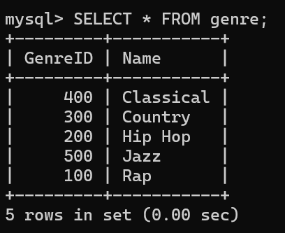

4.Display all playlists

SELECT * FROM playlist;

5. Display all playlists

6. DISPLAY ALL PODCAST INFORMATION

7.Display all song details

8.Display the number of albums

9.Display the number of artist

10.Display the number of genres

11.Display the number of playlist

12. Display the number of songs

13. Display the artist name who’s artistID 7777

14.Display genre details whos genre id is 400

15.Display users who have premium membership

16 Retrieve names of songs longer than 5 mins

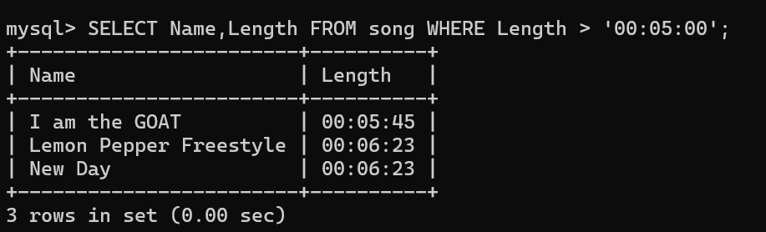

17.Retrieve the names of playlist categorized by genre

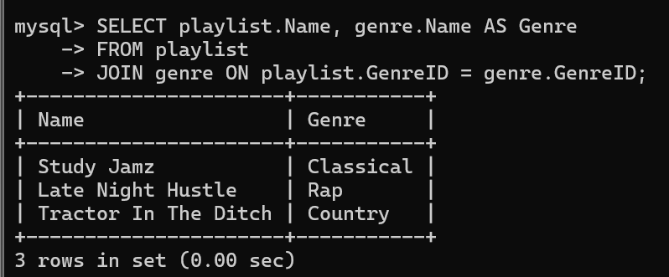

18.List the membership of all users

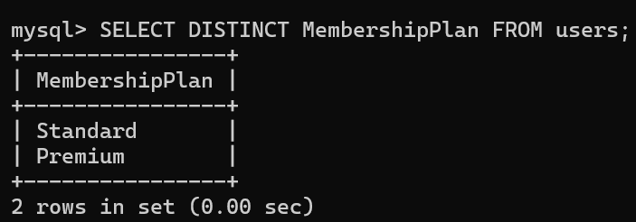

19. Get name of all artist in alphabetical order

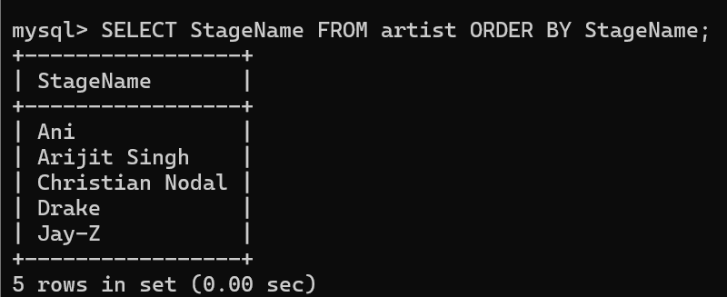

20.Get names of all playlist along with their genres

21.Get names of all songs along with their artists.

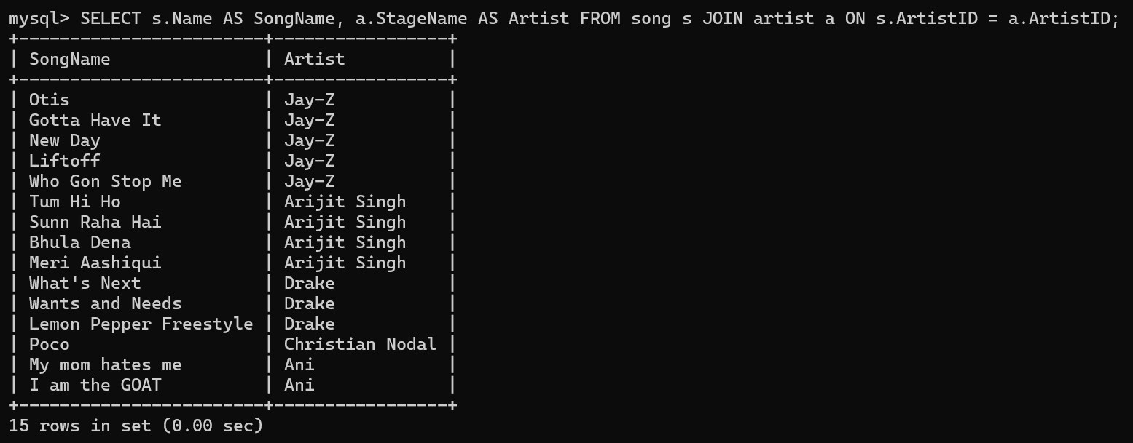

22. Get names of all songs along with their artists

23. Show record label of songs released before year 2020

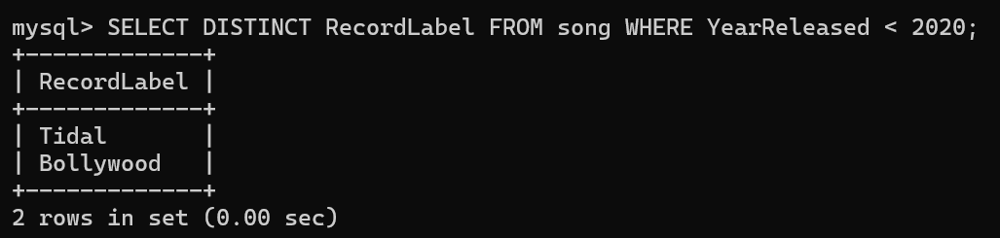

24. List all users along with their email address

25.Show names of artist who have released podcasts

26.Show user names along with their friends

27.Retrieve the name of playlist along with their genre

28. List names of artist along with their their albums

29.Display the max release year of songs each artist

30.Max episode number of podcast for each artist

31.Display the min song length for each album

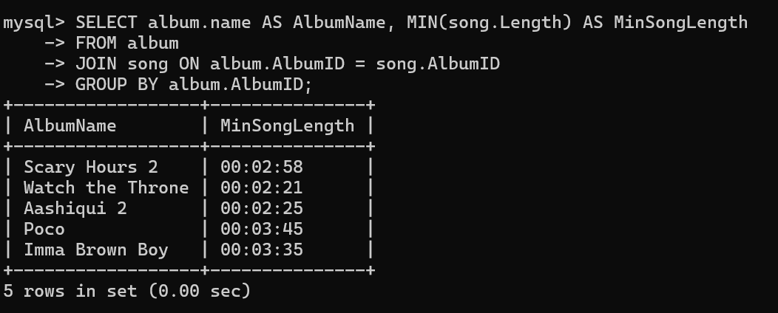

32.Display max and min eps of podcast for each artist

33.Calculate avg length of each song for each artist

34.Count number of songs for each language

35.Calculate total length of songs for each artist

36. Find total songs in each genre

37. Display users with an email containing “gmail.com”

38.Display all songs in English

39.List artist whose desc is longer than 30 words

40. Max and Min ages of artist along with their avg ages

