Exercise 1: Control Structures

Scenario 1: The bank wants to apply a discount to loan interest rates for customers above 60 years old.
  - Question: Write a PL/SQL block that loops through all customers, checks their age, and if they are above 60, apply a 1% discount to their current loan interest rates.

  - Output:
  - 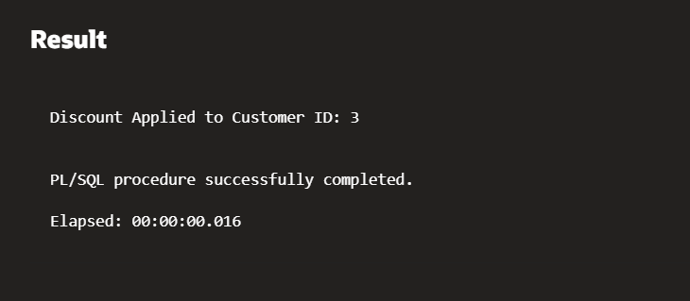

Scenario 2: A customer can be promoted to VIP status based on their balance.
  - Question: Write a PL/SQL block that iterates through all customers and sets a flag IsVIP to TRUE for those with a balance over $10,000.
  - Output:
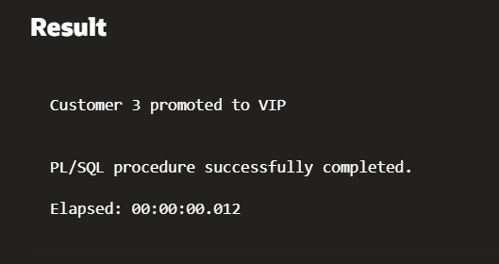

Scenario 3: The bank wants to send reminders to customers whose loans are due within the next 30 days.
  - Question: Write a PL/SQL block that fetches all loans due in the next 30 days and prints a reminder message for each customer.

Exercise 2: Error Handling

Scenario 1: Handle exceptions during fund transfers between accounts.
  - Question: Write a stored procedure SafeTransferFunds that transfers funds between two accounts. Ensure that if any error occurs (e.g., insufficient funds), an appropriate error message is logged and the transaction is rolled back.
  - Output:
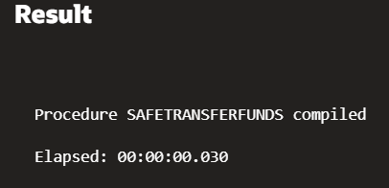

Scenario 2: Manage errors when updating employee salaries.
  - Question: Write a stored procedure UpdateSalary that increases the salary of an employee by a given percentage. If the employee ID does not exist, handle the exception and log an error message.
  - Output:
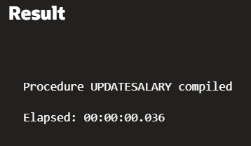

Scenario 3: Ensure data integrity when adding a new customer.
  - Question: Write a stored procedure AddNewCustomer that inserts a new customer into the Customers table. If a customer with the same ID already exists, handle the exception by logging an error and preventing the insertion.

Exercise 3: Stored Procedures

Scenario 1: The bank needs to process monthly interest for all savings accounts.
  - Question: Write a stored procedure ProcessMonthlyInterest that calculates and updates the balance of all savings accounts by applying an interest rate of 1% to the current balance.

Scenario 2: The bank wants to implement a bonus scheme for employees based on their performance.
  - Question: Write a stored procedure UpdateEmployeeBonus that updates the salary of employees in a given department by adding a bonus percentage passed as a parameter.

Scenario 3: Customers should be able to transfer funds between their accounts.
  - Question: Write a stored procedure TransferFunds that transfers a specified amount from one account to another, checking that the source account has sufficient balance before making the transfer.

Exercise 4: Functions

Scenario 1: Calculate the age of customers for eligibility checks.
  - Question: Write a function CalculateAge that takes a customer's date of birth as input and returns their age in years.

Scenario 2: The bank needs to compute the monthly installment for a loan.
  - Question: Write a function CalculateMonthlyInstallment that takes the loan amount, interest rate, and loan duration in years as input and returns the monthly installment amount.

Scenario 3: Check if a customer has sufficient balance before making a transaction.
  - Question: Write a function HasSufficientBalance that takes an account ID and an amount as input and returns a boolean indicating whether the account has at least the specified amount.

Exercise 5: Triggers

Scenario 1: Automatically update the last modified date when a customer's record is updated.
  - Question: Write a trigger UpdateCustomerLastModified that updates the LastModified column of the Customers table to the current date whenever a customer's record is updated.
  - Output:
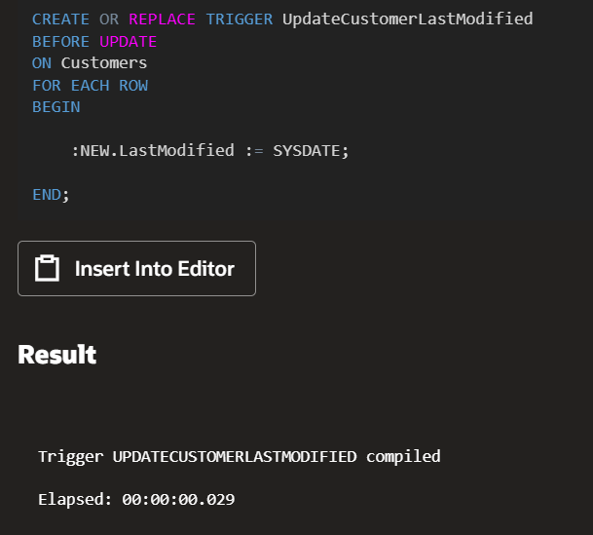
Scenario 2: Maintain an audit log for all transactions.
  - Question: Write a trigger LogTransaction that inserts a record into an AuditLog table whenever a transaction is inserted into the Transactions table.
  - Output:
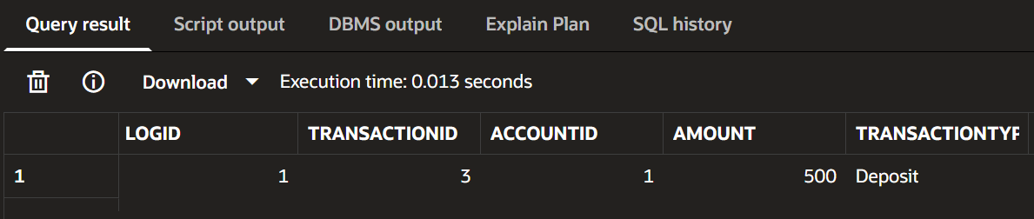

Scenario 3: Enforce business rules on deposits and withdrawals.
  - Question: Write a trigger CheckTransactionRules that ensures withdrawals do not exceed the balance and deposits are positive before inserting a record into the Transactions table.
Exercise 6: Cursors

Scenario 1: Generate monthly statements for all customers.
  - Question: Write a PL/SQL block using an explicit cursor GenerateMonthlyStatements that retrieves all transactions for the current month and prints a statement for each customer.
Scenario 2: Apply annual fee to all accounts.
  - Question: Write a PL/SQL block using an explicit cursor ApplyAnnualFee that deducts an annual maintenance fee from the balance of all accounts.
Scenario 3: Update the interest rate for all loans based on a new policy.
  - Question: Write a PL/SQL block using an explicit cursor UpdateLoanInterestRates that fetches all loans and updates their interest rates based on the new policy.

Exercise 7: Packages

Scenario 1: Group all customer-related procedures and functions into a package.
  - Question: Create a package CustomerManagement with procedures for adding a new customer, updating customer details, and a function to get customer balance.
Scenario 2: Create a package to manage employee data.
  - Question: Write a package EmployeeManagement with procedures to hire new employees, update employee details, and a function to calculate annual salary.
Scenario 3: Group all account-related operations into a package.
  - Question: Create a package AccountOperations with procedures for opening a new account, closing an account, and a function to get the total balance of a customer across all accounts.

Schema to be Created

CREATE TABLE Customers (
CustomerID NUMBER PRIMARY KEY,
Name VARCHAR2(100),
DOB DATE,
Balance NUMBER,
LastModified DATE
);

CREATE TABLE Accounts (
AccountID NUMBER PRIMARY KEY,
CustomerID NUMBER,
AccountType VARCHAR2(20),
Balance NUMBER,
LastModified DATE,
FOREIGN KEY (CustomerID) REFERENCES Customers(CustomerID)
);

CREATE TABLE Transactions (
TransactionID NUMBER PRIMARY KEY,
AccountID NUMBER,
TransactionDate DATE,
Amount NUMBER,
TransactionType VARCHAR2(10),
FOREIGN KEY (AccountID) REFERENCES Accounts(AccountID)
);

CREATE TABLE Loans (
LoanID NUMBER PRIMARY KEY,
CustomerID NUMBER,
LoanAmount NUMBER,
InterestRate NUMBER,
StartDate DATE,
EndDate DATE,
FOREIGN KEY (CustomerID) REFERENCES Customers(CustomerID)
);

CREATE TABLE Employees (
EmployeeID NUMBER PRIMARY KEY,
Name VARCHAR2(100),
Position VARCHAR2(50),
Salary NUMBER,
Department VARCHAR2(50),
HireDate DATE
);

Example Scripts for Sample Data Insertion

INSERT INTO Customers (CustomerID, Name, DOB, Balance, LastModified)
VALUES (1, 'John Doe', TO_DATE('1985-05-15', 'YYYY-MM-DD'), 1000, SYSDATE);

INSERT INTO Customers (CustomerID, Name, DOB, Balance, LastModified)
VALUES (2, 'Jane Smith', TO_DATE('1990-07-20', 'YYYY-MM-DD'), 1500, SYSDATE);

INSERT INTO Accounts (AccountID, CustomerID, AccountType, Balance, LastModified)
VALUES (1, 1, 'Savings', 1000, SYSDATE);

INSERT INTO Accounts (AccountID, CustomerID, AccountType, Balance, LastModified)
VALUES (2, 2, 'Checking', 1500, SYSDATE);

INSERT INTO Transactions (TransactionID, AccountID, TransactionDate, Amount, TransactionType)
VALUES (1, 1, SYSDATE, 200, 'Deposit');

INSERT INTO Transactions (TransactionID, AccountID, TransactionDate, Amount, TransactionType)
VALUES (2, 2, SYSDATE, 300, 'Withdrawal');

INSERT INTO Loans (LoanID, CustomerID, LoanAmount, InterestRate, StartDate, EndDate)
VALUES (1, 1, 5000, 5, SYSDATE, ADD_MONTHS(SYSDATE, 60));

INSERT INTO Employees (EmployeeID, Name, Position, Salary, Department, HireDate)
VALUES (1, 'Alice Johnson', 'Manager', 70000, 'HR', TO_DATE('2015-06-15', 'YYYY-MM-DD'));

INSERT INTO Employees (EmployeeID, Name, Position, Salary, Department, HireDate)
VALUES (2, 'Bob Brown', 'Developer', 60000, 'IT', TO_DATE('2017-03-20', 'YYYY-MM-DD'));

