# create table in Hbase

create 'Hb_Hi_sales','ORDERNUMBER','QUANTITYORDERED','PRICEEACH','ORDERLINENUMBER','SALES','STATUS','QTR_ID','MONTH_ID','YEAR_ID','PRODUCTLINE','MSRP','PRODUCTCODE','PHONE','CITY','STATE','POSTALCODE','COUNTRY','TERRITORY','CONTACTLASTNAME','CONTACTFIRSTNAME','DEALSIZE'



# create temp table in hive

create table hi_hb_sales_stag

(

key string,

ORDERNUMBER string,

QUANTITYORDERED string,

PRICEEACH string,

ORDERLINENUMBER string,

SALES string,

STATUS string,

QTR_ID string,

MONTH_ID string,

YEAR_ID string,

PRODUCTLINE string,

MSRP string,

PRODUCTCODE string,

PHONE string,

CITY string,

STATE string,

POSTALCODE string,

COUNTRY string,

TERRITORY string,

CONTACTLASTNAME string,

CONTACTFIRSTNAME string,

DEALSIZE string

)

ROW FORMAT DELIMITED

FIELDS TERMINATED BY ',' ;

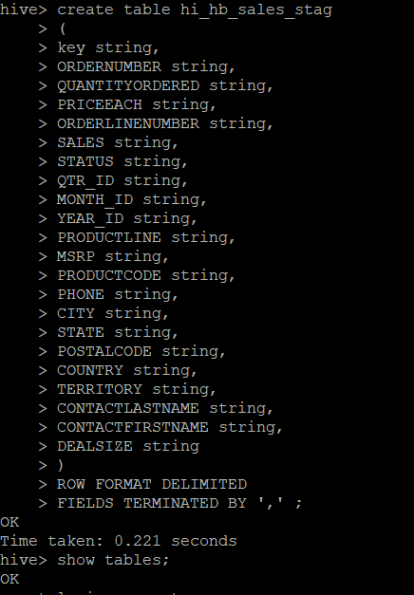

# create main table in hive

create external table hi_hb_sales

(

key string,

ORDERNUMBER string,

QUANTITYORDERED string,

PRICEEACH string,

ORDERLINENUMBER string,

SALES string,

STATUS string,

QTR_ID string,

MONTH_ID string,

YEAR_ID string,

PRODUCTLINE string,

MSRP string,

PRODUCTCODE string,

PHONE string,

CITY string,

STATE string,

POSTALCODE string,

COUNTRY string,

TERRITORY string,

CONTACTLASTNAME string,

CONTACTFIRSTNAME string,

DEALSIZE string

)

ROW FORMAT DELIMITED

FIELDS TERMINATED BY ','

STORED BY 'org.apache.hadoop.hive.hbase.HBaseStorageHandler'

WITH SERDEPROPERTIES

("hbase.columns.mapping"=":key,ORDERNUMBER:ORDERNUMBER,QUANTITYORDERED:QUANTITYORDERED,PRICEEACH:PRICEEACH,ORDERLINENUMBER:ORDERLINENUMBER,SALES:SALES,STATUS:STATUS,QTR_ID:QTR_ID,MONTH_ID:MONTH_ID,YEAR_ID:YEAR_ID,PRODUCTLINE:PRODUCTLINE,MSRP:MSRP,PRODUCTCODE:PRODUCTCODE,PHONE:PHONE,CITY:CITY,STATE:STATE,POSTALCODE:POSTALCODE,COUNTRY:COUNTRY,TERRITORY:TERRITORY,CONTACTLASTNAME:CONTACTLASTNAME,CONTACTFIRSTNAME:CONTACTFIRSTNAME,DEALSIZE:DEALSIZE")

TBLPROPERTIES("hbase.table.name"="Hb_Hi_sales");

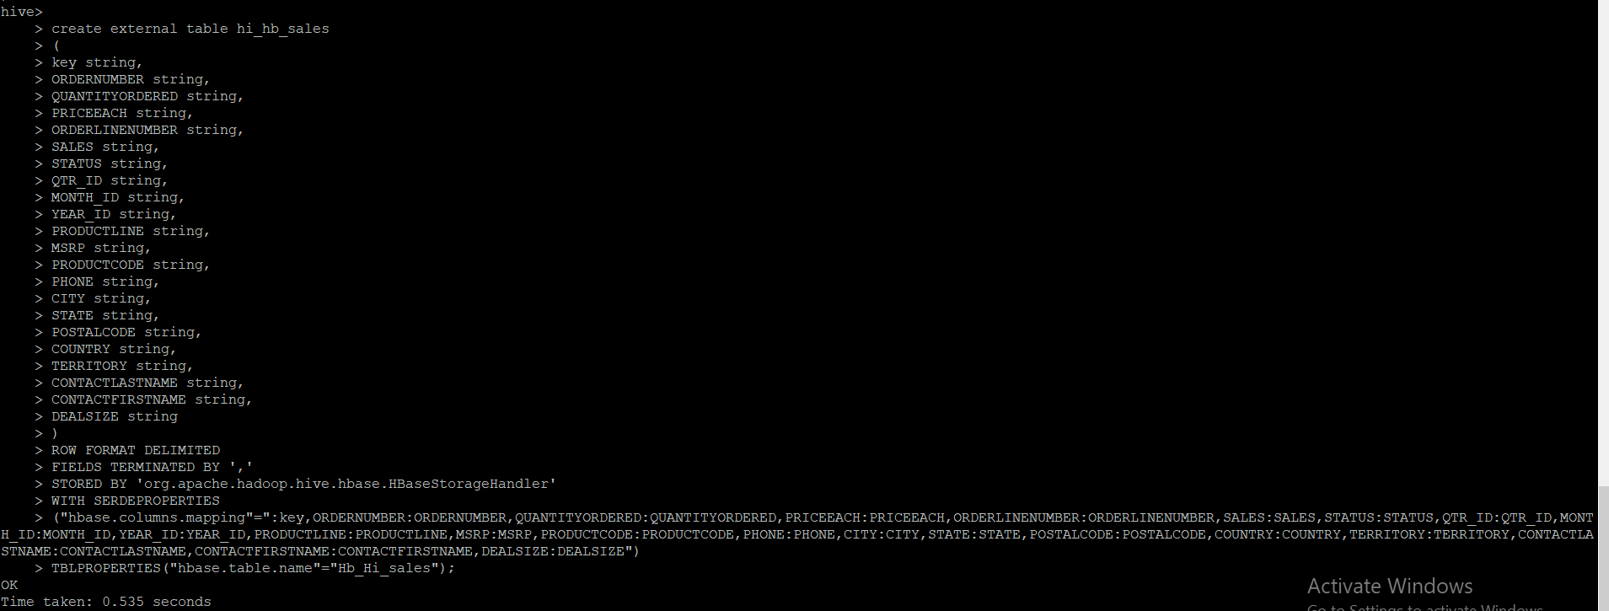

# loading data into temp table from local

load data local inpath '/home/cloudera/Desktop/Hive-Class-main/sales_order_data.csv' into table hi_hb_sales_stag;



# load data into main table from temp table

insert into hi_hb_sales select * from hi_hb_sales_stag;

