

By: M HEMANTH KUMAR

FROM : Dept of data science



**What is MongoDB?**

MongoDB is a **document-oriented** NoSQL database system that provides high scalability, flexibility, and performance. Unlike standard relational databases, MongoDB stores data in a [JSON](https://www.geeksforgeeks.org/json/)document structure form. This makes it easy to operate with dynamic and unstructured data and MongoDB is an open-source and cross-platform database System.

MongoDB is an open source NoSQL database management program. NoSQL (Not only SQL) is used as an alternative to traditional relational databases.

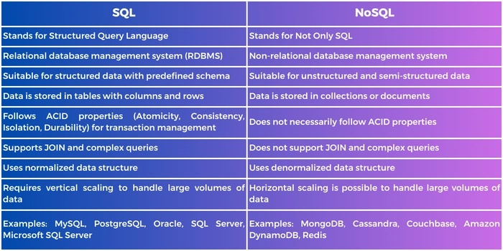

**Database defined:**

A database is an organized collection of structured information, or data, typically stored electronically in a computer system. A database is usually controlled by a database management system (DBMS).

**Database:**

* Database is a container for collections.
* Each database gets its own set of files.
* A single MongoDB server can has multiple databases.

**Why Use MongoDB?**

Document Oriented Storage − Data is stored in the form of JSON documents.

* **Index on any attribute**: Indexing in MongoDB allows for faster data retrieval by creating a searchable structure on selected attributes, optimizing query performance.
* **Replication and high availability**: MongoDB’s replica sets ensure data redundancy by maintaining multiple copies of the data, providing fault tolerance and continuous availability even in case of server failures.
* **Auto-Sharding**: Auto-sharding in MongoDB automatically distributes data across multiple servers, enabling horizontal scaling and efficient handling of large datasets.
* **Big Data and Real-time Application**: When dealing with massive datasets or applications requiring real-time data updates, MongoDB’s flexibility and scalability prove advantageous.
* **Rich queries**: MongoDB supports complex queries with a variety of operators, allowing you to retrieve, filter, and manipulate data in a flexible and powerful manner.
* **Fast in-place updates**: MongoDB efficiently updates documents directly in their place, minimizing data movement and reducing write overhead.
* **Professional support by MongoDB**: MongoDB offers expert technical support and resources to help users with any issues or challenges they may encounter during their database operations.
* **Internet of Things (IoT) Applications:** Storing and analyzing sensor data with its diverse formats often aligns well with MongoDB’s document structure.

**Where to Use MongoDB?**

* Mobile and Social Infrastructure
* Data Hub
* Previous Pag
* Big Data
* User Data Management
* Content Management and Delivery

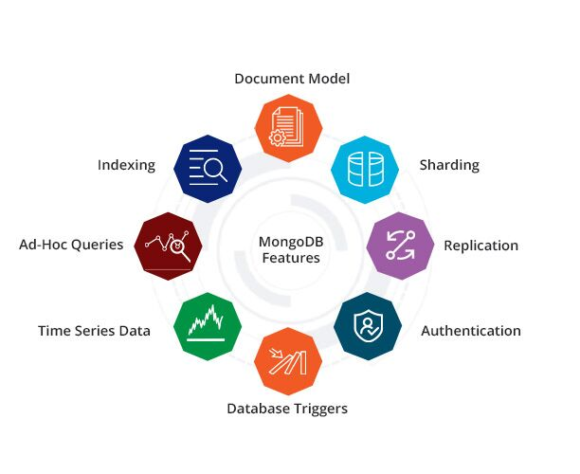

fig 1: -MongoDB features



fig 2: - MongoDB in real world example



**How to Install MongoDB on Windows?**

**Requirements to Install MongoDB on Windows: -**

* MongoDB versions 4.4 and later only support 64-bit versions of Windows.
* If you're using an older version (e.g., MongoDB 7.0), supported Windows versions include:
* Windows Server 2022 (64-bit)
* Windows Server 2019 (64-bit)
* Windows 11 (64-bit)

**Steps to Install MongoDB on windows using MSI: -**

To install MongoDB on Windows, first, download the MongoDB server and then install the MongoDB shell.

**STEP1:** Go to the MongoDB Download Center to download the MongoDB Community Server.

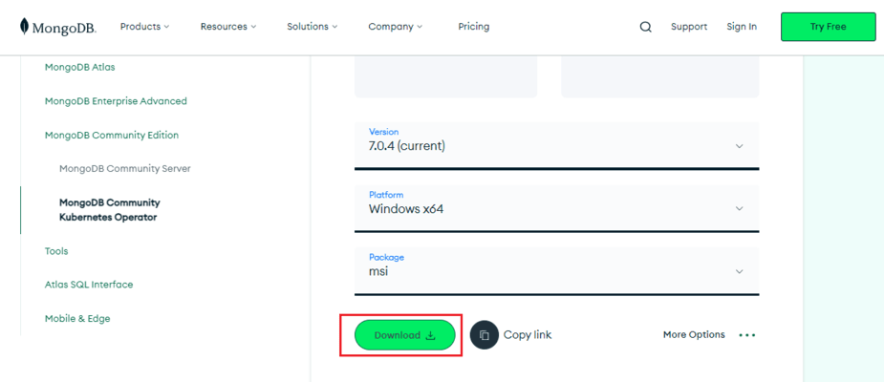

select any version, Windows, and package according to your requirement. For Windows, we need to choose:

* Version: 7.0.4
* OS: Windows x64
* Package: msi

**Step2:** When the download is complete open the msi file and click the next button in the startup screen:

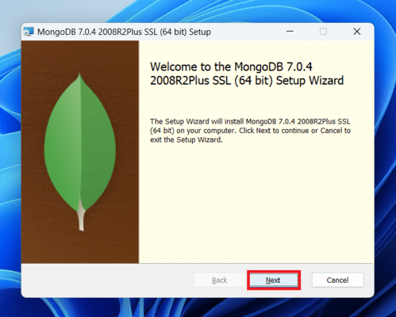

**Step3:**Now accept the End-User License Agreement and click the next button:

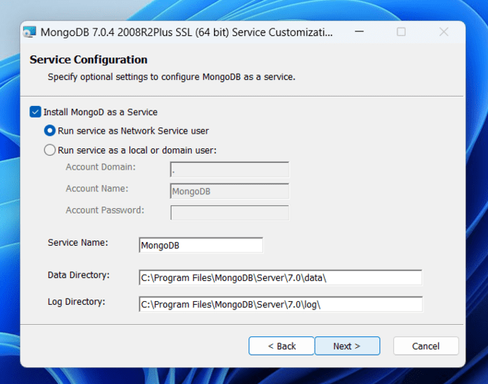

**Step4:** Now select the complete option to install all the program features. Here, if you can want to install only selected program features and want to select the location of the installation, then use the Custom option: +

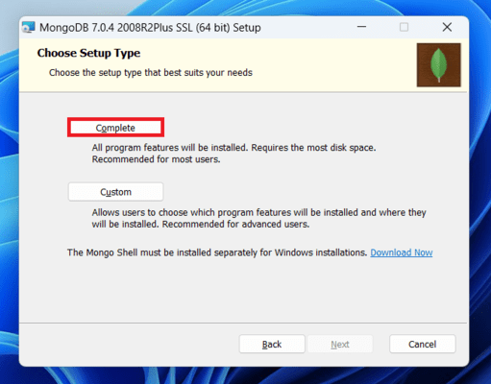

**Step5:** Select “Run service as Network Service user” and copy the path of the data directory. Click Next:

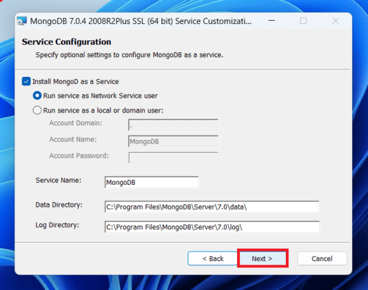

**Step6:** Click the Install button to start the MongoDB installation process:

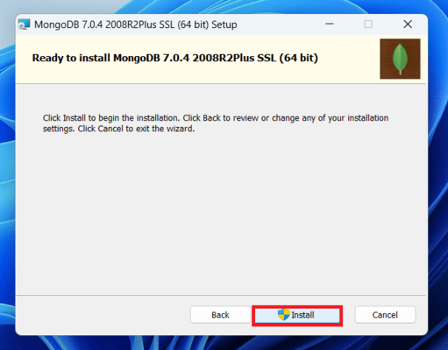

**Step 7:**After clicking on the install button installation of MongoDB begins:

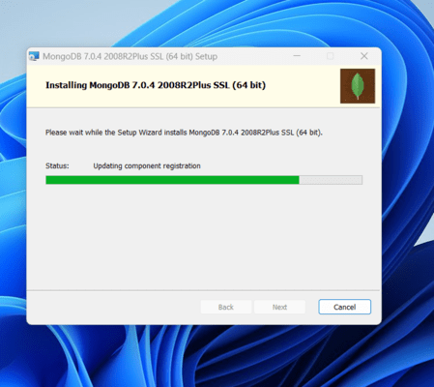

**Step 8:** Now click the Finish button to complete the MongoDB installation process:

# **MongoDB Shell Download:**

MongoDB Shell is the quickest way to connect to (and work with) MongoDB. Easily query data, configure settings, and execute other actions with this modern, extensible command-line interface — replete with syntax highlighting, intelligent autocomplete, contextual help, and error messages.

Note: MongoDB Shell is an open source (Apache 2.0), standalone product developed separately from the MongoDB Server.

Steps to Download MongoDB Shell: -

Step1: Open the MongoDB Shell download page and open the  MongoDB Download Center .

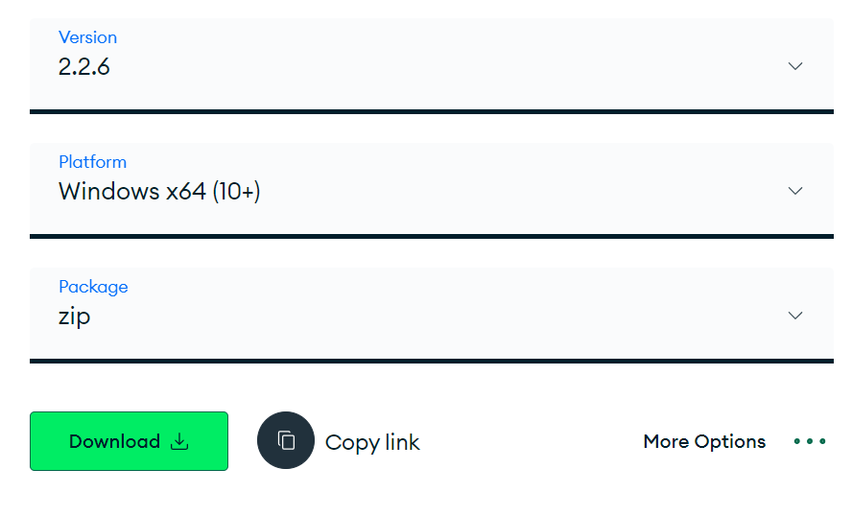

Select any version, Windows, and package according to your requirement. For Windows, we need to choose:

* Version: 2.2.6
* OS: Windows x64
* Package: zip

Step2: Locate the downloaded .zip file in your Downloads folder (or wherever you saved it).

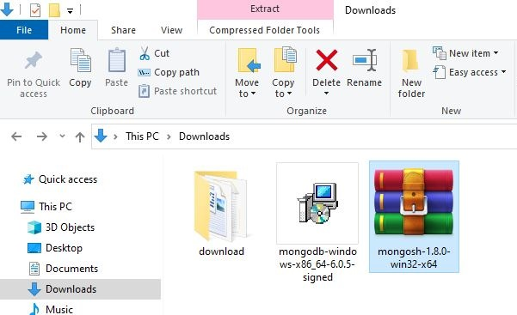

Step3: Right-click on the mongosh-2.2.6-win32-x64 file and select "Extract Here".

Now, click on the downloaded installer file to start the installation wizard, as shown below.

[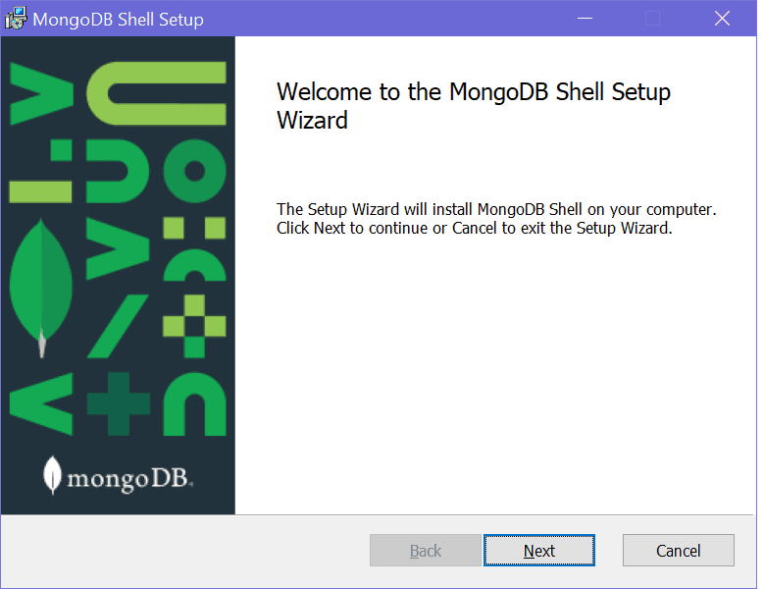](https://www.tutorialsteacher.com/Content/images/mongodb/mongo-shell-install.png)Install New MongoDB Shell - mongosh

Click Next to go to next step shown below.

[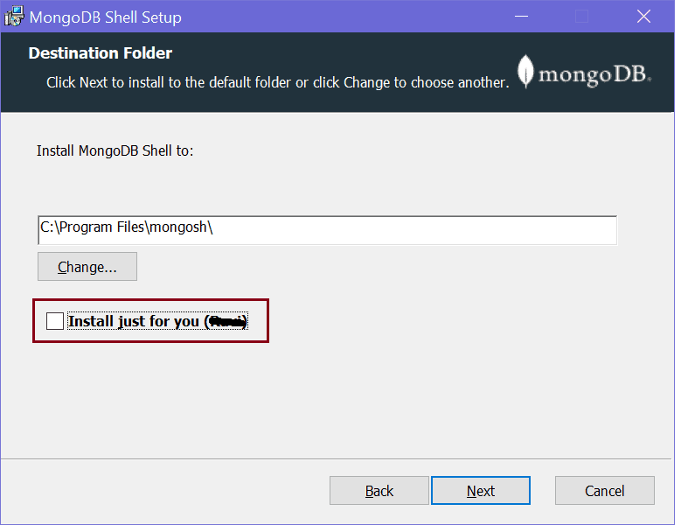](https://www.tutorialsteacher.com/Content/images/mongodb/install-mongoshell2.png)

Here, uncheck the checkbox if you want to install shell for all users on your local machine and click Next.[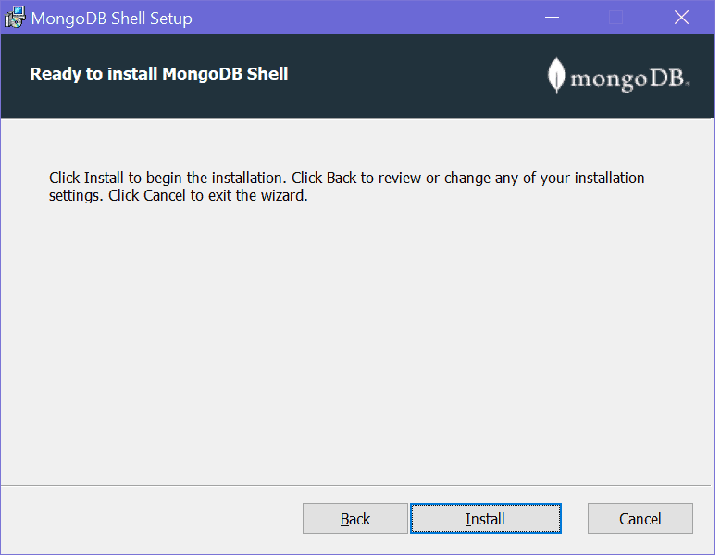](https://www.tutorialsteacher.com/Content/images/mongodb/install-mongoshell3.png)

Click on the Install button to start the installation. It should quickly install it.

[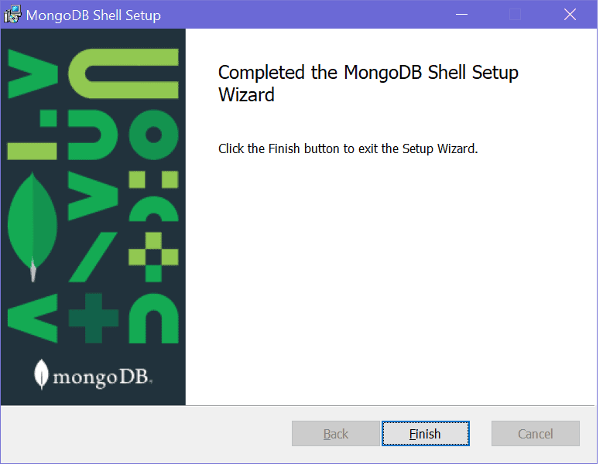](https://www.tutorialsteacher.com/Content/images/mongodb/install-mongoshell4.png)

Once installation completes, click the Finish button to close the wizard.

This should have installed mongosh in "C:\Program Files\mongosh" folder on Windows, as shown below.

[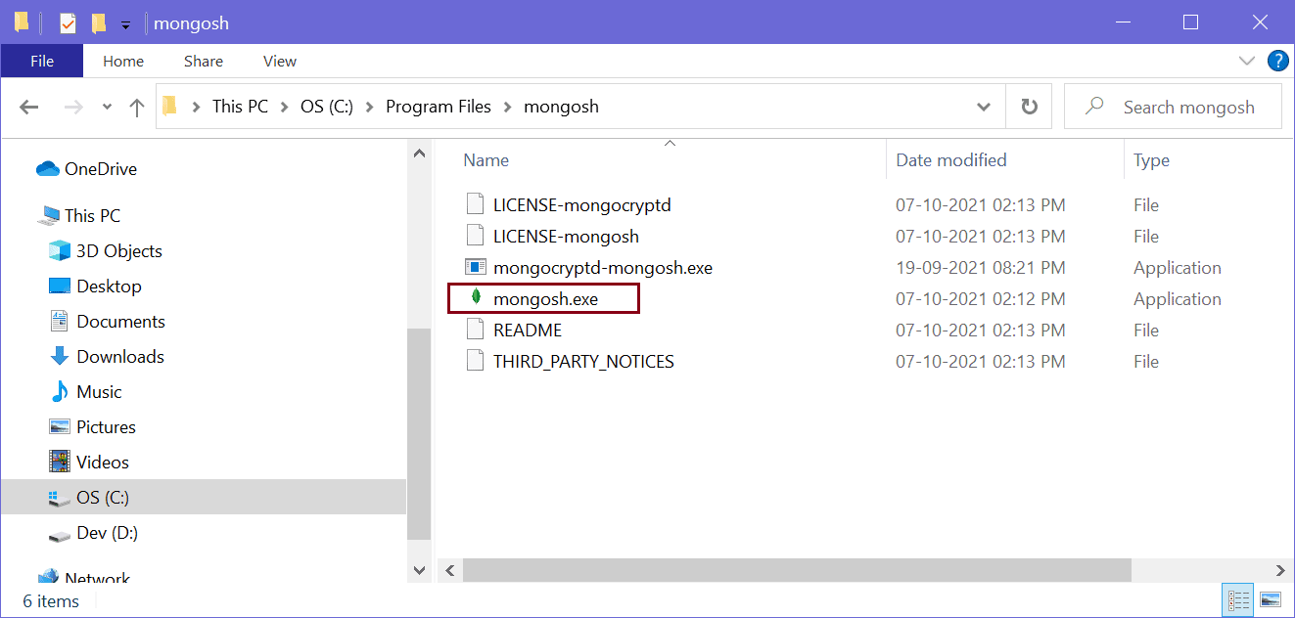](https://www.tutorialsteacher.com/Content/images/mongodb/mongosh-file.png)

Click on the mongosh.exe to open a new MongoDB shell, as shown below.

[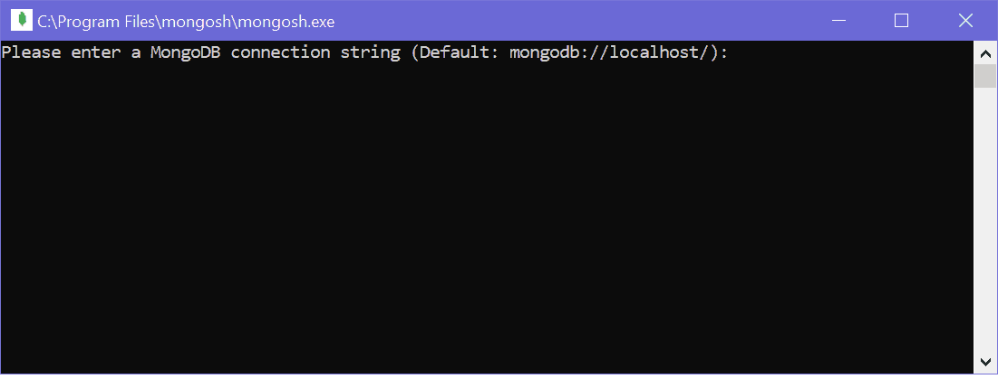](https://www.tutorialsteacher.com/Content/images/mongodb/mongosh.png)

Press Enter to start the shell, as shown below.

[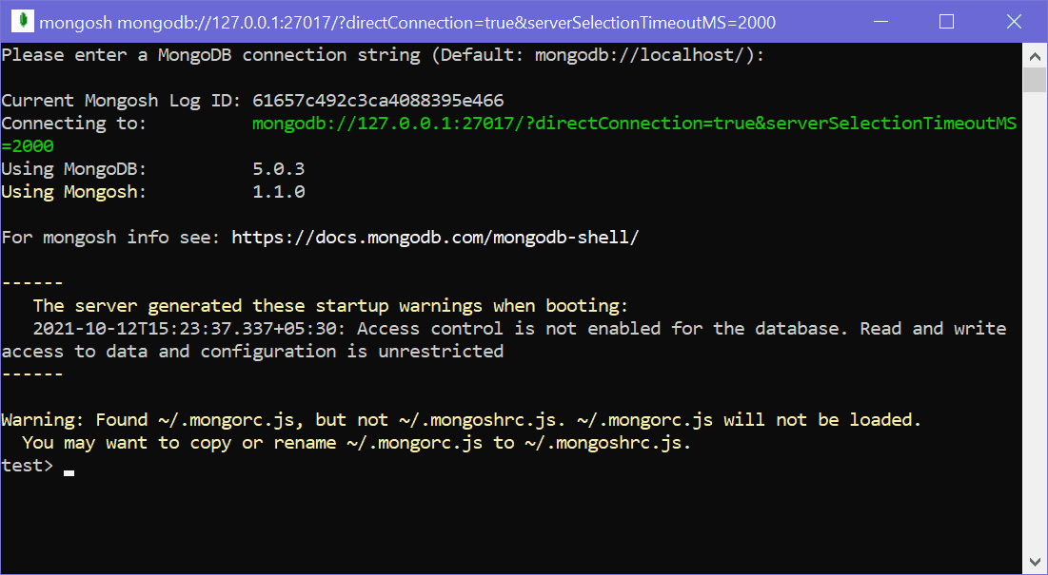](https://www.tutorialsteacher.com/Content/images/mongodb/mongosh2.png)

Now we can use Mongosh to solve any problems releated to database collections.