STUDENT RECORD MANAGER
USING C++
Cornerstone project report submitted to Aditya University in partial
fulfilment of the requirements for the award of the degree of
Bachelor of Technology
in
Artificial Intelligence and Machine Learning
Academic Year 2026–2027
SUBMITTED BY
Kappala Hemanth Sai Venkata Vidya Sagar (25B11AI494)
Baluguri Ganesh (25B11AI084)
Gannabathula Sai (25B11AI320)
Ayenavalli Keerthu Praveen (26B21AI0132)

UNDER THE GUIDANCE OF
T. Vijaya Lakshmi
Assistant Professor
Department of Artificial Intelligence and Machine Learning

DEPARTMENT OF ARTIFICIAL INTELLIGENCE
AND MACHINE LEARNING
ADITYA UNIVERSITY
Aditya Nagar, ADB Road, Surampalem
Andhra Pradesh, India – 533437

DEPARTMENT OF ARTIFICIAL INTELLIGENCE
AND MACHINE LEARNING
ADITYA UNIVERSITY, SURAMPALEM

CERTIFICATE
This is to certify that the Cornerstone Project report entitled “Student Record Manager Using C++” is submitted by Kappala Hemanth Sai Venkata Vidya Sagar (25B11AI494), Baluguri Ganesh (25B11AI084), Gannabathula Sai (25B11AI320) and Ayenavalli Keerthu Praveen (26B21AI0132), in partial fulfilment of the requirements for the award of the Bachelor of Technology degree in Artificial Intelligence and Machine Learning at Aditya University.
The project forms part of the course Object Oriented Programming through C++ (2501CS08) during the academic year 2026–2027. The report presents the design, C++ implementation, output screens and testing of a console application for managing student records and analysing subject marks.
The work is submitted under the guidance of T. Vijaya Lakshmi, Assistant Professor, Department of Artificial Intelligence and Machine Learning.

Project Guide Head of the Department
Dr. K. Naga Bhargavi,
Assistant Professor

T. Vijaya Lakshmi
Assistant Professor

DECLARATION

We hereby declare that the Cornerstone Project entitled “Student Record Manager Using C++” is our project work carried out as part of the course Object Oriented Programming through C++ (2501CS08), under the guidance of T. Vijaya Lakshmi, Assistant Professor, Department of Artificial Intelligence and Machine Learning, Aditya University, Surampalem.
This report describes the project objectives, design, implementation and testing. The program uses classes, an array of student objects, strings and member functions to manage student information and calculate marks statistics.
We acknowledge the learning materials and reference documents used in preparing the project and its documentation. We take responsibility for reviewing the report and the program submitted with it.

Project Associates
Kappala Hemanth Sai Venkata Vidya Sagar (25B11AI494)
Baluguri Ganesh (25B11AI084)
Gannabathula Sai (25B11AI320)
Ayenavalli Keerthu Praveen (26B21AI0132)
Date: ____________________
Place: Surampalem

ACKNOWLEDGEMENT

We express our sincere thanks to our project guide, T. Vijaya Lakshmi, Assistant Professor, Department of Artificial Intelligence and Machine Learning, for her guidance and suggestions during the preparation of our Student Record Manager project.
We thank the Head of the Department and the faculty members of the Department of Artificial Intelligence and Machine Learning, Aditya University, for their support and for providing an opportunity to apply the concepts studied in Object Oriented Programming through C++.
The project helped us connect classroom topics with a working application. Designing the Student and StudentRecordManager classes, organising records in arrays, and testing the menu operations improved our understanding of how a C++ program is structured.
We also thank our classmates, families and friends for their encouragement throughout the project. We appreciate the cooperation of every team member in preparing the program, review presentations and documentation.

Project Associates
Kappala Hemanth Sai Venkata Vidya Sagar (25B11AI494)
Baluguri Ganesh (25B11AI084)
Gannabathula Sai (25B11AI320)
Ayenavalli Keerthu Praveen (26B21AI0132)

ABSTRACT

Student Record Manager is a console-based C++ application that stores student details and subject marks during a program session. It provides a menu for adding records, displaying all records, searching by roll number, analysing marks, updating details and deleting records. These operations reduce the repeated work involved in maintaining small sets of student information manually.
The design uses two classes. Student stores an integer roll number, a name and five subject marks. StudentRecordManager maintains an array of 100 Student objects and a count of active records. Member functions organise the operations, and the manager constructor sets the initial record count to zero.
The subjects are C++, DSA, Java, English and DAE. For each stored student, the program calculates total marks out of 500, the highest and lowest subject marks, the average mark and the percentage. Numeric marks outside the range 0 to 100 are requested again. Linear search locates records, and deletion shifts later array elements to preserve a continuous active record sequence.
The implementation demonstrates classes and objects, encapsulation of manager state, constructors, composition, arrays, strings, loops and conditional statements. Tests confirm the principal record operations and arithmetic on valid numeric input. The current prototype has no persistent storage, login system or name-based search. Identified limitations, including inconsistent marks labels and incomplete input validation, are discussed with future improvements.
Keywords: Student Record Manager, C++, Object-Oriented Programming, Arrays, Linear Search, Marks Analysis, Console Application.

ABBREVIATIONS
Abbreviation | Full form or meaning
SRM | Student Record Manager
OOP | Object-Oriented Programming
AIML | Artificial Intelligence and Machine Learning
CRUD | Create, Read, Update and Delete
UI | User Interface
CLI | Command-Line Interface
I/O | Input and Output
IDE | Integrated Development Environment
ID | Identifier
DFD | Data Flow Diagram
ER | Entity Relationship
STL | Standard Template Library
Subject labels in the program are C++, DSA, Java, English and DAE. They are retained exactly as defined in Project.cpp.

LIST OF FIGURES
Figure | Title | Page
Fig 1.1 | System architecture of Student Record Manager | 3
Fig 1.2 | Flowchart of the student record management process | 5
Fig 1.3 | Class diagram of Student Record Manager | 6
Fig 2.1 | Main menu with seven operations | 16
Fig 2.2 | Adding a student with five subject marks | 16
Fig 2.3 | Displaying all student records | 17
Fig 2.4 | Searching for roll number 101 | 17
Fig 2.5 | Per student marks analysis | 18
Fig 2.6 | Updating the roll number and subject marks | 18
Fig 2.7 | Searching for the updated record | 19
Fig 2.8 | Deleting the updated student record | 19
Fig 2.9 | Empty record message after deletion | 19

LIST OF TABLES
Table | Title | Page
Table 1.1 | Modules and implemented functions | 2
Table 1.2 | Team contributions | 2
Table 1.3 | Software and hardware requirements | 3
Table 1.4 | Data items and storage rules | 6
Table 2.1 | OOP concepts and their implementation | 7
Table 2.2 | Functional test cases and results | 20
Table 2.3 | Tests confirming current limitations | 21

TABLE OF CONTENTS
Contents | Page
Title Page | i
Certificate | ii
Declaration | iii
Acknowledgement | iv
Abstract | v
Abbreviations | vi
List of Figures | vii
List of Tables | viii
CHAPTER 1 PROJECT PLANNING | 1
1.1 Problem Statement | 1
1.2 Project Objectives | 1
1.3 Planned Modules | 2
1.4 System Architecture Algorithm and Flowchart | 3
CHAPTER 2 PROJECT IMPLEMENTATION | 7
2.1 OOP Concepts Used for Implementation | 7
2.2 Code | 8
2.3 Output Screens | 16
2.4 Testing and Results | 20
CHAPTER 3 CONCLUSION AND FUTURE SCOPE | 22
3.1 Conclusion | 22
3.2 Future Scope | 22
References | 23

CHAPTER 1
PROJECT PLANNING

1.1 Problem Statement
Student details and subject marks are frequently needed for academic record maintenance. When information is written in separate registers or lists, finding a student, replacing incorrect details and calculating performance measures require repeated manual work. As records increase, maintaining a consistent list becomes more difficult.
The problem addressed by this project is to build a small C++ application that keeps student information together and supports record maintenance through a console menu. Each record contains a roll number, a name and marks for five fixed subjects. The system should retrieve a record by roll number and calculate useful statistics for each student.
The application is intended for a faculty member or department operator working on one computer. The program offers one common menu; it does not distinguish administrators, faculty and students through separate accounts or permissions.

1.2 Project Objectives
- Represent student information using a Student class and maintain records in an array of objects.
- Provide menu options to add, display, search, update and delete student records.
- Calculate the total, highest subject mark, lowest subject mark, average and percentage for each student.
- Accept names containing spaces using the string type and getline().
- Reject numeric marks below 0 or above 100 and prevent additions beyond the 100-record capacity.
- Apply C++ member functions, loops and selection statements to keep the program organised and understandable.
Scope: data is held in memory for the current run. The current version is a learning prototype for small record sets, rather than a persistent institutional student information system.

1.3 Planned Modules
The record and marks functions are grouped into modules according to their responsibilities. Table 1.1 maps each module to the member functions present in the implementation.
Table 1.1 Modules and implemented functions
Module | Function or class | Responsibility
Student data | Student::input()  Student::display() | Read and display one student’s roll number, name and five marks.
Add records | addStudent() | Check capacity, enter a record and increase count.
Display records | displayStudents() | Display every active record or an empty-list message.
Search | searchStudent() | Find the first record matching an integer roll number.
Marks analysis | marksAnalysis() | Calculate per-student total, extrema, average and percentage.
Update | updateStudent() | Find a roll number and replace all details through input().
Delete | deleteStudent() | Remove a matching record and shift later records left.
Menu control | menu() and main() | Create the manager, dispatch choices and exit on option 7.

Team Contributions
Table 1.2 Team contributions
Member | Responsibility
K Hemanth Sai Venkata Vidya Sagar | OOP class design and student management
B Ganesh | Student data and marks management
G Sai | Search, marks analysis and testing
A Keerthu Praveen | Documentation, PPT and presentation

1.4 System Architecture Algorithm and Flowchart

1.4.1 System Architecture
The console menu receives the operator’s choice and calls a member function of StudentRecordManager. Record operations use Student::input() and Student::display(), while marksAnalysis() reads the stored marks directly. All records remain in the manager’s in-memory array.
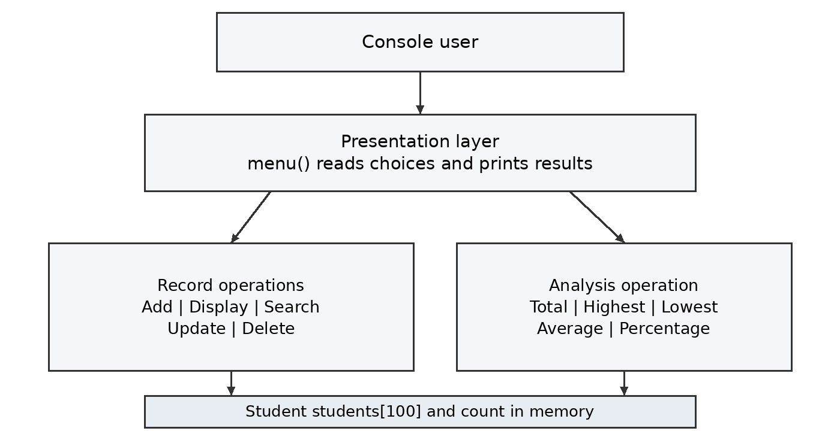
Fig 1.1 System architecture of Student Record Manager

Software and Hardware Requirements
Table 1.3 Software and hardware requirements
Component | Requirement
Language and libraries | C++ with <iostream> and <string>; verified with C++17 compilation.
Build tools | A C++ compiler such as g++ and a text editor or IDE.
Execution environment | A terminal with standard input and output on a compatible computer.
Storage | Space for source and executable files; no database or data file is required.
Hardware | A general-purpose computer capable of running the selected compiler. No project-specific hardware requirement is imposed.

1.4.2 Algorithm
The main program creates one StudentRecordManager object. Its constructor initialises count to zero and main() calls menu(). The following steps describe the execution sequence.
1. Display the seven menu options and read an integer choice.
2. For Add Student, check whether count is already 100. If capacity remains, read the roll number and full name, then read the five marks. Retry a numeric mark while it is outside 0 to 100. Increase count after input is complete.
3. For Display All Students, first check whether the list is empty. Otherwise, call display() for each object from index 0 through count − 1.
4. For Search Student, read the roll number and scan the active array from the beginning. Display the first matching record and return. If no match exists, print “Student not found.”
5. For Marks Analysis, process each student separately. Start total at zero and initialise highest and lowest to the first mark. Visit all five marks, update the total and extrema, and remember the corresponding subject indices.
6. Calculate average as total / 5 and percentage as (total / 500) × 100. Display the total, highest and lowest subject marks, average and percentage.
7. For Update Student, locate the first matching roll number. Call input() on that object to replace the roll number, name and all five marks.
8. For Delete Student, locate the first matching roll number. Copy every following record one position to the left and decrease count.
9. For numeric choices outside 1 to 7, print the invalid-choice message. For choice 7, print the closing message and leave the loop.
10. Repeat the menu after an operation until the user selects option 7.

Marks Calculation Example
For the five marks 80, 90, 70, 85 and 75, the total is 400/500. The highest mark is 90 in DSA and the lowest is 70 in Java. The average is 80/100 and the percentage is 80%. If several subjects tie for the highest or lowest mark, the first matching subject in the fixed subject order is retained.

1.4.3 Flowchart
The flowchart shows menu dispatch and repetition. Each record operation performs its own checks and returns to the menu. The diagram assumes numeric input; recovery from a failed non-numeric input extraction is a future improvement.
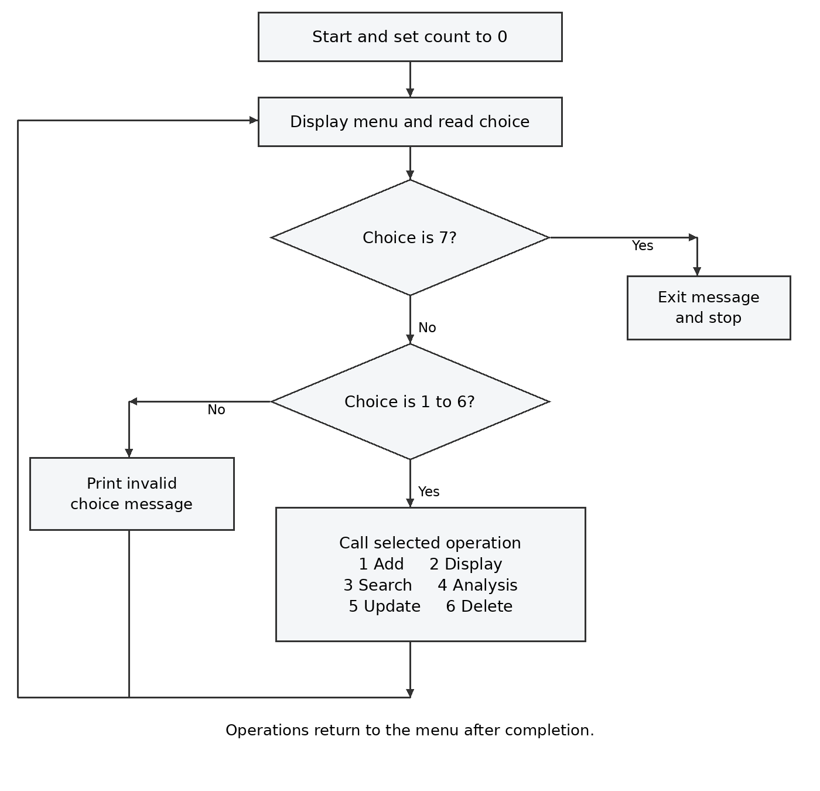
Fig 1.2 Flowchart of the student record management process
Data lifetime: selecting Exit ends the program and discards all records held in memory. No save or load operation is present.

1.4.4 Class Diagram and Data Design
StudentRecordManager owns a fixed array of Student objects. The relationship is composition: record storage is part of the manager object. The Student fields are public in this version, while the manager’s array and record count are private.
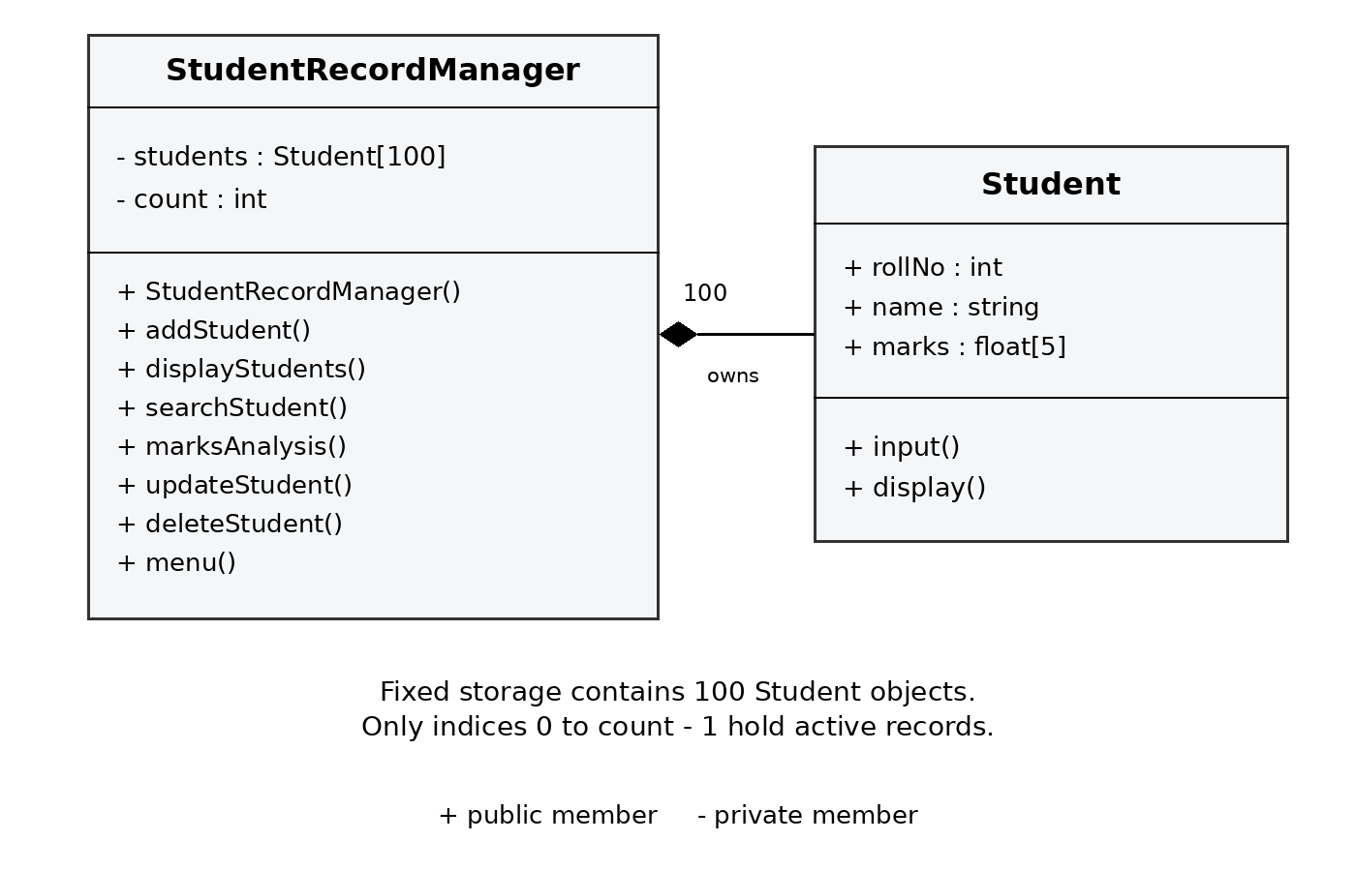
Fig 1.3 Class diagram of Student Record Manager
Table 1.4 Data items and storage rules
Data item | Type and size | Meaning or rule
rollNo | int | Entered roll number; uniqueness and positivity are not enforced.
name | string | Full name read using getline(); spaces are retained.
marks | float[5] | Marks for C++, DSA, Java, English and DAE, in that order.
students | Student[100] | Fixed record storage owned by the manager.
count | int | Number of active records; begins at 0 and is at most 100.
SUBJECTS / MAX_MARKS | const int | Fixed at 5 and 100 respectively.

CHAPTER 2
PROJECT IMPLEMENTATION

2.1 OOP Concepts Used for Implementation
The project organises related data and operations into two classes. This makes each menu operation easier to understand and separates the representation of one student from the management of the record collection.
Table 2.1 OOP concepts and their implementation
Concept | Use in this project
Classes and objects | Student defines one record. StudentRecordManager defines the collection and its operations. main() creates the manager object.
Encapsulation | The students array and count are private. Public member functions expose record operations. Student data members themselves remain public.
Constructor | StudentRecordManager() sets count to zero before menu operations begin. Student has no explicitly written constructor.
Abstraction | The menu calls operations such as addStudent() and deleteStudent() without repeating their internal steps.
Composition | StudentRecordManager contains an array of Student objects as a data member.
Member functions | input() and display() work with one record; manager functions organise collection-level operations.

Other C++ Concepts
The program uses a fixed array of objects, a five-element marks array, string variables, for loops, do-while loops, if statements and a switch statement. Console input and output use cin and cout. getline() reads full names after cin.ignore() consumes the pending newline.
Inheritance, virtual functions, runtime polymorphism, operator overloading and exception handling are not used in this implementation. Grouping methods into classes does not by itself demonstrate those concepts.

2.2 Code

2.2.1 Compilation and Execution
Save the source as Project.cpp and compile it with a C++ compiler. The following command was used to check the submitted program. Compilation completed successfully without warnings from the enabled warning options.
g++ -std=c++17 -Wall -Wextra -pedantic Project.cpp -o student_record_manager
Run ./student_record_manager from a Linux or macOS terminal. On Windows, run the executable produced by the compiler. Select an operation by entering its number and press Enter after each input.

2.2.2 Input and Record Behaviour
The roll number field is an integer. Demonstration inputs therefore use numeric identifiers such as 101 and 102. Alphanumeric university registration numbers are not supported by the current field type. Names may include spaces, and the five subject marks may be decimal values.
Search, update and delete stop at the first matching roll number. Update reads every field again and may change the roll number. Delete closes the gap in the array by copying subsequent records left. The program does not check duplicate roll numbers or request confirmation before deletion.

2.2.3 Marks Rules and Known Display Issue
The implemented numeric range is 0 to 100 inclusive because MAX_MARKS is 100. Total marks are calculated out of 500, and average marks are shown out of 100. However, display() prints “/50” after each subject mark, and the retry message says “between 0 and 50”. These labels conflict with the validation rule and should be corrected in a later code revision.
The complete source listing on the following pages preserves Project.cpp, including its comments, strings and existing display messages. The code is divided across pages only for readability.

2.2.4 Efficiency
For n active students and five fixed subjects, adding a record takes constant time apart from user input. Display, marks analysis, search, update and delete each require at most O(n) time. Deletion includes shifting records. Storage is fixed at 100 Student objects plus their name strings.

2.2.5 Complete Source Code
Project.cpp — lines 1 to 46
#include <iostream>
#include <string>
using namespace std;

const int SUBJECTS = 5;
const int MAX_MARKS = 100;

// Student class
class Student {
public:
int rollNo;
string name;
float marks[SUBJECTS];

// Function to input student details
void input() {
cout << "Enter Roll Number: ";
cin >> rollNo;

cin.ignore();

cout << "Enter Name: ";
getline(cin, name);

string subjects[SUBJECTS] = {
"C++",
"DSA",
"Java",
"English",
"DAE"
};

cout << "\nEnter Marks (Maximum 100 for each subject):\n";

for (int i = 0; i < SUBJECTS; i++) {
do {
cout << subjects[i] << ": ";
cin >> marks[i];

if (marks[i] < 0 || marks[i] > MAX_MARKS) {
cout << "Invalid marks! Enter marks between 0 and 50.\n";
}

} while (marks[i] < 0 || marks[i] > MAX_MARKS);
}
}

Complete Source Code continued
Project.cpp — lines 47 to 96

// Function to display student details
void display() {
string subjects[SUBJECTS] = {
"C++",
"DSA",
"Java",
"English",
"DAE"
};

cout << "Roll No: " << rollNo << endl;
cout << "Name : " << name << endl;

cout << "Marks:\n";

for (int i = 0; i < SUBJECTS; i++) {
cout << subjects[i] << " : " << marks[i] << "/50" << endl;
}
}
};

// Student Record Manager class
class StudentRecordManager {
private:
Student students[100];
int count;

public:

// Constructor
StudentRecordManager() {
count = 0;
}

// Add a student
void addStudent() {
if (count >= 100) {
cout << "\nStudent limit reached!\n";
return;
}

cout << "\n--- Add Student ---\n";

students[count].input();
count++;

cout << "\nStudent added successfully!\n";
}

Complete Source Code continued
Project.cpp — lines 97 to 141

// Display all students
void displayStudents() {
if (count == 0) {
cout << "\nNo student records available.\n";
return;
}

cout << "\n===== All Student Records =====\n";

for (int i = 0; i < count; i++) {
cout << "\nStudent " << i + 1 << endl;
cout << "--------------------------\n";

students[i].display();
}
}

// Search student using roll number
void searchStudent() {
if (count == 0) {
cout << "\nNo student records available.\n";
return;
}

int roll;

cout << "\nEnter Roll Number to Search: ";
cin >> roll;

for (int i = 0; i < count; i++) {

if (students[i].rollNo == roll) {

cout << "\nStudent Found!\n";
cout << "--------------------------\n";

students[i].display();

return;
}
}

cout << "\nStudent not found.\n";
}

Complete Source Code continued
Project.cpp — lines 142 to 188

// Find total, highest, lowest and average marks
void marksAnalysis() {
if (count == 0) {
cout << "\nNo student records available.\n";
return;
}

string subjects[SUBJECTS] = {
"C++",
"DSA",
"Java",
"English",
"DAE"
};

cout << "\n===== Marks Analysis =====\n";

for (int i = 0; i < count; i++) {

float total = 0;
float highest = students[i].marks[0];
float lowest = students[i].marks[0];

int highestSubject = 0;
int lowestSubject = 0;

for (int j = 0; j < SUBJECTS; j++) {

total += students[i].marks[j];

if (students[i].marks[j] > highest) {
highest = students[i].marks[j];
highestSubject = j;
}

if (students[i].marks[j] < lowest) {
lowest = students[i].marks[j];
lowestSubject = j;
}
}

float average = total / SUBJECTS;

cout << "\nStudent: " << students[i].name;
cout << "\nRoll No: " << students[i].rollNo;

Complete Source Code continued
Project.cpp — lines 189 to 231
cout << "\nTotal Marks: " << total << "/500";
cout << "\nHighest Marks: " << highest
<< " (" << subjects[highestSubject] << ")";

cout << "\nLowest Marks: " << lowest
<< " (" << subjects[lowestSubject] << ")";

cout << "\nAverage Marks: " << average << "/100";

cout << "\nPercentage: " << (total / 500) * 100 << "%";

cout << "\n";
}
}

// Update student details
void updateStudent() {
if (count == 0) {
cout << "\nNo student records available.\n";
return;
}

int roll;

cout << "\nEnter Roll Number to Update: ";
cin >> roll;

for (int i = 0; i < count; i++) {

if (students[i].rollNo == roll) {

cout << "\nEnter New Details:\n";

students[i].input();

cout << "\nStudent details updated successfully!\n";

return;
}
}

cout << "\nStudent not found.\n";
}

Complete Source Code continued
Project.cpp — lines 232 to 282

// Delete student record
void deleteStudent() {
if (count == 0) {
cout << "\nNo student records available.\n";
return;
}

int roll;

cout << "\nEnter Roll Number to Delete: ";
cin >> roll;

for (int i = 0; i < count; i++) {

if (students[i].rollNo == roll) {

// Shift remaining records
for (int j = i; j < count - 1; j++) {
students[j] = students[j + 1];
}

count--;

cout << "\nStudent record deleted successfully!\n";

return;
}
}

cout << "\nStudent not found.\n";
}

// Display menu
void menu() {

int choice;

do {

cout << "\n\n================================";
cout << "\n STUDENT RECORD MANAGER";
cout << "\n================================";

cout << "\n1. Add Student";
cout << "\n2. Display All Students";
cout << "\n3. Search Student";
cout << "\n4. Marks Analysis";
cout << "\n5. Update Student";
cout << "\n6. Delete Student";
cout << "\n7. Exit";

Complete Source Code continued
Project.cpp — lines 283 to 336

cout << "\n================================";

cout << "\nEnter your choice: ";
cin >> choice;

switch (choice) {

case 1:
addStudent();
break;

case 2:
displayStudents();
break;

case 3:
searchStudent();
break;

case 4:
marksAnalysis();
break;

case 5:
updateStudent();
break;

case 6:
deleteStudent();
break;

case 7:
cout << "\nThank you for using Student Record Manager!\n";
break;

default:
cout << "\nInvalid choice! Please try again.\n";
}

} while (choice != 7);
}
};

// Main function
int main() {

StudentRecordManager manager;

manager.menu();

return 0;
}

2.3 Output Screens
The following figures reproduce captured terminal input and output from an execution of Project.cpp. The text is rendered for readability. Asha Rao and the numeric roll numbers are sample test data.
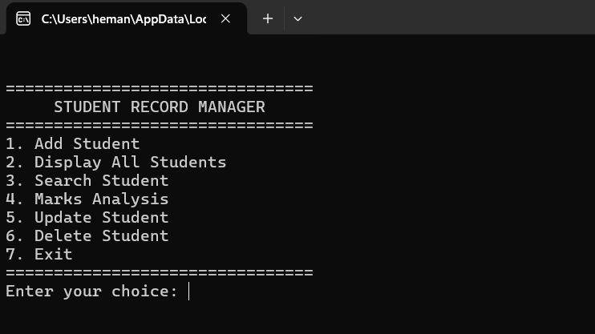
Fig 2.1 Main menu with seven operations
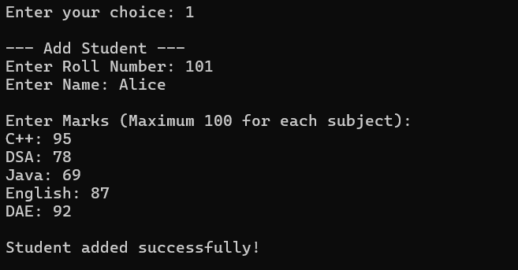
Fig 2.2 Adding a student with five subject marks

2.3.1 Record Display and Search
Option 2 displays the active records, and option 3 searches by numeric roll number. The displayed “/50” suffix is reproduced exactly from the program; the accepted maximum is 100.

Fig 2.3 Displaying all student records
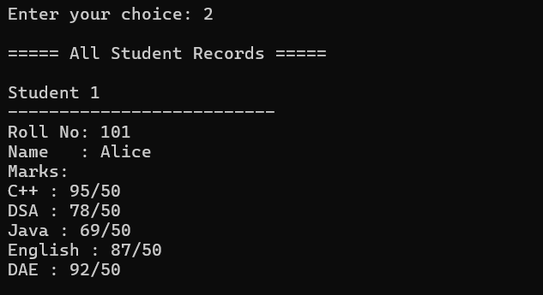
Fig 2.4 Searching for roll number 101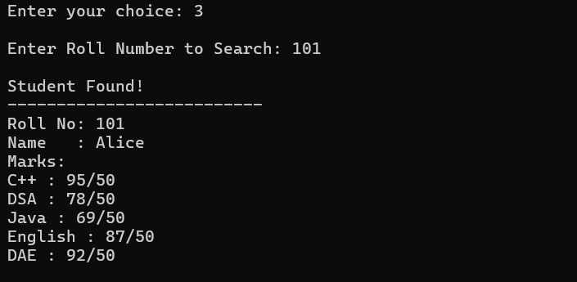

2.3.2 Marks Analysis and Update
For the original marks, the total is 400 and the percentage is 80%. Option 5 then replaces the record’s roll number with 103 and enters a new set of marks.

Fig 2.5 Per student marks analysis
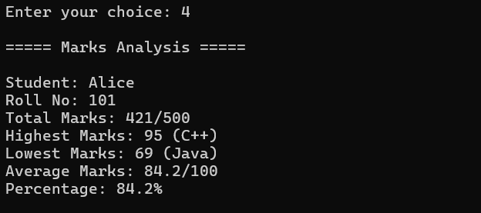

Fig 2.6 Updating the roll number and subject marks
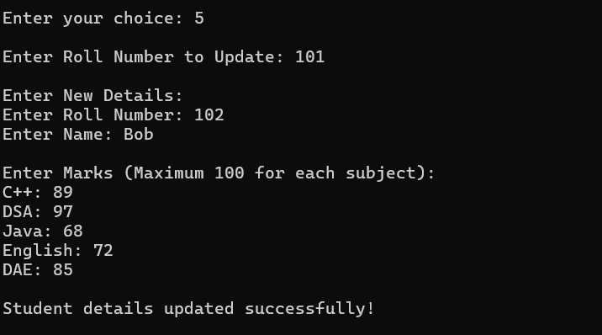

2.3.3 Updated Record and Deletion
Searching for roll number 103 retrieves the revised record. Deleting that record removes the only active student. A subsequent display request reports that the list is empty.
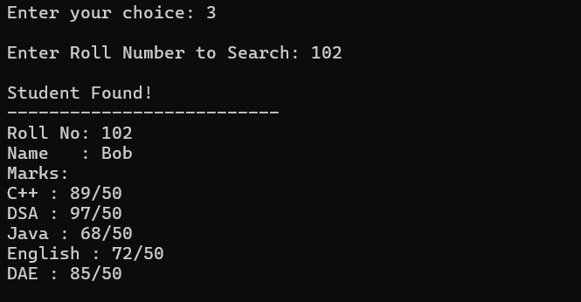
Fig 2.7 Searching for the updated record
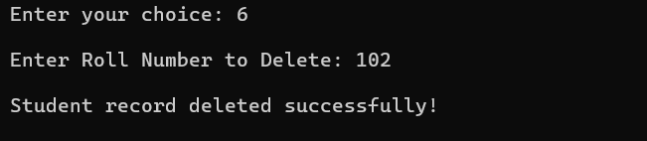
Fig 2.8 Deleting the updated student record
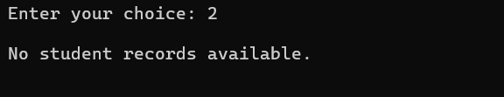
Fig 2.9 Empty record message after deletion

2.4 Testing and Results
Tests were run against the unchanged source compiled with g++ in C++17 mode. Each test started a separate process unless the scenario required several operations in one session. The results below verify specified numeric-input workflows; they do not imply that every possible input is handled safely.
Table 2.2 Functional test cases and results
ID | Scenario and input | Observed result | Status
TC01 | Options 2 to 6 with no records | Each operation prints the empty-record message. | Pass
TC02 | Add 101, Asha Rao, marks 80, 90, 70, 85, 75; display | Record and full name appear. Existing /50 label remains. | Pass*
TC03 | Search roll 101 after adding it | Student Found and matching details appear. | Pass
TC04 | Search roll 999 when only 101 exists | Student not found. | Pass
TC05 | Analyse 80, 90, 70, 85, 75 | Total 400; highest 90 DSA; lowest 70 Java; average 80; percentage 80%. | Pass
TC06 | Update roll 101 to 103 and enter new marks | Search for 103 shows the replacement details. | Pass
TC07 | Add 101 and 102; delete 101; display | Only the second student remains in the active list. | Pass
TC08 | Update and delete unknown roll 999 | Both operations report Student not found. | Pass
TC09 | Enter −1 and 101 before a valid mark 80 | Out-of-range values are retried; valid mark is stored. | Pass*
TC10 | Enter 0, 100, 50, 75, 25 | Boundary values accepted; total 250; extrema 100 and 0. | Pass
TC11 | Enter menu option 9, then 7 | Invalid choice message, then normal exit. | Pass
TC12 | Add 100 records; attempt one more add | Student limit reached; no 101st record requested. | Pass
TC13 | Enter five equal marks of 80 | First subject C++ is reported for both extrema. | Pass
* The operation behaves as tested, but its displayed scale message is incorrect. Numeric validation and the display wording are separate checks.

2.4.1 Additional Checks and Limitations
Table 2.3 Tests confirming current limitations
ID | Check | Observed result
TC14 | Add two students with roll 101 | Both records are accepted; duplicate prevention is absent.
TC15 | Add a record, exit, then run the program again | Display reports no records; session data is not retained.
TC16 | Add a record with roll number 0 | The record is accepted; positivity validation is absent.

Result Analysis
Thirteen functional scenarios completed with the expected operational behaviour. Three additional scenarios confirmed limitations in uniqueness checks, roll-number validation and persistence. The marks example produced the correct total, average, percentage and subject extrema. Updating and deleting records also behaved as expected in the tested sessions.
The output-label defect remains visible in the captured figures. Correcting “/50” to “/100” and the invalid-mark message to “between 0 and 100” would make the interface consistent with the implemented calculations.

Input Handling Review
Source inspection shows that the program does not test cin.fail(), clear a failed input state, or discard an invalid text token. Entering letters where a number is expected is therefore not safely handled. Blank names, negative roll numbers and duplicate roll numbers also need explicit validation. These observations are limitations, not successful validation tests.

Features Planned for Later Development
The review presentations propose name-based search, name formatting, class-level averages and highest or lowest performance across students. Those operations are not present in Project.cpp. The current marks analysis compares five subjects within each student. Additional student fields, attendance, file handling and role-based access are also outside the implemented scope.
A future test suite should cover malformed numeric input, whitespace-only names, duplicate identifiers during both addition and update, and data restoration after persistence is implemented.

CHAPTER 3
CONCLUSION AND FUTURE SCOPE

3.1 Conclusion
Student Record Manager provides a working console interface for maintaining a small set of student details and subject marks. The implemented operations add records, display them, search by roll number, replace existing details and remove records. Marks analysis produces totals, highest and lowest subject marks, averages and percentages for each student.
The project demonstrates how classes and member functions can organise a C++ application. An array of objects stores records, a count tracks the active portion of the array, and straightforward loops perform searching and analysis. The tested examples confirm the principal operations and the arithmetic used in the report.
The prototype remains limited to the current session and assumes well-formed numeric input. Inconsistent marks labels and missing identifier checks must be resolved before the system can be treated as a reliable record-keeping tool.

3.2 Future Scope
- Correct the marks scale in all display and validation messages, then add complete numeric-input recovery.
- Use string-based roll numbers when university registration IDs contain letters, and enforce non-empty, unique identifiers.
- Add file or database storage so records can be saved and restored between runs.
- Implement search by name, optional case-insensitive comparison and consistent name formatting.
- Extend analysis to class averages, subject-wise class statistics and student rankings with clearly defined tie handling.
- Use a dynamic collection when the record limit needs to grow, and add exportable reports or a graphical interface.
- Introduce user accounts and permissions if staff and students require different access to records.

REFERENCES
Project materials
[1] Project team. C++ review - 1pptx.pptx. Student Record Manager project planning and review presentation.
[2] Project team. cpp review - 2.pptx. Student Record Manager project review presentation, including implementation plans and team contributions.
[3] Project team. Project.cpp. C++ source code for Student and StudentRecordManager, used for the implementation listing and execution tests.
[4] College Events Management System project report. cppfinaldoc123_261018_113138.pdf. Reference for the academic report structure and front-matter format.
The reference report is used for document organisation. The Student Record Manager design, implementation description, diagrams and test results in this report refer to the student record management project.

