Issues on NXP
Thursday, August 3, 2023
11:36 AM
1 : can we disconnect sco connection using hci command or it is possible to disconnect 1 SCO connection while in conference call
Yes we can disconnect using the below command
Sudo hcitool -i. hci0 cmd 0gf(02) ocf (0006) handle(based on sco connection) reason (0x13)

To check connected devices/handle number
sudo hcitool conn

2 : why we get unknow connection identifier error code while disconnecting
In the nxp issue we have disconnected the handle and we are trying disconnect the same handle again then it check the handle but it is not able to find so it say unknown connection identifier 0x02

3 LE Create command
Sudo hcitool (-i) hci0 cmd (ogf)08 (0cf)00 0d (0x0004 - 0x4000 (2.5 ms - 10.24)) same values of scan interval , filter policy , peer address type , peer address , own-address type , conn - interval min and max , latency , supervision timeout , max ce length and min ce length

Bluetooth classic
Wednesday, July 3, 2024
2:51 PM

- -> Bluetooth operates in 2.4 ghz to 2.4835ghz - 24
- -> we cannot use this band of frequencies for long distance due to atmosphere where it observers , so it is done as licensed band and cany be used
- ->so it is used for low band of frequencies
- Here the bluetooth is not random for device which is participating In connection other device are no in connection they will have random

Bluetooth bredr connection :
The Bluetooth Basic Rate/Enhanced Data Rate (BR/EDR) connection procedure involves several steps to establish a connection between two Bluetooth devices. Here's a simplified step-by-step overview of the process:

**1. Device Discovery (Inquiry and Paging):**
- **Inquiry**: One device (the initiator) initiates an inquiry process to discover nearby devices. During inquiry, the initiator sends out inquiry messages to find other devices in the vicinity.

- **Paging**: Once the devices are discovered, the initiator selects a specific device and sends a paging request to establish a connection.

**2. Device Addressing and Link Setup:**
- During the inquiry and paging process, devices exchange Bluetooth addresses, which are used to identify each other during connection setup.
- The devices establish a secure and synchronized link by setting parameters like channel hopping sequences and encryption keys.

**3. Channel Negotiation:**
- The devices negotiate which frequency-hopping channels to use for communication. Bluetooth operates in the 2.4 GHz ISM (Industrial, Scientific, and Medical) band and hops between different channels to reduce interference.

**4. Authentication and Encryption:**
- **Pairing**: If security is required, the devices may go through a pairing process to establish a trusted connection. During pairing, they exchange keys to encrypt the data and verify each other's identities.
- **Link Key Generation**: The devices generate a link key for encryption purposes.

**5. Connection Setup:**
- The devices set up the link for data transfer, and each device is assigned a role, either master or slave.
- The master initiates the connection and controls the timing, while the slave follows the master's timing.

**6. Data Transfer:**
- Once the connection is established, devices can exchange data over the established link. Data can be sent in the form of audio, files, or any other type of information.

**7. Connection Termination:**
- Connections can be gracefully disconnected by sending appropriate disconnect messages.
- If the link is lost or interrupted, the devices can attempt to re-establish the connection or enter a low-power mode until reconnection is possible.

Keep in mind that the specific details of the Bluetooth connection procedure can vary based on the profiles and services being used, as well as the security requirements of the connection. This step-by-step overview provides a general understanding of how Bluetooth BR/EDR connections are established and maintained between devices.

INQUIRY AND PAGING :

During the Device Discovery phase of Bluetooth Basic Rate/Enhanced Data Rate (BR/EDR) connection establishment, two main procedures occur: Inquiry and Paging. These procedures involve the exchange of specific inquiry and paging packets to discover and connect with nearby devices.

**Inquiry:**

- **Initiator (Device A)**: Device A wants to discover nearby devices. It initiates an inquiry by sending out inquiry packets.
- **Responder (Device B)**: Device B and other nearby devices receive the inquiry packets.
- **Inquiry Packets**: Device A sends out Inquiry packets that contain its Bluetooth device address and a set of inquiry access codes.
- **Responses**: Device B and other devices respond with Inquiry Response packets that include their Bluetooth addresses and information about their capabilities.
- **Rendezvous**: Device A collects the Inquiry Response packets from nearby devices and learns their addresses, capabilities, and whether they are available for connection.

**Paging:**

- **Initiator (Device A)**: Having discovered nearby devices during inquiry, Device A selects a specific device (Device B) and sends a paging request.
- **Responder (Device B)**: Device B receives the paging request and responds.
- **Paging Request**: Device A sends a paging request packet that contains its own address, the clock information, and the Bluetooth address of Device B.
- **Paging Response**: Device B responds with a paging response packet, acknowledging the request and providing its clock information.
- **Connection Establishment**: Once the devices have exchanged the paging request and response packets, they use the clock information to establish a synchronous link and initiate the connection process.

These packets and procedures allow Device A to discover the presence of nearby devices and select a specific device (Device B) with which to establish a connection. The exchange of inquiry and paging packets is a fundamental part of the Bluetooth BR/EDR connection procedure and enables devices to identify and communicate with each other.

Cypress board
Wednesday, July 3, 2024
2:52 PM

  - About the board
    - Bluetooth support
    - Applications
    - Memory of board
    - Mcu
    - Communications and gpio
    - Detail explanation of board
      - About every component used mainly in developing and debugging
    - Process of building and compiling
    - Generating automatic code
    - Example code explanation of home automation

Arm cortex
  - Low power processor
  - Low interrupt latency
  - Supports floating point arithmetic
  - Fast
  - Its has arm core
  - High performance bus interface
  - It has watch point
    - Printf for debugging support
    - Trace port analyzer
    - Mpu - memory protection unit
    - FPU - Floating point unit

Things to study in board

  - Sensors
    - Motion sensor - 9 axis
      - Accelerometer
      - Gyroscope
      - Magnetometer
    - Thermistor

  - Buttons
    - Recover
    - Reset
    - Push button
  - LEDS
    - D6 - Led green for power on indication
    - D1 and D2 green and red used for i/O can be controlled by user GPIO
    - D7 used for hci uart
    - D11 peripheral uart
  - Switches
  - Debug - j13
  - Clock
  - U7 , U8 , U9 , U10
  - GPIO Test Headers/ Arduino Connectors/ 10-pin Debugger
  - Micro USB - j6
  - Test points
  - USB to UART Level Translator EEPROM Communications and Programming Level Translator

UART TRANSPORT LAYER
Tuesday, November 7, 2023
6:12 PM

Here UART is used in Bluetooth HCI over a serial interface between two UART'S on the same PCB.
HCI UART transport layer assumes that the UART communication is free from line errors.
(Refer to UART PPT)
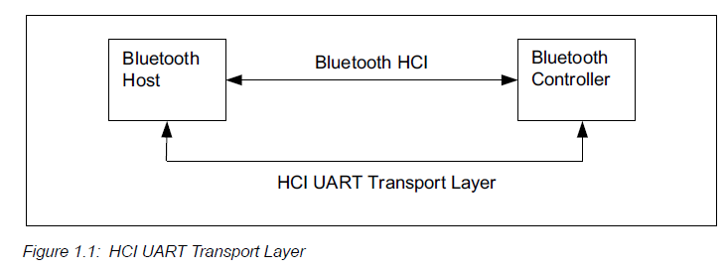

The HCI UART transport layer uses the following settings for RS232
Baud rate : | Manufacturer-specific
Number of data bits | 8
Parity bit | No parity
Stop bit | 1 stop bit
Flow control | RTS/CTS
Flow-off response time | Manufacturer-specific

Here RTS/CTS is used to prevent temporary UART buffer overrun.
It is not used for flow control of HCI , since HCI has its own flow control mechanisms for HCI commands.
If CTS = 1 then Host/controller is allowed to send.
If CTS = 0 then Host/controller is not allowed to send.

The flow off response time is the time taken to set RTS to 0 until the byte flow actually stops.

The RS232 signals should be connected through TXD and RXD to the remote TXD and RXD.

There are five kinds of HCI packets that can be sent via UART Transport layer
1 | HCI Command packet | It is sent to Bluetooth controller | 0x01
2 | HCI Event packet | Sent from Bluetooth controller | 0x02
3 | HCI ACL Data packet | From both host and controller | 0x03
4 | HCI synchronous data packet | From both host and controller | 0x04
5 | HCI ISO Data packet | From both host and controller | 0x05

The specification is applicable for following types of controllers:
- BR/EDR Controller
- BR/EDR/LE Controller
- LE Controller
But the controller can support the following set of functionality:
- BR/EDR only
- LE only
- BR/EDR/LE

HCI FLOW CONTROL
Flow control is done in direction from Host to controller to avoid overflowing the controller data buffers with ACL data destined for a remote device.
Flow control for data moving from the controller to the Host may be in accordance
1 --> Host to controller Data flow control
2 --> Controller to Host flow control

HOST TO CONTROLLER DATA FLOW CONTROL
There are two methods of data flow control
- Packet based flow control
- Data block based flow control
These are buffer management.

Selection of this data flow mechanism is performed by HCI Write flow control mode command

If BR/EDR/LE controller implements separate buffers for ACL Data:

1 - The Host shall use the HCI LE Read buffer size command to determine the buffers that are used for ACL Data on an LE-U Logical link.
2 - The Host shall use separate packet based flow control for each set of buffers.
3 - The connection handle contained in the ACL data packet shall be used by the controller to determine which set of buffers to use and the logical link (ACL-U , APB-U , LE-U)over which the data is to be sent.

CONTROLLER TO HOST DATA FLOW CONTROL
Flow control may also be necessary in the direction from the Controller to Host.
HCI Set Controller to Host Flow control command can be used turn flow control on or off in that direction.
Synchronous Data packets sent from the controller to the Host.
There are two packet types they are ACL and Synchronous Data packets that are stored in the host Buffer.

--------------------------------------------------------------------------------------------------------------------------------------------
DISCONNECTION BEHAVIOR:
Host receiver an HCI Disconnection Complete event , the Host shall assume all the unacknowdged data packets are sent to controller for the return handle have been flushed ,the corresponding buffer are freed.
If flow control is enabled
- If the direction from controller to Host the controller sends the Disconnection complete event and assume that Host will flush the data buffers for handle when it receives the disconnection command
---------------------------------------------------------------------------------------------------------------------------------------------------------
COMMAND FLOW CONTROL

---------------------------------------------------------------------------------------------------------------------------------------------------------
COMMAND ERROR HANDLING

---------------------------------------------------------------------------------------------------------------------------------------------------------
LMP TRANSACTION AND LL PROCEDURE COLLISIONS

---------------------------------------------------------------------------------------------------------------------------------------------------------
LE HOST AND CONTROLLER SYNCHRONIZATION

-----------------------------------------------------------------------------------------------------------------------------------------------------------

HOST CONTROLLER TRANSPORT LAYER
Tuesday, November 7, 2023
2:40 PM

(Pg no - 1810 in core spec 5.3)
HOST CONTROLLER TRANSPORT LAYER

IDS AND HANDLES:

The ID's assigned by the Host , these identifiers used between two peer devices and sent over the air in PDU's
There are CIS_ID has a separate number space for each CIG_ID.
The ids are handles are reused again.
When handles are allocated to the device then other device will not take the used id and handles.

There are two types of Handles are :
- Controller Handles
  - Connection Handles
  - Sync handles
  - Advertising handles
  - BIG handles
- Broad connection handles

It exchange specific HCI information
There are different formats of commands , events and data exchange between the Host and the controller.

1 | HCI COMMAND PACKET
2 | HCI ACL DATA PACKET
3 | HCI SYNCHRONOUS DATA PACKETS
4 | HCI EVENT PACKET
5 | HCI ISO DATA PACKET

---------------------------------------------------------------------------------------------------------------------------------------------------------
1 -- HCI COMMAND PACKET :
---------------------------------------------------------------------------------------------------------------------------------------------------------

- HCI command packet is used to send commands to controller from the Host.
- The controller can accept HCI command packet with up to 255 bytes of data excluding the header.
- The header is the first 3 octets of the packets.
- Each packet has assigned with 2 bytes of opcode used to identify different types of commands
- The opcode is divided into two fields , they are
  - Opcode Group Field
  - Opcode Common Field
OGF - Opcode group field | 6bits | 0x00 to 0x3F
OCF - Opcode common field | 10bits | 0x0000 to 0x03FF

OGF :
0x01 | Link control commands
0x02 | Link policy commands
0x03 | Host control and baseband commands
0x04 | Informational parameters
0x05 | Status parameters
0x08 | LE Controller commands (BLE)
0x09 | LE link layer commands (BLE)
0x0A | Testing commands
0x0C | LE Test commands (BLE)
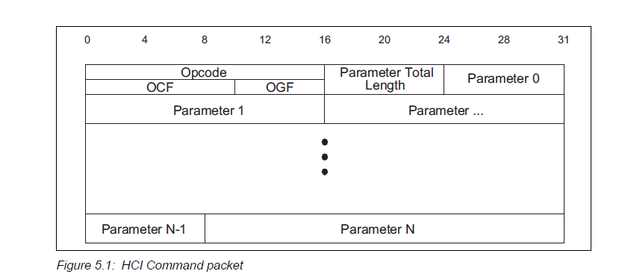
Opcode :
Value | Parameter description
0x0000 | OGF - 6 Bits  OCF - 10 bits
Parameter_total_length :
0x00 --> length of all of the parameters contained in this packet measured in octets

Parameter 0 -- N
This has some specific number of parameters associated with it.

---------------------------------------------------------------------------------------------------------------------------------------------------------
2 -- HCI ACL Data packets
---------------------------------------------------------------------------------------------------------------------------------------------------------

HCI ACL Data packets are used to exchange data between the Host and controller
There are two types of HCI ACL data packets:
--> Automatically-Flushable - based on the flushable - timeout.
-->Non-Automatically-Flushable

Hosts and controllers shall be able to accept HCI ACL Data packets up to 27 bytes of data including the HCI ACL data packet header.
The header is the first 4 octets of the packet.

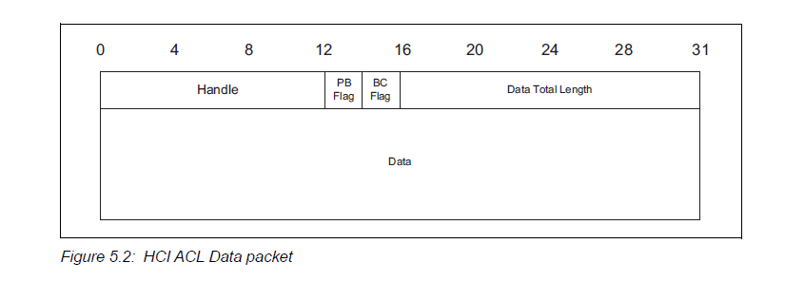
Broadcast flag :

Value | Parameter Description
0b00 | Point-to-point (ACL-U OR LE-U)
0b01 | BR/EDR Broadcast (APB-U)
0b10 | Reserved for future use
0b11 | Reserved for future use

Handle :
The handle is used for transmitting a data packet or segment over a controller.
Range - 0x000 to 0xEFF

---------------------------------------------------------------------------------------------------------------------------------------------------------
3 -- HCI SYNCHRONOUS Data packets
---------------------------------------------------------------------------------------------------------------------------------------------------------
This is used to exchange synchronous data between the host and controller.
The header is the first 3 octets of the packet

Data packet is shown below
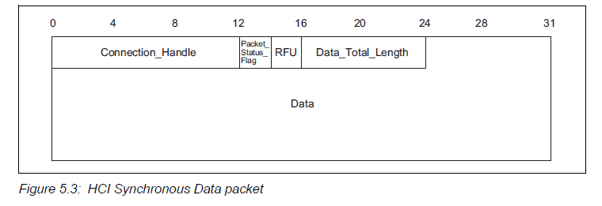
Handle :
The handle is used for transmitting a synchronous data packet or segment
Packet status flag :
It is of 2 bits , which is located from bit 4 to 5 in the second octet of the HCI Synchronous data packet
In host the packet status flag is set to 0b00
When erroneous data reporting is disabled then packet status flag is set to 0b00
If it is enabled then the following happing from below table.

Value | Parameter description
0b00 | Correctly received data , esco or sco packet as good data
0b01 | Possibly invalid data ,esco marked as data with possible errors others are marked as good data
0b10 | No data received , here data is marked as lost data by baseband , payload is set as 0
0b11 | Data partially lost , sco packets shall set to 0

Data total length:
Length of synchronous data measured in octets.

---------------------------------------------------------------------------------------------------------------------------------------------------------4 -- HCI EVENT PACKET
---------------------------------------------------------------------------------------------------------------------------------------------------------
It is used by the controller to notify the host when event occur.
Host shall accept HCI Event packet up to 255 octets of data excluding header packet.
Header is in the first two packets.
Event Code : 0x00
The event code 0xFE is reserved for future use.
The event code 0xFF is reserved for vendor specific debugging events.
1-Octet event used to uniquely identify different types of events.
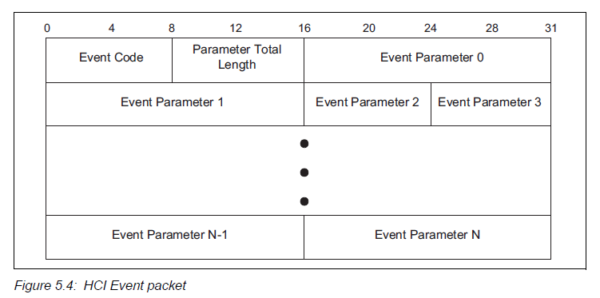

Parameter total length : 0x00

lLength of all parameters contained in this packet , measured in octets.

Event parameter 0 - N: 0x00
Each event has a specific number of parameters associated with it.
Each parameter is an integer number of octets in size.
---------------------------------------------------------------------------------------------------------------------------------------------------------5 -- HCI ISO DATA PACKETS
---------------------------------------------------------------------------------------------------------------------------------------------------------
It is used to exchange isochronous data b/w host and controller.
The data packets may be SDU or part of an SDU.
If SDU size does not match the buffer size then it will fragment the SDU and then controller will wait until it gets all the SDU to send to the host
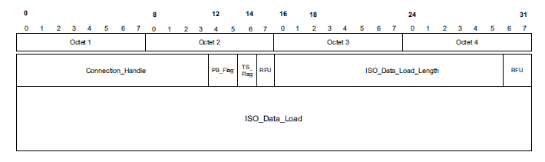
The first 4 octets is the header of ISO data packet
The header has 0 to 11 bits as connection handle , bits 12 to 13 as PB Flag parameter , bit 14 as TS flag , bit 15 as RFU , 16 to 29 bits as ISO Data load length parameter and 30 to 31 as RFU bits

The connection handle shall indicate the identifier of the logical channel between the Host and the controller.

The PB flag shall indicate the packet boundary of an SDU.
Value | parameter description
0b00 | The data load contains a header and the first fragment of a fragmented SDU.
0b01 | It contains a continuation fragment of an SDU.
0b10 | It contains a header and a complete SDU.
0b11 | Contains the last fragment of an SDU.

The TS Flag bit shall be set when there is Time stamp field , this bit is set when pb flag is set to 0b00 or 0b10.

The length of ISO data load length is in octets , the length shall be less than or equal to the size of the buffer supported by the controller.

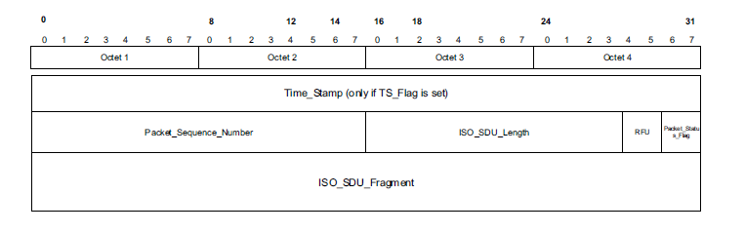
The time stamp shall contain a time in microseconds.

The packet sequence number field contains the sequence number of the SDU.

ISO SDU length field contain the total length of the SDU in octets.

Packet status flag indicates the status of the packet that the controller receiver over the isochronous physical channel.
It is valid in HCI ISO Data packets sent by the controller and is reserved for future use.

Value | Parameter description
0b00 | Valid data , SDU was received correctly
0b01 | Possibly invalid data ,
0b10 | Parts of SDU not received correctly , reported has lost data.
All other values | Reserved for future use

If packet status flag equals 0b10 then PB flag shall equal 0b10

The ISO SDU fragment field shall contain the isochronous data , when packet status flag is set to 0b10 in packet from the controller to host.

---------------------------------------------------------------------------------------------------------------------------------------------------------
HCI CONFIGURATION PARAMETERS (BREDR)
- Scan Enable
- Inquiry scan interval
- Inquiry scan window
- Inquiry scan type
- Inquiry mode
- Page time out
- Connection accept timeout
- Page scan interval
- Page scan window
- Page scan type

- SCAN ENABLE
The scan enable will control weather the Bredr controller will periodically scan for page attempts or inquiry request from other Bredr controllers.

If page scan is enabled then device enter the page scan mode on the value of page scan interval and page scan window parameters.
Same like that inquiry scan is enabled then the device enter the inquiry scan mode based on the value of inquiry scan interval and inquiry scan window parameters.

Value | Parameter description
0x00 | No scan enabled
0x01 | Inquiry scan enabled  Page scan always disabled
0x02 | Inquiry scan disabled  Page scan enabled
All other values | Reserved for future use

- INQUIRY SCAN INTERVAL
  - Inquiry scan is nothing but the amount of time between two consecutive inquiry scans.
  - Its is defined as the time when last inquiry close and starting new inquiry , the time between that is called inquiry scan interval.

Value | Parameter description
N = 0xXXXX | Size : 2 octets  Range : 0x0012 to 0x1000; only even are valid  Default : 0x 1000  Time : N * 0.625 ms  Time Range : 11.25 to 2560 ms  Time Default : 2.56 s

- INQUIRY SCAN WINDOW
It is parameter defines the amount of time for the duration inquiry scan.
It should not be less than or equal to the inquiry scan interval.
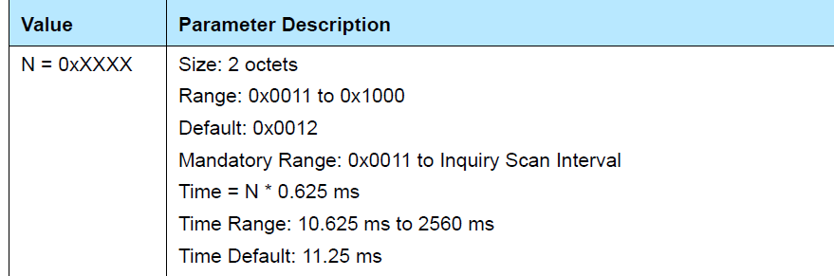

- INQUIRY SCAN TYPE
  - The scan types defines the scan is of interlace scan or non-interlaced scan , Here one is maditory and one is optional
  - 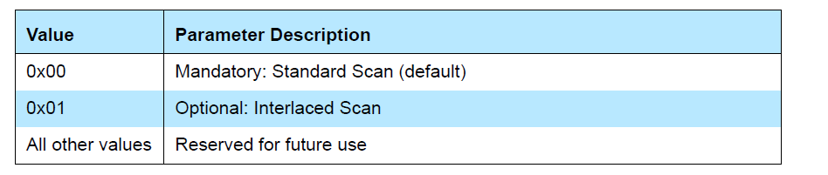

Interlaced scan :
interlaced scan is performed as two back to back scans of Tw_page_scan.

Standard scan :
During a standard scan, a device listens for the duration of the scan window Tw_page_scan (11.25ms default)

If the scan interval is not at least twice the scan window, then generalized interlaced scan shall not be used.

- INQUIRY MODE
  - This mode will define weather the inquiry returns the inquiry result events in standard format with RSSI or with RSSI and extended inquiry response information.
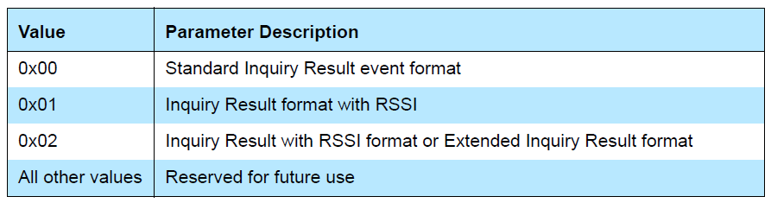

- PAGE TIMEOUT
  - It is the maximum time the local link manager will wait for a baseband page response from the remote device at locally initiated connection attempt.
  - If time expires the remote BR/EDR controller has not respond to the page at baseband level , then the connection will be failed.
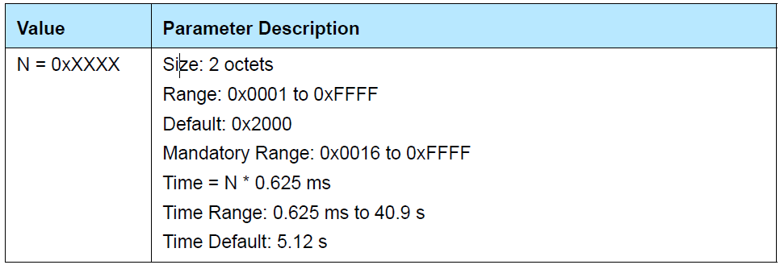

- CONNECTION ACCEPT TIMEOUT

- This allows the BR/EDR or LE controller to automatically deny a connection request after a specified time period has occurred and the new connection is not accepted.
- Bredr controller Sends HCI Connection Request event or LE sends HCI LE CIS Request until controller automatically reject an incoming connection.
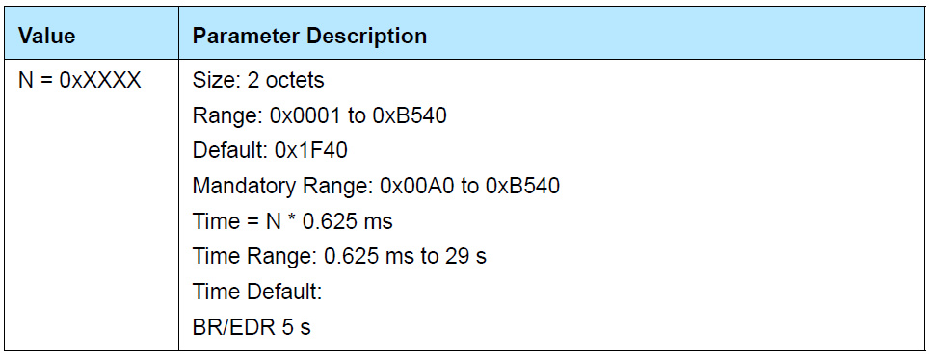

- PAGE SCAN INTERVAL
  - It defines the amount of time between consecutive page scans.
  - The time interval is defined from when the controller started its last page scan until it begins the next page scan.
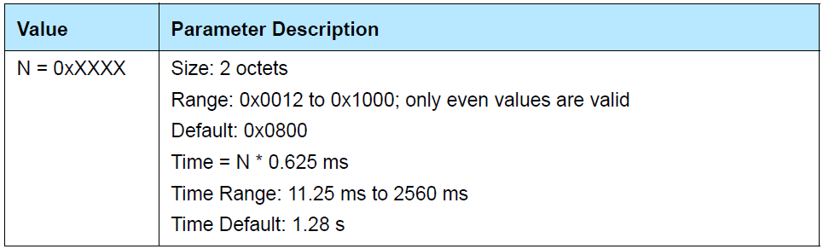

- PAGE SCAN WINDOW
  - The amount of time for the duration of the page scan.
  - The page scan window can only be less than or equal to the page scan interval
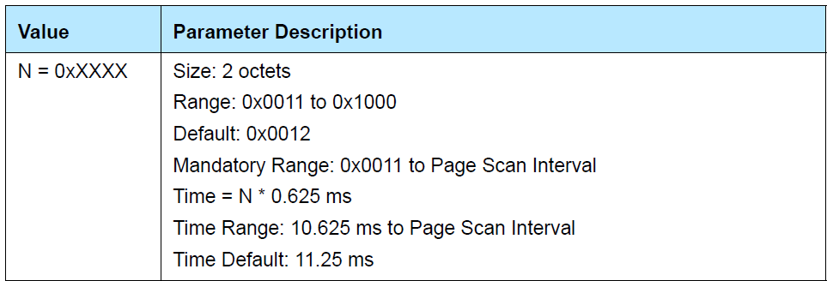

HCI COMMAND AND EVENTS
Monday, November 20, 2023
12:37 PM

LINK CONTROL COMMANDS | 0x01
LINK POLICY COMMANDS | 0x02
CONTROLLER & BASEBAND COMMANDS | 0x03
INFORMATIONAL PARAMETERS | 0x04
STATUS PARAMETERS | 0x05
TESTING COMMANDS | 0x06
EVENTS | -----
LE CONTROLLER COMMANDS | 0x08

1 - LINK CONTROL COMMANDS

The OGF for Link control commands is defined as 0x01

The link control commands allow a controller to control connections to other BR/EDR Controller

HOST
Tuesday, November 21, 2023
10:33 AM

1 | LOGICAL LINK CONTROL AND ADAPTION PROTOCOL (L2CAP)
2 | SERVICE DISCOVERY PROTOCOL (SDP)
3 | GENERIC ACCESS PROFILE(GAP)
4 | ATTRIBUTE PROTOCOL (ATT)
5 | GENERIC ATTRIBUTE PROTOCOL(GATT)
6 | SECURITY MANAGER PROTOCOL(SMP)

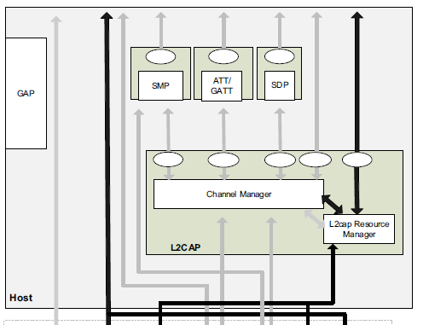

- L2CAP provides connection oriented and connectionless data services to upper layer protocols with protocol multiplexing capability and segmentation and reassembly operation.
- L2CAP permits higher level protocols and applications to transmit and receive upper layer data packets (L2CAP Service Data Units, SDU) up to 64 kilobytes
in length. L2CAP also permits per-channel flow control and retransmission.

Main features of L2CAP

- Protocol /channel multiplexing
- Segmentation and reassembly
- Flow control
- Error control and retransmission
- Fragmentation and recombination
- Quality of service
- Support for streaming

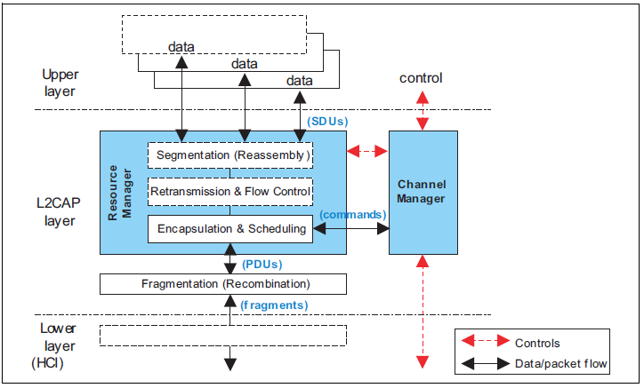

- L2CAP does not support sco and esco logical transport.
- It does not support a reliable broadcast channel.

- L2CAP will work according to the Channel identifiers at each end points of L2CAP.

CHANNEL IDENTIFIERS :

- It is the logical channel end point on the device.
- The destination end point shall be used as NULL identifier.
- The identifiers from 0x0001 to 0x003F are reserved for specific L2CAP functions. There channels are called fixed channels.
- L2CAP Signaling channel(0x0001) or L2CAP LE signaling (0x0005) shall be supported.
- If 0x0005 is supported then 0x0004 and 0x0006 is also supported

Modes of operation in L2CAP

There are different modes for each L2CAP channel
1 | Basic L2CAP Mode
2 | Flow control mode
3 | Retransmission mode
4 | Enhanced retransmission mode
5 | Streaming mode
6 | LE Credit based flow control mode
7 | Enhanced credit based flow control mode

CONTROLLER
Tuesday, November 21, 2023
2:47 PM

1 | RADIO SPECIFICATION
2 | BASEBAND SPECIFICATION
3 | LINK MANAGER PROTOCOL
4

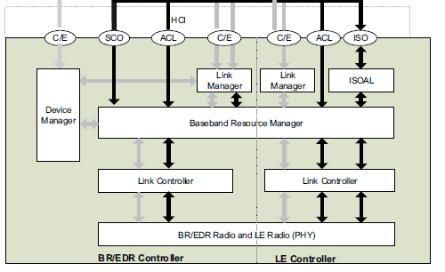

Radio specification :
The bluetooth system operates in the 2.4 GHZ ISM Band , the band is of 2400Mhz to 2483.5Mhz
The Rf channels are seperated by 1MHz and ordered as 79 channels (0 - 78)

There are 3 power classes in Bluetooth
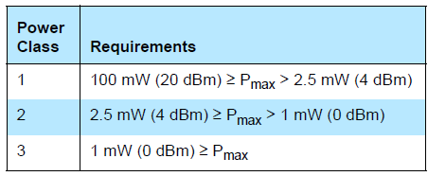

Base band specification
Bluetooth provides a point to point and point to multipoint .
In point to point the physical channel is shared between two devices.
In point to multi point the physical channel is shared between multiple devices.

The data is transmitted in air over packets , for this two modes are defined
Basic rate and enhanced data rate
1 | Basic rate | 1mbps
2 | Enhanced data rate - primary | 2mbps
3 | Enhanced data rate - secondary | 3mbps

The packet format for basic rate has three entities :
1 - Access code
2 - Header
3 - Payload

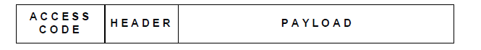
The packet format for enhanced data rate has six entities :
1 - Access code
2 - Header
3 - Guard
4 - Sync
5 - Enhanced data rate payload
6 - trailers
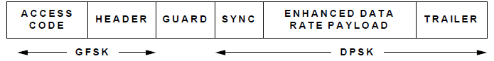

Bluetooth clock

Every Bluetooth device has a native clock that will be derived from free running reference clock , offsets are added to the reference clock to synchronize with native clock provides temporary sync.
The clock is implemented with a counter of 28 bit shall wrap around 2 power 28 -1
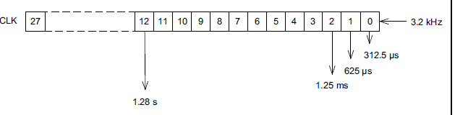

There are 4 periods they are 312.5microsec , 625microsec , 1.25 ms and 1.28s they are CLK0 , CLK1 , CLK2 , CLK3

The different clock used are :
1 | CLKR | Reference clock
2 | CLKN | Native clock
3 | CLKE | Estimated clock
4 | CLK | Central clock

Bluetooth Device addressing
Bluetooth address is of 48 bit device address
The format of Bluetooth is LAP , UAP ,NAP

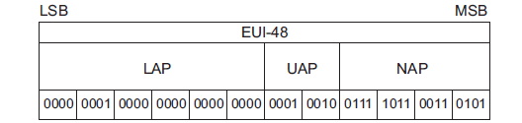

Reserved address :
The block of 64 bit contiguous is reserved for inquiry operations one lap is used for all devices is reserved for general inquiry remaining 63 is used for dedicated inquiry
Reserved lap address are 0x9E8B00 to 0x9E8B3F.
For general inquiry the lap address is 0x9E8B33.

Access code
All transmission over physical channel required an access code
The different access code are
1 Device access code ---- used during page , page scan , central response -- derived from paged device address
2 Channel access code ----- used in connection state , synchronization train substrate --- derived from central device address
3 Inquiry access code ----- one general inquiry access code and 63 dedicated inquiry access code.

PHYSICAL CHANNELS :

The physical channels are characterized by the combination of basic pseudo random frequency hopping sequence, there are specific time slots of the transmission the access code and packet header encoding

Different physical channels :
• basic piconet physical channel
• adapted piconet physical channel
• page scan physical channel
• inquiry scan physical channel
• synchronization scan physical channel

Different physical link
• Synchronous Connection-Oriented (SCO) logical transport
• Extended Synchronous Connection-Oriented (esco) logical transport
• Asynchronous Connection-Oriented (ACL) logical transport
• Active Peripheral Broadcast (APB) logical transport
• Connectionless Peripheral Broadcast (CPB) logical transport

Different logical transport
• Synchronous Connection-Oriented (SCO) logical transport
• Extended Synchronous Connection-Oriented (esco) logical transport
• Asynchronous Connection-Oriented (ACL) logical transport
• Active Peripheral Broadcast (APB) logical transport
• Connectionless Peripheral Broadcast (CPB) logical transport.

Different Logical link
• Link Control (LC)
• ACL Control (ACL-C and APB-C)
• User Asynchronous/Isochronous (ACL-U and APB-U)
• User Synchronous (SCO-S)
• User Extended Synchronous (esco-S)
• Profile Broadcast Data (PBD)

PDU'S
Wednesday, November 22, 2023
11:59 AM

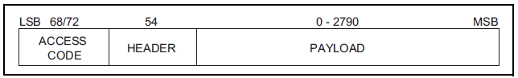

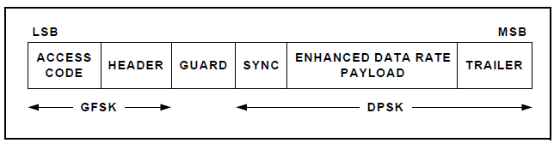

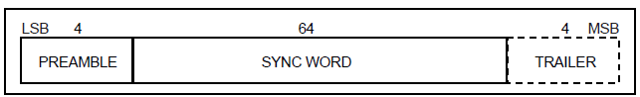

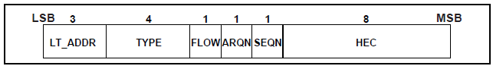

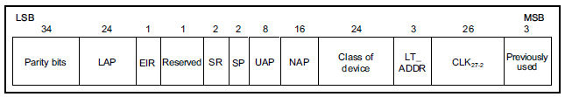
-

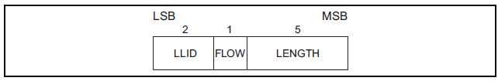

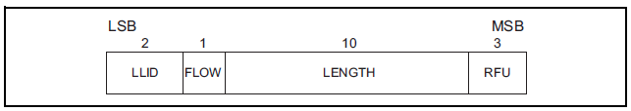

RAW COMMANDS TO MAKE BREDR CONNECTION
Wednesday, November 22, 2023
3:23 PM

Command for write scan enable :

Sudo hcitool -I hci0 03 001a 02
Event : 0x0e plen 4 01 1A 0C 00

command to create connection :

Sudo hcitool -I hci0 cmd 01(ogf) 0005(ocf), (address) cc18 (packet type) 02(page scan repetition r2) 00 (page scan mode ) 0000 (clock offset) 01 (role switch)

Sudo hcitool -I hci0 cmd 01 05 98 8c e8 ef a7 2c 18 cc 02 00 00 00 01

Command to find the remote name :
Sudo hcitool -I hci0 cmd 01 19 98 8c e8 ef a7 2c 02 00 0000

HCITOOL Code
Friday, November 24, 2023
11:26 AM

Main

Pairing types IN Bredr
Tuesday, January 21, 2025
12:40 PM

Pairing in Bluetooth Bredr
there are 2 types of pairing in Bluetooth Bredr
1 - legacy pairing
2 - secure simple pairing

1 - secure simple pairing
1 - IO Capability
2 - Encapsulated p - 192 publickey
3 - Simple pairing number
4 - DH key check
5 - Authentication
6 - Encryption Mode

2 - Legacy pairing

Low power modes info :
Hold Mode During the connection state, the ACL logical transport to the Slave can be set to hold mode. In this mode, the ACL packets are not exchanged. The voice links (SCO, eSCO) are still supported. Before entering the hold mode, the Master and the Slave agree on the time duration for which the Slave will remain in hold mode. During this time duration, the Slave can either go to low power mode or do other activities like scanning, paging, inquiring or participating in another piconet. On expiration of the time duration of the hold mode, the Slave wakes up and listens for transmissions from the Master.

Active Mode In the active mode, one Master and up to seven Slaves can be active at any time in the piconet. The Master schedules the transmissions in different slots based on the SCO/eSCO connections that are established and the traffic requirements from different Slaves. Even if the Master does not have any data to send, it keeps on regularly transmitting POLL packets to the Slaves to keep them synchronized to the channel. If the Slave has data to send, it sends the appropriate data packet. Else it responds with a NULL packet to acknowledge the POLL packet.
Each Slave is assigned a 3-bit address called Active Member Address (AM_ ADDR). The Master uses this address in the packets to identify the Slave for which those packets are meant.

Sniff Mode:
The sniff mode is the most commonly used low power mode. It affects only the ACL logical transport and does not affect the SCO or esco logical transports. This means that when this mode is activated, the transmissions on ACL logical transport are reduced, while the transmissions on SCO or esco logical transport continue as usual. In the sniff mode, the device can become absent from the piconet for a certain period of time. So a duty cycle is defined consisting of the duration for which the device will be present and active in the piconet versus the time it will be absent.
A practical use of the sniff mode is when a connection is made between a mobile phone and a mono headset. The two devices can continue to be connected for several days even when there is no active voice call going on. This ensures that as soon as there is an incoming call, time is not wasted in first creating an ACL connection and then creating a SCO connection to route the call. So, to conserve power, the ACL connection between the mobile phone and the headset is put in sniff mode. Most Bluetooth headsets implement the sniff mode.

Another use of the sniff mode is when a Bluetooth keyboard is attached to a PC or laptop. Since the user may not be actively typing all the time, the ACL link is put into sniff mode after an inactivity timer. As soon as the user types a key, the link is brought back into the active mode. Besides saving power, the sniff mode may also be useful when the device needs to enter into a scatternet scenario. In this scenario, the device may put the ACL link of the current piconet into sniff mode and then become active on another ACL link in the second piconet. So by tuning the sniff parameters it may have periods in which it is absent in first piconet and present in the second piconet and vice versa.

