Data Length Extension

Bluetooth versions and updates on it:

CHANGES FROM v4.0 TO v4.1 :
• BR/EDR secure connections
• Train nudging
• Generalized interlaced scan
• Low duty cycle directed advertising
• 32-bit UUID support in LE
• LE dual mode topology
• Piconet clock adjustment
• LE L2CAP connection-oriented channel support
• LE privacy v1.1
• LE Link Layer topology
• LE ping

CHANGES FROM v4.1 TO v4.2 :

• LE Data Packet Length Extension
• LE Secure Connections
• Link Layer privacy
• Link Layer Extended Scanner Filter policies

CHANGES FROM v4.2 TO v5.0 :

• Slot Availability Mask (SAM)
• 2 Msym/s PHY for LE
• LE Long Range
• High Duty Cycle Non-Connectable Advertising
• LE Advertising Extensions
• LE Channel Selection Algorithm #2

CHANGES FROM v5.0 TO v5.1

• Angle of Arrival (AoA) and Angle of Departure (AoD)
• Advertising Channel Index
• GATT Caching
• Minor Enhancements batch 1
• HCI support for debug keys in LE Secure Connections
• Sleep clock accuracy update mechanism
• ADI field in scan response data
• Interaction between QoS and Flow Specification
• Host channel classification for secondary advertising
• Allow the SID to appear in scan response reports
• Specify the behavior when rules are violated
• Periodic Advertising Sync Transfer

• LE Isochronous Channels
• Enhanced Attribute Protocol
• LE Power Control

LE Data Packet Length Extension
The data length extension feature allows the LE controller to send data channel packet data units (PDUs) with payloads of up to 251 bytes of application data, while in the connected state. Furthermore, a new PDU size can be negotiated by either side at any time during a connection.
Previously, the controller’s largest data channel payload was 27 byte 111111111111111 |  |  | s. This increases the data rate by around 2.5*, compared to Bluetooth Core Specification Versions 4.0 and 4.1 devices (if both devices support extended packet length and are configured properly).
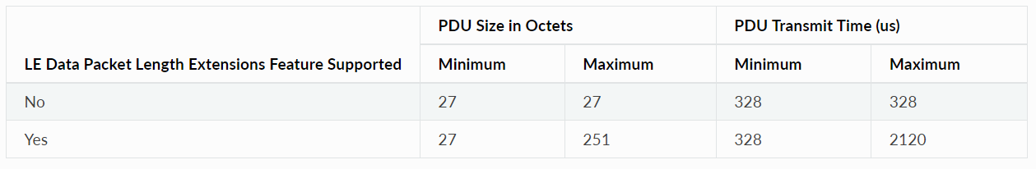

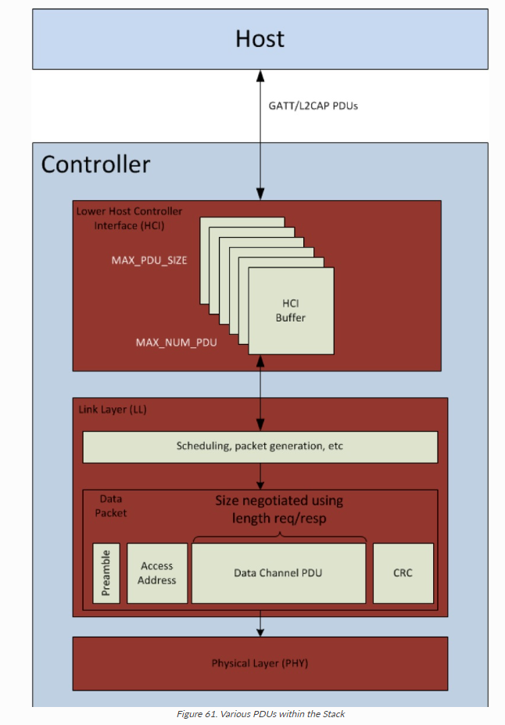

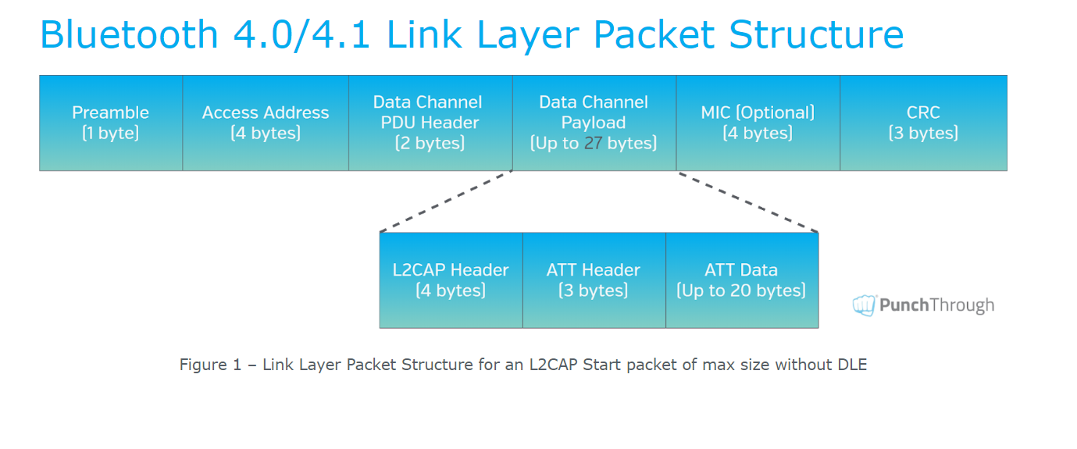

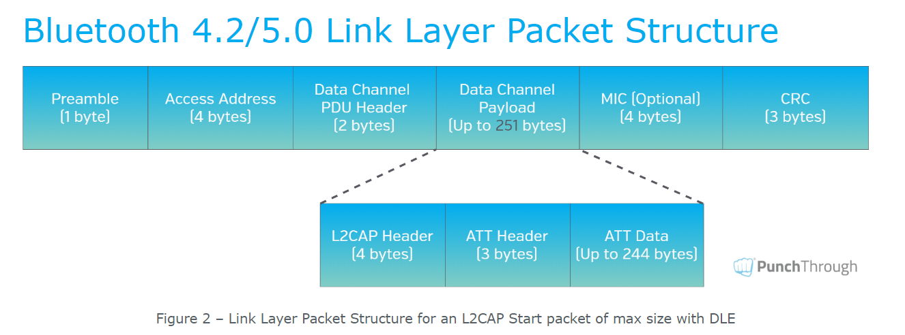

--->Reference https://punchthrough.com/maximizing-ble-throughput-part-3-data-length-extension-dle-2/

According to core spec :

HCI_LE_SET_DATA_LENGTH

OGF | 0x08 | OCF | 0x0022

Parameters ::
-->Connection Handle
-->Tx_octets
-->Tx_time

Return ::
-->Status
-->Connection handle
If the data length is need to changed then HCI_LE_Data_Length_Change event is generated.

HCI_LE_Data_Length_Change

Event code -- 0x3e
Event parameters ::
Sub event code --> 0x07 (LE_Data_Length_change Event)
Connection handle

LL_LENGTH_REQ and LL_LENGTH_RSP

HCI_LE_Read_Suggested_Default_ Data Length

OCF | 0x0023

There is no parameters
The return parameters are
Status,
SuggestedMaxTxOctets,
SuggestedMaxTxTime

The LE_Read_Suggested_Default_Data_Length command allows the Host to read the Host's preferred values for the Controller's maximum transmitted number of payload octets and maximum packet transmission time to be used for new connections.

HCI_LE_Read_Suggested_Default_ Data Length
OCF | 0x0024

Command parameters ::
SuggestedMaxTxOctets,
SuggestedMaxTxTime
Return status ::
Status;

The LE_Write_Suggested_Default_Data_Length command allows the Host to specify its preferred values for the Controller's maximum transmission number of payload octets and maximum packet transmission time to be used for new connections (connInitialMaxTxOctets and connInitialMaxTxTime

connMaxTxTime = (251 + 14 bytes) * 8 bits * 1 μs = 2120 μs.

From <https://punchthrough.com/maximizing-ble-throughput-part-3-data-length-extension-dle-2/>

LE Secure Connections
Thursday, June 6, 2024
12:30 PM

LE secure connection process :::

- Pairing feature exchange
- Public key exchange
- Authentication stage -1
- Authentication stage - 2
- Transport specific key distribution

Central | peripheral

Step 1a and 1b: Pairing feature Exchange

--------------------------------------------------------------- smp pairing request ------------------------------------------------------------------------------->

The initiator starts the Pairing Feature Exchange by sending a Pairing Request command to the responding device
--> Request packet fields

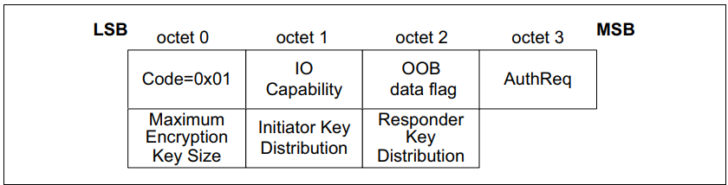

--> opcode == 0x01 --> Pairing request opcode

-->capability (1 octet)
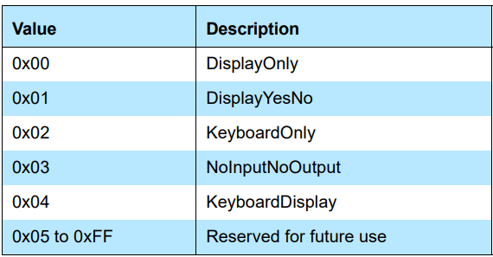

-->OOB data flag(1 octet)
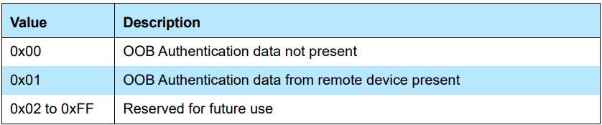

-->Authreq (1 octet)
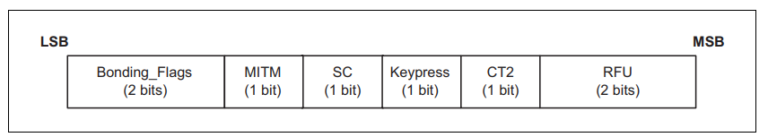

--> Bonding flags
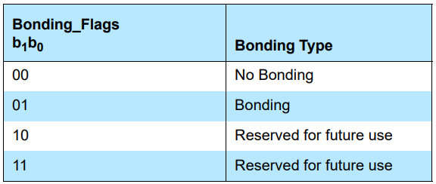

-->The MITM field is a 1-bit flag that is set to one if the device is requesting MITM protection, otherwise it shall be set to 0.
-->The SC field is a 1 bit flag. If LE Secure Connections pairing is supported by the device, then the SC field shall be set to 1, otherwise it shall be set to 0.
-->The keypress field is a 1-bit flag that is used only in the Passkey Entry protocol and shall be ignored in other protocols.
-->The CT2 field is a 1-bit flag that shall be set to 1 upon transmission to indicate support for the h7 function

-->Maximum Encryption Key Size (1 octet)
This value defines the maximum encryption key size in octets that the device can support. The maximum key size shall be in the range 7 to 16 octets.

-->Initiator Key Distribution / Generation (1 octet)
The Initiator Key Distribution field defines which keys the initiator shall distribute and use during the Transport Specific Key Distribution phase

-->Responder Key Distribution / Generation (1 octet)
The Responder Key Distribution field defines which keys the responder shall distribute and use during the Transport Specific Key Distribution phase

<------------------------------------------------------------- smp pairing Response ---------------------------------------------------------------------------------------

This command is used by the responding device to complete the Pairing Feature Exchange after it has received a Pairing Request command from the initiating device, if the responding device allows pairing.

All the features exchanges above will get the responder values which supported or not .

--------------------------------------------------------------------------------------------------------------------------------------------------------------------------------------
Public Key Exchange
-----------------------------------------------------------------------------------------------------------------------------

Next the public keys are exchanged between the two devices. Once a device has received the public key of the peer device, it can start to calculate the Diffie Hellman Key (DHKey). This may take a long time, and should be started early, so that user interaction can hide the calculation time
x and y coordinates --
------------------------------------------------------------------------pairing public key ------------------------------------------------------------------------------------>

This message is used to transfer the device’s local public key (X and Y coordinates) to the remote device. This message is used by both the initiator and responder. This PDU is only used for Secure Connections
By the coordinates sent by both the devices once exchanges then it starts caluculating the DHKey Diffie Hellman Key

x and y coordinates p - 256 is used to generate the public key

<------------------------------------------------------------------------pairing public key ------------------------------------------------------------------------------------
When the Controller receives the HCI_LE_Read_Local_P-256_Public_Key command, the Controller shall send the HCI_Command_Status event to the Host. When the local P-256 public key generation finishes, an HCI_LE_Read_- Local_P-256_Public_Key_Complete event shall be generated.
The HCI_LE_Read_Local_P-256_Public_Key command is used to return the local P-256 public key from the Controller. The Controller shall generate a new P-256 public/private key pair upon receipt of this command.

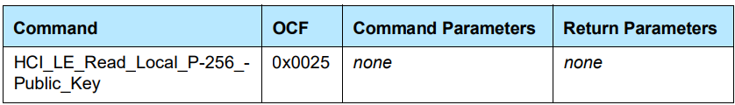

--------------------------------------------------------------------------------------------------------------------------------------------------------------------------------------
Authentication stage -1
-----------------------------------------------------------------------------------------------------------------------------------------------

1 - pairing confirm
2 - pairing random

Ca , Cb . , Na Nb

<------------------------------------------------------------------- Pairing Confirm ------------------------------------------------------------------------------------------

This is used following a successful Pairing Feature Exchange to start STK Generation for LE legacy pairing and LTK Generation for LE Secure Connections pairing.-

The initiating device starts key generation by sending the Pairing Confirm command to the responding device. If the initiating device wants to abort pairing it can transmit a Pairing Failed command instead.

The responding device sends the Pairing Confirm command after it has received a Pairing Confirm command from the initiating device.
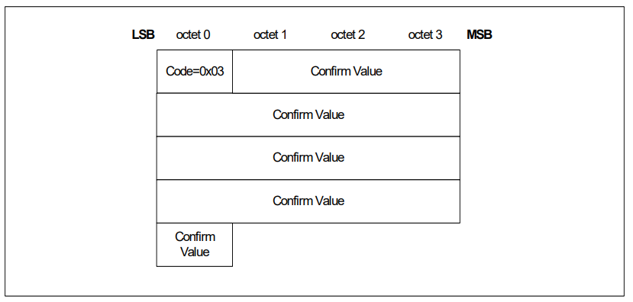

-->Confirm value (16 octets)
-->In LE Secure Connections, Ca and Cb are defined.
-->LE Secure Connections confirm value generation function f4.
-->During the LE Secure Connections pairing process, confirm values are exchanged. These confirm values are computed using the confirm value generation function f4.
-->This confirm value generation function makes use of the MAC function AESCMACX, with a 128-bit key X
-->The inputs to function f4 are: U is 256 bits
V is 256 bits
X is 128 bits
Z is 8 bits
Z is zero (i.e. 8 bits of zeros) for Numeric Comparison and OOB protocol. In the Passkey Entry protocol, the most significant bit of Z is set equal to one and the least significant bit is made up from one bit of the passkey e.g. if the passkey bit is 1, then Z = 0x81 and if the passkey bit is 0, then Z = 0x80.
--> U, V and Z are concatenated and used as input m to the function AES-CMAC and X is used as the key k
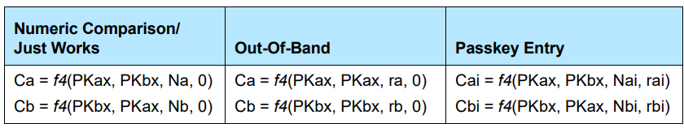

The output of the confirm value generation function f4 is as follows: f4(U, V, X, Z) = AES-CMACX (U || V || Z)

-------------------------------------------------------------------------------------Pairing Random------------------------------------------------------------------------

-->This command is used by the initiating and responding device to send the random number used to calculate the Confirm value sent in the Pairing Confirm command.
-->The initiating device sends a Pairing Random command after it has received a Pairing Confirm command from the responding device.
--> In LE Secure Connections, the responding device shall send a Pairing Random command after it has received a Pairing Random command from the initiating device. If the calculated Confirm value does not match then the responding device shall respond with the Pairing Failed command.
--> The initiating device shall encrypt the link using the generated key (STK in LE legacy pairing or LTK in LE Secure Connections) if the Confirm value calculated on the initiating device matches the Confirm value received from the responding device. The successful encryption or re-encryption of the link is the signal to the responding device that key generation has completed successfully. If the calculated Confirm value does not match then the initiating device shall respond with the Pairing Failed command.
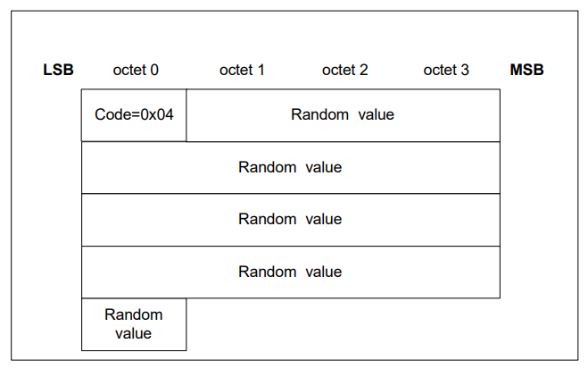

--> Random value (16 octets) :
In LE Secure Connections, the initiating devicee sends Na and the responding device sends Nb.

--------------------------------------------------------------------------------------------------------------------------------------------------------------------------------------
Authentication stage 2 (DHKey checks)
-----------------------------------------------------------------------------------------------------------------------------------------------
Once the LTK calculation and authentication stage 1 have completed, the DHKey value generated is checked by exchanging DHKey Check values generated using the DHKey. If this succeeds, then both devices would have finished displaying information to the user about the process, and therefore the Host can stop displaying this information.

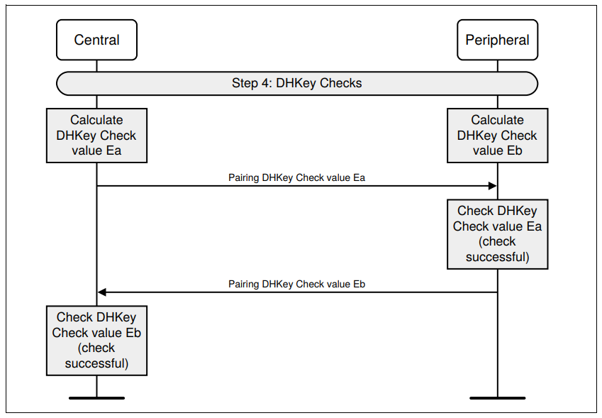
b

->This message is used to transmit the 128-bit DHKey Check values (Ea/Eb) generated using f6
->These are confirmation values generated using the DHKey. This message is used by both initiator and responder. This PDU is only used for LE Secure Connections.

The LE Secure Connections check value generation function f6 is used to generate check values during authentication stage 2 of the LE Secure Connections pairing process

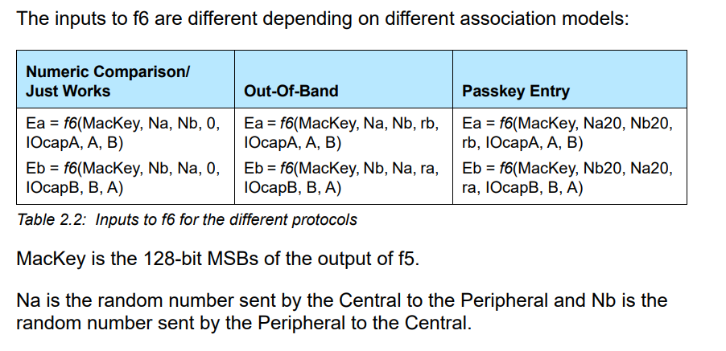

--------------------------------------------------------------------------------------------------------------------------------------------------------------------------------------
Transport specific key distribution
-----------------------------------------------------------------------------------------------------------------------------------------------

LE Secure Connections key distribution:
When using LE Secure Connections, the following keys may be distributed from the Peripheral to the Central:
• IRK using Identity Information command
• Public device or static random address using Identity Address Information command
Identity Address Information is used in the Transport Specific Key Distribution phase to distribute its public device address or static random address. The Identity Address Information command.
• CSRK using Signing Information command.

When using LE Secure Connections, the Central may distribute to the Peripheral the following key:
• IRK using Identity Information command
• Public device or static random address using Identity Address Information command
• CSRK using Signing Information command

When using LE Secure Connections, the keys shall be distributed in the following order:
1. IRK by the Peripheral
2. BD_ADDR by the Peripheral
3. CSRK by the Peripheral
4. IRK by the Central
5. BD_ADDR by the Central
6. CSRK by the Central

Generation of IRK
The Identity Resolving Key (IRK) is used for resolvable private address construction
A Central that has received IRK from a Peripheral can resolve that Peripheral’s random device addresses. A Peripheral that has received IRK from a Central can resolve that Central’s random device addresses. The privacy concept only protects against devices that are not part of the set to which the IRK has been given

Generation of CSRK
The Connection Signature Resolving Key (CSRK) is used to sign data in a connection. A device that has received CSRK can verify signatures generated by the distributing device. The signature only protects against devices that are not part of the set to which CSRK has been given.

Secure connection through HCI_Logs --

1 - SMP pairing feature exchange

2 - SMP public key exchange

3 - SMP Authentication stage 1

4 - SMP Authentication stage 2

5 - SMP Transport specific key distribution

The process is all same as mention above just to know about long term key generated.

After authentication stage 2 after checking the dh-key the encryption will start

Encryption will start through below commands

LE Enable Encryption command

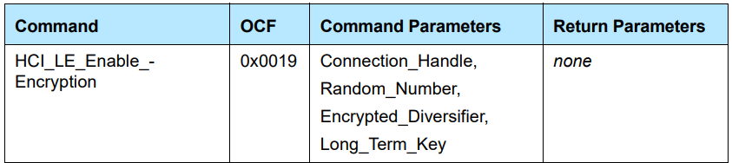

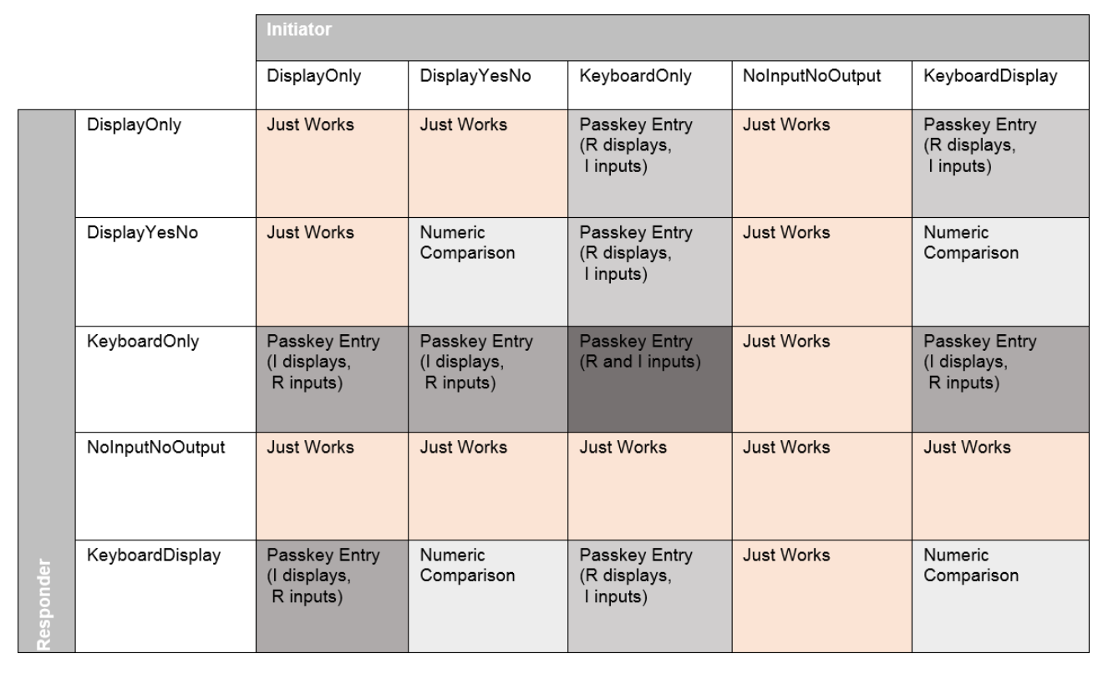

Legacy pairing
Friday, June 21, 2024
11:20 AM

Legacy pairing process :::

1 - Smp pairing feature exchange
- Smp pairing request
- Smp pairing response
2 - short term key generation
- Pairing confirm
- Pairing random
3 - LLCP Encryption start
4 - Smp transport specific key distribution

--------------------------------------------------------------------------------------------------------------------------------------------------------------------------------------------------------------------
SMP PAIRING REQUEST
-------------------------------------------------------------------------------------------------------------------------------------------------------------------------------------------------------------------
The initiator starts the Pairing Feature Exchange by sending a Pairing Request command to the responding device
--> Request packet fields

--> opcode == 0x01 --> Pairing request opcode

-->capability (1 octet)
-->OOB data flag(1 octet)

-->Authreq (1 octet)

--> Bonding flags

-->The MITM field is a 1-bit flag that is set to one if the device is requesting MITM protection, otherwise it shall be set to 0.
-->The SC field is a 1 bit flag. If LE Secure Connections pairing is supported by the device, then the SC field shall be set to 1, otherwise it shall be set to 0.
-->The keypress field is a 1-bit flag that is used only in the Passkey Entry protocol and shall be ignored in other protocols.
-->The CT2 field is a 1-bit flag that shall be set to 1 upon transmission to indicate support for the h7 function

-->Maximum Encryption Key Size (1 octet)
This value defines the maximum encryption key size in octets that the device can support. The maximum key size shall be in the range 7 to 16 octets.

-->Initiator Key Distribution / Generation (1 octet)
The Initiator Key Distribution field defines which keys the initiator shall distribute and use during the Transport Specific Key Distribution phase

-->Responder Key Distribution / Generation (1 octet)
The Responder Key Distribution field defines which keys the responder shall distribute and use during the Transport Specific Key Distribution phase

<------------------------------------------------------------- smp pairing Response -----------------------------------------------------------------------------------------------------------------

This command is used by the responding device to complete the Pairing Feature Exchange after it has received a Pairing Request command from the initiating device, if the responding device allows pairing.

All the features exchanges above will get the responder values which supported or not .

-----------------------------------------------------------------------------------------------------------------------------------------------------------------------------------------------------------------

BREDR Pairing
Monday, July 15, 2024
4:00 PM

1 - BR/EDR Secure Connections Pairing
2 - ssp
3 - Legacy

Link Layer privacy
Thursday, July 25, 2024
7:01 PM

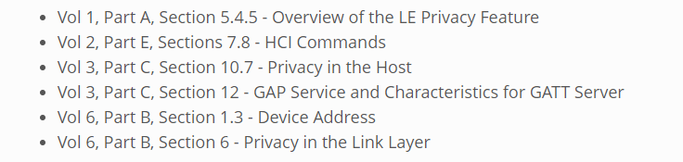

We have different types of address

--> Public & random
In random we have 2 types
1 - static
2 - private is of 2 types
1 - resolvable and non-resolvable

1 - non-resolvable address generation format

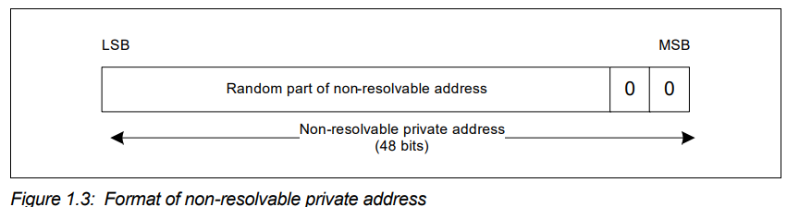

2 - Resolvable address generation format
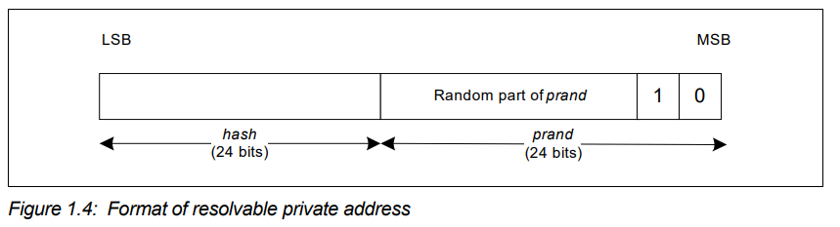
Here we use 24 bit hash and 24 bit prand , prand is nothing but a random number generated where the last 2 bit of rpa should be 10 as it indicates the address type

Here hash is generated using hash = ah(IRK, prand)
randomAddress is randomAddress = prand || hash

Identity Resolving Key (IRK) is a 128-bit key used to generate and resolve random addresses.
->The Identity Resolving Key (IRK) is used for resolvable private address construction.

Resolvable private address resolution procedure
A resolvable private address may be resolved if the corresponding device’s IRK is available using this procedure. If a resolvable private address is resolved, the device can associate this address with the peer device.
->The resolvable private address (RPA) is divided into a 24-bit random part (prand) and a 24-bit hash part (hash). The least significant octet of the RPA becomes the least significant octet of hash and the most significant octet of RPA becomes the most significant octet of prand.
A localHash value is then generated using the random address hash function ah defined in [Vol 3] Part H, Section 2.2.2 with the input parameter k set to IRK of the known device and the input parameter r set to the prand value extracted from the RPA.
localHash = ah(IRK, prand)
The localHash value is then compared with the hash value extracted from RPA. If the localHash value matches the extracted hash value, then the identity of the peer device has been resolved.

PRIVACY FEATURE :
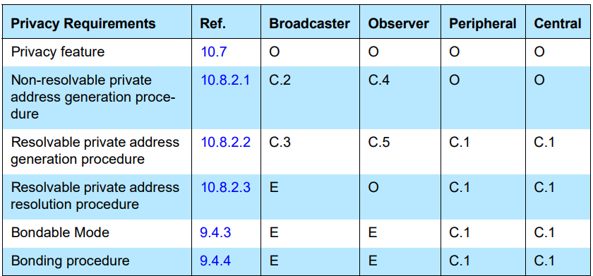

Two modes of privacy exist:

1 - Device privacy mode
When a device is in device privacy mode, it is only concerned about its own privacy. It should accept advertising packets from peer devices that contain their Identity Addresses as well as their private address, even if the peer device has distributed its IRK.
2 - Network privacy mode
When a device is in network privacy mode, it shall not accept advertising packets containing the Identity Address of peer devices that have distributed their IRK.

A device may support either just Host-based privacy or both Host-based and Controller-based privacy. When a device supports Controller-based privacy, the Host configures the Controller to perform some of the privacy functionality

Peripheral
Privacy feature in a Peripheral
The privacy-enabled Peripheral shall use a resolvable private address as the advertiser's device address when in connectable mode.
If a privacy-enabled Peripheral, that has a stored bond, receives a resolvable private address, the Host may resolve the resolvable private address by performing the ‘resolvable private address resolution procedure.
If the resolution is successful, the Host may accept the connection. If the resolution procedure fails, then the Host shall either accept the connection from the new, unresolved device, disconnect with the error code "Authentication failure", or perform the pairing procedure, or perform the authentication procedure.
Accepting the connection from the new, unresolved device, can result in exposing the device name or unique data to the Central.

Privacy feature in a Peripheral with Controller-based privacy
For this it may use undirected or directed connectable mode. The Host shall enable resolvable private address generation by enabling it in the Controller and populating the resolving list.
By default, network privacy mode is used when private addresses are resolved and generated by the Controller.

Privacy feature in a Peripheral with Host-based privacy
A privacy-enabled Peripheral should use the undirected connectable mode to create a connection.
The Host shall generate a resolvable private address using the ‘resolvable private address generation procedure.
or nonresolvable private address procedure.
The Host shall set a timer equal to TGAP(private_addr_int). The Host shall generate a new resolvable private address or non-resolvable private address when the timer TGAP(private_addr_int) expires

Central

Privacy feature in a Central
The privacy-enabled Central shall use a resolvable private address as the initiator's device address. During active scanning, a privacy enabled Central shall use a non-resolvable or resolvable private address.
If, a privacy-enabled Central, that has a stored bond, receives a resolvable private address, the Host may resolve the resolvable private address by performing the "resolvable private address resolution procedure.

Privacy feature in a Central with Controller-based privacy
A privacy-enabled Central with Address Resolution enabled in the Controller can use any of the connection establishment procedures.
By default, network privacy mode is used when private addresses are resolved and generated by the Controller.

Privacy feature in a Central with Host-based privacy
A privacy-enabled Central should use the general connection establishment procedure.

LE Add Device To Resolving List command :

OGF - 0x08
OCF - 0x0027

Parameters :
Peer_Identity_Address_Type | Peer_Identity_Address | Peer_IRK | Local_IRK

The HCI_LE_Add_Device_To_Resolving_List command is used to add one device to the resolving list used to generate and resolve Resolvable Private Addresses in the Controller.
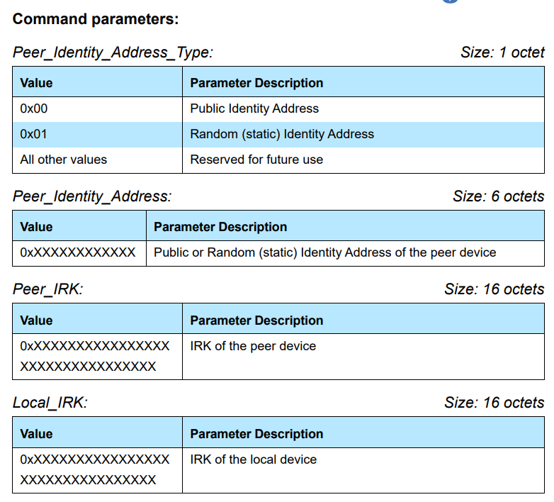

LE Set Address Resolution Enable Command :

OGF - 0x08
OCF - 0x002D

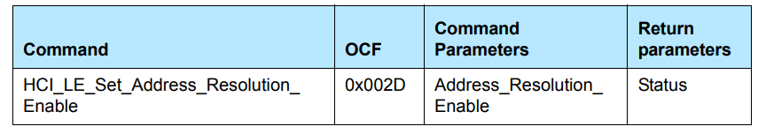

The LE_Set_Address_Resolution_Enable command is used to enable resolution of Resolvable Private Addresses in the Controller. This causes the Controller to use the resolving list whenever the Controller receives a local or peer Resolvable Private Address.

LE Set Resolvable Private Address Timeout Command :

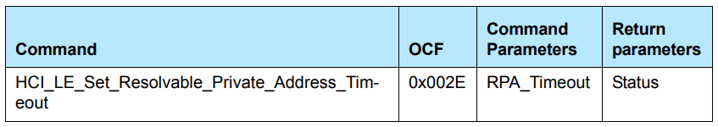
The LE_Set_Resolvable_Private_Address_Timeout command set the length of time the controller uses a Resolvable Private Address before a new resolvable private address is generated and starts being used. This timeout applies to all addresses generated by the controller.

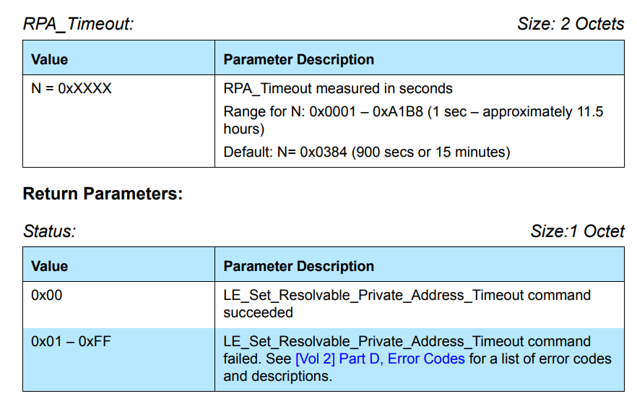

PRIVACY IN THE ADVERTISING STATE
Privacy in the advertising state determines how the Link Layer processes Resolvable Private Addresses for advertising events.

Connectable and scannable undirected event type
The Link Layer may use resolvable private addresses or non-resolvable private addresses for the advertiser’s device address (AdvA field) when entering the Advertising State and using connectable and scannable undirected events

When an advertiser receives a connection request that contains a device Identity Address for the initiator's address field (InitA field), and if that device is in the Resolving List with a non-zero peer IRK for which the Host has specified device privacy mode, then the advertising filter policy (see Section 4.3.2) shall determine if the advertiser establishes a connection.

