Enhancing Car Damage Analysis Through YOLOv8
Based Detection and Localization

A
Project Report

Submitted in partial fulfilment of the
Requirements for the award of the Degree of

M.Akhil 1602-21-737-005
N.Hemantha Giri 1602-21-737-020
Under the guidance of
Mrs.S.Rajyalaxmi
Assistant Professor


Department of Information Technology
Vasavi College of Engineering (Autonomous)
ACCREDITED BY NAAC WITH 'A++' GRADE
(Affiliated to Osmania University)
Ibrahimbagh,
Hyderabad-500 031
2025

Vasavi College of Engineering (Autonomous)
ACCREDITED BY NAAC WITH 'A++' GRADE
(Affiliated to Osmania University)
Hyderabad-500 031
Department of Information Technology

DECLARATION BY THE CANDIDATE
We,M.Akhil and N.Hemantha Giri bearing hall ticket number, 1602-21-737-005 and 1602-21-737-020 hereby declare that the project seminar report Enhancing Car Damage Analysis Through YOLOv8-Based Detection and Localization under the guidance of Mrs.S.Rajyalaxmi,Assistant Professor Department of Information Technology, Vasavi College of Engineering, Hyderabad.
This is a record of bonafide work carried out by us and the results embodied in this project report have not been submitted to any other university or institute for the award of any other degree or diploma.
M.Akhil
1602-21-737-005
N.Hemantha Giri
1602-21-737-020

Vasavi College of Engineering (Autonomous)
ACCREDITED BY NAAC WITH 'A++' GRADE
(Affiliated to Osmania University)
Hyderabad-500 031
Department of Information Technology

DECLARATION BY THE CANDIDATE
I, M.Akhil bearing hall ticket numbers, 1602-21-737-005, hereby declare that the project report entitled Enhancing Car Damage Analysis Through YOLOv8-Based Detection and Localization under the guidance of Mrs.S.Rajyalaxmi,Assistant Professor, Department of Information Technology, Vasavi College of Engineering, Hyderabad, is submitted in partial fulfilment of the requirement for the award of the degree of Bachelor of Engineering in Information Technology
This is a record of bonafide work carried out by me and the results embodied in this project report have not been submitted to any other university or institute for the award of any other degree or diploma.
M.Akhil
1602-21-737-005

Vasavi College of Engineering (Autonomous)
ACCREDITED BY NAAC WITH 'A++' GRADE
(Affiliated to Osmania University)
Hyderabad-500 031
Department of Information Technology

DECLARATION BY THE CANDIDATE
I, N.Hemantha Giri bearing hall ticket numbers, 1602-21-737-020, hereby declare that the project report entitled Enhancing Car Damage Analysis Through YOLOv8-Based Detection and Localization under the guidance of Mrs.S.Rajyalaxmi,Assistant Professor, Department of Information Technology, Vasavi College of Engineering, Hyderabad, is submitted in partial fulfilment of the requirement for the award of the degree of Bachelor of Engineering in Information Technology
This is a record of bonafide work carried out by me and the results embodied in this project report have not been submitted to any other university or institute for the award of any other degree or diploma.
N.Hemantha Giri
1602-21-737-020

Vasavi College of Engineering (Autonomous)
ACCREDITED BY NAAC WITH 'A++' GRADE
(Affiliated to Osmania University)
Hyderabad-500 031
Department of Information Technology

BONAFIDE CERTIFICATE
This is to certify that the project entitled Enhancing Car Damage Analysis Through YOLOv8-Based Detection and Localization being submitted by M.Akhil and N.Hemantha Giri bearing 1602-21-737-005 and 1602-21-737-020 in Bachelor of Engineering in Information Technology in a record of bonafide work carried out by them under my guidance.

Mrs.S.Rajyalaxmi Dr. K. Ram Mohan Rao
Assistant Professor External Examiner Professor& HOD, IT
Internal Guide

Vasavi College of Engineering (Autonomous)
ACCREDITED BY NAAC WITH 'A++' GRADE
(Affiliated to Osmania University)
Hyderabad-500 031
Department of Information Technology

BONAFIDE CERTIFICATE
This is to certify that the project entitled Enhancing Car Damage Analysis Through YOLOv8-Based Detection and Localization being submitted by M.Akhil bearing 1602-21-737-005 in partial fulfilment of the requirements for the award of the degree of Bachelor of Engineering in Information Technology is a record of bonafide work carried out by them under my guidance.

Mrs.S.Rajyalaxmi Dr. K. Ram Mohan Rao
Assistant Professor External Examiner Professor& HOD, IT
Internal Guide

Vasavi College of Engineering (Autonomous)
ACCREDITED BY NAAC WITH 'A++' GRADE
(Affiliated to Osmania University)
Hyderabad-500 031
Department of Information Technology

BONAFIDE CERTIFICATE
Thisis to certify that the project entitled Enhancing Car Damage Analysis Through YOLOv8-Based Detection and Localization being submitted by N.Hemantha Giri bearing 1602-21-737-020 in partial fulfilment of the requirements for the award of the degree of Bachelor of Engineering in Information Technology is a record of bonafide work carried out by them under my guidance.

Mrs.S.Rajyalaxmi Dr. K. Ram Mohan Rao
Assistant Professor External Examiner Professor& HOD, IT
Internal Guide

ACKNOWLEDGEMENT
The satisfaction that accompanies that the successful completion of the Main project would not have been possible without the kind support and help of many individuals. We would like to extend our sincere thanks to all of them.
We wish to convey our special thanks to Dr. S.V.Ramana, Principal of Vasavi College of Engineering and Management for providing facilities. Not to forget, we thank all other faculty and non-teaching staff, who had directly or indirectly helped and supported me in completing my project in time.
We are very much thankful to Dr. K. Ram Mohan Rao, Professor & HOD, Information Technology, for his kind support and for providing necessary facilities to carry out the work.
We are also grateful to C.Sireesha, Assistant Professor, Information Technology for her guidance. Their constant guidance and willingness to share their vast knowledge made us understand this project and its manifestations in great depths and helped us to complete the assigned tasks.
It is with immense pleasure that we would like to take the opportunity to express our humble gratitude to Mrs.S.Rajyalaxmi, Assistant Professor, Information Technology under whom we executed this project.

ABSTRACT
The need for automating vehicle damage assessment arises from the inefficiencies and inconsistencies inherent in traditional manual evaluation processes. These methods heavily rely on human judgment and are prone to biases and errors, leading to delays and inaccurate assessments. With millions of car accidents occurring annually, there is an increasing demand for faster, more accurate, and fair post-accident evaluations. Existing research has primarily focused on isolated tasks such as damage classification or part localization, leaving a gap in holistic systems that integrate these processes seamlessly. Current solutions often struggle with multi-class damage scenarios and lack adaptability to real-world conditions, particularly when dealing with user-acquired, low-quality images.
This paper addresses these limitations by proposing an end-to-end framework that integrates three distinct deep learning modules: vehicle identification, part localization, and damage localization. By leveraging user-acquired images and employing advanced post-processing techniques to aggregate multi-view data, the system enhances prediction reliability and overall accuracy. Unlike traditional automated approaches, which fail to generalize effectively across varying image qualities and perspectives, this model is designed to be robust and adaptable, making it more effective in real-world applications.
The proposed solution significantly reduces assessment times, improving the customer experience while maintaining fairness and consistency in evaluations. By minimizing reliance on manual inspections, insurers can process claims faster, repair shops can provide more accurate estimates, and customers can receive timely responses, leading to increased trust in the system. The research community also benefits from this work as it introduces a structured approach that combines advanced segmentation techniques with adaptable machine learning models, paving the way for further advancements in automated insurance claims processing and vehicle repair planning.

TABLE OF CONTENTS
List of Figures | (xi)
List of Tables | (xi)
1. INTRODUCTION 1
1.1. Problem Statement – Overview 1
1.2. Motivation (content is like Proposed Work) 2
1.3. Scope & Objectives of the Proposed Work 3
1.4. Organization of the Report 5
2. LITERATURE SURVEY 10
3. PROPOSED METHEDOLOGY 14
3.1. Methodology 14
3.1.1 Architecture Diagram 18
3.1.2 Functional Modules 19
4. EXPERIMENTAL SETUP&RESULT 24
4.1.System specifications 24
4.1.1 Software requirements 24
4.1.2 Hardware requirements 25
4.2 Description 26
4.3 Results & Test analysis 37
5. CONCLUSION &FUTURE SCOPE 50
REFERENCES 53
APPENDIX 55
code 55
Plagarism Report
Research Paper

LIST OF FIGURES
Figure Name | Page No
Figure 3.1: System Architecture Diagram | 19
Figure 4.1: HomePage of Web Application  F | 37
Figure 4.2: Login Page of Web Application | 38
Figure 4.3: Login Page of Web Application | 39
Figure 4.4: Image upload Page of Web page | 40
Figure 4.5: Image uploaded output | 41
Figure 4.6: Real time damage detection | 42
Figure 4.7: Video input processing with damage | 43
Figure 4.8: Result of Video input processing | 44
Figure.4.9: Real-time damage detection using webcam | 45
Figure 4.10: Sample detection output on a test image | 46
Figure 4.11 : confusion matrix of the model | 47

LIST OF TABLES
Table Name |  | Page No
Table 4.1 Detection Performance |  | 48

1.INTRODUCTION

1.1 Problem Statement

The assessment of vehicle damage is a critical component of the insurance and automotive repair industries. However, the conventional approach to evaluating car damage relies heavily on manual inspection by insurance adjusters and appraisers. This process is inherently time-consuming, often taking an average of seven days to complete. Additionally, manual evaluations are inconsistent and susceptible to human error and bias, which can lead to disputes, inefficiencies, and delays in claim processing and service delivery to customers.
Current automated solutions in the field of vehicle damage detection primarily focus on isolated tasks such as damage classification or part localization. These systems lack a comprehensive, integrated approach to vehicle damage assessment that incorporates both damage detection and severity estimation. The fragmented nature of these solutions limits their effectiveness in real-world applications, where a complete and accurate damage assessment is essential for efficient claim settlements and repair processes.
One of the major challenges faced by existing automated systems is dealing with real-world images, which users often upload for assessment. These images exhibit a wide range of quality, perspectives, and contexts, making it difficult for current models to consistently and accurately localize and estimate vehicle damage. Variations in lighting conditions, angles, occlusions, and background distractions further complicate the assessment process, reducing the reliability of automated systems.
To address these challenges, there is a pressing need for a robust, efficient, and adaptable solution that can accurately detect vehicle damage, localize the affected areas, and determine the severity of the damage. The solution must be capable of handling diverse real-world scenarios, ensuring high precision and reliability in damage assessment. By reducing dependence on manual intervention, such a system can significantly enhance the efficiency of claim processing, minimize delays, and improve the overall customer experience. Additionally, an automated and integrated approach to vehicle damage assessment can streamline insurance workflows, reduce operational costs, and contribute to a more transparent and objective evaluation process.
Developing a sophisticated AI-driven system that leverages deep learning and computer vision techniques to analyze vehicle damage is essential. The system should be designed to process images captured under varied conditions and provide accurate damage localization and severity estimation. By incorporating advanced object detection and segmentation methodologies, the proposed solution aims to bridge the gap between existing automated systems and real-world applicability. Ultimately, a well-optimized car damage detection system will transform the traditional vehicle inspection landscape, making it more efficient, accurate, and scalable for the insurance and automotive repair industries.
1.2 Motivation
The motivation for this paper stems from the significant inefficiencies and inconsistencies in the traditional vehicle damage assessment process. With over six million car accidents occurring annually in the U.S. alone, there is an urgent need to expedite post-accident evaluations, which currently take an average of seven days to complete. Manual assessments are not only time-consuming but also susceptible to human error and bias, resulting in delays and dissatisfaction among customers and service providers.
Furthermore, existing automated systems are limited in scope, addressing only isolated tasks such as damage classification or part identification. These approaches fall short of delivering a comprehensive solution and struggle to handle real-world conditions, such as varying quality and perspectives in user-acquired photographs. Many of these systems are not robust enough to provide accurate damage localization and severity estimation, reducing their reliability in practical applications.
The paper is motivated by the potential of deep learning and computer vision technologies to revolutionize damage assessment. By automating the process and integrating damage localization with severity estimation, the proposed work aims to enhance efficiency, reduce reliance on manual intervention, and deliver fairer and faster outcomes for customers and insurers alike.
This research seeks to fill the gap in holistic, scalable, and accurate vehicle damage assessment systems. A well-designed AI-driven solution could significantly improve the speed and accuracy of evaluations while ensuring consistency across different scenarios. By incorporating advanced machine learning models, the system would be capable of processing diverse real-world images, overcoming challenges such as varying lighting conditions, occlusions, and complex backgrounds.
Ultimately, this work aims to set the stage for transformative applications in the automotive and insurance sectors, streamlining claim processing and reducing operational costs. A fully automated and integrated vehicle damage assessment system has the potential to redefine industry standards, making damage evaluation more efficient, objective, and scalable for widespread adoption.
Moreover, such a system could facilitate better collaboration between insurance companies, repair shops, and customers by providing real-time, transparent, and consistent evaluations. By minimizing disputes over damage assessments and improving the accuracy of repair estimates, the technology could lead to a more seamless and trustworthy claims process. In turn, this advancement could help build consumer confidence in insurance services while reducing fraudulent claims and unnecessary repair costs.

1.3 Scope and Objectives
The scope of this work focuses on designing a robust, automated system for vehicle damage assessment that seamlessly analyzes user-acquired photographs to identify vehicle presence, localize damaged parts, and estimate the severity of damages. The system is designed to address real-world challenges, including variations in image quality, perspectives, lighting conditions, and diverse vehicle types. Ensuring adaptability and scalability across different scenarios is crucial for practical implementation, making this approach suitable for real-world applications such as insurance claims, repair estimation, and fleet maintenance.
This work aims to minimize manual intervention by employing a fully automated framework that integrates deep learning modules for vehicle identification, part localization, and damage severity estimation. By leveraging convolutional neural networks (CNNs) and transformer-based models, the system enhances precision and generalization across different damage types and severities. Advanced multi-view aggregation techniques further improve accuracy by combining multiple image perspectives, leading to a more comprehensive and reliable evaluation of vehicle damage.
One of the core objectives of this work is to support the research community by providing a modular and extensible framework. This framework can be adapted for various applications, including automated insurance claim processing, predictive maintenance in fleet management, and enhanced customer service in automotive repair. By offering a standardized and scalable solution, this work aims to bridge the gap between academic research and industrial deployment.
Furthermore, the system is designed to integrate seamlessly with cloud-based platforms and mobile applications, enabling users to upload images for instant damage assessment. By incorporating AI-driven solutions into the vehicle inspection process, this approach has the potential to reduce claim processing times, minimize fraudulent claims, and enhance transparency between stakeholders, including insurers, repair shops, and vehicle owners.
In the long term, the adoption of AI-based damage assessment systems can redefine industry standards, ensuring fairness, speed, and efficiency in post-accident workflows. The proposed solution lays the foundation for future advancements in automated vehicle inspection and assessment, ultimately transforming how damage evaluations are conducted in insurance, automotive repair, and fleet management Indus

1.4 Organization of Report
This report is systematically structured into six detailed chapters, each focusing on a distinct phase of the research and development process of the Enhancing Car Damage Analysis Through YOLOv8-Based Detection and Localization. The objective of this report structure is to present a logical flow that guides the reader from problem identification to solution implementation, experimental evaluation, and future scope. The following is a brief yet comprehensive overview of each chapter:

Chapter 1: Introduction
This chapter lays the foundation for the entire study by introducing the core problem—automated car damage detection—and the need for technological advancement in this area. It begins by exploring how car damage is traditionally assessed, typically through manual inspection by human experts or insurance agents. These manual methods are often time-consuming, subjective, error-prone, and not scalable for mass deployment. With the rise of artificial intelligence (AI), particularly deep learning, there exists a promising opportunity to automate this process efficiently and reliably.
The chapter continues by detailing the significance of applying deep learning to this problem. It highlights how Convolutional Neural Networks (CNNs) and object detection frameworks like YOLO (You Only Look Once) have transformed computer vision tasks such as object recognition, localization, and classification. It then articulates the primary objectives of the project, which include detecting damaged car parts from images, classifying the type and severity of damage, and evaluating the performance of the system.
Furthermore, the scope and limitations of the study are clearly defined. The chapter concludes with a roadmap of the entire report, providing a snapshot of what each upcoming chapter contains to guide the reader through the research journey.

Chapter 2: Literature Survey
In this chapter, a thorough review of the current state of research in the domain of car damage detection and related fields is presented. The survey spans early techniques involving classical image processing methods, such as edge detection, color segmentation, and feature extraction, which served as the groundwork for initial attempts at vehicle damage assessment. These traditional methods, while innovative at the time, often struggled with real-world complexities such as varying lighting conditions, angles, and occlusions.
The chapter then transitions into the evolution of machine learning techniques, especially Support Vector Machines (SVMs) and decision trees, which brought more structure and intelligence to image analysis. However, these techniques still required manual feature engineering and had limited adaptability to large, diverse datasets.
The primary focus of this chapter is on deep learning models, particularly CNNs, and their ability to learn hierarchical features from data automatically. The effectiveness of object detection algorithms like YOLO and Faster R-CNN in localizing and classifying damage is discussed with reference to recent studies and benchmark datasets. Existing commercial systems and academic prototypes are also analyzed, followed by a discussion of their limitations, such as lack of generalization, high computational cost, or limited interpretability.
Finally, the research gap is identified, establishing the necessity for a robust, real-time, deep learning-based car damage detection system that is not only accurate but also practical for deployment in scenarios like insurance claim processing, vehicle resale evaluation, and fleet management.

Chapter 3: Proposed System
This chapter delves deeply into the architecture, methodology, and technical design of the proposed Car Damage Detection System. It begins by outlining the system objectives and the problem formulation in a structured manner. The methodology section walks through the entire pipeline from data collection to final output generation, highlighting the logic and motivation behind each design decision.
A detailed overview of the system architecture follows, presenting a high-level diagram that illustrates the flow of data and interaction among components. Key functional modules such as image acquisition, data preprocessing, damage detection, damage classification, and severity estimation are thoroughly described. For each module, the specific tasks performed, the algorithms employed, and the inter-module dependencies are discussed.
In the algorithms section, the rationale for choosing deep learning models like CNNs for feature extraction and YOLO for object detection is provided, supported by literature and empirical evidence. Transfer learning, model tuning, and custom modifications made to enhance accuracy and speed are covered as well.
The implementation subsection provides a technical walkthrough of how the model was built, trained, and integrated into a working prototype. It includes specifics on the programming tools, libraries (such as TensorFlow, OpenCV, and Keras), hardware used for training, and how different components were combined into a seamless pipeline. Emphasis is placed on modularity, reusability, and scalability of the codebase.

Chapter 4: Experimental Setup & Results
This chapter documents the experimental procedures, testing environment, and outcome evaluation for the proposed system. It begins with a comprehensive description of the dataset used, including its source, structure, size, and diversity in terms of damage types, angles, and lighting conditions. Steps taken to preprocess the data—such as resizing, normalization, augmentation, and annotation—are elaborated to give insight into how the dataset was prepared for training.
The system configuration section outlines the hardware specifications (e.g., GPU/CPU details, RAM, and storage) and the software stack (e.g., operating system, frameworks, and libraries) used during development and training.
A dedicated portion is allocated to preprocessing techniques such as contrast enhancement, noise reduction, and image augmentation, which were employed to increase model robustness. The rationale behind using specific transformations (like flipping, rotation, or zoom) is explained in the context of combating overfitting and improving generalization.
Results are then presented with both quantitative and qualitative metrics. Evaluation metrics such as accuracy, precision, recall, F1-score, and Intersection-over-Union (IoU) are computed to measure detection and classification performance. These results are visualized using confusion matrices and performance curves. Real-time testing scenarios are also described to assess the practical feasibility of the system. Comparative analysis with baseline models or existing approaches is included to substantiate the effectiveness of the proposed method.

Chapter 5: Conclusion & Future Scope
The final chapter summarizes the findings and impact of the research. It reiterates the problem addressed, the methodology followed, and the results achieved, providing a concise overview of how the objectives were met. The chapter reflects on the system's ability to accurately detect car damage and estimate severity in real-world scenarios, emphasizing its potential application in areas like insurance automation, fleet inspection, and accident reporting.
A critical evaluation of the system's limitations is also provided—such as its dependency on high-quality images, occasional misclassification under complex occlusions, and computational constraints for mobile deployment.
The future scope section outlines avenues for enhancing the system further. Suggestions include integrating 3D image analysis for depth estimation, using edge devices or IoT-based sensors for real-time monitoring, and developing a mobile application for consumer use. Other potential research directions, such as incorporating multilingual support for broader user accessibility or applying explainable AI to improve transparency, are also proposed.

Chapter 6: References
This chapter provides a detailed and well-structured list of all academic papers, journal articles, websites, code repositories, and tools referenced throughout the report. Each reference is cited according to a standardized format (such as IEEE or APA) and categorized wherever applicable for ease of access. The references not only support the claims and discussions made in the report but also serve as a resource for readers who wish to explore the topic further.
This curated list of references ensures academic integrity and strengthens the credibility of the research work. By systematically documenting all the sources consulted, the report maintains transparency and allows readers to trace the origin of key ideas, methodologies, and technologies adopted in the project. References to foundational theories, contemporary research articles, and the latest advancements in machine learning, image processing, and vehicle damage assessment provide a strong theoretical backbone to the study. Additionally, linking to publicly available datasets and code repositories promotes reproducibility, encouraging further research and development based on the presented system.
Special attention has been given to the inclusion of diverse sources such as open-source libraries (e.g., Albumentations, YOLOv8 implementations), academic conference proceedings, and technical documentation from recognized platforms. Categorizing references into sections like "Research Papers," "Tools and Libraries," and "Datasets" allows readers to easily navigate and locate specific resources of interest. This structured approach not only reflects thorough research practices but also enhances the utility of the document for future learners, researchers, and practitioners seeking to build upon or adapt the solutions discussed in this work.

2.LITERATURE SURVEY
2.1 Car damage detectionand assessment using CNN
AUTHORS: A. Shirode, T. Rathod, P. Wanjari, and A. Halbe
In today's digital world, most businesses are adopting technology in every possible way. Many time it occurs that when the car is damaged insurance claims are done. If the car is insured, a person from the insurance industry visits and takes survey of the customers car and prepares the report. The manual verification is a tedious process. But with the major advancement in field of deep learning algorithms, it can be used in the insurance industry to solve these problems. In the proposed solution we have implemented 2 CNN models. VGG16 is used to detect the damage on the car, location of the damage and its severity. Mask RCNN is used to mask out the exact damaged region. Both the models give a fair idea about the damage caused to the car which can help insurance company to proceed further with the insurance claims without wasting time and resources on manual verification.
2.2 Damage identification of selected car partsusing image classification and deep learning
AUTHORS:A. C. Chua et al.,
This study presents the use of image classification and deep learning in the field of insurance claims and management for the identification and assessment of damaged vehicle parts. Vehicular insurance claims on require appraisers to decide the damage of the vehicles. A two-level machine learning-based system was developed to classify different car parts (front bumper, rear bumper, and car wheels), and to detect the presence of any damages. The image dataset used in the study was obtained from a Google image. This dataset is used for training and validation of the convolutional neural network (CNN) model. The first model yields a training accuracy of 94.84% and validation accuracy of 81.25% for car parts classification. The second model yields a training accuracy of 97.16% and validation accuracy of 49.28% for damage identification.

2.3 Vehicle damage classification and fraudulent image detection including Moiré effect using deep learning
AUTHORS:U. Waqas, N. Akram, S. Kim, D. Lee, and J. Jeon
Image-based vehicle insurance processing and loan management has large scope for automation in automotive industry. In this paper we consider the problem of car damage classification, where categories include medium damage, huge damage and no damage. Based on deep learning techniques, MobileNet model is proposed with transfer learning for classification. Moreover, moving towards automation also comes with diverse hurdles; users can upload fake images like screenshots or taking pictures from computer screens, etc. To tackle this problem a hybrid approach is proposed to provide only authentic images to algorithm for damage classification as input. In this regard, moiré effect detection and metadata analysis is performed to detect fraudulent images. For damage classification 95% and for moiré effect detection 99% accuracy is achieved.

2.4 Albumentations: Fast and flexible image augmentations
AUTHORS:A. Buslaev, V. I. Iglovikov, E. Khvedchenya, A. Parinov, M. Druzhinin,and A. A. Kalinin
Data augmentation is a commonly used technique for increasing both the size and the diversity of labeled training sets by leveraging input transformations that preserve output labels. In computer vision domain, image augmentations have become a common implicit regularization technique to combat overfitting in deep convolutional neural networks and are ubiquitously used to improve performance. While most deep learning frameworks implement basic image transformations, the list is typically limited to some variations and combinations of flipping, rotating, scaling, and cropping. Moreover, the image processing speed varies in existing tools for image augmentation. We present Albumentations, a fast and flexible library for image augmentations with many various image transform operations available, that is also an easy-to-use wrapper around other augmentation libraries. We provide examples of image augmentations for different computer vision tasks and show that Albumentations is faster than other commonly used image augmentation tools on the most of commonly used image transformations.
2.5 Scratch detection in cars using a convolutional neural network bymeans of transfer learning
AUTHORS:C. G. Pachón-Suescún, P. C. U. Murillo, and R. Jimenez-Moreno
This paper presents the development of a system of recognition of scratches in cars, implemented through convolutional neural networks (CNN). For this case the AlexNet architecture is employed making use of the transfer learning technique. As input images, sections of the vehicles are entered for training and, as an exit from CNN, the last Fully-Connected is altered so that it only has two exit categories (sections with scratches and without scratches). After the training, a validation accuracy of 88.29% is obtained and with the test images an average between the categories of 86.99% is reached, presenting disadvantages in the classification because of the analysis of areas that did not correspond to the cars or even dirt in parts of the car that can be confused with scratches.
The literature reviewed for this study has significantly contributed to shaping the proposed approach for automated vehicle damage assessment. Various research works provided insights into deep learning models, image processing techniques, and real-world challenges associated with vehicle damage detection. The findings from these studies guided the selection of methodologies, helping to develop a more robust and scalable solution.
The study on car damage detection and assessment using CNN by Shirode et al. demonstrated the effectiveness of using deep learning models like VGG16 and Mask R-CNN for damage classification and localization. This research reinforced the importance of using multiple models to improve accuracy, influencing the integration of different deep learning techniques in this work. Similarly, Chua et al.’s work on damage identification of selected car parts through image classification highlighted the importance of classifying vehicle parts before assessing damage. This approach was incorporated into the project by first identifying vehicle components before detecting damage, ensuring a structured evaluation process.
Another significant contribution came from Waqas et al., who introduced a hybrid approach for vehicle damage classification and fraudulent image detection using MobileNet and moiré effect detection. Their methodology informed the inclusion of fraud detection mechanisms in the system, ensuring that only authentic images are processed. Furthermore, the study on Albumentations by Buslaev et al. provided valuable insights into image augmentation techniques, allowing the training dataset to be enhanced with diverse transformations to improve model robustness. Finally, Pachón-Suescún et al.’s work on scratch detection using transfer learning with AlexNet demonstrated the potential of pre-trained networks for damage classification, influencing the decision to leverage transfer learning to improve model performance and training efficiency.
Overall, the literature review provided essential knowledge on CNN architectures, fraud detection, image augmentation, and model optimization strategies. By integrating these insights, this research ensures a comprehensive and effective automated vehicle damage assessment system that improves accuracy, reliability, and scalability in real-world applications.
Building on these foundations, the proposed system further refines the damage detection pipeline by incorporating object detection models like YOLOv8, which have shown superior performance in real-time detection tasks. The shift towards lightweight and high-speed architectures was motivated by the need to deploy the solution not just on powerful servers but also on edge devices such as smartphones or in-vehicle systems. Moreover, attention was given to dataset curation strategies inspired by the reviewed studies, emphasizing the collection of varied and high-quality images covering different lighting conditions, angles, and damage severities. This comprehensive dataset preparation ensures that the model generalizes well across different scenarios. Additionally, the integration of severity estimation modules, based on regression analysis techniques, was influenced by recent trends in automotive insurance automation, thereby expanding the system's utility beyond mere detection to actionable evaluation. Through these cumulative learnings from the literature, the project aspires to bridge the gap between theoretical advancements and practical deployment, delivering a solution that is both technically sophisticated and industry-ready.
3.PROPOSED METHEDOLOGY
3.1 Methedology
The proposed methodology outlines a comprehensive and systematic process for developing a YOLOv8-based car damage detection system. The objective of this methodology is to deliver an end-to-end solution that can automatically detect, classify, and localize damage on vehicles with high accuracy and real-time performance. This system is aimed at real-world applicability, enabling use cases such as insurance claim automation, pre-repair inspection, and general vehicle condition monitoring. The development approach is structured into multiple stages, each playing an essential role in ensuring that the final system is not only technically sound but also practical and scalable. These stages include training the model, analyzing predictions, evaluating accuracy, saving the trained model, deploying a prediction module, and integrating an evaluation module. Each phase has been designed to build upon the last, ensuring that the system remains efficient and reliable throughout the pipeline—from data ingestion to user-facing output.
Training the Model:
The development process begins with the training of the YOLOv8 model, a powerful and efficient object detection architecture renowned for its speed and accuracy. The success of this stage heavily relies on the quality and diversity of the dataset used. The training dataset comprises thousands of annotated car images, each labeled with bounding boxes and damage classifications. These annotations include various types of common and uncommon damages found on vehicles, such as front windscreen cracks, broken headlights, shattered rear windshields, damaged side mirrors, broken taillights, and multiple types of dents including those on the bonnet, fender, rear bumper, and roof. Each image not only contains visual cues for damage but also provides spatial information that teaches the model where and what type of damage to expect.
The YOLOv8 architecture processes these images through a training loop, learning to draw bounding boxes around damaged regions and assign them appropriate class labels. This learning is guided by a loss function—typically Mean Average Precision (mAP)—which quantifies the model’s error at each step. The mAP combines the concepts of precision and recall across all object categories and is particularly useful for evaluating object detection tasks where both classification and localization are required. As the model encounters each image, its initial predictions are compared to the ground truth labels. The discrepancy between predicted and actual bounding boxes is penalized by the loss function, and the model learns to minimize this loss over successive iterations.
To further improve learning efficiency and stability, optimization algorithms such as Adam and Stochastic Gradient Descent (SGD) are employed. These optimizers adjust the network's internal weights based on gradients calculated during backpropagation. Learning rate schedules, batch normalization, and data augmentation techniques are also employed to ensure that the model generalizes well and avoids overfitting to the training data. During this stage, numerous hyperparameters—like batch size, number of epochs, anchor sizes, and learning rates—are tuned through experimentation to find the configuration that yields the best performance. This stage is fundamental as it sets the groundwork for all subsequent steps in the pipeline.
Analyze and Prediction:Once training is underway, the model is routinely evaluated on a separate validation set to analyze its prediction capabilities and ensure it is learning appropriately. This phase serves both as a diagnostic tool and a checkpointing mechanism, allowing developers to identify whether the model is overfitting, underfitting, or failing to learn entirely. Predictions made on validation images are compared against the true labels, and the system outputs bounding boxes and associated class labels for detected damages. The model also assigns a confidence score to each prediction, reflecting how certain it is about the detection. This score is particularly important in post-processing, where thresholding techniques are applied to filter out low-confidence detections and retain only the most relevant information.
The prediction stage not only helps in identifying weak spots in the training data—such as underrepresented classes or ambiguities in annotation—but also provides visual confirmation of how well the model is performing. These predictions are displayed over the original images, offering an intuitive view of the model's capabilities. As performance improves across iterations, developers can observe better localization, fewer false positives, and stronger classification. Additionally, this stage enables preliminary evaluations of edge cases, such as overlapping damages or multiple damages within a single image, preparing the model for complex real-world scenarios.
Accuracy On TestSet: The accuracy evaluation on a separate test dataset serves as a crucial step in validating the model’s readiness for deployment. The test dataset comprises images that were not seen during training or validation, ensuring an unbiased estimate of the model’s generalization ability. This simulation of real-world input conditions is necessary to determine whether the model can function reliably across various environments, car types, and lighting conditions. Performance metrics such as precision, recall, F1-score, and especially Mean Average Precision (mAP) are computed to assess the model’s effectiveness in both localization and classification tasks.
Precision measures the proportion of correct damage detections out of all detections made, while recall calculates how many of the actual damages were successfully identified by the model. The F1-score offers a harmonic mean between these two, providing a single metric that balances both false positives and false negatives. The mAP, calculated across all classes, offers a consolidated view of how well the model is detecting different types of damage across the dataset. This metric is particularly valuable when evaluating performance across multiple categories, such as the 14 distinct damage classes used in this project. Test-time augmentations and cross-validation may also be used to enhance the robustness of these metrics.
This evaluation is not just a passive measurement activity but often leads to critical insights that drive further improvements. For instance, if precision is high but recall is low, it might indicate that the model is being overly conservative in making predictions. Conversely, a high recall with low precision might suggest that the model is making too many false detections. Based on these insights, data balancing, additional augmentation, or further fine-tuning can be carried out to achieve the desired level of accuracy.
Saving the trained Model:
After achieving satisfactory performance on the test dataset, the trained YOLOv8 model is saved and prepared for deployment. YOLOv8 supports exporting models in multiple formats, such as PyTorch .pt, ONNX .onnx, or TensorRT .engine, each tailored to different deployment environments. This stage ensures that the trained model is portable and can be reused without needing to retrain from scratch. Exporting also allows for quantization or pruning if needed, especially when the model is to be deployed on devices with limited computational resources, such as mobile phones or embedded systems.
The saved model serves as the core inference engine in all downstream applications. Version control practices are often employed here to track changes between iterations and ensure that the best-performing model is consistently used. Additionally, a configuration file often accompanies the model, storing details about the architecture, class labels, anchor sizes, and other hyper parameters. These files are essential for maintaining consistency between training and inference environments and play a crucial role in the reproducibility and scalability of the solution.

Prediction Module
With the model saved and ready, the prediction module is implemented to enable real-time or batch inference. This module is designed to accept a variety of input formats, including static images, video feeds, or live camera streams. Upon receiving an input, the system preprocesses it—resizing the image, normalizing pixel values, and formatting it into a tensor compatible with YOLOv8. The trained model is then invoked to perform detection, after which the output is post-processed to extract bounding boxes, class labels, and confidence scores. The result is visualized by overlaying these elements on the original image, providing a clear and interpretable output for the user.
The module is engineered for user-friendliness, aiming to deliver insights even to non-technical users. Insurance agents, garage operators, and car owners can use this interface to identify damages without specialized equipment or knowledge. The system predicts 14 unique damage classes, each mapped to a specific car component or type of damage: front windscreen, headlight, rear windscreen, running board, side mirror, taillight, bonnet dent, boot dent, door outer dent, fender dent, front bumper dent, quarter panel dent, rear bumper dent, and roof dent. This granularity ensures that the system captures a comprehensive profile of a vehicle’s condition, which can be critical for insurance assessments or repair estimates.
The classes predicted include:
0: Front-windscreen-damage
1: Headlight-damage
2: Rear-windscreen-Damage
3: Runningboard-Damage
4: Sidemirror-Damage
5: Taillight-Damage
6: Bonnet-dent
7: Boot-dent
8: Doorouter-dent
9: Fender-dent
10: Front-bumper-dent
11: Quaterpanel-dent
12: Rear-bumper-dent
13: Roof-dent
Model Evaluation Module:
The final component of the methodology is the model evaluation module, which functions as a performance monitoring tool post-deployment. This module takes the test dataset—or new user-submitted data—and runs the saved model against it, calculating detailed evaluation metrics. In addition to standard metrics like accuracy, precision, recall, and F1-score, the module generates confusion matrices for each class. These matrices visually represent how often a class was predicted correctly, incorrectly, or confused with another class. Such visualization is instrumental in detecting patterns of misclassification and guiding iterative model improvements.
For example, if the model frequently confuses a boot dent with a rear bumper dent, the confusion matrix will make this trend apparent. This insight can lead to strategic data augmentation, reannotation, or even architectural modifications to better distinguish between visually similar damage types. The evaluation module also plays a critical role in version control, enabling comparisons between model iterations and supporting continuous deployment practices. As new data becomes available, the evaluation module can be reused to assess performance drift or identify new classes of damage, ensuring that the system evolves alongside real-world demands.
3.1.1 System Architecture Diagram
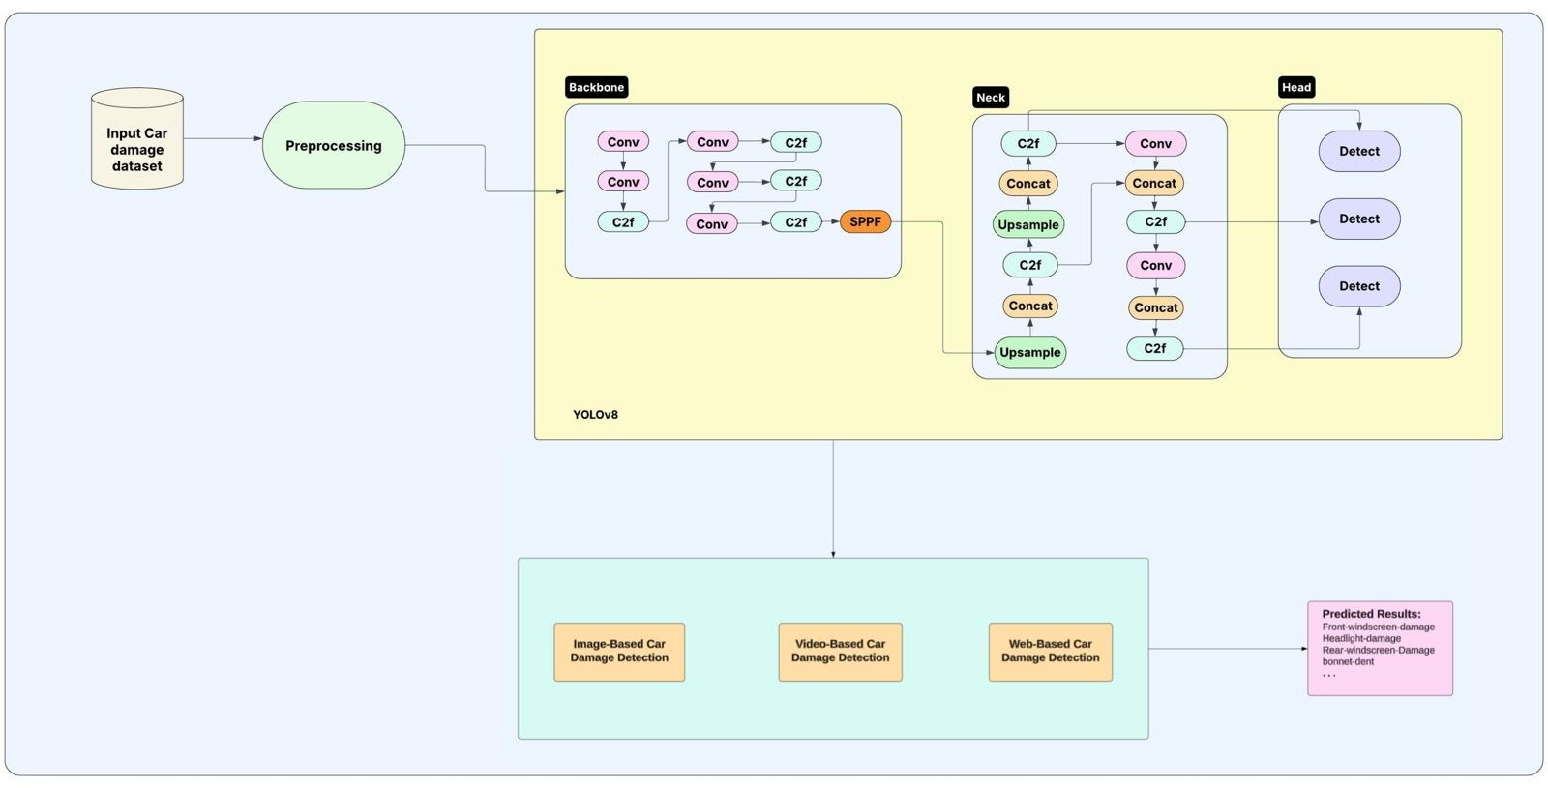
Figure 3.1 Block diagram showing data input, YOLOv8 processing, and result display via Flask web interface
The system architecture of the Car Damage Detection System provides a clear, modular view of how data flows from the input stage to the final result presentation. This architecture is designed for scalability, real-time performance, and ease of deployment, leveraging YOLOv8 for core object detection and Flask for interfacing. The following components make up the system's architectural design:
At the input stage, users submit images or videos containing vehicles. These could be damage claim photos from car owners or footage from surveillance systems. The system accepts this input through a web interface developed using the Flask framework, which ensures compatibility with browsers and minimal setup on the client side.
Once the input is received, it undergoes a preprocessing pipeline where the data is resized, normalized, and prepared to match the expected input format of YOLOv8. This ensures that variations in image resolution, brightness, or orientation do not hinder the model's performance.
The core of the system is the YOLOv8 object detection model, which processes the preprocessed input to detect and classify damages on vehicles. This model identifies different damage types by predicting bounding boxes and assigning class labels. YOLOv8 is particularly suited for this application due to its real-time inference capabilities and high detection accuracy.
The output module takes the results generated by YOLOv8 and overlays them on the original image or video frame. This includes bounding boxes and labels for each detected damage type. The results are then sent back to the Flask server, which renders them for display in the web application.
The Flask-based web interface ensures an accessible user experience. It allows users to upload images, view predictions, and receive feedback in a visually intuitive way. This modular and layered architecture supports both batch and real-time processing and can be deployed locally or on cloud servers, making it adaptable for various use cases such as insurance verification, fleet maintenance, or personal vehicle diagnostics.
[Block Diagram: Data input → Preprocessing → YOLOv8 Inference → Results Visualization via Flask Interface]
This architecture not only ensures robust performance and modularity but also promotes future scalability—new damage classes, UI enhancements, or mobile integration can be added with minimal architectural changes.
3.1.2 Functional Modules
The functional design of the system is divided into key modules, each responsible for a distinct part of the car damage detection process. These modules work in harmony to deliver an end-to-end pipeline that transforms raw image/video input into structured and meaningful output.
InputCarDamageDataset:
This module acts as the data source for the entire system. It comprises images or video frames annotated with labels and bounding boxes that specify the type and location of various car damages. These annotations form the training and validation sets used to teach the YOLOv8 model how to detect and distinguish between different kinds of vehicle damage. The dataset must be diverse—covering multiple lighting conditions, angles, and vehicle types—to ensure the model generalizes well in real-world scenarios.
Preprocessing:
Before feeding the dataset into the model, each input undergoes preprocessing. This includes resizing the images to the resolution expected by YOLOv8, normalizing pixel values for better numerical stability, and applying data augmentation techniques such as horizontal flips, rotations, brightness variations, and cropping. These augmentations simulate real-world conditions and help the model become robust against input variability. Annotations are also converted into the YOLO format, which involves storing bounding box coordinates and class labels in a specific structure.
Backbone:
The backbone is a series of deep convolutional layers responsible for extracting high-level visual features from the input. In YOLOv8, this includes advanced architectural blocks such as C2f (Cross Stage Partial connections with feature fusion), which improve feature reuse and computational efficiency. It also includes a Spatial Pyramid Pooling - Fast (SPPF) layer that helps aggregate context from different regions of the image. The backbone essentially converts the image into a set of deep feature maps that contain rich semantic information required for damage detection.
Neck:
The neck connects the backbone and the head, aggregating features from multiple levels of the backbone to allow multi-scale object detection. This module combines low-level and high-level features through concatenation and upsampling operations. The YOLOv8 neck also includes C2f blocks to enhance gradient flow, which is critical during training, especially for detecting small damages or those located in complex backgrounds.
Head:
The head is where the actual detection happens. It takes feature maps from the neck and predicts bounding boxes, objectness scores, and class probabilities. YOLOv8 typically uses three detection heads for different feature map sizes, enabling it to detect objects at multiple scales. This is particularly useful for identifying both large areas of damage, like rear bumper dents, and small localized issues, like cracks in the side mirror.
Image-Based, Video-Based, and Web-Based Damage Detection:
The system supports multiple modes of deployment. The image-based module processes static photos and highlights damages with bounding boxes. The video-based module scans video frames in real time or as batch input, making it suitable for continuous surveillance footage. The web-based module, built using Flask, provides a user-friendly browser interface, allowing users to upload files and instantly view detection results. This diversity in access ensures that the system caters to insurance professionals, repair mechanics, and everyday car owners alike.
Predicted Results:
Finally, the prediction results are collected, formatted, and displayed to the user. Each output includes the location of the damage via bounding boxes, the type of damage identified (based on the class label), and—optionally—the severity level. For video input, each result is tied to a frame number or timestamp. These results can be visualized on the screen or exported for documentation, insurance assessment, or repair quoting.
To enhance usability, the system also provides options for users to download annotated images or videos with clearly marked damages, along with a detailed report summarizing the findings. This report includes structured information such as the number of damages detected, categorized damage types, severity scores, and confidence levels associated with each prediction. Such documentation is particularly valuable for insurance agents, vehicle owners, and repair professionals, offering a ready-to-use format for claims processing, cost estimation, or service scheduling. Additionally, the user interface is designed to support easy navigation between results, allowing users to review each detected instance interactively.
Moreover, the system ensures that all prediction data is stored in an organized format, typically JSON or CSV, making it easy to integrate with external applications such as insurance management systems or fleet maintenance platforms. This export capability fosters seamless automation between damage detection and subsequent administrative workflows. In future iterations, the platform could be extended to provide real-time alerts, automatic claim generation, or direct communication with service centers based on the detected damage profile, further enhancing the practical value of the solution and pushing toward a fully automated vehicle damage management ecosystem.

4.EXPERIMENT SETUP &RESULTS
4.1 System Specifications
To ensure the successful development, training, deployment, and testing of the proposed vehicle damage detection system using YOLOv8, specific hardware and software configurations are essential. These specifications provide a balanced combination of performance and accessibility, allowing for both efficient deep learning model execution and a smooth user experience through the web interface. Below are the detailed hardware and software requirements for the system.

4.1.1 Hardware requirements
To support the computational needs of a deep learning-based application, especially one involving real-time image and video processing, the hardware must meet a minimum baseline. The following components have been identified as suitable for the development and deployment environment:
- Processor: A system equipped with an Intel Pentium i3 processor or above is recommended. While higher-end CPUs such as Intel i5/i7 or AMD Ryzen series are preferred for training and faster inference, an i3 provides a functional baseline for testing and deployment, particularly in lightweight use cases or demonstrations.
- RAM: A minimum of 8 GB RAM is required to handle multitasking between the web application, the backend inference engine, and any necessary preprocessing tasks. Higher RAM, such as 16 GB or more, is recommended for smoother operation during training or handling larger image/video datasets.
- Storage: At least 500 GB of storage is necessary, preferably on a Solid State Drive (SSD) for faster read/write speeds. This space accommodates dataset storage, trained model files, logs, software packages, and temporary media uploads processed by the application.
- Input Devices: A standard keyboard and mouse are required for user interaction and navigation through the web interface, as well as for running scripts and managing the development environment.
- Display: A 15-inch LED monitor or larger is recommended for better visibility of the system's web interface and visual outputs such as annotated images and video frame detections. A higher resolution display (e.g., Full HD) is beneficial for inspecting bounding box accuracy and model outputs in greater detail.
- Kaggle GPU P100 we utilized the Kaggle platform’s GPU resources, specifically the NVIDIA Tesla P100 GPU. This hardware provided the necessary computational power to efficiently train deep learning models, significantly accelerating the processing of large image datasets. The P100's high memory bandwidth and performance were crucial for handling complex tasks like object detection and damage localization.

4.1.2 Software requirements
The software environment is tailored to support a deep learning pipeline integrated into a lightweight web application. The following tools and frameworks are utilized:
- Operating System: The system is designed to run on Windows 10 or 11, which offers compatibility with most development tools, libraries, and web frameworks used in this project. Linux-based distributions can also be used, depending on user preference and familiarity.
- Programming Language: The primary development language is Python, due to its extensive support for deep learning, web development, and computer vision. Python provides seamless integration with deep learning libraries and allows for rapid prototyping and deployment.
- Web Framework: The backend is powered by Flask, a lightweight and efficient web framework suitable for deploying machine learning models. Flask supports routing, session handling, and API integration, forming the core of the web interface.
- Frontend Technologies: The web interface is built using HTML, CSS, and JavaScript, providing a responsive and intuitive experience. These technologies allow for dynamic image/video uploads and real-time visualization of detection results.
- Deep Learning Library: The detection model is implemented using Ultralytics YOLOv8, which offers state-of-the-art object detection capabilities. This library is known for its high accuracy and real-time performance, making it ideal for detecting various types of vehicle damage efficiently.
- Image Processing Libraries: To handle media preprocessing and result visualization, libraries such as OpenCV and Pillow (PIL) are used. These tools facilitate tasks like image resizing, annotation drawing, and format conversion essential for both training and deployment.
4.2 Description
Modules:
Data Collection
Dataset
Data Preparation
Feature Extraction
Splitting the dataset
Model Selection
Training the Model
Analyze and Prediction
Accuracy on test set
Saving the Trained Model
Prediction Module
Model Evaluation Module

Modules descsription:
Data Collection:
In the first module of A System for Automated Vehicle Damage Localization and Severity Estimation Using Deep Learning, we make the data collection process. This is the first real step towards the real development of a deep learning model, collecting data. This is a critical step that will cascade in how good the model will be, the more and better data that we get; the better our model will perform.
There are several techniques to collect the data, like web scraping, manual interventions. The dataset is located in the model folder. The dataset is referred from the popular dataset repository called kaggle. The following is the link of the dataset:
Dataset Link:
https://universe.roboflow.com/mario-cv/etiquetado-de-danos/dataset/1
Dataset:
a drag-and-drop zone that auto-detects files. Upon uploading, the selected image is Organizing the data into train, val sets and Converting annotations to the format required by YOLOv8.
Annotations typically include bounding boxes around the objects of interest (Car Damage) and their corresponding classes. YOLOv8 requires annotations in a specific format, such as YOLO format (class, x_center, y_center, width, height) and Total dataset size is 6957 images
0: Front-windscreen-damage
1: Headlight-damage
2: Rear-windscreen-Damage
3: Runningboard-Damage
4: Sidemirror-Damage
5: Taillight-Damage
6: bonnet-dent
7: boot-dent
8: doorouter-dent
9: fender-dent
10: front-bumper-dent
11:quaterpanel-dent
12: rear-bumper-dent
13: roof-dent
Data Preparation:
Ensure that each set contains a representative sample of images to avoid overfitting. Convert annotations into the format required by YOLOv8, ensuring consistency between image paths and annotation paths.
Resizing: Resize the images to a consistent size to ensure the model can process them efficiently.
Normalization: Normalize the pixel values of the images to be within a specific range, usually between 0 and 1, to improve model performance.
Feature Extraction:
In YOLOv8, feature extraction is handled by the model architecture itself, specifically by its convolutional layers. These layers extract relevant features from the input images, enabling the model to detect objects such as damaged door, damaged window,damaged headlight,damaged mirror,dent,damaged hood,damaged bumper, damaged wind shield.
Use the YOLOv8 architecture, which is a state-of-the-art object detection model. YOLOv8 extracts features from the images using a backbone network and then predicts bounding boxes and class probabilities.
Splitting the dataset:
Divide your dataset into training and validation to evaluate your model's performance. Typically, you might use an 80-20 split, but this can vary based on your dataset size and specific requirements.
Model Selection:
The training module is responsible for training the deep learning models using the preprocessed data. It implements YOLOv8 architectures
YOLOv8:
Selecting YOLOv8 as the object detection model for tasks like damaged door, damaged window,damaged headlight,damaged mirror,dent,damaged hood,damaged bumper, damaged wind shield detection is a strategic choice owing to its high accuracy and efficiency. YOLOv8, short for "You Only Look Once version 8," represents the latest iteration of the YOLO (You Only Look Once) family of object detection models, known for their real-time performance and strong detection capabilities.

Here's a deeper exploration of why YOLOv8 is a compelling choice:

State-of-the-art Performance: YOLOv8 builds upon the success of its predecessors and incorporates advancements in deep learning techniques and model architectures. It achieves state-of-the-art performance in terms of detection accuracy and speed, making it suitable for various real-world applications.

Efficiency: YOLOv8 is designed to be highly efficient, striking a balance between accuracy and computational resources. Its architecture optimizes the use of hardware resources, allowing for fast inference speeds even on devices with limited computational power. This efficiency makes YOLOv8 particularly appealing for deployment in resource-constrained environments or for applications requiring real-time processing.

Single-stage Detection: YOLOv8 follows the principle of single-stage detection, meaning it processes the entire image in a single forward pass through the network. This design choice eliminates the need for complex post-processing steps and significantly reduces inference time compared to multi-stage detection approaches.

Multi-scale Feature Fusion: YOLOv8 incorporates multi-scale feature fusion techniques, enabling it to capture context and spatial information at different scales within the image. This enhances the model's ability to detect objects of varying sizes and aspect ratios with high accuracy.

Flexibility and Customization: YOLOv8 offers flexibility and customization options to adapt the model to specific use cases and datasets. Users can choose from different model variants (e.g., YOLOv8-s, YOLOv8-m, YOLOv8-l) based on their requirements for speed and accuracy. Additionally, the model can be fine-tuned on custom datasets to further improve performance on specific tasks.

Open-source Implementation: YOLOv8 is often available as an open-source implementation, making it accessible to a wide range of developers and researchers. This fosters collaboration, experimentation, and innovation within the computer vision community.
Overall, the selection of YOLOv8 as the object detection model for tasks like damaged door, damaged window,damaged headlight,damaged mirror,dent,damaged hood,damaged bumper, damaged wind shield detection reflects its reputation for achieving high accuracy and efficiency. By leveraging the strengths of YOLOv8, developers can build robust and effective detection systems capable of meeting the demands of various real-world applications.

Input design
The input design is the link between the information system and the user. It comprises the developing specification and procedures for data preparation and those steps are necessary to put transaction data in to a usable form for processing can be achieved by inspecting the computer to read data from a written or printed document or it can occur by having people keying the data directly into the system. The design of input focuses on controlling the amount of input required, controlling the errors, avoiding delay, avoiding extra steps and keeping the process simple. The input is designed in such a way so that it provides security and ease of use with retaining the privacy. Input Design considered the following things:
What data should be given as input?
How the data should be arranged or coded?
The dialog to guide the operating personnel in providing input.
Methods for preparing input validations and steps to follow when error occur.

Objectives
1.Input Design is the process of converting a user-oriented description of the input into a computer-based system. This design is important to avoid errors in the data input process and show the correct direction to the management for getting correct information from the computerized system.
2.It is achieved by creating user-friendly screens for the data entry to handle large volume of data. The goal of designing input is to make data entry easier and to be free from errors. The data entry screen is designed in such a way that all the data manipulates can be performed. It also provides record viewing facilities.
3.When the data is entered it will check for its validity. Data can be entered with the help of screens. Appropriate messages are provided as when needed so that the userwill not be in maize of instant. Thus the objective of input design is to create an input layout that is easy to follow.
Input design for the Enhancing Car Damage Analysis Through YOLOv8
Based Detection and Localization System focuses on how users will interact with the system and provide the necessary data for damage detection and severity estimation. The input design will include user interfaces, data formats, and any specifications for different modes of input. Here’s a detailed overview:

1. User Interface Components
The main dashboard serves as the heart of user interaction, functioning as a control center for accessing all functionalities provided by the system. Designed with a minimalist and intuitive layout, the dashboard ensures that users of all technical levels can easily navigate the application. The top section features a navigation bar with links to different prediction modules — including image-based, video-based, and real-time webcam-based damage assessments. Each section is clearly labeled and uses iconography for better visual recognition.
On the dashboard, a prominently displayed upload section encourages users to initiate analysis by uploading relevant media files. The use of bold buttons, hover animations, and responsive layout ensures seamless interaction across devices, including smartphones, tablets, and desktops. The dashboard also integrates status indicators, such as upload progress bars and activity spinners, to enhance user engagement and clarity during processing.

Image Upload Interface
This interface is engineered for simplicity and speed. The upload module accepts standard formats such as JPEG or JPG and features immediately rendered as a thumbnail, allowing users to confirm the correct file before initiating processing. This step is essential in reducing errors and ensuring that incorrect or irrelevant media does not consume processing time or model resources.
The “Submit” button triggers the backend analysis engine, during which a loading animation and progress bar are displayed. Thoughtful feedback such as "Analyzing Image…" or "Preparing Results…" keeps the user informed, thereby creating a more transparent and trustworthy user experience.

Video Upload Interface
For users preferring video-based inspections—particularly helpful when documenting a vehicle from multiple angles—the video upload module offers a similar experience. Users can upload clips in MP4 format, and the system imposes constraints such as a five-minute limit and size threshold to preserve performance.
After selecting a file, the interface provides a video player that enables short previews, allowing users to verify they’ve uploaded the correct footage. Once the “Submit” button is pressed, the system processes each frame in sequence and overlays predictions in a final processed video format. All of this occurs in a manner that prioritizes responsiveness and accessibility.

Webcam Capture Interface
A standout feature of the system is the real-time webcam-based interface, empowering users to conduct immediate inspections using a device’s built-in or external camera. Upon selecting this module, users receive a prompt requesting camera access. Once granted, a live feed window appears with dynamic frame rendering at a steady rate suitable for detection (≥15 fps).
Users can initiate real-time damage analysis with a single “Start Analysis” button, which activates the trained YOLOv8 model in inference mode. This real-time feedback is invaluable for users in emergency scenarios or rapid-response inspections by insurance personnel or vehicle assessors.

2. Data Formats
The design of accepted input formats is crucial to maintaining consistency, model accuracy, and system stability. The system defines strict guidelines for input formats while maintaining enough flexibility for real-world application.

Image Data
Images are the most common input type for quick, targeted inspections. The platform primarily accepts JPEG images due to their compression efficiency and wide compatibility. To maintain analysis quality, uploaded images must meet a minimum resolution of 640x480 pixels. However, for best results, users are encouraged to upload images in 1080p or higher resolution. High-resolution inputs allow for more accurate bounding box predictions, especially when damages are subtle or occur on small car components.

Video Data
Videos must be provided in MP4 format, balancing high compression efficiency and broad browser compatibility. The system recommends a minimum frame rate of 15 frames per second to ensure smooth detection across frames. Uploaded videos are constrained to a five-minute limit, which is typically sufficient for a complete visual inspection of a standard vehicle. This limitation ensures that the inference engine can process content in real time or with minimal delay while maintaining model performance.

3. Input Validation

A robust input validation system ensures that all media entering the system adheres to quality and compatibility standards. This safeguards against corrupted files, improper formats, and performance bottlenecks caused by oversized or irrelevant files.

Image Upload Validation
Before an image is accepted for processing, the system verifies its file extension and MIME type to confirm JPEG compliance. The uploaded file size must not exceed 2MB, a limit set to prevent extended upload times and to maintain server responsiveness. Resolution is also checked in the background, and files not meeting the minimum pixel criteria are automatically rejected with a message explaining the requirements.

Video Upload Validation
Similar checks apply to video uploads, where file type validation ensures only MP4 formats are processed. The system limits the file size (typically 5MB) and duration (up to 5 minutes) to maintain processing speed and avoid resource saturation. The uploaded video is scanned to verify these constraints before passing it on to the prediction pipeline.
These checks not only improve system efficiency but also enhance user experience by avoiding ambiguous errors or failed predictions due to incorrect inputs.

4. User Input Feedback
Providing immediate and clear feedback after user interaction is key to a satisfying experience. The system is equipped with dynamic feedback mechanisms that guide users throughout the process.

Loading Indicators
During image or video analysis, the system displays a loading animation and a progress bar, visually communicating that processing is underway. This prevents user confusion and reduces the likelihood of repeated submissions or refreshes.

Success and Failure Messages
Once the system completes the prediction, it informs the user of the outcome with visually distinct message boxes. Green-highlighted success messages indicate that results are available, while red-highlighted error boxes provide specific reasons for failure, such as unsupported formats or upload issues. This detailed feedback minimizes frustration and empowers the user to correct mistakes without external assistance.

Results Display
The results section is designed to clearly show the detected damage locations and corresponding severity estimates. Bounding boxes are displayed directly on the image or video preview, labeled with the damage class and a confidence score. A table or list is also provided beneath the visual result, summarizing the types of damage and estimated severity for quick reference.

5. Accessibility Features

In today’s inclusive digital environment, accessibility is not just an add-on but a necessity. The platform integrates several features to ensure that users with varying abilities can use the system comfortably.

Responsive Design
The entire interface is built with responsive web design principles, meaning that it scales and adapts automatically to different screen sizes and orientations. Whether on a smartphone, tablet, or desktop, users enjoy a consistent and functional experience.

Alt Text for Images
Every graphical element, including buttons, icons, and result images, is annotated with alternative text. This ensures compatibility with screen readers used by visually impaired users, thereby making the system accessible to a broader audience.

Keyboard Navigation
Keyboard shortcuts and logical tab orders are implemented throughout the interface to allow users to navigate without using a mouse. This feature supports users with motor impairments and increases productivity for power users.

Output Design
The effectiveness of the output module is measured by how clearly and accurately it presents the information to the end user. In this system, the goal of output design is to enable quick decision-making by highlighting relevant damage insights in a visually digestible format.
Outputs include annotated images or processed video clips with detected damage regions marked by bounding boxes. Each detected region is labeled with the damage type and its confidence score, presented in visually distinguishable colors. The interface allows users to download annotated media for record-keeping or further sharing.
Moreover, textual summaries are generated alongside the visual output, offering a tabular format listing damage types, location on the vehicle, severity score, and recommendations if applicable. This combination of visual and textual output ensures that users—technical or non-technical—can easily interpret the results and take necessary action.
Finally, outputs serve additional roles such as confirming a user's previous action (e.g., successful upload), signaling issues (e.g., undetected frames), or triggering follow-up actions (e.g., notifying a repair service). This makes output design not just a communication tool but a critical component in the system's interaction flow.

4.3 Results & Test analysis
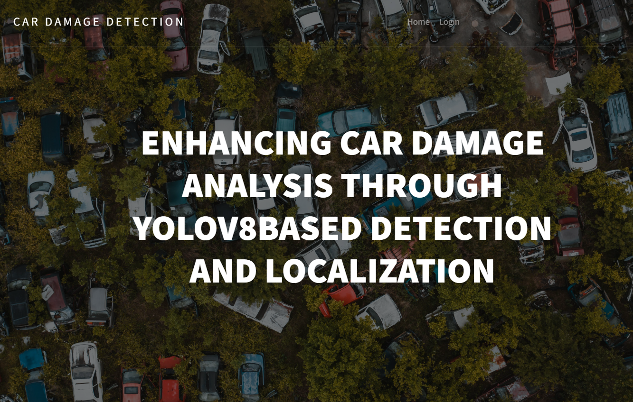
Figure 4.1 Home page of the web application with navigation options.
The homepage of the web application, as illustrated in Figure 4.1, serves as the central dashboard from which users can navigate to various modules of the system—image upload, video processing, or real-time webcam detection. It is designed with simplicity and clarity in mind, providing a seamless user experience that does not require deep technical knowledge to operate. This accessibility is crucial for the system’s broader adoption by insurance agents, car owners, or automotive service centers. The homepage functions as a gateway to all functionalities, embodying the system’s core value of making automated damage assessment available and efficient for real-world users.
The homepage also includes clear navigation links to each detection module, along with brief, helpful instructions to guide users through the process. A minimalistic design approach is maintained to reduce cognitive load, ensuring that users can focus directly on selecting their desired task without unnecessary distractions. Whether the user wishes to upload an image, analyze a video, or perform real-time damage detection via webcam, the homepage facilitates quick access through prominent buttons and straightforward layout. This focus on simplicity, responsiveness, and ease of navigation makes the system accessible to a wide range of users, helping to bridge the gap between advanced AI technology and practical, everyday applications.
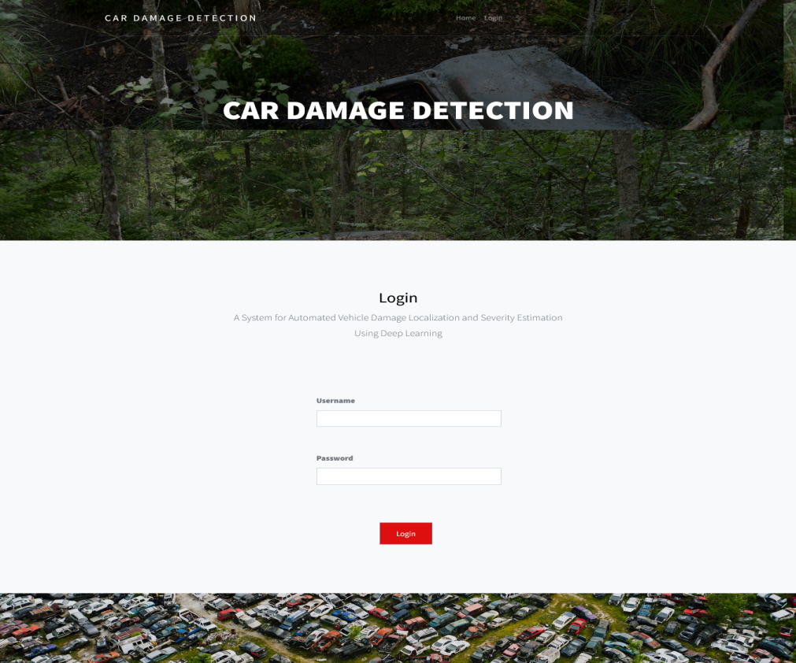
Figure 4.2 Login page of the web application with navigation options.
Figure 4.2 illustrates the login page of the web application, showcasing two views of the login interface. It underscores the importance of user authentication in managing secure access to the platform’s functionalities. Whether intended for insurers, mechanics, or customers, this login mechanism ensures that user data and uploaded vehicle images are handled responsibly. The consistent design and responsiveness of the UI help make the application feel professional and trustworthy, which is essential in fields involving sensitive data such as insurance and personal vehicle details.
The login page maintains the same clean and minimalistic design language as the rest of the application, ensuring visual consistency and ease of use. Users are presented with clearly labeled input fields and action buttons, making the process straightforward even for those who may not be technically inclined. This attention to simplicity and coherence not only improves the overall user experience but also helps build trust, encouraging users to confidently interact with the platform right from the point of entry
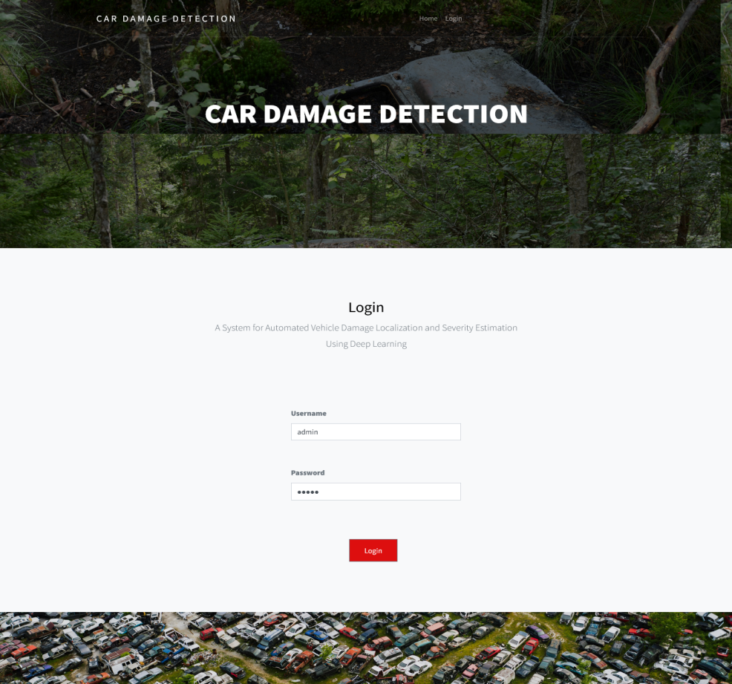
Figure 4.3 Login page of the web application with navigation options.
Figure 4.3 presents two views of the login interface for the web application, emphasizing the importance of user authentication in managing secure access to the platform’s functionalities. Whether the end users are insurers, mechanics, or customers, this login mechanism ensures that sensitive user data and uploaded vehicle images are handled responsibly. The interface's consistent design and responsiveness, as depicted in the figure, contribute to a professional and trustworthy user experience—an essential aspect in domains dealing with personal and insurance-related information.
The login interface is intentionally kept simple, with clearly defined fields and a straightforward layout that allows users to access their accounts with minimal effort. Visual consistency, including the use of uniform fonts, colors, and button styles, helps create a cohesive experience that aligns with the rest of the application. By focusing on clarity and ease of use, the login page not only facilitates quick access but also reinforces the platform’s emphasis on security, reliability, and user-centric design.
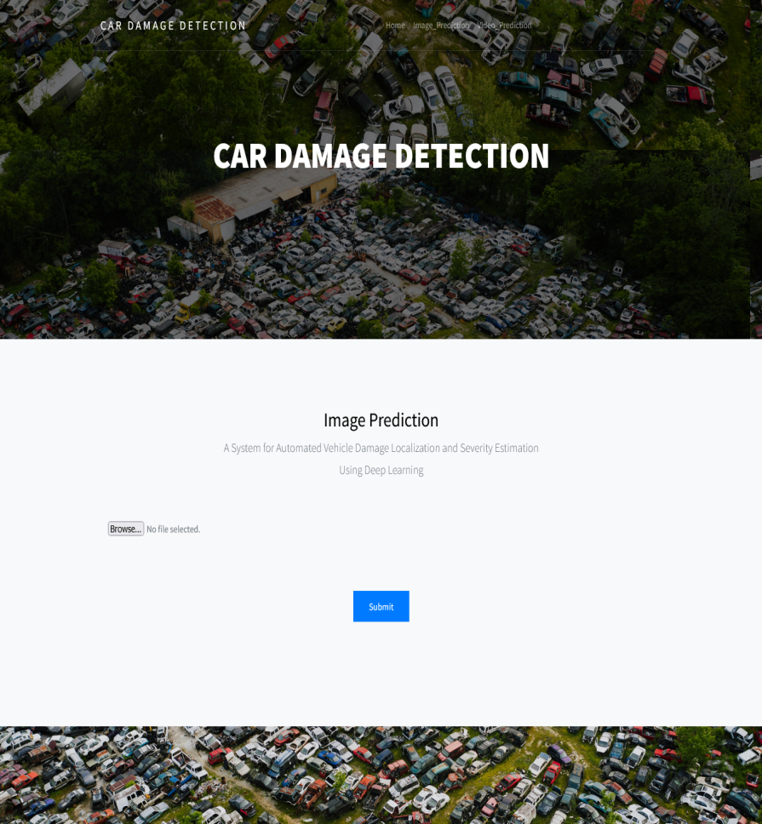
Figure 4.4 Image upload screen with visual damage detection output.
Figure 4.4 displays the image upload screen alongside the visual output generated by the damage detection model. These screenshots demonstrate the image upload process and the resulting output post-processing by the model. The user can easily upload a photograph of a damaged vehicle, which is then immediately analyzed using the trained YOLOv8 model. The output shows bounding boxes over detected damages, along with class labels indicating specific types such as "fender dent" or "headlight damage." This feature is central to the application’s goal of streamlining damage analysis, offering immediate, automated feedback that can be used for repair estimates or insurance claims. The side-by-side presentation of input and output, as seen in the figure, fosters transparency and builds user confidence in the system’s capabilities.
The interface ensures that the upload and analysis process remains intuitive, with progress indicators and clear visual results that make it easy for users to interpret the findings. By presenting both the original and annotated images together, users can quickly verify the accuracy of detections and better understand the nature and extent of the damage. This immediate visual feedback not only enhances user trust but also supports faster decision-making, whether for initiating repairs, filing insurance claims, or conducting vehicle inspections, aligning perfectly with the application’s mission to deliver accessible and efficient damage assessment.
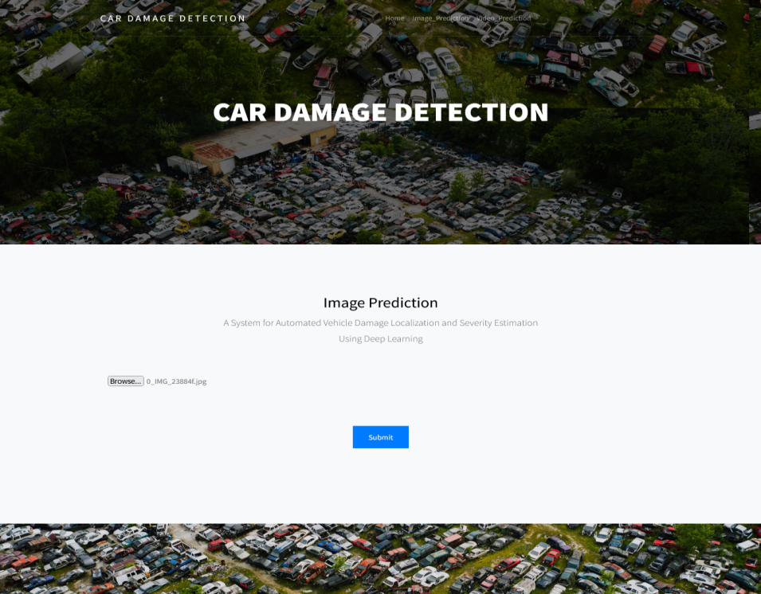
Figure 4.5 Image upload screen with visual damage detection output.
Figure 4.5 illustrates the image upload screen and the corresponding visual output from the damage detection process. These screenshots demonstrate the image upload process and the resulting output post-processing by the model. The user can easily upload a photograph of a damaged vehicle, which is then immediately analyzed using the trained YOLOv8 model. The output shows bounding boxes over detected damages, along with class labels indicating specific types such as "fender dent" or "headlight damage." This feature is central to the application’s goal of streamlining damage analysis, offering immediate, automated feedback that can be used for repair estimates or insurance claims. The side-by-side presentation of input and output, as shown in the figure, fosters transparency and builds user confidence in the system’s capabilities.
The simplicity of the upload mechanism ensures that users with minimal technical background can efficiently interact with the system. Clear instructions and user-friendly prompts guide the user through each step, minimizing errors and making the overall process quick and seamless. By reducing the time and effort traditionally associated with manual damage assessment, the platform not only increases operational efficiency but also enhances the user experience, reinforcing its value as a practical tool for real-world automotive and insurance-related applications.
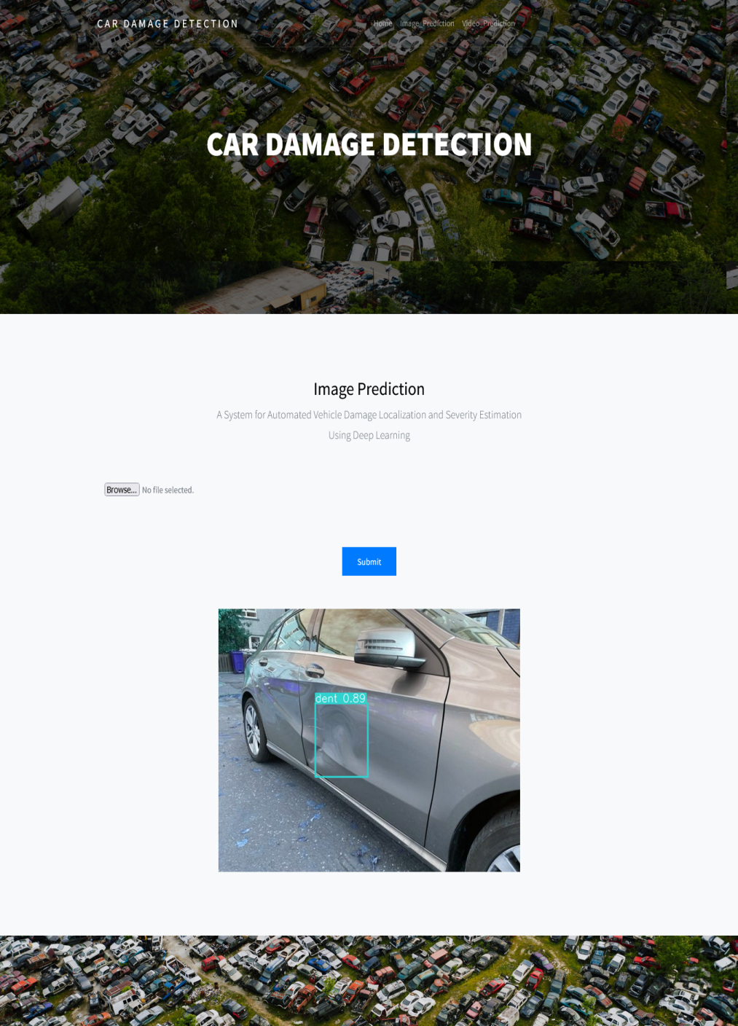
Figure 4.6 Real-time damage detection using image
Figure 4.6 highlights the system's ability to process a static image and generate real-time annotations identifying damage regions. The model scans the image and overlays bounding boxes precisely where damage is detected, showcasing the power of deep learning in understanding and localizing complex patterns even in varied lighting or image quality. This feature enables use cases such as instant roadside assessments, where a quick picture can yield an accurate report without needing expert evaluation.
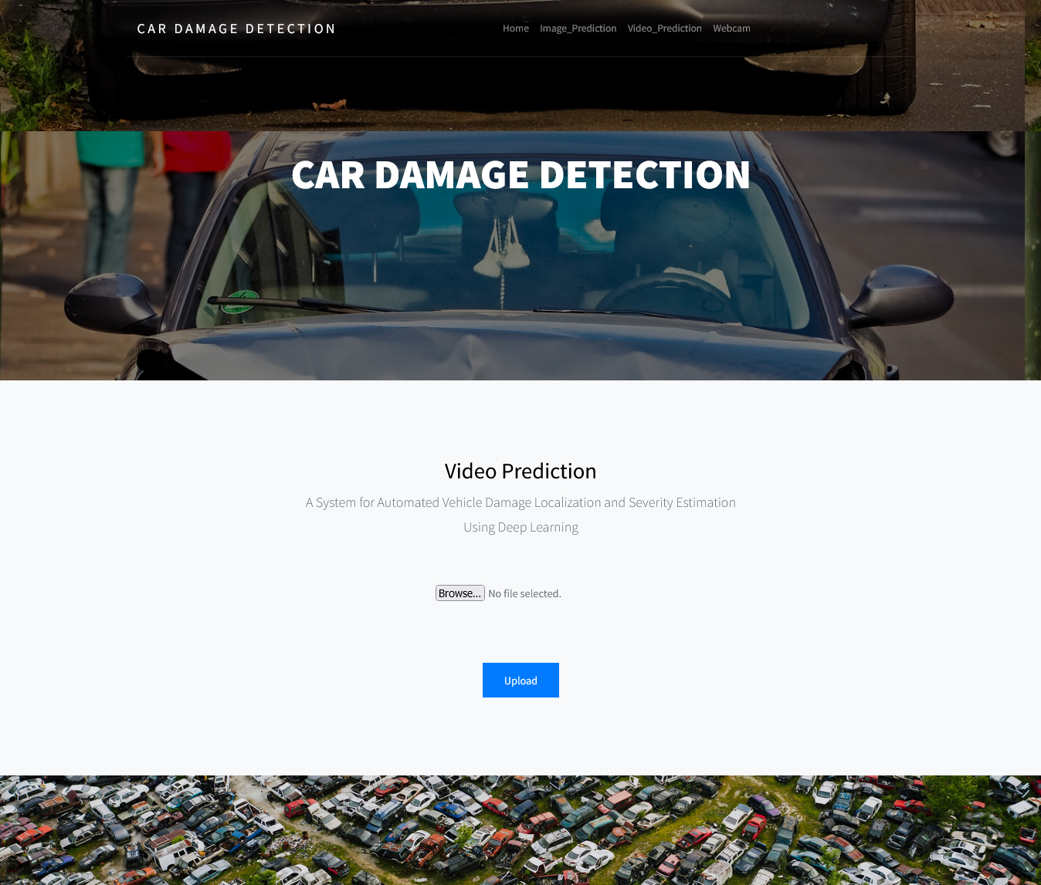
Figure 4.7 Video input processing with damage annotations on each frame.
Figure 4.7 displays frames from a video being processed with damage annotations applied to each frame. These figures illustrate how the system performs frame-by-frame analysis for damage localization. The system identifies and tracks multiple damages across sequential frames, which is particularly useful in applications like traffic surveillance, car rental returns, or forensic analysis of accident footage. The consistent labeling across frames, as shown in the figure, demonstrates the system’s stability and robustness in dynamic environments. The results also serve as visual evidence for insurance companies or legal purposes, making the system applicable beyond just technical diagnostics.

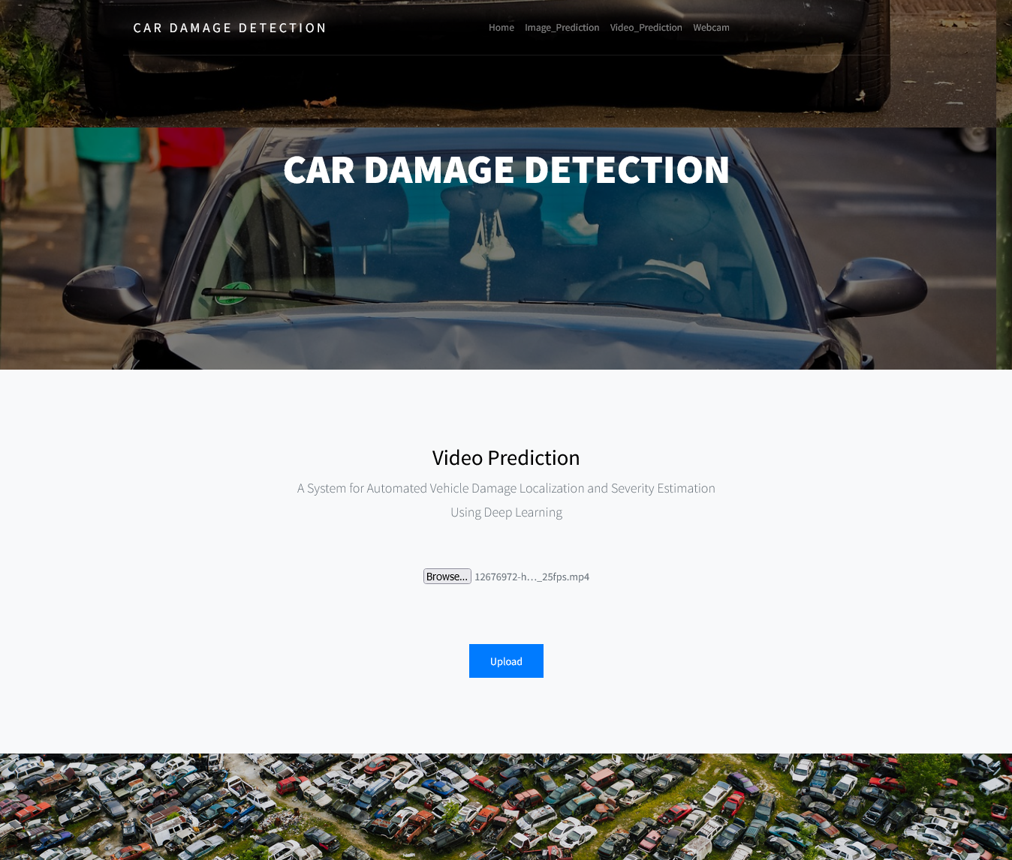
Figure 4.8 Result of Video input processing with damage annotations on each frame.
Figure 4.8 presents the results of video input processing, showing damage annotations applied to each frame. These figures display frames from a video being processed frame-by-frame for damage localization. The system identifies and tracks multiple damages across sequential frames, which is particularly useful in applications like traffic surveillance, car rental returns, or forensic analysis of accident footage. The consistent labeling across frames, as depicted in the figure, demonstrates the system’s stability and robustness in dynamic environments. The results also serve as visual evidence for insurance companies or legal purposes, making the system applicable beyond just technical diagnostics.

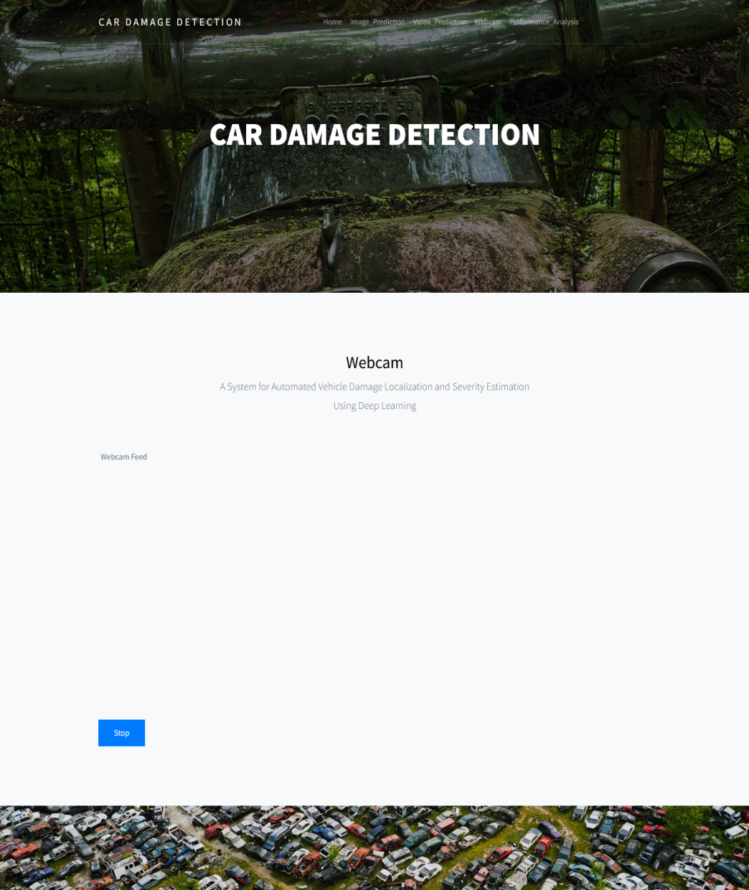
Figure 4.9 Real-time damage detection using webcam feed
Figure 4.9 demonstrates the live detection capabilities of the system when connected to a webcam feed. This figure showcases how the model operates in a continuous feedback loop, analyzing a real-time video stream and instantly annotating any visible damages. This feature has high practical value in scenarios such as vehicle inspections at service centers or real-time assessments during field operations. The integration of this functionality into the web interface, as shown in the figure, ensures that the system remains lightweight yet powerful, operating without the need for high-end GPUs or dedicated devices.

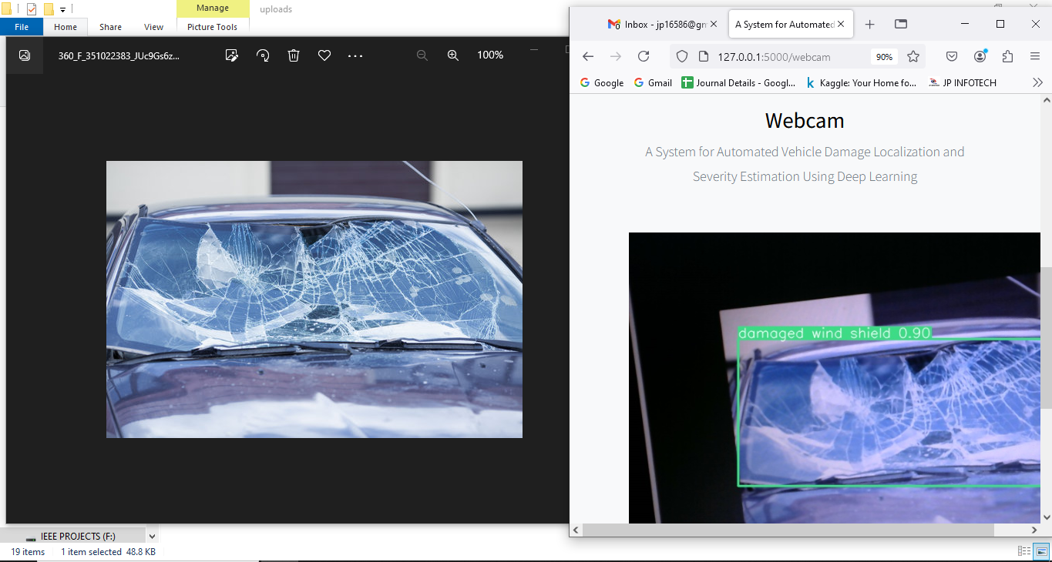

Figure 4.10 Sample detection output on a test image with bounding boxes.
Figure 4.10 showcases the performance of the trained YOLOv8 model on a benchmark test image containing visible damages. Multiple damage classes are accurately detected and labeled, reflecting the model’s capability to generalize well to unseen data. The bounding boxes are tightly fitted, and the labels are clearly assigned, demonstrating high precision in both localization and classification. This output validates the quality of the model’s training and supports the use of the system in real-world deployments where accurate, multi-class detection is essential.

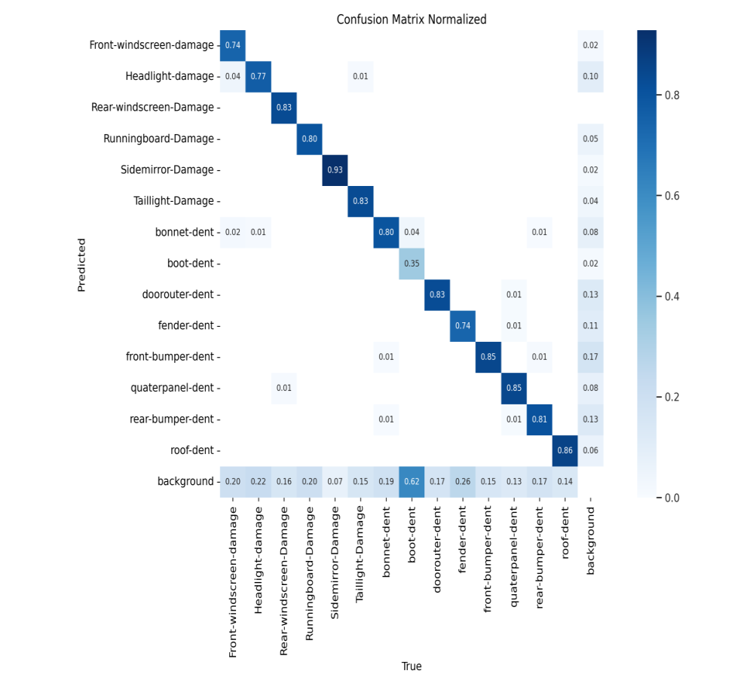
Figure 4.11 : confusion matrix of the model
Figure 4.11 provides a detailed view of the model’s classification performance across the 14 predefined damage categories in the form of a confusion matrix. The matrix helps in understanding how often each damage type is correctly identified versus when it is misclassified. Diagonal elements represent correct predictions, while off-diagonal entries indicate confusion between similar damage types. Analyzing this figure is crucial for evaluating the model’s reliability and for identifying areas where additional training data or model tuning may be necessary. It also serves as a valuable reference for stakeholders looking to assess the model’s real-world applicability in terms of accuracy and consistency.

Table 4.1 Detection Performance
Metric | Value(%)
Precision | 87.7
Recall | 74.8
F1-Score | 81
mAP@50 | 83.1
mAP@50-95 | 63.9

Table 4.1 provides a quantitative summary of the performance metrics achieved by the YOLOv8-based vehicle damage detection model on the test dataset. It includes five critical evaluation metrics: Precision, Recall, F1-Score, mAP@50, and mAP@50-95, each offering valuable insight into different aspects of the model’s effectiveness.
The Precision of the model is reported as 87.7%, which indicates that a high proportion of the predicted damage detections were accurate, meaning there were few false positives. This is particularly important in the automotive damage domain, where overestimating damages could lead to unnecessary repair costs or inflated insurance claims. On the other hand, the Recall score is 74.8%, representing the model’s ability to correctly identify actual damage instances from all ground truth cases. While slightly lower than precision, this still shows good coverage and implies that the model misses few actual damages, which is crucial for fair and complete assessments.The F1-Score, a harmonic mean of precision and recall, stands at 81. It confirms that the model maintains solid overall performance without favoring either extreme—accuracy or completeness—too heavily. Additionally, the mAP@50 is a strong 83.1%, demonstrating that the bounding boxes predicted by the model closely match the ground truth annotations in most cases. This is a key indicator of localization accuracy, especially when different types of damages must be precisely marked.
5.CONCLUSIONS & FUTURE SCOPE
5.1 CONCLUSION
In conclusion, the Automated Vehicle Damage Localization and Severity Estimation System developed as part of this project represents a significant advancement in the field of computer vision-driven automotive diagnostics. The system utilizes the power of the YOLOv8 model—recognized for its real-time object detection capabilities and high accuracy—to address longstanding challenges in traditional vehicle damage assessment methods. These conventional methods, which often rely on manual inspections by insurance assessors or technicians, are not only time-consuming but also subjective, inconsistent, and error-prone. The proposed system bridges this gap by providing an intelligent, objective, and automated approach to damage detection.
By leveraging YOLOv8’s advanced architecture, the system can effectively detect and classify a wide range of vehicle damages, including front and rear bumper dents, headlight and taillight damage, windshield cracks, and more. The model’s precision in localizing the damage using bounding boxes enables fine-grained analysis, which is vital for generating accurate repair estimates or validating insurance claims. With the ability to process images, videos, and live webcam feeds, the system exhibits exceptional versatility. Whether deployed in garages, insurance offices, roadside environments, or even integrated into mobile devices, it can cater to a variety of use cases with minimal configuration and training overhead.
Another major highlight of the project is the successful integration of this model into a full-stack web application using Python, Flask, HTML, CSS, and JavaScript. This user interface is intentionally kept lightweight and responsive, allowing users to easily upload images or videos and view detection results with annotated visual feedback. The web deployment ensures accessibility across devices and platforms, making it a practical tool for both end-users and enterprise use.
Furthermore, the multi-modal detection capability—supporting static image analysis, video input processing, and real-time webcam-based predictions—enables the system to adapt to real-world operational settings. For example, real-time detection using webcam feeds can be highly beneficial during on-site vehicle inspections, while video input processing may be used for reviewing surveillance footage post-accident. This flexible approach ensures that the system is not limited to lab environments or static datasets, but rather performs reliably in varied lighting, orientation, and background conditions.
Importantly, the system also contributes to improving operational efficiency across sectors. For the insurance industry, the solution can automate initial claim evaluations, reduce dependency on manual verification, and increase throughput. For automobile repair shops, the system can serve as a pre-diagnosis tool, helping mechanics understand the extent of damage even before starting physical inspection. For individual users, it offers transparency and clarity about their vehicle’s condition, empowering them to make informed decisions.
By combining cutting-edge machine learning with a robust web interface, this project delivers a highly usable, accurate, and scalable solution for vehicle damage detection. The adoption of such AI-based systems has the potential to not only accelerate claim processing and reduce costs but also to establish a new benchmark in how post-accident workflows are conducted in the modern automotive and insurance sectors.

5.2 FUTURE SCOPE:
Looking forward, the current system provides a solid foundation upon which several meaningful enhancements can be built. These future directions aim at improving model performance, expanding the system's capabilities, and ensuring broader applicability in related domains.
One potential area for enhancement is the integration of additional deep learning models. While YOLOv8 has proven to be highly effective in this project, experimenting with alternative object detection models such as EfficientDet, Faster R-CNN, or DETR could provide valuable comparative insights and improve performance in specific scenarios. Models with specialized capabilities might outperform YOLOv8 in situations involving occlusions, overlapping damage zones, or low-light conditions, offering more versatility and adaptability in complex real-world environments.
Another important avenue for future development is the expansion and diversification of the dataset. To further improve generalization, the dataset used for training can be enriched by including images from a variety of vehicle types, lighting conditions, angles, and geographic regions. Incorporating datasets from different manufacturers and real-world environments, such as urban, rural, and off-road settings, would help make the model more robust in handling varied use cases, reducing potential biases and enhancing the system’s overall effectiveness across a broader spectrum of scenarios.
In addition to dataset expansion, there is also the possibility for finer damage classification granularity. The current system categorizes damage into 14 distinct types, but future iterations could introduce a more detailed classification. By distinguishing between more subtle types of damage, such as surface scratches versus deep dents or broken glass versus cracked panels, the system could offer a richer, more nuanced analysis. This would be particularly valuable for repair cost estimation, insurance claims, and fraud detection, as it would allow for more precise and accurate assessments of the extent and nature of the damage.
To achieve this enhanced granularity, additional labeled data and more advanced image processing techniques would be required to train the model for the finer distinctions between various damage types. The system could benefit from incorporating more diverse real-world examples, including variations in vehicle models, lighting conditions, and damage severity, more effectively. By improving the model’s ability to recognize and differentiate between these nuanced damage types, the platform would provide even greater value to users, enabling more accurate damage assessments and ultimately supporting better decision-making in repair and insurance contexts. This level of detail could also contribute to better fraud detection by identifying inconsistencies in damage reports and photographs, further strengthening the system’s role in the industry.
REFERENCES
[1] A. Shirode, T. Rathod, P. Wanjari, and A. Halbe, “Car damage detectionand assessment using CNN,” in Proc. IEEE Delhi Sect. Conf.(DELCON), Feb. 2022, pp. 1–5, doi: 10.1109/DELCON54057.2022.9752971.

[2] A. C. Chua et al., “Damage identification of selected car partsusing image classification and deep learning,” in Proc. IEEE13th Int. Conf. Humanoid, Nanotechnol., Inf. Technol., Commun.Control, Environ., Manage. (HNICEM), Nov. 2021, pp. 1–5, doi:10.1109/HNICEM54116.2021.9731806.

[3] U. Waqas, N. Akram, S. Kim, D. Lee, and J. Jeon, “Vehicledamage classification and fraudulent image detection includingMoiré effect using deep learning,” in Proc. IEEE Can. Conf.Electr. Comput. Eng. (CCECE), Aug. 2020, pp. 1–5, doi:10.1109/CCECE47787.2020.9255806.

[4] A. Buslaev, V. I. Iglovikov, E. Khvedchenya, A. Parinov, M. Druzhinin,and A. A. Kalinin, “Albumentations: Fast and flexible imageaugmentations,” Information, vol. 11, no. 2, p. 125, Feb. 2020.[Online]. Available: https://www.mdpi.com/2078-2489/11/2/125, doi:10.3390/info11020125.

[5] C. G. Pachón-Suescún, P. C. U. Murillo, and R. Jimenez-Moreno,“Scratch detection in cars using a convolutional neural network bymeans of transfer learning,” Int. J. Appl. Eng. Res., vol. 13, no. 16,pp. 12976–12982, 2018.

[6] L.-C. Chen, Y. Zhu, G. Papandreou, F. Schroff, and H. Adam,“Encoder–decoder with atrous separable convolution for semanticimage segmentation,” in Proc. Eur. Conf. Comput. Vis. (ECCV), 2018,pp. 801–818.

[7] D. R. Cox, “The regression analysis of binary sequences,” J. Roy. Stat.Soc. B, Methodol., vol. 21, no. 1, p. 238, Jan. 1959.

[8] J. Deng, W. Dong, R. Socher, L.-J. Li, K. Li, and L. Fei-Fei, “ImageNet:A large-scale hierarchical image database,” in Proc. IEEE Conf. Comput.Vis. Pattern Recognit., Jun. 2009, pp. 248–255.

[9] H. Bandi, S. Joshi, S. Bhagat, and A. Deshpande, “Assessing cardamage with convolutional neural networks,” in Proc. Int. Conf.Commun. Inf. Comput. Technol. (ICCICT), Jun. 2021, pp. 1–5, doi:10.1109/ICCICT50803.2021.9510069.

[10] K. He, X. Zhang, S. Ren, and J. Sun, “Deep residual learning forimage recognition,” in Proc. IEEE Conf. Comput. Vis. Pattern Recognit.(CVPR), Jun. 2016, pp. 770–778.

[11] A. G. Howard et al., “MobileNets: Efficient convolutional neural networksfor mobile vision applications,” 2017, arXiv:1704.04861.

[12] Y. Huang and Y. Chen, “Autonomous driving with deep learning: Asurvey of state-of-art technologies,” 2020, arXiv:2006.06091.

[13] K. Pasupa, P. Kittiworapanya, N. Hongngern, and K. Woraratpanya,“Evaluation of deep learning algorithms for semantic segmentation ofcar parts,” Complex Intell. Syst., vol. 8, no. 5, pp. 3613–3625, Oct. 2022,doi: 10.1007/s40747-021-00397-8.

[14] K. Patil, M. Kulkarni, A. Sriraman, and S. Karande, “Deep learningbased car damage classification,” in Proc. 16th IEEE Int.Conf. Mach. Learn. Appl. (ICMLA), Dec. 2017, pp. 50–54, doi:10.1109/ICMLA.2017.0-179.

[15] P. M. Kyu and K. Woraratpanya, “Car damage detection and classification,”in Proc. 11th Int. Conf. Adv. Inf. Technol., Jul. 2020, vol. 11,no. 46, pp. 1–6, doi: 10.1145/3406601.3406651.

APPENDIX
Code:
import argparse
import io
import os
import base64
import cv2
from flask import Flask, render_template, request, redirect, url_for, flash, Response
from werkzeug.utils import secure_filename
from ultralytics import YOLO
from PIL import Image
# Initialize the YOLO model only once
model = YOLO('best.pt')
# Configuration
ALLOWED_EXTENSIONS = {'jpg', 'jpeg', 'png', 'mp4'}
UPLOAD_FOLDER = os.path.join(os.path.dirname(__file__), 'uploads')
OUTPUT_VIDEO_PATH = os.path.join(os.path.dirname(__file__), 'output.mp4')
os.makedirs(UPLOAD_FOLDER, exist_ok=True)
app = Flask(__name__)
app.secret_key = 'your_secret_key' # Needed for flashing messages
app.config['UPLOAD_FOLDER'] = UPLOAD_FOLDER
terminate_flag = False # Global flag for webcam termination
def allowed_file(filename):
return '.' in filename and filename.rsplit('.', 1)[1].lower() in ALLOWED_EXTENSIONS
def generate():
global terminate_flag
terminate_flag = False
cap = cv2.VideoCapture(0)
try:
while cap.isOpened() and not terminate_flag:
success, frame = cap.read()
if not success:
break
try:
results = model(frame)
annotated_frame = results[0].plot()
except Exception as e:
print(f"Inference error: {e}")
continue
ret, jpeg = cv2.imencode('.jpg', annotated_frame)
yield (b'--frame\r\n'
b'Content-Type: image/jpeg\r\n\r\n' + jpeg.tobytes() b'\r\n')
finally:
cap.release()
cv2.destroyAllWindows()
@app.route('/')
@app.route('/first')
def first():
return render_template("first.html")
@app.route('/login')
def login():
return render_template("login.html")
@app.route('/chart')
def chart():
return render_template("chart.html")
@app.route('/performance')
def performance():
return render_template("performance.html")
@app.route('/image')
def image():
return render_template("image.html")
@app.route('/predict', methods=['POST'])
def predict():
if 'file' not in request.files:
flash('No file part')
return redirect(url_for('image'))
file = request.files['file']
if file.filename == '' or not allowed_file(file.filename):
flash('Invalid file type')
return redirect(url_for('image'))
try:
upl_img = Image.open(file)
result = model.predict(source=upl_img)[0]
res_img = Image.fromarray(result.plot())
image_byte_stream = io.BytesIO()
res_img.save(image_byte_stream, format='PNG')
image_byte_stream.seek(0)
image_base64=base64.b64encode(image_byte_stream.read()).decode('utf-8')
returnrender_template('image.html',detection_results=image_base64)
except Exception as e:
flash(f'Prediction error: {e}')
return redirect(url_for('image'))
@app.route("/video")
def video():
return render_template('video.html')
@app.route("/predict_img", methods=["GET", "POST"])
def predict_img():
if request.method == "POST":
if 'file' in request.files:
f = request.files['file']
if not allowed_file(f.filename):
flash("Unsupported file type")
return redirect(url_for('video'))
filename = secure_filename(f.filename)
filepath = os.path.join(app.config['UPLOAD_FOLDER'], filename)
f.save(filepath)
if filename.rsplit('.', 1)[1].lower() == 'mp4':
cap = cv2.VideoCapture(filepath)
frame_width = int(cap.get(cv2.CAP_PROP_FRAME_WIDTH))
frame_height = int(cap.get(cv2.CAP_PROP_FRAME_HEIGHT))
fourcc = cv2.VideoWriter_fourcc(*'mp4v')
out = cv2.VideoWriter(OUTPUT_VIDEO_PATH, fourcc, 30.0, frame_width, frame_height))
try:
while cap.isOpened():
ret, frame = cap.read()
if not ret:
break
results = model(frame)
res_frame = results[0].plot()
out.write(res_frame)
except Exception as e:
flash(f"Video processing error: {e}")
finally:
cap.release()
out.release()
cv2.destroyAllWindows()
flash("Video processed successfully.")
return redirect(url_for('video')
return render_template('video.html')
@app.route('/webcam')
def webcam():
return render_template('webcam.html')
@app.route('/video_feed')
def video_feed():
return Response(generate(), mimetype='multipart/x-mixed-replace; boundary=frame')
@app.route('/stop', methods=['POST'])
def stop():
global terminate_flag
terminate_flag = True
flash("Webcam stopped.")
return redirect(url_for('first'))
if __name__ == "__main__":
parser = argparse.ArgumentParser(description="Flask app exposing YOLOv8 models")
parser.add_argument("--port", default=5000, type=int, help="Port number")
args = parser.parse_args()
app.run(host="0.0.0.0", port=args.port, debug=True)

