

**Design Patterns and Maintainability**

**By**

**Hemanth Kothapalli**

**Professor**

**Fadi Wedyan**

**Date:01-07-2022**

# ACKNOWLEDGMENTS

I would like to extend my best wishes to our Professor Mr. Fadi Wedyan who guided us with great learning material. The material and the syllabus contain topics like GQM, Design Patterns, Quality attributes and so on. The reference material provided is wonderful sharing great amount of knowledge. I also like to thank my friends who extended their help.

1. **ABSTRACT**

In the course project, I will perform an empirical evaluation to measure the effect of some “independent variable” i.e “Design Patterns (few)” on a relevant quality attribute that is maintainability. I am using a large project containing different design patterns to conduct my experiment.

Here in the project my independent variables are “Few design patterns”. I am using different methodologies like back ground and literature review, case study, observation and experiment to go ahead with my project and study my results.

1. **INTRODUCTION**

Here I would like to just give an overview of what I am going to do in the course project. Initially I will work on a big project containing different subject programs and size 1k LoC. Later, generating ck metrics using the tool provided in week2.

Link for the tool: <https://github.com/mauricioaniche/ck>

Then, I detect the design patterns (all or few) used in the project using a ‘Design Pattern detection using Similarity Scoring’ tool during Assignment2.

The tool is available at: <https://users.encs.concordia.ca/~nikolaos/pattern_detection.html>

The detection tool gives me the information of which class using which design pattern. I identify the metrics for the particular classes and study the effect on quality attribute maintainability.

1. **BACK GROUND AND LITERATURE REVIEW**

There are different thoughts about using design patterns and their effect on maintainability. Some researchers say there is a good maintainability with the implementation of patterns. And few say that their usage should be smart enough and optimal. I have gone through a few papers and want to conduct an experiment myself; and judge the result based on the fact of at least 3 metrics.

1. **METHODOLOGY**

Already mentioned that the methodology I am using is a mixture of back ground and literature review, case study and an experiment.

I will develop ck metrics on the project using the sample command on the bash:

‘java -jar ck-0.7.1-SNAPSHOT-jar-with-dependencies.jar C:\finalprojects\Huston false 0 true c:\temp\’

The deign pattern detection tool uses root project package as input, we need to mention whether we want details of all the design patterns or a few of them (Here I will choose ‘all’ option). Then the output is exported to a XML.

1. **RESULTS**

The project used for my study containing different design patterns is ‘huston’.

First, I will generate ck metrics:

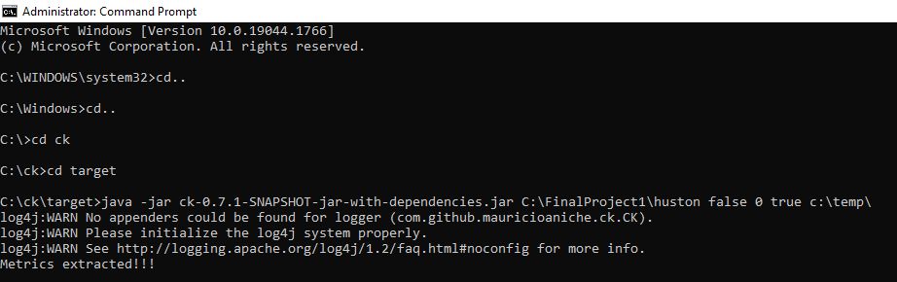



Four metric files are generated, among them I analyze the class file for the project.

Now I provide the java project as input to detection tool and retrieve the result in XML file.



I matched few classes from XML to metrics file:

Here I am reading the values of popular ck metrics like rfc, dit and lcom.

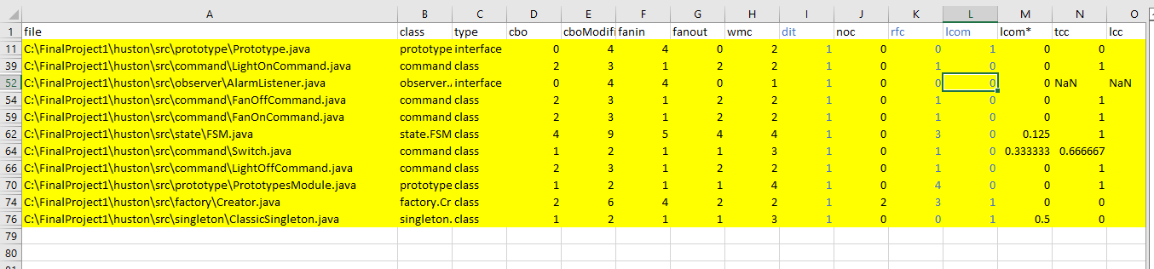

We can observe the low values for all these three metrics. This indicates that there is a high project maintainability.

1. **CONCLUSION**

From my study and experiment I can conclude that using design patterns result in a good software(project) maintainability.

**Links to my raw data:**

Ck metrics file:

Output XML:

**REFERENCES**

**1.** https://github.com/mauricioaniche/ck

2. https://users.encs.concordia.ca/~nikolaos/pattern_detection.html

3. Impact of design patterns on software quality:a systematic literature review, by Fadi Wedyan, Somia Abufakher