SIMATS ENGINEERING (SAVEETHA SCHOOL OF ENGINEERING)
Department of Artificial Intelligence and Data Science
ASSESSMENT TOOL 2 – SCENARIO BASED

Course Code: | DSA03 | Course Title: | Natural Language Processing
CO Assessed: | CO2 – Manipulation | Assessment: | Assessment Tool 2 – SCENARIO BASED
Weightage: | 35% of CIA
CO5 Statement: | Design inflectional, derivational, finite-state parsing, stemming algorithms and for analyse morphological methods. (BL-3)
Student Name: | Hemanth P | Reg. No.: | 192472285
Section / Batch: | CSE(AI) | Date: | 30-10-2026

Code of Conduct
I __________________________ (Name / Reg No) certify that this submission is my original work and that I have adhered to the guidelines specified for this assessment. I understand that any violation of academic integrity rules will result in disciplinary action.
Signature of the Student: _________________________

Instructions
- Read all questions carefully before attempting the answers.
- Answer all five questions. Each question carries equal marks.
- Show all intermediate steps, calculations, probability computations, tagging decisions, and justifications wherever applicable.
- Duration: 30 minutes.

Section / Topic | Focus | Q Nos
English Word Classes, Tagsets for English, Part of Speech Tagging | Morphological decomposition of analyzing, analysis, and analytical; identification of roots, affixes, inflectional and derivational forms, and normalization for indexing. | Q1
English Word Classes, Tagsets for English, Stochastic Part of Speech Tagging | Morphological parsing of disagree, agreement, and agreeable; identification of prefixes, suffixes, base forms, and semantic effects of derivation. | Q2
Counting Words, English Word Classes, Part of Speech Tagging | Morphology-based normalization of govern, government, and governance for topic modeling, clustering, and lexical standardization. | Q3
Rule-Based Part of Speech Tagging, Transformation-Based Tagging | Morphological analysis of activate, activation, and reactivation; identification of derivational layers, word-class changes, and semantic shifts. | Q4
Rule-Based Part of Speech Tagging, English Word Classes, Part of Speech Tagging | Inflectional normalization of create, creates, and creating; extraction of root forms and classification of tense/aspect transformations. | Q5

- Morphological Processing for a Search Engine

Aim

To design a morphological processing system that analyzes the words analyzing, analysis, and analytical, identifies their roots and affixes, classifies their morphological forms, and normalizes related words for search engine indexing.

Algorithm

- Read the input words.
- Identify the root and suffix of each word using predefined rules.
- Classify each word as inflectional or derivational.
- Map the related words to a common representation.
- Display the original word, root, affix, transformation type, and normalized form.

Morphological Analysis

Original Word | Root | Affix | Type | Normalized Form
analyzing | analyze | -ing | Inflectional | analyz
analysis | analys | -is | Derivational / lexical form | analyz
analytical | analyt | -ical | Derivational | analyz

Explanation:

- Analyzing: The suffix -ing indicates an ongoing action. The base verb is analyze.
- Analysis: This is a related noun form, but it cannot be accurately decomposed into analyze + -is using a simple suffix rule. Its relationship to analyze is lexical and involves a spelling change.
- Analytical: The suffix -ical forms an adjective related to analysis.
For this specific indexing task, all three words can be mapped to the common representation analyz. This is a task-specific normalization choice, not a universal linguistic root.

Python Program

words = ["analyzing", "analysis", "analytical"]

data = {
"analyzing": ("analyz", "-ing", "Inflectional"),
"analysis": ("analyz", "lexical variation", "Derivational"),
"analytical": ("analyz", "-ical", "Derivational")
}

print(f"{'Word':<15}{'Root':<12}{'Affix':<22}{'Type':<18}{'Normalized'}")

for word in words:
root, affix, kind = data[word]
print(f"{word:<15}{root:<12}{affix:<22}{kind:<18}{root}")

Expected Output

Word Root Affix Type Normalized
analyzing analyz -ing Inflectional analyz
analysis analyz lexical variation Derivational analyz
analytical analyz -ical Derivational analyz
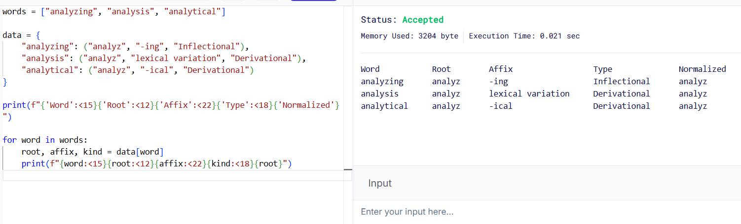

Result

The program groups analyzing, analysis, and analytical under the common indexing representation analyz. This helps a search engine retrieve documents containing related forms.

2.Morphological Parsing for Sentiment Analysis

Aim

To develop a morphological parser that identifies the prefixes, roots, and suffixes of disagree, agreement, and agreeable, and analyzes how word formation affects their meanings.

Algorithm

- Read the input words.
- Identify the prefix, root, and suffix.
- Classify the morphological transformation.
- Determine the semantic effect of each affix.
- Normalize the words to the base form agree.
- Display the results in a table.

Morphological Analysis

Original Word | Prefix | Root | Suffix | Type | Semantic Interpretation | Normalized Root
disagree | dis- | agree | None | Derivational | Opposite of agree | agree
agreement | None | agree | -ment | Derivational | State or result of agreeing | agree
agreeable | None | agree | -able | Derivational | Pleasant or acceptable | agree
Explanation:
- Disagree: The prefix dis- expresses opposition or the absence of agreement.
- Agreement: The suffix -ment forms a noun describing the state or result of agreeing.
- Agreeable: The suffix -able forms an adjective meaning pleasant, acceptable, or willing to agree, depending on context.
All three words are derivational forms. However, normalizing them to agree should not remove their semantic differences.

Python Program
words = ["disagree", "agreement", "agreeable"]

data = {
"disagree": (
"dis-", "agree", "None",
"Derivational", "Opposition to agreement"
),
"agreement": (
"None", "agree", "-ment",
"Derivational", "State or result of agreeing"
),
"agreeable": (
"None", "agree", "-able",
"Derivational", "Pleasant or acceptable"
)
}

print("Word\t\tPrefix\tRoot\tSuffix\tType")
print("-" * 75)

for word in words:
prefix, root, suffix, kind, meaning = data[word]

print(f"{word}\t{prefix}\t{root}\t{suffix}\t{kind}")
print("Meaning:", meaning)
print("Normalized Root:", root)
print()

Expected Output

Word Prefix Root Suffix Type
---------------------------------------------------------------------------
disagree dis- agree None Derivational
Meaning: Opposition to agreement
Normalized Root: agree
agreement None agree -ment Derivational
Meaning: State or result of agreeing
Normalized Root: agree
agreeable None agree -able Derivational
Meaning: Pleasant or acceptable
Normalized Root: agree
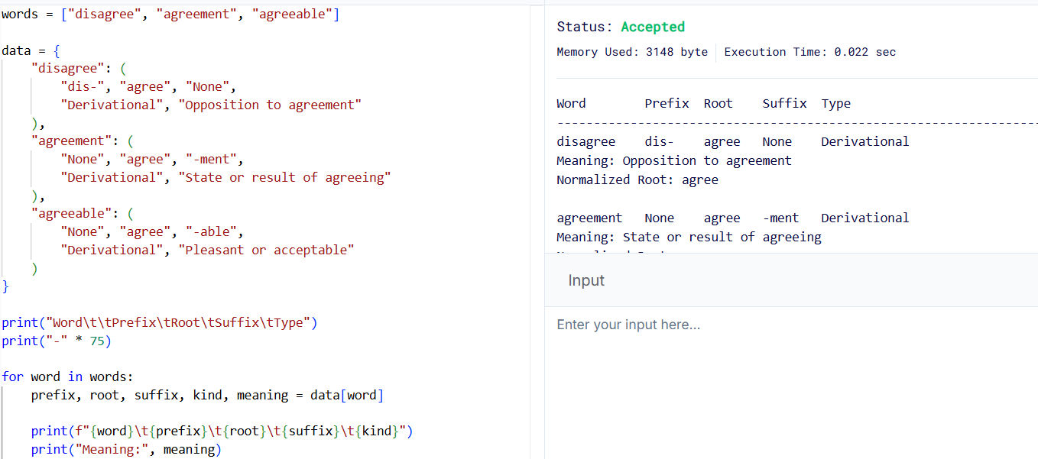

Result

The program identifies the morphological components and normalizes all three words to agree. The semantic information is retained to help the sentiment analysis system distinguish agreement from disagreement.

3.Morphological Normalization for News Aggregation

Aim

To develop a morphology-based normalization module that analyzes govern, government, and governance, identifies their derivational suffixes, and groups them under a common lexical representation for topic modeling and document clustering.

Algorithm

- Read the input words.
- Identify the common root govern.
- Detect the suffixes added to the root.
- Determine the derivational level of each word.
- Normalize the words to govern.
- Display the original word, root, affix, derivational level, and normalized form.

Morphological Analysis

Original Word | Root | Affix | Derivational Level | Word Class | Normalized Form
govern | govern | None | Level 0 | Verb | govern
government | govern | -ment | Level 1 | Noun | govern
governance | govern | -ance | Level 1 | Noun | govern

Explanation:

- Govern: The original verb and the common root.
- Government: The suffix -ment forms a noun referring to the system or body that governs.
- Governance: The suffix -ance forms a noun describing the process or manner of governing.
Both government and governance are derivational forms of govern. They belong to the same broad lexical family but have different meanings.

Python Program
words = ["govern", "government", "governance"]

data = {
"govern": ("govern", "None", 0, "Verb"),
"government": ("govern", "-ment", 1, "Noun"),
"governance": ("govern", "-ance", 1, "Noun")
}

print("Word\t\tRoot\t\tAffix\tLevel\tNormalized")

for word in words:
root, affix, level, word_class = data[word]

print(f"{word:<15}{root:<15}{affix:<10}"
f"{level:<8}{root}")

print("Word Class:", word_class)
print()

Expected Output

Word Root Affix Level Normalized
govern govern None 0 govern
Word Class: Verb

government govern -ment 1 govern
Word Class: Noun

governance govern -ance 1 govern
Word Class: Noun
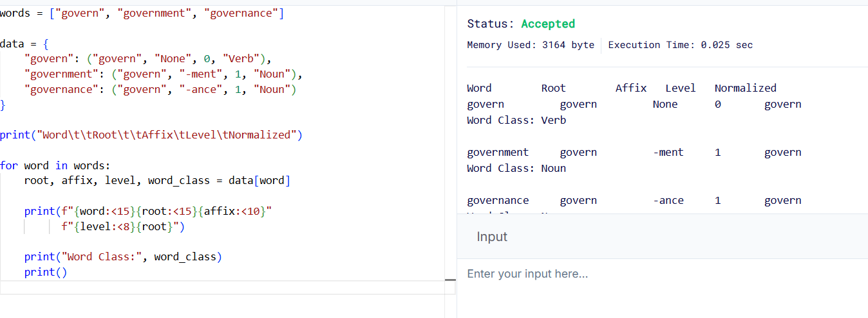

Result

The program maps govern, government, and governance to the common representation govern. This supports the grouping of related news articles during topic modeling and document clustering.

4.Morphological Parsing for Document Classification

Aim

To design a morphological parsing system that analyzes activate, activation, and reactivation, identifies their prefixes and suffixes, and normalizes them to a common base representation.

Algorithm

- Read the input words.
- Identify the root, prefix, and suffix.
- Determine the sequence of derivational transformations.
- Identify changes in word class and meaning.
- Normalize all words to activate.
- Display the morphological structure and normalized output.

Morphological Analysis

Original Word | Prefix | Root/Base | Suffix | Derivational Sequence | Normalized Form
activate | None | activate | None | Base verb | activate
activation | None | activate | -ion | activate → activation | activate
reactivation | re- | activate | -ion | activate → activation → reactivation | activate

Explanation:

1. Activate
- It is the base verb.
- It means to make something active or operational.
- Normalized form: activate.
2. Activation
- The suffix -ion forms a noun from the verb activate, with a spelling adjustment.
- It refers to the process or state of activating something.
- Normalized form: activate.
3. Reactivation
- The prefix re- means doing something again.
- The suffix -ion forms the noun reactivation.
- It means the process of activating something again.
- Normalized form: activate.
The suffix -ion changes the word from a verb to a noun. The prefix re- adds the meaning of repetition.

Python Program
words = ["activate", "activation", "reactivation"]

data = {
"activate": (
"None", "activate", "None",
"Base verb", "activate"
),
"activation": (
"None", "activate", "-ion",
"activate -> activation", "activate"
),
"reactivation": (
"re-", "activate", "-ion",
"activate -> activation -> reactivation", "activate"
)
}

print("Word\t\tPrefix\tRoot\t\tSuffix")
print("-" * 65)

for word in words:
prefix, root, suffix, sequence, normalized = data[word]

print(f"{word}\t{prefix}\t{root}\t{suffix}")
print("Derivation:", sequence)
print("Normalized:", normalized)
print()

Expected Output

Word Prefix Root Suffix
-----------------------------------------------------------------
activate None activate None
Derivation: Base verb
Normalized: activate

activation None activate -ion
Derivation: activate -> activation
Normalized: activate

reactivation re- activate -ion
Derivation: activate -> activation -> reactivation
Normalized: activate
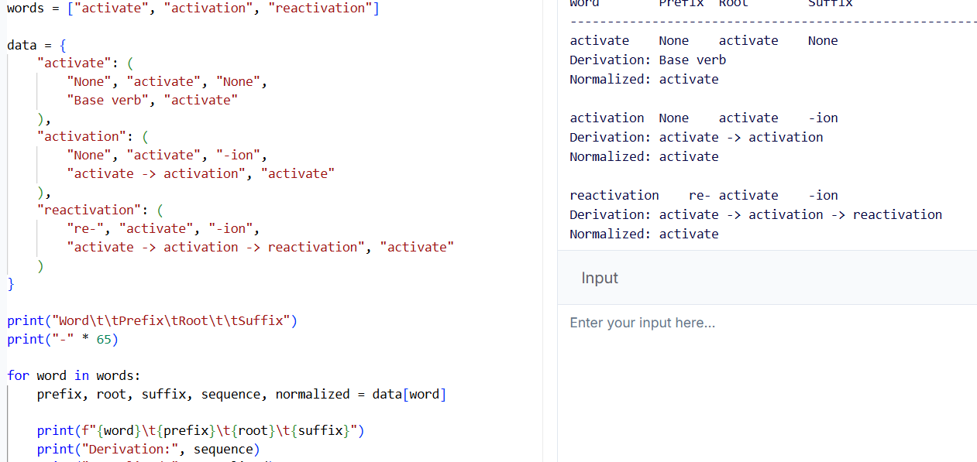

Result

The program identifies the derivational structures of the three words and maps them to activate. This helps a document classification system group documents containing related forms.
Note: The displayed decomposition is a simplified morphological representation. The actual spelling changes in activate → activation mean that the suffix is not attached by a simple, unchanged concatenation rule.

5.Inflectional Morphology for Search Optimization

Aim

To develop an inflectional morphology-based normalization module that analyzes create, creates, and creating, identifies grammatical suffixes, and normalizes all forms to the base verb create.

Algorithm

- Read the input words.
- Identify the grammatical suffix, if present.
- Determine the grammatical category of each word.
- Remove the suffix and restore the base form where necessary.
- Normalize all words to create.
- Display the original word, suffix, grammatical category, root, and normalized form.

Morphological Analysis

Original Word | Root | Suffix | Grammatical Category | Transformation Type | Normalized Form
create | create | None | Base form | No transformation | create
creates | create | -s | Third-person singular present | Inflectional | create
creating | create | -ing | Present participle / progressive form | Inflectional | create

Explanation:

1. Create
- It is the base form of the verb.
- No suffix needs to be removed.
- Normalized form: create.
2. Creates
- The suffix -s indicates the third-person singular present tense.
- Removing -s gives create.
- Normalized form: create.
3. Creating
- The suffix -ing indicates the present participle.
- The final e in create is dropped before adding -ing.
- The base form is restored to create.
- Normalized form: create.
These forms are inflectional variations of the same verb. They differ grammatically but retain the core meaning of creating something.

Python Program
words = ["create", "creates", "creating"]

data = {
"create": ("None", "Base form", "create"),
"creates": ("-s", "Third-person singular present", "create"),
"creating": ("-ing", "Present participle", "create")
}

print("Word\t\tSuffix\tCategory\t\t\tRoot\tNormalized")
print("-" * 90)

for word in words:
suffix, category, root = data[word]

if word == "create":
kind = "Base form"
else:
kind = "Inflectional"

print(f"{word:<15}{suffix:<10}{category:<32}"
f"{root:<12}{root}")
print("Transformation:", kind)
print()

Expected Output

Word Suffix Category Root Normalized
------------------------------------------------------------------------------------------
create None Base form create create
Transformation: Base form

creates -s Third-person singular present create create
Transformation: Inflectional

creating -ing Present participle create create
Transformation: Inflectional

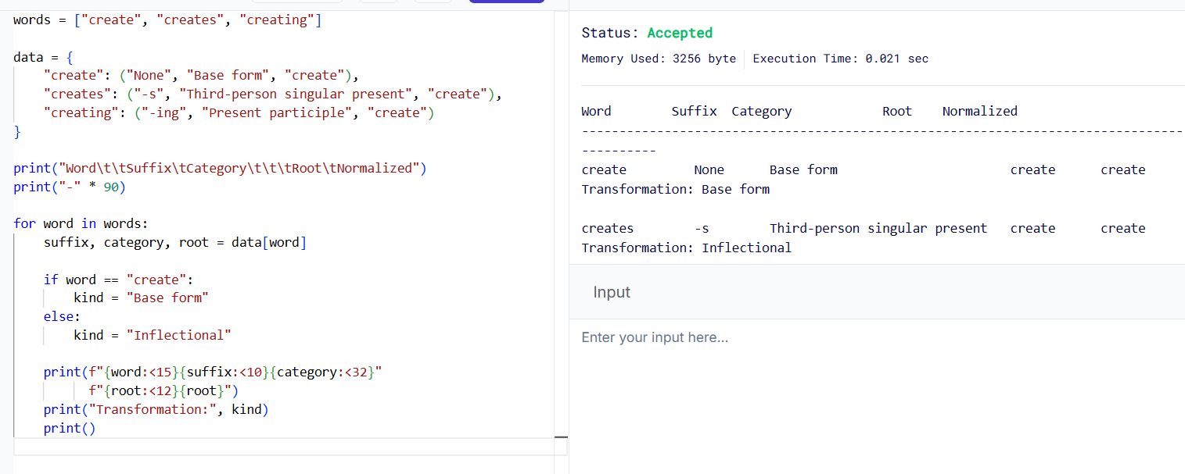

Result

The program identifies the grammatical variations of create and normalizes create, creates, and creating to the common base form create. This improves search consistency and document retrieval.

Conclusion

Morphological processing helps NLP systems identify relationships between words by analyzing their roots, prefixes, and suffixes.
- Search engine indexing: Groups related word forms under a common representation.
- Sentiment analysis: Identifies word formation while preserving important semantic differences.
- News aggregation: Groups related terms for topic modeling and document clustering.
- Document classification: Identifies derivational layers and normalizes related words.
- Search optimization: Normalizes inflectional variations to improve information retrieval.

Rubrics for Calculation

Criteria | Weightage (%) | Level 4 (Exemplary) | Level 3 (Proficient) | Level 2 (Developing) | Level 1 (Beginning)
Understanding of Scenario | 20% | Demonstrates clear and complete understanding of the scenario and context | Shows good understanding with minor gaps | Partial understanding; misses key aspects | Misinterprets or fails to understand the scenario
Identification of Key Issues | 20% | Accurately identifies all relevant issues and factors involved | Identifies most key issues with minor omissions | Identifies limited issues; some irrelevant points | Unable to identify key issues
Application of Concepts | 25% | Applies appropriate concepts effectively to address the scenario | Applies concepts with minor errors | Limited or partially correct application | Unable to apply relevant concepts
Decision Making | 20% | Makes well-reasoned, logical decisions with strong rationale | Makes reasonable decisions with some justification | Makes weak decisions with limited justification | No clear decisions made or rationale provided
Clarity of Response | 15% | Response is clear, structured, and logically presented | Generally clear with minor issues | Somewhat unclear or poorly structured | Disorganized and difficult to understand

Q. No. / Criteria Level | Understanding of Scenario | Identification of Key Issues | Application of Concepts | Decision Making | Clarity of Response | Sub. Total | Total %
1
2
3
4
5

Faculty In-charge | Course Coordinator | Program Director
Signature: _______________ | Signature: _______________ | Signature: _______________
Date: ___________________ | Date: ___________________ | Date: ___________________

