SIMATS ENGINEERING (SAVEETHA SCHOOL OF ENGINEERING)
Department of Computer Science and Engineering
Assesment CO1-AT1(Programs)
Name: Hemanth P
Reg No :192472285
Course Code: DSA0310
Course Name: Natural Language Processing

Question 1: Resume Information Extraction Using Regex

import re

resumes = [
"""
Name: Arun Kumar
Email: arun@gmail.com
Mobile: 9876543210
Skills: Python, Java, SQL, Machine Learning
Experience: 3 years
""",
"""
Name: Ravi
Email: ravi@gmail.com
Mobile: 9123456780
Skills: Java, SQL, NLP
Experience: 1 year
""",
"""
Name: Priya
Email: priya@gmail.com
Mobile: 9876501234
Skills: Python, NLP, SQL
Experience: 2 years
"""
]

for resume in resumes:
name = re.search(r"Name:\s*(.+)", resume)
email = re.search(r"[\w.+-]+@[\w.-]+\.[A-Za-z]{2,}", resume)
mobile = re.search(r"\b[6-9]\d{9}\b", resume)
experience = re.search(r"Experience:\s*(\d+)\s*years?", resume, re.I)

skills = re.findall(
r"\bPython\b|\bJava\b|\bSQL\b|Machine Learning|\bNLP\b",
resume, re.I
)

exp_years = int(experience.group(1)) if experience else 0
skill_list = sorted(set(skill.title() for skill in skills))

print("\n--- Candidate Profile ---")
print("Name:", name.group(1).strip() if name else "Not found")
print("Email:", email.group() if email else "Not found")
print("Mobile:", mobile.group() if mobile else "Not found")
print("Skills:", ", ".join(skill_list) if skill_list else "None")
print("Experience:", exp_years, "years")

if exp_years >= 2 and any(s.lower() == "python" for s in skill_list):
print("Eligibility: Eligible")
else:
print("Eligibility: Not Eligible")
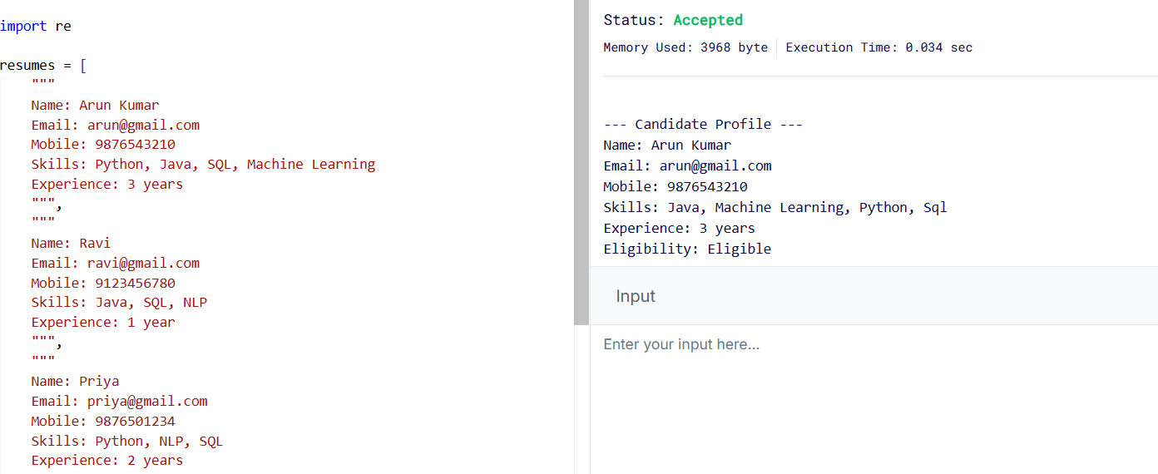
Explanation:
- re.search() extracts the name, email, mobile number, and experience.
- re.findall() identifies technical skills.
- The if condition selects candidates with at least 2 years of experience and Python skill.

Question 2: Product Search System Using Regex

import re
products = [
"Laptop",
"Laptop Bag",
"Gaming Laptop",
"Smartphone",
"Smart Watch",
"Wireless Mouse",
"Wireless Keyboard",
"Bluetooth Speaker"
]

def search_products(keyword, search_type):
keyword = keyword.strip()

if not keyword:
print("Please enter a keyword.")
return

if search_type == "exact":
pattern = r"^" + re.escape(keyword) + r"$"
elif search_type == "prefix":
pattern = r"^" + re.escape(keyword)
elif search_type == "suffix":
pattern = re.escape(keyword) + r"$"
elif search_type == "partial":
pattern = re.escape(keyword)
else:
print("Invalid search type.")
return

matches = [
product for product in products
if re.search(pattern, product, re.IGNORECASE)
]

print("\nSearch type:", search_type)
print("Keyword:", keyword)
print("Matching products:")

if matches:
for product in matches:
print("-", product)
else:
print("No products found.")

print("Total matching products:", len(matches))

search_products("Laptop", "exact")
search_products("Wireless", "prefix")
search_products("Laptop", "suffix")
search_products("phone", "partial")

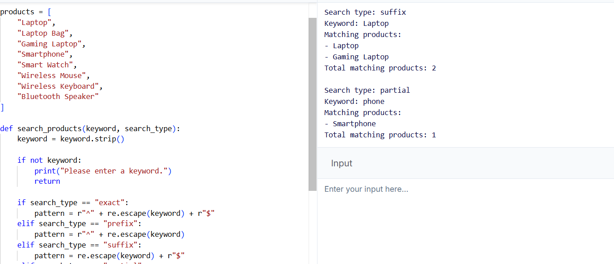
Explanation:
- ^ matches the beginning of a product name.
- $ matches the end of a product name.
- re.escape() treats the keyword as normal text.
- re.IGNORECASE enables case-insensitive searches.
- len(matches) calculates the total number of matching products.

Question 3: University Registration System Using Regex

import re
register_no = input("Enter Register Number: ").strip()
email = input("Enter Institutional Email: ").strip()
course_code = input("Enter Course Code: ").strip()
semester = input("Enter Semester (1-8): ").strip()
mobile = input("Enter Mobile Number: ").strip()

# Validate register number
reg_valid = bool(re.fullmatch(
r"\d{2}[A-Z]{3}\d{3}", register_no
))

# Validate institutional email
email_valid = bool(re.fullmatch(
r"[\w.+-]+@simats\.edu\.in", email, re.I
))

# Validate course code
course_valid = bool(re.fullmatch(
r"[A-Z]{3}\d{2}", course_code, re.I
))

# Validate semester
semester_valid = bool(re.fullmatch(
r"[1-8]", semester
))

# Validate mobile number
mobile_valid = bool(re.fullmatch(
r"[6-9]\d{9}", mobile
))

print("\n--- Validation Report ---")

print("Register Number:",
"Valid" if reg_valid else "Invalid")

print("Institutional Email:",
"Valid" if email_valid else "Invalid")

print("Course Code:",
"Valid" if course_valid else "Invalid")

print("Semester:",
"Valid" if semester_valid else "Invalid")

print("Mobile Number:",
"Valid" if mobile_valid else "Invalid")

if all([reg_valid, email_valid, course_valid,
semester_valid, mobile_valid]):
print("\nRegistration Status: Successful")
else:
print("\nRegistration Status: Failed")
print("Please correct the invalid details.")
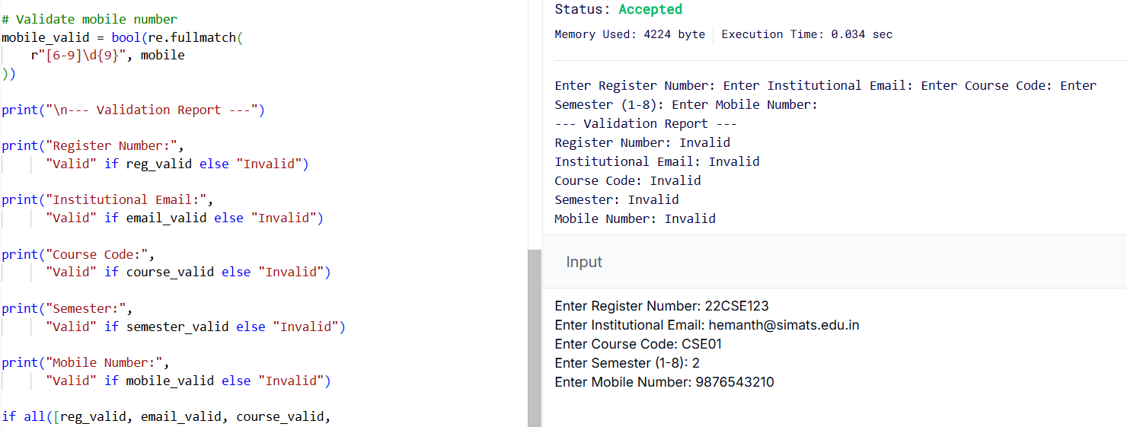
Explanation:
- re.fullmatch() checks whether the entire input follows the required format.
- \d matches digits.
- [A-Z] matches uppercase letters.
- \d{10} represents ten digits.
- all() checks whether every validation is successful.
- The program displays the validation result for each field and the final registration status.

