A Project Report on

“Modelling and Simulation of solar powered DC fast charging using AI Based ANFIS Technology ELECTRIC VEHICLES”
Submitted to in partial fulfillment of the requirements for the award of the Degree of
BACHELOR OF TECHNOLOGY
In
ELECTRICAL AND ELECTRONICS ENGINEERING
Submitted by
NIHARIKA .K 20AK1A0217
REDDY PRANEETH .R 20AK1A0222
CHANDRIKA .M 21AK5A0204
HEMANTH .G 20AK1A0209
Under the Esteemed Guidance of
Mr. K. KESAVULU, M. Tech.,
Assistant Professor, Dept of EEE

DEPARTMENT OF ELECTRICAL AND ELECTRONICS ENGINEERING
ANNAMACHARYA INSTITUTE OF TECHNOLOGY AND SCIENCES, TIRUPATI
(Autonomous)
Approved by AICTE NEW DELHI & Permanent Affiliation to JNTUA. Anantapuramu Recognized under section 2 (f)& 12 (B) of UGCC Act of 1956.
Three B. Tech programmes CSE,ECE & CIVIL are accredited by National Board of Accreditation (NBA). New Delhi; Accredited by NAAC-'A' Grade, Bangalore: •A • Grade awarded by AP knowledge Mission; Accredited by the Institution of Engineers IE(I), Kolkata
Venkatapuram(V), Karakambadi Road, Renigunta (M).
TIRUPATI- 517520.
(2023-2024)

ANNAMACHARYA INSTITUTE OF TECHNOLOGY AND SCIENCES, TIRUPATI
(Autonomous)
DEPARTMENT OF ELECTRICAL AND ELECTRONICS ENGINEERING

CERTIFICATE

This is to certify that the project work entitled, “Modelling and Simulation of solar powered DC fast charging using AI Based ANFIS Technology in Electric Vehicles” done by K. NIHARIKA (20AK1A0217), R. REDDY PRANEETH (20AK1A0222), M. CHANDRIKA (21AK5A0204),G.HEMANTH(20AK1A0209). In partial fulfilment of the requirements for the Degree of BACHELOR OF TECHNOLOGY in ELECTRICAL AND ELECTRONICS ENGINEERING, is a record of bonafied work carried out by them.

UNDER THE GUIDANCE HEAD OF THE DEPARTMENT Mr. K. KESAVULU, M. Tech., Dr. R. MURUGESAN, M. Tech, Ph. D.,
Assistant Professor, Professor
Dept of EEE, Dept of EEE,
AITS, Tirupati AITS, Tirupati

Submitted for the Viva-Voce held on: _________________

INTERNAL EXAMINER EXTERNAL EXAMINER

ACKNOWLEDGEMENT

The needs and deeds of a particular person are only satisfied with the support and endurance of many. We take this opportunity to thank almighty first for giving our health and patience in completing assigned jobs.

Our heartful thanks to the guide Mr. K. KESAVULU, _{M.Tech}. Assistant professor in Department of EEE, Annamacharya Institute of Technology and Sciences. For his valuable guidance and suggestions in analysis and testing throughout the period, till the end of project work completion.

Our special thanks to Dr. R. MURUGESAN, _{M.Tech,} _{Ph.D}. Head of the Department of Electrical and Electronics Engineering during the progress of project work. For his timely suggestions and help in spite of his busy schedule.

We wish to express our sincere gratitude to Dr. C. NADHAMUNI REDDY, _{M.} _{Tech.,} _{Ph.D}. Principal, Annamacharya Institute of Technology and Sciences for his consistent help and encouragement to complete the project work.

We would like to express our grateful and sincere thanks to Dr. C. GANGI REDDY honorary secretary, Annamacharya Education Trust for providing all the necessary facilities during the course of study.

We wish to convey our gratitude and express sincere thanks to all D.C (Department committee) and P.R.C (Project Review Committee) members for their support and cooperation rendered for successful submission of my project work.

Finally, we would like to express our sincere thanks to faculty members of E.E.E Department, Lab Technicians, and friends one and all that has helped me to complete the project work successfully.

As a gesture of respect for our family members and for the support we received from them.

Submitted by
NIHARIKA K 20AK1A0209
REDDY PRANEETH R 20AK1A0222
CHANDRIKA M 21AK5A0204
HEMANTH G 20AK1A0209

DECLARATION

We K.NIHARIKA (20AK1A0217),R.REDDY PRANEETH(20AK1A0222), M.CHANDRIKA (21AK5A0204), G.HEMANTH (20AK1A0209) studying final year B.Tech in Department of Electrical and Electronics Engineering of ANNAMACHARYA INSTITUTE OF TECHNOLOGY AND SCIENCES. We have registered for the final year project entitled“MODELLING AND SIMULATION OF SOLAR POWERED DC FAST CHARGING USING AI BASED ANFIS TECHNOLOGY IN ELECTRIC VEHICLES” submitted for the B. Tech degree under the guidance of Mr. K.KESAVULU, M. Tech., and we promise to meet all the mandatory requirements as a specified by the project review committee. We declare that we will not hold the college, the department, and the lectures responsible for the outcome of our project result.

Submitted by

NIHARIKA K 20AK1A0217
REDDY PRANEETH R 20AK1A0222
CHANDRIKA M 21AK5A0204
HEMANTH G 20AK1A0209

CONTENTS
CHAPTER | TOPIC | PAGE NO
 | LIST OF FIGURES | I
 | LIST OF ABBREVIATIONS
 | ABSTRACT
1 | INTRODUCTION  - ELECTRIC VEHICLES  - PV SYSTEM  1.1 LITERATURE REVIEW | (1-5)  1  2  4
2 | ELECTRIC VEHICLES  2.1 HISTORY  2.2 ELECTRIC VEHICLES OF OFFER SEVERAL KEY  ADVANTAGES  2.3 THE CONCEPT OF ELECTRIC VEHICLES EVOLVES,  THERE ARE DIFFERENT TYPES OF EVS AVAILABLE  2.3.1 BATTERY ELECTRIC VEHICLE (BEV)  2.3.2 PLUG-IN ELECTRIC VEHICLE (PEV) | (6-24)  6  8  8  8  10
 | 2.3.3 HYBRID ELECTRIC VEHICLE (HEV)  2.3.4 FUEL CELL ELECTRIC VEHICLE (FCEV)  2.4 PARTS OF ELECTRIC VEHICLE  2.5 TYPES OF CHARGING METHODS  2.5.1 LEVEL 1 CHARGING  2.5.2 CHARGING POWER (LEVEL 2 CHARGING)  2.5.3 DC FAST CHARGING (LEVEL 3 CHARGING)  2.5.4 AC CHARGING METHOD  2.5.5 DC CHARGING METHOD  2.5.6 WIRELESS CHARGING METHOD  2.6 SOLAR ELECTRIC VEHICLE  2.7 POWER MANAGEMENT  2.8 ELECTRIC VEHICLE CHARGING STATION  2.9 MATHEMATICAL MODELING  2.9.1 POWER DEMAND  2.9.2 HARMONICS  2.9.3 VOLTAGE PROFILE  2.9.4 TRANSFORMER PERFORMANCE | 11  13  15  16  16  16  17  18  18  19  21  22  22  23  23  24  24  24
3 | SOLAR PV SYSTEM | (25-38)
 | 3.1 ELECTRICAL CONNECTION OF THE CELLS | 28
 | 3.2 THE PHOTOVOLTAIC ARRAY | 30
 | 3.3 MAXIMUM POWER POINT TRACKING  3.3.1 PRINCIPLE OF MPPT  3.3.2 FLOW CHART OF PERTURB OBSERVE METHOD  3.3.3 HILL CLIMB SEARCH STRATEGY  3.3.4 MPPT SCHEME OF β METHOD | 30  30  31  32  32
 | 3.4 INCREMENTAL CONDUCTANCE METHOD  3.5 MAXIMUM POWER POINT OF THE SYSTEM  3.6 DESIGN OF BOOST CONVERTER | 34  36  36
4 | DUAL ACTIVE BRIDGE CONVERTER | (39-40)
 | 4.1 BASIC CONFIGURATION | 39
 | 4.2 OPERATING PRINCIPLES  4.3 MODES OF OPERATION | 39  39
5 | CONTROL TECHNIQUE  5.1 FUZZY INTERFACE SYSTEM | (41-42)  41
6 | MODELLING OF INDUCTION MOTOR  6.1 INTRODUCTION  6.2 NEED FOR DYNAMICAL MODELLING OF INDUCTION  MOTOR  6.3 DYNAMIC D-Q MODEL  6.3.1 AXES TRANSFORMATION  6.3.2 SYNCHRONOUSLY ROTATING REFERENCE  FRAME-DYNAMIC MODAL  6.3.3 STATIONARY FRAME-DYNAMIC MODEL  6.3.4 DYNAMIC MODEL STATE-SPACE EQUATIONS | (43-53)  43  43  44  45  47  50  51
7 | MATLAB & SIMULINK | (54-64)
 | 7.1 MATLAB | 54
 | 7.1.1 INTRODUCTION | 54
 | 7.1.2 KEY FEATURES | 54
 | 7.2 SIMULINK | 54
 | 7.2.1 INTRODUCTION | 54
 | 7.2.3 BLOCK DIAGRAM | 55
 | 7.2.4 SIMULINK BLOCK LIBRARIES  7.2.5 SUB SYSTEM | 56  57
 | 7.2.6 SOLVERS | 57
 | 7.2.7 FIXED-STEP SOLVERS | 57
 | 7.2.8 VARIABLE-STEP SOLVERS | 58
 | 7.2.9 CONTINOUS STEP SOLVERS | 58
 | 7.3 THE POWER SYSTEM BLOCK SET | 58
 | 7.4 SIMULINK BLOCKS USED IN THE SIMULATION  7.4.1 THREE-PHASE SOURCE  7.4.2 IN PORT  7.4.3 OUT PORT  7.4.4 SUB-SYSTEM  7.4.5 GAIN  7.4.6 SCOPE  7.4.7 SIMPLIFIED SYNCHRONOUS MACHINE  7.4.8 VOLTAGE MEASUREMENT  7.4.9 BREAKER  7.4.10 BUS BAR  7.4.11 CURRENT MEASUREMENT  7.4.12 DISTRIBUTED PARAMETER LINE  7.4.13 EXCITATION SYSTEM  7.4.14 STEAM TURBINE AND GOVERNOR  7.4.15 LINEAR TRANSFORMER  7.4.16 SATURABLE TRANSFORMER | 59  59  59  60  60  60  60  61  61  61  62  62  62  63  63  64  64
8 | MODELLING & SIMUALTION | (65 -68)
 | 8.1 MODELLING OF SIMULINK DIAGRAM | 65
 | 8.2 SIMULATION RESULTS | 66
9 | CONCLUSION | 69
 | REFERENCES | 70

LIST OF FIGURES
FIGURE NO | NAME OF THE FIGURES | PAGE NO
Fig. 2.1 | C-max SEV charging technique involving concentrating photovoltaic panels (CPV) and concentrating parking lenses. | 21
Fig. 2.2 | Block Diagram of an Electric Vehicle Charging Station | 22
Fig. 2.3 | Impacts of Electric Vehicle | 23
Fig. 3.1 | Diagram of Solar PV System | 27
Fig. 3.2 | Series connection of cells, with resulting current-voltage characteristic | 28
Fig. 3.3 | Parallel connection of cells, with resulting current-voltage characteristic | 29
Fig. 3.4 | Flow chart of the MPPT algorithm with P&O method | 31
Fig. 3.5 | MPPT flow chat for β-method | 33
Fig. 3.6 | Incremental Conductance Method Algorithm | 35
Fig. 3.7 | Step-up dc-dc Boost Converter Circuit | 36
Fig. 3.8 | Point Tracking of Photovoltaic Sources | 37
Fig. 5.1 | Block diagram of fuzzy interference system | 41
Fig. 6.1 | a. Coupling effect in three-phase Stator and rotor windings  b. Equivalent two phase machine | 44
Fig. 6.2 | Stationary frame a-b-c to d_{s}-q_{s} axes transformation | 45
Fig. 6.3 | Stationary frame d_{s}-q_{s} to synchronously rotating frame d_{e}-q_{e} transformation | 46
Fig. 6.4 | dynamic d_{e}-q_{e} equivalent circuits of machine (a)q_{e}-axis circuit, (b) d_{e}-axis circuit | 48
Fig. 6.5 | Complex synchronous frame d_{qs} equivalent circuit | 49
Fig. 6.6 | Flux and current vectors in d_{e}-q_{e} frame | 49
Fig. 6.7 | Synchronously rotating frame machine model with input voltage and output current transformations | 50
Fig. 6.8 | d_{s}-q_{s} equivalent circuits | 51
Fig. 6.8.1 | a. Stationary frame complex equivalent circuit  b. simplified per phase equivalent circuit | 52  52
Fig. 8.1 | Simulation diagram of solar powered DC fast charging Using ANFIS technology with lithium-ion battery | 65
Fig. 8.2  Fig.8.3 | Sub system of AI based ANFIS controller  Solar output Voltage, current and power | 65  66
Fig. 8.4 | Controlled switching pulses at each switch of two input and output converter | 66
Fig. 8.5 | Transmitter coil/ primary winding voltage and current | 67
Fig. 8.6  Fig. 8.7 | Receiving coil/ secondary winding voltage and current  Battery State of charge, Battery current and Battery voltage | 67  68

LIST OF ABBREVIATIONS
EV | ELECTRIC VEHICLES
ICE | INTERNAL COMBUSTION ENGINE
PV | PHOTOVOLTAIC
RES | RENEWABLE ENERGY SOURCES
DAB | DUAL AVCTIVE BRIDGE
VSI | VOLTAGE SOURCE INVERTER
IGBT | INSULATED GATE BIPOLAR TRANSISTER
ANFIS | ADAPTIVE NEURO-FUZZY INFERENCE SYSTEM
VSC | VOLTAGE SOURCED CONVERTERS
PWM | PULSE WIDTH MODULATION
BEV | BATTERY ELECTRIC VEHICLE
PEV | PLUG-IN ELECTRIC VEHICLE
MATLAB | MAXTRIX LABORATORY
HEV | HYBRID ELECTRIC VEHICLE
FCEV | FUEL CELL ELECTRIC VEHICLE
FC | FIXED CAPACITORS
VCU | VEHICLE CONTROL UNIT
SOC | STATE OF CHARGE
THD | TOTAL HARMONIC DISTORTION
MPPT | MAXIMUM POWER POINT TRACKING
MOSFET | METAL OXIDE SEMI-CONDUCTOR FIELD EFFECT TRANSISTOR
NN | NEURAL-NETWORK
UPFC | UNIFIED POWER FLOW CONTROLLER
AIPs | APPLICATION PROGRAMMING INTERFACES
FL  AI | FUZZY-LOGIC  ARTIFICIAL INTELLIGENCE

ABSTRACT
The proliferation of electric vehicles (EVs) has experienced an exponential surge in recent times, propelled by their environmentally-friendly attributes and the escalating price of conventional fuels like gasoline and diesel. Nevertheless, a prominent drawback of EVs lies in the protracted charging duration they entail. This manuscript delves into an examination of the wireless charging time for EVs through the utilization of a dual active bridge direct current (DC)- to-direct current (DC) converter. The battery's energy derives from sustainable solar power, an unwavering, cost-efficient, and low-maintenance source. Additionally, the document expounds upon power electronic constituents, alternating current (AC) mechanisms, and electric. Specifically, a three-phase squirrel cage induction motor functions as the driving force behind motors the EV. To oversee the dual active bridge converter, an artificial intelligence-based adaptive neuro fuzzy inference system (ANFIS) controller is employed. The endeavor was executed using MATLAB SIMULINK. The outcomes illustrated that a lithium-ion battery can achieve a 75% charge within a span of 50 minutes, and the vehicle can operate with optimal efficiency even amidst disturbances and fluctuations.

CHAPTER-1
INTRODUCTION
1.1 ELECTRIC VEHICLES
Electric vehicles (EVs) have a fascinating history spanning over a century. In the 19th century, inventors like Robert Anderson and Thomas Davenport made significant strides in electric-propelled transportation. EVs gained popularity in the late 19th and early 20th centuries due to their quiet operation and environmentally friendly attributes. However, the emergence of electric starters for internal combustion engine vehicles and the discovery of abundant petroleum reserves caused a decline in interest in EVs. Renewed enthusiasm for electric mobility emerged in the late 20th century, driven by concerns about environmental pollution and dependence on oil. Advancements in battery technology, along with the introduction of groundbreaking models like General Motors' EV1 in 1996, set the stage for the modern EV landscape. Today, EVs are experiencing a remarkable surge in popularity, supported by government efforts to phase out traditional combustion-engine vehicles. The future holds immense promise for electric mobility with ongoing developments in autonomous driving and the integration of renewable energy, revolutionizing the transportation sector. The usage percentage of electric vehicles (EVs) has experienced significant growth globally from 2000 to 2021. Initially, EV market share was limited to niche vehicles and experimental prototypes. However, advancements in battery technology, environmental concerns, and government incentives have spurred the adoption of EVs. While specific percentage values for each year are unavailable, the mid-2010s witnessed a notable acceleration in EV adoption with the introduction of mass-market models like the Nissan Leaf, Tesla Model S, and Chevrolet Volt. Government policies promoting electric mobility, coupled with expanding charging infrastructure, improved driving range, and more affordable EV options, have further fueled this growth. For precise usage percentage data for each year, it is advisable to consult up-to-date research from reputable organizations specializing in EV studies, as the market has been rapidly evolving, and figures may vary by region and country.
Electric vehicles (EVs) possess numerous advantages over traditional internal combustion engine (ICE) vehicles. EVs offer significant environmental benefits by producing zero tailpipe emissions, reducing air pollution, and combating climate change. They also enable the integration of renewable energy sources, further decreasing reliance on fossil fuels. In terms of energy efficiency, EVs have higher overall efficiency due to the electric motor's ability to convert a greater percentage of energy from the grid into propulsion. Additionally, regenerative braking allows EVs to recover and store energy during deceleration, enhancing efficiency further. EVs provide cost savings through lower operating costs, such as reduced fuel expenses and maintenance requirements. Tax incentives and subsidies further incentivize EV adoption. EVs offer exceptional performance with instant torque, providing quick acceleration and a smooth driving experience. Advanced features like regenerative braking and smart connectivity are also commonly integrated into EVs. They contribute to noise pollution reduction through their silent operation, enhancing comfort for passengers and reducing noise in urban environments. Moreover, EVs promote energy independence and grid resilience by diversifying energy sources and serving as mobile energy storage units, supporting the electricity grid during peak demand periods and emergencies. While challenges remain, ongoing technological advancements and supportive policies continue to enhance the advantages of electric vehicles.
Electric vehicles (EVs) encompass certain disadvantages pertaining to the charging process and battery limitations. The charging duration of an EV typically exceeds that of a conventional vehicle, even with the provision of fast-charging alternatives, thereby posing inconvenience for long-distance travel and individuals with time constraints. Furthermore, challenges persist with regard to the availability and accessibility of charging infrastructure, particularly in regions where the number of charging stations remains limited, consequently impacting the convenience associated with EV ownership. An additional drawback resides in the limited driving range exhibited by EVs in comparison to their internal combustion engine counterparts, consequently rendering long-distance travel a more intricate undertaking. Battery-related concerns encompass the progressive degradation experienced over time, manifesting as reduced range and performance, alongside the eventual requirement for costly battery replacements.
1.2 PV SYSTEM
Renewable energy sources, encompassing solar, wind, hydropower, biomass, and geothermal energy, harbor a multitude of inherent advantages vis-à-vis conventional energy sources. Notably, they boast negligible environmental ramifications, yielding scant greenhouse gas emissions and abating air pollution. By dint of diversifying the energy mix and attenuating reliance on external resources, renewable energy fortifies energy security and engenders autonomy. Moreover, the profusion and sustainable nature of these sources ensure perpetuity and attenuate dependence on finite reserves. Concurrently, the ever-declining costs of renewables foster cost competitiveness while proliferating job opportunities and stimulating economic growth. Distributed renewable energy systems bolster grid stability while affording localities the benefits of localized energy generation and avenues for investment. Pioneering technological advancements propel innovation and augment efficiency within the renewable energy landscape. The embrace of renewable energy sources emerges as an indispensable undertaking, ushering in a sustainable future, countering climate change, and facilitating the cultivation of an unblemished, resilient energy infrastructure. Solar photovoltaic (PV) systems offer a myriad of advantages over conventional energy systems. By harnessing the inexhaustible power of the sun, solar PV systems provide a renewable and sustainable energy source while concurrently mitigating environmental impacts through the emission-free generation of electricity. Facilitating energy self-sufficiency, solar PV systems empower individuals and communities to attain autonomy in electricity generation, thereby reducing dependency on centralized power grids. The installation of solar panels facilitates considerable long-term savings, as the cost of electricity generation is greatly diminished. Furthermore, various financial incentives, including tax credits and grants, are frequently available to promote the adoption of solar PV systems. With an extended operational lifespan and minimal maintenance requirements, solar PV systems represent a reliable and adaptable investment, capable of addressing diverse energy needs in various contexts. The proliferation of the solar industry engenders job creation, bolsters local economies, and fortifies the resilience of power grids. Collectively, solar PV systems epitomize a sustainable, economically viable, and ecologically conscious alternative to conventional energy systems, fostering a transition towards a more sustainable future.
When electric vehicles (EVs) are fueled by solar energy, they offer numerous advantages. Solar-powered EVs provide emission-free transportation, enhancing air quality and reducing pollution. The synergy between solar energy and EVs is evident as solar panels generate electricity during peak sunlight hours, aligning with optimal charging periods. This maximizes the utilization of clean energy. Solar-powered EVs also result in cost savings by eliminating or reducing fuel costs. They promote energy independence, particularly in remote areas or during power outages, as owners generate their own electricity. These vehicles contribute to a lower environmental impact by reducing reliance on finite fossil fuels and avoiding associated extraction and transportation risks. Solar-powered EVs help alleviate strain on the electricity grid during peak demand, enhancing stability and efficiency. Overall, they represent a sustainable transportation solution that supports the transition to cleaner energy sources. Among all the other charging methods discussed in this paper, we are focusing on wireless charging of electric vehicles (EVs). Utilizing a Dual Active Bridge (DAB) converter as the wireless charging topology is an innovative technology that facilitates efficient power transfer without the need for physical cables, based on the principle of mutual inductance. The DAB converter, consisting of bridge arms with switches and inductors, connects the primary and secondary sides of the system. The primary side converts AC power into high-frequency AC, while the secondary side employs a resonant tank circuit for optimal power transfer. By controlling the switching of the bridge arms, the DAB converter regulates power flow and induces a voltage in the secondary side. However, widespread adoption may require further standardization and infrastructure development. Expert consultation is recommended for detailed insights into the design, implementation, and limitations of wireless charging systems using DAB converters.
Advanced AI-based ANFIS (Adaptive Neuro-Fuzzy Inference System) control technology is employed to regulate the DC-DC dual active bridge converter. ANFIS controller, combining neural networks and fuzzy logic, is widely employed in the control of dual active bridge (DAB) converters. ANFIS offers adaptive and self-learning capabilities, allowing it to optimize performance by adapting to changing operating conditions. It effectively handles the DAB converter's nonlinear characteristics and provides robust control in the face of uncertainties. ANFIS controllers enhance efficiency, performance, and dynamic response, optimizing power losses and achieving faster transient behavior. They also offer flexibility, adaptability, and customization options, tailoring the DAB converter's control objectives
1.3 LITERATURE REVIEW
The utilization of AI-based Adaptive Neuro-Fuzzy Inference System (ANFIS) technology in the modeling and simulation of solar-powered DC fast charging systems represents significant advancement in sustainable energy solutions. This integration combines the efficiency of solar power with the rapid charging capabilities of DC systems, promising a greener and more efficient charging infrastructure for electric vehicles (EVs)
Furthermore, the integration of ANFIS technology facilitates the development of advanced control strategies for solar-powered DC fast charging systems, enabling seamless coordination between the charging infrastructure, grid connectivity, and energy management systems. This holistic approach enhances grid stability, reduces peak demand, and promotes the integration of renewable energy sources into the existing power grid. In addition to its technical benefits, the adoption of AI-based ANFIS technology in solar-powered DC fast charging systems holds significant implications for the future of sustainable transportation. By enabling faster and more efficient charging capabilities, these systems help overcome one of the primary barriers to widespread EV adoption, namely, range anxiety. This, in turn, accelerates the transition towards a low-carbon transportation ecosystem, contributing to global efforts to combat climate change and reduce dependence on fossil fuels.
Overall, the integration of AI-based ANFIS technology represents a groundbreaking approach to modeling and simulating solar-powered DC fast charging systems, offering unprecedented levels of efficiency, reliability, and sustainability. As the demand for clean energy solutions continues to grow, innovations like these will play a crucial role in shaping the future of transportation and energy infrastructure.

CHAPTER-2
ELECTRIC VEHICLES
2.1 HISTORY
The history of electric vehicles (EVs) can be traced back to the early 19th century when inventors like Robert Anderson and Thomas Davenport pioneered the development of some of the first practical electric vehicles. These early EVs utilized non-rechargeable batteries and exhibited limited range and speed, but they marked the initial steps toward harnessing electric power for transportation. However, it wasn't until the late 19th and early 20th centuries that electric cars started gaining popularity, especially among the affluent members of society.
During this time, companies like Thomas Edison's Electric Vehicle Company capitalized on the growing interest in electric vehicles. Electric cars were considered more comfortable and cleaner than their gasoline counterparts, and their quiet operation and absence of exhaust emissions made them particularly appealing to urban dwellers. Edison himself believed that electric vehicles had immense potential, and he worked on developing batteries that could offer improved performance and range.
Despite the advantages of electric cars, they faced formidable competition from internal combustion engine (ICE) vehicles. Gasoline-powered cars were becoming increasingly affordable due to advancements in mass production techniques, notably exemplified by Henry Ford's Model T. The discovery of large oil reserves and the consequent expansion of gas stations further solidified the dominance of ICE vehicles. The widespread availability of gasoline and the ease of refueling contributed to the convenience and popularity of gasoline cars, overshadowing the electric alternatives.
The resurgence of electric vehicles began in the late 20th century as concerns regarding environmental pollution and the limited supply of fossil fuels intensified. As a result, various manufacturers embarked on the development of prototypes and experimental electric cars to explore the feasibility of electric mobility. Companies such as General Motors, Toyota, and Nissan played significant roles during this period.
However, it was Tesla Motors, founded in 2003 by entrepreneur Elon Musk, that revolutionized the electric vehicle industry. Tesla's innovative approach and unwavering commitment to advancing electric vehicles propelled the industry into a new era. The company's introduction of high-performance, long-range electric vehicles captured the public's attention and shattered preconceived notions about the capabilities of electric cars. Tesla's subsequent models, including the Model S, Model 3, Model X, and Model Y, further solidified the brand's position as a leader in the electric vehicle market. These vehicles combined sleek designs, cutting-edge technology, and extended driving ranges, appealing to a broader consumer base. Tesla's success not only demonstrated the market potential for electric vehicles but also inspired other automakers to invest heavily in electric vehicle research and development.
Recognizing the need to reduce greenhouse gas emissions and combat climate change, governments worldwide began implementing supportive policies and incentives to encourage electric vehicle adoption. Tax credits, subsidies, and grants were introduced to make electric vehicles more affordable for consumers, while investments in charging infrastructure aimed to alleviate range anxiety and promote the convenience of electric vehicle ownership. These measures created a favorable environment for electric vehicles to thrive and contributed to their mainstream acceptance.
In recent years, electric vehicles have experienced significant growth in market share. Major automakers have expanded their electric vehicle lineups, offering a wider range of models to cater to different consumer preferences. Additionally, new startups have emerged, bringing fresh ideas and competition to the electric vehicle market. This increased competition and technological advancement have driven down costs and further improved electric vehicle performance and driving range. To support the widespread adoption of electric vehicles, substantial efforts have been made to expand the charging infrastructure. Governments, businesses, and organizations have collaborated to install public charging stations in urban areas, highways, and other strategic locations. The development of fast-charging technologies has reduced charging times, making electric vehicles even more practical for every day. The concept of electric vehicles (EVs) revolves around utilizing electric power as the primary source of propulsion instead of relying on internal combustion engines (ICE) that use fossil fuels. The fundamental idea behind EVs is to reduce carbon emissions, minimize environmental impact, and promote sustainable transportation.
At the core of the concept, EVs incorporate electric motors as their primary means of propulsion. These motors convert electrical energy from rechargeable batteries into mechanical energy to drive the vehicle's wheels. The batteries store electrical energy and provide power to the motor, allowing the vehicle to move. Electric cars were considered more comfortable and cleaner than their gasoline counterparts, and their quiet operation and absence of exhaust emissions made them particularly appealing to urban dwellers. Companies such as General Motors, Toyota, and Nissan played significant roles during this period of emission.
2.2 ELECTRIC VEHICLES OFFER SEVERAL KEY ADVANTAGES
- Environmental Friendliness: EVs produce zero tailpipe emissions while operating on electricity, which significantly reduces air pollution and greenhouse gas emissions. By shifting away from fossil fuels, EVs help mitigate the adverse effects of climate change and improve local air quality.
- Energy Efficiency: Electric motors are more efficient than internal combustion engines. They convert a higher percentage of electrical energy from the battery into motion, resulting in less energy waste. This energy efficiency translates to more miles traveled per unit of energy consumed.
- Lower Operating Costs: EVs generally have lower operating costs compared to ICE vehicles. The cost of electricity is typically lower than that of gasoline or diesel fuel, resulting in potential savings on fuel expenses. Additionally, EVs require less frequent maintenance due to fewer moving parts and reduced wear on components like brakes.
- Noise Reduction: Electric motors produce less noise compared to the noisy combustion engines found in traditional vehicles. This feature contributes to a quieter and more peaceful driving experience, particularly in urban areas.
- Flexibility in Charging: EVs offer flexibility in charging options. They can be charged at home using a standard electrical outlet or dedicated charging stations. Additionally, public charging infrastructure continues to expand, providing convenient charging solutions for EV owners while traveling or at various locations.
- Technological Advancements: The concept of EVs has spurred significant advancements in battery technology, resulting in improved energy storage capacity, longer driving ranges, and faster charging times. Continued research and development in the EV industry drive innovation and lead to the discovery of more efficient and cost-effective solutions.
2.3 THE CONCEPT OF ELECTRIC VEHICLES EVOLVES, THERE ARE
DIFFERENT TYPES OF EVS AVAILABLE
2.3.1 BATTERY ELECTRIC VEHICLE (BEV)
A Battery Electric Vehicle (BEV) is an electric vehicle that operates solely on electricity stored in rechargeable batteries. It does not have a traditional internal combustion engine (ICE) and relies entirely on an electric motor for propulsion. BEVs are known for their zero tailpipe emissions, making them environmentally friendly options for transportation. They typically have lower operating costs compared to traditional gasoline-powered vehicles, as electricity is generally cheaper than gasoline on a per-mile basis. Additionally, BEVs often require less maintenance since they have fewer moving parts than internal combustion engine vehicles. BEVs offer several advantages and disadvantages compared to conventional vehicles, which are worth considering
Advantages of Battery Electric Vehicles
- Environmental Friendliness: BEVs produce zero tailpipe emissions when running on electricity. They help reduce greenhouse gas emissions and improve air quality, contributing to a cleaner and healthier environment.
- Energy Efficiency: Electric motors are more efficient than internal combustion engines. BEVs convert a higher percentage of electrical energy from the battery into propulsion, resulting in better energy efficiency and reduced energy waste.
- Lower Operating Costs: BEVs have lower operating costs compared to conventional vehicles. Electricity is generally cheaper than gasoline or diesel, resulting in potential savings on fuel expenses. Additionally, BEVs require less maintenance due to fewer moving parts and less wear on components like brakes.
- Quieter Operation: Electric motors operate silently, reducing noise pollution. This feature provides a quieter and more peaceful driving experience, particularly in urban areas.
- Regenerative Braking: BEVs use regenerative braking technology, which recovers energy during braking and deceleration. This energy is converted back into electrical energy and stored in the battery, increasing overall efficiency and extending the driving range.
Disadvantages of Battery Electric Vehicles
- Limited Driving Range: The driving range of BEVs is typically less compared to conventional vehicles. Although battery technology has improved significantly, long-distance travel may require planning for charging stops and longer charging times.
- Charging Infrastructure: The availability of charging infrastructure can be a limitation for BEV owners. Public charging stations are not as widespread as gas stations, and charging times can be longer, depending on the charging method used.
- Charging Time: Charging a BEV takes longer than refueling a conventional vehicle. While fast-charging technology has improved, it still requires more time compared to filling a gas tank. However, advancements in charging infrastructure and battery technology are addressing this issue.
- Upfront Cost: BEVs generally have a higher upfront cost compared to conventional vehicles. The cost of battery technology and electric drivetrain components contributes to the initial purchase price. However, this cost difference is gradually decreasing as technology advances and economies of scale improve.
- Battery Life and Recycling: BEV batteries have a limited lifespan and will eventually need to be replaced. The cost of battery replacement can be significant. Additionally, battery recycling and disposal need to be properly managed to minimize environmental impact.
2.3.2 PLUG-IN ELECTRIC VEHICLE (PEV)
A Plug-in Electric Vehicle (PEV) is a type of electric vehicle that combines an electric motor with a rechargeable battery and a traditional internal combustion engine (ICE). PEVs offer the flexibility of running on electricity from the battery, providing zero-emissions driving for shorter trips, and utilizing the combustion engine for longer journeys. There are two main types of PEVs: Plug-in Hybrid Electric Vehicles (PHEVs) and Extended-Range Electric Vehicles (EREVs).
Advantages of Plug-in Electric Vehicles
- Environmental Benefits: Like Battery Electric Vehicles (BEVs), the electric mode of PEVs produces zero tailpipe emissions, contributing to reduced greenhouse gas emissions and improved air quality. PEVs offer the advantage of being able to drive in electric-only mode for shorter distances, minimizing local pollution.
- Extended Driving Range: The inclusion of a combustion engine in PEVs provides an extended driving range compared to pure electric vehicles. When the battery charge is depleted, the vehicle can continue operating using the combustion engine, eliminating concerns about range anxiety. Extending driving range provides enhanced convenience, independence, and environmental sustainability while saving time and costs associated with refueling or recharging.
- Flexibility and Convenience: PEVs offer the convenience of being able to recharge the battery using a standard electrical outlet or dedicated charging stations. They provide the flexibility of using electricity for shorter trips, taking advantage of cost savings and emissions reduction, while still having the option to rely on the combustion engine for longer journeys without the need for frequent recharging.
- Reduced Fuel Consumption: PEVs significantly reduce fuel consumption compared to conventional vehicles. By utilizing the electric mode for shorter trips, drivers can rely less on fossil fuels, resulting in potential savings on fuel costs and reduced dependence on gasoline or diesel.
- Regenerative Braking: PEVs, like BEVs, incorporate regenerative braking technology. This system converts kinetic energy into electrical energy during braking and deceleration, works by converting some of the kinetic energy generated during braking or coasting into electrical energy, which is then used to recharge the battery. This feature improves energy efficiency and extends the vehicle's overall range.
Disadvantages of Plug-in Electric Vehicles
- Limited Electric-only Range: While PEVs offer extended range compared to BEVs, the electric-only range is still limited compared to the total range of conventional vehicles. This limitation necessitates a transition to the combustion engine when the battery charge is depleted, reducing the overall electric driving experience.
- Complex Powertrain: The integration of both an electric motor and a combustion engine makes the powertrain of PEVs more complex compared to conventional vehicles. This complexity can lead to increased maintenance requirements and potential challenges in terms of reliability and repair costs.
- Higher Initial Cost: PEVs generally have a higher initial purchase cost compared to conventional vehicles due to the inclusion of electric drivetrain components and the dual power sources. However, it is worth noting that costs are gradually decreasing as technology advances and economies of scale improves
- Charging Infrastructure: Although PEVs offer the flexibility of utilizing gasoline or electricity, the availability of charging infrastructure can still be a limitation. Public charging stations may not be as widespread as gas stations, particularly in certain regions, making access to charging points less convenient. It is important to consider these advantages and disadvantages of Plug-in Electric Vehicles when evaluating their suitability for individual needs and considering the transition to more sustainable transportation options. As technology continues to advance and infrastructure expands, PEVs are expected to become even more viable and widespread in the future.
2.3.3 HYBRID ELECTRIC VEHICLE (HEV)
A Hybrid Electric Vehicle (HEV) is a type of vehicle that combines an internal combustion engine (ICE) with an electric motor and a battery. HEVs utilize both gasoline (or diesel) and electricity to power the vehicle, offering several advantages and disadvantages
Advantages of Hybrid Electric Vehicles
- Increased Fuel Efficiency: HEVs achieve higher fuel efficiency compared to conventional vehicles. The electric motor assists the combustion engine during acceleration and low-speed driving, reducing the reliance on gasoline or diesel. This results in improved mileage and reduced fuel consumption, leading to potential cost savings for the owner. maximizes fuel efficiency by capturing and storing energy, extending the vehicle's range. Regenerative braking contributes to increased fuel efficiency in electric and hybrid vehicles by converting kinetic energy into electricity during deceleration.
- Reduced Emissions: HEVs produce lower emissions compared to conventional vehicles. The electric motor's assistance helps optimize the combustion engine's efficiency, resulting in reduced greenhouse gas emissions and improved air quality.
- Regenerative Braking: HEVs utilize regenerative braking technology to capture energy during braking and deceleration. The energy is converted into electrical energy and stored in the battery for later use, improving overall energy efficiency and reducing wear on the braking system.
- Extended Driving Range: HEVs have a longer driving range compared to pure electric vehicles (EVs). The inclusion of the combustion engine ensures that the vehicle can continue to operate when the battery charge is depleted, eliminating range anxiety and offering the convenience of longer trips without the need for frequent recharging.
- Seamless Transition: HEVs offer a seamless transition between the electric motor and the combustion engine. The vehicle's control system intelligently manages the power sources based on driving conditions, optimizing efficiency and performance. Seamless transitions offer numerous advantages, such as maintaining user engagement, enhancing user experience, reducing frustration, and creating a sense of fluidity in interactions or processes. There are two main types of PEVs
Disadvantages of Hybrid Electric Vehicles
- Limited Electric-Only Range: Unlike plug-in electric vehicles (PEVs) or battery electric vehicles (BEVs), HEVs have a limited electric-only range. The electric motor in HEVs provides supplementary power but cannot solely power the vehicle for long distances, requiring the combustion engine's support.
- Higher Initial Cost: HEVs generally have a higher upfront cost compared to conventional vehicles. The additional components, such as the electric motor, battery, and control systems, contribute to the higher purchase price. However, over time, the fuel savings may offset the higher initial cost.
- Complex Powertrain: The integration of both an internal combustion engine and an electric motor makes the powertrain of HEVs more complex than that of conventional vehicles. This complexity can increase maintenance requirements and potential repair costs.
- Dependence on Fuel: Although HEVs offer improved fuel efficiency, they still rely on gasoline or diesel as a primary fuel source. fuel in traditional gasoline vehicles is a significant aspect of their operation and infrastructure. These vehicles rely on a constant supply of gasoline, typically sourced from fossil fuels, to power their internal combustion engines. This dependency on fossil fuels means that HEVs do not eliminate the environmental impact associated with fuel extraction, refinement, and combustion.
- Limited Charging Infrastructure: Unlike plug-in hybrid electric vehicles (PHEVs) or battery electric vehicles (BEVs), HEVs do not require external charging infrastructure. However, the availability of charging infrastructure can still be a limitation for PHEVs, which rely on both electricity and gasoline.
When considering the purchase of a hybrid electric vehicle, it's essential to evaluate individual driving habits, the availability of charging infrastructure, and the environmental impact, taking into account the advantages and disadvantages mentioned above. As technology continues to advance, hybrid electric vehicles are expected to evolve, offering even greater efficiency and reduced emissions in the future.
2.3.4 FUEL CELL ELECTRIC VEHICLE (FCEV)
A Fuel Cell Electric Vehicle (FCEV) is an electric vehicle that uses a fuel cell to generate electricity on-board, producing power through a chemical reaction between hydrogen fuel and oxygen from the air. FCEVs offer several advantages and disadvantages compared to other types of electric vehicles. Fuel Cell Electric Vehicles (FCEVs) utilize hydrogen fuel cells to generate electricity, offering zero-emission transportation with fast refueling times.
Advantages of Fuel Cell Electric Vehicles
- Zero Emissions: FCEVs produce zero tailpipe emissions since the only byproduct of the hydrogen fuel cell reaction is water vapor. They offer a clean and environmentally friendly transportation option, reducing greenhouse gas emissions and improving air quality. The primary advantage of zero emissions is environmental sustainability.
- Longer Driving Range: FCEVs typically have a longer driving range compared to battery electric vehicles (BEVs) and require shorter refueling times. This is because fuel cells provide a continuous flow of electricity as long as hydrogen fuel is supplied, allowing for extended driving distances without the need for frequent recharging.
- Quick Refueling: FCEVs can be refueled with hydrogen in a matter of minutes, similar to refueling a conventional gasoline or diesel vehicle. Quick refueling enables gasoline vehicles to be swiftly replenished at gas stations, offering drivers convenience and minimal downtime compared to the longer recharging times associated with electric vehicles. Quick refueling is a notable advantage of traditional gasoline vehicles, allowing drivers to rapidly replenish their fuel tanks at gas stations. This quick refueling time offers convenience and a familiar refueling experience for drivers, making FCEVs more suitable for long-distance travel and reducing concerns about range anxiety.
- Versatility: Fuel cell technology can be used in various vehicle types, including cars, buses, trucks, and even boats. This versatility makes FCEVs a potential solution for different transportation needs, including both personal and commercial applications.
- Energy Efficiency: Fuel cell systems have high energy efficiency, often exceeding that of internal combustion engines. They convert chemical energy from hydrogen into electricity with minimal energy loss, providing efficient power for the vehicle's electric motor.
Disadvantages of Fuel Cell Electric Vehicles
- Limited Hydrogen Infrastructure: One of the main challenges for FCEVs is the limited availability of hydrogen refueling infrastructure. Hydrogen fueling stations are not as widespread as conventional gasoline stations or electric charging stations. This lack of infrastructure makes it challenging for FCEV owners to find convenient refueling options, particularly in certain regions.
- Hydrogen Production and Storage: Producing and storing hydrogen can be energy-intensive and complex. The current methods of hydrogen production often rely on fossil fuels, resulting in carbon emissions. Hydrogen production and storage technologies enable the efficient generation and preservation of hydrogen, facilitating its use as a clean energy carrier for various applications, including fuel cells and industrial processes. Developing sustainable methods for hydrogen production, such as electrolysis powered by renewable energy, is essential to maximize the environmental benefits of FCEVs.
- Cost and Durability: FCEVs tend to have a higher initial cost compared to conventional vehicles and other electric vehicles. The cost of fuel cell technology and the limited production volume contribute to the higher price. Additionally, the durability and lifespan of fuel cells need further improvement to ensure their long-term reliability and cost-effectiveness.
- Safety Concerns: Hydrogen is highly flammable and requires specific safety measures for storage and transportation. While rigorous safety standards are in place, concerns about the handling, storage, and potential leakage of hydrogen must be addressed to ensure the widespread adoption of FCEVs.
- Limited Vehicle Models: Currently, the selection of FCEVs available on the market is more limited compared to other electric vehicle options. As the technology develops further and gains popularity, the variety of FCEV models is expected to expand.
Fuel cell electric vehicles hold promise as a clean and efficient alternative to conventional vehicles. Overcoming challenges related to infrastructure, cost, and hydrogen production will be crucial for their widespread adoption and to maximize their environmental benefits. Continued research, investment, and technological advancements are necessary to address these limitations and make FCEVs a viable transportation option.
2.4 PARTS OF ELECTRIC VEHICLE
Electric vehicles consist of several key components that work together to enable their operation. Here are some of the main parts of an electric vehicle.
- Battery Pack: The battery pack is the heart of an electric vehicle. It stores electrical energy to power the vehicle. Typically, lithium-ion batteries are used due to their high energy density and efficiency. The battery pack is usually located under the vehicle's floor or in the rear, ensuring optimal weight distribution.
- Electric Motor: The electric motor is responsible for converting electrical energy from the battery into mechanical energy for propulsion. It drives the wheels of the vehicle, providing torque and power. Electric motors are more efficient than internal combustion engines and offer instant torque for quick acceleration.
- Power Electronics: Power electronics control the flow of electrical energy between the battery, motor, and other components. They consist of various devices such as inverters, converters, and controllers. Power electronics manage the voltage, current, and frequency of electricity, ensuring efficient power delivery and control.
- Onboard Charger: The onboard charger converts AC (alternating current) power from an external charging station or outlet into DC (direct current) power to recharge the vehicle's battery. It controls the charging process, monitors battery conditions, and ensures safe and efficient charging.
- DC-DC Converter: The DC-DC converter converts high-voltage DC power from the battery into lower-voltage DC power to operate the vehicle's auxiliary systems and charge the 12V battery. It regulates and steps down the voltage to power components such as lights, infotainment systems, and other electronics.
- Thermal Management System: Electric vehicles require a thermal management system to regulate and maintain optimal operating temperatures. It may use liquid or air cooling methods.
- Regenerative Braking System: Electric vehicles utilize regenerative braking to capture and convert kinetic energy during braking and deceleration into electrical energy. This energy is fed back into the battery, improving overall efficiency and extending the vehicle's range.
- Charging Port: Electric vehicles are equipped with a charging port that allows them to connect to external charging stations or power sources. The charging port provides a physical interface to facilitate the transfer of electricity between the vehicle and the charging infrastructure.
- Vehicle Control Unit (VCU): The VCU acts as the central control system of the electric vehicle. It manages and coordinates the operation of various components, including the battery, motor, power electronics, and other systems.
These are some of the key components found in electric vehicles. Each part plays a crucial role in enabling the vehicle's electric propulsion, energy storage, charging, and overall performance. Advances in technology and ongoing research are continuously improving these components to enhance the efficiency, range, and reliability of electric vehicles.
2.5 TYPES OF CHARGING METHODS
There are several types of charging methods used for Electric Vehicles (EVs). Let's explore three common methods along with their advantages and disadvantages:
2.5.1 LEVEL 1 CHARGING
- Charging Power: Typically, up to 2.3 kW (120V, 15A).
- Charging Time: Slower charging speed, ranging from several hours to overnight.
Advantages
- Can be done using a standard household outlet.
- Minimal installation costs since no additional charging equipment is required.
- Suitable for overnight charging or when time is not a constraint.
Disadvantages
- Slow charging speed, limiting the daily driving range.
- Not suitable for long trips or when quick charging is needed.
- May require dedicated circuits and electrical safety upgrades.
2.5.2 CHARGING POWER (LEVEL 2 CHARGING)
- Typically ranges from 3.6 kW to 22 kW (240V, 15-100A).
- Charging Time: Faster charging speed compared to Level 1, typically a few hours.
Advantages
- Suitable for home charging and public charging stations.
- Offers a significant increase in charging speed compared to Level 1.
- Can be installed at residences, workplaces, and public locations.
Disadvantages
- Requires a dedicated charging station installation, increasing upfront costs.

- Limited availability of Level 2 charging stations in certain areas.
- May require professional installation and electrical upgrades.
2.5.3 DC FAST CHARGING (LEVEL 3 CHARGING)
- Charging Power: Typically ranges from 50 kW to 350 kW.
- Charging Time: Rapid charging, can provide a significant charge in 30 minutes or less.
Advantages
- Extremely fast charging speeds, suitable for long trips and quick refueling.
- Widely available in public charging networks, especially along highways.
- Enables long-distance travel by reducing charging time.
Disadvantages
- Higher installation and equipment costs compared to Level 1 and Level 2 charging.
- Requires specialized charging equipment and infrastructure.
- May cause increased battery degradation due to higher charging power.
It’s important to note that charging times and power levels may vary depending on the specific vehicle model and charging equipment. The choice of charging method depends on individual needs, driving habits, and the desired balance between charging speed, convenience, and cost.
2.5.4 AC CHARGING METHOD
AC charging, also known as Alternating Current charging, is one of the common charging methods used for Electric Vehicles (EVs). Let's explore its advantages and disadvantages:
Advantages of AC Charging
- Compatibility: AC charging is compatible with standard electrical outlets found in homes and commercial buildings. It utilizes the existing AC infrastructure, making it widely accessible and convenient for EV owners.
- Flexibility: AC charging supports various power levels, typically ranging from 3.6 kW to 22 kW. This flexibility allows users to choose the charging power that suits their needs, balancing charging speed and cost.
- Cost-Effective: AC charging equipment is generally less expensive compared to DC fast charging infrastructure. The lower cost of AC charging stations and equipment makes it an affordable option for residential and workplace charging installations.
- Ease of Installation: AC charging stations can be relatively easy to install, especially when a suitable electrical circuit is already present. Professional installation may still be required, but it typically involves simpler and less complex procedures compared to DC fast charging installations.
- Charging Time for Daily Use: AC charging is suitable for overnight charging or when time is not a constraint. It can provide a significant charge overnight, allowing EV owners to start each day with a full or nearly full battery.
Disadvantages of AC Charging
- Slower Charging Speed: Compared to DC fast charging, AC charging is generally slower. The charging power levels for AC charging are lower, resulting in longer charging times compared to high-power DC charging options.
- Limited for Long-Distance Travel: AC charging may not be practical for long-distance travel due to the slower charging speed. For extended trips, DC fast charging is more suitable as it provides rapid charging and reduces charging time significantly.
- Charging Infrastructure Availability: While AC charging stations can be found in various locations, the availability may be limited in some areas, especially in public spaces and along highways.
- Dependence on Existing Electrical Infrastructure: AC charging relies on the existing electrical grid and infrastructure. In some cases, the electrical system may not be capable of providing high-power AC charging, requiring electrical upgrades to support faster charging speeds.
- Not Ideal for Battery Longevity: Continuous use of AC charging at high power levels may increase battery degradation over time. It is recommended to balance charging speed and battery health by utilizing slower AC charging when not in a hurry.
Understanding the advantages and disadvantages of AC charging helps EV owners make informed decisions about their charging needs. While it may not offer the fastest charging speeds for long trips, AC charging is a practical and cost-effective solution for daily charging at home, workplace, or locations with AC charging infrastructure.
2.5.5 DC CHARGING METHOD
DC charging, also known as Direct Current charging, is a fast charging method used for Electric Vehicles (EVs). Let's explore its advantages and disadvantages.
Advantages of DC Charging
- Rapid Charging Speed: DC charging provides significantly faster charging speeds compared to AC charging. It can deliver high-power charging levels ranging from 50 kW to 350 kW, allowing EVs to gain a substantial charge in a short amount of time. This makes DC charging ideal for long-distance travel and quick refueling stops.
- Long-Distance Travel: The fast charging speed of DC charging makes it practical for long-distance travel. With DC fast charging stations located along highways and major routes, EV owners can recharge their vehicles quickly and continue their journey, minimizing charging time during road trips.
- Infrastructure Availability: DC fast charging infrastructure is expanding rapidly, with charging stations being installed at public locations, service stations, and commercial establishments. The increasing availability of DC charging networks makes it convenient for EV owners to find charging stations, reducing range anxiety and promoting widespread adoption.
- High Charging Power: DC charging stations can provide high-power charging directly to the vehicle's battery, bypassing the need for on-board chargers. This allows for efficient charging and reduces heat generation, leading to more energy being transferred to the battery.
Disadvantages of DC Charging
- Higher Costs: DC charging infrastructure and equipment tend to be more expensive compared to AC charging. The high-power charging stations and specialized equipment required for DC charging result in higher installation and operational costs.
- Electrical Grid Limitations: DC charging stations require a robust electrical infrastructure to handle the high power demands. In areas with weak or limited electrical grid capacity, the installation of DC charging stations may require significant upgrades or modifications to the grid infrastructure.
- Battery Stress: Rapid charging at high power levels can generate more heat, potentially causing increased battery stress and degradation over time. keeping the device at moderate temperatures, and occasionally letting the battery discharge partially before recharging.
- Compatibility Constraints: Different EV models have varying DC charging capabilities and connector types. This can result in compatibility issues, limiting the options for EV owners when accessing DC charging stations.
- Limited for Home Installation: Due to the high power requirements and specialized equipment, DC charging is not typically feasible for home installations. It is primarily installed in public charging networks and commercial settings, making it less accessible for residential EV charging.
While DC charging offers rapid charging and long-distance travel convenience, it is important to consider factors such as cost, battery health, and infrastructure availability when utilizing this charging method.
2.5.6 WIRELESS CHARGING METHOD
Wireless charging is an emerging technology that allows Electric Vehicles (EVs) to charge their batteries without the need for physical cables. Let's explore its advantages and disadvantages.
Advantages of Wireless Charging
- Convenience and Ease of Use: Wireless charging eliminates the need for manually plugging and unplugging cables, providing a seamless and convenient charging experience. EV owners can simply park their vehicles over a charging pad or designated area for automatic charging initiation.
- Reduction in Physical Wear and Tear: Wireless charging eliminates the wear and tear associated with physical connectors, as there is no need for repeated insertion and removal of charging cables. This can lead to increased durability and longevity of both the charging equipment and the vehicle's charging port.
- Improved Safety: Wireless charging reduces the risk of electrical hazards such as electric shock or short circuits that may occur when handling charging cables. It provides a safer charging option, especially in wet or adverse weather conditions.
- Increased Charging Efficiency: Wireless charging systems have been designed to improve charging efficiency by minimizing energy loss during the charging process. With advancements in resonant inductive coupling technology, wireless charging can achieve efficiency levels comparable to traditional wired charging. Increased charging efficiency denotes the ability to charge a device or vehicle more rapidly and effectively, reducing charging times and maximizing energy.
Disadvantages of Wireless Charging
- Lower Charging Efficiency: While wireless charging has improved over time, it still tends to have lower efficiency compared to wired charging. Energy losses occur during wireless power transfer, resulting in slower charging speeds and slightly reduced overall charging efficiency.
- Limited Range and Alignment Requirements: Wireless charging requires precise alignment between the charging pad and the vehicle's receiver. Misalignment can lead to reduced charging efficiency or no charging at all. This limitation requires drivers to accurately position their vehicles over the charging pad, which may be challenging in some cases.
- Cost and Infrastructure: Wireless charging infrastructure, including the installation of charging pads and associated equipment, can be more expensive compared to traditional wired charging solutions. Addressing these cost and infrastructure-related challenges requires strategic planning, stakeholder engagement, and targeted investments to overcome barriers and unlock the benefits of zero emissions and enhanced safety. The cost of retrofitting existing infrastructure with wireless charging capabilities may also be a consideration. Addressing these cost and infrastructure-related challenges requires strategic planning, stakeholder engagement, and targeted investments to overcome barriers and unlock the benefits of zero emissions and enhanced safety.
- Compatibility Challenges: Wireless charging standards and technologies are not yet standardized across all EV manufacturers. This may result in compatibility challenges, as different vehicles may require different types of wireless charging systems or pads.
- Lower Power Levels: Wireless charging systems currently have lower power levels compared to high-power DC fast charging options. This can result in longer charging times for EVs with larger battery capacities or higher energy requirements Lower power levels signify reduced energy consumption or output, which can lead to improved efficiency, cost savings, and environmental sustainability, particularly in energy-intensive.
It's important to note that wireless charging technology is still evolving, and ongoing research and development efforts are focused on addressing its limitations. As the technology advances, wireless charging has the potential to become a more widely adopted and convenient charging solution for EVs.
2.6 SOLAR ELECTRIC VEHICLE
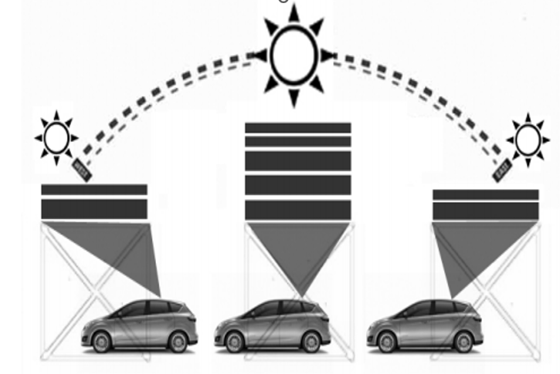
Solar electric vehicle (SEV) is an electric vehicle powered importantly or completely by direct solar energy. Through solar arrays installed on top of the vehicle, often photovoltaic (PV) cells, solar energy is converted directly into electric energy. Since converted solar energy is the only source, it powers all or part of SEV's propulsion, electronics, communication, navigation, security and other auxiliary features. Sensors provide assistance to the driver similar to conventional vehicles. Here, gathered information allows monitoring the car's energy consumption, solar energy capture and other parameters. SEVs can be equipped with a battery pack assistance to ensure continuous driving during shaded days or night use giving an extended range of autonomy to the users.
Fig 2.1. C-max SEV charging technique involving concentrating photovoltaic panels (CPV) and concentrating parking lenses.
2.7 POWER MANAGEMENT
Control strategies for hybrid-electric vehicles generally target several simultaneous objectives. The primary one is the minimization of the vehicle fuel consumption, while also attempting to minimize emissions and to maintain or enhance drivability. To date, the power management (PM) system in EVs is basically formed by two layers; High level software-based supervision and low level hardware-based control which can be divided into two control layers low level component and low level control. Both hardware and software control layers works together to optimize PM system in EVs. Major challenge of energy management system (EMS) in an electric vehicle is to assure optimal use and regeneration of the total energy in the vehicle. Regardless of number of sources, the powertrain configuration, at any time and for any vehicle speed, the control strategy has to determine the power distribution between different energies. When two storage systems or two fuel converters are available additional power distribution between the RESSs and between the fuel converters has to be determined. These decisions are constrained by two factors. First of all, the motive power requested by the driver must always be satisfied up to a maximum power demand already known. Then, charge status must be maintained within, allowing the vehicle to be charge continuously.
2.8 ELECTRIC VEHICLE CHARGING STATION
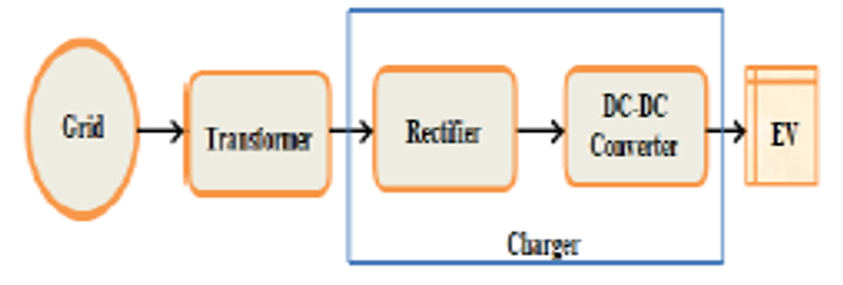
Electric vehicle charging stations are not sufficient. There are two types of charging stations exists i.e. public and private charging stations. Government has established few charging stations in different cities of Bangladesh but maximum charging stations are private. These private charging stations have taken a higher charging rate. Electric vehicle charging stations provide essential infrastructure for EV owners to conveniently recharge their vehicles, supporting the widespread adoption of electric transportation and reducing reliance on traditional fossil fuels.
Fig 2.2 Block Diagram of an Electric Vehicle Charging Station
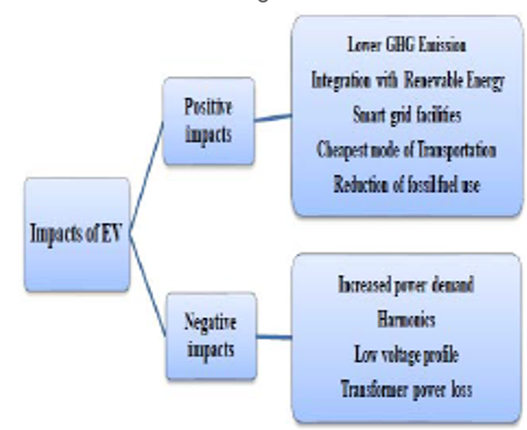
As the EV loads are increasing day by day in a rapid manner, thus the impacts of EVs should be analyzed. The impact of mass EV penetration on power system is expressed in Fig. 2.3 below. Although EV penetration has cheapest transportation system, lower GHG emission facility, smart grid facilities. But negative impacts on power system network are very much significant.
Fig 2.3 Impacts of Electric Vehicle
2.9 MATHEMATICAL MODELING
As a non-linear load, EV charger produces harmonics, low voltage profile and power loss in distribution transformer. For EV charging level 2 type AC charging scheme is used where maximum current rating is 16 A and maximum power rating is 3.3 kW. Most of the electric vehicles have power ranges from 0.5 kW to 1 kW and all of them use single phase 240 V, 50 Hz supply system. In this section, we have developed mathematical modeling for harmonics, voltage profile and transformer overloading due to EV charging.
2.9.1 POWER DEMAND
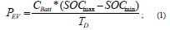
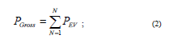
Electric Vehicle battery takes charge from the power distribution system. The increased power demand affects the stability of the system due to non-linearity. The power demand by an EV can be expressed as in Equation (1).
Where C Batt is the battery capacity, TD is the duration of charging. Battery SOC is a factor whether the EV takes high or small power. The gross power demand of the EVs is the summation of individual power demand of all EVs which likely signifies as in Equation (2).
2.9.2 HARMONICS
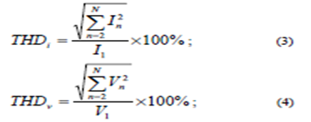
The rise in high frequency components of voltage and current with compared to fundamental frequency is defined as harmonics. Harmonics distorts the voltage & current waveforms and thereby affecting power quality. It can be measured by total harmonic distortion (THD) of current & voltage
Equation (3) & (4) express the Total Harmonic Distortion (THD) for current and voltage respectively . For slow charging THD_{i}, THD_{v} will be less than the fast charging. Thus, the EV with low SOC will have a great chance to produce harmonics.
2.9.3 VOLTAGE PROFILE
The low voltage profile becomes a threatening issue induced by EV charging. Voltage stability refers to the ability that the power network being stable after the sudden increase or decrease in the loads. EV loads take large amount of power at a very short duration. Thus, voltage profile will be degraded and grid will be unstable.
2.9.4 TRANSFORMER PERFORMANCE
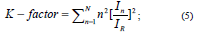
Mass deployment of EVs creates an additional stress on distribution transformers and their life cycles. Another problem is that, the EV charging rate should be limited per day and charging stations should keep far away from transformer for reducing power loss. Harmonic current is responsible for occurring load losses in transformer whereas harmonic voltage incurs no load loss. Due to these harmonic losses, heating is increased relative to the pure sinusoidal wave. This harmonic withstand capability can be measured by a factor called k- factor. In is the current related to nth harmonic and IR is the rated load current. The presence of harmonics causes overheating in the transformer.
CHAPTER-3
SOLAR PV SYSTEM
The photovoltaic effect was reported by Edmund Becquerel in 1839 when he observed that the action of light on a silver coated platinum electrode immersed in electrolyte produced an electric current. Forty years later the solid state photovoltaic devices were constructed by workers investigating the recently discovered photoconductivity of selenium. In 1876 William Adams and Richard Day found that a photocurrent could be produced in a sample of selenium when contacted by two heated platinum contacts. The photovoltaic action of the selenium from its photoconductive action in that a current was produced spontaneously by the action of light. No external power supply was needed. In this early photovoltaic device, a rectifying junction had been formed between the semiconductor and the metal contact. In 1894, Charles Fritts prepared what was probably the large area solar cell by pressing a layer of selenium between gold and another metal. In the following years photovoltaic were observed in copper oxide thin structures, in lead sulphide and thallium-sulphide. These early cells were thin Schottky barrier devices, where a semitransparent layer of metal deposited on top of the semiconductor provided both the asymmetric electronic junction, which is necessary for photovoltaic action, and access to the junction for the incident light. The photovoltaic of structures like this was related to the existence of a barrier to current ow at one of the semiconductor{metal interfaces (i.e., rectifying action) by Goldman and Brodsky in 1914. Later, during the 1930s, the theory of metal{semiconductor barrier layers was developed by Walter Schottky, Neville Mott and others.
However, it was not the photovoltaic properties of materials like selenium which excited researchers, but the photoconductivity. The fact that the current produced was proportional to the intensity of the incident light, and related to the wavelength in a way meant that photoconductive materials were ideal for photographic light meters. The photovoltaic in barrier structures was an added, meaning that the light meter could operate without a power supply. It was not until the 1950s, with the development of good quality silicon wafers for applications in the new solid state electronics, that potentially useful quantities of power were produced by photovoltaic devices in crystalline silicon. A solar photovoltaic (PV) system harnesses sunlight to generate electricity through solar panels, offering a sustainable and renewable energy solution for residential, commercial, and industrial applications, contributing to reduced carbon emissions and energy independence. In the 1950s, the development of silicon electronics followed the discovery of a way to manufacture p-n junctions in silicon. Naturally n type silicon wafers developed a p type skin when exposed to the gas boron trichloride. Part of the skin could be etched away to give access to the n type layer beneath. These p-n junction structures produced much better rectifying action than Schottky barriers, and better photovoltaic behavior.
The silicon solar cell was reported by Chapin, Fuller and Pearson in 1954 and converted sunlight with an efficiency of 6%, six times higher than the best previous attempt. these cells were not seriously considered for power generation for several decades. Nevertheless, the early silicon solar cell did introduce the possibility of power generation in remote locations where fuel could not easily be delivered. The obvious application was to satellites where the requirement of reliability and low weight made the cost of the cells unimportant and during the 1950s and 60s, silicon solar cells were widely developed for applications in space.
Also in 1954, a cadmium sulphide p-n junction was produced with an efficiency of 6%, and in the following years studies of p-n junction photovoltaic devices in gallium arsenide, indium phosphide and cadmium telluride were stimulated by theoretical work indicating that these materials would a higher efficiency. However, silicon remained and remains the foremost photovoltaic material, benefiting from the advances of silicon technology for the microelectronics industry. Short histories of the solar cell are given elsewhere [Shive, 1959; Wolf, 1972; Green, [1990].
In the 1970s the crisis in energy supply experienced by the oil-dependent western world led to a sudden growth of interest in alternative sources of energy, and funding for research and development in those areas. Photovoltaics was a subject of intense interest during this period, and a range of strategies for producing photovoltaic devices and materials more cheaply and for improving device efficiency were explored. Routes to lower cost included photoelectrochemical junctions, and alternative materials such as polycrystalline silicon, amorphous silicon, other `thin materials and organic conductors.
Strategies for higher efficiency included tandem and other multiple band gap designs. Although none of these led to widespread commercial development, our understanding of the science of photovoltaics is mainly rooted in this period. During the 1990s, interest in photovoltaics expanded, along with growing awareness of the need to secure sources of electricity alternative to fossil fuels. The trend coincides with the widespread deregulation of the electricity markets and growing recognition of the viability of decentralized power. During this period, the economics of photovoltaics improved primarily through economies of scale. In the late 1990s the photovoltaic production expanded at a rate of 15-25% per annum, driving a reduction in cost. Photovoltaics became competitive in contexts where conventional electricity supply is most expensive, for instance, for remote low power applications such as navigation, telecommunications, and rural electric and for enhancement of supply in grid-connected loads at peak use [Anderson,2001]. As prices fall, new markets are opened up. An important example is building integrated photovoltaic applications, where the cost of the photovoltaic system is by the savings in building materials.
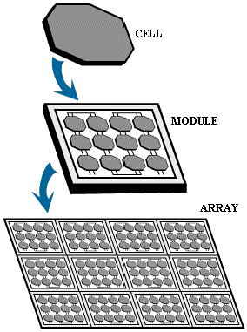
A number of solar cells electrically connected to each other and mounted in a single support structure or frame is called a ‘photovoltaic module’. Modules are designed to supply electricity at a certain voltage, such as a common 12 volt system. The current produced is directly dependent on the intensity of light reaching the module. Several modules can be wired together to form an array. Photovoltaic modules and arrays produce direct-current electricity. They can be connected in both series and parallel electrical arrangements to produce any required voltage and current combination. Solar PV systems convert sunlight into electricity through the photovoltaic effect, offering clean and reliable power generation with minimal environmental impact.
Fig 3.1 Diagram of Solar PV System
  - ELECTRICAL CONNECTION OF THE CELLS
The electrical output of a single cell is dependent on the design of the device and the Semi-conductor material(s) chosen, but is usually insufficient for most applications. In order to provide the appropriate quantity of electrical power, a number of cells must be electrically connected. There are two basic connection methods: series connection, in which the top contact of each cell is connected to the back contact of the next cell in the sequence, and parallel connection, in which all the top contacts are connected together, as are all the bottom contacts. In both cases, this results in just two electrical connection points for the group of cells.
Series connection
Figure shows the series connection of three individual cells as an example and the resultant group of connected cells is commonly referred to as a series string. The current output of the string is equivalent to the current of a single cell, but the voltage output is increased, being an addition of the voltages from all the cells in the string (i.e. in this case, the voltage output is equal to 3Vcell).
Fig 3.2 Series connection of cells, with resulting current-voltage characteristic
It is important to have well matched cells in the series string, particularly with respect to current. If one cell produces a significantly lower current than the other cells (under the same illumination conditions), then the string will operate at that lower current level and the remaining cells will not be operating at their maximum power points. while series connection offers increased voltage, ensuring the optimal performance of the series string requires careful attention to cell matching. Each cell within the string must exhibit similar characteristics, particularly concerning current output. If one cell produces a significantly lower current than the others under identical illumination conditions, the entire string will operate at the lower current level. This mismatch can lead to a reduction in overall efficiency, as the remaining cells fail to operate at their maximum power points.
Parallel connection
Figure shows the parallel connection of three individual cells as an example. In this case, the current from the cell group is equivalent to the addition of the current from each cell, but the voltage remains equivalent to that of a single cell. As before, it is important to have the cells well matched in order to gain maximum output, but this time the voltage is the important parameter since all cells must be at the same operating voltage.
Fig 3.3 Parallel connection of cells, with resulting current-voltage characteristic
If the voltage at the maximum power point is substantially different for one of the cells, then this will force all the cells to operate off their maximum power point, with the poorer cell being pushed towards its open-circuit voltage value and the better cells to voltages below the maximum power point voltage. In all cases, the power level will be reduced below the optimum.
3.2 THE PHOTOVOLTAIC ARRAY
A PV array consists of a number of PV modules, mounted in the same plane and electrically connected to give the required electrical output for the application. The PV array can be of any size from a few hundred watts to hundreds of kilowatts, although the larger systems are often divided into several electrically independent sub arrays each feeding into their own power conditioning system.
3.3 MAXIMUM POWER POINT TRACKING
3.3.1 PRINCIPLE OF MPPT
Maximum power point tracker (or MPPT) is a high efficiency DC to DC converter that presents an optimal electrical load to a solar panel or array and produces a voltage suitable for the load.
PV cells have a single operating point where the values of the current (I) and Voltage (V) of the cell result in a maximum power output. These values correspond to a particular load resistance, which is equal to V/I as specified by Ohm's Law. A PV cell has an exponential relationship between current and voltage, and the maximum power point (MPP) occurs at the knee of the curve, where the resistance is equal to the negative of the differential resistance (V/I = -dV/dI). Maximum power point trackers utilize some type of control circuit or logic to search for this point and thus to allow the converter circuit to extract the maximum power available from a cell.
Traditional solar inverters perform MPPT for an entire array as a whole. In such systems the same current, dictated by the inverter, flows though all panels in the string. But because different panels have different IV curves, i.e. different MPPs (due to manufacturing tolerance, partial shading, etc.) this architecture means some panels will be performing below their MPP, resulting in the loss of energy. Some companies (see power optimizer) are now placing peak power point converters into individual panels, allowing each to operate at peak efficiency despite uneven shading, soiling or electrical mismatch.
At night, an off-grid PV power system uses batteries to supply its loads. Although the battery pack voltage when fully charged may be close to the PV array's peak power point, this is unlikely to be true at sunrise when the battery is partially discharged. Charging may begin at a voltage considerably below the array peak power point, and a MPPT can resolve this mismatch.
When the batteries in an off-grid system are full and PV production exceeds local loads, a MPPT can no longer operate the array at its peak power point as the excess power has nowhere to go. The MPPT must then shift the array operating point away from the peak power point until production exactly matches demand. In a grid-tied photovoltaic system, the grid is essentially a battery with near infinite capacity. The grid can always absorb surplus PV power, and it can cover shortfalls in PV production (e.g., at night). Batteries are thus needed only for protection from grid outages. The MPPT in a grid tied PV system will always operate the array at its peak power point unless the grid fails when the batteries are full and there are insufficient local loads.
3.3.2 FLOW CHART OF PERTURB OBSERVE METHOD
Fig 3.4 Flow chart of the MPPT algorithm with P&O method
By comparing the recent values of power and voltage with previous ones, the P&O method shown in the flow chart can determine the value of reference current to adjust the output power toward the maximum point.
MPPTs can be designed to drive an electric motor without a storage battery. They provide significant advantages, especially when starting a motor under load. This can require a starting current that is well above the short-circuit rating of the PV panel. A MPPT can step the panel's relatively high voltage and low current down to the low voltage and high current needed to start the motor.
Once the motor is running and its current requirements have dropped, the MPPT will automatically increase the voltage to normal. In this application, the MPPT can be seen as an electrical analogue to the transmission in a car; the low gears provide extra torque to the wheels until the car is up to speed.
3.3.3 HILL CLIMB SEARCH STRATEGY
Due to the similarities of the shape of the wind and PV array power curves, a similar maximum power point tracking scheme known as the hill climb search (HCS) strategy is often applied to these energy sources to extract maximum power. The HCS strategy perturbs the operating point of the system and observes the output.
If the direction of the perturbation (e.g an increase or decrease in the output voltage of a PV array) results in a positive change in the output power, then the control algorithm will continue in the direction of the previous perturbation. A hill climb search strategy is a simple yet effective optimization technique used to find the peak (maximum) of a given objective function. It begins with an initial solution and iteratively explores neighboring solutions by making small changes to the current solution. At each iteration, the fitness of neighboring solutions is evaluated using the objective function, and the algorithm moves to the best neighboring solution if it has a higher fitness than the current one. This process continues until a termination condition is met, such as reaching a maximum number of iterations or finding a solution with satisfactory fitness. While hill climbing is efficient and easy to implement, it's important to note that it's a local search algorithm and may get stuck in local optima. To address this limitation, various enhancements like random restart, simulated annealing, and tabu search can be applied to improve its effectiveness in exploring complex solution spaces and finding better solutions.
Conversely, if a negative change in the output power is observed, then the control algorithm will reverse the direction of the pervious perturbation step. In the case that the change in power is close to zero (within a specified range) then the algorithm will invoke no changes to the system operating point since it corresponds to the maximum power point (the peak of the power curves.
3.3.4 MPPT SCHEME OF β METHOD
Fast MPPT scheme, called the “β” method, was suitably modified and used for the given application . The scheme is based on the observation that the value of an intermediate variable “β”, defined only at MPP condition, varies with in a narrow band (β_{max} − β_{min}) as the MPP varies from PMPP(max) to PMPP(min) over the full insolation and temperature range (λ_{max}, T_{max} to λ_{min}, T_{min}), as shown in algorithm. β is a subset of β’, which is applicable to any point on the P–V curve, including MPPT.
There are also a considerable number of MPPT overview and comparative surveys, where the MPPT flow chat have been mostly classified as the conventional and novel methods. A combined approach of two or more conventional and/or novel MPPT flow chart is also categorized and called as hybrid MPPT method.
Fig 3.5 MPPT flow chat for β-method
β is obtained by using the MPP condition, ∂P/dV = 0 and is given by,
=ln(I_{o}c)ln$\frac{I_{pv}}{V_{pv}}-$cV_{pv}
where I_{o} is the reverse saturation current of the diode. Therefore, by tracking β using large iterative steps, the operating point can be quickly brought into a narrow band of MPP. Also, controlling “β” indirectly controls the operating voltage (OV) of the PV array, which helps in balancing the power across capacitor C_{PV}.
It is important to note that problems may arise during the low insolation phase when the generated PV power is very small and the value of “M”, as computed by the MPP algorithm, is small. Under such conditions, as FC continues to feed the deficit power, this will result in a voltage increase across C_{PV} due to imbalance between the input and output power. This may lead to shifting of OV of the PV array toward the OCC. The array will remain at OCC even when high or normal insolation is restored and the system will continue to draw the required power from FC. To avoid such a situation, the algorithm has been suitably modified to ensure that the PV array voltage is always less than or equal to a critical voltage (V_{crit} ), which is less than the PV array’s V_{OC}. Whenever the array voltage goes beyond V_{crit} (which occurs only when the power drawn from the FC is not fed into the grid due to the low value of M) and array power is less than the minimum power P_{min}, the modulation index is set to a fixed value (M_{con}) by the algorithm. This ensures that V_{PV} ≤ V_{crit} .
3.4 INCREMENTAL CONDUCTANCE METHOD
This method consists in using the slope of the derivative of the current with respect to the voltage in order to reach the maximum power point.What advantage does MPPT give in the real world that depends on the array, their climate, and their seasonal load pattern. It gives us an effective current boost only when the V_{pp} is more than about 1V higher than the battery voltage. In cold weather however, the V_{pp} can rise to 18V. Its purpose is to continuously adjust the operating point of the solar panel to ensure that it operates at its maximum power point (MPP) under varying environmental conditions. If there energy use is greatest in the winter (typical in most homes) and the have cold winter weather, then the can gain a substantial boost in energy when the need it the most. The Incremental Conductance Method is a widely used algorithm in Maximum Power Point Tracking (MPPT) systems for photovoltaic (PV) solar panels. Its popularity stems from its effectiveness in continuously adjusting the operating point of the solar panel to maximize power output, particularly under varying environmental conditions.
Here is an example of MPPT action on a cold winter day Outside temperature: 20°F (-7°C) Wind is blowing a bit, so the PV cell temperature rises to only around 32°F (0°C). V_{pp} = 18V Batteries are a bit low, and loads are on, so battery voltage = 12.0
Ratio of V_{pp} to battery voltage is 18:12 = 1.5:1
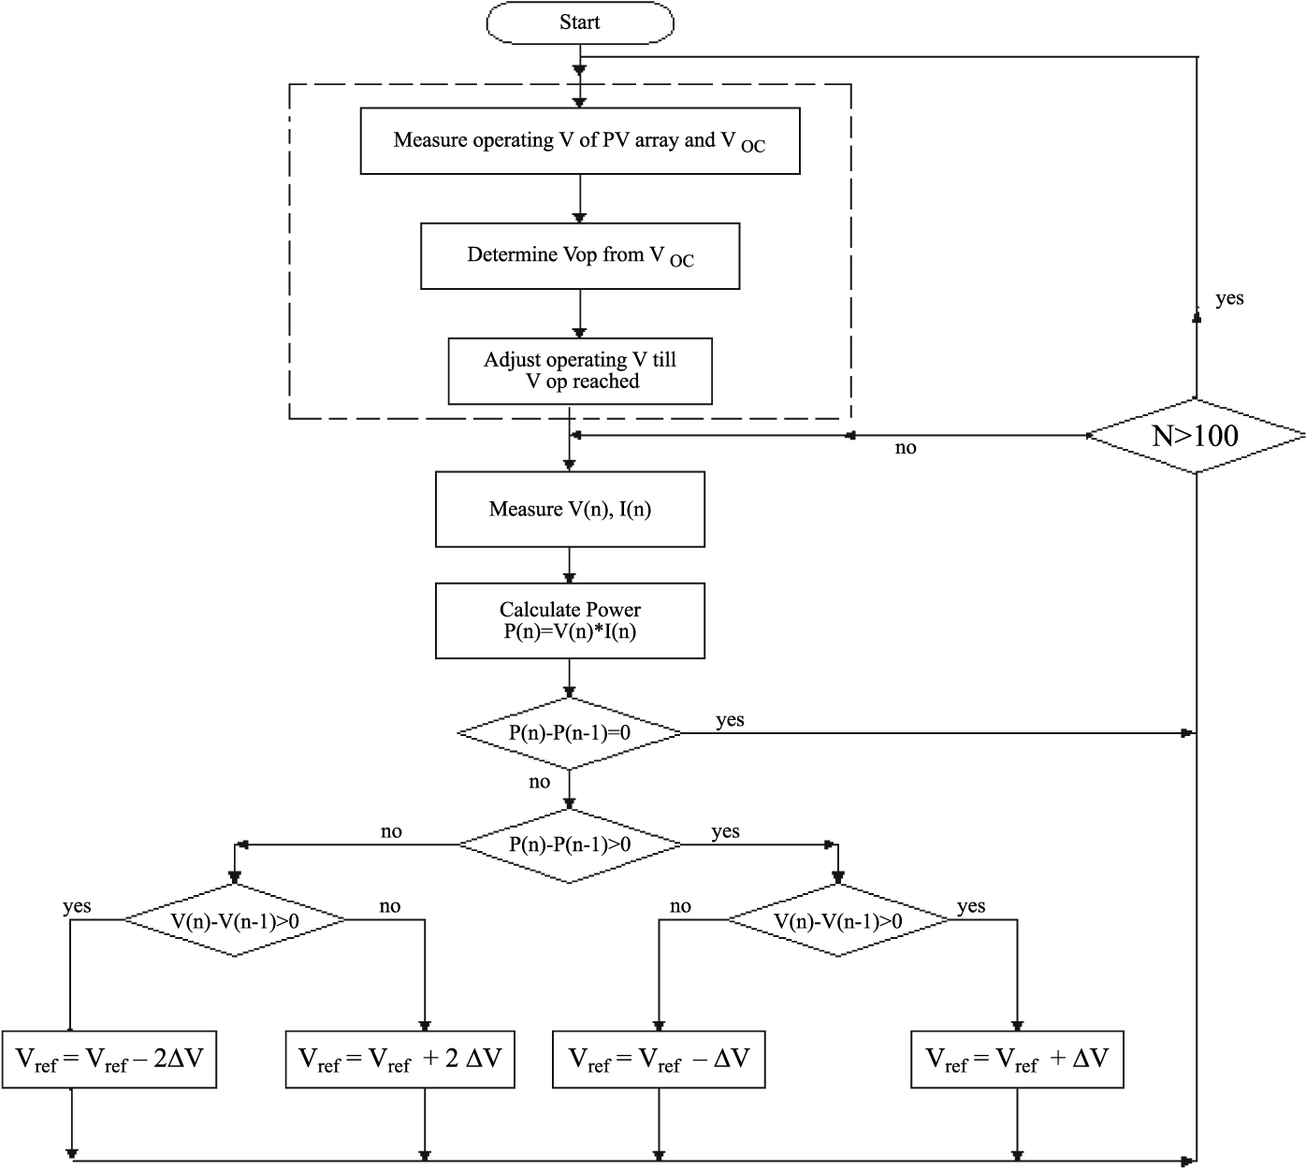
Fig 3.6 Incremental Conductance Method Algorithm
Under these conditions, a theoretically perfect MPPT (with no voltage drop in the array circuit) would deliver a 50% increase in charge current. In reality, there are losses in the conversion just as there is friction in a car's transmission. Reports from the field indicate that increases of 20 to 30% are typically observed.
Both the wind turbine and the photovoltaic array must be adjusted to operate at their point of maximum power. Many different maximum power point tracking (MPPT) algorithms like perturbation observation method, incremental conductance method have been developed and widely used for such systems. The perturbation observation method is adopted in this paper for both the wind turbine and the photovoltaic array for it simplicity and accuracy. The algorithm starts by choosing an initial reference rotor speed for the wind turbine and an initial reference voltage for the photovoltaic array. The corresponding output powers of the two systems are measured. If this power does not correspond to their maximum powers, then their initial reference values are incremented or decremented by one step. If this adjustment leads to an increase in their output powers, then the next adjustment is made in the same direction and vice-versa. The above steps are repeated till the maximum power points of the wind turbine and photovoltaic array are reached.
3.5 MAXIMUM POWER POINT OF THE SYSTEM
Both the wind turbine and the photovoltaic array must be adjusted to operate at their point of maximum power. Many different maximum power point tracking (MPPT) algorithms like perturbation observation method, incremental conductance method have been developed and widely used for such systems. The perturbation observation method is adopted in this paper for both the wind turbine and the photovoltaic array for it simplicity and accuracy. The algorithm starts by choosing an initial reference rotor speed for the wind turbine and an initial reference voltage for the photovoltaic array. The corresponding output powers of the two systems are measured. If this power does not correspond to their maximum powers, then their initial reference values are incremented or decremented by one step. If this adjustment leads to an increase in their output powers, then the next adjustment is made in the same direction and vice-versa. The above steps are repeated till the maximum power points of the wind turbine and photovoltaic array are reached.
3.6 DESIGN OF BOOST CONVERTER
The basic structure and control topology of the dc-dc boost converter are shown above. The converter divides the input dc-link voltage into two levels: variable dc-link voltage at the output terminals of the energy source and fixed dc-link voltage at the input terminals of the voltage source inverter. In this section, the operation of the boost chopper is theoretically analyzed. The inverter circuit is simulated as a resistive load connected to a fixed dc-link, since it can be controlled to behave as a current source at the high power factor. The inductance and capacitance of the system are assumed to be sufficiently large, such that the switching device current and the dc output voltage are filtered by the inductor and capacitor respectively. The energy is stored in L, when Sdc is “1”, and the energy is transferred to C, when Sdc equals “0”
Fig 3.7 Step-up dc-dc Boost Converter Circuit
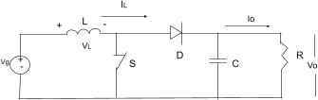
Fig 3.8 Point Tracking of Photovoltaic Sources
This DC power converter is used to step up the voltage.
The schematic diagram displays a (DC-DC) step-up converter having Vg(input voltage), inductor(L), diode(D), capacitor(C), load (R) and a switch(S). Operating condition; while Switch is open, the diode is in off state, and current increases linearly in the inductor.Otherwise, the current decreases linearly, and the polarity of the inductor is changed because of which current is supplied to the RC circuit through the diode.
Equation is, 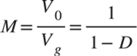 (10)
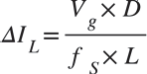
Some other related equations used are: Inductor ripple current
(11)
Capacitor ripple voltage
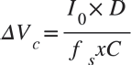

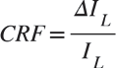
Current ripple factor (CRF)
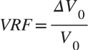
Voltage ripple factor(VRF)
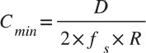
The critical value of inductor
Filter capacitor’s minimum value is
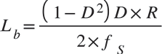
For the continuous operation of the circuit, C>C_{min} and L>L_{b} conditions should be satisfied. The values of the term CRF(Current ripple factor) and VRF(voltage ripple factor) should not exceed 30% and 5% respectively .
Specification of boost converter used in this module are:
  - Boost Inductor - 120µH
  - Input filter capacitor - 4000µF
  - MOSFET
  - Resistive load - 3.8 ohm
  - Output filter capacitor - 70µF
  - Switching frequency - 25 kHz

CHAPTER-4
DUAL ACTIVE BRIDGE CONVERTER
The dual active bridge (DAB) converter is a power electronics topology commonly used in high-power applications, such as electric vehicle charging systems, renewable energy systems, and grid-connected energy storage systems. It provides bidirectional power flow with high efficiency and offers a wide voltage conversion range. In this converter, two full-bridge converters are connected back-to-back, allowing for independent control of the voltage and current on both sides. Here is a brief overview of the DAB converter and its operation
4.1 BASIC CONFIGURATION
The DAB converter consists of two full-bridge converters, referred to as the primary and secondary bridges. Each bridge comprises four power switches (typically implemented using IGBTs or MOSFETs) and four diodes. The primary bridge is connected to the AC source or the energy source, while the secondary bridge is connected to the load or the energy storage system.
4.2 OPERATING PRINCIPLES
The DAB converter operates based on the principle of phase-shift modulation. By controlling the phase shift angle between the primary and secondary bridges, the converter can regulate the voltage and current levels and achieve bidirectional power flow. The control system monitors the input and output voltages and currents, adjusts the phase-shift angle, and controls the switching of the power devices to maintain the desired power transfer.
4.3 MODES OF OPERATION
The DAB converter supports four operating modes, which are as follows
- Rectification Mode: In this mode, power flows from the AC source to the load or energy storage system. The switches in the primary bridge are controlled to rectify the AC input voltage into a DC voltage, while the secondary bridge operates as an inverter to regulate the output voltage and deliver power to the load.
- Inversion Mode: In this mode, power flows from the energy storage system or load to the AC grid. The primary bridge operates as an inverter, converting the DC input voltage into an AC voltage, while the secondary bridge acts as a rectifier to regulate the output voltage and deliver power to the grid.
- Capacitive Energy Transfer Mode: This mode allows bidirectional power flow between the primary and secondary sides. It is used for energy transfer between two DC sources, such as two energy storage systems. The DAB converter controls the power flow direction and maintains the desired voltage levels.
- Inductive Energy Transfer Mode: Similar to capacitive energy transfer mode, this mode enables bidirectional power flow between the primary and secondary sides. It is used for energy transfer between two DC sources, such as energy storage systems, with the additional feature of galvanic isolation between the primary and secondary sides using a high-frequency transformer.
Advantages
The dual active bridge converter offers several advantages, including
- Bidirectional power flow: It allows power to flow in both directions, enabling energy transfer between different sources or systems.
- High efficiency: The DAB converter can achieve high efficiency due to its soft-switching operation and optimal control techniques.
- Wide voltage conversion range: It supports a wide range of input and output voltage levels, making it suitable for various applications.
- Independent control: The primary and secondary bridges can be controlled independently, providing flexibility in voltage and current regulation.
- Reduced size and weight: The DAB converter's high-frequency operation allows for the use of smaller magnetics, resulting in a compact and lightweight design.
These are the basic aspects of a dual active bridge converter. For more detailed information, including control strategies, modulation techniques, and specific applications, you can refer to research papers, academic publications, and technical articles focused on power electronics and converter technologies.

CHAPTER-5
CONTROL TECHNIQUE
5.1 FUZZY INTERFACE SYSTEM
Fuzzy Inference System is the key unit of a fuzzy logic system having decision making as its primary work. It uses the “IF…THEN” rules along with connectors “OR” or “AND” for drawing essential decision rules.
Characteristics of Fuzzy Inference System Following are some characteristics of FIS –
- The output from FIS is always a fuzzy set irrespective of its input which can be fuzzy or
Crisp.
- It is necessary to have fuzzy output when it is used as a controller.
- A defuzzification unit would be there with FIS to convert fuzzy variables into crisp variables.
Functional Blocks of FIS The following five functional blocks will help you understand the construction of FIS -
- Rule Base - It contains fuzzy IF-THEN rules.
- Database - It defines the membership functions of fuzzy sets used in fuzzy rules.
- Decision-making Unit - It performs operation on rules.
- Fuzzification Interface Unit - It converts the crisp quantities into fuzzy quantities.
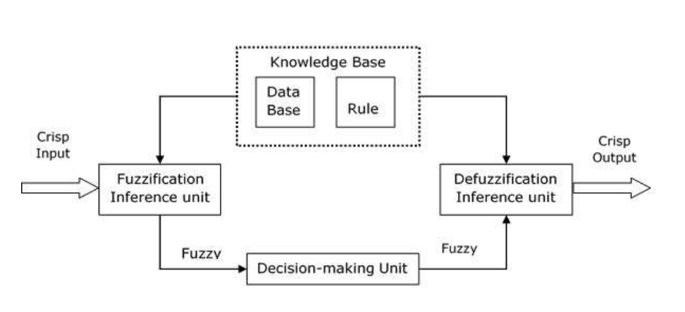
- Defuzzification Interface Unit - It converts the fuzzy quantities into crisp quantities.
Fig 5.1 Block diagram of fuzzy interference system
Working of FIS, The working of the FIS consists of the following steps
- A fuzzification unit supports the application of numerous fuzzification methods, and convert the crisp input into fuzzy input.
- A knowledge base - collection of rule base and database is formed upon the conversion of crisp input into fuzzy input.
- The defuzzification unit fuzzy input is finally converted into crisp output.
- Methods of FIS Let us now discuss the different methods of FIS.
Following are the two important methods of FIS, having different consequent of fuzzy rules
- Mamdani Fuzzy Inference System
- Takagi - Surgeon Fuzzy Model (TS Method) Fuzzy Inference Systems
Advantages
- Intuitive
- Well-suited to human input and more interpretable and rule-base
- Has widespread acceptance
- Computationally efficient
- Functions well with linear techniques, like PID control
- Functions with optimization and adaptive techniques
- Guarantees output surface continuity
- Well-suited to mathematical analysis
Disadvantages
- Fuzzy Interference system Let us look at the drawbacks of Fuzzy Logic systems
- The accuracy of these systems is compromised as the system mostly works on inaccurate data and inputs
- There is no single systematic approach to solve a problem using Fuzzy Logic. As a result, many solutions arise for a particular problem, leading to confusion
- Due to inaccuracy in results, they are not always widely accepted
- You have to regularly update the rules of a Fuzzy Logic control system
- These systems cannot recognize machine learning or neural networks
- The systems require a lot of testing for validation and verification
Applications of FIS A fuzzy inference system is used in different fields, for example, information order, choice examination, master system, time arrangement forecasts, advanced mechanics, and example acknowledgment.

CHAPTER-6
MODELLING OF INDUCTION MOTOR
6.1 INTRODUCTION
A dynamic model of the machine subjected to control must be known in order to understand and design vector controlled drives. Due to the fact that every good control has to face any possible change of the plant, it could be said that the dynamic model of the machine could be just a good approximation of the real plant. Nevertheless, the model should incorporate all the important dynamic effects occurring during both steady state and transient operations. Furthermore, it should be valid for any changes in the inverter’s supply such as voltages and currents. Such a model can be obtained by means of either the space vector phasor theory or two axes theory of electrical machines. Despite the compactness and the simplicity of the space phasor theory, both methods are actually close and both methods will be explained. For simplicity, the induction motor considered will have the following Assumptions
- Symmetrical two-pole, three phase windings.
- The slotting effects are neglected.
- The permeability of the iron parts is infinite.
- The flux density is radial in the air gap.
- Iron losses are neglected.
- The stator and the rotor windings are simplified as a single, multi-turn full pitch coil situated on the two sides of the air gap.
6.2 NEED FOR DYNAMICAL MODELLING OF INDUCTION MOTOR
The per phase equivalent circuit of the machine is only valid in steady-state condition. When studying steady state performance of the machine, the electrical transients are neglected during load changes and stator frequency variations. In an adjustable - speed drive, the machine normally constitutes an element with in a feedback loop, it could be said that the dynamic model of the machine could be just a good approximation of the real plant. Dynamical modeling of induction motors is crucial for optimizing performance, predicting behavior under varying conditions, and designing efficient control strategies, essential for applications ranging from industrial automation to renewable energy integration. And therefore, its transient behavior has to be taken in to consideration. Besides, high-performance drive control, such as vector or field-oriented control is based on the dynamic d-q model of the machine. Therefore, to understand vector control principles, a good understanding of the d-q model is mandatory.
6.3 DYNAMIC D-Q MODEL
The dynamic performance of an ac machine is somewhat complex because the three-phase rotor windings move with respect to the three-phase stator windings as shown in figure 6.1(a).
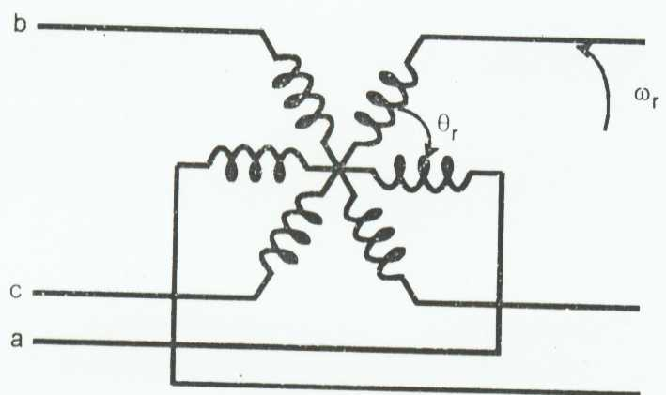
Fig 6.1 (a) Coupling effect in three-phase Stator and rotor windings
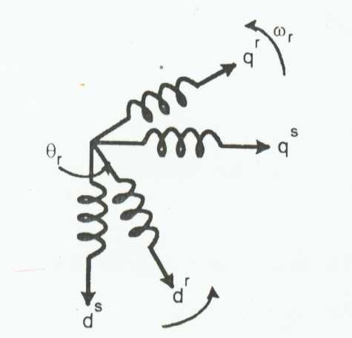
Fig 6.1 (b). Equivalent two phase machine
Basically, it can be looked on a s a transformer with a moving secondary, where the coupling coefficients between the stator and rotor phases change continuously with the change of rotor position θ_{r}. The machine can be described by differential equations with time-varying mutual inductances, but such a model tends to be very complex. Note that a three-phase machine can be represented by an two-phase machine as shown in 6.1(b), where d_{s}-q_{s} correspond to stator direct and quadrature axes, and d_{r}-q_{r} correspond to rotor direct and quadrature axes.
Although, it is somewhat simple, the problem of time-varying parameters still remains. R.H. Park, in 1920s, proposed a new theory of electric machine analysis to solve this problem. He formulated a change of variables, Which, in effect, replaced the variables (voltages, currents and flux linkages) associated with the stator windings of synchronous machine with variables associated with fictitious windings rotating with the rotor with synchronous speed. Essentially, he transformed, or referred, the stator variables to a synchronously rotating reference frame fixed in the rotor. With such transformation (called park’s transformation), he showed that all the time-varying inductances that occur due to an electric circuit in relative motion and electric circuits with varying magnetic reluctances can be eliminated. Later, in
The 1930s, H. C. Stanley showed that time-varying inductances in the voltage equations of the induction machine due to electric circuits in relative motion can be eliminated by transforming the rotor variables to variables associated with fictitious stationary windings. In this case, the rotor variables are transformed to a stationary reference frame fixed on the stator. Later, G. Kron proposed a transformation of both rotor and stator variables to a synchronously rotating reference frame that moves with the rotating magnetic field. D. S. Brereton proposed a transformation of stator to a rotating reference frame that is fixed on the rotor. In fact, it was shown later by Krause and Thomas that time-varying inductances can be eliminated by referring the stator and rotor variables to a common reference frame which may rotate at any speed (arbitrary reference frame). Without going deep in to rigor of machine analysis, we will try to develop a dynamic machine model in a synchronously rotating and stationary reference frames.
6.3.1 AXES TRANSFORMATION
Consider a symmetrical three-phase induction machine with stationary as-bs-cs axes at 2Π/3 angle apart, as shone in figure 6.2 . Our is to transform the three-phase stationary reference frame (as-bs-cs) variables into two –phase stationary reference frame (d^{s}-q^{s}) variables and then these to synchronously rotating reference frame (d^{e}-q^{e}), and vice versa.
Assume that the d^{s}-q^{s} axes are oriented at θ angle, as shown in figure 3.2. The voltages v_{ds}^{s} and v_{qs}^{s} can be resolved into as-bs-cs components and ca n be represented in matrix form as
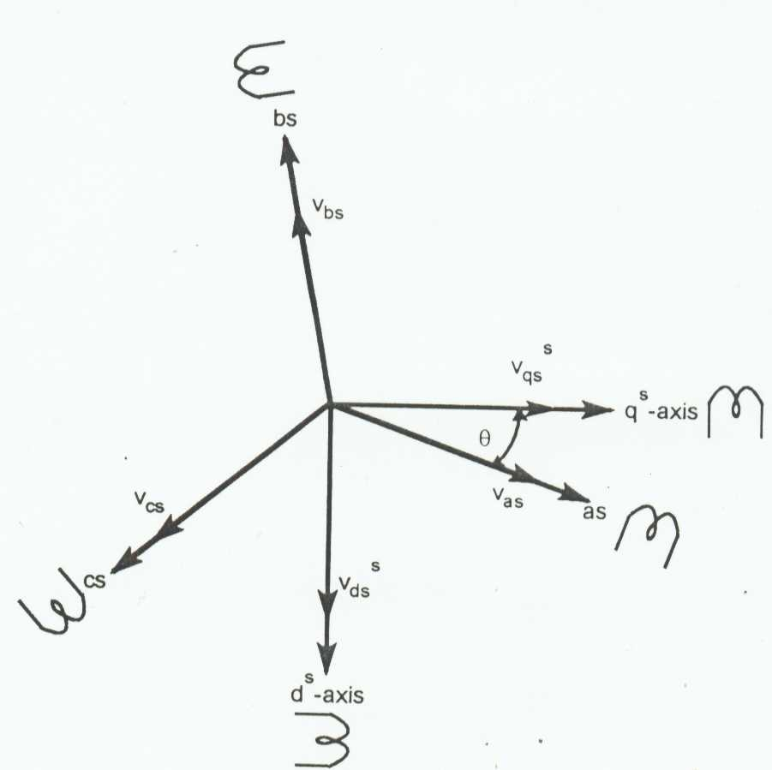
Fig 6.2 Stationary frame a-b-c to ds-qs axes transformation
= (3.1)
The corresponding inverse relation is
= (3.2)
Where V_{os}^{s} is added as the zero sequence component, which may or may not be present. We have considered voltage as the variable. The current and flux linkages can be transformed by similar equations. It is convenient to set θ = 0, so that the q^{s}-axis is aligned with the as-axis. Ignoring the zero sequence components, the transformation relations can be simplified as
V_{as} = V_{qs}^{s} (3.3)
V_{bs} = - (1/2)V_{qs}^{s} - (√3/2) V_{ds}^{s} (3.4)
V_{cs} = -(1/2) V_{qs}^{s} + (√3/2) V_{ds}^{s} (3.5)
V_{qs}^{s}=(2/3) V_{as} –(1/3) V_{bs} – (1/3) V_{cs} = (3.6)
And inversely
V_{qs}^{s}=(2/3) V_{as} –(1/3) V_{bs} – (1/3) V_{cs} = (3.7)
V_{ds}^{s} = -(1/√3) V_{bs} +(1/√3) V_{cs} (3.8)
Figure 6.3 Shows the synchronously rotating d^{e}-q^{e} axes, which rotate at synchronous speed ω_{e} with respect to the d^{s}-q^{s} axes and the angle θe = ω_{e}t. Two-phase d^{s}-q^{s} windings are transformed into the hypothetical windings mounted on the d^{e}-q^{e} axes. The voltages on the d^{s}-q^{s} axes can be converted (or resoled) into the d^{e}-q^{e} frame as follows:
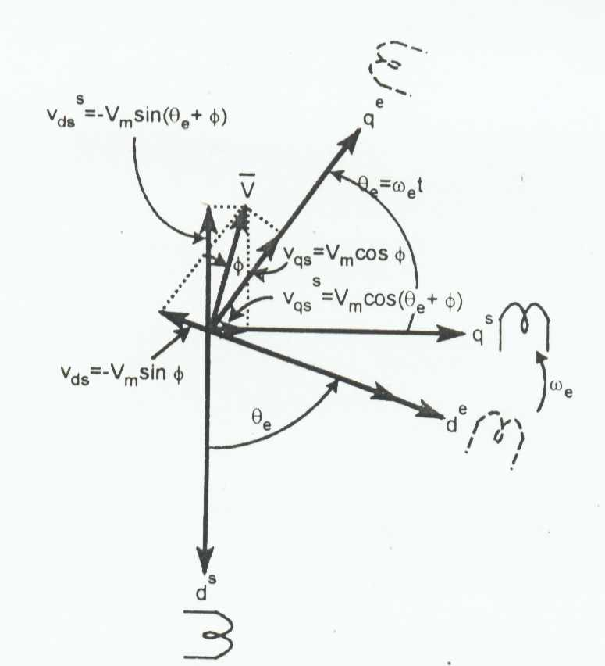
Fig 6.3 Stationary frame ds-qs to synchronously rotating frame de-qe transformation
V_{qs} = V_{qs}^{s} cosθe - V_{ds}^{s} sin θe (3.9)
V_{ds} = V_{qs}^{s} sin θe + V_{ds}^{s} cosθe (3.10)
For convenience, the superscript “e” has been dropped from now on, from the synchronously rotating frame parameters. Again, resolving the rotating frame parameters into a stationary frame, the relations are
V_{qs}^{s} = V_{qs} cosθe + V_{ds} sinθe (3.11)
V_{ds}^{s} = - V_{qs} sin θe + V_{ds} cosθe (3.12)
6.3.2 SYNCHRONOUSLY ROTATING REFERENCE FRAME-DYNAMIC MODEL
For the two-phase machine shown in figure 6.1(b), we need to represent both d^{s}-q^{s} and d^{r}-q^{r} circuits and their variables in a synchronously rotating d^{e}-q^{e} frame. We can write the following stator equations
V_{qs}^{s} = R_{s} i_{qs}^{s} + dψ_{qs}^{s}/dt (3.13)
V_{ds}^{s} = R_{s} i_{ds}^{s} + dψ_{ds}^{s}/dt (3.14)
Where, ψ_{qs}^{s} and ψ_{ds}^{s} are q-axis and d-axis stator flux linkages, respectively. When these equations are converted to d^{e}-q^{e} frame, the following equations can be written
V_{qs} = R_{s} i_{qs} + dψ_{qs}/dt + ω_{e}ψ_{ds} (3.15)
V_{ds} = R_{s} i_{qs} + dψ_{ds}/dt - ω_{e}ψ_{qs} (3.16)
Where, all the variables are in rotating form. The last term in the equations (3.15) and (3.16) can be defined as speed emf due to rotation of the axis, that is, when ω_{e} = 0, the equations revert to stationary form. Note that the flux linkage in the d^{e} and q^{e} axes induces emf in the q^{e} and d^{e} axes, respectively, with π/2 lead angle. If the rotor is not moving, that is ω_{r} = 0, the rotor equations for a doubly fed wound rotor machine will be similar to equations (3.15) - (3.16).
V_{qr} = R_{r} i_{qr} + dψ_{qr}/dt + ω_{e}ψ_{dr} (3.17)
V_{dr} = R_{r}i_{dr} + dψ_{dr}/dt - ω_{e}ψ_{qr} (3.18)
Where, all the variables and parameters are referred to the stator. Since the rotor actually moves at speed ω_{r}, the d-q axes fixed on the rotor move at a speed ω_{e} - ω_{r} relative to the synchronously rotating frame. Therefore, in d^{e}-q^{e} frame, the rotor equations should be modified as
V_{qr} = R_{r}i_{qr}+dψ_{qr}/dt + (ω_{e} - ω_{r} )ψ_{dr} (3.19)
V_{dr} = R_{r}i_{dr}+dψ_{dr}/dt - (ω_{e} - ω_{r} ) ψ_{qr} (3.20)
Figure 6.4 Shows the d^{e}-q^{e} dynamic model equivalent circuits that satisfy equations (3.15) - (3.16) and (3.19) – (3.20). A special advantage of the d^{e}-q^{e} dynamic model of the machine is that all the sinusoidal variables in stationary frame appear as dc quantities in synchronous frame, as discussed before. The flux linkage equations in terms of currents can be written from figure 6.4. as follows
ψ_{qs} = L_{ls} i_{qs} + L_{m}(i_{qs} + i_{qr}) (3.21)
ψ_{qr} = L_{lr} q_{r} + L_{m}(i_{qs +} i_{qr}) (3.22)
ψ_{qm} = L_{m} (i_{qs} + i_{qr}) (3.23)
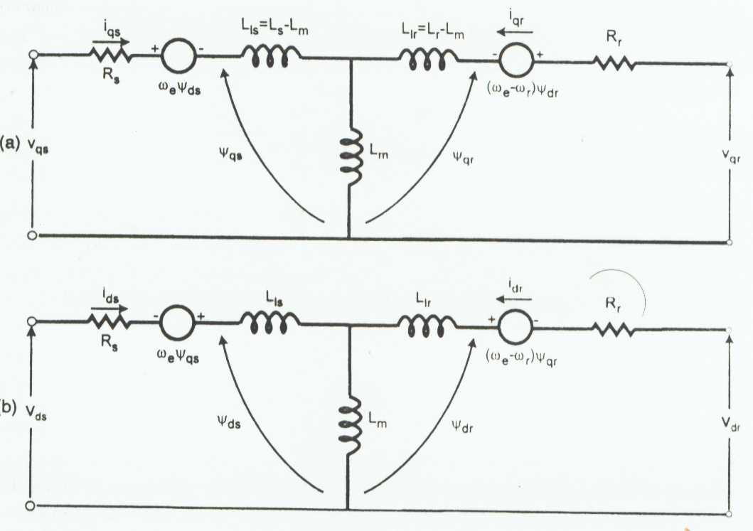
Fig 6.4 dynamic d^{e}-q^{e} equivalent circuits of machine (a)q^{e}-axis circuit, (b) d^{e}-axis circuit
ψ_{ds} = L_{ls} i_{ds} + L_{m} (i_{ds} + i_{dr}) (3.24)
ψ_{dr} = L_{lr} i_{dr} + L_{m} (i_{ds} + i_{dr}) (3.25)
ψ_{dm}= L_{m} (i_{ds} + i_{dr}) (3.26)
Combining the above expressions with (3.15), (3.16), (3.19) and (3.20), the electrical transient model in terms of voltages and currents can be given in matrix form as
(3.27)
Where, S is the Laplace operator. For a singly-fed machine, such as a cage motor, v_{qr} = v_{dr} = 0. If the speed ω_{r} is considered constant (infinite inertia load), the electrical dynamics of the machine are given by a fourth-order linear system. Then, knowing the inputs V_{qs}, V_{ds} and ω_{e}, the currents i_{qs}, i_{ds}, i_{dr} and i_{qr} can be solved from equation (3.27). If the machine is fed by current source i_{qs}, i_{ds} and ω_{e} are independent. Then, the independent variables V_{qs}, V_{ds,} i_{dr} and i_{qr} can be solved from equation (3.27). The speed ω_{r} in equation (3.27) cannot normally be treated as a constant. It can be related to the torques as
Te = T_{L} + J dω_{m}/dt = T_{L} + (2/P) J dω_{r}/dt (3.28)
Often, for compact representation, the machine model and equivalent circuits are expressed in complex form .Multiplying Equation (3.16) by –j and adding with equation (3.15) gives
V_{qs} - jv_{ds} = Rs(i_{qs} - ji_{ds}) + d(ψ_{qs}- jψ_{ds})/dt + jω_{e}(ψ_{qs} - jψ_{ds)} (3.29)
or
V_{qds} = R_{s}i_{qds} + d(ψ_{qds})/dt + jω_{e} ψ_{qds} (3.30)
where V_{qds} and i_{qds} etc. are complex vectors (the subscript “e” has been omitted). Similarly, the rotor equations (3.19) – (3.20) can be combined to represent
V_{qdr} = R_{r}i_{qdr} +dψ_{qdr}/dt + j(ω_{e} – ω_{r}) ψ_{qdr} (3.31)
Figure 6.5 shows the complex equivalent circuit in rotating frame where v_{qds} = 0. Note that the steady-state equations can be always be derived by substituting the time derivative components to zero. Therefore, from equations (3.30) – (3.31) the steady-state equations can be derived as
V_{s} = R_{s}I_{s} + jω_{e}ψ_{s} (3.32)
0 = (R_{r}/S)I_{r} + ω_{e}ψ_{r} (3.33)
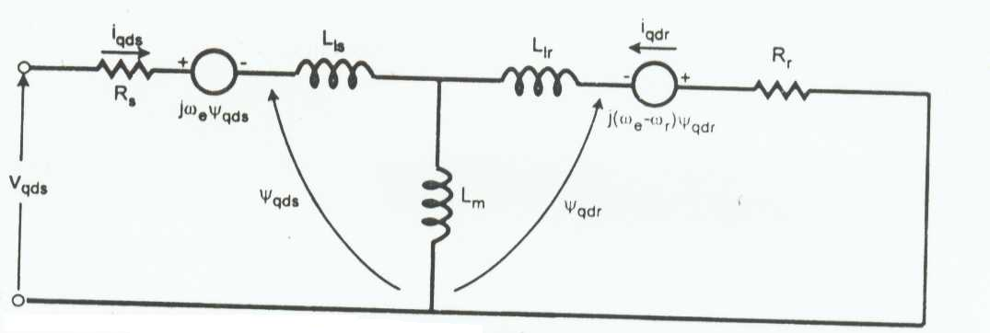
Fig 6.5 complex synchronous frame d_{qs} equivalent circuit
Where the complex vectors have been substituted by the corresponding rms phasors. These equations satisfy the steady-state equivalent circuit of the induction motor if the parameter R_{m} is neglected.The development of torque by the interaction of air gap flux and rotor mmf was discussed earlier in this chapter. Hence it will be expressed in more general form, relating the d-q components of variables. From equation T_{e} = (3/2)(p/2)ψ^_{m}I_{r}sinδ, the torque can be generally expressed in the vector form as
T_{e} = (3/2)(p/2)ψ_{m} * I_{r} (3.34)
Resolving the variables into d_{e}-q_{e} components, as shown in figure 3.6
T_{e} = (3/2)(p/2) (ψ_{dm}I_{qr} – ψ_{qm}I_{dr}) (3.35)
Several other torque expressions can be derived easily as follows
T_{e} = (3/2)(p/2) (ψ_{dm}I_{qs} – ψ_{qm}I_{ds}) (3.36)
= (3/2)(p/2)(ψ_{ds}I_{qs} – ψ_{qs}I_{ds}) (3.37)
= (3/2)(p/2)L_{m}(i_{dr}i_{qs} –i_{ds}i_{qr}) (3.38)
= (3/2)(p/2)(ψ_{dr}I_{qr} – ψ_{qr}I_{dr}) (3.39)
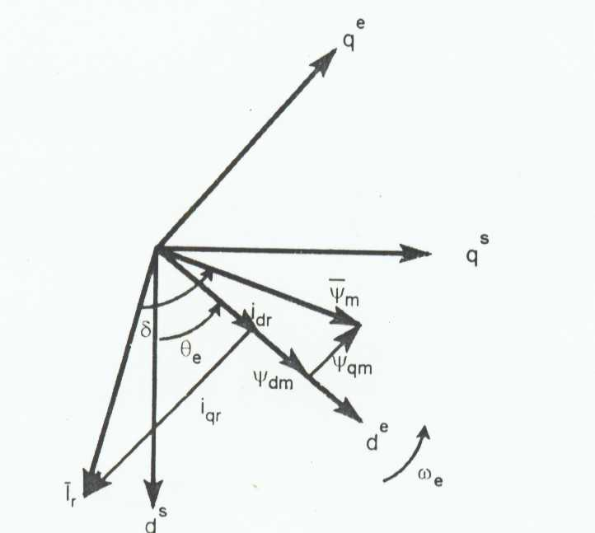
Fig 6.6 flux and current vectors in d^{e}-q^{e} frame
Equations (3.27), (3.28) and (3.38) give the complete model of the electro-mechanical dynamics of an induction machine in synchronous frame. The composite system is of the fifth order and the nonlinearity of the model is evident. Figure 6.7 shows the block diagram of the machine model along with input voltage and output current transformations.
6.3.3 STATIONARY FRAME-DYNAMIC MODEL
The dynamic machine in stationary frame can be derived simply substituting ω_{e}=0 in equation (3.27) or in (3.15), (3.16), (3.19) and (3.20) . The corresponding stationary frame equations are given as
V_{qs}^{s} = R_{s} i_{qs}^{s} + dψ_{qs}^{s}/dt (3.40)
V_{ds}^{s} = R_{s} i_{ds}^{s} + dψ_{ds}^{s}/dt (3.41)
0 = R_{r} i_{qr}^{s} + dψ_{qr}^{s}/dt – ω_{r}ψ_{dr}^{s} (3.42)
0 = R_{r} i_{dr}^{s} + dψ_{dr}^{s}/dt – ω_{r}ψ_{qr}^{s} (3.43)
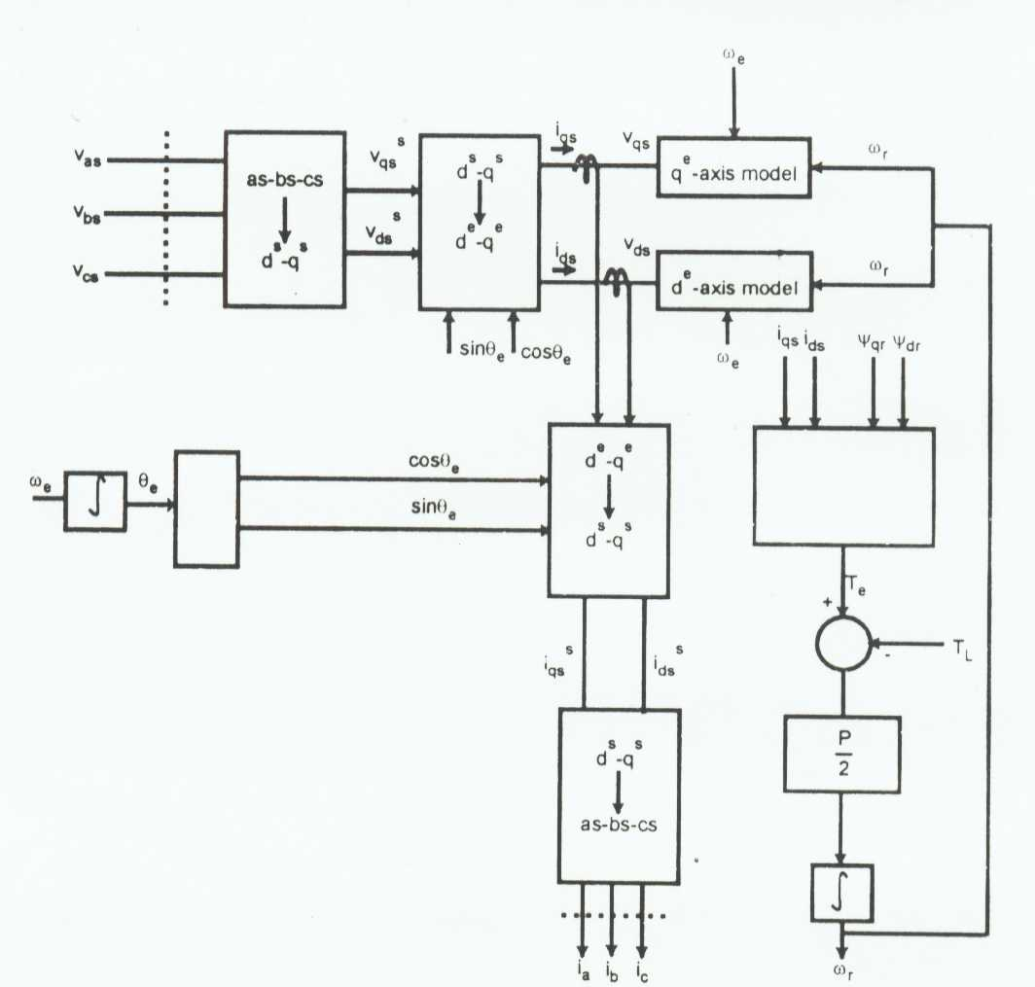
Fig 6.7 synchronously rotating frame machine model with input voltage and output current transformations
where v_{qr} = v_{dr} =0. Figure 6.8 shows the corresponding equivalent circuits. As mentioned before, in the stationary frame, the variables appear as sine waves in steady state with sinusoidal inputs. The torque equations (3.36) – (3.39) can also be written with the corresponding variables in stationary frame as
T_{e} = (3/2)(p/2) (ψ_{dm}^{s}I_{qr}^{s} – ψ_{qm}^{s}I_{dr}^{s}) (3.44)
= (3/2)(p/2) (ψ_{dm}^{s}I_{qs}^{s} – ψ_{qm}^{s}I_{ds}^{s}) (3.45)
= (3/2)(p/2) (ψ_{ds}^{s}I_{qs}^{s} – ψ_{qs}^{s}I_{ds}^{s}) (3.46)
= (3/2)(p/2)L_{m}(i_{qs}^{s}i_{dr}^{s} –i_{ds}^{s}i_{qr}^{s}) (3.47)
= (3/2)(p/2)(ψ_{dr}^{s}I_{qr}^{s} – ψ_{qr}^{s}I_{dr}^{s}) (3.48)
Equations (3.13) –(3.14) and (3.42) – (3.43) can easily combined to drive the complex model as - 28 -
V_{qds}^{s} = R_{s}i_{qds}^{s} + dψ_{qds}^{s}/dt) (3.49)
0 = R_{r} i_{qds}^{s} + dψ_{qdr}^{s}/dt – jω_{r}ψ_{qd} (3.50)
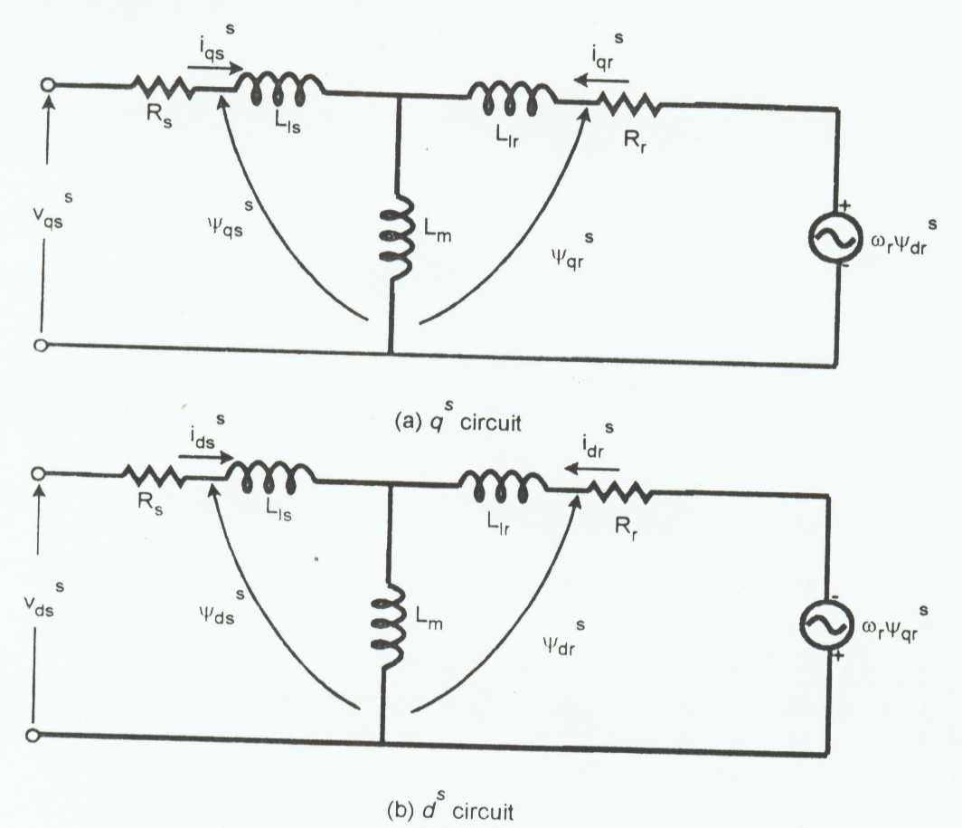
Fig 6.8 ds-qs equivalent circuits

Where v_{qds}^{s} = v_{qs}^{s} – jv_{ds}^{s}, ψ_{qds}^{s} = ψ_{qs}^{s} - jψ_{ds}^{s}, i_{qds}^{s} = i_{qs}^{s} – ji_{ds}^{s}, ψ_{qdr}^{s} = ψ_{qr}^{s} - jψ_{dr}^{s}, etc. The complex equivalent circuit in stationary frame is shown in figure 6.8 . Often, a per phase equivalent circuit with CEMF (ω_{r}ψ_{r}) and sinusoidal variables is described in the form of figure 6.8.
6.3.4. DYNAMIC MODEL STATE-SPACE EQUATIONS
The dynamic machine model in state-space form is important for transient analysis, particularly for computer simulation study. Although the rotating frame model is generally preferred, the stationery frame model can also be used. The electrical variables in the model can be chosen as fluxes, currents, or a mixture of both. In this section, we will derive state-space equations of the machine in rotating frame with flux linkages as the main variables.
Let’s define the flux linkage variables as follows
F_{qs} = ω_{b}ψ_{qs} (3.51)
F_{qr} = ω_{b}ψ_{qr} (3.52)
F_{ds} = ω_{b}ψ_{ds} (3.53)
F_{dr} = ω_{b}ψ_{dr} (3.54)
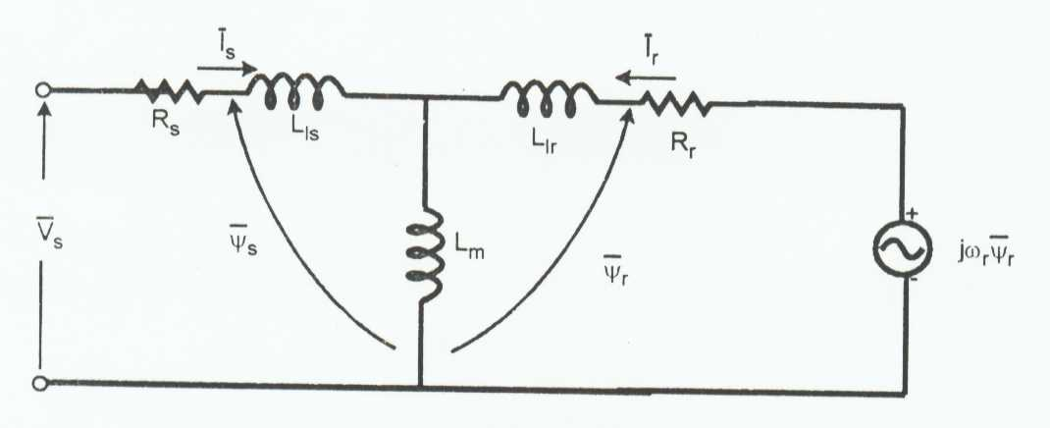
Fig 6.8.1 (a) stationary frame complex equivalent circuit
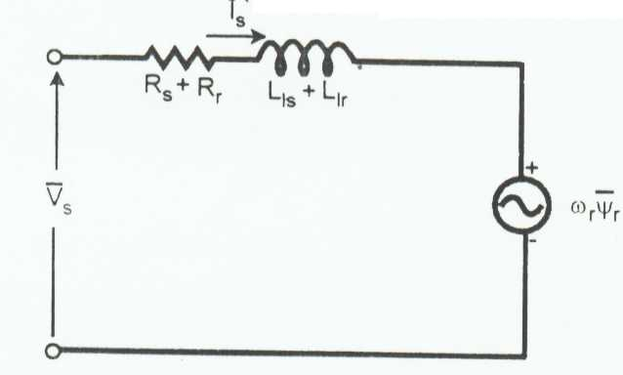
Fig 6.8.1 (b) simplified per phase equivalent circuit
Complex stationary frame with dqs equivalent circuits
Where, ω_{b} = base frequency of the machine
Substituting the above relations in equations (3.15), (3.16), (3.19) and (3.20), we can write
V_{qs} = R_{s}i_{qs} + (1/ω_{b})*dF_{qs}/dt + (ω_{e}/ω_{b})F_{ds} (3.55)
V_{ds} = R_{s}i_{ds} + (1/ω_{b})*dF_{ds}/dt - (ω_{e}/ω_{b})F_{qs} (3.56)
0 = R_{r}i_{qr} + (1/ω_{b})*dF_{qr}/dt + ((ω_{e} – ω_{r}) /ω_{b})F_{dr} (3.57)
0 = R_{r}i_{dr} + (1/ω_{b})*dF_{dr}/dt - ((ω_{e} – ω_{r}) /ω_{b})F_{qr} (3.58)
where it is assumed that v_{qr} = v_{dr} =0
Multiplying equations (3.21) – (3.26) by ω_{b} on both sides, the flux linkage expressions can be written as
F_{qs} = ω_{b}ψ_{qs} = X_{ls}i_{qs} + X_{m}(i_{qs +} i_{qr}) (3.59)
F_{qr}= ω_{b}ψ_{qr} = X_{lr}i_{qr} + X_{m}(i_{qs +} i_{qr}) (3.60)
F_{qm} = ω_{b}ψ_{qm} = X_{m}(i_{qs +} i_{qr}) ) (3.61)
F_{ds} = ω_{b}ψ_{ds} = X_{ls}i_{qs} + X_{m}(i_{ds +} i_{dr}) (3.62)
F_{dr} = ω_{b}ψ_{dr} = X_{lr}i_{qr} + X_{m}(i_{ds+} i_{dr}) (3.63)
F_{dm} = ω_{b}ψ_{dm} = X_{m}(i_{ds +} i_{dr}) (3.64)
Where X_{ls} = ω_{b}l_{ls}, X_{lr} = ω_{b}l_{lr}, X_{m} = ω_{b}l_{m},
or
F_{qs} = X_{ls} i_{qs} + F_{qm} (3.65)
F_{qr} = X_{lr} i_{qr} + F_{qm} (3.66)
F_{ds} = X_{ls} i_{ds} + F_{dm} (3.67)
F_{dr} = X_{lr} i_{dr} + F_{dm} (3.68)
From equations (3.65)-(3.68) the currents can be expressed in terms of the flux linkages as
I_{qs} = (F_{qs} – F_{qm})/X_{ls} (3.69)
I_{qr} = (F_{qr} – F_{qm})/X_{lr} (3.70)
I_{ds} = (F_{ds} – F_{dm})/X_{ls} (3.71)
I_{dr} = (F_{dr} – F_{dm})/X_{ls} (3.72)
Substituting equations (3.69)-(3.72) in (3.65)-(3.66) respectively, the F_{qm} expression is given as
F_{qm} = X_{ml}[((F_{qs} – F_{qm})/X_{ls}) + ((F_{qr} – F_{qm})/X_{lr})] (3.73)
F_{qm} = (X_{ml}/X_{ls})F_{qs} +(X_{ml}/X_{lr})F_{qr} (3.74)
Where
X_{ml} = 1/((1/X_{m})+(1/X_{ls})+(1/X_{lr})) (3.75)
Similar derivation can be made for F_{qm} as follows:
F_{dm} = (X_{ml}/X_{ls})F_{ds} +(X_{ml}/X_{lr})F_{dr} (3.76)
Substituting the current equations (3.69)-(3.72) into the voltage equations (33.55)-(33.68),
V_{qs} = R_{s}(F_{qs} – F_{qm})/ X_{ls} + (1/ω_{b})*dF_{qs}/dt + (ω_{e}/ω_{b})F_{ds} (3.77)
V_{ds} = R_{s}(F_{ds} – F_{dm})/ X_{ls} + (1/ω_{b})*dF_{ds}/dt - (ω_{e}/ω_{b})F_{qs} (3.78)
0 = R_{r}(F_{qr} – F_{qm})/ X_{lr} + (1/ω_{b})*dF_{qr}/dt + ((ω_{e} – ω_{r}) /ω_{b})F_{dr} (3.79)
0 = R_{s}(F_{dr} – F_{dm})/ X_{lr} + (1/ω_{b})*dF_{dr}/dt - ((ω_{e} – ω_{r}) /ω_{b})F_{qr} (3.80)
which can be expressed in state-space form as?
dF_{qs}/dt = ω_{b}[v_{qs} - (ω_{e}/ω_{b})F_{ds} – (R_{s}/X_{ls}) (F_{qs} – F_{qm}) (3.81)
dF_{ds}/dt = ω_{b}[v_{qs} - (ω_{e}/ω_{b})F_{qs} – (R_{s}/X_{ls}) (F_{ds} – F_{dm}) (3.82)
dF_{qr}/dt = -ω_{b}[((ω_{e} – ω_{r})/ω_{b})F_{dr} – (R_{r}/X_{lr}) (F_{qr} – F_{qm})] (3.83)
dF_{dr}/dt = -ω_{b}[ - ((ω_{e} – ω_{r})/ω_{b})F_{qr} – (R_{r}/X_{lr}) (F_{dr} – F_{dm})] (3.84)
Finally, from equation (3.37)
T_{e} = (3/2)(p/2) (F_{ds}i_{qs} – F_{qs}i_{ds}) (3.85)
Equations (3.81)-(3.85) ,along with Equation (3.28) ,describe the complete model in state-space from F_{qs}, F_{ds}, F_{qr}, F_{dr} are the state variables.
CHAPTER-7
MATLAB & SIMULINK
7.1 MATLAB
7.1.1 INTRODUCTION
MATLAB® is a high-level technical computing language and interactive environment for algorithm development, data visualization, data analysis, and numeric computation. Using the MATLAB product, you can solve technical computing problems faster than with traditional programming languages, such as C, C++, and FORTRAN.
MATLAB is used in wide range of applications, including signal and image processing, communications, control design, test and measurement, financial modeling and analysis, and computational biology. Add-on toolboxes (collections of special-purpose MATLAB functions, available separately) extend the MATLAB environment to solve particular classes of problems in these application areas. MATLAB provides a number of features for documenting and sharing your work. You can integrate your MATLAB code with other languages and applications, and distribute your MATLAB algorithms and applications.

7.1.2 KEY FEATURES
- High-level language for technical computing
- Development environment for managing code, files, and data
- Interactive tools for iterative exploration, design, and problem solving
- Mathematical functions for linear algebra, statistics, Fourier analysis, filtering, optimization, and numerical integration
- 2-D and 3-D graphics functions for visualizing data.
- Tools for building custom graphical user interfaces
- Functions for integrating MATLAB based algorithms with external applications and languages, such as C, C++, Fortran, Java, COM, and Microsoft Excel
7.2 SIMULINK
7.2.1 INTRODUCTION
Simulink® is an environment for multidomain simulation and Model-Based Design for dynamic and embedded systems. It provides an interactive graphical environment and a customizable set of block libraries that let you design, simulate, implement, and test a variety of time-varying systems, including communications, controls, signal processing, video processing, and image processing. Add-on products extend Simulink software to multiple modeling domains, as well as provide tools for design, implementation, and verification and validation tasks.
Simulink is integrated with MATLAB®, providing immediate access to an extensive range of tools that let you develop algorithms, analyze and visualize simulations, create batch processing scripts, customize the modeling environment, and define signal, parameter, and test data.
7.2.2 KEY FEATURES
- Extensive and expandable libraries of predefined blocks
- Interactive graphical editor for assembling and managing intuitive block diagrams
- Ability to manage complex designs by segmenting models into hierarchies of design components
- Model Explorer to navigate, create, configure, and search all signals, parameters, properties, and generated code associated with your model
- Application programming interfaces (APIs) that let you connect with other simulation programs and incorporate hand-written code, external hardware or software in real-time.
- Embedded MATLAB™ Function blocks for bringing MATLAB algorithms into Simulink and embedded system implementations
- Simulation modes (Normal, Accelerator, and Rapid Accelerator) for running simulations interpretively or at compiled C-code speeds using fixed- or variable-step solvers
- Graphical debugger and profiler to examine simulation results and then diagnose performance and unexpected behavior in your design
- Full access to MATLAB for analyzing and visualizing results, customizing the modeling environment, and defining signal, parameter, and test data
- Model analysis and diagnostics tools to ensure model consistency and identify modeling errors.
7.2.3 BLOCK DIAGRAM
A Simulink block diagram is a pictorial model of a dynamic system. It consists of a set of symbols, called blocks, interconnected by lines The lines represent connections of block inputs to block outputs. Every block in a block diagram is an instance of a specific type of block. making it suitable for real-time applications in MPPT controllers. Its effectiveness, The type of the block determines the relationship between a block's outputs and its inputs, states, and time. A block diagram can contain any number of instances of any type of block needed to model a system. Blocks represent elementary dynamic systems that Simulink knows how to simulate.
A block comprises one or more of the following
- A set of inputs
- A set of states
- A set of outputs
A block's output is a function of time and the block's inputs and states (if any). The specific function that relates a block's output to its inputs, states, and time depends on the type of block of which the block is an instance. Continuous Versus discrete Blocks Simulink standard block set includes continuous blocks and discrete blocks. Continuous blocks respond continuously to continuously changing input. Discrete blocks, by contrast, respond to changes in input only at integral multiples of a fixed interval called the block's sample time. Discrete blocks hold their output constant between successive sample time hits. Each discrete block includes a sample time parameter that allows you to specify its sample rate. The Simulink blocks can be either continuous or discrete, depending on whether they are driven by continuous or discrete blocks. A block that can be either discrete or continuous is said to have an implicit sample rate. The implicit sample time is continuous if any of the block's inputs are continuous. The implicit sample time is equal to the shortest input sample time if all the input sample times are integral multiples of the shortest time. Otherwise, the input sample time is equal to the fundamental sample time of the inputs, where the fundamental sample time of a set of sample times is defined as the greatest integer divisor of the set of sample times. Some blocks in Simulink have internal states or parameters that affect their behavior. These states can represent things like the current state of a dynamic system (e.g., the position and velocity of a mass in a spring-mass-damper system) or the coefficients of a mathematical equation (e.g., the parameters of a transfer function). The output of such blocks may depend not only on the current inputs but also on the history of inputs and the current state of the block.
Simulink can optionally color code a block diagram to indicate the sample times of the blocks it contains, e.g., black (continuous), magenta (constant), yellow (hybrid), red (fastest discrete), and so on. The block contains block name, icon, and block library that contain the block, the purpose of the block
7.2.4 SIMULINK BLOCK LIBRARIES
Simulink organizes its blocks into block libraries according to their behavior
- The Sources library contains blocks that generate signals.
- The Sinks library contains blocks that display or write block output.
- The Discrete library contains blocks that describe discrete-time components.
- The Continuous library contains blocks that describe linear functions.
- The Math library contains blocks that describe general mathematics functions.
- The Functions & Tables library contains blocks that describe general functions and table.
- look-up operations.
- The Nonlinear library contains blocks that describe nonlinear functions.
- The Signal & Systems library contains blocks that allow multiplexing and demultiplexing, implement external input/output, pass data to other parts of the model & perform other functions.
- The Subsystems library contains blocks for creating various types of subsystems. The Block sets and Toolboxes library contains the Extras block library of specialized blocks.
7.2.5 SUB SYSTEMS
Simulink allows to model a complex system as a set of interconnected subsystems each of which is represented by a block diagram. We create a subsystem using Simulink's Subsystem block and the Simulink model editor. We can embed subsystems with subsystems to any depth to create hierarchical models. We can create conditionally executed subsystems that are executed only when a transition occurs on a triggering or enabling input.
7.2.6 SOLVERS
Simulink simulates a dynamic system by computing its states at successive time step solver a specified time span, using information provided by the model. The process of computing the successive states of a system from its model is known as solving the model. No single method of solving a model suffices for all systems. Accordingly, Simulink provides a set of programs, known as solvers, that each embody a particular approach to solving a model. The Simulation Parameters dialog box allows us to choose the solver most suitable for our model.
7.2.7 FIXED-STEP SOLVERS
Fixed-step solvers solve the model at regular time intervals from the beginning to the end of the simulation. The size of the interval is known as the step-size. We can specify the step size or let the solver choose the step size. Generally decreasing the step size increases the accuracy of the results while increasing the time required to simulate the system.
7.2.8 VARIABLE-STEP SOLVERS
Variable-step solvers vary the step size during the simulation, reducing the step size to increase accuracy when a model's states are changing rapidly and increasing the step size to avoid taking unnecessary steps when the model's states are changing slowly. And it can reduce the total number of steps, and hence simulation time, required to maintain a specified level of accuracy for models with rapidly changing or piecewise continuous states. The implicit sample time is continuous if any of the block's inputs are continuous. The implicit sample time is equal to the shortest input sample time if all the input sample times are integral multiples of the shortest time.
7.2.8 CONTINUOUS SOLVERS
Continuous solvers use numerical integration to compute a model's continuous states at the current time step from the states at previous time steps and the state derivatives. Continuous solvers rely on the model's blocks to compute the values of the model's discrete states at each time step. Mathematicians have developed a wide variety of numerical integration techniques for solving the ordinary differential equations (ODEs) that represent the continuous states of dynamic systems. Simulink provides an extensive set of fixed-step and variable-step continuous solvers, each implementing a specific ODE solution method. Some continuous solvers subdivide the simulation time span into major and minor steps, where a minor time step represents a subdivision of the major time step. The solver produces a result at each major time step. It uses results at the minor time steps to improve the accuracy of the result at the major time step.
7.2.9 DISCRETE SOLVERS
Discrete solvers exist primarily to solve purely discrete models. They compute the next simulation time-step for a model and nothing else. They do not compute continuous states and they rely on the model's blocks to update the model's discrete states. We can use a continuous solver, but not a discrete solver, to solve a model that contains both continuous and discrete states. This is because a discrete solver does not handle continuous states. If you select a discrete solver for a continuous model, Simulink disregards your selection and uses a continuous solver instead when solving the model. Simulink provides two discrete solvers, a fixed-step discrete solver and a variable-step discrete solver. The fixed-step solver by default chooses a step size and hence simulation rate fast enough to track state changes in the fastest block in our model. The variable-step solver adjusts the simulation step size to keep pace with the actual rate of discrete state changes in our model. This can avoid unnecessary steps and hence shorten simulation time for multi rate models.
7.3 THE POWER SYSTEM BLOCK SET
Electrical power systems are combinations of electrical circuits and Electro-mechanical devices, like motors and generators. Engineers working in this discipline are frequently tasked to improve the performance of the systems. Requirements for drastically increased efficiency have forced power system designers to use power electronic devices and sophisticated control system concepts that tax traditional analysis tools and techniques. Further complicating the analyst’s role is the fact that the system is often so nonlinear that the only way to understand it is through simulation. Land-based power generation from hydroelectric, steam, or other devices is not the only use of power systems. A common attribute of these systems is their use of power electronics and control systems to achieve their performance objectives. The Power System Block set was designed to provide a modern design tool that will allow scientists and engineers to rapidly and easily build models that simulate power systems. The block set uses the Simulink® environment allowing a model to be built using simple click and drag procedures. Not only can the circuit topology be drawn rapidly, but the analysis of the circuit can include its interactions with mechanical, thermal, control, and other disciplines. This is possible because all the electrical parts of the simulation interact with Simulink extensive modeling library. Because Simulink uses MATLAB® as the computational engine, you can use MATLAB’s toolboxes as you design your simulation.
The block set can be put to work rapidly. The libraries contain models of typical power equipment, such as transformers, lines, machines, and power electronics. These models are proven ones coming from textbooks, and their validity is based on the experience of the Power Systems Testing and Simulation Laboratory of Hydro-Québec, a large North American utility located in Canada. The capabilities of the block set for modeling a typical electrical grid are illustrated in demonstration files. The block set fits well with other specialized analytical tools you use in the power system community.
7.4 SIMULINK BLOCKS USED IN THE SIMULATION
7.4.1 THREE-PHASE SOURCE
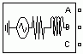
Purpose: Implement three-phase source with internal R-L impedance
Description: The Three-Phase Source block implements a balanced three-phase voltage source with internal R-L impedance. The three voltage sources are connected in Y with a neutral connection that can be internally grounded or made accessible. You can specify the source internal resistance and inductance either directly by entering R and L values or indirectly by specifying the source inductive short-circuit level and X/R ratio.
7.4.2 IN PORT
Purpose: Provide a link to an external input and for linearization.
Description: In ports are the links from the outside world into a system. Inside a subsystem block, there is an in port corresponding to each input port on the block. A signal that arrives at an input port on a subsystem block flows out of the corresponding in port within that block. The imports within a subsystem block must be numbered consecutively, starting with1.
7.4.3 OUT PORT
Purpose: provide a link to an external output and for linearization.
Description: The Out port block provides a mechanism for labeling a system’s outputs. In a subsystem, output ports correspond to outputs on the subsystem block.
7.4.4 SUB-SYSTEM
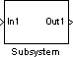
Purpose: Group blocks into a subsystem
Description: Subsystem blocks represent one system within another system. Any set of blocks and lines can be converted to a Subsystem block with the Group command on the options menu. The Group command removes all selected objects from the active window and replaces them within a Subsystem block. This new block, when opened, redisplays all of the grouped objectives.
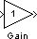
7.4.5 GAIN
Purpose: Multiply its input by a constant.
Description: The Gain block implements Y=KU, where Y is the output, U is the input, and K is the specified gain. The Gain block displays scalar gain data entered as variable or a constant. The block displays the text as it appears in the dialog box.

7.4.6 SCOPE
Purpose: Display signals during simulation.
Description: While the simulation is running, the Scope block displays the output of the block driving it. Opening a scope block produces a scope window. The title of this window matches the name of the block.
7.4.7 SIMPLIFIED SYNCHRONOUS MACHINE
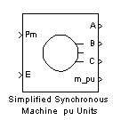
Purpose: Model the dynamics of a simplified three-phase synchronous machine
Description: The Simplified Synchronous Machine block models both the electrical and mechanical characteristics of a simple synchronous machine. The electrical system for each phase consists of a voltage source in series with RL impedance, which implements the internal impedance of the machine. The value of R can be zero but the value of L must be positive.
7.4.8 VOLTAGE MEASUREMENT
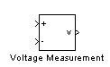
Purpose: Measure a voltage in a circuit
Description: The Voltage Measurement block is used to measure the instantaneous voltage between two electric nodes. The output is a Simulink signal that can be used
by other Simulink blocks.
7.4.9 BREAKER
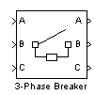
Purpose: Implement a circuit breaker opening at current zero crossing
Description: The Breaker block implements a circuit breaker that is controlled by a Simulink signal applied on its second input. The control signal must be 0 or 1, 0 for open and 1 for closed. The arc extinction process is simulated by opening the breaker when the current passes through zero (first current zero-crossing following the transition of the Simulink control input from 1 to 0). When the breaker is closed, it behaves as a series RL circuit. The R and L values can be set as small as necessary in order to be negligible compared with external components (typical values Ron=10m?, Lon=10µH). When the breaker is open, it has infinite impedance. If the breaker’s initial state is set to 1 (closed), initializes all the states of the linear circuit and breaker initial current so that the simulation starts in steady-state.
7.4.10 BUS BAR
Purpose: Implement a labeled network node
Description: The Bus Bar block is used to interconnect components. It allows multiple electrical block outputs and inputs to be connected together.
7.4.11 CURRENT MEASUREMENT
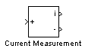
Purpose: Measure a current in a circuit
Description: The Current Measurement block is used to measure the instantaneous current flowing in any electrical block or connection line. The first output provides a Simulink signal that can be used by other Simulink blocks.
7.4.12 DISTRIBUTED PARAMETER LINE
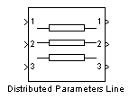
Purpose: Implement an N-phase distributed parameter transmission line model with lumped losses
Description: The Distributed Parameter Line block implements an N-phase distributed parameter line model with lumped losses.
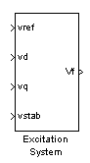
7.4.13 EXCITATION SYSTEM
Purpose: Provide an excitation system for the synchronous machine and regulate its terminal voltage in generating mode
Description: The basic elements that form the Excitation System block are the voltage regulator and the exciter. The voltage regulator consists of a main regulator with gain K_{a} and time constant T_{a} and a lead-lag compensator with time constants T_{b} and T_{c}. A derivate feedback is also provided with gain K_{f} and time constant T_{f}. The limits E_{fmin} and E_{fmax} are imposed to the output of the voltage regulator. The upper limit can be constant and equal to Efmax or variable and equal to the rectified stator terminal voltage V_{tf} times a proportional gain K_{p}. If K_{p} is set to zero, the former will apply. If K_{p} is set to a positive value, the latter will apply. The stator terminal voltage transducer is represented by a first-order low-pass filter with time constant T_{r}.
7.4.14 STEAM TURBINE AND GOVERNOR
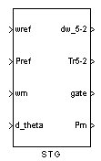
Purpose: Model a steam turbine and a PID governor system
Description: The Steam Turbine and Governor implement a steam turbine model, a PID governor system, and a servo-motor. The static gain of the governor is equal to the inverse of the permanent droop Rp in the feedback loop. The input to this feedback loop can be selected to be the gate position or the electrical power deviation by setting the droop reference parameter in the dialog box to one or zero, respectively.

7.4.15 LINEAR TRANSFORMER
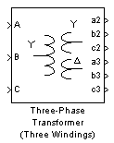
Purpose: Implement a two- or three-winding linear transformer
Description: The Linear Transformer block model shown below consists of three coupled windings wound on the same core.
7.4.16 SATURABLE TRANSFORMER
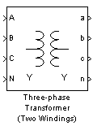
Purpose: Implement a two- or three-winding saturable transformer
Description: The Saturable Transformer block model shown below consists of three coupled windings wound on the same core.

CHAPTER-8
MODELLING & SIMUALTION
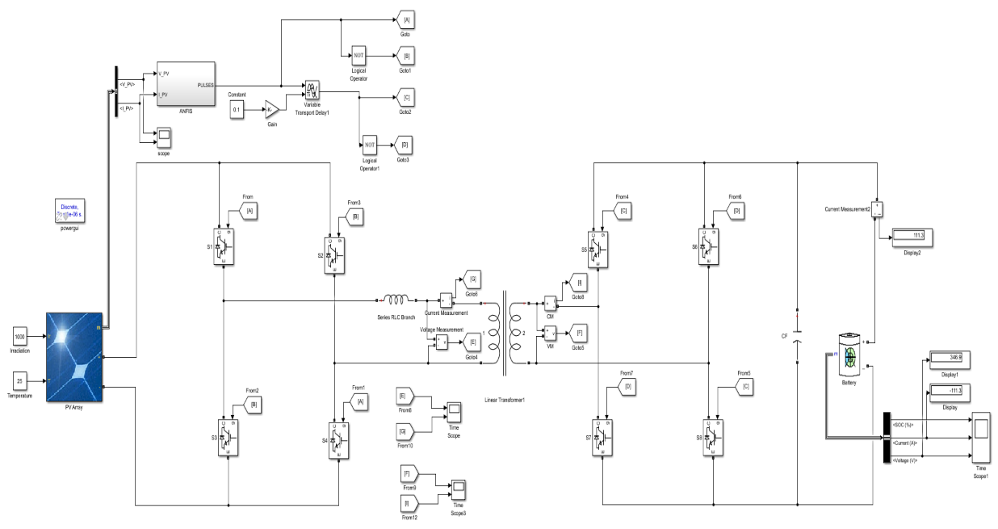
8.1 MODEL OF SIMULATION DIAGRAM
Fig 8.1 Simulation diagram of solar powered DC fast charging Using ANFIS technology with lithium-ion battery
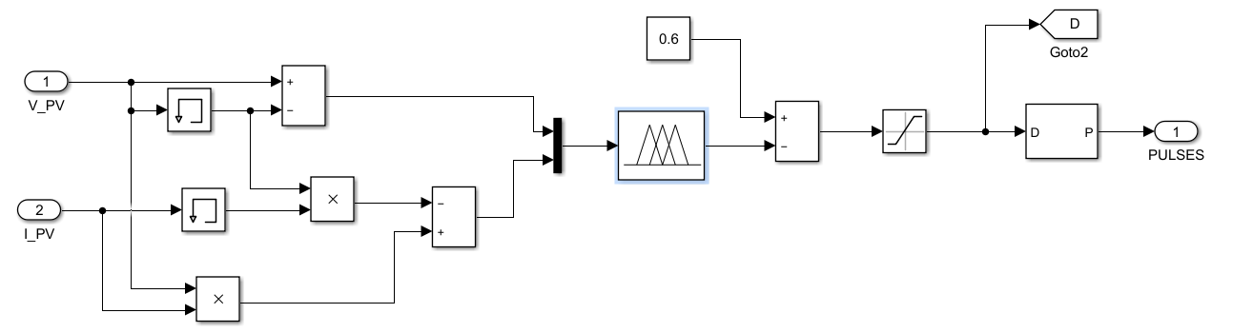
Fig 8.2 Sub system of AI based ANFIS controller
8.2 SIMULATION RESULTS
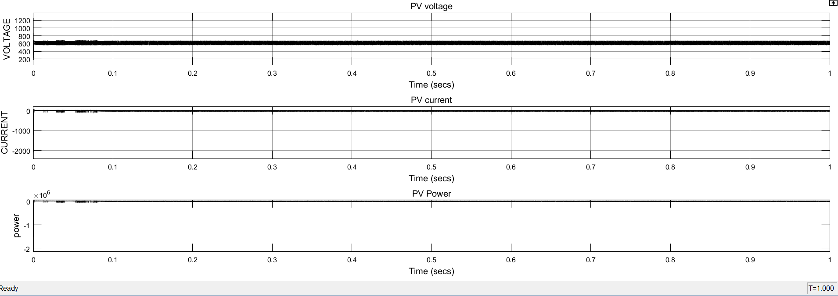
Fig 8.3. Solar output Voltage, current and power
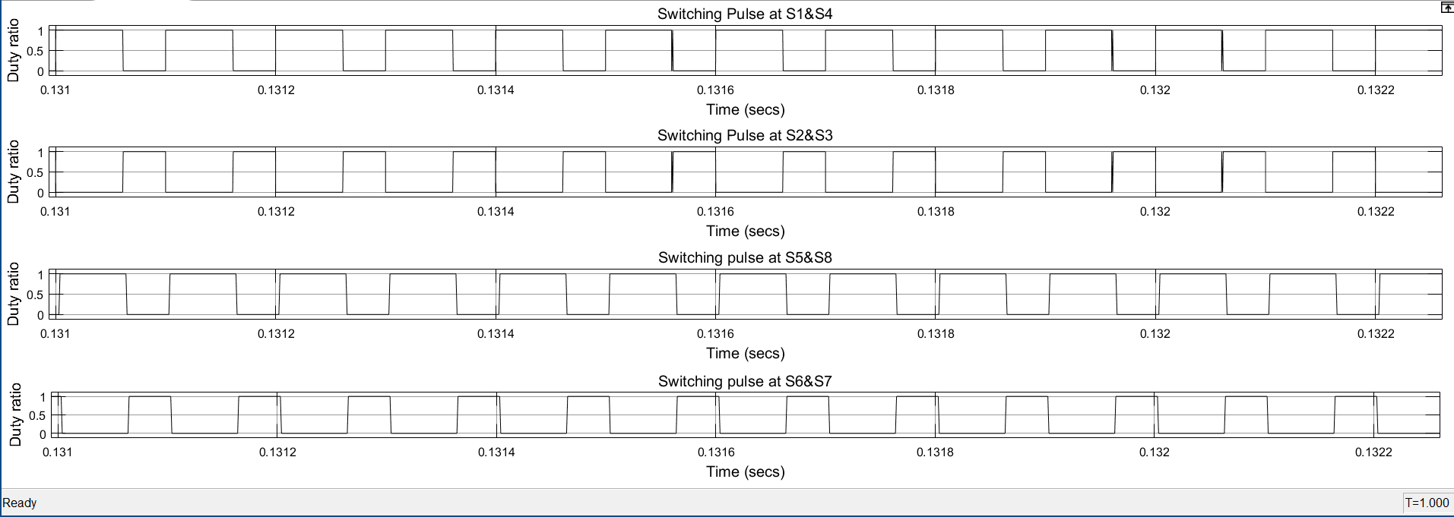
The above figure illustrates the PV voltage and PV current generated by a PV solar panel under specific conditions of 1000 irradiations and 25 degrees temperature, exhibiting minimal ripple content. This output is then fed into the ANFIS controller to obtain a regulated output voltage, which is subsequently stored in the battery.
Fig 8.4 Controlled switching pulses at each switch of two input and output converter
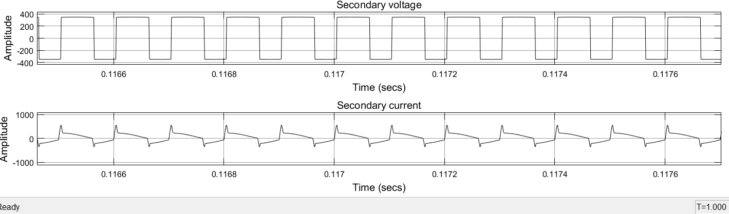
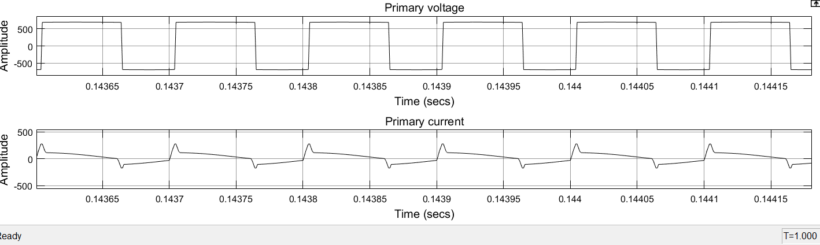
Fig 8.5. Transmitter coil/ primary winding voltage and current
Fig 8.6. Receiving coil/ secondary winding voltage and current
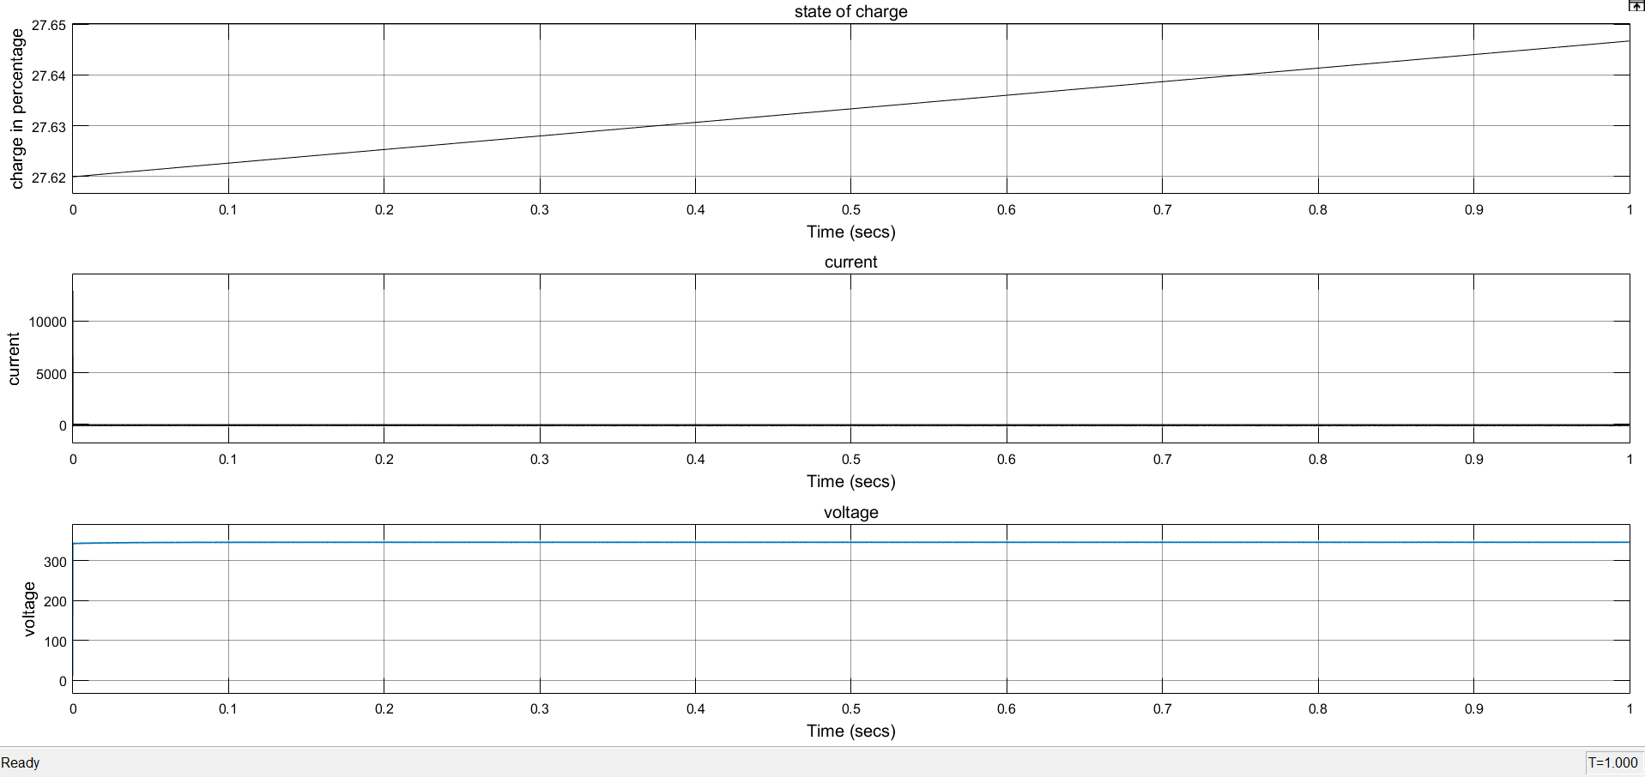
Fig 8.7. Battery State of charge, Battery current and Battery voltage
The aforementioned figure displays the Battery State of Charge, Battery Voltage, and Battery Current. Initially, the battery has a charge of 27%. Through the efficient utilization of PV energy source, the battery is charged by 75% within a time period of 50 min. The output voltage and current exhibit minimal ripple content.

CHAPTER-9
CONCLUSION
Designed and simulated the model using MATLAB SIMULINK software. The results indicate that the electric vehicle was able to charge up to 75% in less than an hour. In this approach, the vehicle's battery was charged using renewable solar energy through a wireless connection based on the mutual inductance principle, employing a Dual Active Bridge converter. The output of the Dual Active Bridge converter was effectively regulated using an Artificial Intelligence-based ANFIS controller. Battery is recharges itself through regenerative braking when brake applies. Additionally, energy flowed in both directions, from the grid to the vehicle and from the vehicle to the grid. The results demonstrated that this proposed system is highly efficient and cost-effective. In future Machine learning technology is used to improve the charging capacity.

REFERENCES
[1] Artur. J. Moradewicz; Rafał M. Miśkiewicz, “Bidirectional inductive contactless energy transfer system topology for electric vehicles”, 2014 IEEE International Electric Vehicle Conference (IEVC), 09 March 2015.
[2] Lei Zhao; Duleepa J. Thrimawithana; Udaya K. Madawala; Craig A. Baguley, “Performa -nce optimization of LC bi-directional inductive power transfer system”, 2015 IEEE 13th Brazilian Power Electronics Conference and 1st Southern Power Electronics Conference (COBEP/SPEC),29 February 2016.
[3] Abhinav Bhattacharjee; Sangit Saha; D Elangovan; G Arunkumar, “Design of circuit for battery charging of electric vehicles: From renewable energy sources”, 2017 Conference on Energy, Communication, Data Analytics and Soft Computing (ICECDS),21 June 2018.
[4] Karima Amara; Arezki Fekik; D. Hocine; Mohamed Lamine Bakir; El-Bay Bourennane, “Improved Performance of a PV Solar Panel with Adaptive Neuro Fuzzy Inference Syste -m ANFIS based MPPT”, 2018 7th International Conference on Renewable Energy Research and Applications (ICRERA),09 December 2018.
[5] Anjeet Verma; Bhim Singh, “Solar PV Array-WECS Based Integrated EV Charging System with Dual Mode of Operation”, 2018 IEEE 8th Power India International Confer -ence (PIICON),02 May 2019.
[6] Nesar Uddin; Md. Saiful Islam, “Optimization of PV Energy Generation based on ANFIS”, 2018 International Conference on Innovations in Science, Engineering and Technology (ICISET),27 June 2019.
[7] Pin-Yu Huang;Takahiro Ohta;"Bidirectional Isolated Ripple Cancel Dual Active Bridge DC-DC Converter", 2019 IEEE Third International Conference on DC Microgrids (ICDCM), 20-23 May 2019.
[8] Jitendra Gupta; Bhim Singh, “A Bidirectional Home Charging Solution for an Electric Vehicle”, 2019 IEEE International Conference on Environment and Electrical engineerin -g and 2019 IEEE Industrial and Commercial Power Systems Europe (EEEIC / I&CPS Europe),01 August 2019.
[9] Marcos Aguirre; Amirnaser Yazdani, “A Single-Phase dc-ac Dual-Active-Bridge Based Resonant Converter For Grid-Connected Photovoltaic (PV) Applications”, 2019 21st European Conference on Power Electronics and Applications (EPE '19 ECCE Europe), 28 November 2019.
[10] M. K. Loganathan; Cher Ming Tan; Bikash Mishra; Titus A. M. Msagati; Lukas W. Snyman, “Review and selection of advanced battery technologies for post 2020 era electric vehicles”, 2019 IEEE Transportation Electrification Conference (ITEC-India),30 April 2020.
[11] Puja Vilas Patil; Syed A. Naveed, “Implementation of VFD Application for Speed Control of Induction Motor”, 2020 International Conference on Smart Innovations in Design, Environment, Management, Planning and Computing (ICSIDEMPC),01 January 2021.
[12] P. Suwanapingkarl; S. Prakobkit; K. Srivallop; M. Boonthienthong, “Reviews: The Impacts of Electric Vehicles (EVs) and Renewable Energy Resources (REs) on The Distribution Power Network”, 2020 International Conference on Power, Energy and Innovations (ICPEI),18 May 2021.

