DATA SCIENCE TOOLBOX: PYTHON PROGRAMMING PROJECT REPORT
(Project Semester August-December 2018)

Exploratory Data Analysis of IPL Dataset for Player and Team Performance

Submitted by
T.Hemanth Yadav
Registration No: 12409760
Programme and Section: P132, 324PB Course Code: INT375

Under the Guidance of

Dr. Gargi Sharma UID: 29439

Discipline of CSE/IT

Lovely School of Computer Science And Engineering

Lovely Professional University, Phagwara

CERTIFICATE

This is to certify that T.Hemanth Yadav bearing Registration no. 12409760 has completed INT375 project titled, “.................................” under my guidance and supervision. To the best of my knowledge, the present work is the result of his/her original development, effort and study.

Signature and Name of the Supervisor Designation of the Supervisor
School of Computer Science And Engineering
Lovely Professional University Phagwara, Punjab.

Date: 22-04-2026

DECLARATION

I, T.Hemanth Yadav, student of B.Tech, under CSE/IT Discipline at, Lovely Professional University, Punjab, hereby declare that all the information furnished in this project report is based on my own intensive work and is genuine.

Hemanth yadav
Date: 22-04-2026 Signature

Registration No.: 12417615 Name of the student: hemanth

Table of Contents

Section No. Title | Page No.
1 Introduction | 6
1.1 Overview of IP | 6
1.2 Importance of Data Analysis | 6
1.3 Objectives of the Project | 7
2 Scope of the Analysis | 5
2.1 Areas Covered | 6
2.2 Limitations | 6
3 Existing System | 8
3.1 Traditional Analysis Methods | 9
3.2 Limitations of Existing System | 10
4 Source of Dataset | 11
5 ETL Process | 12
5.1 Data Extraction | 13
5.2 Data Cleaning | 14
5.3 Data Transformation | 15
6 Methodology | 16
7 Data Cleaning and Preprocessing | 17
8 Analysis on Dataset | 18
8.1 Player Analysis | 19
8.2 Team Analysis | 20
8.3 Captain Analysis | 21
8.4 Special Player Analysis (MS Dhoni) | 23
8.5 Distribution Analysis | 24
8.6 Comparative Analysis | 25
9 Results and Insights | 26
10 Visualization | 27
11 Future Scope | 28
12 References | 29
13 Bibliography | 30

- Introduction

The Indian Premier League (IPL) is one of the most popular T20 cricket leagues in the world. It consists of multiple teams representing different cities and includes both international and domestic players. Over the years, IPL has generated a large amount of data related to matches, players, and team performance. In this project, Exploratory Data Analysis (EDA) is performed on IPL data to understand patterns, trends, and performance metrics. The dataset contains detailed information such as runs scored, balls faced, strike rate, number of fours and sixes, and match details. The main purpose of this project is to analyze player and team performance using data science techniques and visualize the results using different graphs. This helps in gaining insights and understanding the importance of data in sports analytics.

  - Overview of IPL

The project is trying to do a few specific things, so here they are straight —

Understand how pollution is actually distributed across different regions, not just on average but where it concentrates and where it doesn't. Clean the data properly before touching any analysis — missing values, outliers, the usual mess that comes with real datasets. Visualise the patterns so the numbers aren't just sitting in a table doing nothing. Build a Linear Regression model that predicts average pollution using minimum and maximum values as inputs. Check if that model actually works using MSE, MAE and R². And finally pull out something useful from all of it — something that could actually inform a decision, not just fill pages.

  - Importance of Data Analysis

Data analysis plays a crucial role in modern sports. Teams use data to evaluate player performance, identify strengths and weaknesses, and make better decisions. In cricket, factors like strike rate, runs scored, and boundary percentage are important indicators of performance. By analyzing such data, teams can improve strategies such as batting order and player selection. Exploratory Data Analysis helps in understanding the dataset by identifying trends, patterns, and relationships. It is the first step in any data science project and provides valuable insights

1.3. Objectives of the Project

The main objectives of this project are to perform Exploratory Data Analysis on the IPL dataset, to analyze player performance based on runs, strike rate, and boundaries, to identify top players and consistent performers, to analyze team performance and match trends, to visualize the data using graphs such as bar charts, pie charts, histograms, and box plots, and to understand how data analysis can be applied in sports analytics.

- Scope of the Analysis

The scope of this project is to perform Exploratory Data Analysis on the IPL dataset to understand player performance, team performance, and overall match trends. The analysis focuses on identifying key insights such as top run scorers, strike rate analysis, boundary contributions, and consistency of players. It also includes team-based analysis such as total runs, matches played, and venue distribution. Special attention is given to captain performance and individual player analysis such as MS Dhoni. The project uses various visualization techniques to represent data clearly and effectively. The scope is limited to data analysis and visualization and does not include advanced machine learning models.

2.1 Areas Covered

This project covers multiple areas of analysis including player performance, team statistics, captain analysis, and match-related insights. Player analysis includes runs scored, strike rate, boundaries, and consistency. Team analysis includes total runs, matches played, and performance comparison. Captain analysis focuses on leadership performance such as runs scored and sixes hit. Distribution analysis is also performed to understand how runs and strike rates vary across players. Visualization techniques such as bar charts, pie charts, histograms, scatter plots, and box plots are used to present the data.

2.2 Limitations

The analysis is limited to the available dataset and does not consider external factors such as pitch conditions, weather, or player fitness. Some missing values in the dataset were handled during preprocessing, which may slightly affect the accuracy of results. The project focuses only on Exploratory Data Analysis and does not include predictive modeling or machine learning techniques. The insights are based on historical data and may not fully represent future performance
- Existing System
In traditional cricket analysis, performance is evaluated manually using basic statistics such as total runs, batting average, and strike rate. Analysts and commentators rely on simple comparisons and past records to understand player and team performance. Most of the analysis is descriptive and does not use advanced data processing techniques. This approach makes it difficult to analyze large datasets and identify deeper patterns or relationships. With the increase in data generated from leagues like IPL, traditional methods are not efficient for extracting meaningful insights.
3.1 Traditional Analysis Methods
Earlier, cricket analysis was mainly based on scorecards and basic statistics. Coaches and analysts used manual calculations and visual observations to evaluate players. Metrics like runs scored, number of wickets, and match results were used to judge performance. There was limited use of technology, and most decisions were based on experience rather than data-driven insights. This method is time-consuming and cannot handle complex data effectively.
3.2 Limitations of Existing System
The existing system has several limitations. It cannot process large volumes of data efficiently and fails to identify hidden patterns in the dataset. It lacks visualization techniques, making it difficult to understand trends clearly. The analysis is often subjective and may vary from person to person. It does not support detailed comparisons between players or teams based on multiple parameters. Due to these limitations, there is a need for a data-driven approach using modern tools and techniques.

- Source of Dataset

The dataset used in this project is based on IPL match and player data collected from publicly available sources. It contains detailed information about matches, players, teams, and performance statistics. The data includes attributes such as runs scored, balls faced, number of fours and sixes, strike rate, match identifiers, team names, venue details, and captain information. This dataset is suitable for performing Exploratory Data Analysis as it provides both player-level and match-level information.
The data is structured in tabular format and is loaded into Python using libraries such as Pandas. Each row in the dataset represents a record related to player performance in a match. The dataset is large enough to perform meaningful analysis and extract insights about player consistency, team performance, and scoring patterns.
The dataset was chosen because it represents real-world cricket data and allows analysis from multiple perspectives such as player performance, team contribution, and match trends. It helps in understanding how data science techniques can be applied to sports analytics.

- ETL Process
The ETL process stands for Extraction, Transformation, and Loading. It is an important step in any data analysis project as it prepares the raw data for analysis. In this project, the IPL dataset is processed using ETL techniques to ensure that the data is clean, consistent, and ready for analysis. The process includes extracting the dataset from the source, cleaning and transforming the data, and loading it into a suitable format for analysis using Python libraries.
5.1 Data Extraction
The data is extracted from a CSV file containing IPL match and player details. The dataset is loaded into the Python environment using the Pandas library. The data is read using functions like read_csv() and stored in a DataFrame. This step allows easy access and manipulation of the data for further processing.
5.2 Data Cleaning
Data cleaning is performed to handle missing values, remove duplicates, and correct any inconsistencies in the dataset. Columns with missing or irrelevant values are either filled or removed based on the requirement. This step ensures that the data is accurate and reliable for analysis. Any unnecessary columns that do not contribute to the analysis are dropped to improve efficiency.
5.3 Data Transformation
In this step, the data is transformed into a suitable format for analysis. New columns are created such as strike rate and runs per ball. Data types are converted where necessary, and grouping operations are performed to aggregate data based on players or teams. This step helps in preparing the dataset for visualization and deeper analysis.

- Methodology

The methodology used in this project is based on Exploratory Data Analysis (EDA). It involves understanding the dataset, cleaning and preparing the data, performing analysis using statistical techniques, and visualizing the results. The process starts with loading the dataset and checking its structure, followed by handling missing values and selecting relevant features. After preprocessing, different types of analysis are performed to study player performance, team statistics, and match trends.
The analysis is carried out using Python libraries such as Pandas for data manipulation, Matplotlib for basic visualization, and Seaborn for advanced visualization. Various techniques such as grouping, aggregation, and filtering are used to extract meaningful information from the dataset.
Different types of graphs are used to represent the data clearly. Bar charts are used to compare players and teams, pie charts are used to show proportions, histograms are used to understand distribution, scatter plots are used to study relationships, and box plots are used to identify consistency and variation.
This methodology helps in identifying patterns, trends, and insights from the dataset in a structured and efficient way.

- Data Cleaning and Preprocessing

Data cleaning and preprocessing is an important step before performing analysis. In this project, the IPL dataset is cleaned to remove errors and inconsistencies and to ensure accurate results. The raw dataset may contain missing values, duplicate entries, and unnecessary columns which need to be handled properly.
Initially, the dataset is inspected to understand its structure, data types, and missing values. Missing values are handled by either removing them or filling them based on the requirement. Duplicate records are identified and removed to avoid incorrect analysis.
Unnecessary columns that do not contribute to the analysis are dropped to simplify the dataset. Data types of columns are checked and converted where required. For example, numerical values such as runs and balls faced are ensured to be in the correct format.
New features are also created during preprocessing. Columns such as strike rate and runs per ball are calculated using existing data. Grouping and aggregation techniques are applied to summarize data based on players and teams.
This step ensures that the dataset is clean, consistent, and ready for analysis, which improves the accuracy and quality of the results.

8. Analysis on Dataset
In this section, detailed analysis is performed on the IPL dataset to understand player performance using different statistical measures and visualization techniques. The analysis focuses on identifying top performers, scoring patterns, and consistency among players. Various graphs are used to represent the data clearly and extract meaningful insights.

8.1 Player Analysis
Player analysis focuses on evaluating individual performance based on metrics such as runs, strike rate, boundaries, and consistency. This helps in identifying key players and understanding their contribution in matches.

8.1.1 Top Run Scorers
This analysis identifies the players who have scored the highest total runs in the IPL dataset. Total runs is one of the most important indicators of a player’s performance and consistency over time. By grouping the data based on player names and summing their runs, we can determine the top run scorers.
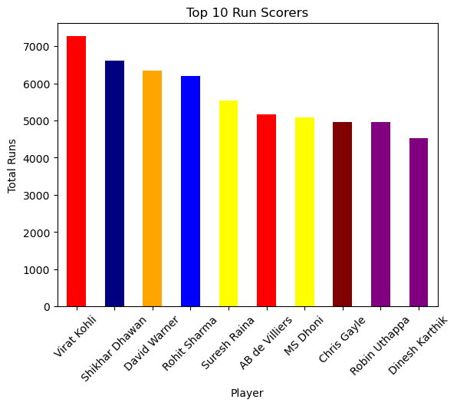
From the above graph, it is observed that a few players dominate in terms of total runs scored. These players are consistent performers and contribute significantly to their teams. Their ability to score runs across multiple matches makes them reliable batsmen.

8.1.2 Highest Individual Scores
This analysis focuses on identifying players who have achieved the highest runs in a single match. It highlights the ability of players to perform exceptionally well in individual games.
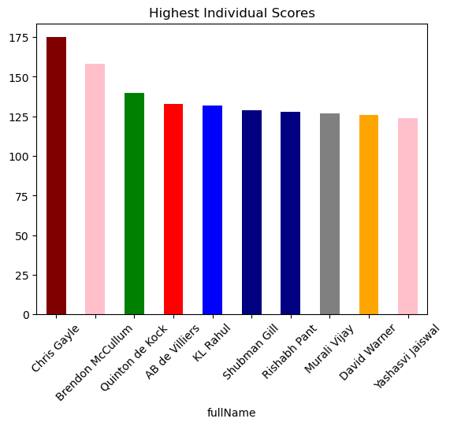
The graph shows that some players have achieved very high individual scores, indicating their capability to play match-winning innings. These performances are often crucial in determining the outcome of matches.

8.1.3 Strike Rate Analysis
Strike rate is a key performance metric in T20 cricket, as it represents how quickly a player scores runs. It is calculated as runs scored per 100 balls faced. Players with higher strike rates are considered aggressive and impactful.
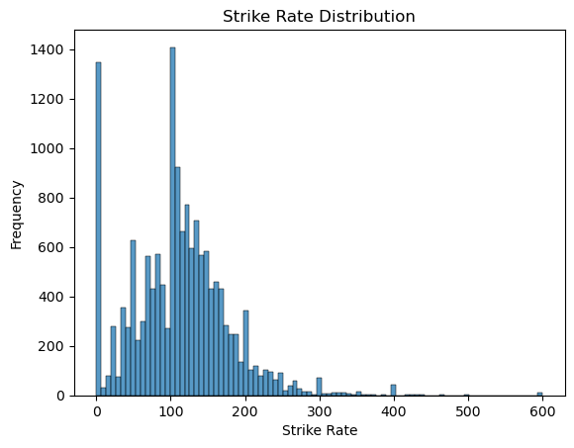
From the graph, it is clear that players with high strike rates contribute to faster scoring. These players are important in maintaining the run rate and putting pressure on the opposing team.

8.1.4 Boundary Analysis (Fours and Sixes)
This analysis examines the number of boundaries hit by players, including fours and sixes. Boundaries are important as they contribute to quick scoring and increase the overall run rate.
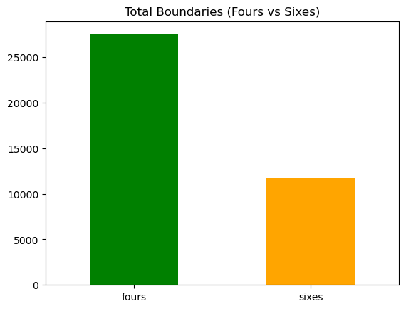
The graph indicates that players who hit more boundaries tend to score runs quickly and dominate the game. Boundary hitters play a crucial role in T20 matches by accelerating the scoring rate.

8.1.5 Consistent Players
Consistency is an important factor in evaluating player performance. In this analysis, consistency is measured using statistical methods such as variance. Players with lower variance in their scores are considered more consistent.
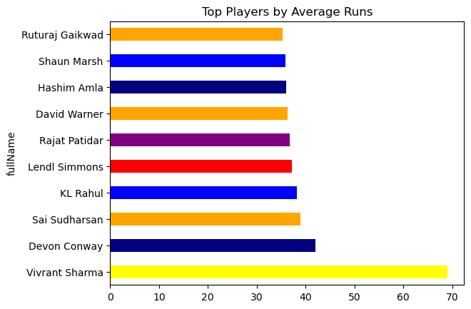
From the analysis, it is observed that some players maintain stable performance across matches. These players are dependable and contribute regularly to their team’s success.

8.2 Team Analysis
Team analysis focuses on evaluating the performance of different teams based on matches played, total runs scored, and venue distribution. This helps in understanding team participation, scoring strength, and match locations. By analyzing team-level data, we can compare teams and identify strong performers.

8.2.1 Matches Played by Teams
This analysis shows the number of matches played by each team in the dataset. It helps in understanding team participation and involvement across seasons. The data is collected by combining home and away matches and counting the total occurrences for each team.
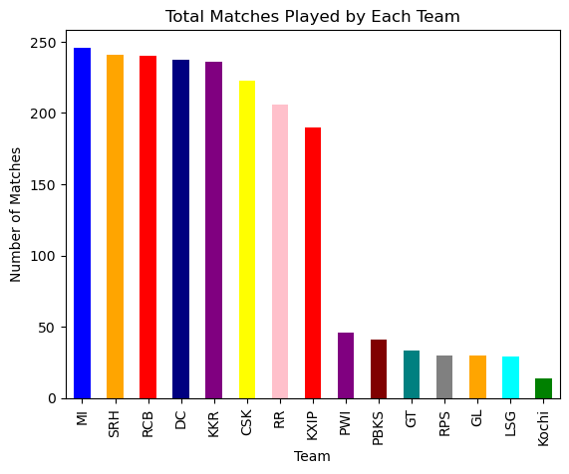
From the graph, it is observed that some teams have played more matches compared to others. This indicates their consistent participation in the IPL over multiple seasons. Teams with higher match counts have more exposure and experience.

8.2.2 Team Run Contribution
This analysis focuses on the total runs scored by each team. It helps in identifying teams with strong batting performance. The runs are aggregated for each team and compared using visualization.
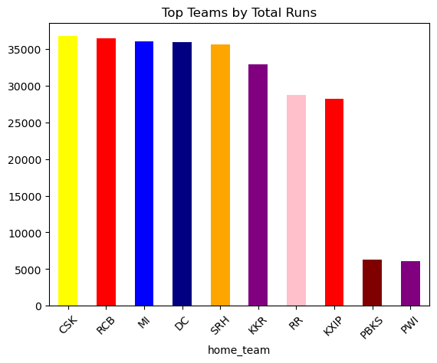
The graph shows that certain teams have scored significantly higher runs than others. These teams have strong batting lineups and consistent performance across matches. Higher total runs indicate better offensive strength

.

8.2.3 Venue Analysis
This analysis examines the number of matches played at different venues. It helps in understanding which stadiums host more matches and their importance in the IPL.
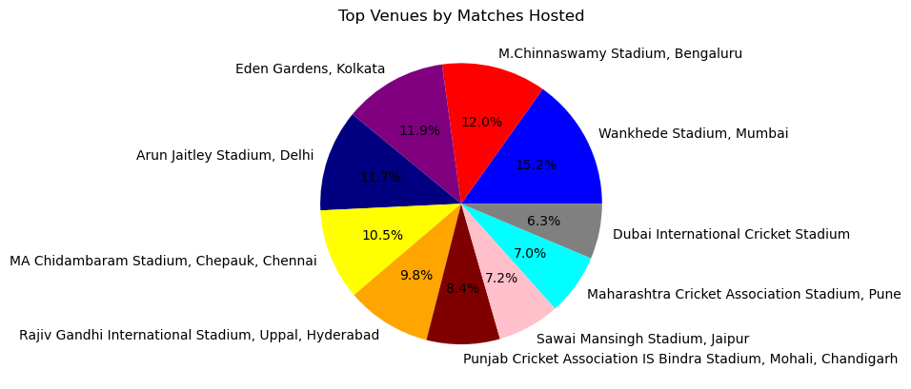
From the graph, it is observed that some venues host more matches than others. Popular stadiums are used more frequently due to better infrastructure and fan support. Venue analysis helps in understanding match distribution across locations.

8.3 Captain Analysis
Captain analysis focuses on evaluating the performance of players who have served as captains. It helps in understanding how leadership and individual performance contribute to team success. This analysis includes metrics such as matches played, runs scored, and sixes hit by captains.

8.3.1 Captains with Most Matches
This analysis shows the number of matches played by different captains. It helps in identifying experienced captains who have led their teams over multiple seasons.
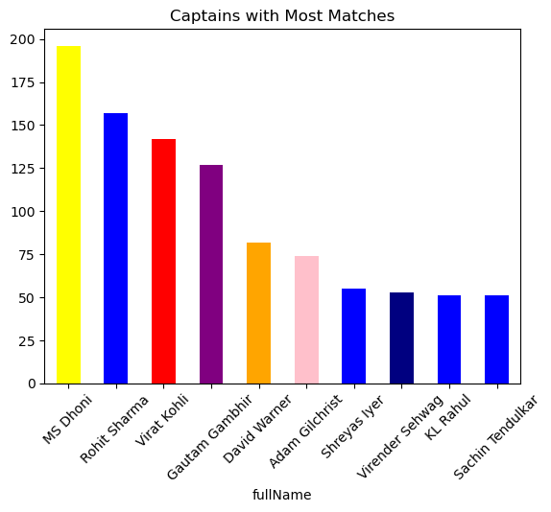
From the graph, it is observed that some captains have led their teams in a large number of matches. This indicates their experience and long-term contribution to the team.

8.3.2 Captains by Runs
This analysis focuses on the total runs scored by captains. It helps in identifying captains who contribute significantly with their batting performance.
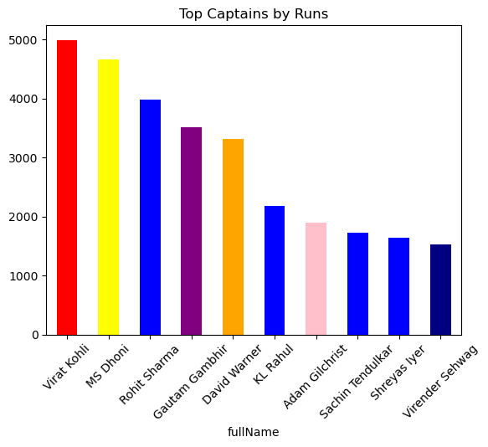The graph shows that some captains not only lead the team but also perform well as batsmen. These players play a dual role by contributing both as leaders and performers.

8.3.3 Captains by Sixes
This analysis examines the number of sixes hit by captains. It helps in understanding the aggressive batting style of captains.
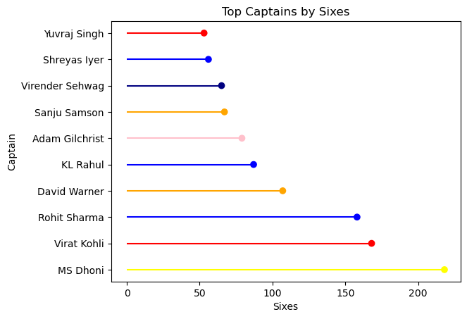
From the graph, it is observed that certain captains are powerful hitters and play an important role in accelerating the scoring rate.

8.4 Special Player Analysis
Special player analysis focuses on evaluating the performance of a specific player in detail. In this project, MS Dhoni is selected for analysis due to his experience, leadership, and finishing ability. This section helps in understanding how an individual player contributes to the team across different matches.

8.4.1 MS Dhoni Performance
This analysis includes the overall performance of MS Dhoni based on runs scored, strike rate, boundaries, and matches played. It helps in understanding his consistency and impact in the game.
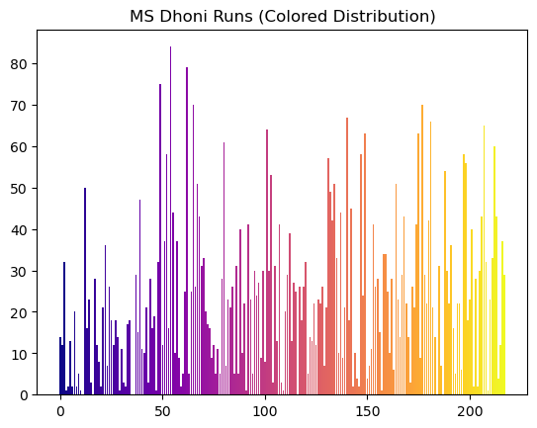
From the graph, it is observed that MS Dhoni has consistently contributed to his team with stable performance. His ability to score runs efficiently makes him a reliable player.

8.4.2 Dhoni vs Other Players
This analysis compares the performance of MS Dhoni with other top players based on metrics such as strike rate, runs per ball, and efficiency. It helps in understanding how Dhoni performs relative to other players.
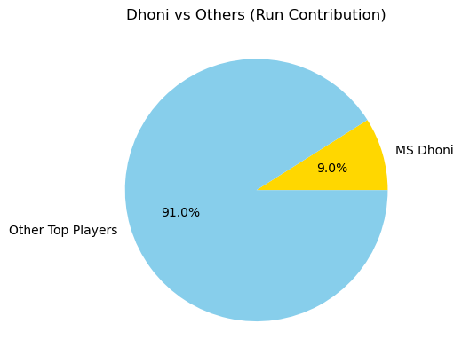
The graph shows that MS Dhoni performs competitively with other top players. His efficiency and finishing ability make him stand out even among high-performing players.

8.5 Distribution and Outlier Analysis
Distribution and outlier analysis helps in understanding how data values are spread and identifying unusual values in the dataset. It provides insights into player performance variability and highlights extreme performances.

8.5.1 Runs Distribution
This analysis shows how runs are distributed among players using a histogram. It helps in understanding whether most players score low runs or if there are many high scorers.
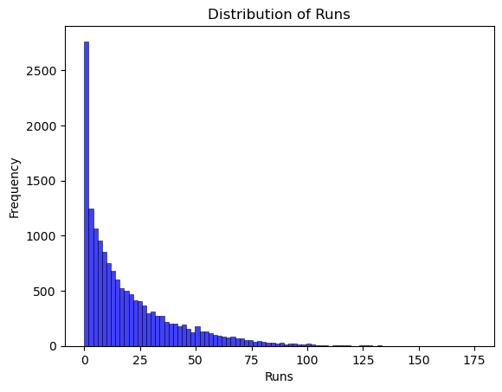
From the graph, it is observed that most players score moderate runs, while only a few players achieve very high scores. This indicates a right-skewed distribution where extreme values are less frequent.

8.5.2 Strike Rate Distribution
This analysis focuses on the distribution of strike rates among players. It helps in identifying how aggressively players score runs.

The graph shows that most players have an average strike rate, while a few players have very high strike rates, indicating aggressive batting styles.

8.5.3 Outlier Detection
Outlier detection is used to identify unusual or extreme values in the dataset. Box plots are commonly used to detect outliers in runs and strike rates.
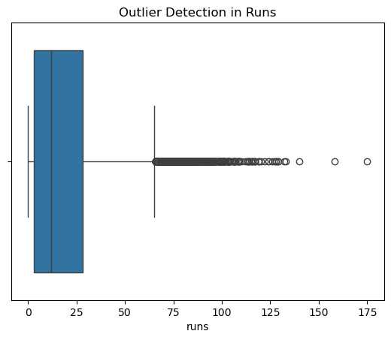
From the graph, it is observed that some players have exceptionally high runs or strike rates compared to others. These outliers represent extraordinary performances and can significantly impact match outcomes.

8.6.1 Runs vs Strike Rate
This analysis examines the relationship between runs scored and strike rate using a scatter plot. It helps in identifying players who score both high runs and maintain a high strike rate.
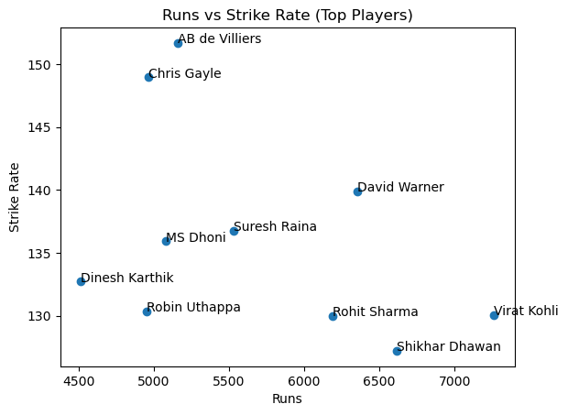

From the graph, it is observed that some players have both high runs and high strike rates, indicating strong overall performance. Players located in the upper-right region of the graph are considered the most effective batsmen.

9. Results and Insights
This section summarizes the key findings obtained from the analysis of the IPL dataset. By analyzing player performance, team statistics, and match patterns, several important insights have been identified.
From the player analysis, it is observed that a few players consistently dominate in terms of total runs scored. These players maintain strong performance across multiple matches and seasons. Strike rate analysis shows that aggressive players play a crucial role in T20 cricket by maintaining a high scoring rate.
Boundary analysis highlights that players who hit more fours and sixes contribute significantly to quick scoring. Consistency analysis shows that some players maintain stable performance, making them reliable for the team.
From the team analysis, it is observed that certain teams have played more matches and scored higher total runs. This indicates their strong participation and batting strength. Venue analysis shows that some stadiums host more matches, making them important locations in the IPL.
Captain analysis reveals that experienced captains not only lead their teams effectively but also contribute significantly with their batting performance. Special player analysis of MS Dhoni shows that he is a consistent and efficient player, especially known for his finishing ability.
Distribution and outlier analysis indicate that most players have average performance, while a few players achieve exceptionally high values. These outliers represent outstanding performances that can change the outcome of matches.
Comparative analysis shows that players with both high runs and high strike rates are the most impactful. Efficiency analysis further highlights players who utilize balls effectively to score runs.
Overall, the analysis demonstrates that performance in IPL depends on multiple factors such as consistency, strike rate, boundary hitting, and efficiency. These insights can be useful for teams, analysts, and decision-making processes.

10. Visualization
Visualization plays a crucial role in understanding and presenting data effectively. In this project, different types of graphs are used to represent the IPL dataset in a clear and meaningful way. Visualizations help in identifying patterns, trends, and relationships that may not be easily visible in raw data.
Various graph types such as bar charts, horizontal bar charts, pie charts, donut charts, histograms, scatter plots, and box plots are used in this project. Each type of graph is selected based on the nature of the data and the purpose of the analysis. For example, bar charts are used to compare players and teams, pie charts are used to show proportions, histograms are used to understand distribution, and scatter plots are used to analyze relationships between variables.
Visualization makes complex data easy to understand and helps in communicating insights effectively. It also improves the readability of the analysis and makes the project more interactive and visually appealing.
The graphs used in this project clearly show player performance, team contribution, scoring patterns, and distribution of values. These visualizations support the analysis and help in drawing accurate conclusions.

10.1 Heatmap Analysis
Heatmap is used to show the correlation between different numerical features in the dataset such as runs, balls faced, fours, and sixes. It helps in understanding how strongly the variables are related to each other.
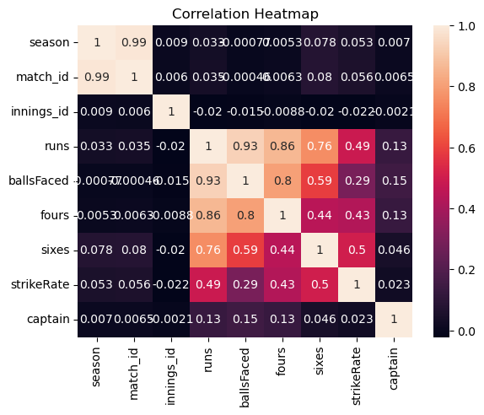
From the graph, it is observed that some features have strong positive correlation, indicating that as one variable increases, the other also increases.

10.2 Pairplot Analysis
Pairplot is used to visualize the relationships between multiple variables in the dataset. It shows scatter plots for each pair of variables along with distribution plots on the diagonal.
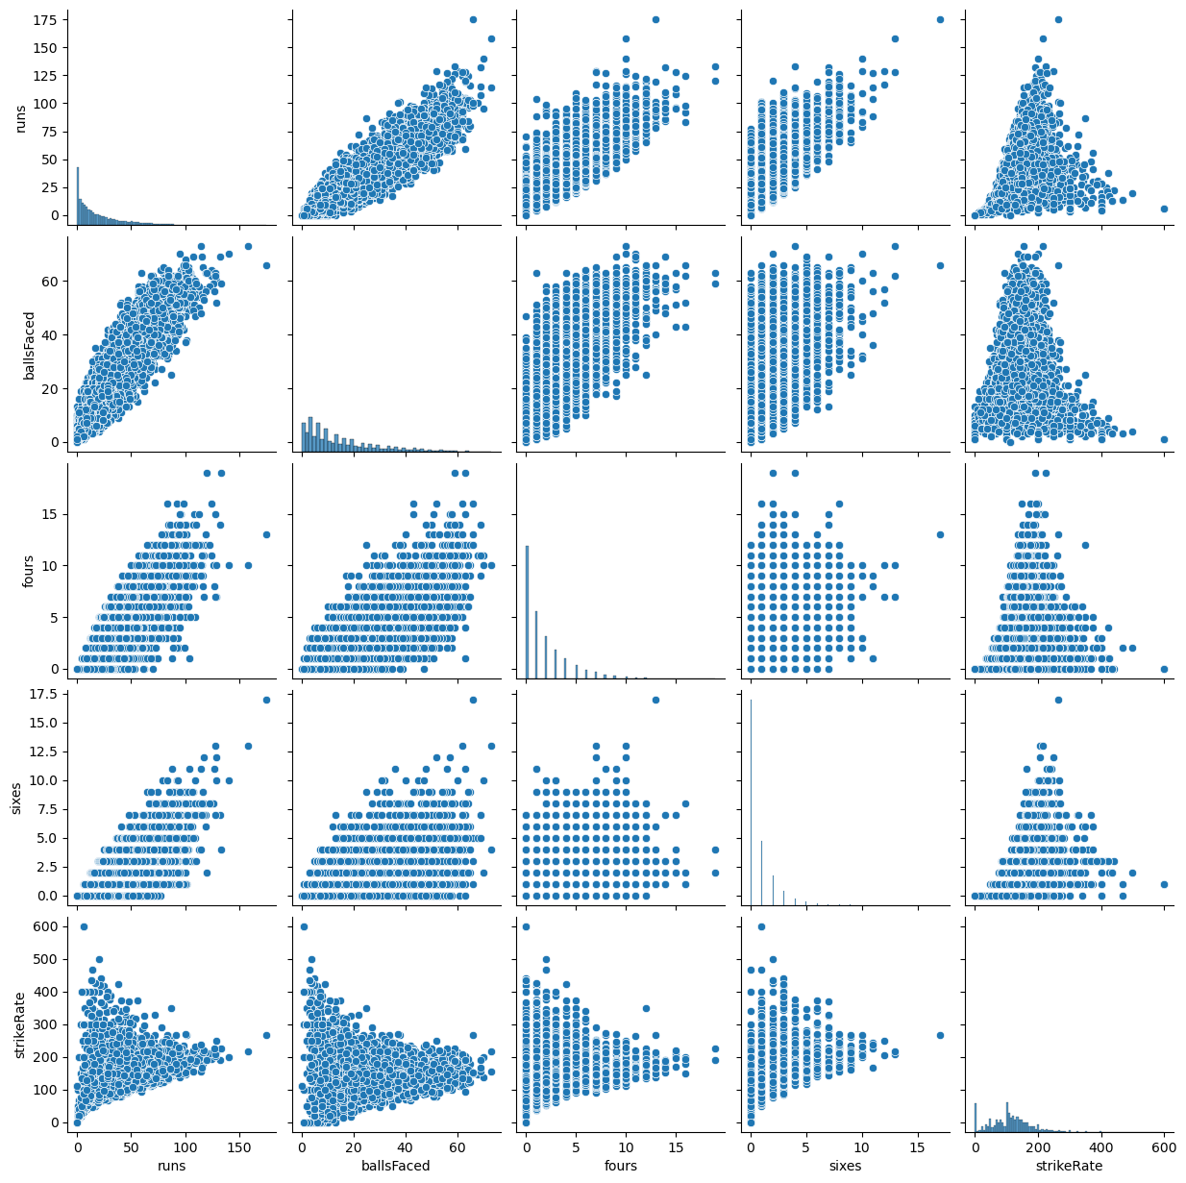

From the graph, it is observed that relationships between variables such as runs, balls faced, and boundaries can be clearly seen. It helps in identifying patterns and trends in the dataset.

11. Future Scope
This project focuses on Exploratory Data Analysis of the IPL dataset, but it can be extended further using advanced techniques. One of the main future improvements is the application of machine learning models to predict match outcomes based on historical data.
Player performance prediction can also be developed using features such as past runs, strike rate, and consistency. This can help teams in selecting players and planning strategies. Similarly, team performance models can be created to forecast match results.
Another extension is building an interactive dashboard using tools like Power BI or Tableau. This will allow users to explore data dynamically and gain insights in real time.
The analysis can also be improved by including additional factors such as pitch conditions, weather, and player fitness. These factors can provide more accurate and detailed insights.
Overall, this project can be expanded into a complete sports analytics system that supports decision-making and performance evaluation.

12. References
The data used in this project is collected from publicly available IPL datasets. The following sources were referred during the development of this project:
- IPL Dataset from Kaggle (https://www.kaggle.com/)
- Official IPL Website (https://www.iplt20.com/)
- Pandas Documentation (https://pandas.pydata.org/)
- Matplotlib Documentation (https://matplotlib.org/)
- Seaborn Documentation (https://seaborn.pydata.org/)
These sources were helpful in understanding the dataset, performing analysis, and implementing visualization techniques.

13. Bibliography
- Python for Data Analysis by Wes McKinney
- Introduction to Data Science using Python
- Online tutorials and learning resources related to data analysis and visualization

.

