## 

**PRINCIPLES OF SOFTWARE ENGINEERING**

## COURSE CODE: SWE1003

## TRAVEL AND TOURISM MANAGEMENT SYSTEM

### NAMES REG NO

### Hemanth Chowdary -18MIS7023

### Akash Reddy -18MIS7208

### Venkatesh -18MIS7176

### Dinesh -18MIS7181

### OBJECTIVES:

The objective of this project is to implement the Travel and tourism management system which provide the about tour places, journey details, reservation, billing and cancellation of tour on various types of reservation and management namely to the best satisfaction of the customer. The normal process which was followed until recently was to manually fill the data and then process the data which used to cause a lot of inconvenience to both the administrator and the customer as well.

Now, we would like to use databases to facilitate this process

of smooth reservation of Travel and tourism management system with minimal work on the part of both the customer and the administrators involved .

Now let us look at the various aspects of Travel and tourism management system

The various aspects of the Travel and tourism management system can be presented in views of the different people involved with it. The main people involved in the airline reservation are

1. Administrator
2. Customer

**Administrator’s view:**-

The administrator needs to know and control the following information at all times

1) Total Number of seats per flight and Bus seats available (1st and 2nd classes and AC and NON-AC if applicable)

2) Number of reservations per flight and bus (1st and 2nd classes and AC and NON-AC if applicable)

3) A proper schedule has been assigned,so that the passengers can plan according to it.

4) Updating information from time to time according to the possibility of busses and flights .

5) Family packages has been displayed for tours and travels to make their trip more enjoyable.

1. Information about bus routes and data of the customers.

Information about the traveler includes details like

1. Name
2. Gmail
3. Date of birth

d) Address, City, State, Zip Code

e) Phone number

and other information like is he requesting for any concession or not

7) Other perks like giving rewards to Travelers who have Travelled most frequently in that month and special offers for those customers which are normally half full or less is decided automatically

**Customer’s view:-**

A customer needs to know the following information:

1) Availability of Roadways and Airways to the destination from the departure.

2) Reservation status for a particular flight and bus.

3) Ticket price and the Concessions.

4) Details of tourist places and packages information relative to the seating capability

5) Status i.e., if the ticket has been confirmed or still in waiting list for both bus and flight.

1. Confirm reservation for tour package.
2. Departure Date reservation.
3. Online reservation for Journey.
4. Advance reservation

**LIST OF TASK DONE IN LAB**

1.Do the Requirements Analysis and Prepare SRS.

2. Analyze the SRS to the Proposed Project.

3. Design System Flow.

4. Draw Use cases, E-R diagrams, DFD’S for the project.

5. Develop any one module and test.

6.Design of Test cases based on requirements and design.

7. Post Implementation Review

8.Future Enhancements.

**INDEX**

|  |  |  |
| --- | --- | --- |
| **Sr. No** | **Title** | **Page No** |
| 1 | Abstract (Project Profile) | 1 |
| 2 | Existing System | 2 |
| 3 | Need for new System | 3 |
| 4 | Functional Specification | 4 |
| 5 | Hardware and Software Requirement | 7 |
| 6 | System Flow Chart | 9 |
| 7 | Timeline Chart | 10 |
| 8 | E-R Diagram | 11 |
| 9 | UML Diagrams | 12 |
|  | 9.1 Use Case Diagram | 13 |
|  | 9.2 Activity Diagram | 15 |
|  | 9.3 Class Diagram | 17 |
|  | 9.4 Sequence Diagram | 18 |
|  | 9.5 Collaboration Diagram | 20 |
| 10 | Data Dictionary | 22 |
|  |  |  |
|  |  |  |
|  |  |  |
| **Sr. No** | **Title** | **Page No** |
| 11 | Input Design | 30 |
| 12 | Output Design | 62 |
| 13 | Testing | 65 |
| 14 | Post Implementation Review | 68 |
| 15 | Future Enhancement | 69 |
| 16 | Bibliography | 70 |

**PROJECT PROFILE**

|  |  |
| --- | --- |
| **Project Name** | TRAVEL AND TOURISM MANAGEMENT SYSTEM |
| **Objective** | The objective of this project is to implement the Travel and tourism management system which provide the about tour places, journey details, reservation, billing and cancellation of tour on various types of reservation and management namely to the best satisfaction of the customer. The normal process which was followed until recently was to manually fill the data and then process the data which used to cause a lot of inconvenience to both the administrator and the customer as well.  Now, we would like to use databases to facilitate this process  of smooth reservation of Travel and tourism management system with minimal work on the part of both the customer and the administrators involved . |
| **Platform** | Website |
| **Front End** | NETBEANS and ECLIPSE with JAVA,DATABASE |
| **Back End** | MYSQL Server 2008 |
| **Other Tools** | MS Office 2007 |
| **Project Duration** | 90days |

**EXISTING PROJECT**

In the present system a customer has to approach various agencies to find details of places and to book tickets. This often requires a lot of time and effort. A customer may not get the desired information from these offices and often the customer may be misguided. It is tedious for a customer to plan a particular journey and have it executed properly.

**NEED FOR NEW SYSTEM**

The proposed system is a web based application and maintains a centralized repository of all related information. The system allows one to easily access the relevant information and make necessary travel arrangements. Users can decide about places they want to visit and make bookings online for travel and accommodation.

**FUNCTIONAL SPECIFICATIONS**

### USER SPECIFICATION

**Administrator’s view:**-

The administrator needs to know and control the following information at all times

1)Total Number of seats per flight and Bus seats available (1st and 2nd classes and AC and NON-AC if applicable)

2) Number of reservations per flight and bus (1st and 2nd classes and AC and NON-AC if applicable)

3) Schedule of all flights and bus in a day and places and flights which have arrived.

4) Schedule of a particular flight in a week. Schedule of bus to particular place In a week.

5) Booking certain packages which are available in different type of seats capacity

1. Information about bus routes and data of the customers.

Information about the traveler includes details like

1. Name
2. Gmail
3. Date of birth

d) Address, City, State, Zip Code

e) Phone number

and other information like is he requesting for any concession or not

7) Other perks like giving rewards to Travelers who have Travelled most frequently in that month and special offers for those customers which are normally half full or less is decided automatically

**Customer’s view:-**

A customer needs to know the following information:

1) Availability of flights and buses to the destination from the departure.

2) Reservation status for a particular flight and bus.

3) Ticket price and the Concessions.

4) Details of tourist places and packages information relative to the seating capability

5) Status i.e., if the ticket has been confirmed or still in waiting list for both bus and flight.

1. Confirm reservation for tour package.
2. Departure Date reservation.
3. Online reservation for Journey.
4. Advance reservation

**MODULE SPECIFICATION**

***ADMINISTRATOR MODULE:***

        This module provides administrator related functionality. Administrator manages all information and has access rights to add, delete, edit and view the data related to places, travels, routes, bookings, etc.

***TRAVELS MODULE:***

        This module provides the details of various travel agencies. A user can select the appropriate agency depending on convenience and accessibility.

***ROUTES MODULE:***

        This module provides information related to various routes connecting sources and destinations. For each route, information such as source, destination, fare, reservation details, pick up points etc are provides. Only administrator can add, delete, edit and manage the data. Users can only view the information.

***RESERVATIONS MODULE:***

        This module provides functionalities that allow a user to book tickets or cancel previously booked tickets. The module maintains the details of all reservations made so far and allows administrator to either confirm or reject the bookings.

***TESTIMONIALS MODULE:***

        Users of this application can post their opinions, complaints and suggestions regarding this portal and services to the administrator. Accordingly, the administrator can take various steps to act on the complaints and suggestions.

***INTERFACES:***

***SOFTWARE INTERFACES:***

Technology : Java and J2ee

          Web Technologies : Html, JavaScript, CSS

          Web Server : Tomcat5.5

          Database        : MySql5.0

         JDK Version                  : JDK1.5

***HARDWARE INTERFACES:***

Hardware                      : Pentium

           RAM                              : 1GB

**HARDWARE REQUIREMENT**

CLIENT SIDE:

|  |  |
| --- | --- |
| **RAM** | 1GB |
| **Hard disk** | 10 GB |
| **Processor** | 1.0 GHz |

SERVER SIDE:

|  |  |
| --- | --- |
| **RAM** | 1 GB |
| **Hard disk** | 20 GB |
| **Processor** | 2.0 GHz |

**SOFTWARE REQUIREMENT**

CLIENT SIDE:

|  |  |
| --- | --- |
| **RAM** | 1 GB |
| **Hard disk** | 20 GB |
| **Processor** | 2.0 GHz |

SERVER SIDE:

|  |  |
| --- | --- |
| **RAM** | 1 GB |
| **Hard disk** | 20 GB |
| **Processor** | 2.0 GHz |

**SYSTEM FLOWCHART**

**TIMELINE CHART**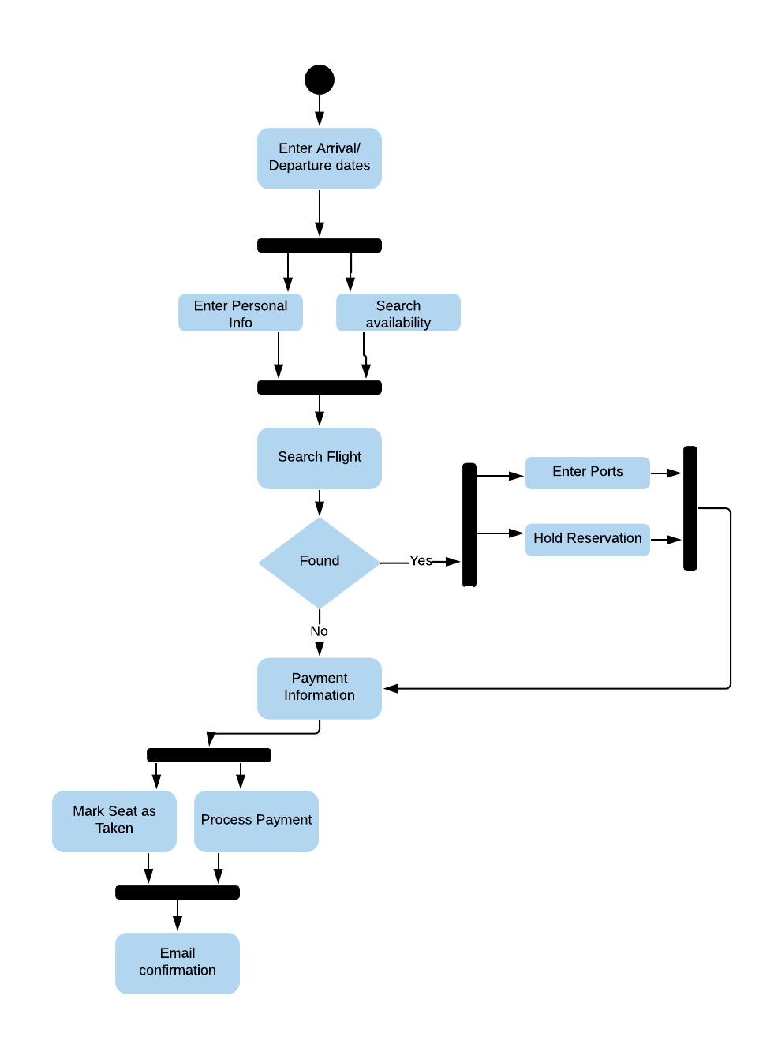

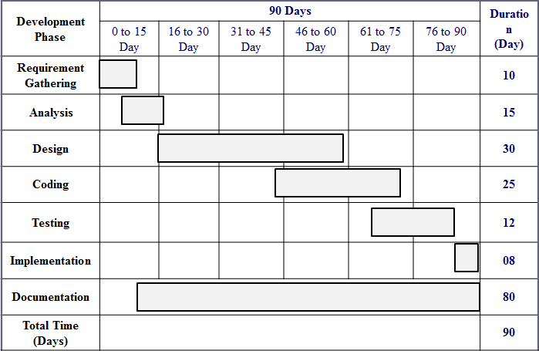

UML DIAGRAMS

**USE CASE DIAGRAM**

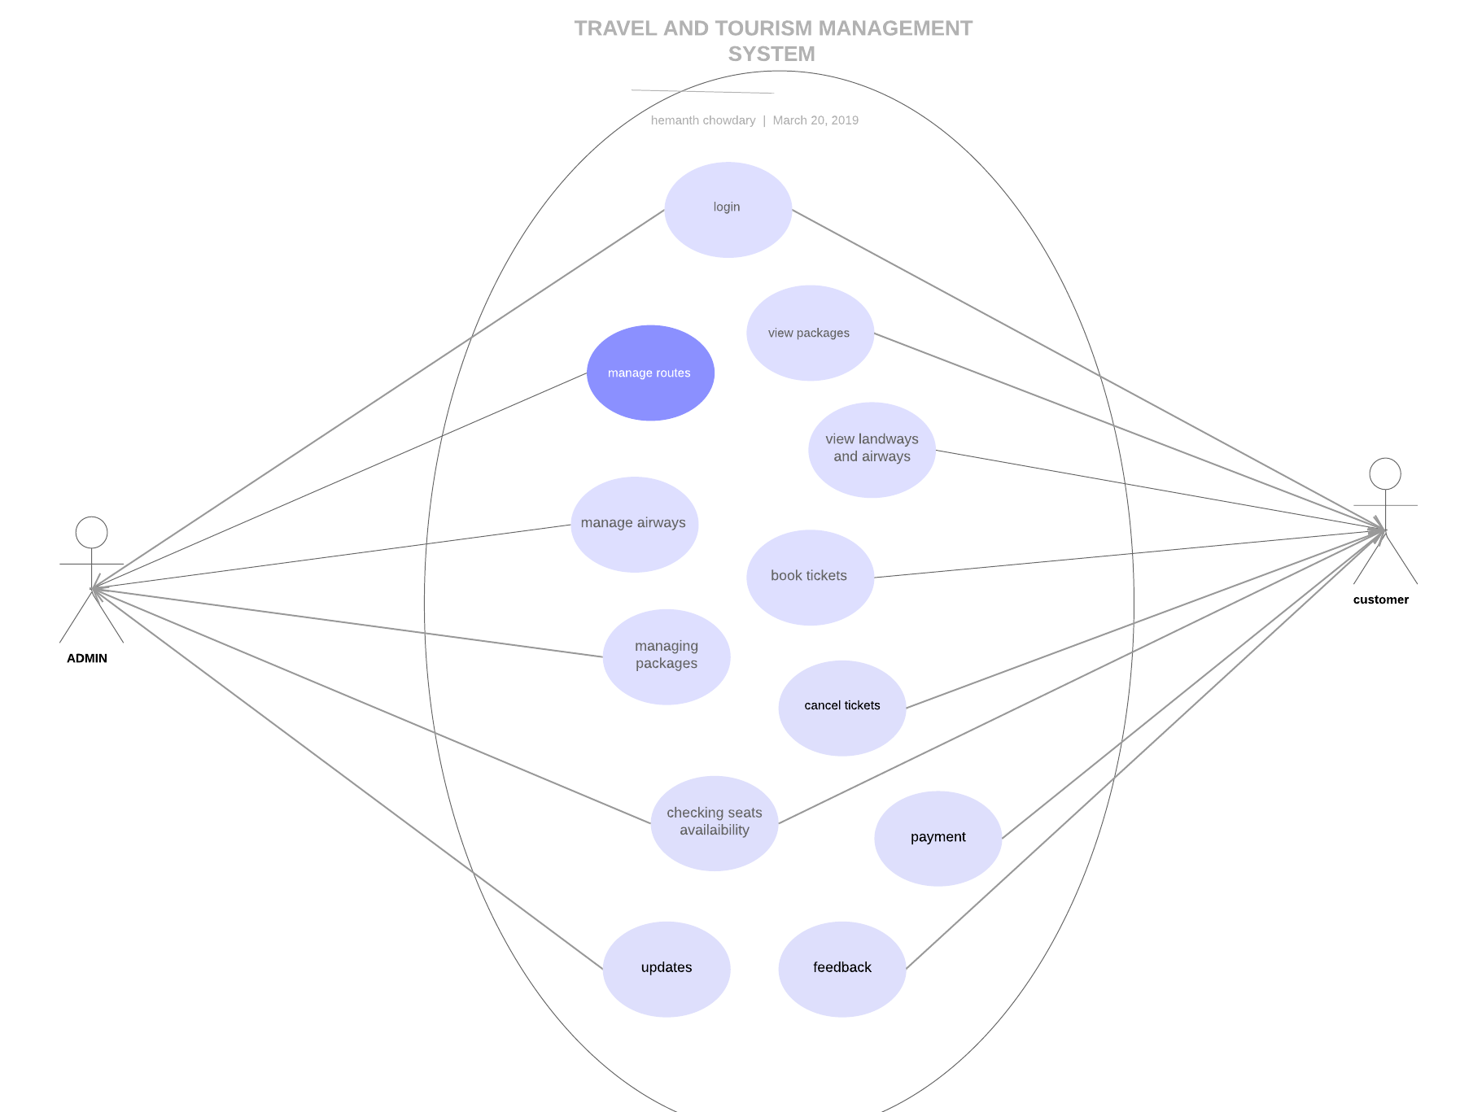**SEQUENCE DIAGRAM**

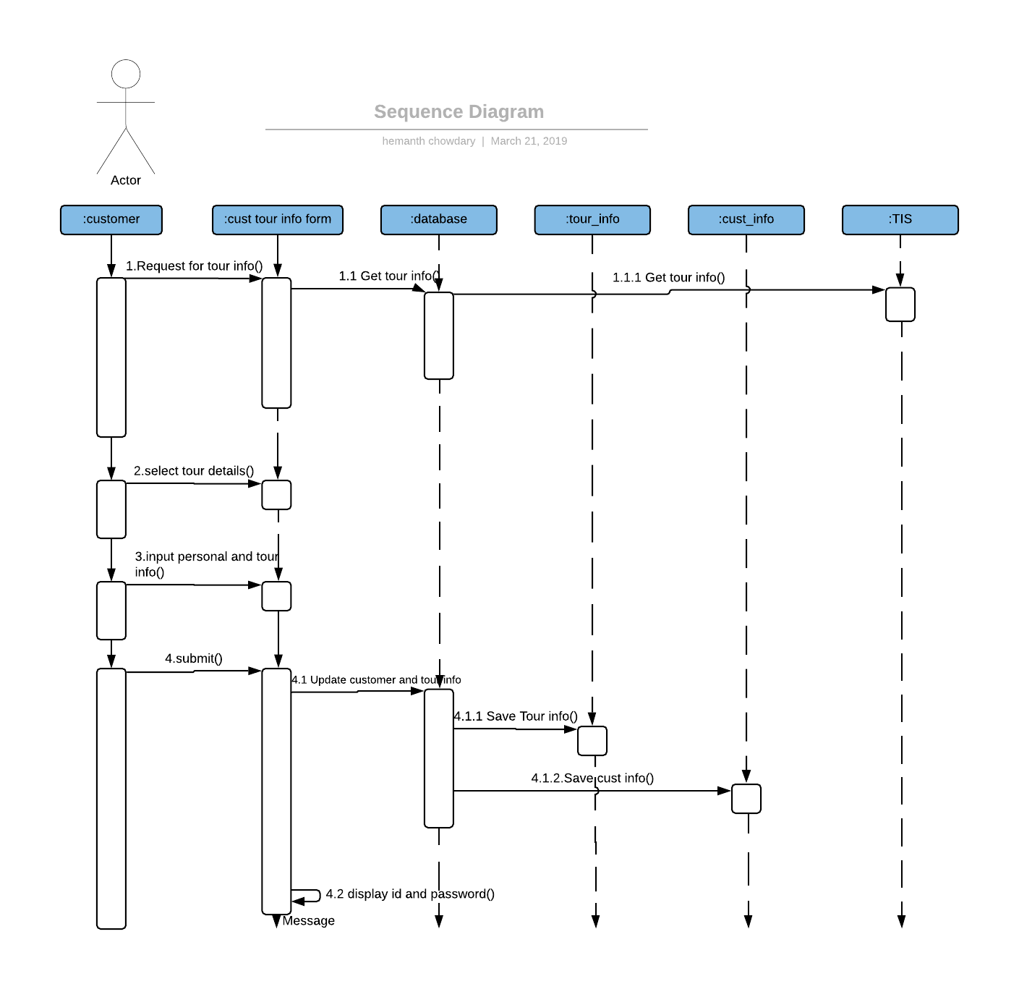

**STATE DIAGRAM**

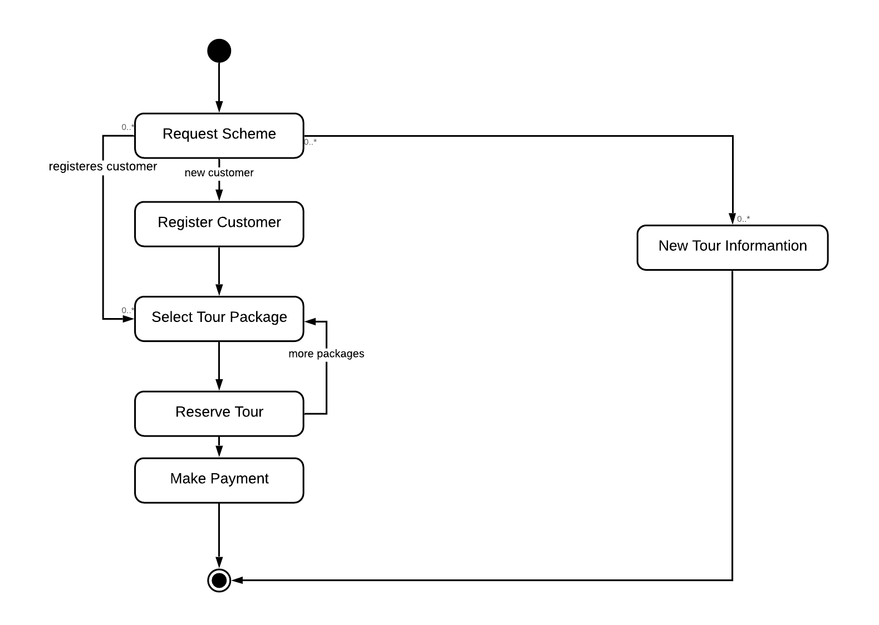

**CLASS DIAGRAM**

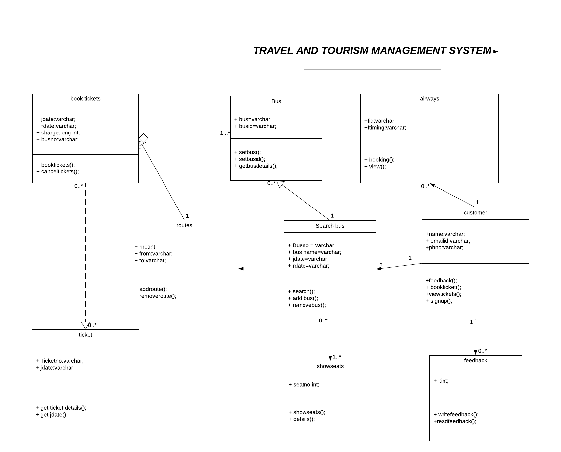

**ACTIVITY DIAGRAM**

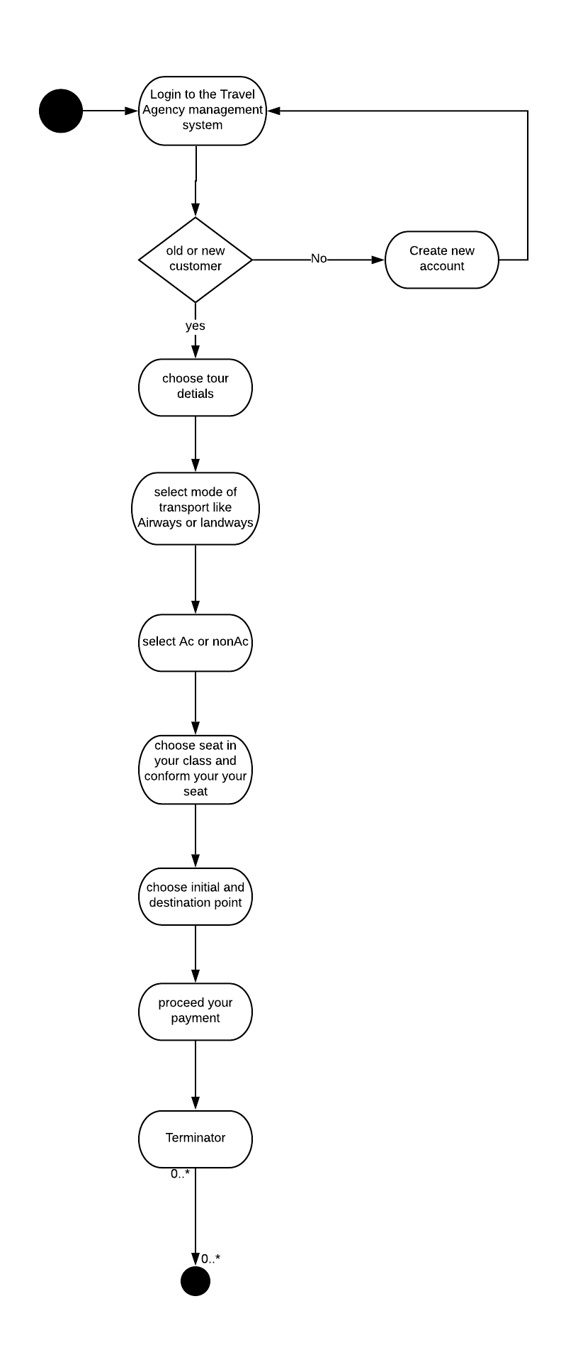

**COLLABORATION DIAGRAM**

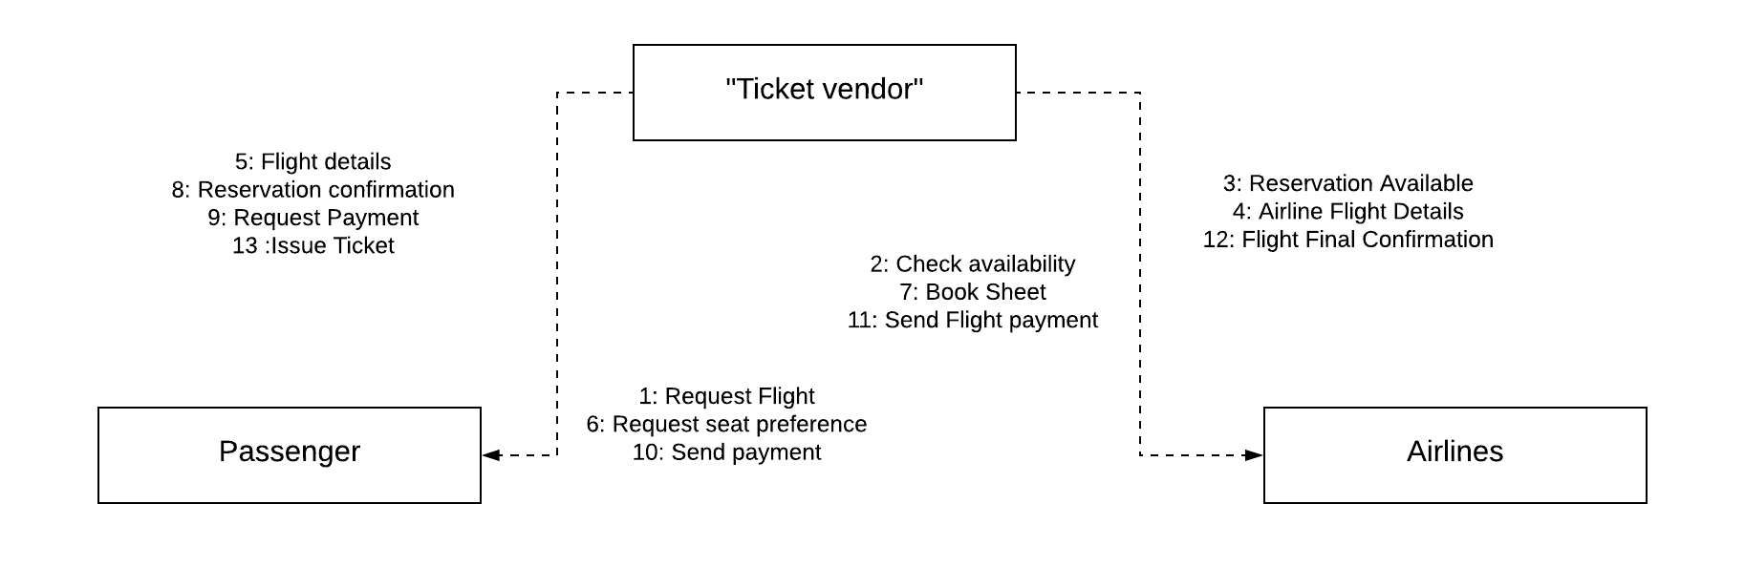

DATA DICTIONARY

ADMIN

|  |  |
| --- | --- |
| **Table Name** | Admin |
| **Description** | This table is store information about Admin |
| **Primary Key** | A_id |
| **Foreign Key** | - |
| **Sr. No** | **Field Name** | **Data type(Size)** | **Constraints** | **Description** |
| 1 | A_id | Int | Primary Key | It is store Admin id |
| 2 | A_Name | Varchar(10) | Not Null | It is store admin name |
| 3 | Password | Varchar(20) | Not Null | It is store the password of Admin |
| 4 | Contact_No | Varchar(12) | NotNull | It is store the Contact no of Admin |
| 5 | E_mail | Varchar(70) | NotNull | It is store the Email id of Admin |

PAYMENT TABLE

|  |  |  |  |  |
| --- | --- | --- | --- | --- |
| **Sr. No** | **Field Name** | **Data type(Size)** | **Constraints** | **Description** |
| 1 | A_id | Int | Primary Key | It is store Admin id |
| 2 | A_Name | Varchar(10) | Not Null | It is store admin name |
| 3 | Password | Varchar(20) | Not Null | It is store the password of Admin |
| 4 | Contact_No | Varchar(12) | NotNull | It is store the Contact no of Admin |
| 5 | E_mail | Varchar(70) | NotNull | It is store the Email id of Admin |

|  |  |  |  |  |
| --- | --- | --- | --- | --- |
| **Sr. No** | **Field Name** | **Data type(Size)** | **Constraints** | **Description** |
| 1 | A_id | Int | Primary Key | It is store Customer id |
| 2 | A_Name | Varchar(10) | Not Null | It is store Customer name |
| 3 | Password | Varchar(20) | Not Null | It is store the password of Customer |
| 4 | Contact_No | Varchar(12) | NotNull | It is store the Contact no of Customer |
| 5 | E_mail | Varchar(70) | NotNull | It is store the Email id of Customer |

Input Design

**VALID LOGIN OUTPUT:**

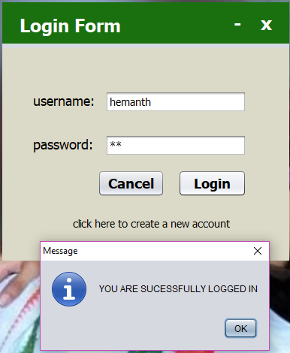

**INVALID LOGIN OUTPUT:**

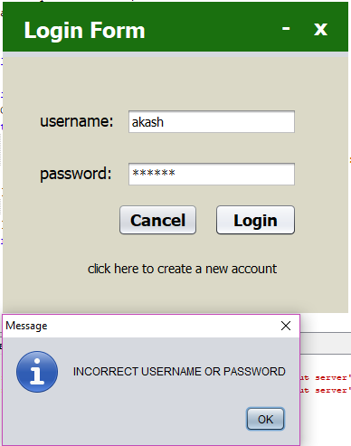

**VALID REGISTRATION OUTPUT:**

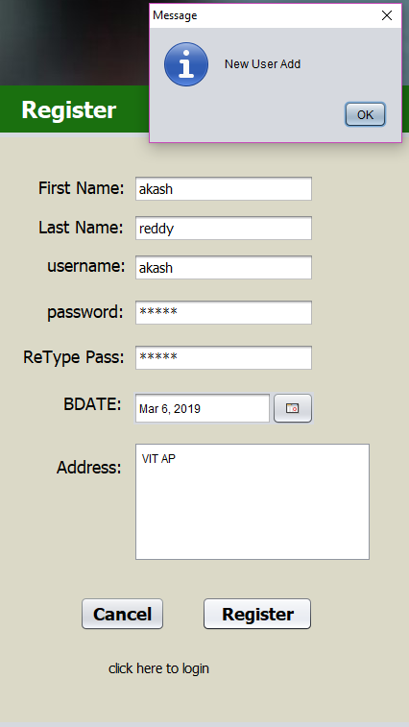

**INVALID REGISTRATION OUTPUT**

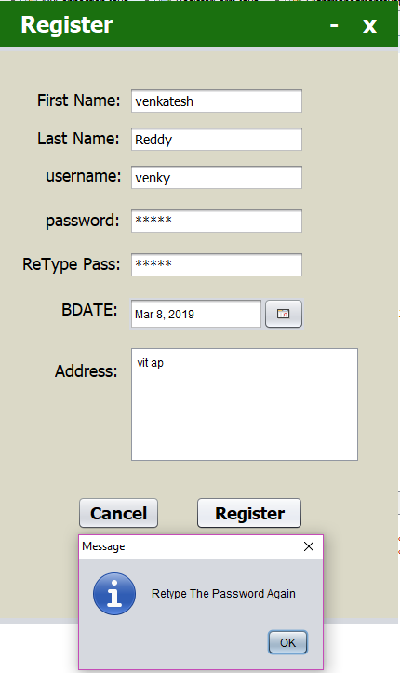

OUTPUT

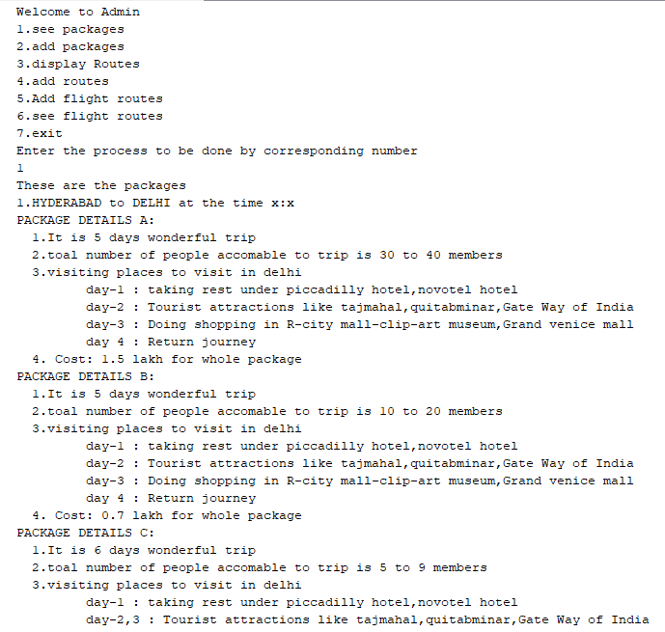

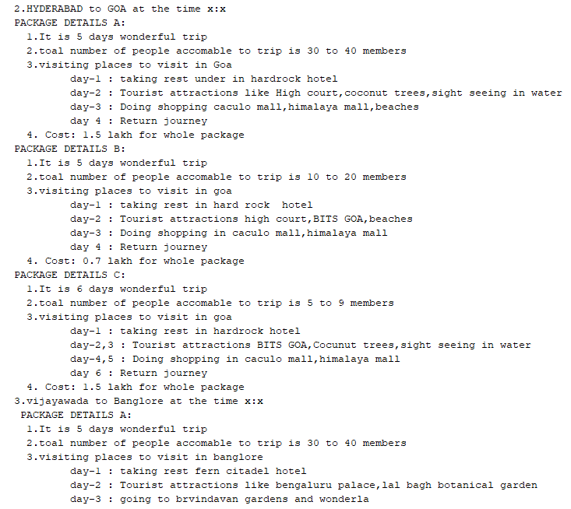

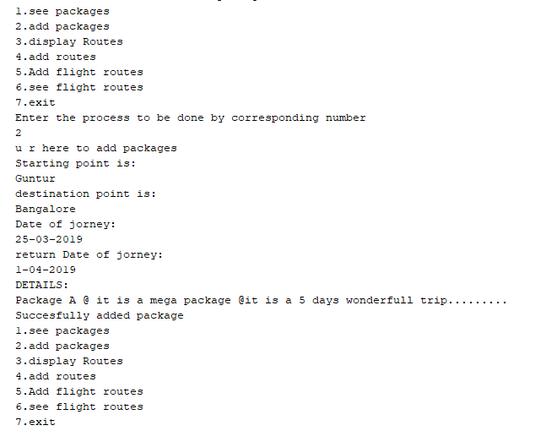

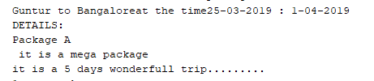

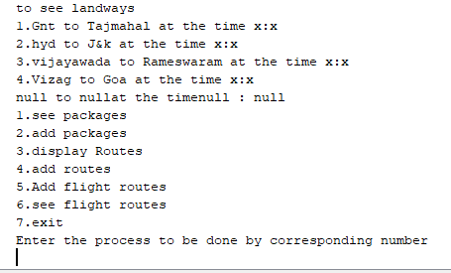

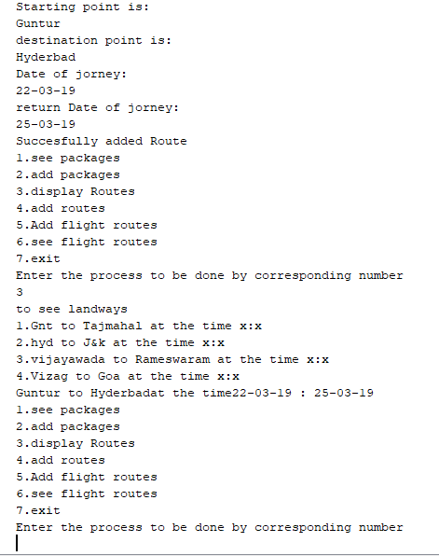

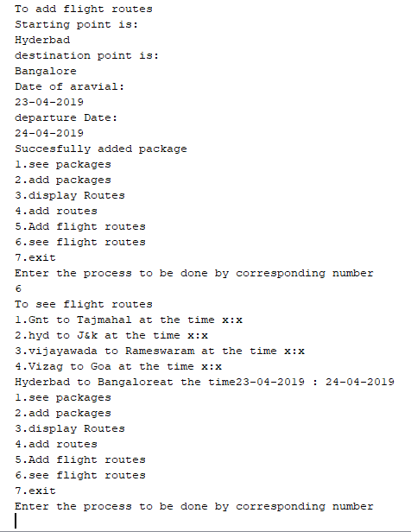

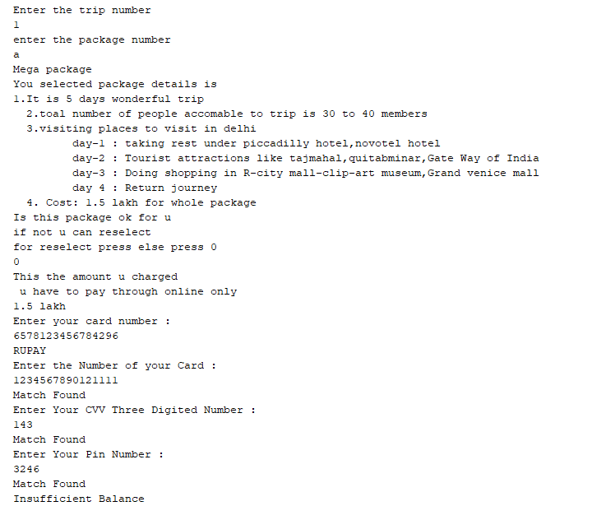

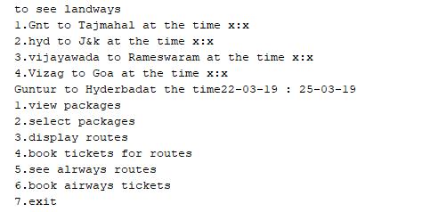

POST IMPLEMENTATION

* The Database application is self maintained.
* The project support already multiple busses and flights.
* There is no need to provide post implementation support.
* The Admin can accesses add,edit,delete processes.

FUTURE ENHANCEMENT

* Add new busses and flights is representing the list.
* The user can get the receipt after he/she done with his payments.
* Add the current project for booking easy.
* Adding other mode of transport like Water ways.
* Encouraging/taking the feedback from the customers.

BIBLIOGRAPHY

* Book Reference:

Asp.net with J# .by Shyam N.chavda

Author: Shyam N.chavda

* Web References:
  + - * [www.code.project.com](http://www.code.project.com)
      * [www.asp.net](http://www.asp.net)
      * [www.ASPjava-suresh.com](http://www.aspjava-suresh.com)
      * [www.1000projects.com](http://www.1000projects.com)