Bending Setup

Aim:
- To make a bending setup using a strain gauge in a cantilever beam and measure the load using an amplifier and ADC converter.

Components Required:
- Cantilever Beam
- Support
- Strain Guage
- Amplifier (with ADC - Analog to Digital Converter)
Key formulas:
Deflection | Strain | Stress
$$δ=\frac{4PL^{3}}{Ebh^{3}}= \frac{PL^{3}}{EI}$$ | $$ε=\frac{6PL}{Ebh^{2}}$$ | $$σ=\frac{6PL}{bh^{2}}$$

For detailed understanding visit: https://www.allaboutcircuits.com/textbook/direct-current/chpt-9/strain-gauges/
Types of Wheatstone Configurations
- Quarter Bridge Configuration

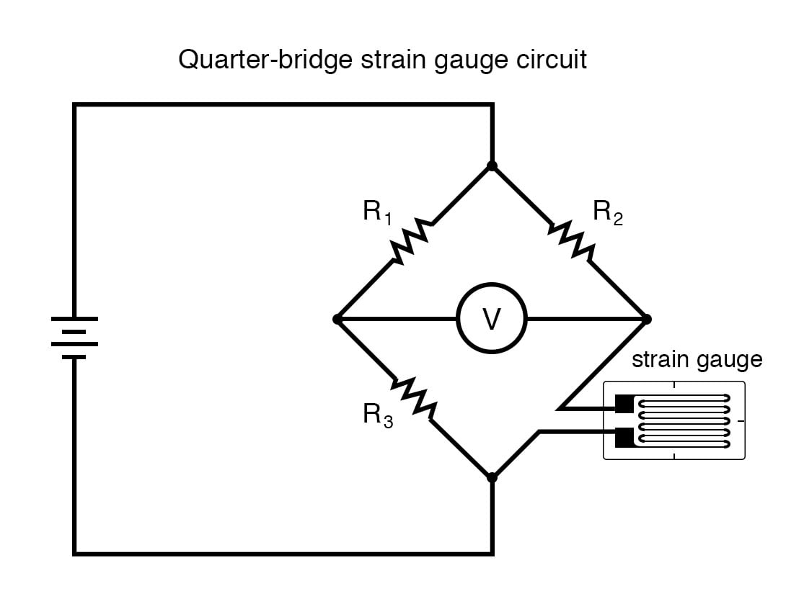

Fig (1) – Quarter Wheatstone bridge
- R1 = R2 = R3 = R4
Since All R are equal the bridge is balanced Vo = 0
Now due to strain R4 change,
R4 = R + ΔR
Using voltage divider principles:
Left midpoint voltage:
$$V_{left}= Vcc × [\frac{ R3}{\left(R1 + R3\right)}]$$

Right midpoint voltage:
$$V_{right}= Vcc ×[\frac{\left(R + ΔR\right)}{ (R2 + (R + ΔR)}]$$

Bridge output:
$$Vo = V_{left} - V_{right}$$

$$Vo = Vcc × \left[\frac{R}{2R + ΔR}-\frac{1}{2}\right]≈ (\frac{VccΔR}{4R})$$
- Half bridge Configuration
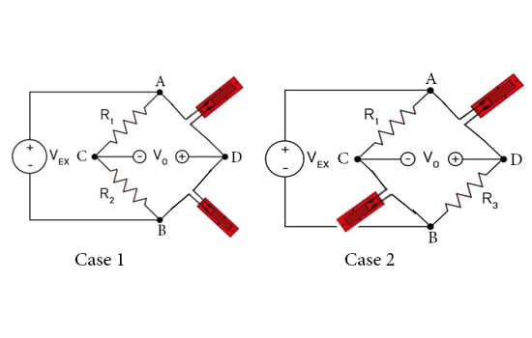

Fig (2) – Half Wheatstone Bridge

- R1 = R2 = R3 = R4
- If both the Strain Guage resistances vary in same direction they should be placed in same side of the bridge (Case 1)
- If both the Strain Guage resistances vary in opposite direction they should be placed in opposite side of the bridge (Case 2)
Case 1:
R3 = R + ΔR (Tension)
R4 = R − ΔR (Compression)
$V_{o}=\frac{V_{cc}\left(ΔR\right)}{2R}$x

Case 2:
R1 = R + ΔR
R2 = R + ΔR
$$V_{o}=\frac{V_{cc}\left(ΔR\right)}{2R}$$

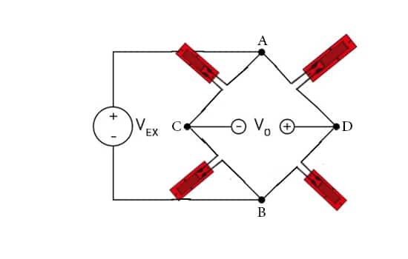
- Full Bridge configuration

Fig (3) – Full Wheatstone Bridge

R1 = R + ΔR (Tension)
R2 = R − ΔR (Compression)
R3 = R + ΔR (Tension)
R4 = R − ΔR (Compression)
$$V_{o}=\frac{V_{cc}\left(ΔR\right)}{R}$$

Gauge Factor (G.F) tells the change in electrical resistance due to the mechanical strain occurs.
$$G.F=\frac{ΔR}{R.ε}$$

Amplifier (with ADC)

