Respiration Rate monitoring system using graphite on paper (GOP) based sensor and ESP8266 microcontroller

Authors

**Abstract:**

Respiration rate monitoring is a vital medical parameter in determining the chronic respiratory diseases like asthma and chronic obstructive pulmonary disease (COPD). Various researchers have developed more efficient, eco-friendly sensors for wearable electronics. The major work was focused on exploring the temperature and pressure sensitivity of the graphite. Graphite based sensors have proven to be the best replacement for the harmful and non-biodegradable sensors due to the excellent sensitivity of the GOP(Graphite-on-paper) sensors. Thermal conductivity of the graphite can be used to monitor the respiration rate non-invasively. A novel approach is used to design the respiration rate monitoring system. Design consists of three components: a) GOP based sensor, b) Signal Conditioning Circuit, c) Alerting system using ESP8266 NodeMCU. The dimensions of the GOP sensor were finalized after a series of experiments. The final dimensions of the sensor are chosen as 1cm×0.5cm such that they have least variation in resistance at room temperature (i.e., 300K). The sensor was placed on a double tape to avoid change in resistance due to piezoelectric effect. As mentioned in the above sections, the GOP sensor is low-cost, flexible, eco-friendly, home-made, highly sensitive and doesn’t require any clean rooms for manufacture. It is observed that the GOP sensor signals lie in the range 1Hz-0.5kHz, concluded from the FFT analysis of the signal. A Signal Conditioning circuit is designed for the GOP sensor to make the signal compatible for ESP8266 MCU, for further processing. The Circuit design is flexible in nature and dimensions are 20mm×29mm. The Signal Conditioning Circuit is a low-cost, flexible and low-power device (can be operated at 5V). After observing the conditioned signal, we can observe peaks and nadirs, which have occurred due to respiration. The Alerting system consists of the ESP8266 NodeMCU which has a WIFI module and operates at 3.3V. An alert message can be sent to the mobile through the ESP8266 NodeMCU in case of abnormal respiration rate. The whole system including the Sensor, Signal Conditioning Circuit, alerting system can be embedded on the mask. This system does not require any contact of the patient’s philtrum. This enhances the comfort of the elderly people and children.

*Index Terms*—GOP (Graphite on paper), Signal Conditioning Circuit, ESP8266 NodeMCU, Flexible Circuit, FFT (Fast Fourier Transform),

# INTRODUCTION[1]

T

HE world of electronics is diverse and always evolving. The wearable electronics have been an integral part of our lives. The substrates used in the sensors are non-planar, uncommon and low cost [1-4]. Due to these substrates, the applications of these devices increased exponentially. Wearable devices play a significant role in real time human health monitoring [5,6-9]. The wearable devices are embedded with complementary data readout and signal conditioning circuit [10-14]. Raw data is processed and transmitted wirelessly over internet. Polymer substrates are ideal for deployment of these sensor devices and circuits due to their burgeoning properties such as light weight, low cost, flexibility, bendability, foldability, stretchability, and conformability to uneven surfaces [15-17].

Advances in wearable sensors and electronics are gaining a lot of interest and support, especially in areas such as health monitoring, entertainment, and the fashion industry [1,4,18]. Research interests lie in the development of biosensors that can be easily integrated into wearable substrates/gadgets for continuous health monitoring [19]. Wearable sensors aim to improve healthcare systems, especially for the elderly and chronically ill patients who need constant monitoring. Most of these sensors are based on monitoring biological fluids like sweat, lactate, cholesterol and pH levels [14,20,21]. Sweat sensors can be further functionalized to detect different biomolecules and salinity. Human physiological activities like pulse rate, hydration, temperature, motion, pressure, strain should be monitored regularly [4,15,22,23]. Sensor patches are incorporated directly into the human epidermis using biocompatible materials and substrates, or by placing sensors on textiles or other secondary compatible substrates used as part of wearable devices [24-27]. The various types of wearable sensors are classified in the Figure 1.

Respiratory monitoring sensors are growing rapidly and are often reported alongside other iconic human physiological monitoring sensors [28]. Respiration is the rate at which a person breathes over a period of time. The normal range of breathing rates for a healthy person under normal conditions is 15-20 breaths per minute, but values ​​above 25 and he below 12 are considered dangerous [29,30]. Respiratory rate is altered as a result of various physiological disorders such as asthma, chronic obstructive pulmonary disease (COPD), chronic bronchitis, pneumonia, nasal and sinus congestion, cough, and mild fever. Continuous airway monitoring is therefore essential. Early detection and diagnosis of any anomalies that occur is of utmost importance.

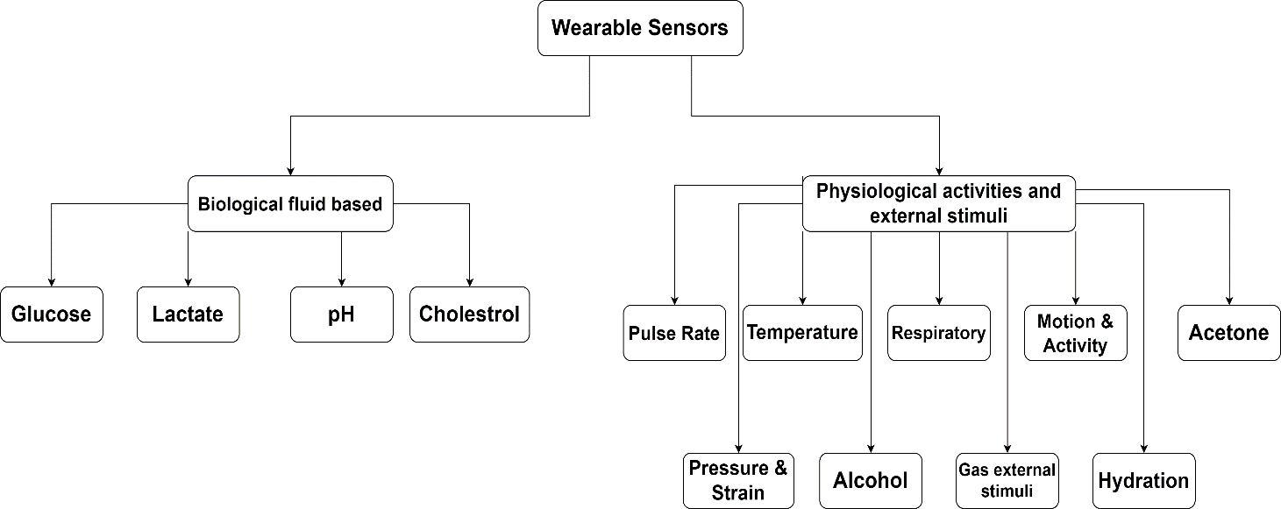

Figure [1]: Classification of wearable sensors

# Literature Survey

Various sensors have been developed to analyze respiration rate. For example, highly accurate and sensitive temperature sensors are used to detect nasal activity during breathing. The slight change in body temperature caused by inhaling and exhaling is used as a measure of the respiratory rate. Polymer-based (PVDF) nose sensors have also been used as cantilevers to take advantage of their piezoelectric properties when bent [31]. Such systems are bulky, and unfriendly, especially for older people. Wearable technology is therefore highly desirable as it can be attached to other parts of the body without disrupting nasal activity. The best location for these sensors (such as the human chest) has been reported to be ideal in this scenario. Chest expansion and contraction during inspiration and expiration can be easily monitored using strain sensors.

Large area printed electronics have greatly facilitated such development and enabled effective integration into non-planar substrates. A screen-printed strain sensor based on MWCNT paste has been described on a textile substrate for respiration rate measurement [32]. Changes in electrical resistance as a result of chest expansion and contraction were recorded for each inspiration and expiration. MWCNT/PDMS nanocomposites were also investigated for respiratory rate monitoring using strain measurements based on the capacitive structure of interdigitated electrodes (IDEs) [33]. Further development proposed an innovative approach to measure respiration rate based on humidity sensors printed on paper [34]. A PVDF layer was sandwiched between two printed Ag layers that generate electrical signals upon deformation induced in the human chest. Graphene has recently been investigated for a wide range of sensing applications. A fully coated respiration sensor was recently fabricated using a film of silica nanoparticles combined with a sensitive graphite layer [35].

Heat flow sensors on biodegradable printed paper represent another interesting idea recently presented by using solvent-free and inexpensive graphite [30]. The use of multi-core optical fibers in smart textiles enabled heart rate and respiration monitoring [36].

.

# Respiration Rate Monitoring System Design

Researchers have developed more efficient, eco-friendly sensors for the wearable electronics. The major work was focused on exploring the temperature and pressure sensitivity of the graphite. Graphite based sensor have proven to be the best replacement for the harmful and non-biodegradable sensors due to the excellent sensitivity of the GOP(Graphite-on-paper) sensors. Thermal conductivity of the graphite can be used to monitor the respiration rate non-invasively.

A novel approach is used to design the respiration rate monitoring system. As shown in the Figure 2, design consists:  
a) Graphite on paper based sensor (Flexible)

b) Signal Conditioning Circuit (Flexible)

c) Alerting system using ESP8266 NodeMCU (Rigid)

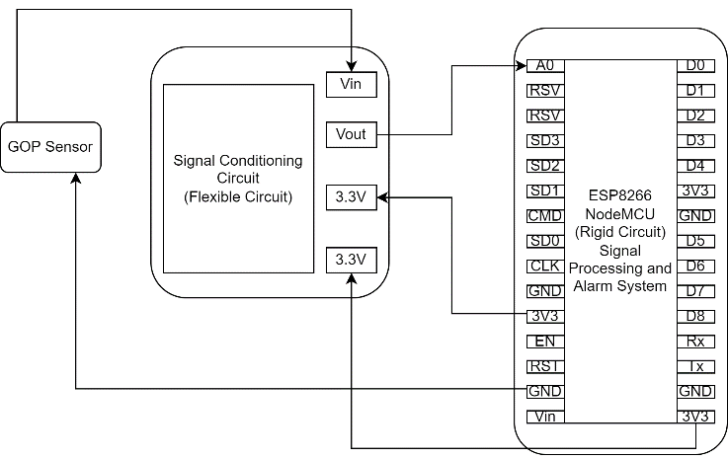

Figure [2]: Block Diagram of Respiration rate system.

## Sensor Design Methodology

Sensor was fabricated by mechanical abrasion of pencil graphite trace on paper for 10-12 times. The dimensions of the sensor were finalized after a series of experiments. The sensor is placed on the double tape to avoid disturbance due to piezoelectric effect. The sensor fabricated is shown in the Figure 3. Graphite was used due to its nature to act like thermistor having negative temperature coefficient.

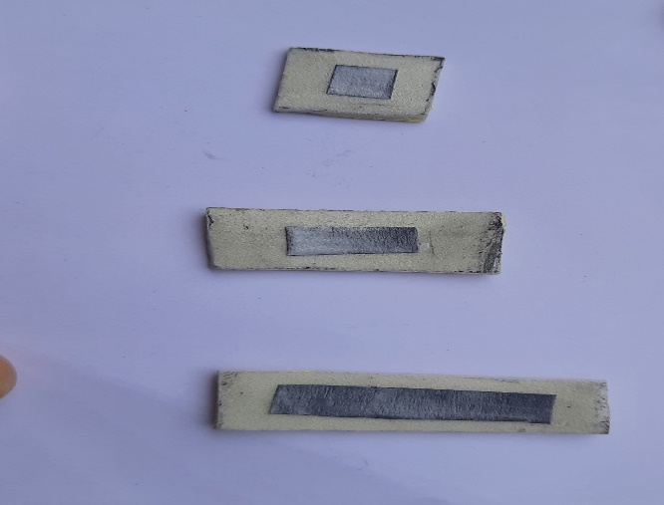

Figure [3]: Fabricated GOP sensors placed on double tape of various dimensions.

In room temperature (i.e., 300K), the change in resistance varies for different grading of pencils (i.e., HB,2B,3B,4B).

The resistance changes of graphite sensor for HB and 2B are shown in Figure 4. The change in resistance of graphite sensor for 3B and 4B are shown in Figure 5.

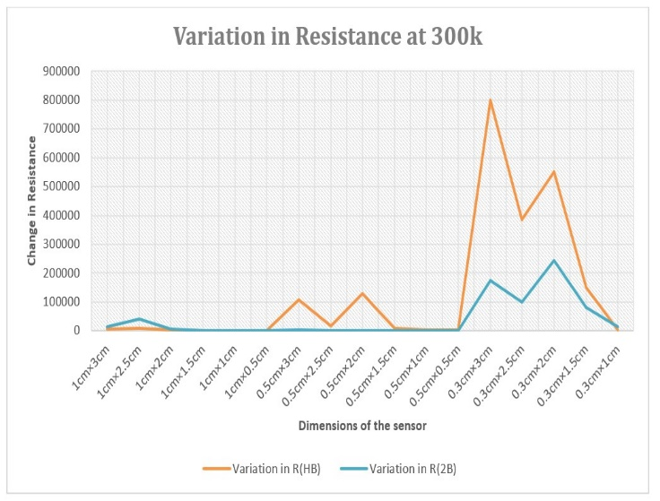

Figure [4]: Graph showing the variation of resistance at room temperature across various dimensions of GOP sensor. The graphite grading is HB, 2B.

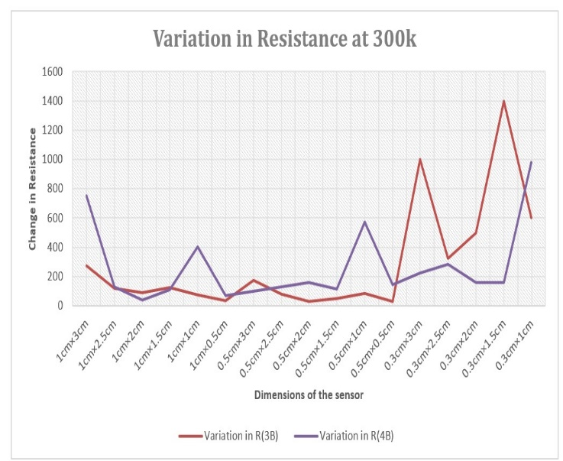

Figure [5]: Graph showing the variation of resistance at room temperature across various dimensions of GOP sensor. The graphite grading is 3B, 4B.

The graphs conclude that the graphite on paper sensor made using 4B pencil have least change in resistance at constant temperature (i.e., 300K). It can be concluded that the 4B pencil can be used for sensor fabrication.

## Signal Conditioning Circuit Design Methodology

The Signal from the sensor cannot be used directly by the Signal processing unit. So, the below Signal Conditioning Circuit is designed. The flowchart is shown in Figure 6.

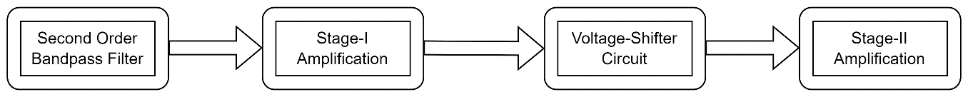

Figure [6]: Flowchart of Signal Conditioning Circuit

Initially, the sensor signal was observed. The signal represents the change in voltage due to the change in resistance of the GOP sensor. The Figure 11 shows the signal from the GOP sensor. To find the frequency range of the signal Fast Fourier Transform analysis was done for the GOP signal. We can conclude that signal frequencies lie in the range 1Hz to 0.49KHz. The Figures 7,8,9 shows the power spectrum analysis, power density analysis and CCDF Measurements. The analysis was done using MATLAB Simulink.

To obtain the signal frequencies in the range 1Hz to 0.49KHz, Second Order Bandpass Filter was used. These filters have a high input impedance which means that it can be easily cascaded with other active filter circuits to give more complex filter designs. The second-order filters are preferred over the first order due to its high roll-off rate. The lower cutoff frequency is set to 1Hz and upper cutoff frequency is set to 0.49KHz. Refer the calculations sections for the values of the components in the filter. The Figure 10 shows the output of the bandpass filter.

In the next stage amplifier with gain equal to 10 is arranged. The output of Stage I amplifier is shown in Figure 12. To eliminate the negative voltage, Voltage Shifter circuit was designed. The output of Voltage Shifter Circuit is shown in Figure 13. Stage II amplifier with gain equal to 10 is assigned to the output of the Voltage Shifter Circuit. The design flow is shown in Figure 15.

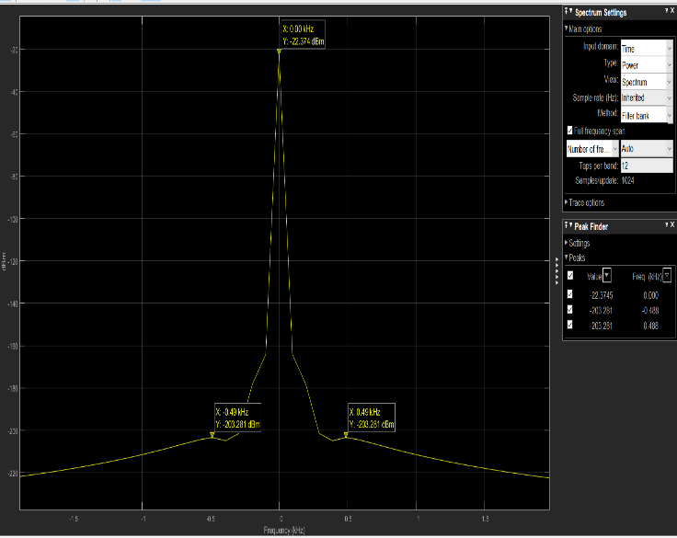

Figure [7]: Power Spectrum analysis for the GOP sensor.

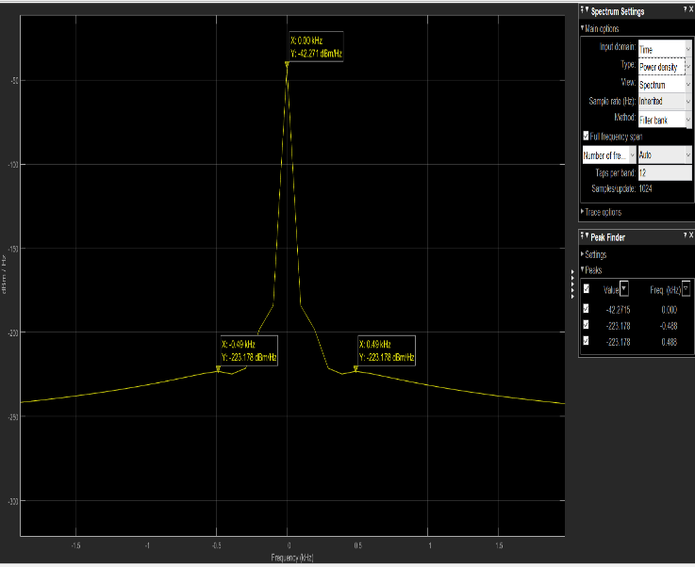

Figure [8]: Power density Spectrum for GOP sensor.

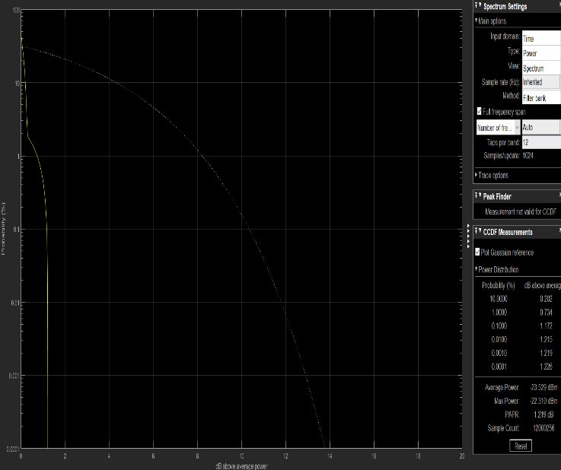

Figure [9]: CCDF Measurements for GOP sensor

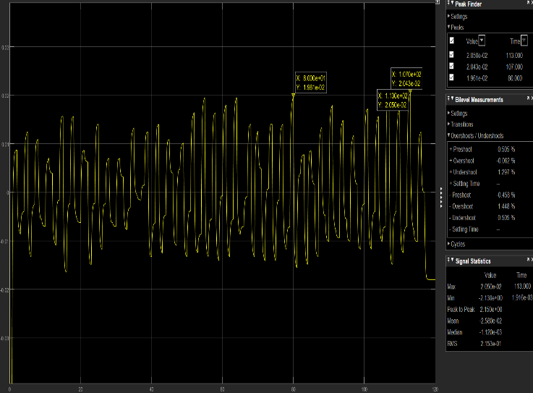

Figure [10]: Output of Second Order Bandpass Filter

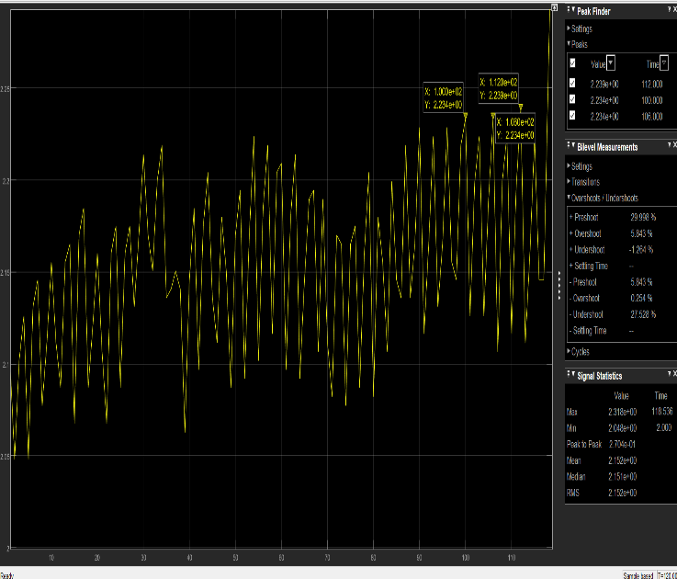

Figure [11]: Output for GOP sensor.

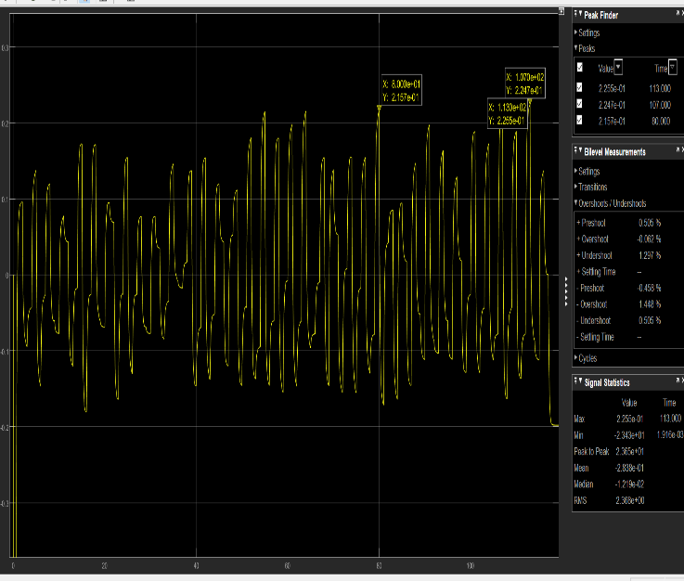

Figure [12]: Output of Stage I Amplifier

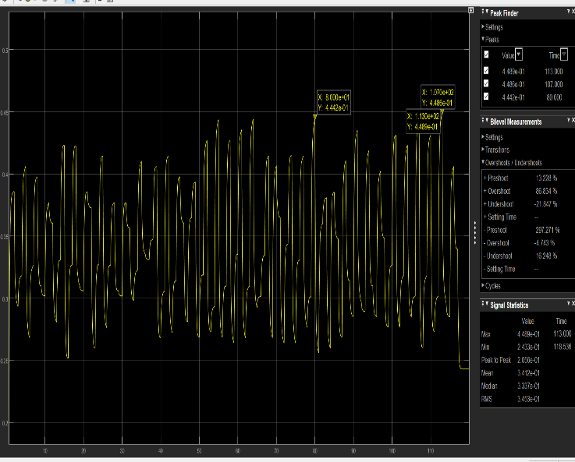

Figure [13]: Output of Voltage Shifter Circuit

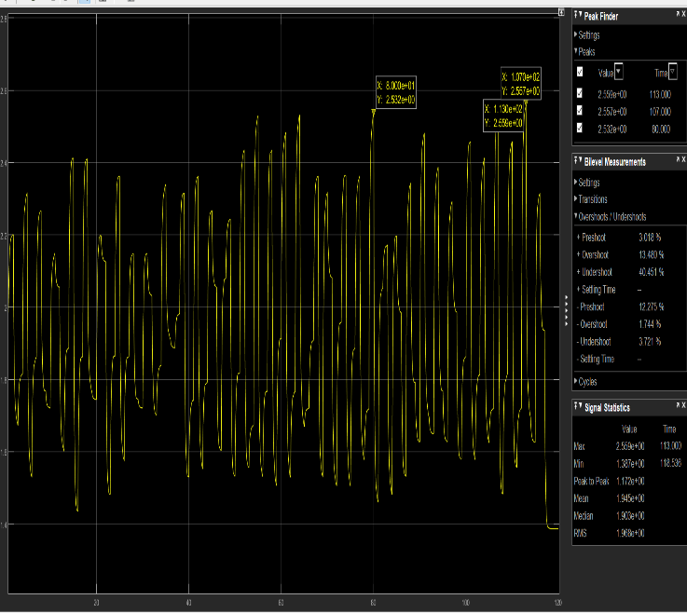

Figure [14]: Output of Stage II Amplifier

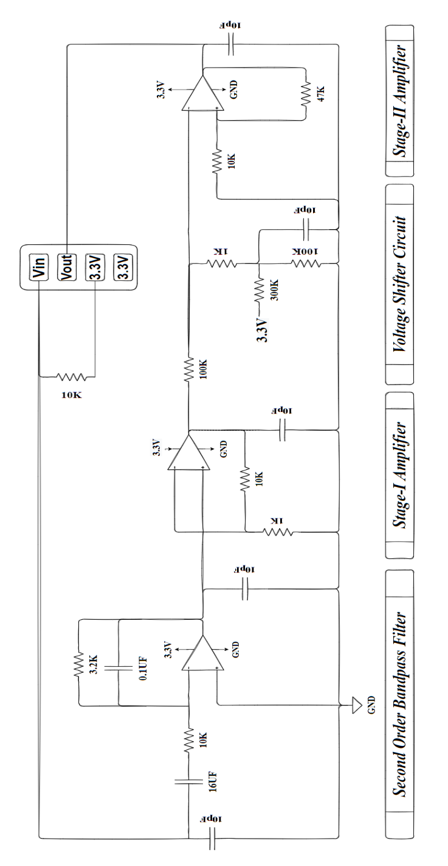

Figure [15]: Schematics of Signal Conditioning Circuit

## PCB Design Methodology

Flexible substrate was used to design the PCB of Signal Conditioning Circuit. The PCB Layer Stack is shown in Figure 16. The PCB Layout was designed using Altium PCB Designer. The Layout is shown in Figure 17. The Top and Bottom Layer Layout is shown in Figures 18,19. The Dimensions of the PCB is 20mm×29mm. The components used in the PCB are Surface mounted devices. Soldering of components was done using Solder station at temperature 593K to 613K.

The op-amps used are MCP6231UT-E/OTCT-ND. The maximum supply voltage is 6V which is greater than 4V. The Voltage input offset is 5mV which is sufficient for the amplifier to supply the output to the next stages. The Fabricated PCB’s top and bottom layers are shown in Figures 20,21.

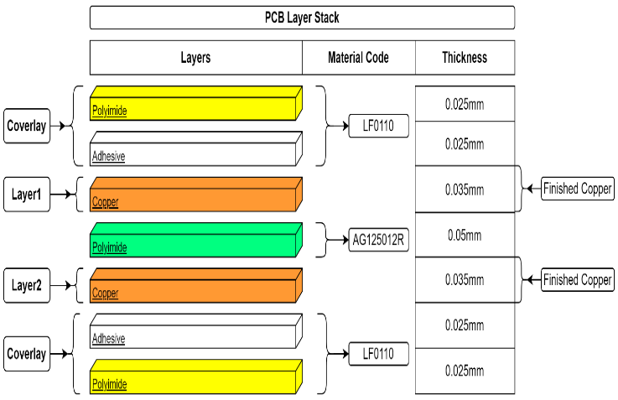

Figure [16]: PCB Layer Stack

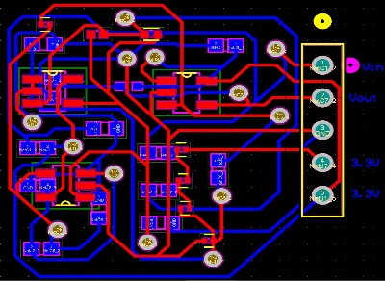

Figure [17]: PCB Layout designed using Altium PCB Designer

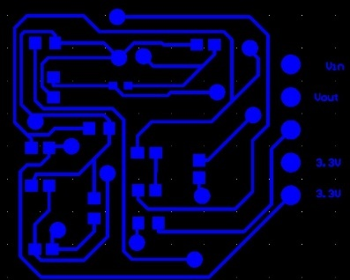

Figure [18]: PCB Bottom layer layout



Figure [19]: PCB Top layer layout

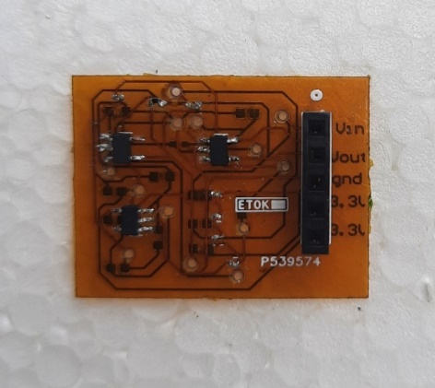

Figure [20]: PCB Top View

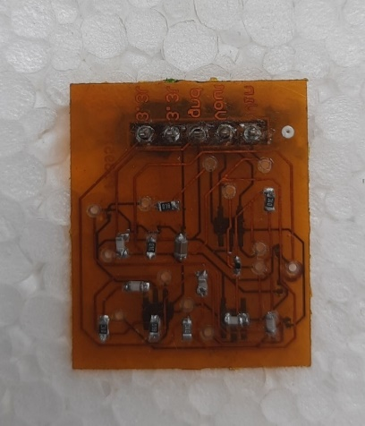

Figure [21]: PCB Bottom View

# Deep Learning Analysis

## Deep Learning Model Architecture

The model uses only neural networks. The inputs for the model are the signal from GOP sensor and output from the Signal Conditioning Circuit. The model consists of four dense layers. The first three layers uses RELU activation function. The final layer uses the linear activation function. The Figure 22 describes the layer information.

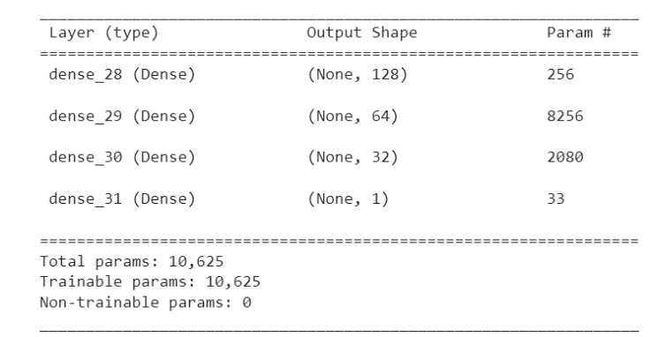

Figure [22]: Model Architecture which is designed using neural nets.

## Results

After running the model with the dataset consisting the practical values. The training and validation MAE is shown in Figure 23. The training and validation loss in shown in Figure 24. The predicted values against real values are shown in Table 1. The loss for the model is 4.5164e-04. The mean average error is 0.0160. Mean squared error from neural net is 0.0004516378976404667 and Mean absolute error from neural net is 0.01598966121673584. The shows the effectiveness of the model.

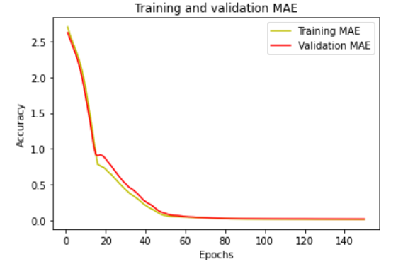

Figure [23]: Training and Validation MAE

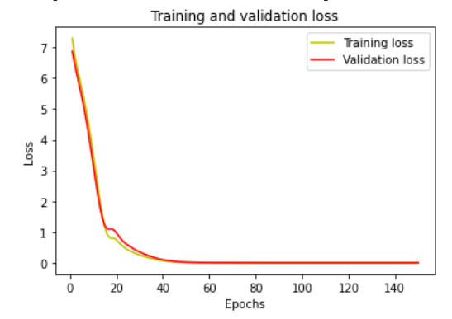

Figure [24]: Training and Validation loss

|  |  |  |
| --- | --- | --- |
| S.NO | Real Output Value | Predicted Output value |
| 1 | 2.658942 | 2.6582606 |
| 2 | 2.658911 | 2.6871536 |
| 3 | 2.671876 | 2.6751812 |
| 4 | 2.684715 | 2.67768 |
| 5 | 2.672020 | 2.6751812 |

Table [1]: Predicted values against real values from the model outputs.

# CALCULATIONS

## Calculations for Second Order Bandpass Filter

From FFT analysis shown in above sections, we can conclude that the signal frequencies lie between 1Hz to 0.49KHz. So, to extract the signal and reduce the noise a bandpass filter must be used.

To design a bandpass filter, we need the lower cut-off frequency as 1Hz and upper cut-off frequency as 0.49kHz. To find the values of the capacitor and resistor of the filter, we can the below formulas:

-(1)

 -(2)

|  |  |  |  |
| --- | --- | --- | --- |
| **S.No** | **Parameter** | **Assumed Parameter** | **Calculated Parameter** |
| **1** |  | 1Hz | - |
| **2** |  | 0.49KHz | - |
| **3** | R1 | 10K | - |
| **4** | C1 | - | 15F |
| **5** | R2 | - | 3.2K |
| **6** | C2 | 0.1F | - |

Table [2]: Bandpass filter parameters table.

We can substitute the  as 1Hz and assume either R1 or C1 as some value and find the remaining parameter. This methodology can be followed using .The results are shown in the Table 2.

# ALARM SYSTEM USING ESP8286 NODEMCU

The outputs will be provided to the ESP8266 NodeMCU. The NodeMCU ESP8266 development board comes with an ESP-12E module. This module contains an ESP8266 chip with a Tensilica Xtensa 32-bit LX106 RISC microprocessor. This microprocessor supports RTOS and operates at adjustable clock frequencies from 80 MHz to 160 MHz The NodeMCU has 128KB of RAM and 4MB of flash memory for storing data and programs. The high processing power and deep sleep operation function with built-in Wi-Fi / Bluetooth make it ideal for IoT projects. The NodeMCU can be powered via a micro-USB socket and a VIN pin (external power pin). It supports UART, SPI and I2C interfaces. It has a 10-bit ADC and a 2.4GHz antenna. For the programming the nodemcu, we follow this methodology The signal from the PCB is processed and the median voltage is determined and this value will be considered as threshold voltage. A count variable will declare. When the input voltage crosses the threshold value in a time interval of 1sec, then the count value increases by 1 unit. The count value obtained per minute is considered as respiration rate. An alert message will be sent to the mobile in case of abnormal respiration rate. Normal respiration rate of an adult is 12-16 breaths/sec.

# RESULTS AND OBSERVATIONS

The inputs and outputs of the PCB are shown in the Figures 25,26,27,28. The variation of resistance across different dimensions are provided in the Supplementary material. The outputs shows that the signal from the PCB is in the range of 0V to 3.3V. Depending of the dimensions of GOP sensor, the input values are varied.

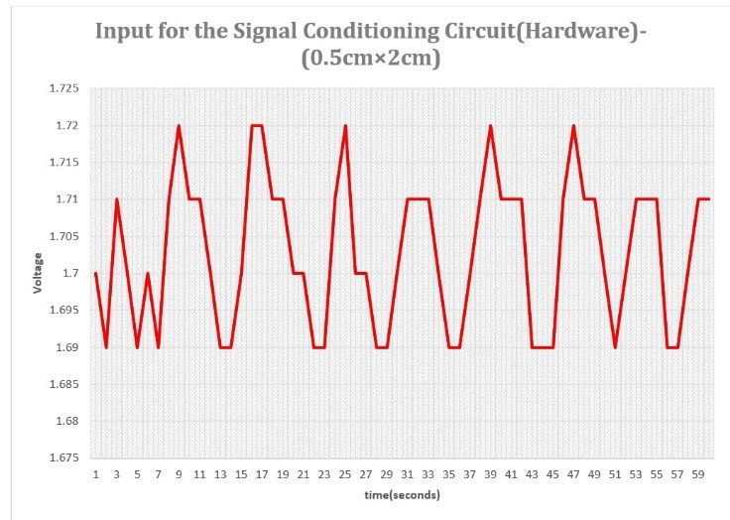

Figure [25]: Input for the Signal Conditioning Circuit (Hardware)-(0.5cm×2cm)

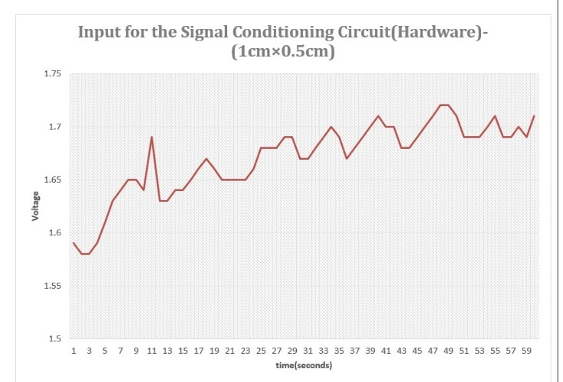

Figure [26]: Input for the Signal Conditioning Circuit (Hardware)-(1cm×0.5cm)

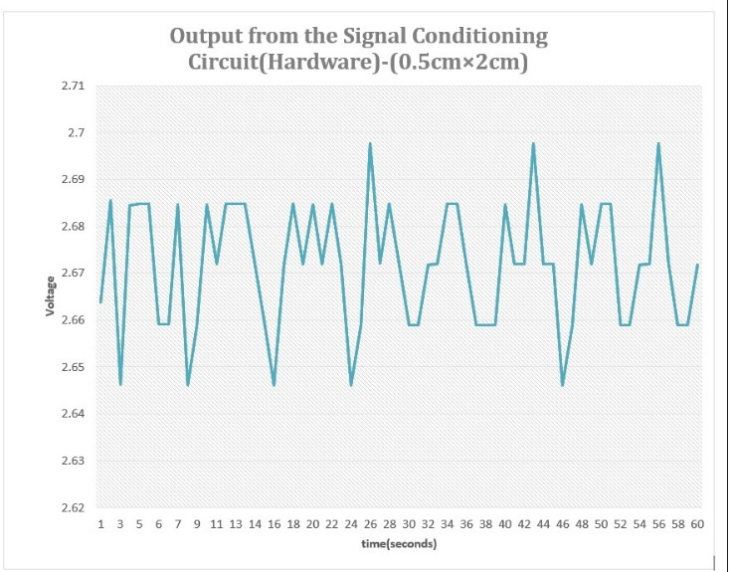

Figure [27]: Output for the Signal Conditioning Circuit (Hardware)-(0.5cm×2cm)

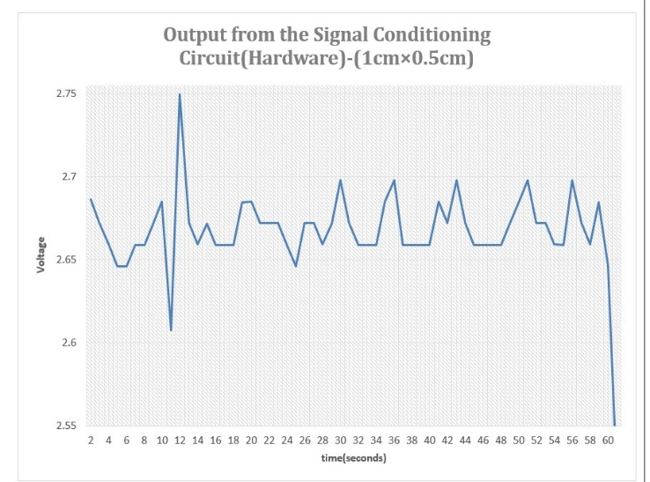

Figure [28]: Input for the Signal Conditioning Circuit (Hardware)-(1cm×0.5cm)

# CONCLUSION

Graphite based sensors have proven to be the best replacement for the harmful and non-biodegradable sensors due to the excellent sensitivity of the GOP(Graphite-on-paper) sensors. Thermal conductivity of the graphite can be used to monitor the respiration rate non-invasively. A novel approach is used to design the respiration rate monitoring system. Design consists of three components: a) GOP based sensor, b) Signal Conditioning Circuit, c) Alerting system using ESP8266 NodeMCU. The dimensions of the GOP sensor were finalized after a series of experiments. The final dimensions of the sensor are chosen as 1cm×0.5cm such that they have least variation in resistance at room temperature (i.e., 300K). The sensor was placed on a double tape to avoid change in resistance due to piezoelectric effect. As mentioned in the above sections, the GOP sensor is low-cost, flexible, eco-friendly, home-made, highly sensitive and doesn’t require any clean rooms for manufacture. It is observed that the GOP sensor signals lie in the range 1Hz-0.5kHz, concluded from the FFT analysis of the signal. A Signal Conditioning circuit is designed for the GOP sensor to make the signal compatible for ESP8266 MCU, for further processing. The Circuit design is flexible in nature and dimensions are 20mm×29mm. The Signal Conditioning Circuit is a low-cost, flexible and low-power device (can be operated at 5V). After observing the conditioned signal, we can observe peaks and nadirs, which have occurred due to respiration. The Alerting system consists of the ESP8266 NodeMCU which has a WIFI module and operates at 3.3V. An alert message can be sent to the mobile through the ESP8266 NodeMCU in case of abnormal respiration rate. The whole system including the Sensor, Signal Conditioning Circuit, alerting system can be embedded on the mask. This system does not require any contact of the patient’s philtrum. This enhances the comfort of the elderly people and children.

Acknowledgment

Our special acknowledgment for Dr. G. Arun Kumar Sir for soldering the SMD components on the PCB substrate.

References

1. Nakata, S.; Arie, T.; Akita, S.; Takei, K. Wearable, flexible, and multifunctional healthcare device with an ISFET chemical sensor for simultaneous sweat pH and skin temperature monitoring. ACS Sens. 2017, 2,443–448.
2. Mishra, R.K.; Martin, A.; Nakagawa, T.; Barfidokht, A.; Lu, X.; Sempionatto, J.R.; Lyu, K.M.; Karajic, A.; Musameh, M.M.; Kyratzis, I.L.; et al. Detection of vapor-phase organophosphate threats using wearable conformable integrated epidermal and textile wireless biosensor systems. Biosens. Bio electron. 2018, 101, 227–234.
3. Someya, T.; Bao, Z.; Malliaras, G.G. The rise of plastic bioelectronics. Nature 2016, 540, 379.
4. Wang, X.; Liu, Z.; Zhang, T. Flexible sensing electronics for wearable/attachable health monitoring. Small 2017, 13, 1602790.
5. Shiwaku, R.; Matsui, H.; Nagamine, K.; Uematsu, M.; Mano, T.; Maruyama, Y.; Nomura, A.; Tsuchiya, K.; Hayasaka, K.; Takeda, Y.; et al. A Printed Organic Circuit System for Wearable Amperometric Electrochemical Sensors. Sci. Rep. 2018, 8, 6368.
6. Kassal, P.; Steinberg, M.D.; Steinberg, I.M. Wireless chemical sensors and biosensors: A review. Sens. Actuators B: Chem. 2018, 226, 228–245.
7. Heikenfeld, J.; Jajack, A.; Rogers, J.; Gutruf, P.; Tian, L.; Pan, T.; Li, R.; Khine, M.; Kim, J.; Wang, J.; et al.Wearable sensors: Modalities, challenges, and prospects. Lab Chip 2018, 18, 217–248.
8. Oh, S.Y.; Hong, S.Y.; Jeong, Y.R.; Yun, J.; Park, H.; Jin, S.W.; Lee, G.; Oh, J.H.; Lee, H.; Lee, S.-S.; et al.Skin-Attachable, Stretchable Electrochemical Sweat Sensor for Glucose and pH Detection. ACS Appl. Mater. Interfaces 2018, 10, 13729–13740.
9. Nela, L.; Tang, J.; Cao, Q.; Tulevski, G.; Han, S.-J. Large-Area High-Performance Flexible Pressure Sensor with Carbon Nanotube Active Matrix for Electronic Skin. Nano Lett. 2018, 18, 2054–2059.
10. Nag, A.; Mukhopadhyay, S.C.; Kosel, J. Wearable flexible sensors: A review. IEEE Sens. J. 2017, 17, 3949–3960.
11. Yu, G.; Hu, J.; Tan, J.; Gao, Y.; Lu, Y.; Xuan, F. A wearable pressure sensor based on ultra-violet/ozone
12. microstructured carbon nanotube/polydimethylsiloxane arrays for electronic skins. Nanotechnology 2018, 29, 115502.
13. Luo, X.; Yu, H.; Cui, Y. A Wearable Amperometric Biosensor on a Cotton Fabric for Lactate. IEEE Electron.Device Lett. 2018, 39, 123–126.
14. Lee, H.; Hong, Y.J.; Baik, S.; Hyeon, T.; Kim, D.H. Enzyme-Based Glucose Sensor: From Invasive to Wearable Device. Adv. Healthc. Mater. 2018, 7, 1701150.
15. Zhan, Z.; Lin, R.; Tran, V.-T.; An, J.; Wei, Y.; Du, H.; Tran, T.; Lu, W. Paper/Carbon Nanotube-Based Wearable
16. Pressure Sensor for Physiological Signal Acquisition and Soft Robotic Skin. ACS Appl. Mater. Interfaces 2017, 9, 37921–37928.
17. Shafiee, H.; Asghar, W.; Inci, F.; Yuksekkaya, M.; Jahangir, M.; Zhang, M.H.; Durmus, N.G.; Gurkan, U.A.; Kuritzkes, D.R.; Demirci, U. Paper and flexible substrates as materials for biosensing platforms to detect multiple biotargets. Sci. Rep. 2015, 5, 8719.
18. MacDonald, W.A.; Looney, M.; MacKerron, D.; Eveson, R.; Adam, R.; Hashimoto, K.; Rakos, K. Latest advances in substrates for flexible electronics. J. Soc. Inf. Disp. 2007, 15, 1075–1083.
19. Zardetto, V.; Brown, T.M.; Reale, A.; di Carlo, A. Substrates for flexible electronics: A practical investigation on the electrical, film flexibility, optical, temperature, and solvent resistance properties. J. Polym. Sci. Part B: Polym. Phys. 2011, 49, 638–648.
20. Yamamoto, Y.; Harada, S.; Yamamoto, D.; Honda, W.; Arie, T.; Akita, S.; Takei, K. Printed multifunctional flexible device with an integrated motion sensor for health care monitoring. Sci. Adv. 2016, 2, e1601473.
21. Steinberg, M.D.; Kassal, P.; Steinberg, I.M. System architectures in wearable electrochemical sensors. Electroanalysis 2016, 28, 1149–1169.
22. Shi, W.; Luo, X.; Cui, Y. A Tube-Integrated Painted Biosensor for Glucose and Lactate. Sensors 2018, 18, 1620.
23. AitMou, Y.; Elgendy, M.; Jan, S.; Lucas, A.M.; Elzein, A.; Bermak, A. Smart wearable sensing platform with wireless communication and embedded processing for health monitoring applications. In Proceedings of the Qatar Foundation Annual Research Conference Proceedings, Doha, Qatar, 19–20 March 2018; p. HBPD924.
24. Kano, S.; Fujii, M. All-painting process to produce respiration sensor using humidity-sensitive nanoparticle film and graphite trace. ACS Sustain. Chem. Eng. 2018, 6, 12217–12223.
25. Bhide, A.; Muthukumar, S.; Saini, A.; Prasad, S. Simultaneous lancet-free monitoring of alcohol and glucose from low-volumes of perspired human sweat. Sci. Rep. 2018, 8.
26. Cao, H.; Landge, V.; Tata, U.; Seo, Y.-S.; Rao, S.; Tang, S.-J.; Tibbals, H.F.; Spechler, S.; Chiao, J.-C.An implantable, batteryless, and wireless capsule with integrated impedance and pH sensors for gastroesophageal reflux monitoring. IEEE Trans. Biomed. Eng. 2012, 59, 3131–3139.
27. Coyle, S.; Morris, D.; Lau, K.-T.; Diamond, D.; Moyna, N. Textile-based wearable sensors for assisting sports performance. In Proceedings of the Wearable and Implantable Body Sensor Networks, Berkeley, CA, USA, 3–5 June 2009; pp. 307–311.
28. Yoon, H.; Xuan, X.; Jeong, S.; Park, J.Y. Wearable, Robust, Non-enzymatic Continuous Glucose Monitoring System and Its In Vivo Investigation. Biosens. Bioelectron. 2018, 117, 267–275.
29. Tao, X.; Liao, S.; Wang, S.; Wu, D.; Wang, Y.A. Body Compatible Thermometer Based on Green Electrolytes.ACS Sens. 2018, 3, 1338–1346.
30. Servati, A.; Zou, L.; Wang, Z.J.; Ko, F.; Servati, P. Novel flexible wearable sensor materials and signal processing for vital sign and human activity monitoring. Sensors 2017, 17, 1622.
31. Shen, C.-L.; Huang, T.-H.; Hsu, P.-C.; Ko, Y.-C.; Chen, F.-L.; Wang, W.-C.; Kao, T.; Chan, C.-T. Respiratory Rate Estimation by Using ECG, Impedance, and Motion Sensing in Smart Clothing. J. Med. Biol. Eng. 2017, 37, 826–842.
32. Dinh, T.; Phan, H.-P.; Nguyen, T.-K.; Qamar, A.; Woodfield, P.; Zhu, Y.; Nguyen, N.-T.; Dao, D.V. Solvent-free fabrication of biodegradable hot-film flow sensor for noninvasive respiratory monitoring. J. Phys. D: Appl. Phys. 2017, 50, 215401.
33. Nag, A.; Mukhopadhyay, S.C.; Kosel, J. Flexible carbon nanotube nanocomposite sensor for multiple physiological parameter monitoring. Sens. Actuators A: Phys. 2016, 251, 148–155.
34. Güder, F.; Ainla, A.; Redston, J.; Mosadegh, B.; Glavan, A.; Martin, T.; Whitesides, G.M. Paper-based electrical respiration sensor. Angew. Chem. Int. Ed. 2016, 55, 5727–5732
35. Kano, S.; Fujii, M. All-painting process to produce respiration sensor using humidity-sensitive nanoparticle film and graphite trace. ACS Sustain. Chem. Eng. 2018, 6, 12217–12223.
36. Koyama, Y.; Nishiyama, M.; Watanabe, K. Smart textile using hetero-core optical fiber for heartbeat and respiration monitoring. IEEE Sens. J. 2018, 18, 6175–6180.

1.