# PREDICTING HOUSE PRICES

|  |  |
| --- | --- |
| **EX.N0 : 1** | **Predicting House Prices** |
| **DATE : 24/07/2024** |

**PROBLEM STATEMENT:** Build a regression model to predict house prices based on features like location, size, and amenities.

**PYTHON CONCEPTS:** Functions, classes, numeric types, sequences.

**VISUALIZATION:** Plotting regression line, residual plots.

**MULTIVARIATE ANALYSIS:** Multiple regression.

**DATASET:** Kaggle House Prices

# ALGORITHM:

Step 1: Start the program.

Step 2: Import necessary libraries. Step 3: Load the dataset.

Step 4: Encode categorical variable, define feature & testing set.

Step 5: Split the dataset into training & testing set, create trained model. Step 6: Print equal metric & test the cell.

# PROGRAM:

import pandas as pd

from sklearn.preprocessing import LabelEncoder from sklearn.model_selection import train_test_split

from sklearn.linear_model import LinearRegression

from sklearn.metrics import r2_score, mean_absolute_error import matplotlib.pyplot as plt

file_path = 'C:/Users/HARISH/Downloads/Housing.csv' housing_data = pd.read_csv(file_path)

categorical_features = ['mainroad', 'guestroom', 'basement', 'hotwaterheating', 'airconditioning', 'prefarea', 'furnishingstatus']

le = LabelEncoder()

for feature in categorical_features:

housing_data[feature] = le.fit_transform(housing_data[feature]) X = housing_data.drop('price', axis=1)y = housing_data['price']

X_train, X_test, y_train, y_test = train_test_split(X, y, test_size=0.2, random_state=42) model = LinearRegression()

model.fit(X_train, y_train) y_pred = model.predict(X_test) r2 = r2_score(y_test, y_pred)

mae = mean_absolute_error(y_test, y_pred) plt.figure(figsize=(10, 6))

plt.scatter(y_test, y_pred, alpha=0.7, color='b') plt.plot([y_test.min(), y_test.max()],

[y_test.min(), y_test.max()], 'k--', lw=2) plt.xlabel('Actual Price') plt.ylabel('Predicted Price') plt.title('Actual vs Predicted Prices') plt.show()

print(f'R-squared (R²): {r2}')

print(f'Mean Absolute Error (MAE): {mae}')

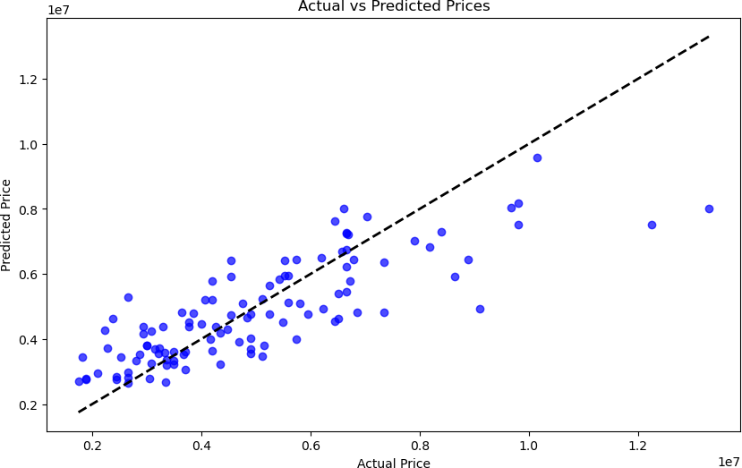





# RESULT:

Thus, the program for house price prediction is executed successfully.

# CUSTOMER SEGMENTATION FOR AN E-COMMERCE COMPANY

|  |  |
| --- | --- |
| **EX.N0 : 2** | **Customer Segmentation for an E-commerce Company** |
| **DATE : 05/08/2024** |

**PROBLEM STATEMENT:** Perform cluster analysis to segment customers based on purchasing behaviour.

**PYTHON CONCEPTS:** Data structures, file reading/writing.

**VISUALIZATION:** Cluster plots.

**MULTIVARIATE ANALYSIS:** Cluster analysis with k-means, hierarchical clustering.

**DATASET:** Online Retail Dataset

# ALGORITHM:

Step 1: Start the program.

Step 2: Import necessary libraries. Step 3: Load the dataset.

Step 4: Encode categorical variable, define feature & testing set.

Step 5: Split the dataset into training & testing set, create trained model. Step 6: Print equal metric & test the cell.

# PROGRAM:

import pandas as pd import numpy as np

from sklearn.preprocessing import StandardScaler from sklearn.cluster import KMeans

import matplotlib.pyplot as plt import seaborn as sns

import os

os.environ['OMP_NUM_THREADS'] = '1'

data = {'CustomerID': [1, 2, 3, 4, 5, 6, 7, 8, 9, 10],

'Age': [25, 45, 35, 50, 23, 33, 43, 36, 29, 55],

'AnnualIncome': [50000, 60000, 70000, 80000, 40000, 75000, 85000, 72000, 48000, 90000],

'SpendingScore': [60, 70, 80, 90, 50, 85, 90, 78, 65, 95] }

df = pd.DataFrame(data)

features = df[['Age', 'AnnualIncome', 'SpendingScore']] scaler = StandardScaler()

scaled_features = scaler.fit_transform(features) inertia = [] k_range = range(1, 11) for k in k_range:

kmeans = KMeans(n_clusters=k, n_init=10, random_state=0) kmeans.fit(scaled_features)

inertia.append(kmeans.inertia_) plt.figure(figsize=(8, 5)) plt.plot(k_range, inertia, marker='o')

plt.xlabel('Number of Clusters') plt.ylabel('Inertia') plt.title('Elbow Method for Optimal k') plt.show() optimal_k = 3

kmeans = KMeans(n_clusters=optimal_k, n_init=10, random_state=0) df['Cluster'] = kmeans.fit_predict(scaled_features) plt.figure(figsize=(10, 7))

sns.scatterplot(data=df, x='AnnualIncome', y='SpendingScore', hue='Cluster', palette='viridis', s=100)

plt.title('Customer Segments') plt.xlabel('Annual Income') plt.ylabel('Spending Score') plt.legend(title='Cluster') plt.show()

print(df)

# OUTPUT:

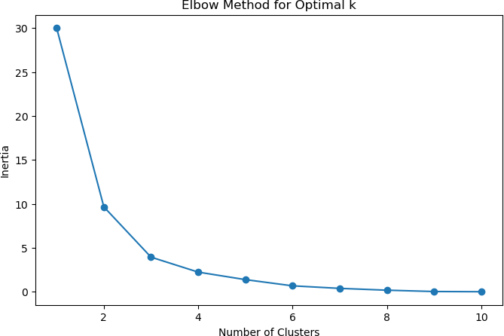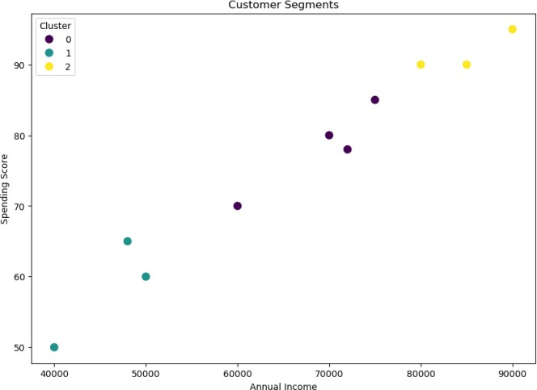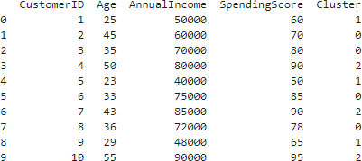

**RESULT:**

Thus, the program for Customer Segmentation for an E-commerce Company is executed successfully.

# SENTIMENT ANALYSIS OF MOVIE REVIEWS

|  |  |
| --- | --- |
| **EX.N0 : 3** | **SENTIMENT ANALYSIS OF MOVIE REVIEWS** |
| **DATE : 07/08/2024** |

**PROBLEM STATEMENT:** Classify movie reviews as positive or negative using text Data.

**PYTHON CONCEPTS:** Text files, sequences, flow controls.

**VISUALIZATION:** Word cloud, bar plots.

**MULTIVARIATE ANALYSIS:** PCA for text data, logistic regression.

**DATASET:** IMDB Movie Reviews.

# ALGORITHM:

Step 1: Start the program.

Step 2: Import necessary libraries. Step 3: Load the dataset.

Step 4: Encode categorical variable, define feature & testing set.

Step 5: Split the dataset into training & testing set, create trained model. Step 6: Print equal metric & test the cell.

# PROGRAM:

import pandas as pd

import matplotlib.pyplot as plt from wordcloud import WordCloud

from sklearn.feature_extraction.text import TfidfVectorizer from sklearn.decomposition import PCA

from sklearn.linear_model import LogisticRegression

from sklearn.metrics import classification_report, confusion_matrix from sklearn.model_selection import train_test_split

from sklearn.preprocessing import LabelEncoder import nltk

from nltk.corpus import stopwords

from nltk.tokenize import word_tokenize from nltk.stem import PorterStemmer import seaborn as sns nltk.download('punkt') nltk.download('stopwords')

df = pd.read_csv('C:/Users/AI_LAB/Downloads/IMDB Dataset.csv') stop_words = set(stopwords.words('english'))

stemmer = PorterStemmer() def preprocess_text(text):

tokens = word_tokenize(text.lower())

tokens = [stemmer.stem(word) for word in tokens if word.isalpha() and word not in stop_words] return ' '.join(tokens)

df['cleaned_review'] = df['review'].apply(preprocess_text) vectorizer = TfidfVectorizer(max_features=5000)

X = vectorizer.fit_transform(df['cleaned_review']).toarray() encoder = LabelEncoder()

y = encoder.fit_transform(df['sentiment']) pca = PCA(n_components=2)

X_pca = pca.fit_transform(X) plt.figure(figsize=(8, 6))

plt.scatter(X_pca[:, 0], X_pca[:, 1], c=y, cmap='coolwarm', alpha=0.5) plt.title('PCA of Movie Reviews')

plt.xlabel('Principal Component 1')

plt.ylabel('Principal Component 2') plt.colorbar(label='Sentiment') plt.show()

X_train, X_test, y_train, y_test = train_test_split(X, y, test_size=0.2, random_state=42) model = LogisticRegression(max_iter=1000)

model.fit(X_train, y_train)

y_pred = model.predict(X_test) print("Confusion Matrix:") print(confusion_matrix(y_test, y_pred)) print("\nClassification Report:") print(classification_report(y_test, y_pred))

positive_reviews = ' '.join(df[df['sentiment'] == 1]['cleaned_review']) negative_reviews = ' '.join(df[df['sentiment'] == 0]['cleaned_review']) plt.figure(figsize=(12, 6))

if len(positive_reviews.strip()) > 0:

plt.subplot(1, 2, 1) plt.imshow(WordCloud(width=800, height=400,

background_color='white').generate(positive_reviews), interpolation='bilinear') plt.title('Positive Reviews')

plt.axis('off')

else: print("No content available for positive reviews.") if len(negative_reviews.strip()) > 0:

plt.subplot(1, 2, 2)

plt.imshow(WordCloud(width=800, height=400, background_color='white').generate(negative_reviews), interpolation='bilinear')

plt.title('Negative Reviews') plt.axis('off') else:

print("No content available for negative reviews.") plt.show()

sns.countplot(x='sentiment', data=df) plt.title('Sentiment Distribution') plt.xlabel('Sentiment') plt.ylabel('Count')

plt.show()

# OUTPUT:

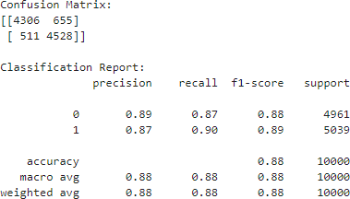

**RESULT:**

Thus, the program for sentiment analysis of movie reviews is executed successfully.

# STOCK MARKET ANALYSIS

|  |  |
| --- | --- |
| **EX.N0 : 4** | **STOCK MARKET ANALYSIS** |
| **DATE : 14/08/2024** |

**PROBLEM STATEMENT:** Analyse stock market data to predict future stock prices.

**PYTHON CONCEPTS:** Data structures, file reading/writing, functions.

**VISUALIZATION:** Line plots, candlestick charts. **MULTIVARIATE ANALYSIS:** Time series analysis, regression. **DATASET:** Yahoo Finance Stock Data.

# ALGORITHM:

Step 1: Start the program.

Step 2: Import necessary libraries. Step 3: Load the dataset.

Step 4: Encode categorical variable, define feature & testing set.

Step 5: Split the dataset into training & testing set, create trained model. Step 6: Print equal metric & test the cell.

# PROGRAM:

import pandas as pd

import matplotlib.pyplot as plt import mplfinance as mpf

from statsmodels.tsa.arima.model import ARIMA from sklearn.metrics import mean_squared_error import numpy as np

file_path = r'C:\Users\HARISH\Downloads\yahoo_data.xlsx'

data = pd.read_excel(file_path, index_col='Date', parse_dates=True) data.rename(columns={'Close*': 'Close', 'Adj Close**': 'Adj Close'}, inplace=True) data.sort_index(inplace=True)

data.ffill(inplace=True)

if 'Adj Close' in data.columns:

plt.figure(figsize=(12, 6))

plt.plot(data['Adj Close'], label='Adjusted Close Price') plt.title('Adjusted Close Price Over Time') plt.xlabel('Date')

plt.ylabel('Price (USD)') plt.legend()

plt.show()

reduced_data = data[-100:] # Reduce data points for candlestick chart mpf.plot(reduced_data, type='candle', style='charles', title='Candlestick Chart')

train_data, test_data = data['Adj Close'][:int(len(data)*0.8)], data['Adj Close'][int(len(data)*0.8):] model = ARIMA(train_data, order=(5, 1, 0))

model_fit = model.fit()

forecast = model_fit.forecast(steps=len(test_data)) mse = mean_squared_error(test_data, forecast) rmse = np.sqrt(mse)

print(f'RMSE: {rmse}') plt.figure(figsize=(12, 6))

plt.plot(train_data.index, train_data, label='Train Data') plt.plot(test_data.index, test_data, label='Test Data') plt.plot(test_data.index, forecast, label='Forecast') plt.title('Stock Price Prediction')

plt.xlabel('Date') plt.ylabel('Price (USD)') plt.legend()

plt.show()

# OUTPUT:

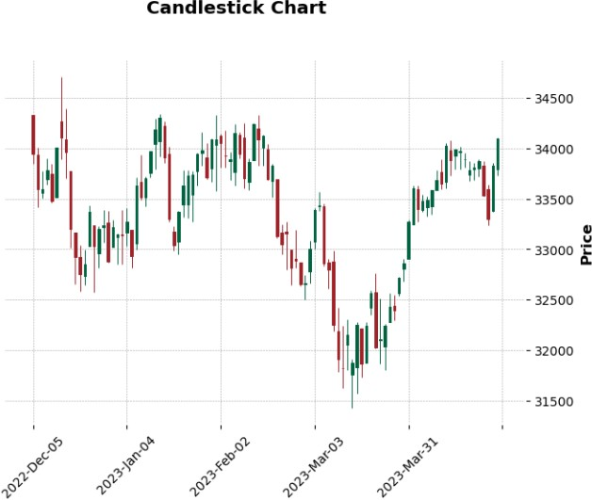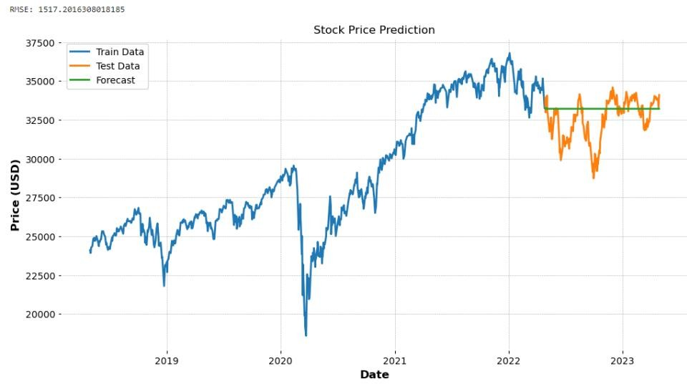

**RESULT:**

Thus, the program for stock market analysis is executed successfully.

# LOAN DEFAULT PREDICTION

|  |  |
| --- | --- |
| **EX.N0 : 5** | **LOAN DEFAULT PREDICTION** |
| **DATE : 21/08/2024** |

**PROBLEM STATEMENT:** Predict loan default probability based on borrower information.

**PYTHON CONCEPTS:** Classes, functions, sequences.

**VISUALIZATION:** ROC curve, bar plots.

**MULTIVARIATE ANALYSIS:** Logistic regression, factor analysis.

**DATASET:** Lending Club Loan Data

# ALGORITHM:

Step 1: Start the program.

Step 2: Import necessary libraries. Step 3: Load the dataset.

Step 4: Encode categorical variable, define feature & testing set.

Step 5: Split the dataset into training & testing set, create trained model. Step 6: Print equal metric & test the cell.

# PROGRAM:

import pandas as pd

import matplotlib.pyplot as plt import seaborn as sns

from sklearn.model_selection import train_test_split from sklearn.linear_model import LogisticRegression from sklearn.metrics import roc_curve, auc

from sklearn.preprocessing import StandardScaler from sklearn.decomposition import PCA

import os

file_path = 'C:/Users/HARISH/Downloads/loan_data.csv' # Update path accordingly if os.path.exists(file_path):

df = pd.read_csv(file_path) print("Data loaded successfully.") else:

print(f"File not found: {file_path}")

dummies = pd.get_dummies(df['purpose'], drop_first=True) df = pd.concat([df, dummies], axis=1)

df.drop('purpose', inplace=True, axis=1) X = df.drop(['not.fully.paid'], axis=1)

y = df['not.fully.paid'] scaler = StandardScaler()

X_scaled = scaler.fit_transform(X) pca = PCA(n_components=2)

X_pca = pca.fit_transform(X_scaled)

X_train, X_test, y_train, y_test = train_test_split(X_pca, y, test_size=0.33, random_state=42) model = LogisticRegression()

model.fit(X_train, y_train)

y_pred_prob = model.predict_proba(X_test)[:, 1] fpr, tpr, _ = roc_curve(y_test, y_pred_prob) roc_auc = auc(fpr, tpr)

plt.figure(figsize=(8, 6))

plt.plot(fpr, tpr, color='blue', lw=2, label=f'ROC curve (area = {roc_auc:.2f})') plt.plot([0, 1], [0, 1], color='gray', linestyle='--')

plt.xlim([0.0, 1.0])

plt.ylim([0.0, 1.05]) plt.xlabel('False Positive Rate') plt.ylabel('True Positive Rate')

plt.title('Receiver Operating Characteristic (ROC)') plt.legend(loc='lower right')

plt.show()

# OUTPUT:

**RESULT:**

Thus, the program for loan default prediction is executed successfully.

# IMAGE CLASSIFICATION

|  |  |
| --- | --- |
| **EX.N0 : 6** | **IMAGE CLASSIFICATION** |
| **DATE : 04/09/2024** |

**PROBLEM STATEMENT:** Classify images into categories using various features.

**PYTHON CONCEPTS:** File handling, classes. **VISUALIZATION:** Image plots, feature importance plots. **MULTIVARIATE ANALYSIS:** PCA, clustering.

**DATASET:** CIFAR-10 Dataset

# ALGORITHM:

Step 1: Start the program.

Step 2: Import necessary libraries. Step 3: Load the dataset.

Step 4: Encode categorical variable, define feature & testing set.

Step 5: Split the dataset into training & testing set, create trained model. Step 6: Print equal metric & test the cell.

# PROGRAM:

import tensorflow as tf

from tensorflow.keras import layers, models

from tensorflow.keras.preprocessing.image import ImageDataGenerator import matplotlib.pyplot as plt

import numpy as np

(X_train, y_train), (X_test, y_test) = tf.keras.datasets.cifar10.load_data()

X_train, X_test = X_train / 255.0, X_test / 255.0 class_names = ['airplane', 'automobile', 'bird', 'cat', 'deer', 'dog', 'frog', 'horse', 'ship', 'truck'] plt.figure(figsize=(10,10))

for i in range(25): plt.subplot(5,5,i+1) plt.xticks([]) plt.yticks([]) plt.grid(False) plt.imshow(X_train[i], cmap=plt.cm.binary) plt.xlabel(class_names[y_train[i][0]]) plt.show() model = models.Sequential([

layers.Conv2D(32, (3, 3), activation='relu', input_shape=(32, 32, 3)),

layers.MaxPooling2D((2, 2)),

layers.Conv2D(64, (3, 3), activation='relu'),

layers.MaxPooling2D((2, 2)),

layers.Conv2D(64, (3, 3), activation='relu'), layers.Flatten(), layers.Dense(64, activation='relu'), layers.Dense(10) ]) model.compile(optimizer='adam',

loss=tf.keras.losses.SparseCategoricalCrossentropy(from_logits=True), metrics=['accuracy'])

history = model.fit(X_train, y_train, epochs=10, validation_data=(X_test, y_test))

test_loss, test_acc = model.evaluate(X_test, y_test, verbose=2) print(f"\nTest accuracy: {test_acc}")

plt.figure(figsize=(8, 4))

plt.subplot(1, 2, 1) plt.plot(history.history['accuracy']) plt.plot(history.history['val_accuracy']) plt.title('Model accuracy')

plt.ylabel('Accuracy') plt.xlabel('Epoch') plt.legend(['Train', 'Test'], loc='upper left') plt.subplot(1, 2, 2) plt.plot(history.history['loss']) plt.plot(history.history['val_loss']) plt.title('Model loss') plt.ylabel('Loss') plt.xlabel('Epoch')

plt.legend(['Train', 'Test'], loc='upper left') plt.tight_layout() plt.show()

predictions = model.predict(X_test) plt.figure(figsize=(10, 10))

for i in range(25): plt.subplot(5, 5, i+1) plt.xticks([]) plt.yticks([]) plt.grid(False) plt.imshow(X_test[i], cmap=plt.cm.binary) predicted_label = np.argmax(predictions[i]) true_label = y_test[i][0]

color = 'blue' if predicted_label == true_label else 'red' plt.xlabel(f"{class_names[predicted_label]} ({class_names[true_label]})", color=color) plt.show()

# OUTPUT:

**RESULT:**

Thus, the program for Image Classification is executed successfully.

# PREDICTING DIABETES

|  |  |
| --- | --- |
| **EX.N0 : 7** | **PREDICTING DIABETES** |
| **DATE : 11/09/2024** |

**PROBLEM STATEMENT:** Predict the onset of diabetes based on medical measurements.

**PYTHON CONCEPTS:** Data structures, numeric types, functions.

**VISUALIZATION:** Scatter plots, heatmaps. **MULTIVARIATE ANALYSIS:** Logistic regression, LDA. **DATASET:** Pima Indians Diabetes Database **ALGORITHM:**

Step 1: Start the program.

Step 2: Import necessary libraries. Step 3: Load the dataset.

Step 4: Encode categorical variable, define feature & testing set.

Step 5: Split the dataset into training & testing set, create trained model. Step 6: Print equal metric & test the cell.

# PROGRAM:

import pandas as pd import seaborn as sns

import matplotlib.pyplot as plt

from sklearn.model_selection import train_test_split from sklearn.linear_model import LogisticRegression

from sklearn.metrics import classification_report, confusion_matrix, accuracy_score

url = https://raw.githubusercontent.com/jbrownlee/Datasets/master/pima-indians-diabetes.data.csv columns = ['Pregnancies', 'Glucose', 'BloodPressure', 'SkinThickness', 'Insulin', 'BMI', 'DiabetesPedigreeFunction', 'Age', 'Outcome']

data = pd.read_csv(url, header=None, names=columns) print("First 5 records:\n", data.head()) print("\nStatistical Summary:\n", data.describe()) print("\nDataset Info:\n")

print(data.info()) sns.pairplot(data, hue='Outcome') plt.show()

correlation_matrix = data.corr() plt.figure(figsize=(10, 8))

sns.heatmap(correlation_matrix, annot=True, cmap='coolwarm') plt.show()

X = data.drop('Outcome', axis=1) y = data['Outcome']

X_train, X_test, y_train, y_test = train_test_split(X, y, test_size=0.3, random_state=42) model = LogisticRegression(max_iter=1000)

model.fit(X_train, y_train) y_pred = model.predict(X_test) print("Confusion Matrix:")

print(confusion_matrix(y_test, y_pred)) print("\nClassification Report:") print(classification_report(y_test, y_pred)) accuracy = accuracy_score(y_test, y_pred)

print(f"\nModel Accuracy: {accuracy * 100:.2f}%") sample = X_test.iloc[0].values.reshape(1, -1) sample_prediction = model.predict(sample)

print(f"\nPrediction for sample case (1 = Diabetes, 0 = No Diabetes): {sample_prediction[0]}")

# OUTPUT:

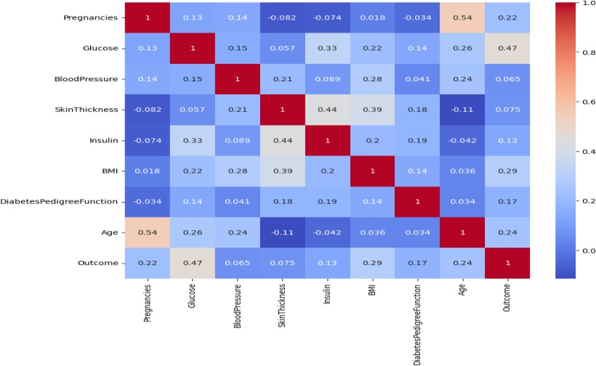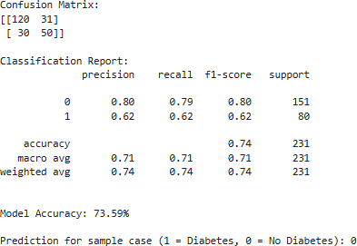

**RESULT:**

Thus, the program for predicting diabetes is executed successfully.

# WINE QUALITY PREDICTION

|  |  |
| --- | --- |
| **EX.N0 : 8** | **WINE QUALITY PREDICTION** |
| **DATE : 18/09/2024** |

**PROBLEM STATEMENT:** Predict the quality of wine based on various chemical properties.

**PYTHON CONCEPTS:** Classes, sequences, file handling.

**VISUALIZATION:** Histograms, box plots.

**MULTIVARIATE ANALYSIS:** Multiple regression, factor analysis.

**DATASET:** Wine Quality Dataset

# ALGORITHM:

Step 1: Start the program.

Step 2: Import necessary libraries. Step 3: Load the dataset.

Step 4: Encode categorical variable, define feature & testing set.

Step 5: Split the dataset into training & testing set, create trained model. Step 6: Print equal metric & test the cell.

# PROGRAM:

import pandas as pd import numpy as np

import matplotlib.pyplot as plt import seaborn as sns

from sklearn.model_selection import train_test_split from sklearn.linear_model import LinearRegression

from sklearn.metrics import mean_squared_error, r2_score class WineQualityPredictor:

def init (self, num_samples=1000):

self.num_samples = num_samples self.data = None

self.model = None

def generate_data(self):

np.random.seed(42)

quality = np.random.randint(3, 9, self.num_samples) # Quality scores between 3 and 8 fixed_acidity = np.random.uniform(4.6, 15.9, self.num_samples)

volatile_acidity = np.random.uniform(0.12, 1.58, self.num_samples) citric_acid = np.random.uniform(0, 1, self.num_samples) residual_sugar = np.random.uniform(1.9, 15.5, self.num_samples) chlorides = np.random.uniform(0.012, 0.1, self.num_samples) free_sulfur_dioxide = np.random.uniform(1, 72, self.num_samples) total_sulfur_dioxide = np.random.uniform(6, 289, self.num_samples) density = np.random.uniform(0.99007, 1.00369, self.num_samples) pH = np.random.uniform(2.74, 4.01, self.num_samples) sulfur_dioxide = np.random.uniform(10, 60, self.num_samples) alcohol = np.random.uniform(8.0, 14.9, self.num_samples)

self.data = pd.DataFrame({

'fixed acidity': fixed_acidity, 'volatile acidity': volatile_acidity, 'citric acid': citric_acid, 'residual sugar': residual_sugar, 'chlorides': chlorides, 'free sulfur dioxide': free_sulfur_dioxide, 'total sulfur dioxide': total_sulfur_dioxide, 'density': density, 'pH': pH,

'sulphur dioxide': sulfur_dioxide, 'alcohol': alcohol, 'quality': quality })

print(f"Synthetic Data Generated: {self.data.shape[0]} rows and {self.data.shape[1]} columns") def visualize_data(self):

self.data.hist(bins=15, figsize=(15, 10)) plt.suptitle('Histograms of Wine Quality Features') plt.show() plt.figure(figsize=(10, 6)) sns.boxplot(x='quality', y='fixed acidity', data=self.data) plt.title('Box Plot of Fixed Acidity by Quality') plt.show() def preprocess_data(self):

X = self.data.drop('quality', axis=1) y = self.data['quality']

return X, y def train_model(self, X, y):

X_train, X_test, y_train, y_test = train_test_split(X, y, test_size=0.2, random_state=42) self.model = LinearRegression()

self.model.fit(X_train, y_train) y_pred = self.model.predict(X_test) return y_train, y_test, y_pred

def evaluate_model(self, y_test, y_pred):

mse = mean_squared_error(y_test, y_pred) r2 = r2_score(y_test, y_pred)

print(f'Mean Squared Error: {mse}') print(f'R^2 Score: {r2}') def predict_quality(self, input_features):

input_df = pd.DataFrame([input_features], columns=self.data.columns[:-1]) prediction = self.model.predict(input_df) return prediction[0]

def run(self): self.generate_data() self.visualize_data() X, y = self.preprocess_data()

y_train, y_test, y_pred = self.train_model(X, y) self.evaluate_model(y_test, y_pred)

if name == " main ":

wine_predictor = WineQualityPredictor(num_samples=1000) wine_predictor.run()

example_features = {

'fixed acidity': 7.4, 'volatile acidity': 0.7, 'citric acid': 0.0,

'residual sugar': 1.9, 'chlorides': 0.076, 'free sulfur dioxide': 11.0,

'total sulfur dioxide': 34.0, 'density': 0.9978, 'pH': 3.51,

'sulphur dioxide': 45.0, 'alcohol': 9.4 }

predicted_quality = wine_predictor.predict_quality(example_features) print(f'Predicted Wine Quality: {predicted_quality:.2f}')

# OUTPUT:

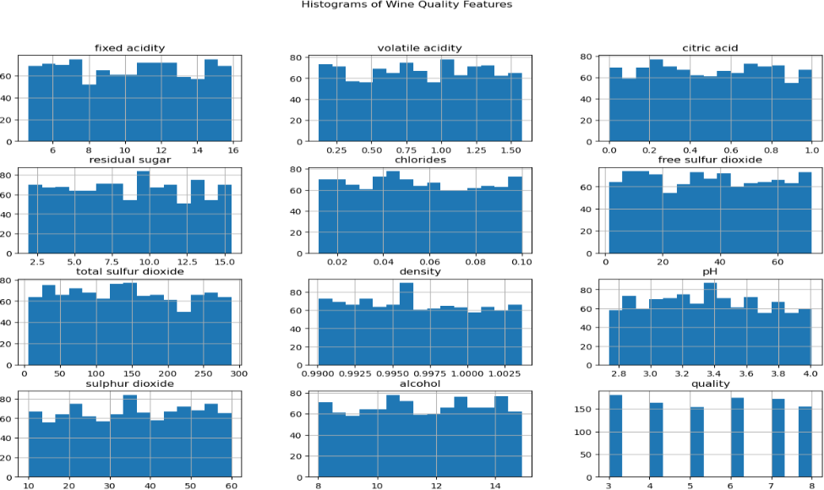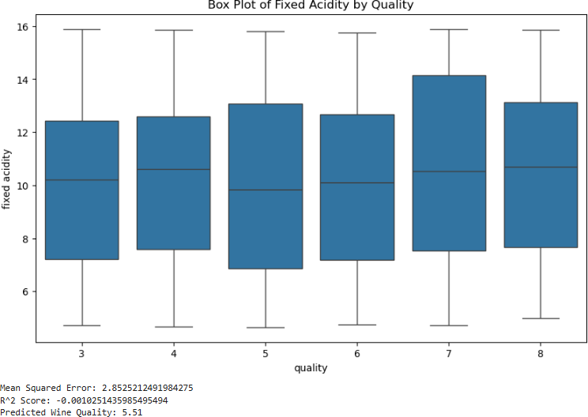

**RESULT:**

Thus, the program for wine quality prediction is executed successfully.

# HEART DISEASE PREDICTION

|  |  |
| --- | --- |
| **EX.N0 : 9** | **HEART DISEASE PREDICTION** |
| **DATE : 07/10/2024** |

**PROBLEM STATEMENT:** Predict heart disease based on clinical parameters

**PYTHON CONCEPTS:** Functions, data structures.

**VISUALIZATION:** Pair plots, ROC curve. **MULTIVARIATE ANALYSIS:** Logistic regression, PCA. **DATASET:** Heart Disease Dataset

# ALGORITHM:

Step 1: Start the program.

Step 2: Import necessary libraries. Step 3: Load the dataset.

Step 4: Encode categorical variable, define feature & testing set.

Step 5: Split the dataset into training & testing set, create trained model. Step 6: Print equal metric & test the cell.

# PROGRAM:

import numpy as np import pandas as pd

import matplotlib.pyplot as plt import seaborn as sns

from sklearn.model_selection import train_test_split from sklearn.preprocessing import StandardScaler

from sklearn.linear_model import LogisticRegression

from sklearn.metrics import accuracy_score, confusion_matrix, classification_report np.random.seed(42) # For reproducibility

num_samples = 1000

age = np.random.randint(30, 80, num_samples) sex = np.random.randint(0, 2, num_samples) cp = np.random.randint(0, 4, num_samples)

trestbps = np.random.randint(90, 200, num_samples) chol = np.random.randint(150, 300, num_samples) fbs = np.random.randint(0, 2, num_samples)

restecg = np.random.randint(0, 2, num_samples) thalach = np.random.randint(60, 200, num_samples) exang = np.random.randint(0, 2, num_samples) oldpeak = np.random.uniform(0, 6, num_samples) slope = np.random.randint(0, 3, num_samples)

ca = np.random.randint(0, 4, num_samples) thal = np.random.randint(1, 4, num_samples) target = np.random.randint(0, 2, num_samples) data = pd.DataFrame({

'age': age, 'sex': sex, 'cp': cp, 'trestbps': trestbps, 'chol': chol,

'fbs': fbs, 'restecg': restecg, 'thalach': thalach, 'exang': exang, 'oldpeak': oldpeak, 'slope': slope, 'ca': ca,

'thal': thal, 'target': target})

X = data.drop('target', axis=1) y = data['target']

X_train, X_test, y_train, y_test = train_test_split(X, y, test_size=0.2, random_state=42) scaler = StandardScaler()

X_train = scaler.fit_transform(X_train) X_test = scaler.transform(X_test) model = LogisticRegression() model.fit(X_train, y_train)

y_pred = model.predict(X_test)

accuracy = accuracy_score(y_test, y_pred) conf_matrix = confusion_matrix(y_test, y_pred)

class_report = classification_report(y_test, y_pred) print(f'Accuracy: {accuracy:.2f}')

print('Confusion Matrix:') print(conf_matrix) print('Classification Report:') print(class_report) plt.figure(figsize=(8, 6))

sns.heatmap(conf_matrix, annot=True, fmt='d', cmap='Blues', xticklabels=['No Disease', 'Disease'], yticklabels=['No Disease', 'Disease'])

plt.title('Confusion Matrix') plt.xlabel('Predicted') plt.ylabel('Actual') plt.show()

importance = model.coef_[0] features = X.columns

importance_df = pd.DataFrame({'Feature': features, 'Importance': importance}) importance_df = importance_df.sort_values(by='Importance', ascending=False) plt.figure(figsize=(10, 6))

sns.barplot(data=importance_df, x='Importance', y='Feature', palette='viridis') plt.title('Feature Importance')

plt.xlabel('Coefficient Value') plt.ylabel('Features')

plt.axvline(0, color='red', linestyle='--') # Adding a vertical line at 0 plt.show()

# OUTPUT:

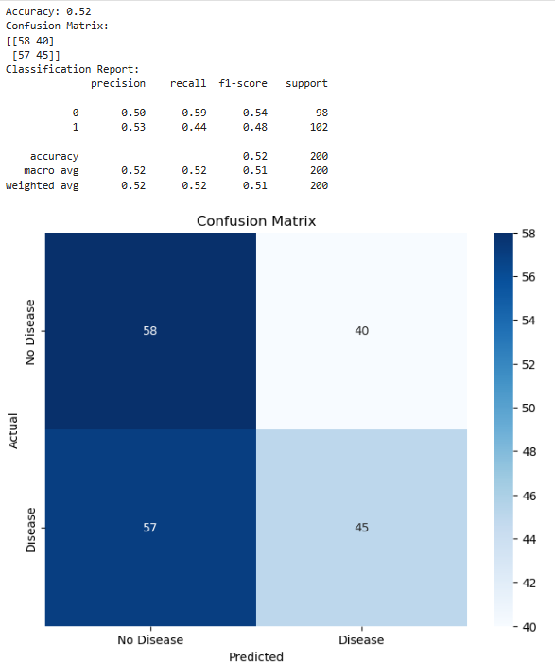

**RESULT:**

Thus, the program for heart disease prediction is executed successfully.

# BREAST CANCER DIAGNOSIS

|  |  |
| --- | --- |
| **EX.N0 : 10** | **Breast Cancer Diagnosis** |
| **DATE : 09/10/2024** |

**PROBLEM STATEMENT:** Classify tumors as benign or malignant based on features.

**PYTHON CONCEPTS:** Classes, sequences. **VISUALIZATION:** Confusion matrix, bar plots. **MULTIVARIATE ANALYSIS:** LDA, logistic regression. **DATASET:** Breast Cancer Wisconsin Dataset **ALGORITHM:**

Step 1: Start the program.

Step 2: Import necessary libraries. Step 3: Load the dataset.

Step 4: Encode categorical variable, define feature & testing set.

Step 5: Split the dataset into training & testing set, create trained model. Step 6: Print equal metric & test the cell.

# PROGRAM:

import numpy as np import pandas as pd

import matplotlib.pyplot as plt import seaborn as sns

from sklearn.model_selection import train_test_split from sklearn.preprocessing import StandardScaler

from sklearn.linear_model import LogisticRegression

from sklearn.metrics import accuracy_score, confusion_matrix, classification_report np.random.seed(42) # For reproducibility

num_samples = 1000

age = np.random.randint(30, 80, num_samples) sex = np.random.randint(0, 2, num_samples) cp = np.random.randint(0, 4, num_samples)

trestbps = np.random.randint(90, 200, num_samples) chol = np.random.randint(150, 300, num_samples) fbs = np.random.randint(0, 2, num_samples)

restecg = np.random.randint(0, 2, num_samples) thalach = np.random.randint(60, 200, num_samples) exang = np.random.randint(0, 2, num_samples) oldpeak = np.random.uniform(0, 6, num_samples) slope = np.random.randint(0, 3, num_samples)

ca = np.random.randint(0, 4, num_samples) thal = np.random.randint(1, 4, num_samples) target = np.random.randint(0, 2, num_samples) data = pd.DataFrame({

'age': age, 'sex': sex, 'cp': cp, 'trestbps': trestbps, 'chol': chol,

'fbs': fbs, 'restecg': restecg, 'thalach': thalach, 'exang': exang, 'oldpeak': oldpeak, 'slope': slope, 'ca': ca,

'thal': thal, 'target': target})

X = data.drop('target', axis=1) y = data['target']

X_train, X_test, y_train, y_test = train_test_split(X, y, test_size=0.2, random_state=42) scaler = StandardScaler()

X_train = scaler.fit_transform(X_train) X_test = scaler.transform(X_test) model = LogisticRegression() model.fit(X_train, y_train)

y_pred = model.predict(X_test)

accuracy = accuracy_score(y_test, y_pred) conf_matrix = confusion_matrix(y_test, y_pred)

class_report = classification_report(y_test, y_pred) print(f'Accuracy: {accuracy:.2f}')

print('Confusion Matrix:') print(conf_matrix) print('Classification Report:') print(class_report) plt.figure(figsize=(8, 6))

sns.heatmap(conf_matrix, annot=True, fmt='d', cmap='Blues', xticklabels=['No Disease', 'Disease'], yticklabels=['No Disease', 'Disease'])

plt.title('Confusion Matrix') plt.xlabel('Predicted') plt.ylabel('Actual') plt.show()

importance = model.coef_[0] features = X.columns

importance_df = pd.DataFrame({'Feature': features, 'Importance': importance}) importance_df = importance_df.sort_values(by='Importance', ascending=False) plt.figure(figsize=(10, 6))

sns.barplot(data=importance_df, x='Importance', y='Feature', palette='viridis') plt.title('Feature Importance')

plt.xlabel('Coefficient Value') plt.ylabel('Features')

plt.axvline(0, color='red', linestyle='--') # Adding a vertical line at 0 plt.show()

# OUTPUT:

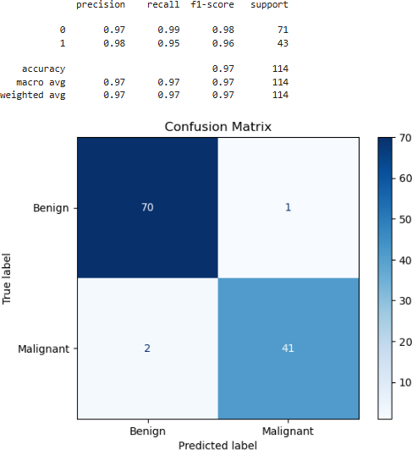

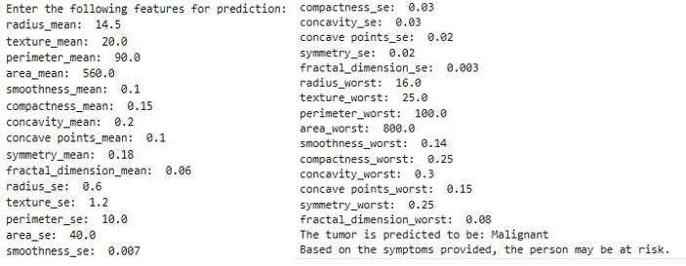

**RESULT:**

Thus, the program for breast cancer diagnosis is executed successfully.

# PREDICTING FLIGHT DELAYS

|  |  |
| --- | --- |
| **EX.N0 : 11** | **PREDICTING FLIGHT DELAYS** |
| **DATE : 16/10/2024** |

**PROBLEM STATEMENT:** Predict flight delays based on historical data.

**PYTHON CONCEPTS:** File reading/writing, functions.

**VISUALIZATION:** Line plots, scatter plots. **MULTIVARIATE ANALYSIS:** Regression, clustering. **DATASET:** Flight Delay Dataset

# ALGORITHM:

Step 1: Start the program.

Step 2: Import necessary libraries. Step 3: Load the dataset.

Step 4: Encode categorical variable, define feature & testing set.

Step 5: Split the dataset into training & testing set, create trained model. Step 6: Print equal metric & test the cell.

# PROGRAM:

import pandas as pd import numpy as np

import matplotlib.pyplot as plt import seaborn as sns

from sklearn.model_selection import train_test_split from sklearn.linear_model import LinearRegression

from sklearn.metrics import mean_absolute_error, mean_squared_error, r2_score df = pd.read_csv('C:/Users/HARISH/Downloads/Airline_Delay_Cause.csv') print(df.columns)

print(df.isnull().sum())

df.dropna(inplace=True) # or df.fillna(method='ffill', inplace=True) if 'year' in df.columns and 'month' in df.columns:

df['date'] = pd.to_datetime(df[['year', 'month']].assign(day=1)) plt.figure(figsize=(10, 5))

sns.lineplot(data=df, x='date', y='arr_delay') # Adjust if necessary plt.title('Flight Delays Over Time')

plt.xticks(rotation=45) plt.show()

delay_column = 'arr_delay' # Using 'arr_delay' for now

if 'carrier_delay' in df.columns and delay_column in df.columns: plt.figure(figsize=(10, 5))

sns.scatterplot(data=df, x='carrier_delay', y=delay_column) # Adjust as needed plt.title('Carrier Delay vs Arrival Delays') plt.xlabel('Carrier Delay (minutes)') plt.ylabel('Arrival Delay (minutes)') plt.show()

else: print("Check the delay columns: 'carrier_delay' or 'arr_delay' do not exist in the DataFrame.")

df['day_of_week'] = df['date'].dt.dayofweek # Monday=0, Sunday=6 features = ['day_of_week', 'arr_flights', 'carrier_ct'] # Modify as needed X = df[features] y = df[delay_column]

X_train, X_test, y_train, y_test = train_test_split(X, y, test_size=0.2, random_state=42) model = LinearRegression()

model.fit(X_train, y_train) predictions = model.predict(X_test)

print('Mean Absolute Error:', mean_absolute_error(y_test, predictions)) print('Mean Squared Error:', mean_squared_error(y_test, predictions)) print('R-squared:', r2_score(y_test, predictions))

plt.figure(figsize=(10, 5)) plt.scatter(y_test, predictions)

plt.plot([min(y_test), max(y_test)], [min(y_test), max(y_test)], color='red', linewidth=2) # Line of equality

plt.title('Predictions vs Actual Delays') plt.xlabel('Actual Delays') plt.ylabel('Predicted Delays') plt.show()

# OUTPUT:

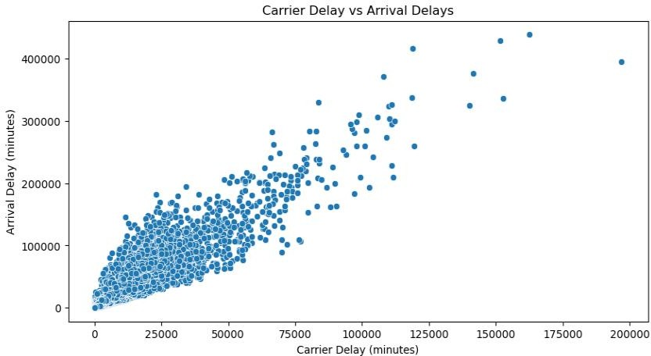

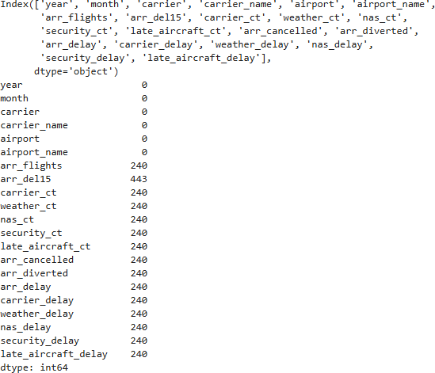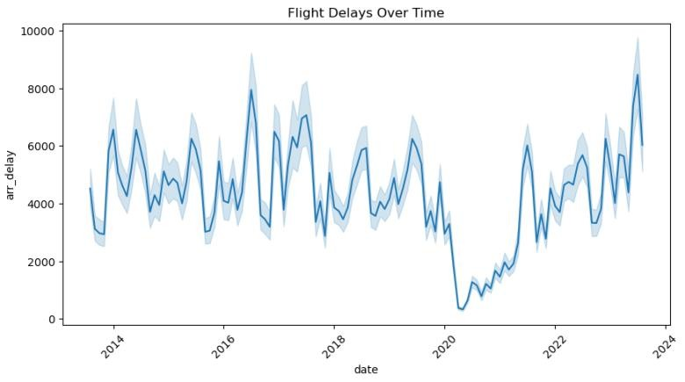

**RESULT:**

Thus, the program for predicting flight delays is executed successfully.

# ENERGY CONSUMPTION FORECASTING

|  |  |
| --- | --- |
| **EX.N0 : 12** | **ENERGY CONSUMPTION FORECASTING** |
| **DATE : 23/10/2024** |

**PROBLEM STATEMENT:** Forecast energy consumption based on historical data.

**PYTHON CONCEPTS:** Functions, numeric types.

**VISUALIZATION:** Line plots, heatmaps.

**MULTIVARIATE ANALYSIS:** Time series analysis, regression.

**DATASET:** Energy Consumption Dataset

# ALGORITHM:

Step 1: Start the program.

Step 2: Import necessary libraries. Step 3: Load the dataset.

Step 4: Encode categorical variable, define feature & testing set.

Step 5: Split the dataset into training & testing set, create trained model. Step 6: Print equal metric & test the cell.

# PROGRAM:

import pandas as pd import numpy as np

import matplotlib.pyplot as plt import seaborn as sns

from statsmodels.tsa.arima.model import ARIMA from sklearn.metrics import mean_squared_error

data = pd.read_csv('C:/Users/HARISH/Downloads/energy_consumption_dataset.csv', parse_dates=['Timestamp'], index_col='Timestamp')

print(data.head()) print(data.info())

data = data.fillna(method='ffill') plt.figure(figsize=(14, 6))

plt.plot(data['EnergyConsumption'], color='blue', label='Energy Consumption') plt.title('Energy Consumption Over Time')

plt.xlabel('Date') plt.ylabel('Consumption') plt.legend() plt.show()

numeric_data = data.select_dtypes(include=[np.number]) plt.figure(figsize=(10, 8))

sns.heatmap(numeric_data.corr(), annot=True, cmap='coolwarm') plt.title('Correlation Matrix') plt.show()

from statsmodels.tsa.seasonal import seasonal_decompose

result = seasonal_decompose(data['EnergyConsumption'], model='additive', period=24) # Adjust period based on your data's frequency

result.plot() plt.show() train_size = int(len(data) * 0.8)

train, test = data['EnergyConsumption'][:train_size], data['EnergyConsumption'][train_size:] model = ARIMA(train, order=(5, 1, 0)) # Adjust (p,d,q) based on your data's behavior fitted_model = model.fit()

forecast = fitted_model.forecast(steps=len(test)) forecast_index = test.index

mse = mean_squared_error(test, forecast) rmse = np.sqrt(mse)

print(f'RMSE: {rmse}') plt.figure(figsize=(14, 6)) plt.plot(train, label='Train') plt.plot(test, label='Test')

plt.plot(forecast_index, forecast, label='Forecast') plt.title('Energy Consumption Forecast') plt.xlabel('Date')

plt.ylabel('Consumption') plt.legend()

plt.show()

# OUTPUT:

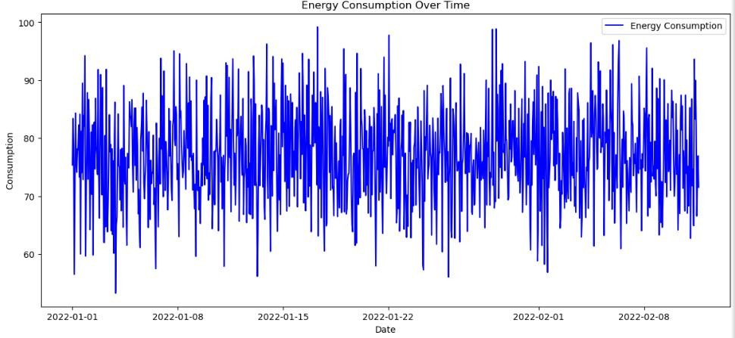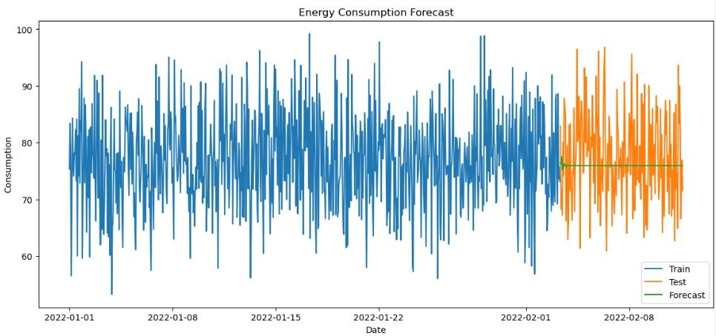

**RESULT:**

Thus, the program for energy consumption forecasting is executed successfully.