**Implementprogramtoapplymovingaveragesmoothingfordata preparation and time series forecasting.**

**EX:No.6**

**DATE:22/03/25**

# AIM:

Implementprogramtoapplymovingaveragesmoothingfordatapreparationandtimeseries forecasting.

## OBJECTIVE:

Toapplymovingaveragesmoothingforeffectivetimeseriesdatapreparationandforecastingofairpollutiontrends.

## BACKGROUND:

* Timeseriesdataoftencontainsrandomfluctuationsthatcanobscuremeaningful patterns.
* Movingaveragesmoothingreduces noise,enablingclearer visualization oflong-term trends.

## SCOPEOFTHEPROGRAM:

* ThetechniqueisapplicabletovariousairpollutantslikePM2.5,CO,NO₂,SO₂,andO₃.
* Smootheddatasupports betterforecastingandhelps inmakinginformed environmental policydecisions.

**CODE:**

importpandasaspd

importmatplotlib.pyplotasplt

#Loadthedataset

file_path='/content/us_air_pollution_2012_2021.csv' df = pd.read_csv(file_path)

#Convert'Date'columntodatetimeformatandsetasindex df['Date'] = pd.to_datetime(df['Date'])

df.set_index('Date',inplace=True)

#Selectthe'PM2.5(µg/m³)'columnandapplymovingaveragesmoothing pollutant_col = 'PM2.5 (µg/m³)'

ts = df[pollutant_col].dropna()

#Applya7-daymovingaverage window_size = 7

smoothed_ts=ts.rolling(window=window_size).mean()

#Plotoriginalvssmoothedtimeseries plt.figure(figsize=(14, 6))

plt.plot(ts, label='Original PM2.5', alpha=0.5) plt.plot(smoothed_ts,label='7-DayMovingAverage',color='red') plt.title('PM2.5 (µg/m³) - Original vs Smoothed Time Series')

plt.xlabel('Date') plt.ylabel('PM2.5(µg/m³)') plt.legend()

plt.grid(True) plt.tight_layout() plt.show()

# OUTPUT:

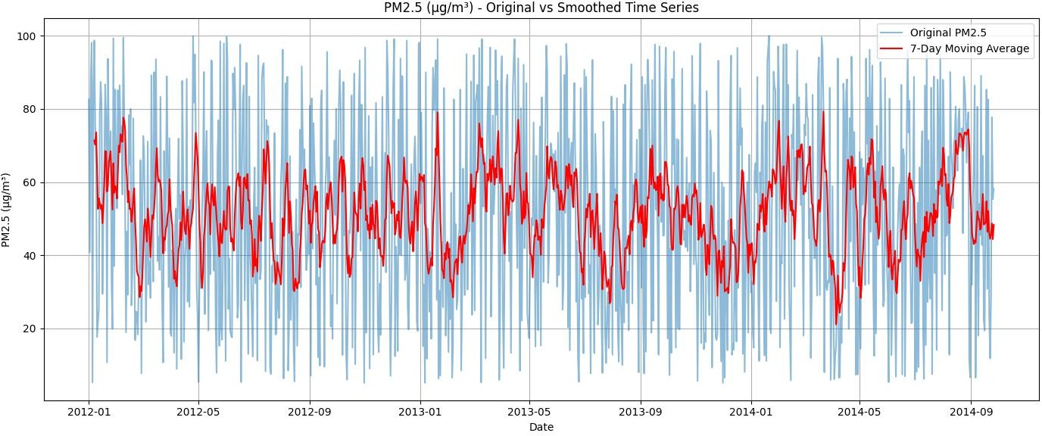

**RESULT:**

Thus,theprogramusingthetimeseriesdataimplementationhasbeendonesuccessfully.