ShopEZ
E-Commerce Platform
Backend Technical Documentation
Microservices Architecture with ASP.NET Core 10& Docker

Name  Trainer Name | Hemanth Bhupalam  Narasimha Rao
Tech Stack | ASP.NET Core 10+ Docker + SQL Server
Documentation Type | Backend Documentation
Date of Creation | 16/05/2026
Batch | B3.NETFSD

1. Introduction
ShopEZ is a full-stack e-commerce platform built as a capstone project. The backend is architected as a distributed microservices system powered by ASP.NET Core 8, enabling modularity, independent scalability, and clean separation of concerns across its three core domains: Authentication, Products, and Orders.
Each microservice owns its dedicated SQL Server database, communicates through well-defined REST APIs with JWT-based authorization, and is containerized using Docker. An Ocelot-based API Gateway serves as the single entry point at http://localhost:5139, routing all frontend requests to the appropriate downstream service.

1.1 Objectives
- Design a loosely coupled, independently deployable microservices backend
- Implement JWT-based authentication using BCrypt password hashing and token generation with configurable expiry
- Use Entity Framework Core (EF Core) for ORM in Auth and Order services
- Use Dapper (micro-ORM) in the Product Service for high-performance raw SQL queries with pagination and search
- Expose a unified API surface via Ocelot API Gateway at port 5139 (dev) / 5000 (Docker)
- Orchestrate all services using Docker Compose for one-command deployment
- Achieve comprehensive unit test coverage using xUnit and Moq across Controllers, Services, and Repositories
- Implement centralized structured logging via Serilog with daily rolling log files

1.2 Scope
This document covers the complete backend implementation of ShopEZ — architecture decisions, API design, database schema, system design diagrams, testing strategy, deployment guide, and future roadmap. Refer to the Frontend Documentation for the Angular 21 SPA.

2. Problem Statement — Issues in Existing Systems
Traditional monolithic e-commerce backends face a range of structural limitations that make them difficult to scale, maintain, and evolve:

2.1 Monolithic Architecture Problems
- All business domains (auth, products, orders) are tightly coupled inside a single deployable unit
- A bug or failure in one module can bring down the entire application
- Scaling requires replicating the entire monolith, even if only one domain experiences high load
- Deploying a small change requires redeploying and retesting the whole system
- Technology lock-in: the entire stack must use the same language, framework, and ORM

2.2 Database Coupling
- Single shared database creates schema coupling — changing one table risks breaking unrelated modules
- Concurrent writes across all domains contend on the same connection pool, creating bottlenecks
- No domain isolation: a bad migration in the products table can corrupt user data

2.3 Deployment & Operations Issues
- No container-based deployment makes environment consistency (dev vs prod) difficult
- Manual setup of dependencies across environments leads to "works on my machine" failures
- No clear API gateway layer — frontend developers must hardcode individual service URLs

2.4 Testing Gaps
- Tightly coupled code makes unit testing nearly impossible without spinning up the entire application
- Absence of mock-based testing leads to slow, fragile integration tests that depend on live database connections

3. Proposed System
ShopEZ resolves these problems through a microservices architecture with clear domain boundaries, independent databases, containerized deployment, JWT security, and a dedicated API gateway layer.

3.1 Microservices Decomposition

Service | Responsibility | Port (Dev) | Port (Docker) | ORM | Database
Auth Service | Registration, Login, JWT auth, User management | 5004 | 5001:8080 | EF Core | AuthDB
Product Service | CRUD, Search, Pagination, Stock Management | 5096 | 5002:8080 | Dapper | ProductDB
Order Service | Order creation, history, status updates | 5280 | 5003:8080 | EF Core | OrderDB
API Gateway | Route forwarding via Ocelot | 5139 | 5000:8080 | — | —

3.2 Technology Choices
- ASP.NET Core 8: Modern, cross-platform, high-performance Web API framework
- BCrypt.Net: Secure password hashing for all user passwords in AuthService
- JWT (JSON Web Tokens): Stateless authentication tokens with 1-day expiry, signed with HS256
- EF Core 8: Code-first ORM with automatic migrations for Auth and Order services
- Dapper 2.x: Lightweight micro-ORM for Product Service — explicit SQL with better performance for search/pagination
- Ocelot: .NET-native API Gateway that handles routing and can be extended for auth middleware
- Docker Compose: Declarative multi-container orchestration for one-command spin-up
- SQL Server 2022: Production-grade relational database with full ACID compliance
- Serilog: Structured logging with Console and daily rolling file sinks
- xUnit + Moq: Modern .NET testing stack — xUnit for test runner, Moq for mock-based unit tests

3.3 Architecture Benefits
- Each service can be deployed, scaled, and updated independently
- Database-per-service ensures complete data isolation (AuthDB, ProductDB, OrderDB)
- Docker Compose handles networking, environment variables, and dependency ordering automatically
- Ocelot gateway provides a stable API surface — frontend never calls microservices directly
- Clean 4-layer architecture (Controller → Service → Repository → DbContext/Dapper) enables easy unit testing
- JWT validation configured per-service with shared Issuer/Audience/Key — Admin-only and Auth-only routes secured

4. Tech Stack Details

4.1 Backend Framework

Technology | Version | Purpose
ASP.NET Core | 8.0 | Web API framework for all microservices
C# | 12 | Primary programming language
Entity Framework Core | 8.x | ORM for Auth and Order services
Dapper | 2.x | Micro-ORM for Product Service — raw SQL with pagination/search
BCrypt.Net | Latest | Secure password hashing (HashPassword / Verify)
JWT Bearer | 8.x | Authentication middleware — validates JWT on secured routes
Ocelot | 23.x | API Gateway routing and forwarding
Serilog | 3.x | Structured logging — Console + daily rolling file
xUnit | 2.x | Unit test framework
Moq | 4.x | Mocking framework for unit tests

4.2 Infrastructure & DevOps

Technology | Version | Purpose
Docker | Latest | Service containerization — each service has its own Dockerfile
Docker Compose | 3.9 | Multi-container orchestration — runs 5 containers with one command
SQL Server | 2022 | Relational database for all three microservices
mcr.microsoft.com/mssql/server | 2022-latest | SQL Server Docker image with SA credentials

4.3 Development Tools
- Visual Studio 2022 — IDE with full .NET 8 and Docker Compose support
- Swagger / Swashbuckle — Auto-generated API documentation and testing UI on each service
- Postman — API endpoint testing during development
- Docker Desktop — Local container management

4.4 Architecture Pattern
Each microservice follows a 4-layer clean architecture:
- Controller Layer: Receives HTTP requests, validates input via Data Annotations, delegates to Service layer. Applies [Authorize] and [Authorize(Roles)] attributes for JWT-based access control.
- Service Layer: Contains business logic, validation rules, and orchestration. Injected into controllers via constructor DI.
- Repository Layer: Handles all database operations via EF Core DbContext or Dapper IDbConnection. Service layer never accesses DB directly.
- DTO Layer: Defines request/response data shapes — prevents exposing internal entity models to clients. Includes Data Annotations for validation.

5. System Design

5.1 High-Level Architecture Diagram

Angular 21 SPA (http://localhost:4200)
↓ JWT Bearer Token attached via jwtInterceptor
Ocelot API Gateway (http://localhost:5139 / Docker: 5000)
/api/auth/* → Auth Service (dev:5004 / docker:5001) /api/products/* → Product Service (dev:5096 / docker:5002)
/api/orders/* → Order Service (dev:5280 / docker:5003)
↓
SQL Server 2022 (docker: shopez-sqlserver) | AuthDB | ProductDB | OrderDB

5.2 Component-Level Architecture
The internal layer structure of each microservice follows the same clean 4-layer pattern:

HTTP Request
↓ [Authorize] / [Authorize(Roles="Admin")] attribute check
Controller (AuthController / ProductsController / OrdersController)
↓ delegates to
Service Layer (AuthService1 / ProductService / OrderService)
↓ delegates to
Repository Layer (UserRepository / ProductRepository / OrderRepository)
↓ ORM/SQL
DbContext (EF Core) / IDbConnection (Dapper)
↓
SQL Server Database

5.3 Data Flow Diagram

Level 0 DFD (Context Diagram)
External entities: Browser/Angular SPA. Central process: ShopEZ Backend. Data stores: 3 SQL Server databases (AuthDB, ProductDB, OrderDB). All external requests pass through the Ocelot API Gateway before reaching any service.

Level 1 DFD
Decomposes the central process into three microservices. Shows data flows for: user registration/login with JWT token issuance, product listing/search/CRUD with pagination and stock management, and order creation/history with multi-item order support and status updates.

5.4 Use Case Diagram
Actors: Customer and Admin.
- Customer use cases: Register, Login, Browse Products (with pagination and search), View Product Details, Add to Cart, Checkout (Place Multi-Item Order), View Order History, Delete Own Order
- Admin use cases: Login, Add Product, Edit Product, Delete Product, Reduce Product Stock, View All Orders, Update Order Status, Delete Order, Get All Users, Update User Role

5.5 Entity Relationship Diagram

AuthDB — Users table

Column | Type | Constraints
UserId | int IDENTITY | PRIMARY KEY
Name | nvarchar(max) | NOT NULL
Email | nvarchar(450) | NOT NULL, UNIQUE INDEX
PasswordHash | nvarchar(max) | NOT NULL (BCrypt hash)
Role | nvarchar(max) | DEFAULT "Customer"

ProductDB — Products table

Column | Type | Constraints
ProductId | int IDENTITY | PRIMARY KEY
Name | nvarchar(max) | NOT NULL, min 3 chars
Description | nvarchar(max) | NOT NULL, min 10 chars
Price | decimal(18,2) | NOT NULL, range 1–1,000,000
ImageUrl | nvarchar(max) | NOT NULL
Stock | int | NOT NULL, range 0–10,000
CategoryName | nvarchar(max) | NOT NULL, min 3 chars

OrderDB — Orders & OrderItems tables

Column | Type | Constraints
OrderId | int IDENTITY | PRIMARY KEY
UserId | int | NOT NULL (from Auth service)
CustomerName | nvarchar(max) | NOT NULL, min 3 chars
TotalPrice | decimal(18,2) | NOT NULL, range 1–1,000,000
OrderDate | datetime2 | NOT NULL
Status | nvarchar(max) | NOT NULL
Items | ICollection<OrderItem> | Navigation property
OrderItemId | int IDENTITY | PRIMARY KEY (OrderItems)
ProductId | int | NOT NULL
ProductName | nvarchar(max) | NOT NULL
Quantity | int | NOT NULL, range 1–100
Price | decimal(18,2) | NOT NULL, range 1–1,000,000
TotalAmount | decimal(18,2) | NOT NULL

5.6 Ocelot API Gateway Routes

Frontend Calls (upstream) | Gateway Forwards To (downstream) | HTTP Methods
/api/auth/{everything} | Auth Service localhost:5004 / docker:authservice:8080 | GET, POST, PUT, DELETE
/api/products/{everything} | Product Service localhost:5096 / docker:productservice:8080 | GET, POST, PUT, DELETE
/api/orders/{everything} | Order Service localhost:5280 / docker:orderservice:8080 | GET, POST, PUT, DELETE

5.7 API Endpoint Reference

Auth Service — /api/auth

Method | Endpoint | Auth | Description | Request Body / Response
POST | /api/auth/register | None | Register new user. Hashes password with BCrypt. Role defaults to Customer. | RegisterDto: {name, email, password} → {message}
POST | /api/auth/login | None | Validate credentials, return JWT token with user details. | LoginDto: {email, password} → AuthResponseDto: {token, userId, name, email, role}
GET | /api/auth | Admin only | Get all registered users (excluding password hash). | → [{userId, name, email, role}]
PUT | /api/auth/{id}/role | Admin only | Update user role (Customer/Admin). | UpdateRoleDto: {role} → {message}

Product Service — /api/products

Method | Endpoint | Auth | Description | Request / Response
GET | /api/products | None | Get all or paginated products. Pass ?page=&pageSize=&search= for pagination/search. | → [Product[]] or PaginationResponseDto
GET | /api/products/{id} | None | Get single product by ID. | → ProductDto or 404
POST | /api/products | Admin | Create new product. | ProductDto → ProductDto
PUT | /api/products/{id} | Admin | Update existing product by ID. | ProductDto → {message}
DELETE | /api/products/{id} | Admin | Delete product by ID. | → {message} or 404
PUT | /api/products/{id}/reduce-stock | None | Reduce product stock by quantity. Called internally by Order service after order placement. | ?quantity=N → {message} or 400 (insufficient)

Order Service — /api/orders

Method | Endpoint | Auth | Description | Request / Response
GET | /api/orders | Admin | Get all orders across all users. | → [Order[]] with Items
GET | /api/orders/user/{userId} | Auth | Get all orders for a specific user by userId. | → [Order[]] with Items
GET | /api/orders/{orderId} | Auth | Get single order by orderId with full item details. | → Order with Items or 404
POST | /api/orders | Auth | Create new multi-item order. Calls Product Service to reduce stock per item. | OrderDto: {userId, customerName, totalAmount, status, orderItems:[]} → Order
PUT | /api/orders/{orderId}/status | Admin | Update order status (Pending/Confirmed/Shipped/Delivered). | [FromBody] string status → {message}
DELETE | /api/orders/{orderId} | Auth | Delete order by orderId. | → {message} or 404

6. Project Demo — Screenshots
The following screenshots demonstrate the running application. All services were tested via Swagger UI and Postman after executing docker-compose up --build, or by running individual services in development mode via dotnet run.

6.1 Docker Compose — All Services Running
The docker-compose up --build command builds all Dockerfiles and starts 4 containers: shopez-sqlserver, shopez-authservice, shopez-productservice, and shopez-orderservice (plus shopez-apigateway). The API Gateway at port 5000 (mapped to 5139 in dev) becomes the single entry point for the Angular frontend.

6.2 Auth Service — Swagger UI
The Auth Service Swagger UI at http://localhost:5001 exposes 4 endpoints: POST /api/auth/register, POST /api/auth/login, GET /api/auth (Admin only), and PUT /api/auth/{id}/role (Admin only). JWT authorization is configured on the secured endpoints.
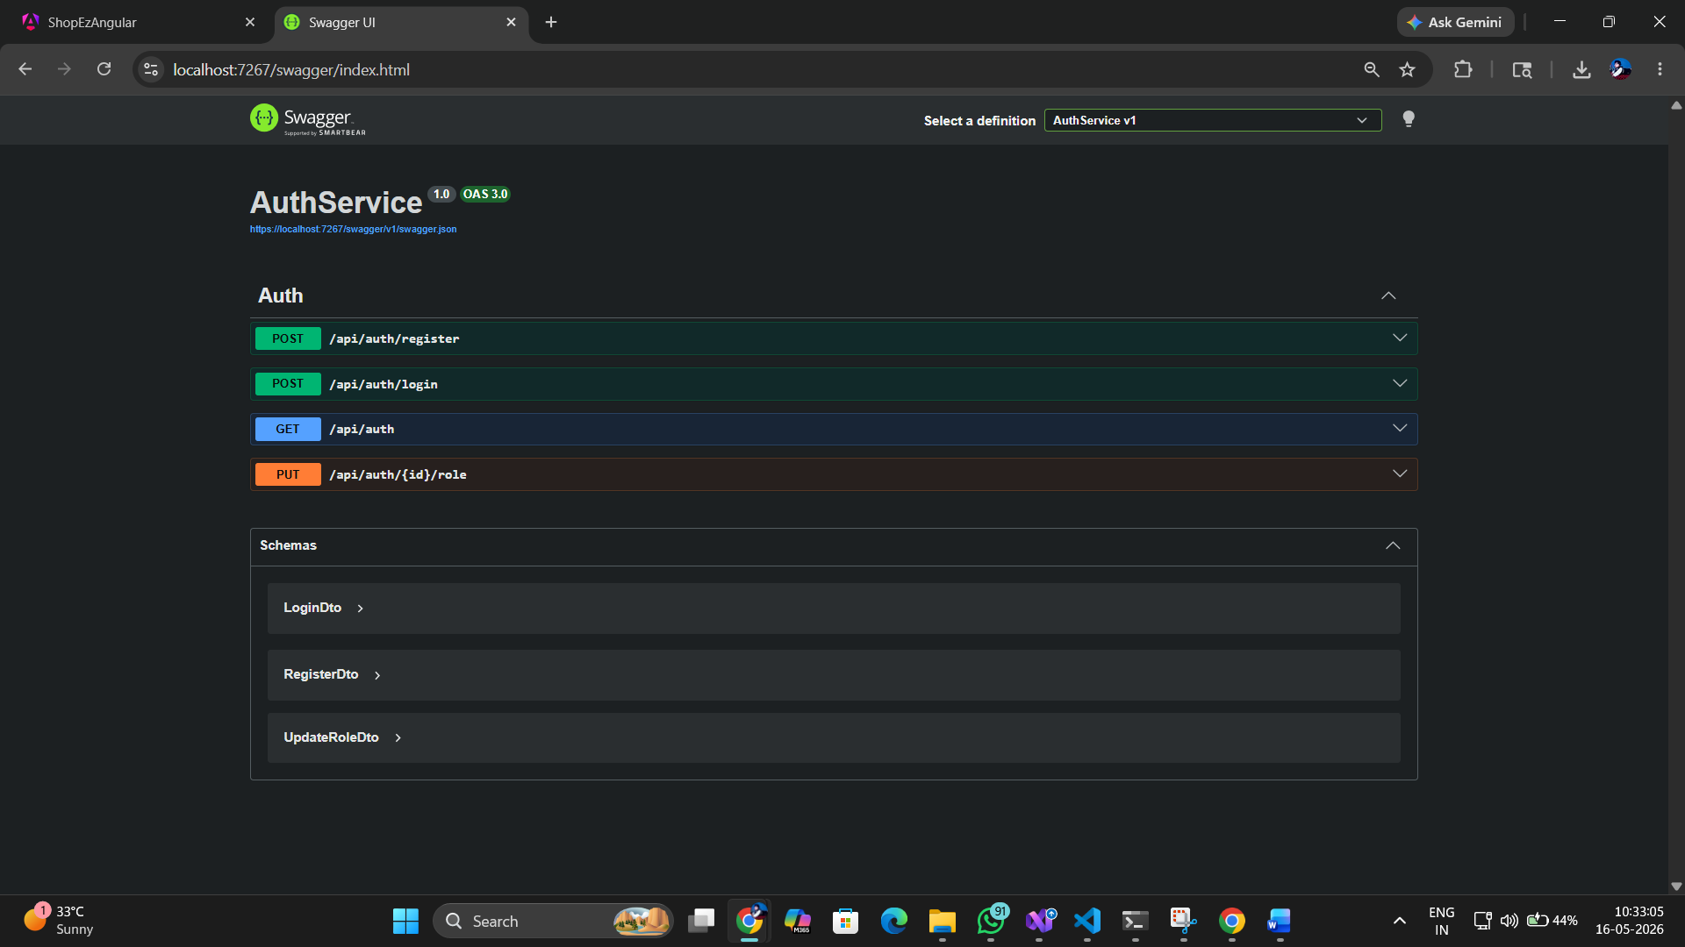

6.3 User Registration (POST /api/auth/register)
A valid RegisterDto with {name, email, password} creates a new user with BCrypt-hashed password and defaults Role to "Customer". Returns 200 with {message: "Registration Successful"}. Returns 400 if email already exists.
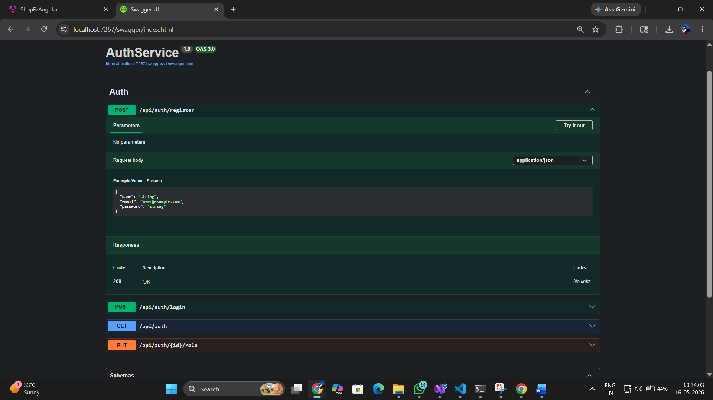

6.4 User Login (POST /api/auth/login)
A valid LoginDto verifies BCrypt hash and returns an AuthResponseDto containing the JWT token, userId, name, email, and role. The JWT is signed with HS256, includes NameIdentifier, Name, Email, and Role claims, and expires in 1 day.
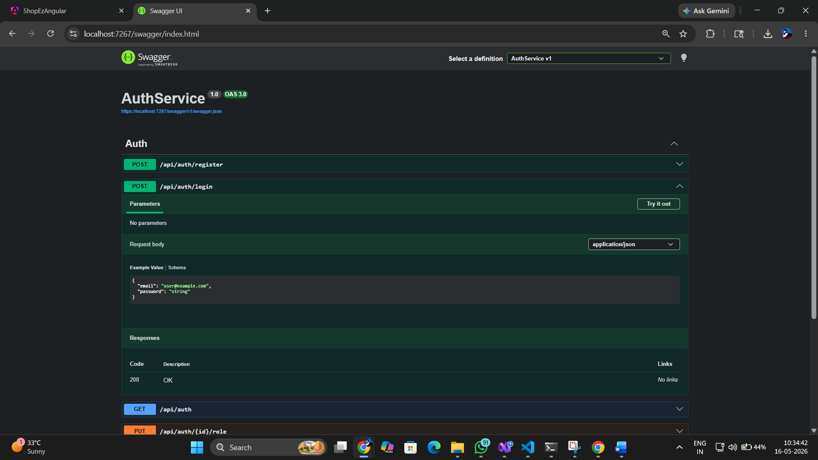

6.5 Product Service — Swagger UI
The Product Service Swagger UI at http://localhost:5002 exposes 6 endpoints for full CRUD and stock management. The GET /api/products endpoint supports optional ?page=&pageSize=&search= query params for paginated search via Dapper.
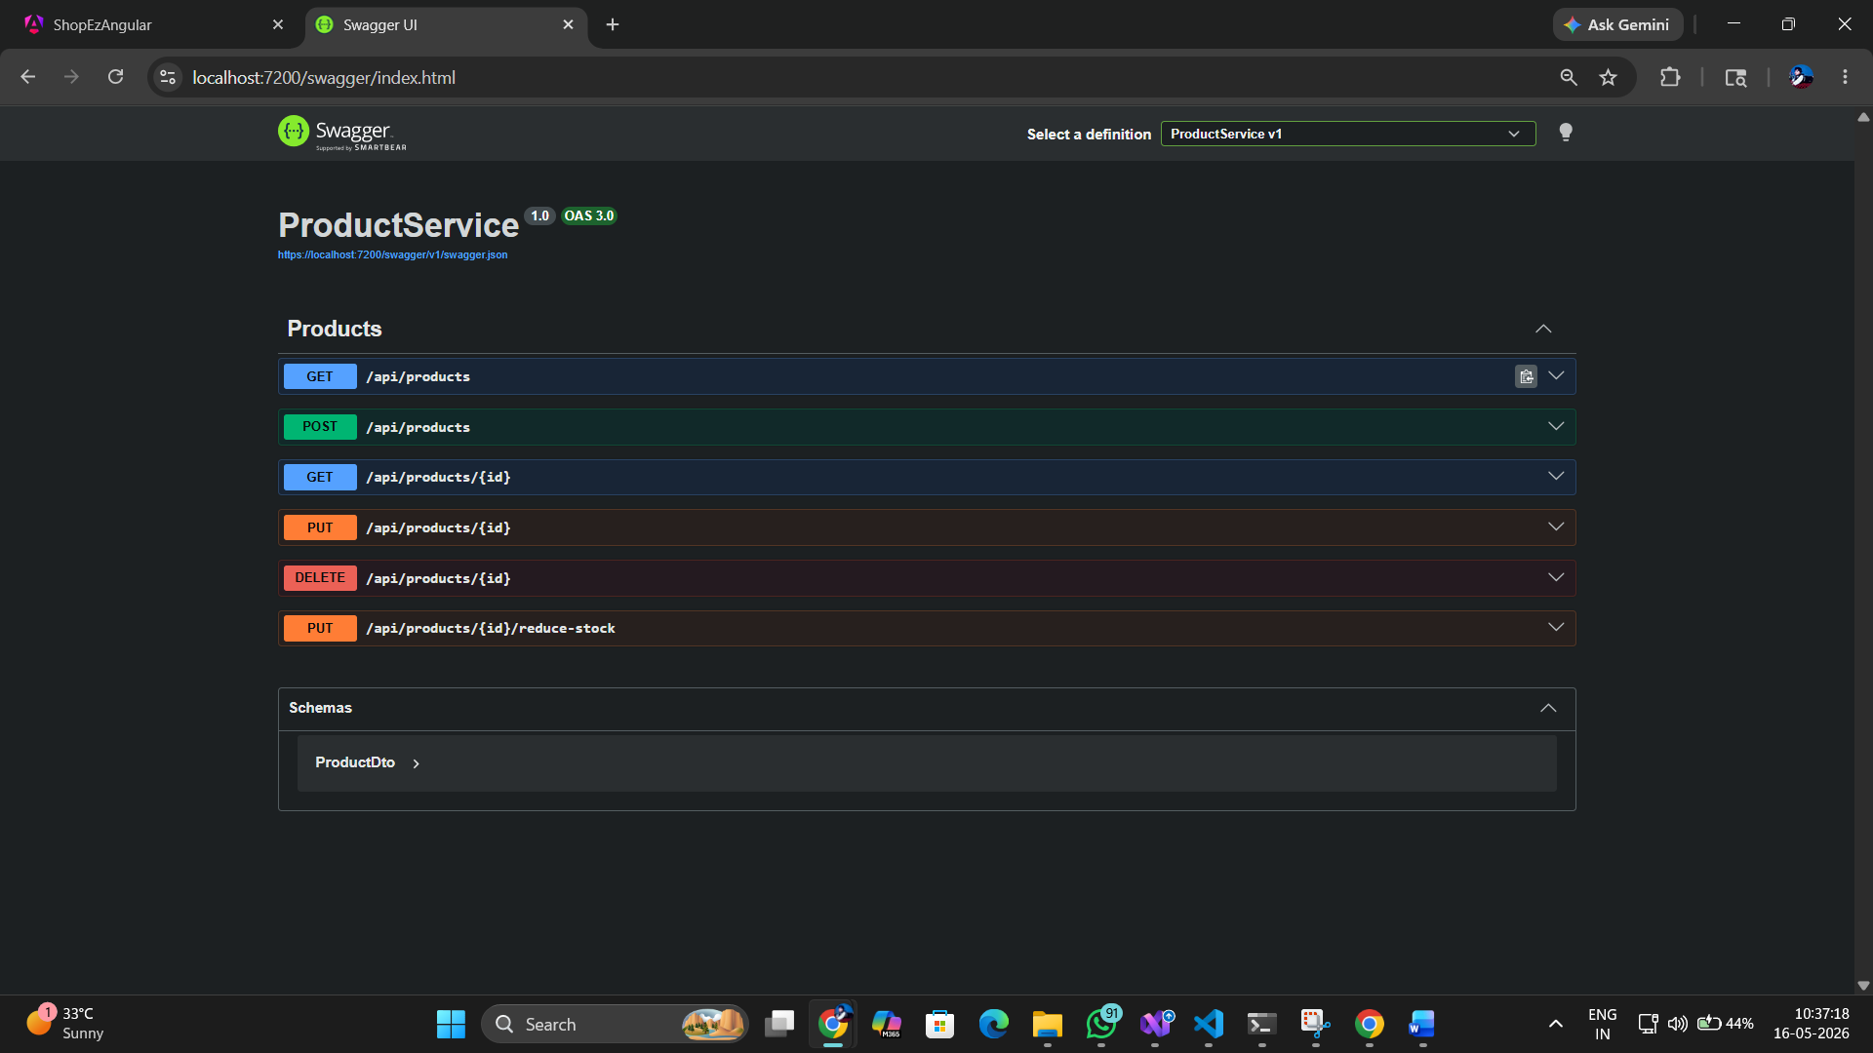

6.6 Product Listing (GET /api/products)
Returns all products as an array when called without query params, or a PaginationResponseDto when called with ?page=&pageSize=. The Product entity includes ProductId, Name, Description, Price, ImageUrl, Stock, and CategoryName.
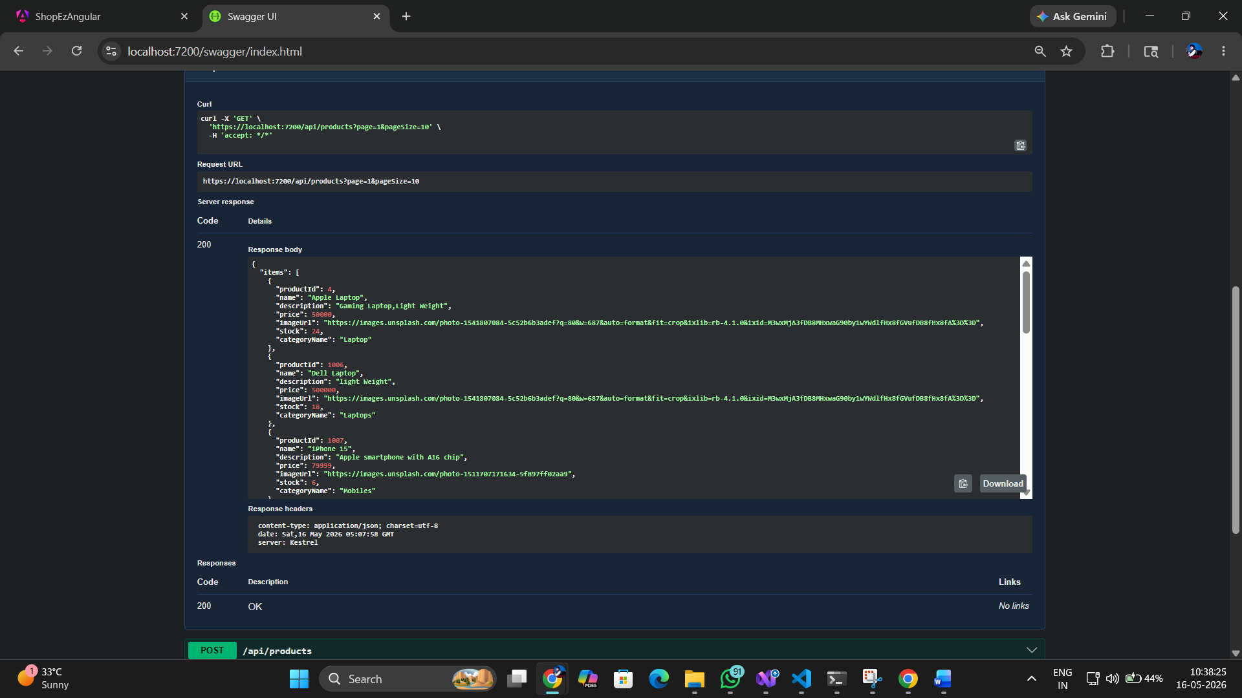

6.7 Order Service — Create Order (POST /api/orders)
Accepts an OrderDto with userId, customerName, totalAmount, status, and a list of OrderItemDtos. The service persists the order with all items, then calls the Product Service to reduce stock for each ordered item. Requires [Authorize] JWT header.
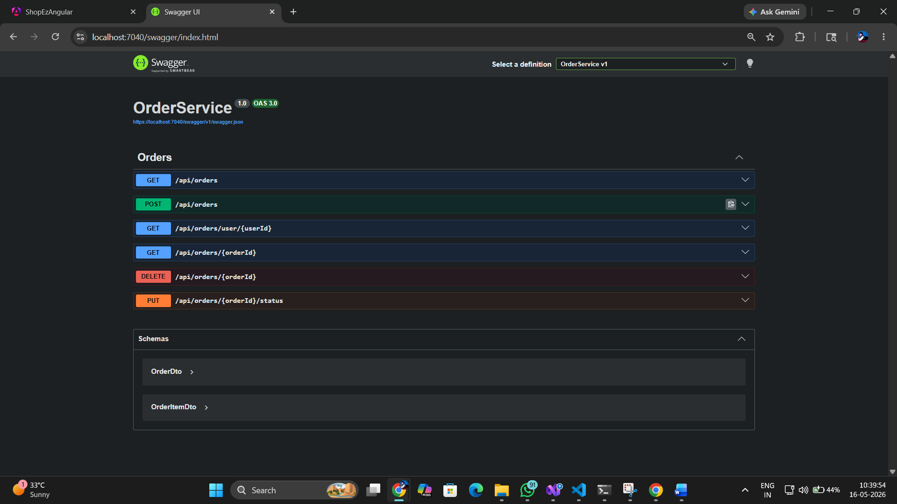

6.8 Order History (GET /api/orders/user/{userId})
Returns all orders for the authenticated user, each with full OrderItem details (productId, productName, quantity, price, totalAmount). The response allows the Angular frontend to display a complete order history with line items.
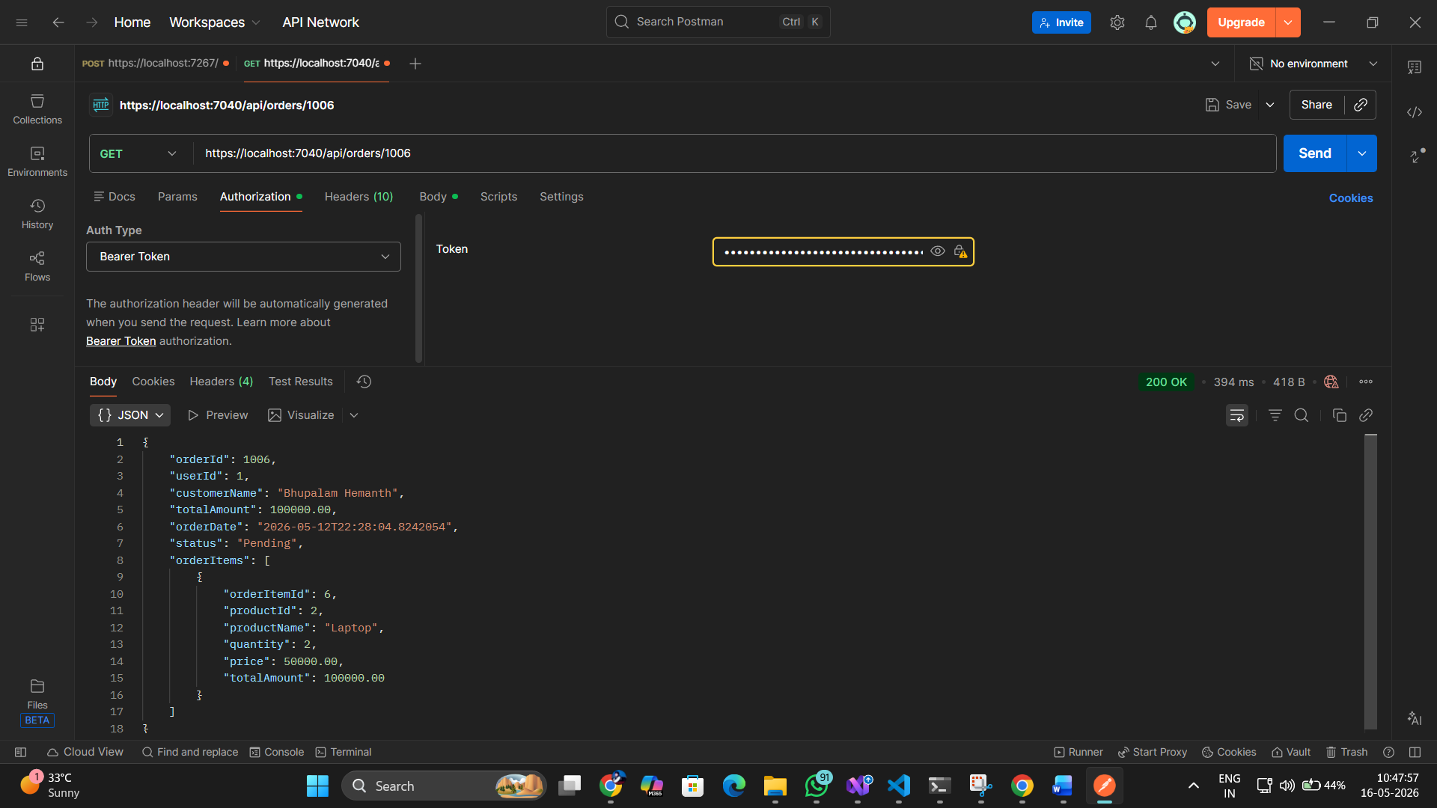

6.9 API Gateway Routing
The Ocelot API Gateway at http://localhost:5139 (dev) transparently proxies requests to downstream services. The ocelot.json configures three route groups — /api/auth, /api/products, and /api/orders — each mapped to their respective services by host and port.
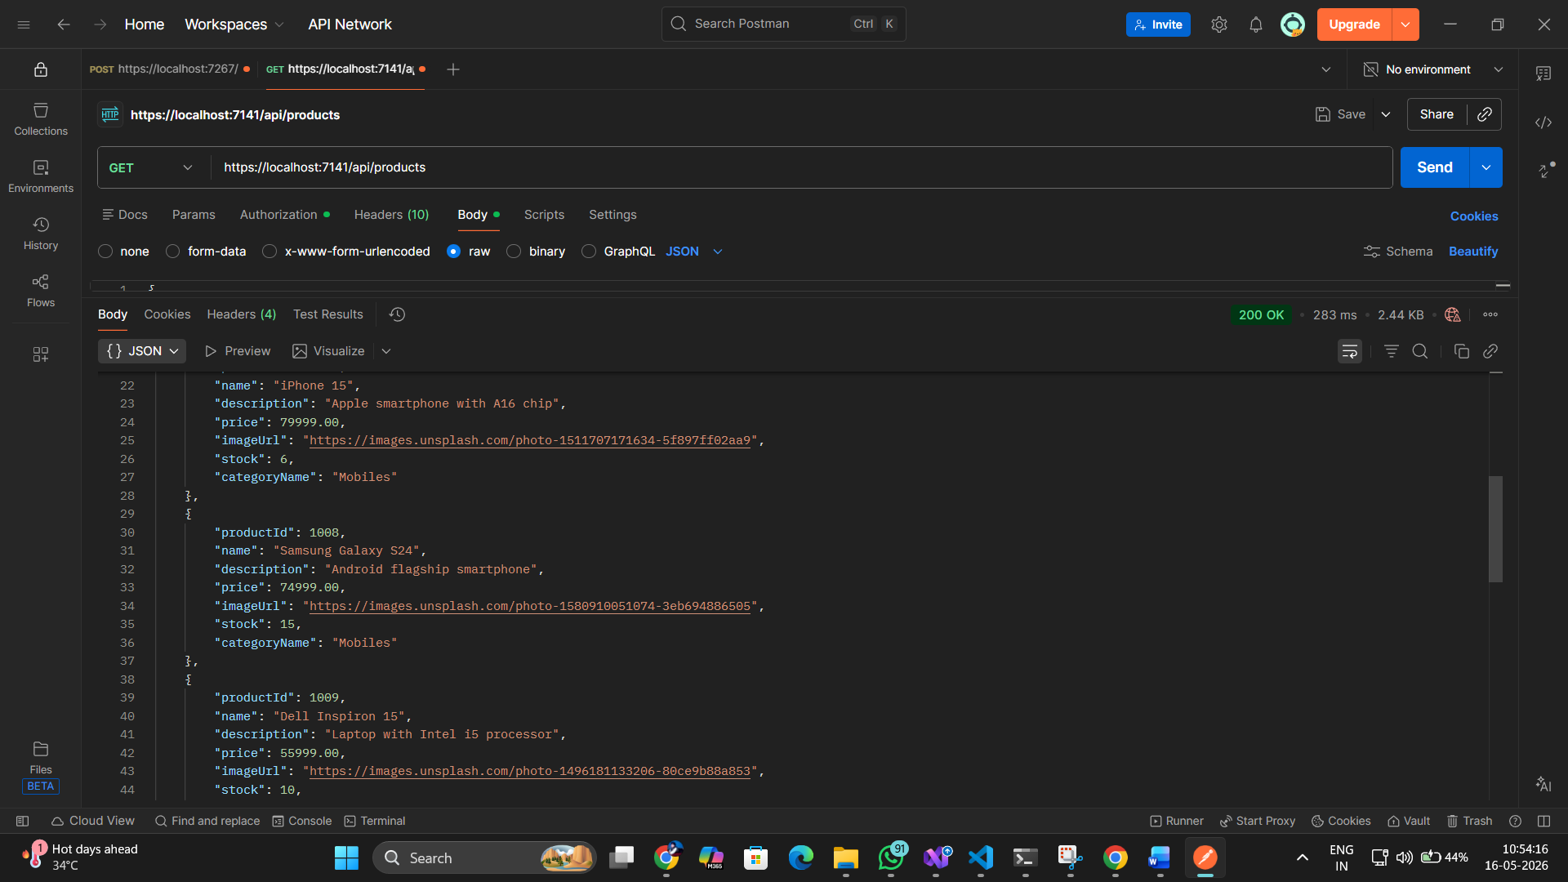

7. Testing — Test Reports
ShopEZ uses xUnit as the test runner and Moq for mock-based isolation. All tests are located in the /Backend/Tests directory, with dedicated test projects per microservice. Tests cover Controller, Service, and Repository layers without touching a real database.

7.1 Test Summary

Service | Test Project | Test Files | Test Count | Coverage Focus
Auth Service | AuthService.Tests | AuthControllerTests, AuthService1Tests, UserRepositoryTests | 15+ tests | Register, Login, JWT, role update, validation, duplicate email
Product Service | ProductService.Tests | ProductsControllerTests, ProductServiceTests, ProductRepositoryTests | 12+ tests | CRUD, search, pagination, stock reduction, not-found cases
Order Service | OrderService.Tests | OrdersControllerTests, OrderServiceTests, OrderRepositoryTests | 12+ tests | Create order, get all, get by user, get by id, status update, delete

7.2 Test Execution
Run all tests for a service using the dotnet test CLI:
cd CapstoneProject/Backend/Tests/AuthService.Tests && dotnet test
cd CapstoneProject/Backend/Tests/ProductService.Tests && dotnet test
cd CapstoneProject/Backend/Tests/OrderService.Tests && dotnet test
Run all tests from the solution root:
cd CapstoneProject/Backend && dotnet test

7.3 Unit Test Results
[ Screenshot: dotnet test results — All Tests Passed for all 3 services ]

7.4 Sample Test Cases — Auth Service

Test Method | Scenario | Expected Result | Status
Register_Should_Return_Ok | Valid RegisterDto with unique email | Returns 200 OkObjectResult with success message | Pass
Register_DuplicateEmail_ReturnsBadRequest | Email already exists in InMemory DB | Returns 400 BadRequest with "Email already exists" | Pass
Login_Should_Return_Ok_With_Token | Valid email + correct BCrypt password | Returns 200 with AuthResponseDto containing JWT token | Pass
Login_WrongPassword_ReturnsUnauthorized | Valid email, wrong password | Returns 401 Unauthorized with "Invalid Email or Password" | Pass
Login_NonExistentEmail_ReturnsUnauthorized | Email not in database | Returns 401 Unauthorized | Pass
GetUsers_AdminRole_ReturnsUserList | Admin user requests user list | Returns list of users without PasswordHash | Pass
UpdateRole_ValidUser_ReturnsOk | Admin updates role to "Admin" | Returns 200 with "Role updated successfully" | Pass
UpdateRole_UserNotFound_ReturnsNotFound | Invalid userId provided | Returns 404 NotFound | Pass

7.5 Sample Test Cases — Product Service

Test Method | Scenario | Expected Result | Status
GetProductsAsync_Should_Return_Data | Valid search/page params | Returns PaginationResponseDto with Items list (may be empty) | Pass
GetByIdAsync_Should_Return_Product | Valid product ID | Returns ProductDto with correct data | Pass
AddAsync_Should_Add_Product | Valid ProductDto submitted | Repository.AddAsync called, ProductDto returned | Pass
UpdateAsync_Should_Return_True | Valid product ID + updated DTO | Repository.UpdateAsync called, returns true | Pass
DeleteAsync_Should_Return_True | Valid product ID | Repository.DeleteAsync called, returns true | Pass
ReduceStockAsync_Should_Reduce | Valid product with sufficient stock | Stock decremented by quantity, returns true | Pass
ReduceStockAsync_InsufficientStock | Requested quantity > available stock | Returns false without modifying stock | Pass

7.6 Sample Test Cases — Order Service

Test Method | Scenario | Expected Result | Status
GetAllOrdersAsync_Should_Return_Data | Admin requests all orders | Returns list (may be empty), no null | Pass
GetOrderByIdAsync_Should_Return_Order | Valid orderId | Returns Order entity with Items collection | Pass
GetOrdersByUserIdAsync_Should_Return | Valid userId | Returns user-specific orders list | Pass
CreateOrderAsync_Should_Create_Order | Valid OrderDto with items | Order persisted, HttpClient called for stock reduction | Pass
UpdateOrderStatusAsync_Should_Return_True | Valid orderId + status string | Status updated in DB, returns true | Pass
DeleteOrderAsync_Should_Return_True | Valid orderId | Order removed from DB, returns true | Pass

7.7 Testing Approach
- Arrange-Act-Assert (AAA) pattern used in all tests for clarity and consistency
- AuthService uses InMemory EF Core database (UseInMemoryDatabase) + real JwtHelper for integration-style controller tests
- ProductService and OrderService use Moq to create fake IRepository implementations — no real SQL Server connection required
- Mock.Setup() defines expected repository behavior; Mock.Verify() confirms calls were made
- IHttpClientFactory mocked in OrderService tests to avoid real HTTP calls to Product Service for stock reduction
- Assert.NotNull() and Assert.IsType<>() for positive path validation; Assert.True/False for boolean return values

8. Deployment Guide

8.1 Prerequisites
- Docker Desktop installed and running — https://www.docker.com/products/docker-desktop
- Minimum 4GB RAM allocated to Docker (configured in Docker Desktop settings)
- Ports 5000–5003 (Docker), 5004, 5096, 5139, 5280 (dev), and 1433 must be free on the host machine
- .NET 8 SDK installed for running/testing services in development mode — https://dotnet.microsoft.com

8.2 Step-by-Step Deployment (Docker)
Step 1 — Navigate to the Backend project folder:
cd CapstoneProject/Backend
Step 2 — Build and Start All Services:
docker-compose up --build
First run takes 5–10 minutes (downloads SQL Server image, builds all Dockerfiles). Subsequent runs are faster as layers are cached.
Step 3 — Verify Services (Swagger UIs):

Service | Swagger URL | Health Check Endpoint
Auth Service | http://localhost:5001 | POST /api/auth/login → 200
Product Service | http://localhost:5002 | GET /api/products → 200
Order Service | http://localhost:5003 | GET /api/orders/user/1 → 200
API Gateway | http://localhost:5000 | GET /api/products → 200 (forwarded)

Step 4 — Connect Angular Frontend:
Start the Angular app with ng serve. The environment is pre-configured to call http://localhost:5139/api/* (API Gateway). Update environment.ts if using Docker ports instead.
Step 5 — Stop All Services:
docker-compose down
docker-compose down -v # also removes SQL Server data volume

8.3 Development Mode (without Docker)
Run each service individually for development and debugging:
cd CapstoneProject/Backend/Services/AuthService && dotnet run
cd CapstoneProject/Backend/Services/ProductService && dotnet run
cd CapstoneProject/Backend/Services/OrderService && dotnet run
cd CapstoneProject/Backend/ApiGateway && dotnet run
Ensure SQL Server is available locally or via Docker (docker run for SQL Server only) and update connection strings in appsettings.json to point to your local instance.

8.4 Docker Compose Services

Container | Image / Build Context | Host Port | Container Port | Environment
shopez-sqlserver | mcr.microsoft.com/mssql/server:2022-latest | 1433 | 1433 | SA_PASSWORD=YourStrong@Pass123, ACCEPT_EULA=Y
shopez-authservice | ./Services/AuthService/Dockerfile | 5001 | 8080 | ConnectionStrings__DefaultConnection to sqlserver
shopez-productservice | ./Services/ProductService/Dockerfile | 5002 | 8080 | ConnectionStrings__DefaultConnection to sqlserver
shopez-orderservice | ./Services/OrderService/Dockerfile | 5003 | 8080 | ConnectionStrings__DefaultConnection to sqlserver
shopez-apigateway | ./ApiGateway/Dockerfile | 5000 | 8080 | ASPNETCORE_ENVIRONMENT=Development
shopez-frontend | ./frontend-angular/Dockerfile | 4200 | 80 | Served via Nginx

8.5 Environment Variables

Variable | Value | Used By
SA_PASSWORD | YourStrong@Pass123 | SQL Server container
ACCEPT_EULA | Y | SQL Server container
ConnectionStrings__DefaultConnection | Server=sqlserver;Database=AuthDB/ProductDB/OrderDB;... | All microservices
Jwt:Key | Configured in appsettings.json | Auth Service (token generation & validation)
Jwt:Issuer | Configured in appsettings.json | Auth Service
Jwt:Audience | Configured in appsettings.json | Auth Service

9. Conclusion
ShopEZ successfully demonstrates a production-style microservices backend built entirely on the .NET ecosystem. The project achieves its core objectives of modularity, database isolation, containerized deployment, JWT security, clean layered architecture, and comprehensive unit testing.

Key outcomes of this project include:
- A fully functional 5-container Docker environment that launches with a single docker-compose up --build command
- Three independently deployable microservices, each with its own database and clean 4-layer architecture
- JWT-based authentication with BCrypt password hashing — secure, stateless, and role-based
- Mixed ORM strategy: EF Core for Auth and Order services, Dapper for high-performance Product queries with search/pagination
- Ocelot API Gateway providing a stable, unified API surface at http://localhost:5139 to the Angular frontend
- Serilog structured logging with daily rolling file sinks across all services for production-ready observability
- Comprehensive test coverage across Controller, Service, and Repository layers using xUnit and Moq with zero real database dependencies

The architecture choices made in ShopEZ directly address the limitations of monolithic systems — each domain can be modified, scaled, or redeployed without impacting others. The project provides a solid foundation for enterprise-scale e-commerce development.

10. Future Scope

10.1 Security Enhancements
- JWT validation moved to Ocelot API Gateway level — eliminates per-service JWT configuration duplication
- Token refresh endpoint with sliding expiry — prevents forced re-login during active sessions
- HTTPS/TLS termination at the gateway using Let's Encrypt or Azure App Gateway

10.2 Real-Time & Messaging
- Apache Kafka integration for event-driven communication — OrderPlaced event triggers inventory decrement asynchronously
- SignalR for real-time order status notifications pushed to the Angular frontend
- RabbitMQ as a lighter alternative for pub/sub messaging between services

10.3 Observability
- Centralized log aggregation with Serilog + Elasticsearch + Kibana (ELK stack)
- Distributed tracing using OpenTelemetry + Jaeger — trace a request across all microservices
- Health check endpoints (/health) on each service, monitored by Docker or Kubernetes readiness probes

10.4 Infrastructure Upgrades
- Kubernetes (K8s) deployment with Helm charts for auto-scaling and self-healing
- Redis caching layer for product listings and frequently accessed data to reduce SQL Server load
- CI/CD pipeline using GitHub Actions — automated build, test, and push to Docker Hub on PR merge
- Separate Read/Write replicas per service database for high-read traffic scenarios

10.5 Feature Additions
- Payment gateway integration (Razorpay / Stripe) in a dedicated Payment Microservice
- Product review and rating system with aggregated score calculation
- Admin dashboard with sales analytics — revenue by date, top products, order volume trends
- Multi-image support per product with file upload to Azure Blob Storage or AWS S3
- Product recommendation engine using collaborative filtering based on order history

