ShopEZ
E-Commerce Platform
Frontend Technical Documentation
Angular 21 Single Page Application with SSR

Name  Trainer Name | Hemanth Bhupalam  Narasimha Rao
Tech Stack | Angular 21 + ASP.NET Core 8
Documentation Type | Frontend Documentation
Date of Creation | 16/05/2026
Batch | B3 .NET FSD

1. Introduction
ShopEZ is a feature-rich e-commerce Single Page Application (SPA) built with Angular 21. It serves as the frontend layer of the ShopEZ full-stack platform, consuming REST APIs provided by backend microservices through an Ocelot API Gateway. The application supports two user roles — Customer and Admin — each with a tailored experience and role-based access control enforced via Angular Guards.
The frontend leverages Angular 21's latest standalone component architecture, Server-Side Rendering (SSR) for optimal SEO and performance, lazy loading, reactive programming with RxJS, and HTTP interceptors for seamless API communication including automatic JWT token attachment. Cart state management is handled client-side via localStorage, while authentication state uses BehaviorSubject for reactive updates across the component tree.

1.1 Objectives
- Build a fully functional e-commerce SPA using Angular 21's standalone component model
- Implement lazy-loaded routing for optimal initial load performance across all feature pages
- Enable Server-Side Rendering (SSR) using Angular Universal for improved SEO and first-paint speed
- Integrate with the ShopEZ backend microservices via the API Gateway at http://localhost:5139
- Implement role-based access control — Admin-only routes protected by adminGuard, auth-required routes by authGuard
- Use Angular Reactive Forms for user input handling in login, register, checkout, and admin forms
- Implement HTTP interceptors for automatic JWT token injection and centralized error handling
- Achieve unit test coverage for services, guards, interceptors, and components using Karma + Jasmine

1.2 Scope
This document covers the complete Angular 21 frontend of ShopEZ — project structure, component hierarchy, routing, service layer, state management, system design diagrams, screen-by-screen UI documentation, unit test reports, and deployment instructions. Refer to the Backend Documentation for the ASP.NET Core microservices.

2. Problem Statement — Issues in Existing Systems
Traditional e-commerce frontends built with plain HTML/CSS/jQuery suffer from numerous structural and user experience limitations:

2.1 Multi-Page Application Problems
- Each navigation requires a full page reload, causing visible latency and poor user experience
- State (like cart contents, logged-in user) is lost on every page reload unless manually persisted
- Code duplication is common — shared UI elements like headers and footers must be repeated across pages
- Managing asynchronous operations (API calls, form submissions) becomes complex without a structured approach

2.2 State Management Challenges
- No reactive data binding — DOM must be updated manually via jQuery selectors after every data change
- Synchronizing UI state across multiple pages (e.g., cart badge count) requires custom event systems
- Without a structured service layer, API call logic gets duplicated across multiple JS files

2.3 Security & Access Control
- Traditional frontends have no clean mechanism to protect routes based on user role
- Admin pages rely on manual checks inside component code rather than a centralized guard system
- JWT tokens must be manually attached to every API request without interceptors

2.4 Maintainability
- Component logic, template markup, and styles are mixed in large files with no enforced separation
- No type safety — JavaScript-based frontends are prone to runtime errors from typos in property names
- Unit testing is difficult because logic is intertwined with DOM manipulation

3. Proposed System
ShopEZ's Angular 21 frontend resolves these problems through a structured component-based architecture, reactive services, HTTP interceptors, and modern Angular patterns including SSR support.

3.1 Single Page Application Architecture
Angular's router handles all navigation client-side. Only the changed component is re-rendered — the shell (Navbar, Footer) stays persistent. Page transitions are instant with no full reloads. SSR pre-renders pages on the server for fast first paint and SEO.

3.2 Component Hierarchy

Component / Page | Route | Access | Responsibility
HomeComponent | / | Public | Landing page with product highlights
ProductListComponent | /products | Public | Browse and search all products with pagination
ProductDetailsComponent | /products/:id | Public | View single product details and add to cart
CartComponent | /cart | Public | View and manage cart items with totals
CheckoutComponent | /checkout | Auth required | Place order (authGuard protected)
OrdersComponent | /orders | Auth required | View user order history (authGuard protected)
AdminDashboardComponent | /admin | Admin only | Admin shell with child routes (adminGuard)
AdminProductsComponent | /admin/products | Admin only | Product CRUD management
AdminOrdersComponent | /admin/orders | Admin only | View and manage all orders
AdminUsersComponent | /admin/users | Admin only | View users and update roles
LoginComponent | /login | Public | User login form with JWT response
RegisterComponent | /register | Public | New user registration form
NavbarComponent | — | Always shown | Navigation, cart badge, auth state display
FooterComponent | — | Always shown | Application footer with links

3.3 Service Layer

Service | Responsibility | Backend Endpoint
AuthService | Login, Register, Logout, JWT token state (BehaviorSubject) | POST /api/auth/login & /api/auth/register
ProductService | Get all, get by ID, create, update, delete, paginate+search | GET/POST/PUT/DELETE /api/products
CartService | Add, remove, update quantity, clear cart (localStorage) | Client-side only (localStorage)
OrderService | Place order, get user orders, get all orders, delete order | GET/POST/DELETE /api/orders
UserService | Get all users, update user role | GET /api/auth | PUT /api/auth/{id}/role

3.4 Route Guards
- authGuard: Protects /checkout and /orders — redirects unauthenticated users to /login. Validates JWT token presence in localStorage.
- adminGuard: Protects /admin and all child routes — redirects non-Admin users to home page. Checks role === "Admin" from stored user.
- Both guards are SSR-safe using isPlatformBrowser() to prevent localStorage access during server rendering.

3.5 HTTP Interceptors
- jwtInterceptor: Automatically attaches "Authorization: Bearer <token>" header to every outgoing HTTP request if user is authenticated.
- errorInterceptor: Handles global API errors — maps HTTP status codes (0, 401, 403, 500) to human-readable error messages. Logs errors via console.error in browser.

4. Tech Stack Details

4.1 Core Technologies

Technology | Version | Purpose
Angular | 21.2.x | SPA framework — standalone components, router, DI, SSR
TypeScript | 5.x | Type-safe JavaScript superset
RxJS | 7.x | Reactive programming — Observables, BehaviorSubject
Angular HttpClient | 21.x | HTTP calls to backend API Gateway with interceptor support
Angular Router | 21.x | Client-side routing with lazy loading (loadComponent)
Angular Universal (SSR) | 21.x | Server-side rendering via express engine
Angular Reactive Forms | 21.x | Form handling with built-in validation
Karma | 6.x | Test runner for Angular unit tests
Jasmine | 5.x | Assertion and test structure framework

4.2 Architecture Highlights
- Standalone Components: Every component uses standalone: true — no NgModule declarations needed (Angular 17+ pattern, continued in v21)
- Lazy Loading: All route components are loaded on demand using loadComponent() — reduces initial bundle size
- Server-Side Rendering: app.config.server.ts and server.ts enable Angular Universal SSR for SEO and performance
- Dependency Injection: Services injected via providedIn: "root" — singleton throughout the application
- BehaviorSubject: AuthService maintains user$ as a BehaviorSubject — any component can subscribe to auth state changes
- TypeScript Interfaces: All API response shapes are typed via interfaces in src/app/models/
- SSR-Safe localStorage: All browser API access wrapped in isPlatformBrowser() checks for SSR compatibility

4.3 Project Structure

Folder / File | Purpose
src/app/components/ | Feature components — ProductList, Cart, Checkout, Orders, ProductDetails
src/app/pages/ | Page components — Home, Login, Register, Admin (Dashboard, Products, Orders, Users)
src/app/services/ | Service classes — ProductService, CartService, OrderService, UserService
src/app/core/services/ | Core singleton services — AuthService
src/app/core/guards/ | Route guards — authGuard, adminGuard
src/app/core/interceptors/ | HTTP interceptors — jwtInterceptor, errorInterceptor
src/app/models/ | TypeScript interfaces — Product, User, Order, OrderItem, AuthResponse
src/app/shared/components/ | Shared UI — NavbarComponent, FooterComponent
src/app/app.routes.ts | Application route configuration with lazy loading and guards
src/app/app.config.ts | Root app configuration — HttpClient, Router, Interceptors providers
src/app/app.config.server.ts | SSR-specific configuration — provideServerRendering()
src/environments/ | Environment files — apiUrl configuration (http://localhost:5139/api)

5. System Design

5.1 High-Level Architecture Diagram
The Angular SPA runs in the browser and communicates exclusively with the API Gateway at http://localhost:5139. It never calls individual microservices directly. The application also supports SSR, where the Angular Universal server pre-renders pages for bots and first-time visitors.

Browser / SSR Server
Angular 21 SPA (http://localhost:4200)
[ NavbarComponent | FooterComponent ] (always shown)
Router Outlet (lazy-loaded feature components)
↓ JWT Interceptor attaches Bearer token to every request
Ocelot API Gateway (http://localhost:5139)
AuthService :5004 | ProductService :5096 | OrderService :5280
SQL Server Databases (AuthDB | ProductDB | OrderDB)

5.2 Component Tree Diagram

AppComponent (Root)
├─ NavbarComponent (shared)
├─ <router-outlet> (lazy-loaded)
├─ HomeComponent [/]
├─ ProductListComponent [/products]
├─ ProductDetailsComponent [/products/:id]
├─ CartComponent [/cart]
├─ CheckoutComponent [/checkout] ⚠ authGuard
├─ OrdersComponent [/orders] ⚠ authGuard
├─ LoginComponent [/login]
├─ RegisterComponent [/register]
└─ AdminDashboardComponent [/admin] ⚠ adminGuard
├─ AdminProductsComponent [/admin/products]
├─ AdminOrdersComponent [/admin/orders]
└─ AdminUsersComponent [/admin/users]
└─ FooterComponent (shared)

5.3 Data Flow Diagram

Level 0 DFD (Context Diagram)
External entity: Browser User / Bot. Central process: ShopEZ Angular 21 SPA (with SSR). Data stores: API Gateway (proxied to backend services) and localStorage (cart, user session). The SPA is the only external-facing system; all backend communication flows through it.

Level 1 DFD

Decomposes the Angular SPA into functional processes: Authentication (Login/Register/Logout), Product Browsing (List/Details/Search), Cart Management (Add/Remove/Update/Clear — localStorage), Order Placement (Checkout/History), and Admin Management (Products/Orders/Users). Shows data flows between components, services, and the API Gateway.

5.4 Use Case Diagram
Two actors: Customer and Admin.
- Customer use cases: Register, Login, Browse Products, Search Products, Filter by Category, View Product Details, Add to Cart, Update Cart Quantity, Remove from Cart, Checkout (Place Order), View Order History
- Admin use cases: Login, Add Product, Edit Product, Delete Product, View All Orders, Update Order Status, View All Users, Update User Role

5.5 Application ER Diagram (Frontend Models)

Interface | Fields | Type | Notes
User | userId, name, email, role, token | TypeScript interface | Stored in localStorage on login
Product | productId, name, description, price, imageUrl, stock, categoryName | TypeScript interface | From ProductService API response
Order | orderId, userId, totalAmount | TypeScript interface | From OrderService API response
OrderItem | productId, quantity, price | TypeScript interface | Nested inside Order creation request
AuthResponse | userId, name, email, role, token | TypeScript interface | Returned on successful login

5.6 Service-API Mapping

Component | Service Used | API Call | Description
LoginComponent | AuthService | POST /api/auth/login | Authenticate user, receive JWT
RegisterComponent | AuthService | POST /api/auth/register | Create new user account
ProductListComponent | ProductService | GET /api/products?page=&pageSize=&search= | Load paginated/searched products
ProductDetailsComponent | ProductService + CartService | GET /api/products/:id | View details, add to local cart
CartComponent | CartService | localStorage | Manage cart state client-side
CheckoutComponent | OrderService + CartService | POST /api/orders | Place order, clear cart
OrdersComponent | OrderService | GET /api/orders/user/:userId | View logged-in user orders
AdminProductsComponent | ProductService | POST/PUT/DELETE /api/products | Full product CRUD for admins
AdminOrdersComponent | OrderService | GET /api/orders, PUT /api/orders/:id/status | View and manage all orders
AdminUsersComponent | UserService | GET /api/auth, PUT /api/auth/:id/role | View users, promote to Admin

6. Project Demo — Screenshots
The following section documents the live running Angular 21 application at http://localhost:4200, connected to the ShopEZ backend via the API Gateway at http://localhost:5139.

6.1 Home Page
The Home page (/) serves as the landing page for ShopEZ. It showcases featured products and provides quick navigation to the product catalog. The Navbar displays login/register links for guests and the cart badge for all users.
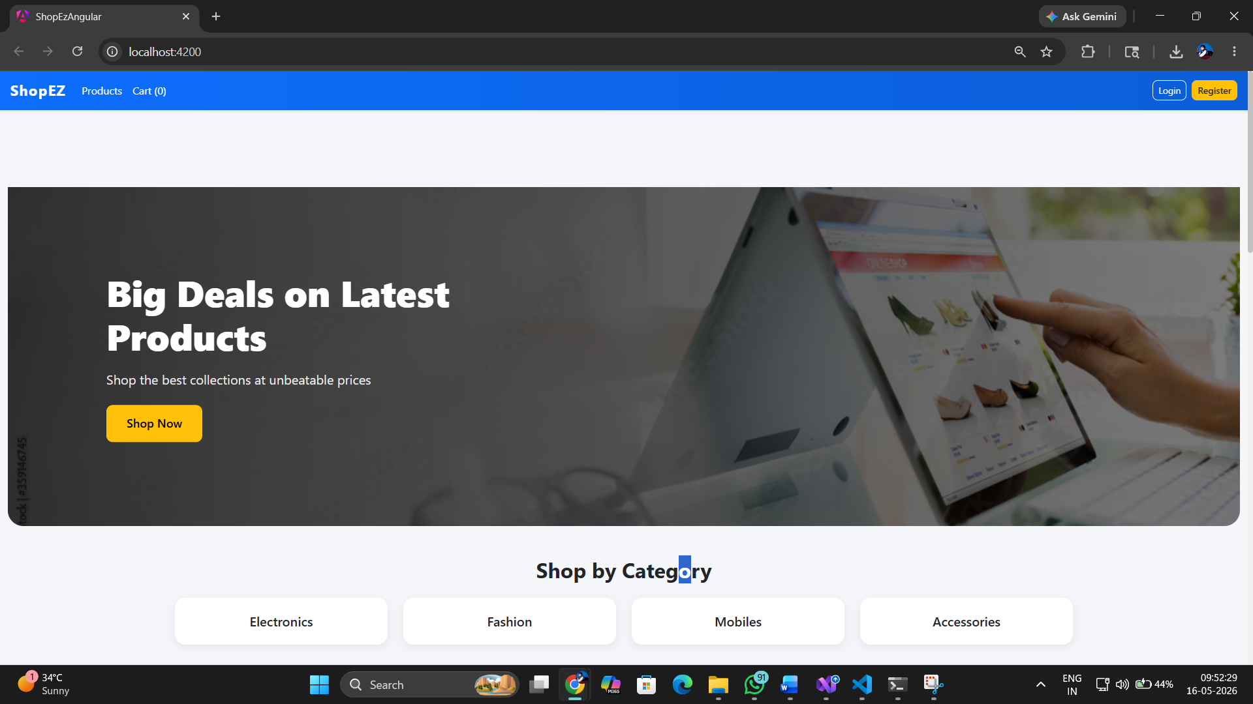

6.2 Product List Page
The Product List page (/products) displays all products with pagination support (default 10 per page). Supports real-time search filtering by product name. Each product card shows the image, name, price, category, and an Add to Cart button.
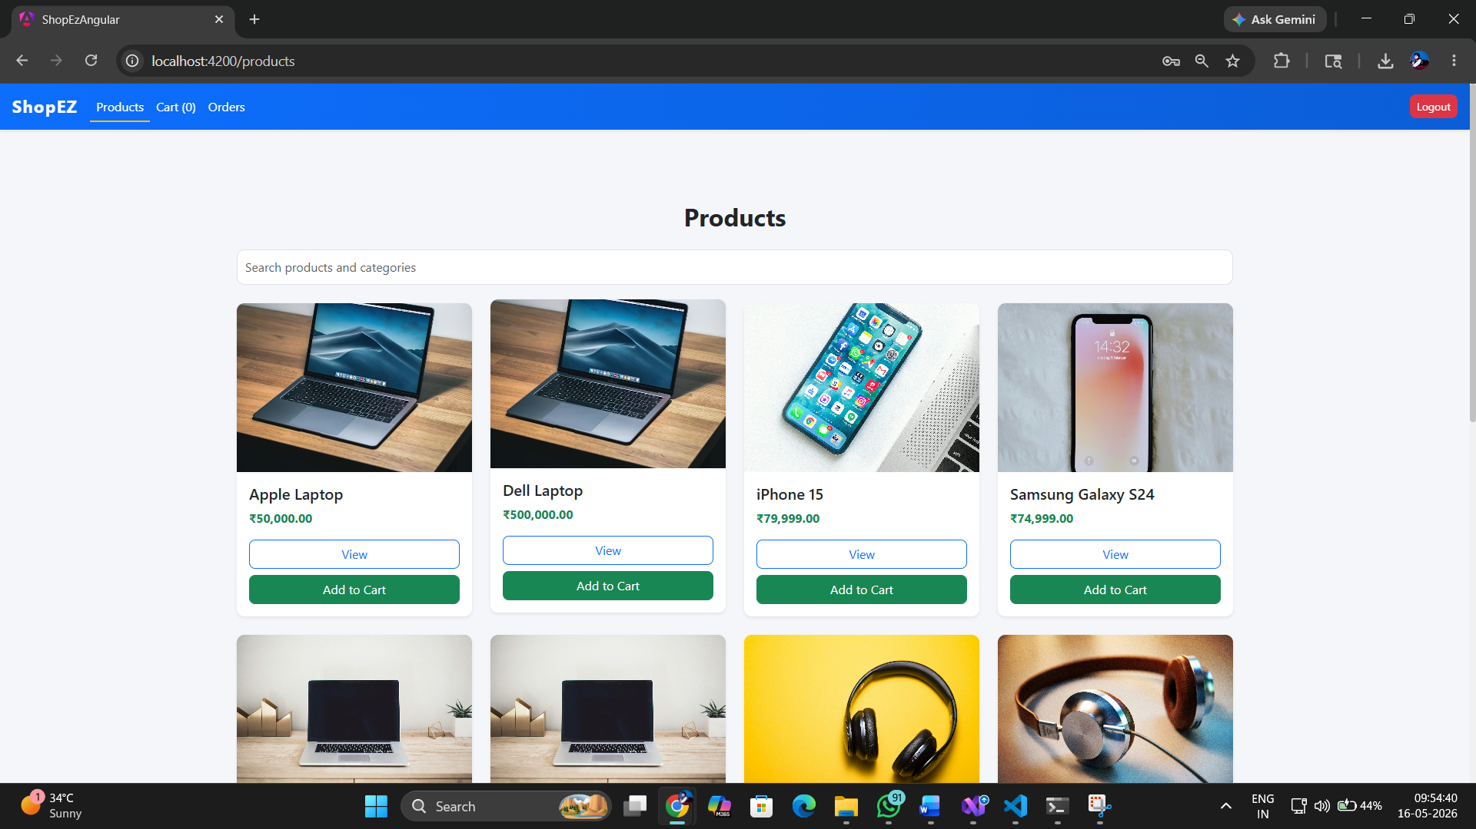

6.3 Product Details Page
The Product Details page (/products/:id) shows the full product information — name, description, price, category, and stock level. Customers can add the item to their local cart directly from this page.
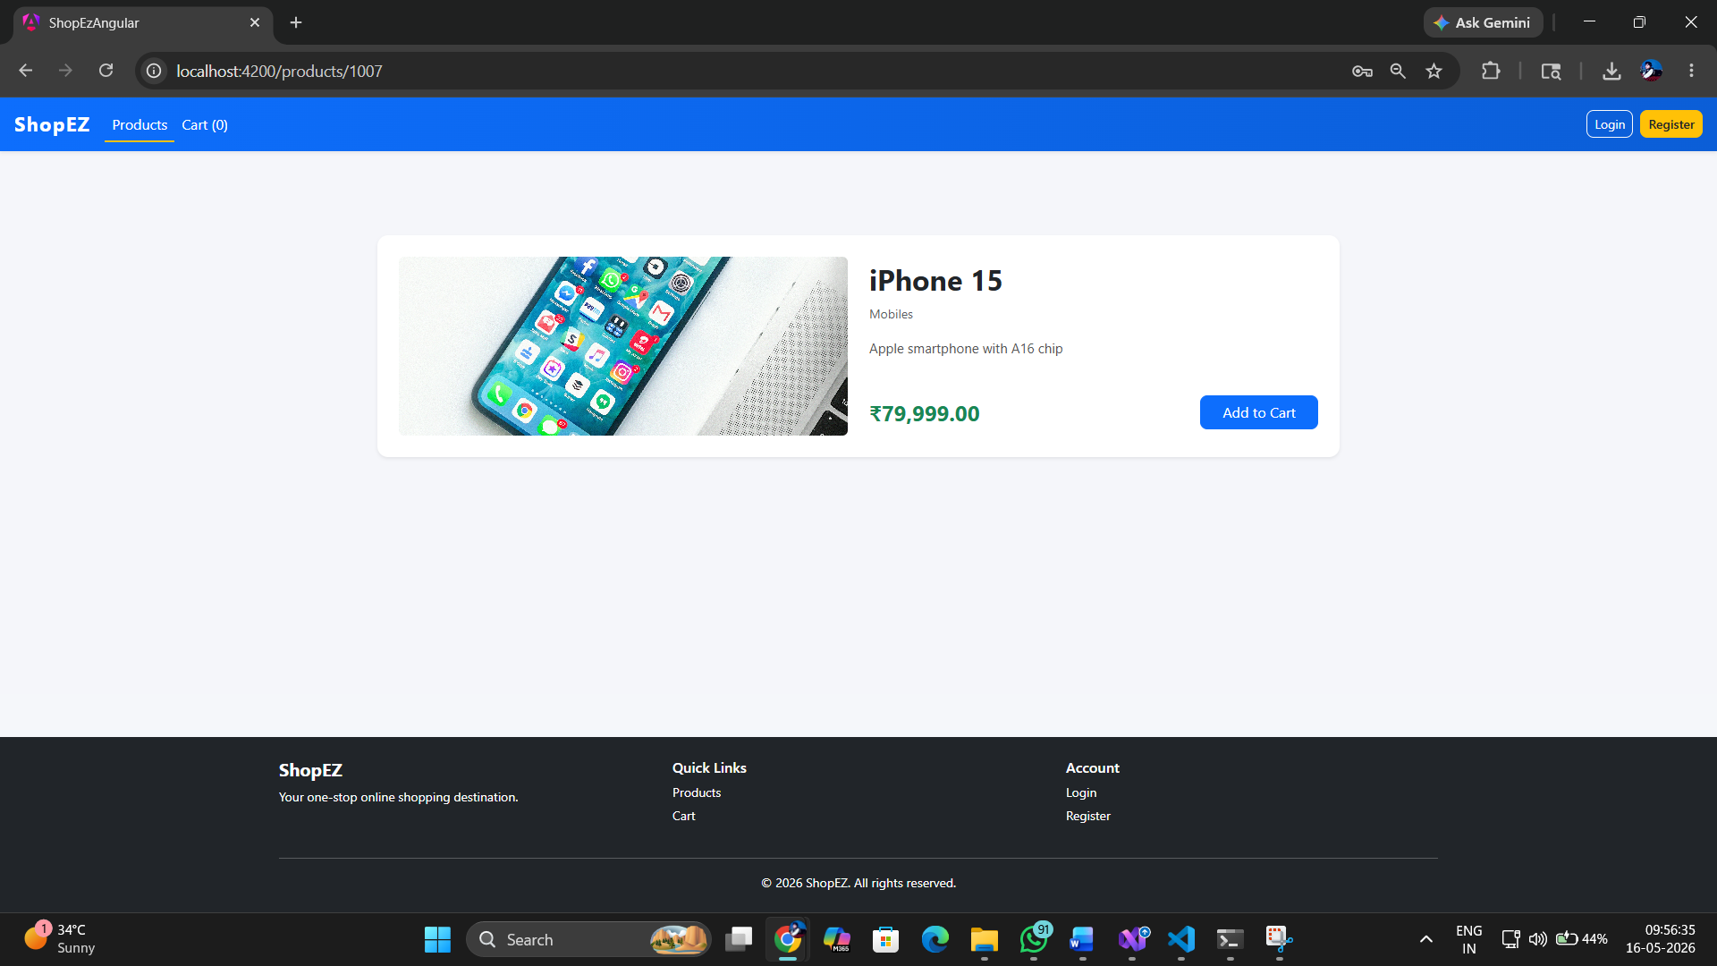


6.4 Register Page
The Register page (/register) presents a reactive form with Name, Email, and Password fields. Validates input (minimum lengths, email format) before submitting to the AuthService which calls POST /api/auth/register.
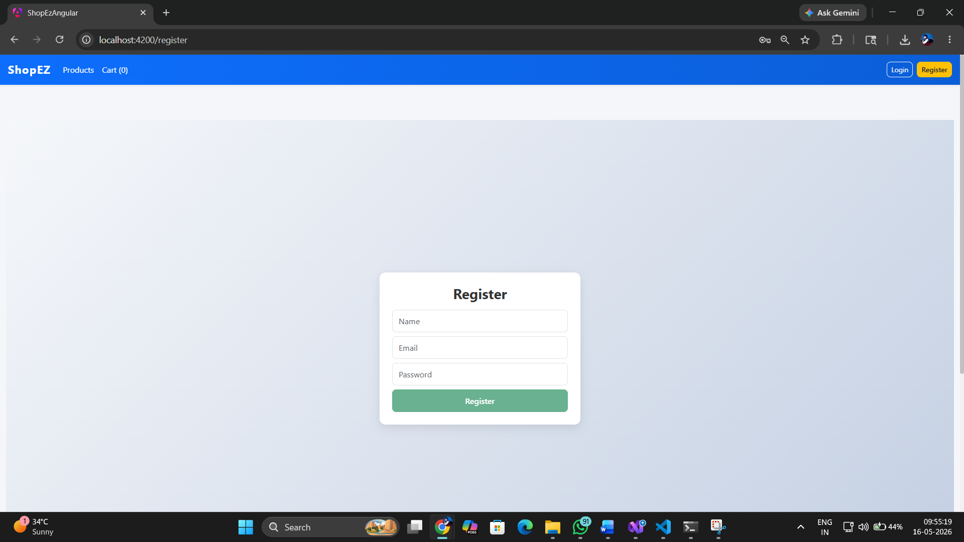

6.5 Login Page
The Login page (/login) accepts Email and Password. On success, the AuthService stores the full user object (including JWT token) in localStorage and emits the new user via the BehaviorSubject. TheNavbar reactively updates to show the user's name.
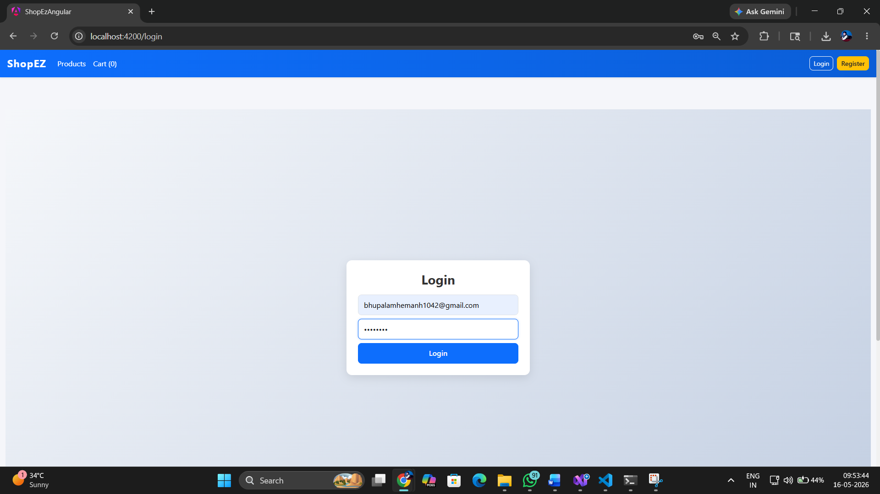

6.6 Login Success — Navbar Update
After a successful login, the Navbar component reactively updates via AuthService.user$ subscription. The login/register links are replaced with the user's name and a Logout button. The cart badge shows the current item count.

6.7 Cart Page
The Cart page (/cart) renders all items from the CartService (backed by localStorage). Users can increment/decrement quantities, remove individual items, and see the running total. Cart state persists across page refreshes.
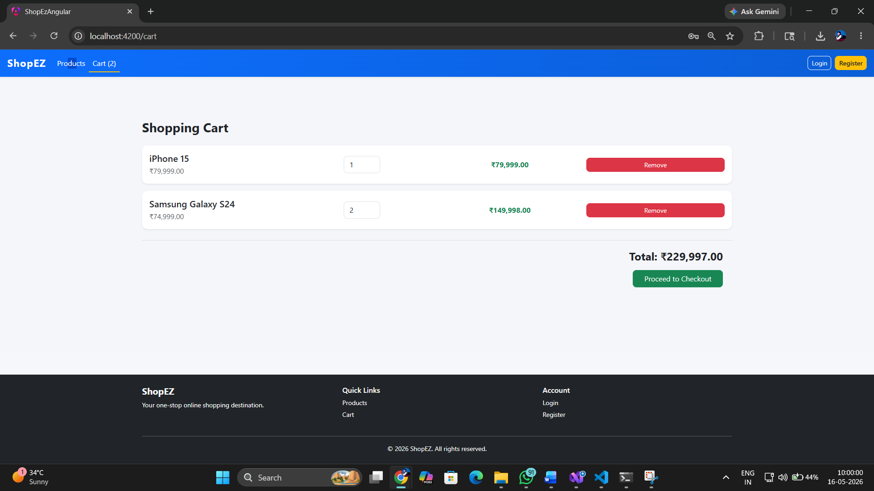

6.8 Checkout Page
The Checkout page (/checkout) is protected by authGuard. It displays a summary of cart items and the total price. On submit, OrderService calls POST /api/orders with the full order payload including all cart items.
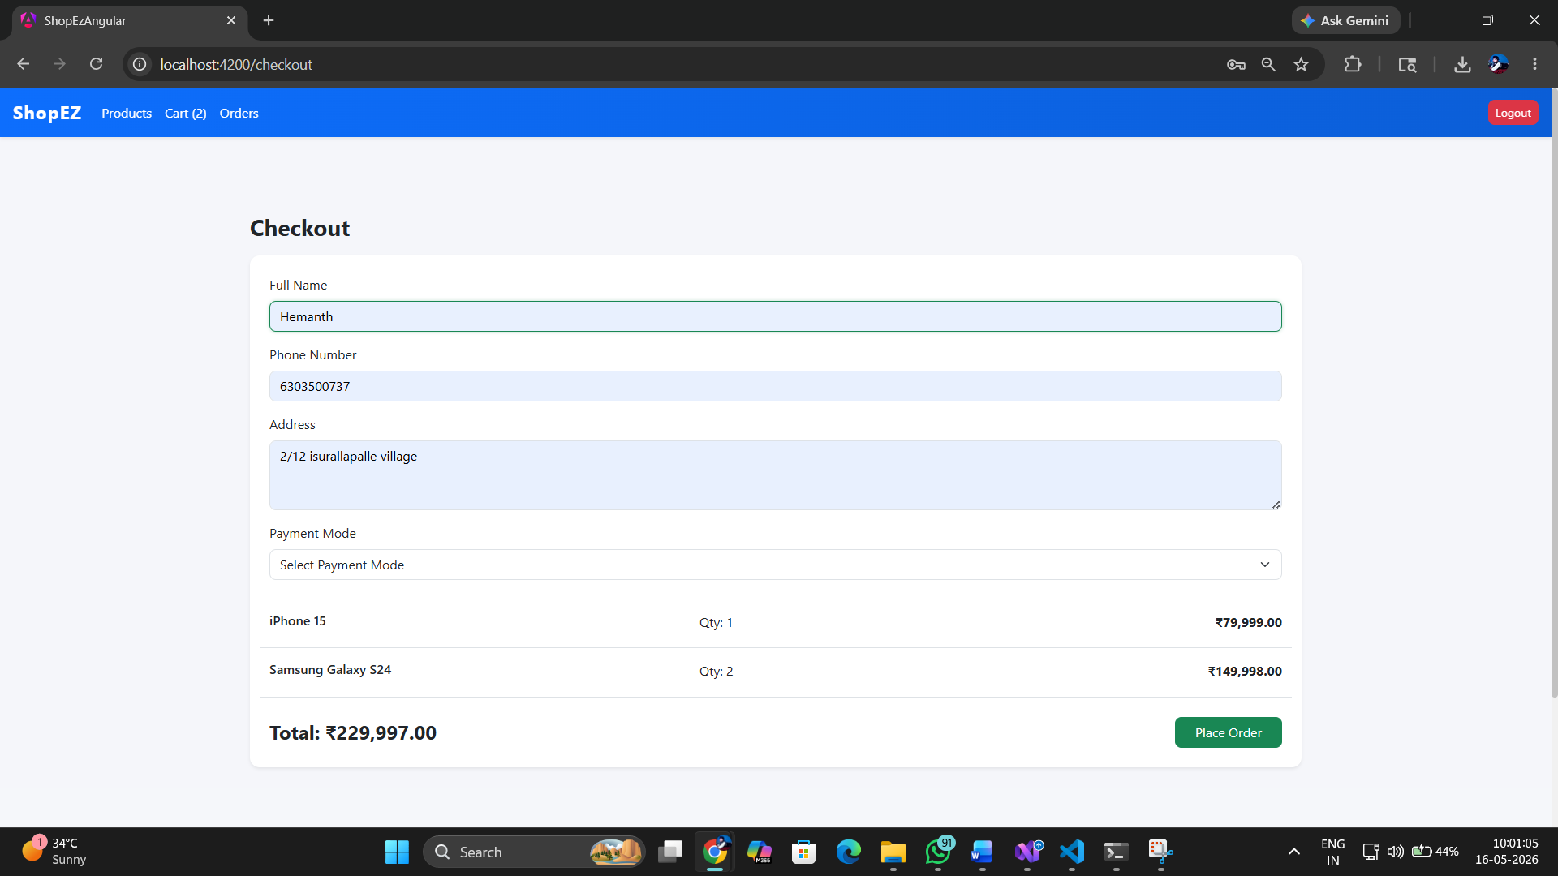

6.9 Order Placed Confirmation
After a successful order placement, the cart is cleared and the user sees a confirmation message with the order details. The user is prompted to visit the Orders page to view their order history.
It will show order placed succesfully message and it will redirect to home page

6.10 Orders Page
The Orders page (/orders) is protected by authGuard. It displays all orders for the logged-in user by calling GET /api/orders/user/:userId. Each order shows the order ID, date, status, and total amount.
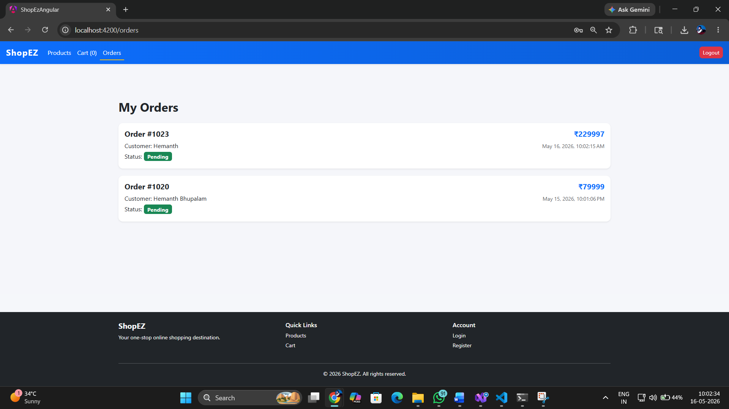

6.11 Admin — Products Management
The Admin Products page (/admin/products) allows admins to view all products, create new products via a form, edit existing product details, and delete products. All mutations call the ProductService which attaches the JWT token via the jwtInterceptor.
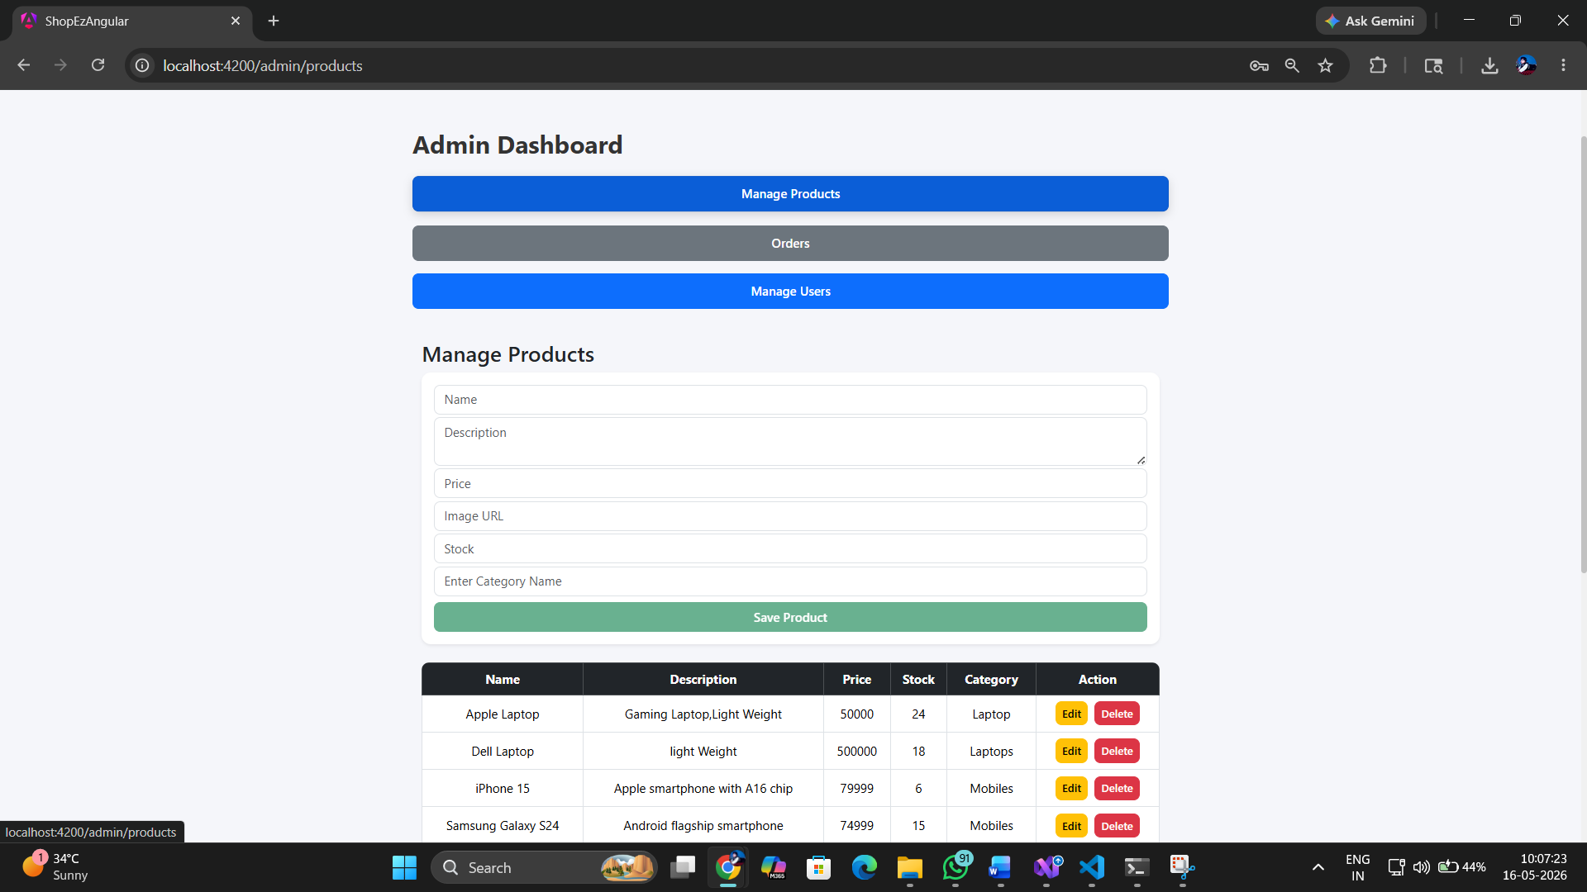

6.12 Admin — Orders Management
The Admin Orders page (/admin/orders) lists all platform orders. Admins can view order details and update the status. Calls GET /api/orders (all orders) and PUT /api/orders/:id/status for status updates.
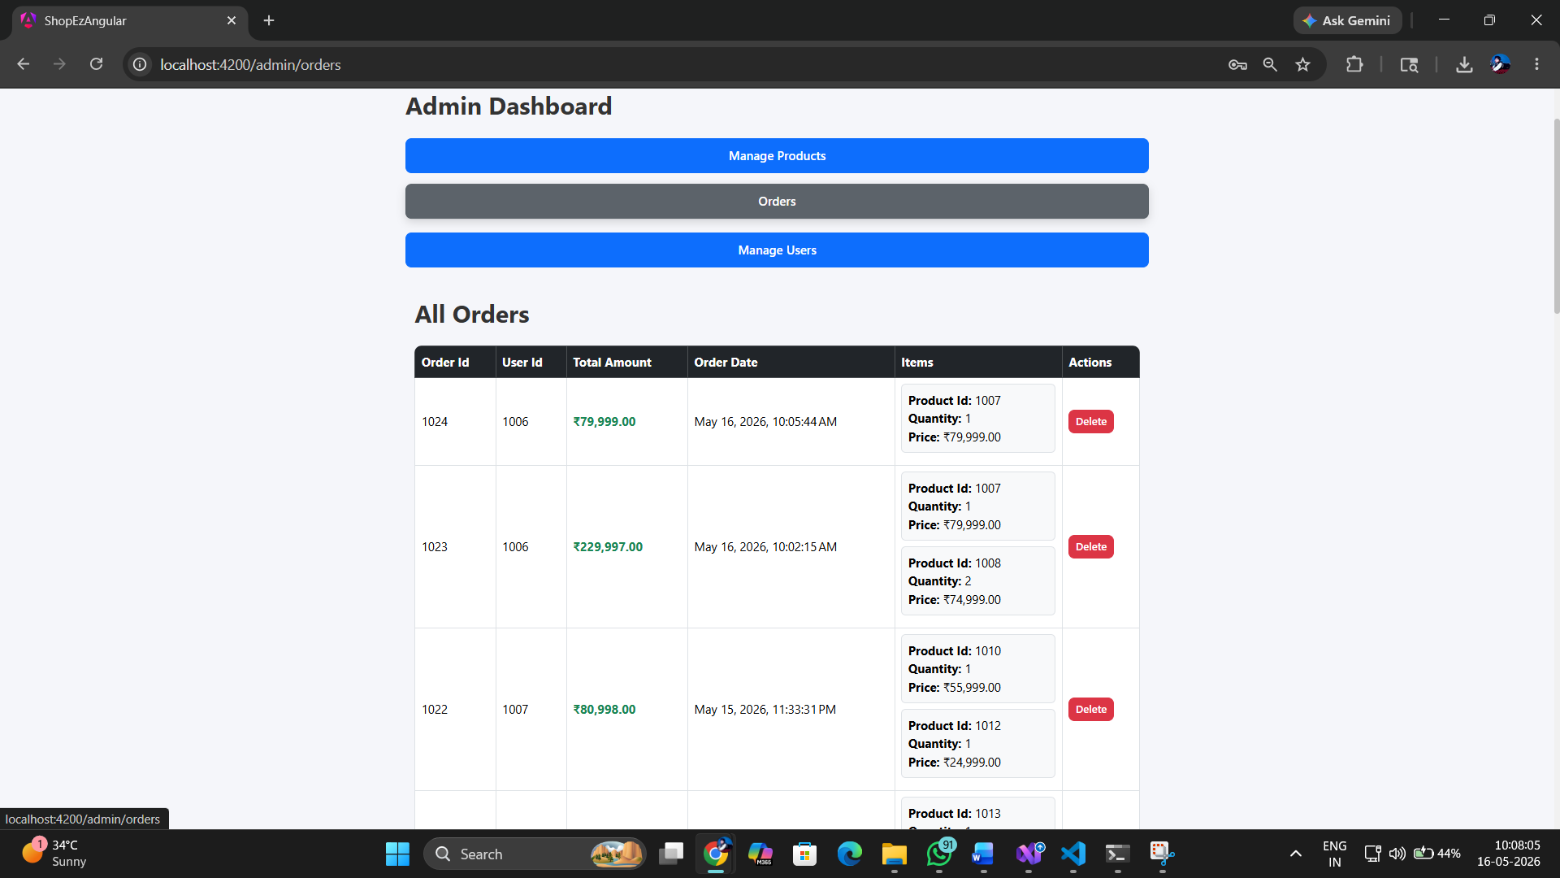

6.13 Admin — Users Management
The Admin Users page (/admin/users) lists all registered users. Admins can view user details and update roles (Customer / Admin) by calling PUT /api/auth/:id/role via UserService.
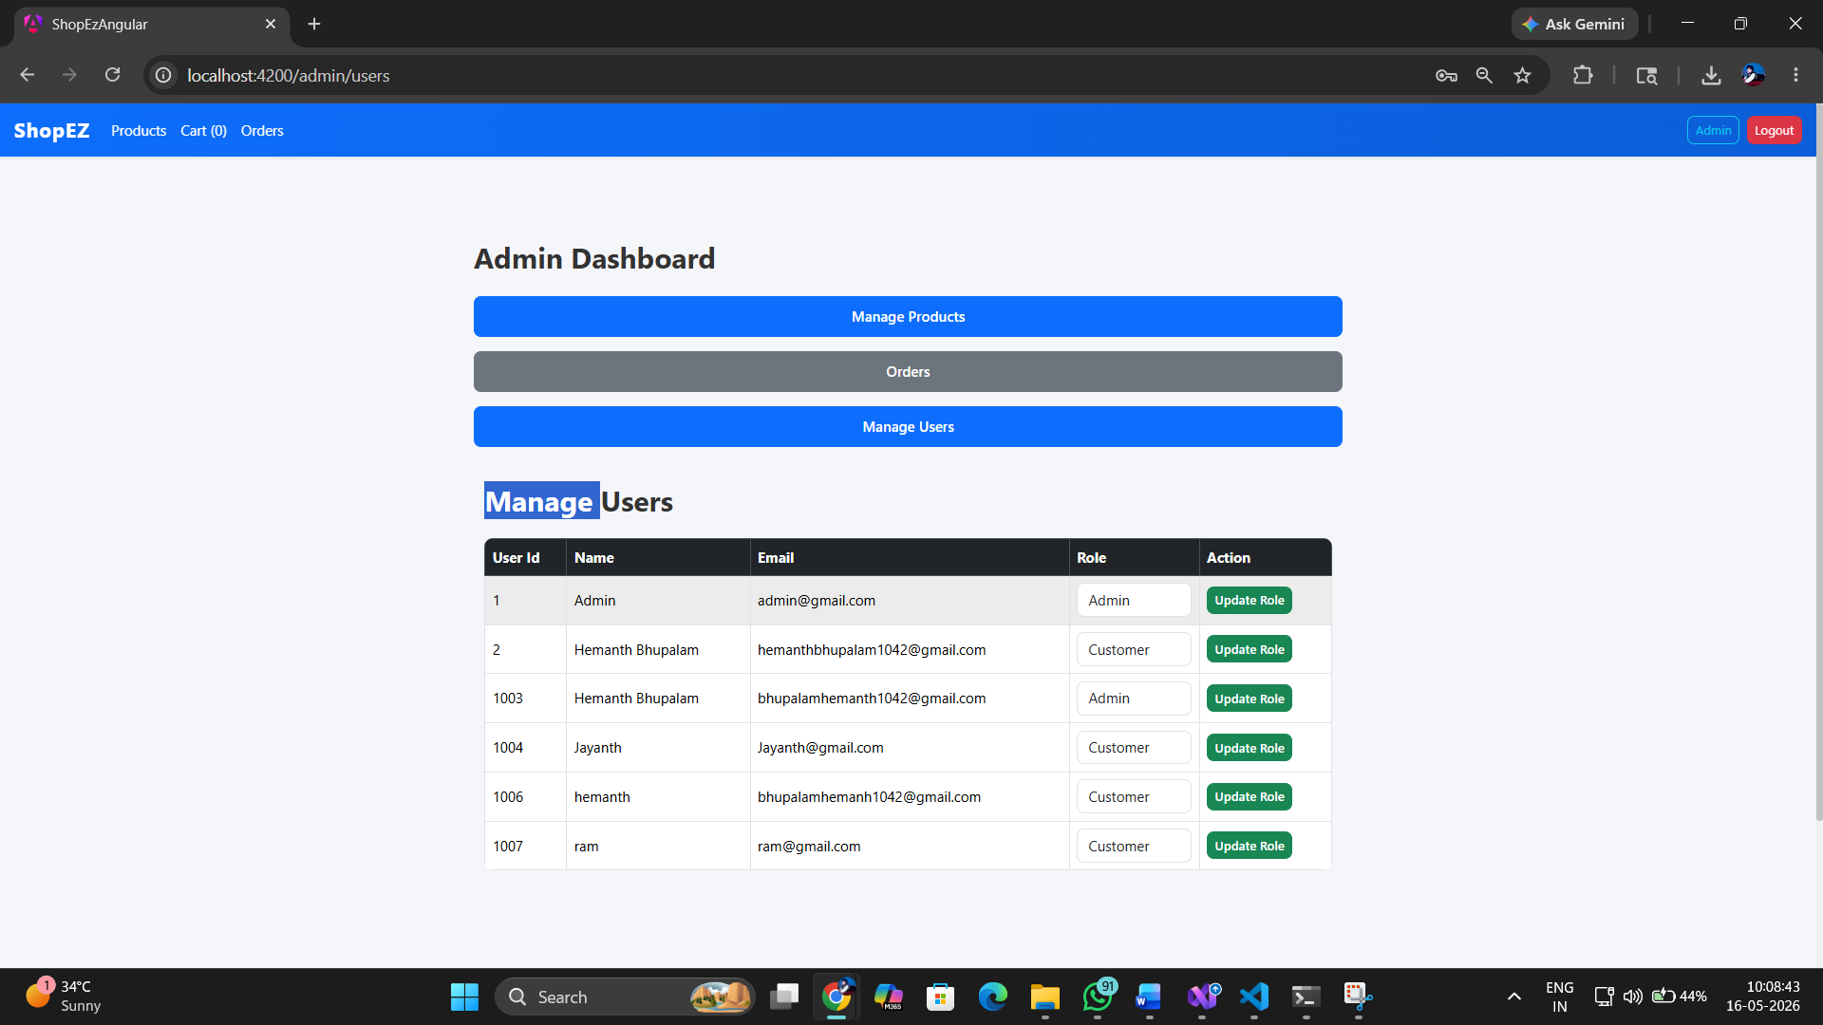

6.14 Guard Redirect — Unauthorized Access
Attempting to navigate to /checkout or /orders without being logged in automatically redirects to /login. Attempting to access /admin as a Customer redirects to the home page. Both behaviors are enforced by the SSR-safe authGuard and adminGuard.
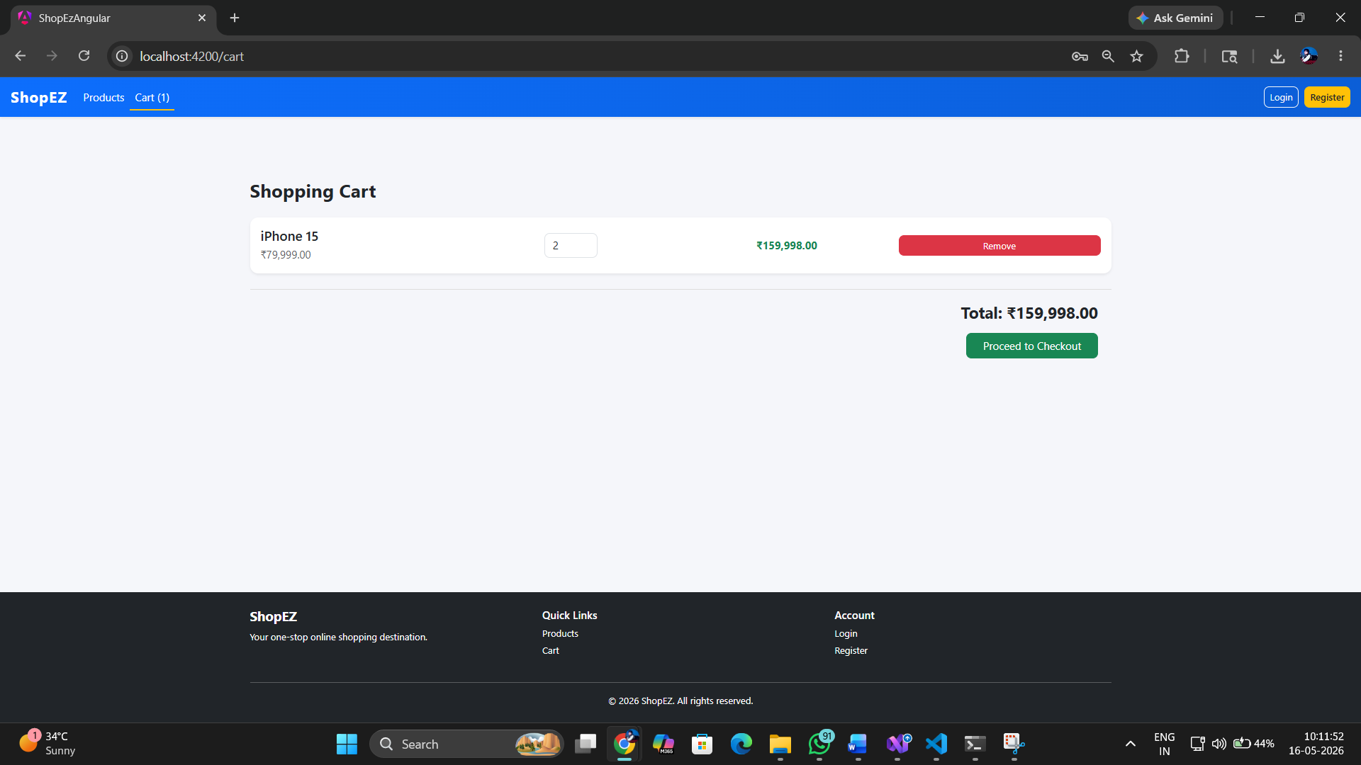

7. Testing — Test Reports
ShopEZ's Angular 21 frontend uses Karma as the test runner and Jasmine as the testing framework. Tests cover services, guards, interceptors, and components with a comprehensive set of spec files across all feature areas.

7.1 Test Summary

Test File | Component / Service | Coverage Focus
core/services/auth.spec.ts | AuthService | Login, Register, Logout, BehaviorSubject state, token getter
services/product.spec.ts | ProductService | getAll, getById, create, update, delete, getPaged
services/cart.spec.ts | CartService | add, remove, updateQuantity, clear, total, localStorage restore
services/order.spec.ts | OrderService | placeOrder, getOrders, getAllOrders, deleteOrder
services/user.spec.ts | UserService | getUsers, updateRole
core/guards/auth-guard.spec.ts | authGuard | Authenticated pass, unauthenticated redirect to /login
core/guards/admin-guard.spec.ts | adminGuard | Admin pass, Customer redirect to /
core/interceptors/jwt-interceptor.spec.ts | jwtInterceptor | Token attachment, no-token passthrough
core/interceptors/error-interceptor.spec.ts | errorInterceptor | 401, 403, 500, network error handling
components/product-list.spec.ts | ProductListComponent | Component creation, product display, search
components/cart.spec.ts | CartComponent | Cart item render, total calculation
components/checkout.spec.ts | CheckoutComponent | Order submission, cart clear on success
components/orders.spec.ts | OrdersComponent | Order history display
components/product-details.spec.ts | ProductDetailsComponent | Product info display, add to cart
pages/admin/*.spec.ts | Admin Components | Admin dashboard, products, orders, users CRUD
shared/navbar.spec.ts | NavbarComponent | Auth state display, cart badge count
shared/footer.spec.ts | FooterComponent | Component creation, link presence
app.spec.ts | AppComponent | Root component creation, router outlet

7.2 Running Tests
ng test
This launches Karma in a Chrome browser window and runs all spec files. Results are displayed in real time with pass/fail indicators. For CI/headless mode:
ng test --watch=false --browsers=ChromeHeadless

7.3 Test Execution Results
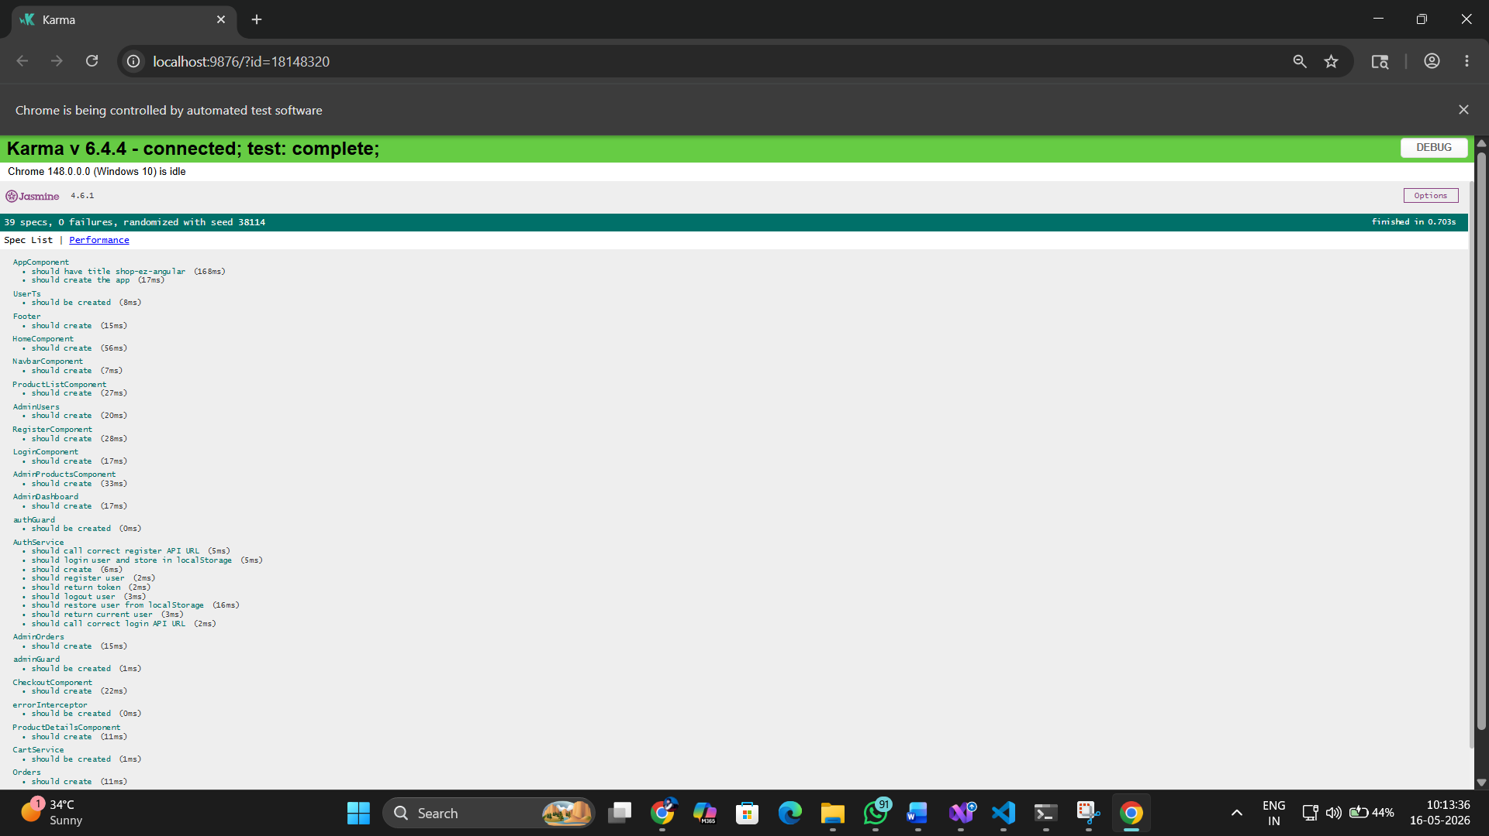

7.4 Sample Test Cases — AuthService

Test Method | Scenario | Expected Result | Status
login — valid credentials | Correct email + password POSTed | User stored in localStorage, user$ emits user object with JWT token | Pass
login — invalid credentials | Wrong password submitted | HTTP 401 returned, error interceptor handles response | Pass
register — new user | Valid registration data | POST called, HTTP 200 with success message | Pass
logout — clear session | logout() called | localStorage cleared, user$ emits null, token returns null | Pass
token getter — browser | User logged in with token | Returns JWT token string from localStorage user object | Pass
token getter — SSR | Running during server rendering | Returns null safely without accessing localStorage | Pass

7.5 Sample Test Cases — CartService

Test Method | Scenario | Expected Result | Status
add — new product | Product not in cart | Product added with quantity 1, cart$ emits updated array | Pass
add — existing product | Same product added again | Quantity incremented by 1, no duplicate entry created | Pass
remove — valid index | Remove item at index 0 | Item spliced from array, cart$ emits reduced array | Pass
updateQuantity | Change qty at index 1 to 3 | Cart item quantity updated, cart$ emits | Pass
clear | clear() called | localStorage removed, cart$ emits empty array | Pass
total | Cart with 2 items | Returns correct sum of price * quantity for all items | Pass

7.6 Testing Approach
- HttpClientTestingModule used in service tests to intercept and mock HTTP requests without real network calls
- HttpTestingController.expectOne() verifies the correct URL and HTTP method is called by each service method
- TestBed.createComponent() used in component tests to create component instances in isolation
- fixture.detectChanges() triggers Angular's change detection cycle for DOM-based assertions
- spyOn() used to mock service methods in component tests, isolating component logic from real HTTP calls
- isPlatformBrowser mocked using PLATFORM_ID injection for SSR-safe guard and interceptor testing

8. Deployment Guide

8.1 Prerequisites
- Node.js 20+ installed — https://nodejs.org (required by Angular 21)
- Angular CLI 21+ installed: npm install -g @angular/cli
- ShopEZ backend services must be running (see Backend Deployment Guide)
- Backend API Gateway must be accessible at http://localhost:5139

8.2 Step-by-Step Deployment
Step 1 — Navigate to the Angular project folder:
cd CapstoneProject/Frontend
Step 2 — Install dependencies:
npm install
Step 3 — Start the development server:
ng serve
Step 4 — Open in browser: Navigate to http://localhost:4200
Step 5 — Build for SSR production (optional):
ng build
node dist/shop-ez-angular/server/server.mjs

8.3 Environment Configuration

File | Variable | Value
src/environments/environment.ts | apiUrl | http://localhost:5139/api
src/environments/environment.development.ts | apiUrl | http://localhost:5139/api
All services use environment.apiUrl as their base URL. For production, update this to your production API Gateway URL.

8.4 Common Issues

Issue | Cause | Fix
CORS error on API calls | Backend not running or wrong port | Ensure backend services are running on expected ports
ng serve fails | Node modules not installed | Run npm install first
Login redirects but user not saved | localStorage blocked (private mode) | Use regular browser window
Admin panel not visible | User role is Customer not Admin | Update role via Admin Users panel or direct DB
SSR 404 on refresh | Server not handling all routes | Configure server to serve index.html for all routes
JWT token expired | Token older than 1 day | Log out and log in again to get fresh token

9. Conclusion
The ShopEZ Angular 21 frontend successfully demonstrates a modern, production-quality SPA built with Angular's latest patterns. The application provides a complete e-commerce user experience — from product discovery and cart management to order placement and admin operations — while maintaining clean code organization, type safety, and reactive state management.

Key achievements of the frontend project include:
- Fully standalone Angular 21 component architecture — no NgModules, cleaner and more maintainable
- Server-Side Rendering (SSR) via Angular Universal for improved SEO and first-paint performance
- Lazy-loaded routing for all feature pages — reduces initial bundle size and improves first load time
- Role-based access control via dedicated SSR-safe route guards — clean separation of Customer and Admin flows
- Reactive service layer using RxJS BehaviorSubject — auth state automatically propagates to all subscribed components
- JWT interceptor for automatic token attachment and a global error interceptor for centralized error handling
- Client-side cart management with localStorage persistence across page refreshes
- Comprehensive test coverage for services, guards, interceptors, and components using Karma + Jasmine
- Full admin panel covering products, orders, and user role management

10. Future Scope

10.1 UI/UX Improvements
- Integrate Angular Material or a custom design system for consistent, polished components
- Add product image carousel on the details page
- Implement skeleton loaders during API calls instead of blank screens
- Add toast/snackbar notifications for cart operations and order placement
- Responsive mobile design with CSS Grid breakpoints and a hamburger menu for Navbar

10.2 State Management
- Migrate to NgRx Store for complex global state management — especially useful for cart and product filters
- NgRx Effects for managing side effects like API calls in a predictable, testable way
- Sync cart state to backend via OrderService API so cart survives across devices

10.3 Authentication Enhancements
- Token refresh mechanism using Angular's HTTP interceptor to silently refresh expired tokens
- Social login (Google OAuth) integration
- Remember Me functionality with secure token storage

10.4 Performance Optimizations
- OnPush change detection strategy on all stateless components for better rendering performance
- Virtual scrolling for large product lists using Angular CDK VirtualScrollViewport
- Image lazy loading with Angular's native loading="lazy" attribute
- Service Worker (Angular PWA) for offline capability and faster repeat visits

10.5 Feature Additions
- Product reviews and ratings system with star-based UI
- Order tracking page with real-time status updates via WebSocket or SignalR
- Wishlist functionality with localStorage/API persistence
- Advanced search with filters — price range, category, in-stock only, sort by price/rating
- Internationalization (i18n) support using Angular's built-in i18n pipeline

